. 7. Supplementary figures
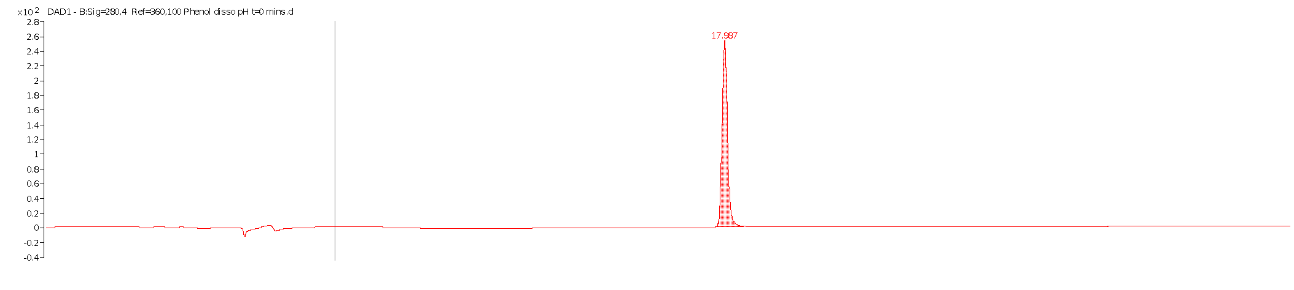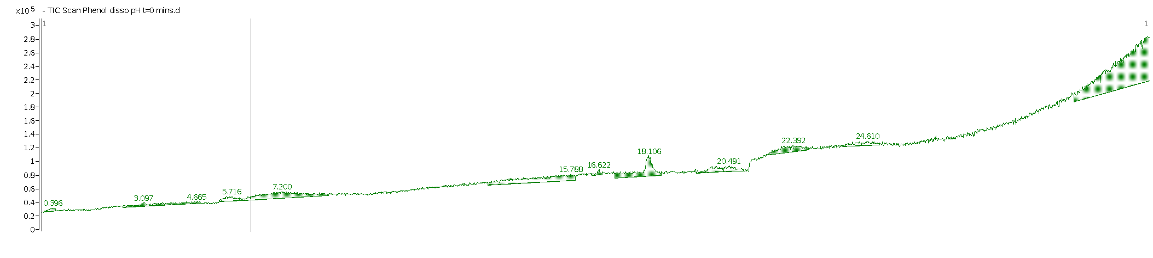

(a)
(b)
Phenol C₆H₆O
Weakly ionised
SF 1: (a) DAD [280 nm] and (b) TIC chromatograms of phenol (C₆H₆O) RT = 17.897 min

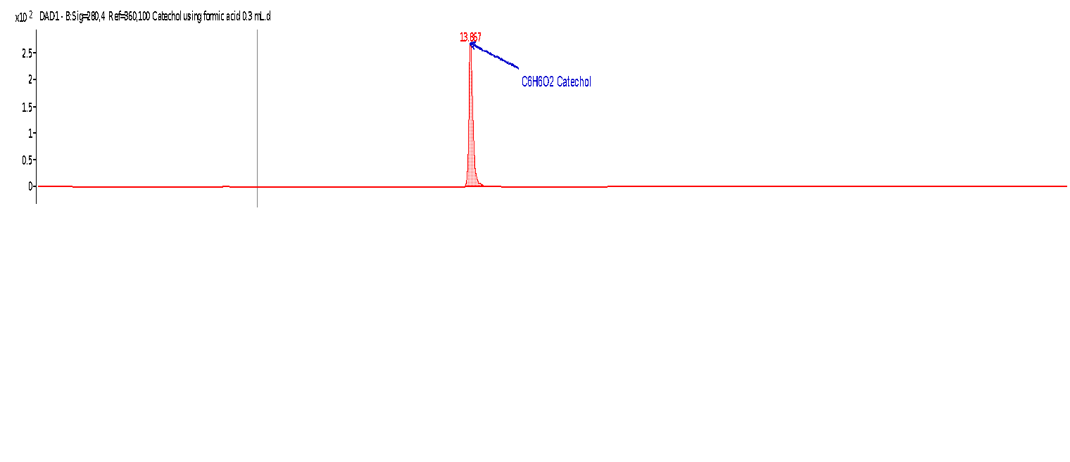
SF 2: DAD and TIC chromatograms of pure catechol standard (C₆H₆O₂) RT= 13.867 min

SF 3: EIC of Catechol C₆H₆O₂ produced upon ozonation of phenol
SF 4: EIC of acrylic acid C₃H₄O₂ (compound 21) produced upon ozonation of phenol

SF 5: EIC of isomer of Catechol C₆H₆O₂ produced upon ozonation of phenol RT = 20.639 mins
SF 6: EIC of one of two dimerised compounds of phenol ozonation in alkaline medium C₁₂H₁₀O₂

SF 7: EIC of second dimerization compound of phenol ozonation C₁₂H₁₀O₂
SF 8: EIC of trimer C₁₈H₁₄O₃ produced upon alkaline ozonation of phenol

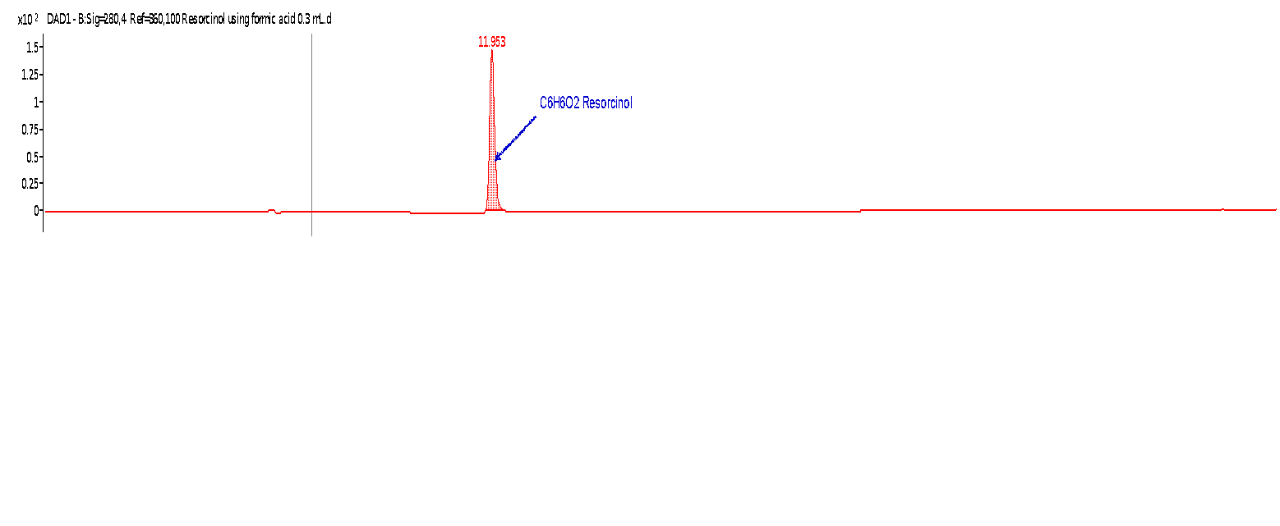
SF 9: DAD and TIC chromatograms for resorcinol (C₆H₆O₂) RT= 11.963 min
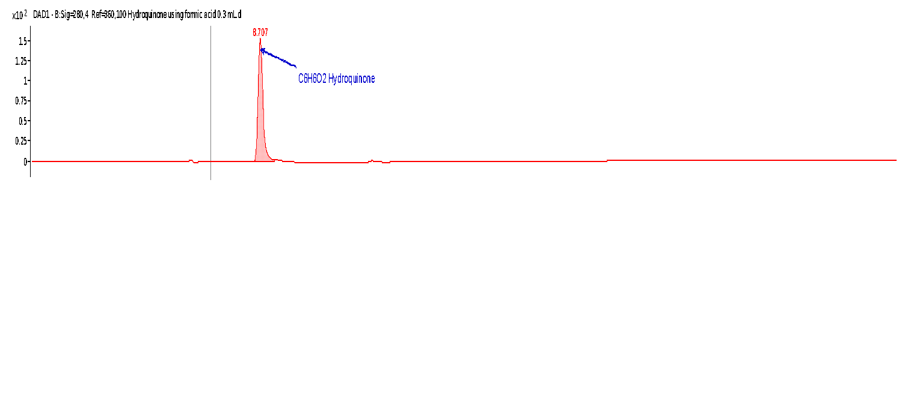
SF 10: DAD and TIC chromatograms for hydroquinone (C₆H₆O₂) RT = 8.707 min
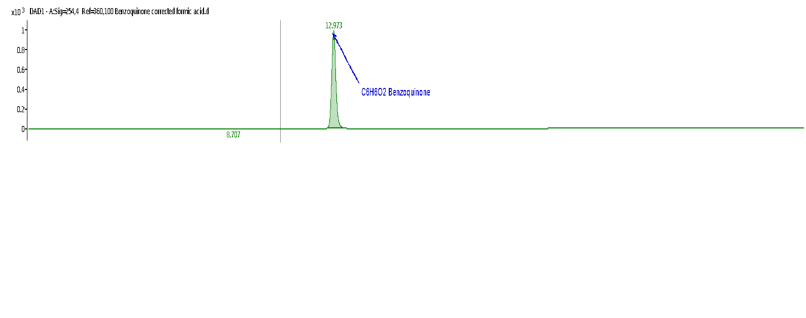
SF 11: DAD and TIC chromatograms for benzoquinone (C₆H₄O₂) RT = 12.973 min

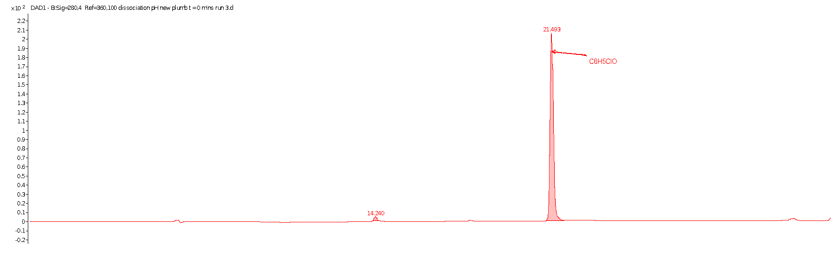
SF 12: Representative chromatogram for 2-chlorophenol RT= 21.493
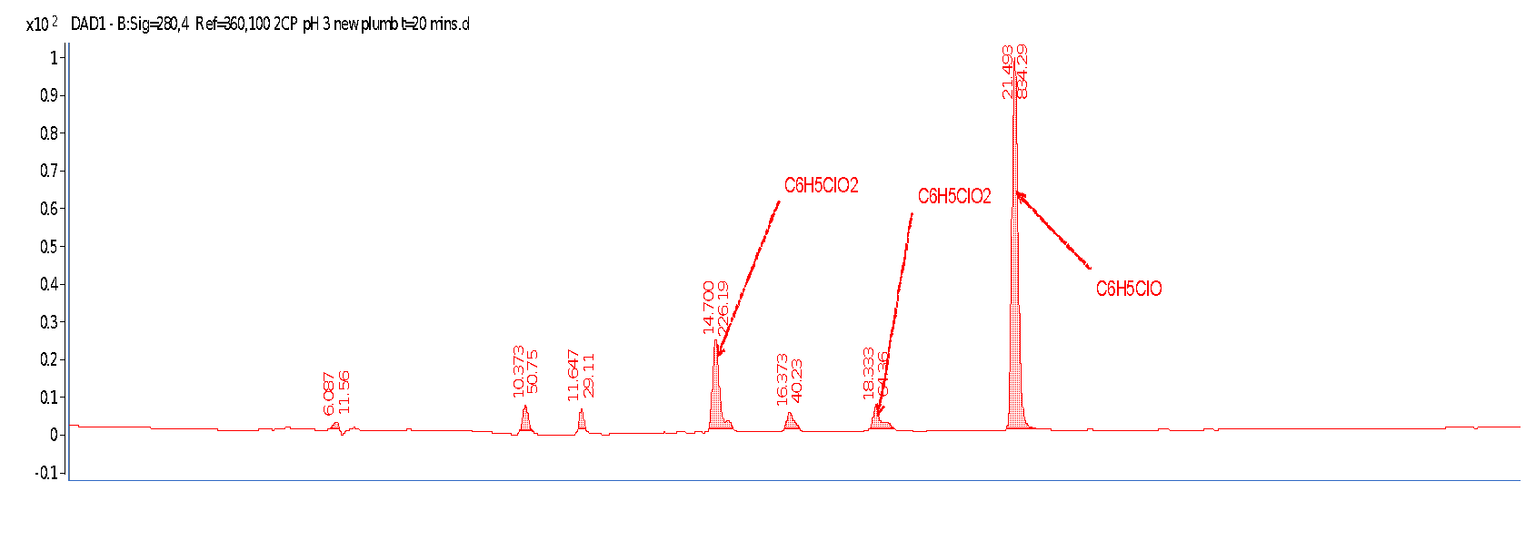
SF 13: DAD (280 nm) chromatogram for 2-chlorophenol ozonation in acidic media (pH 3) t=20mins
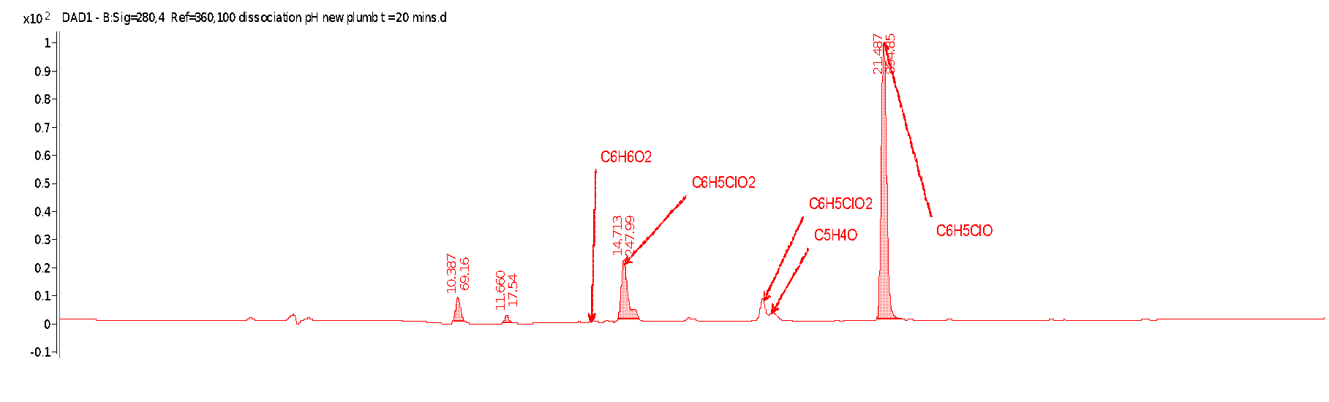
SF 14: DAD (280 nm) chromatogram for 2-chlorophenol ozonation without pH control t=20mins

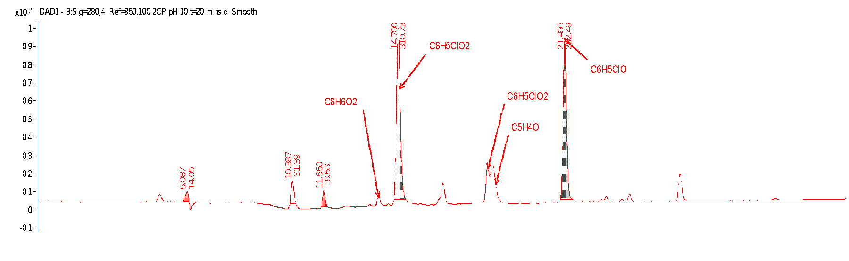
SF 15: DAD (280 nm) chromatogram for 2-chlorophenol ozonation in alkaline media (pH 10) t=20mins

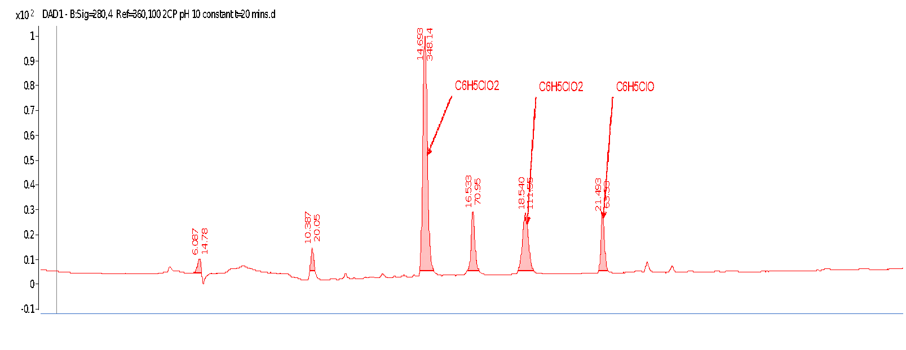
SF 16: DAD (280 nm) chromatogram for 2-chlorophenol ozonation constant alkaline media (pH 10) t=20mins
SF 17: Mass spectrum of catechol C₆H₆O₂ produced upon hydroxylation of 2-chlorophenol
SF 18: Mass spectrum of first hydroxylation product of 2-chlorophenol C₆H₅ClO₂
SF 19: Mass spectrum of second hydroxylation product of 2-chlorophenol ozonation C₆H₅ClO₂

SF 20: Representative chromatogram of 4-chlorophenol (RT=22,287). Top DAD. Bottom TIC.
SF 21: Mass spectrum of 4-chlorophenol showing isotope distributions C₆H₅ClO

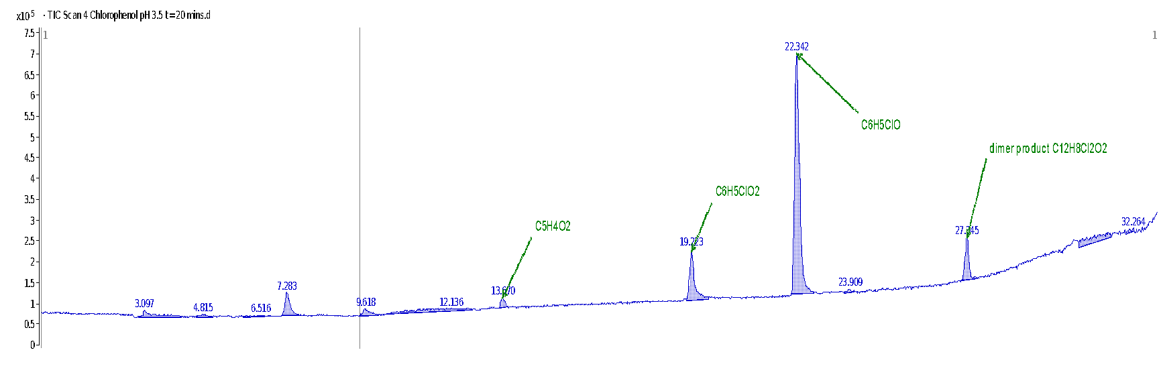
SF 22: Total ion chromatogram (TIC) for 4-chlorophenol ozonation in acidic medium. Starting pH 3.5, t=20 minutes

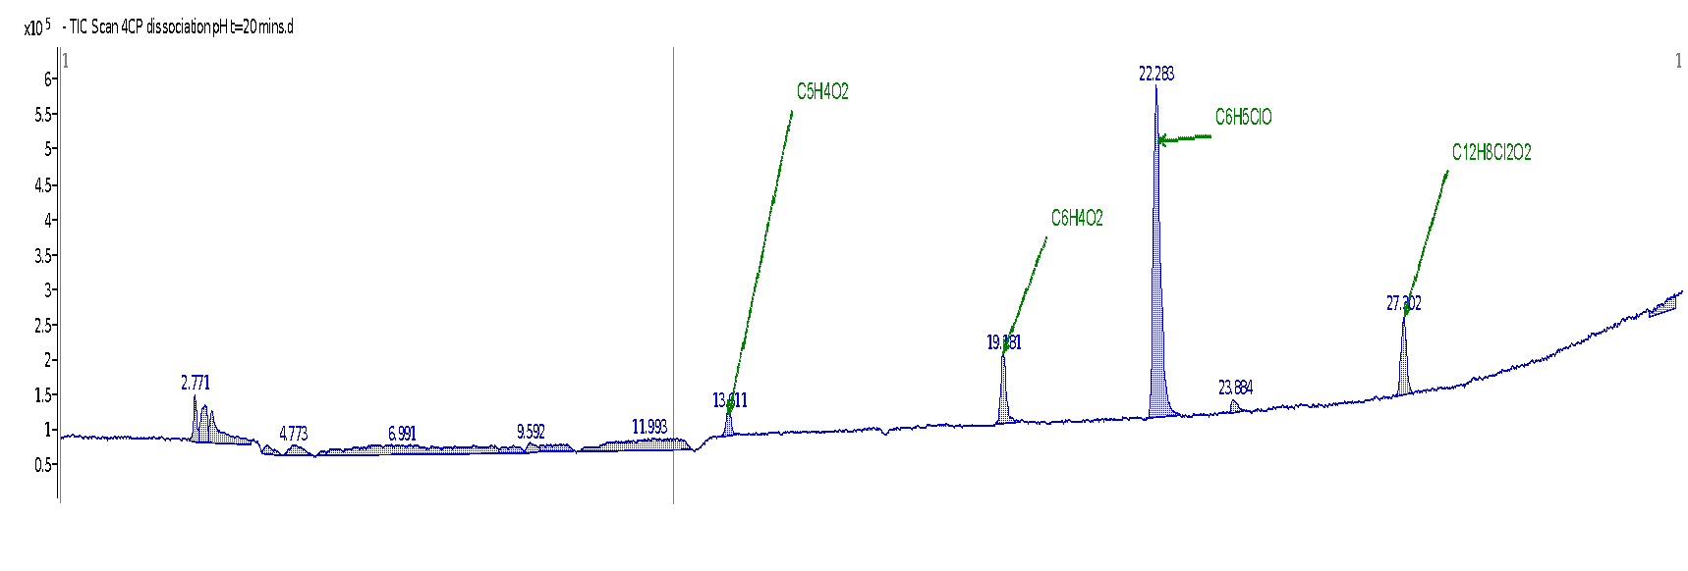
SF 23: Total ion chromatogram (TIC) for 4-chlorophenol ozonation at dissolution pH 6 t=20 minutes
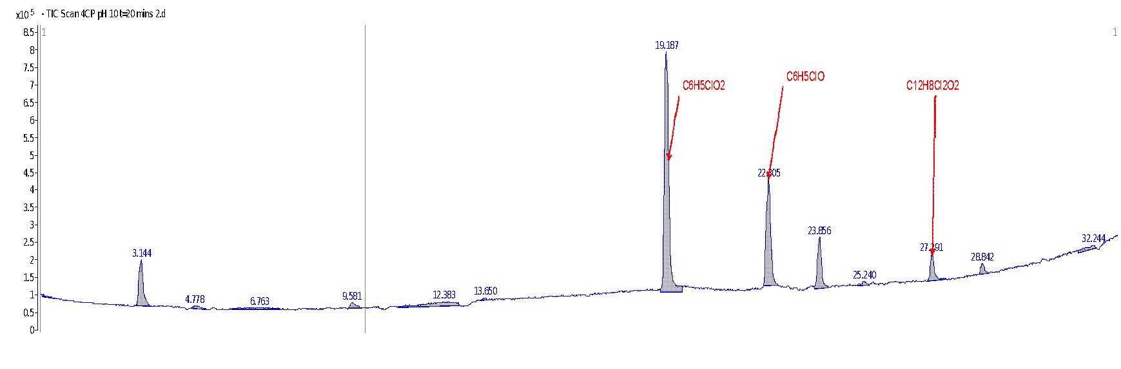
SF 24: Total ion chromatogram (TIC) for 4-chlorophenol ozonation in alkaline medium. Starting pH 10, t=20 minutes
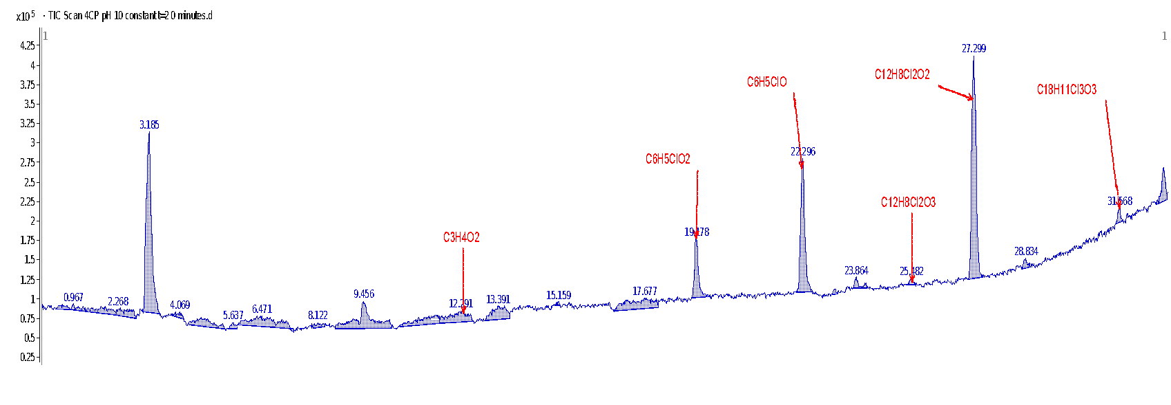
SF 25: Total ion chromatogram (TIC) for 4-chlorophenol ozonation with pH held constant at pH 10. Time =20 minutes
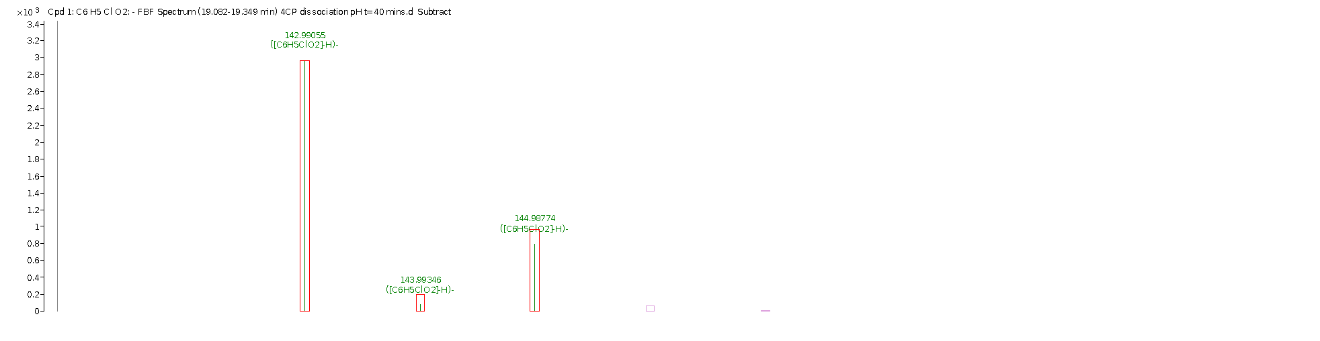
SF 26: Mass spectrum of single hydroxylation product of 4-chlorophenol ozonation C₆H₅ClO₂
SF 27: Mass spectrum of dimerised product of 4-chlorophenol ozonation C₁₂H₈Cl₂O₂
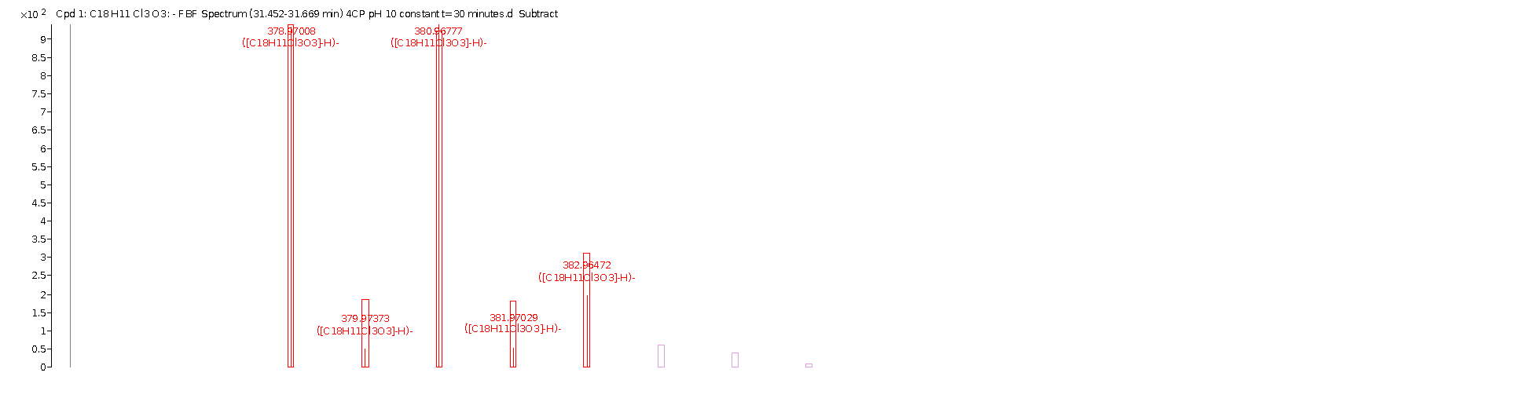
SF 28: Mass spectrum of trimerised product of 4-chlorophenol ozonation C₁₈H₁₁Cl₃O₃

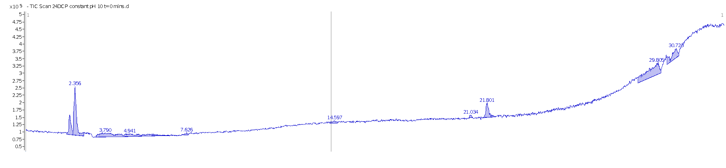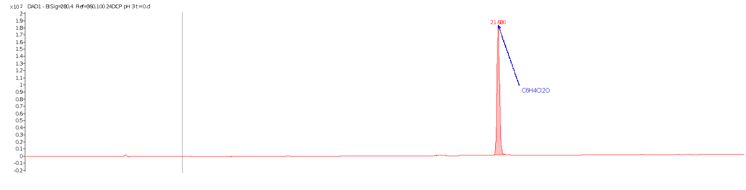

SF 29: Representative DAD and TIC chromatogram for 2,4-dichlorophenol at the start of each experiment. RT= 21.680 minutes.
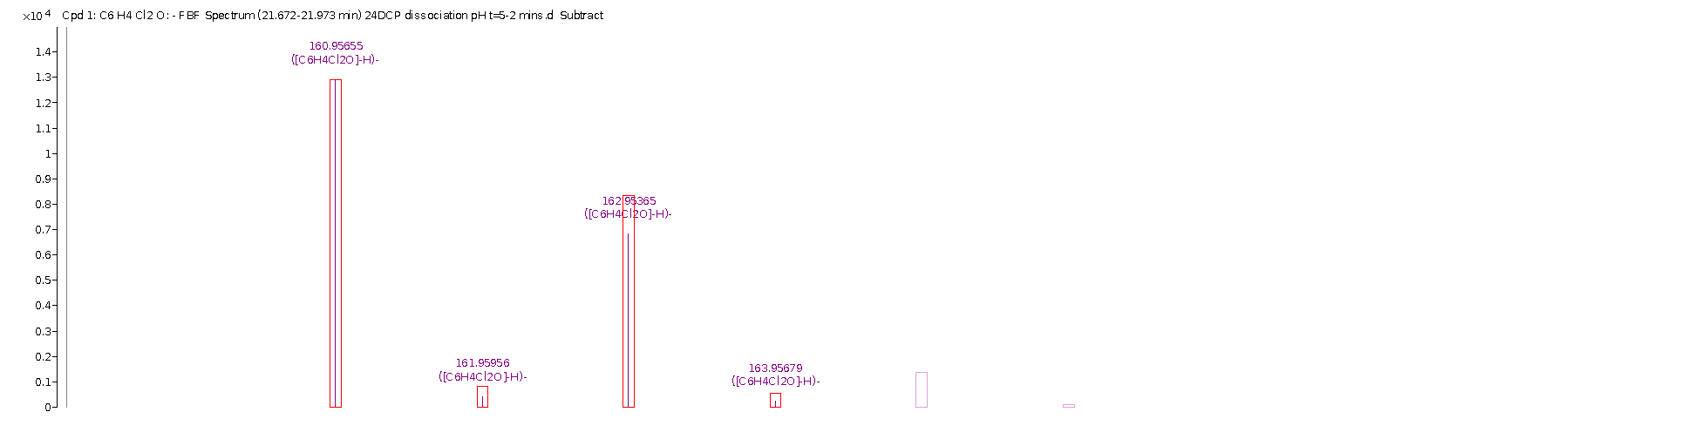
SF 30: Mass spectrum of 2,4-dichlorophenol showing isotope spacing used for identification C₆H₄Cl₂O

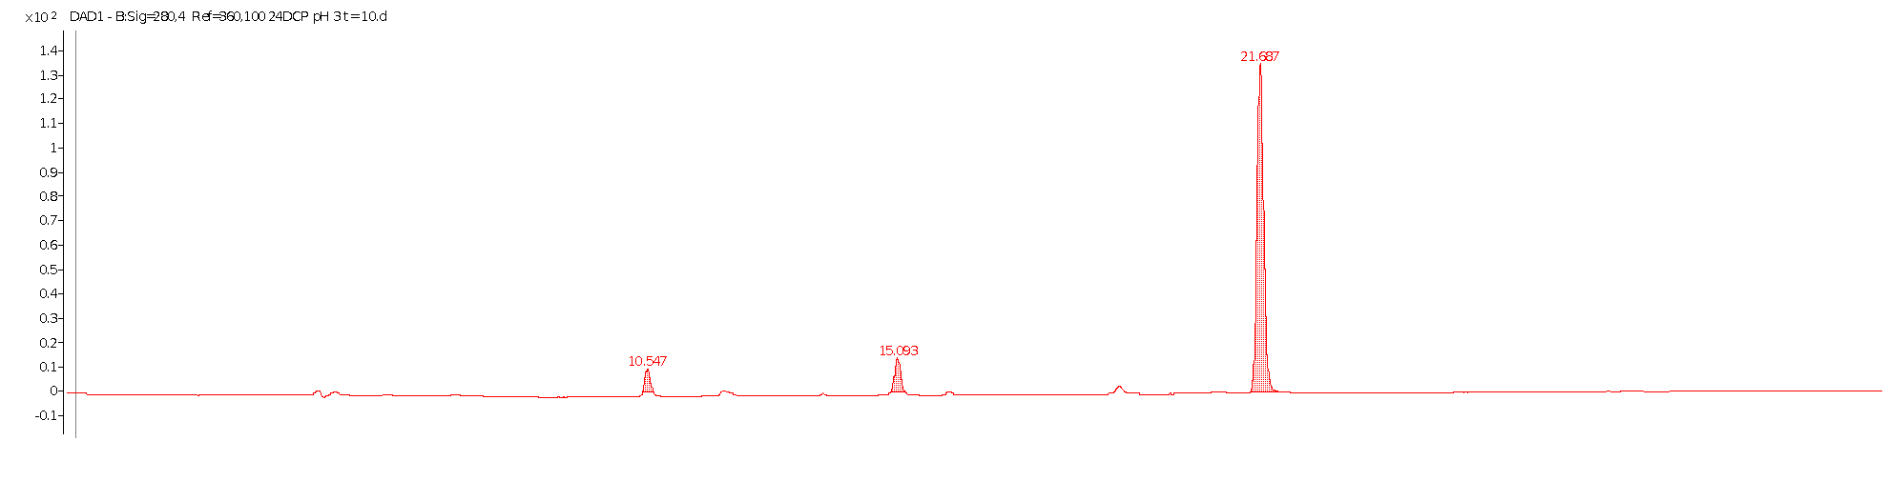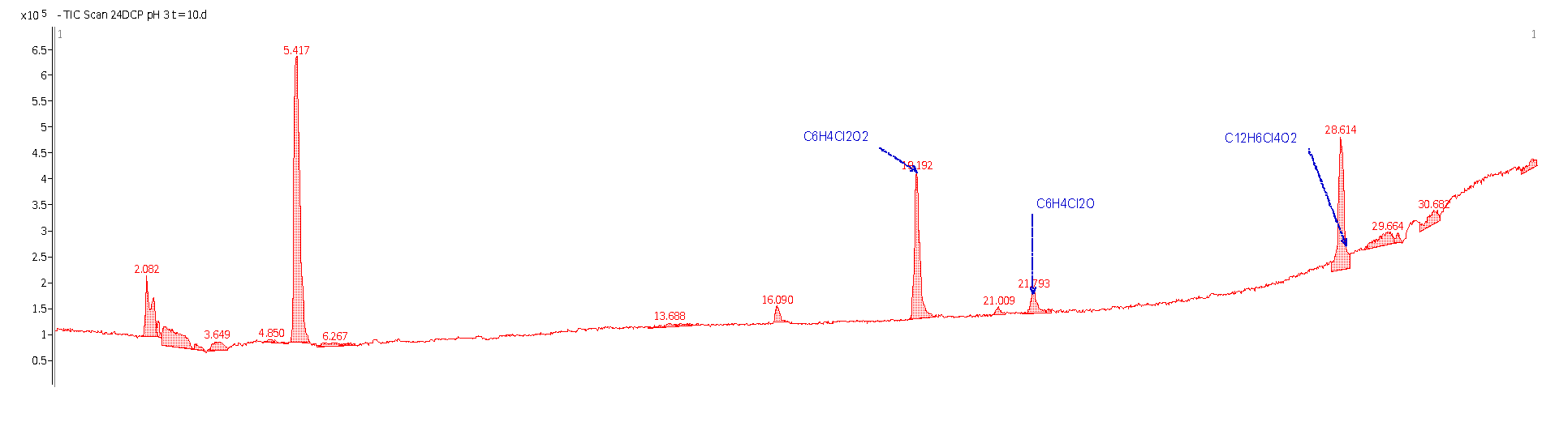

SF 31: DAD (280 nm) and TIC chromatogram for 2,4-dichlorophenol at t= 10 minutes in acidic media. pH 3
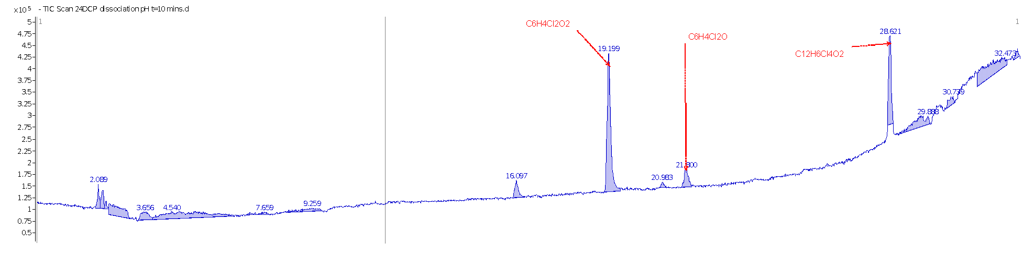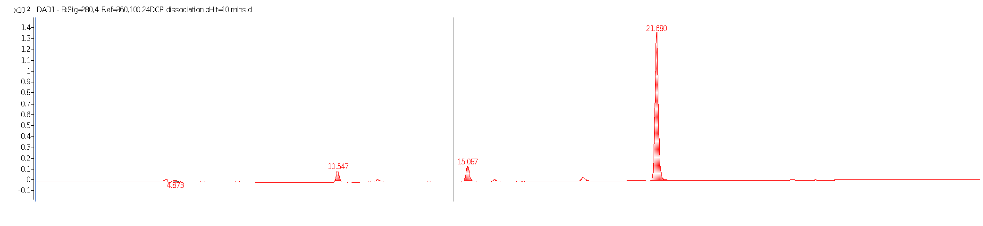

SF 32: DAD (280 nm) and TIC chromatogram for 2,4-dichlorophenol at t= 10 minutes without pH control.
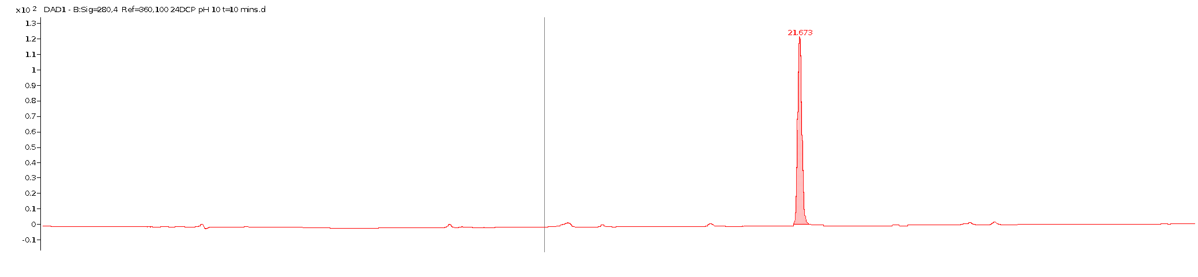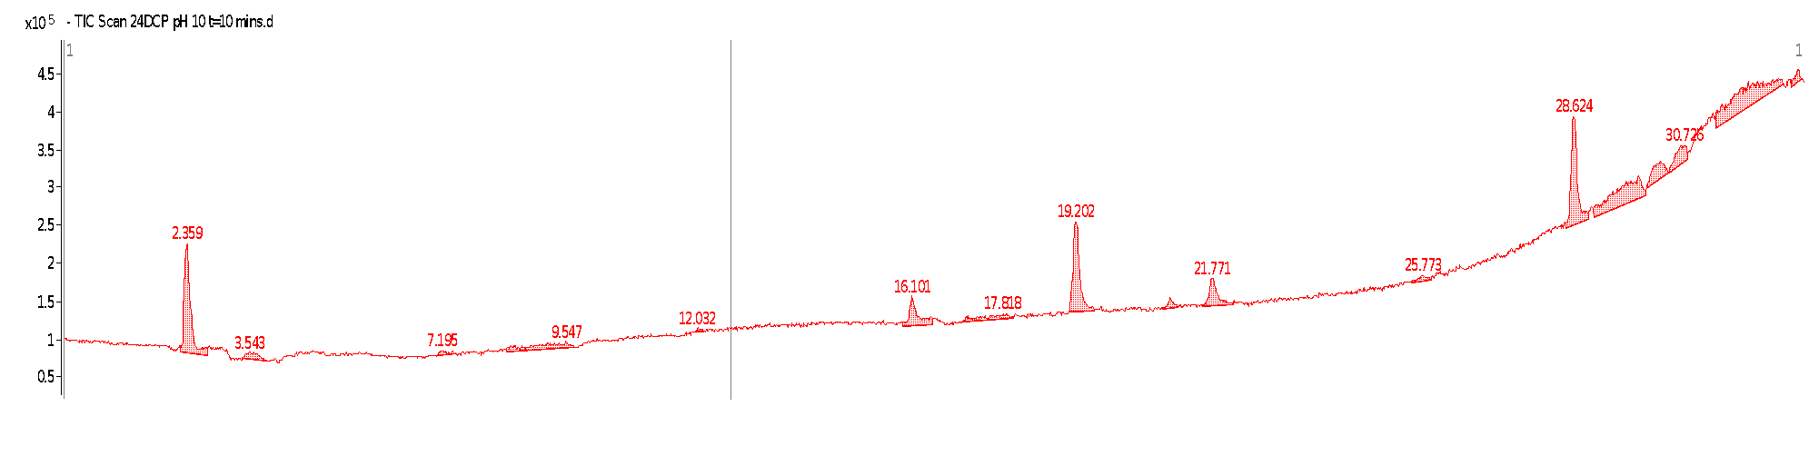

SF 33: DAD (280 nm) and TIC chromatogram for 2,4-dichlorophenol at t= 10 minutes in alkaline medium. pH 10.
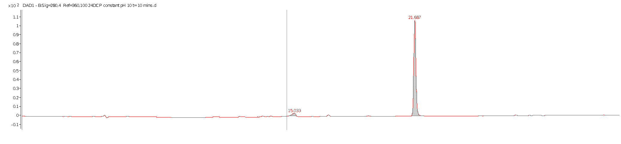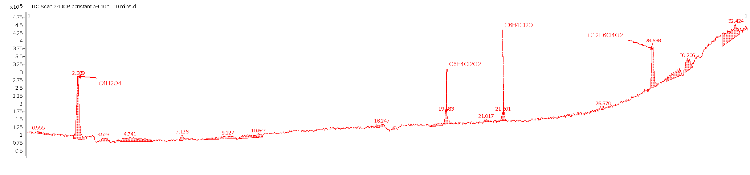

SF 34: DAD (280 nm) and TIC chromatogram for 2,4-dichlorophenol at t= 10 minutes. pH held constant in alkaline medium (pH 10).
SF 35: Mass spectrum of hydroxylation product on ozonation of 2,4-dichlorophenol C₆H₄Cl₂O₂
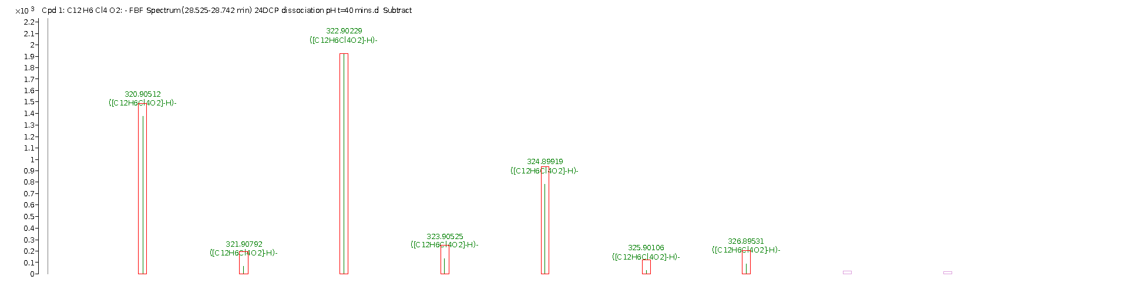
SF 36: Mass spectrum of first dimerization product of 2,4-dichlorophenol ozonation C₁₂H₆Cl₄O₂
SF 37: Mass spectrum of dechlorination product of 2,4-dichlorophenol ozonation C₆H₅ClO₂

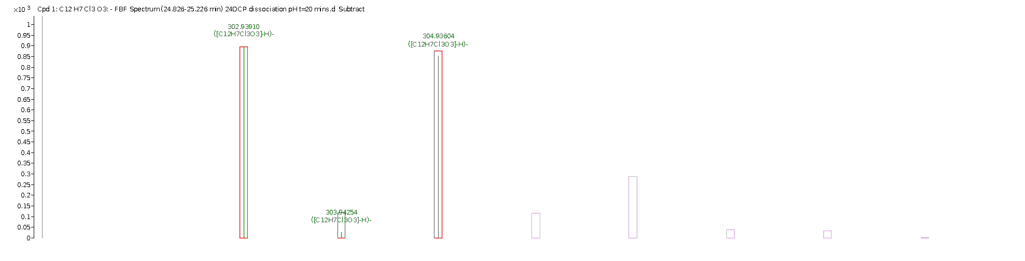
SF 38: Mass spectrum of second dimerization product of 2,4-dichlorophenol ozonation C₁₂H₇Cl₃O₃

7.0 Supplementary tables

ST 1: Intermediates of phenol ozonation at varying pH as followed by LC-MS
Time (min) |  | Acidic pH (3) |  |  | Dissolution pH 6 |  |  | Alkaline pH (10) [not held constant] |  |  | Constant alkaline pH (10)
 |  | RT | mass | Formula | RT | mass | Formula | RT | mass | Formula | RT | mass | Formula
0 |  | 17,987 |  | C6H6O | 17,987 |  | C6H6O | 17,987 |  | C6H6O | 17,987 |  | C6H6O
10 | 1 | 13,996 | 110,03721 | C6H6O2 | 13,998 | 110,03759 | C6H6O2 | 12,8 | 72,02096 | C3H4O2 | 3,153 | 113,99286 | C4H2O4
 | 2 |  |  |  |  |  |  | 14,003 | 110,03625 | C6H6O2 | 21,13 | 186,06842 | C12H10O2
 | 3 |  |  |  |  |  |  | 20,812 | 110,03676 | C6H6O2 | 23,044 | 186,06852 | C12H10O2
 | 4 |  |  |  |  |  |  | 20,814 | 136,0525 | C8H8O2
 | 5 |  |  |  |  |  |  | 21,134 | 186,06903 | C12H10O2
 | 6 |  |  |  |  |  |  | 22,888 | 94,04237 | C6H6O
 | 7 |  |  |  |  |  |  | 23,047 | 186,0691 | C12H10O2
20 | 1 | 12,797 | 72,02222 | C3H4O2 | 13,995 | 13,99500 | C6H6O2 | 13,995 | 110,03725 | C6H6O2 | 3,177 | 113,99286 | C4 H2 O4
 | 2 | 13,996 | 110,03721 | C6H6O2 |  |  |  | 19,749 | 110,03712 | C6H6O2 | 4,512 | 140,01121 | C6 H4 O4
 | 3 |  |  |  |  |  |  | 22,881 | 94,04284 | C6H6O | 4,563 | 178,04825 | C6 H10 O6
 | 4 |  |  |  |  |  |  |  |  |  | 5,717 | 146,02211 | C5 H6 O5
 | 5 |  |  |  |  |  |  |  |  |  | 5,721 | 88,01662 | C3 H4 O3
 | 6 |  |  |  |  |  |  |  |  |  | 8,026 | 220,03786 | C11 H8 O5
 | 7 |  |  |  |  |  |  |  |  |  | 8,971 | 222,05347 | C11 H10 O5
 | 8 |  |  |  |  |  |  |  |  |  | 12,505 | 138,03221 | C7 H6 O3
 | 9 |  |  |  |  |  |  |  |  |  | 12,755 | 72,02145 | C3 H4 O2
 | 10 |  |  |  |  |  |  |  |  |  | 13,995 | 110,03656 | C6 H6 O2
 | 11 |  |  |  |  |  |  |  |  |  | 14,772 | 164,04707 | C9 H8 O3
 | 12 |  |  |  |  |  |  |  |  |  | 20,81 | 110,03697 | C6 H6 O2
 | 13 |  |  |  |  |  |  |  |  |  | 20,812 | 136,05279 | C8 H8 O2
 | 14 |  |  |  |  |  |  |  |  |  | 21,129 | 186,06892 | C12 H10 O2
 | 15 |  |  |  |  |  |  |  |  |  | 22,883 | 96,02153 | C5 H4 O2
 | 16 |  |  |  |  |  |  |  |  |  | 22,884 | 124,01611 | C6 H4 O3
 | 17 |  |  |  |  |  |  |  |  |  | 22,884 | 94,04247 | C6 H6 O
 | 18 |  |  |  |  |  |  |  |  |  | 23,043 | 186,06892 | C12 H10 O2
 | 19 |  |  |  |  |  |  |  |  |  | 27,573 | 278,09535 | C18 H14 O3
30 | 1 | 12,797 | 72,02222 | C3H4O2 | 12,807 | 72,02235 | C3H4O2 | 12,749 | 72,01976 | C3H4O2 | 3,2 | 113,99286 | C4 H2 O4
 | 2 | 13,996 | 110,03721 | C6H6O2 | 13,998 | 110,03763 | C6H6O2 | 14,008 | 110,03447 | C6H6O2 | 4,508 | 140,01152 | C6 H4 O4
 | 3 |  |  |  |  |  |  | 22,892 | 94,04244 | C6H6O | 4,561 | 178,04877 | C6 H10 O6
 | 4 |  |  |  |  |  |  |  |  |  | 4,649 | 134,02187 | C4 H6 O5
 | 5 |  |  |  |  |  |  |  |  |  | 4,657 | 72,02182 | C3 H4 O2
 | 6 |  |  |  |  |  |  |  |  |  | 5,48 | 176,03098 | C6 H8 O6
 | 7 |  |  |  |  |  |  |  |  |  | 5,717 | 146,02046 | C5 H6 O5
 | 8 |  |  |  |  |  |  |  |  |  | 5,721 | 192,02596 | C6 H8 O7
 | 9 |  |  |  |  |  |  |  |  |  | 5,726 | 88,01532 | C3 H4 O3
 | 10 |  |  |  |  |  |  |  |  |  | 5,729 | 150,01516 | C4 H6 O6
 | 11 |  |  |  |  |  |  |  |  |  | 7,002 | 96,02034 | C5 H4 O2
 | 12 |  |  |  |  |  |  |  |  |  | 7,25 | 96,02031 | C5 H4 O2
 | 13 |  |  |  |  |  |  |  |  |  | 8,026 | 220,03632 | C11 H8 O5
 | 14 |  |  |  |  |  |  |  |  |  | 8,441 | 114,03057 | C5 H6 O3
 | 15 |  |  |  |  |  |  |  |  |  | 8,97 | 222,05216 | C11 H10 O5
 | 16 |  |  |  |  |  |  |  |  |  | 12,501 | 138,03162 | C7 H6 O3
 | 17 |  |  |  |  |  |  |  |  |  | 12,721 | 116,01021 | C4 H4 O4
 | 18 |  |  |  |  |  |  |  |  |  | 12,725 | 72,02178 | C3 H4 O2
 | 19 |  |  |  |  |  |  |  |  |  | 13,998 | 110,03719 | C6 H6 O2
 | 20 |  |  |  |  |  |  |  |  |  | 14,774 | 164,04757 | C9 H8 O3
 | 21 |  |  |  |  |  |  |  |  |  | 20,807 | 136,05298 | C8 H8 O2
 | 22 |  |  |  |  |  |  |  |  |  | 20,807 | 110,03703 | C6 H6 O2
 | 23 |  |  |  |  |  |  |  |  |  | 21,128 | 186,0692 | C12 H10 O2
 | 24 |  |  |  |  |  |  |  |  |  | 22,884 | 94,04251 | C6 H6 O
 | 25 |  |  |  |  |  |  |  |  |  | 22,884 | 96,02147 | C5 H4 O2
 | 26 |  |  |  |  |  |  |  |  |  | 22,885 | 124,01622 | C6 H4 O3
 | 27 |  |  |  |  |  |  |  |  |  | 23,043 | 186,06916 | C12 H10 O2
 | 28 |  |  |  |  |  |  |  |  |  | 27,579 | 278,09543 | C18 H14 O3

ST 2: Intermediates for 2-chlorophenol ozonation at varying pH as followed by LCMS
Time mins |  | Acidic pH (3) |  |  | Dissolution pH 6 |  |  | Alkaline pH (10) [not held constant] |  |  | Constant-alkaline pH (10)
 |  | RT | Mass | Formula | RT | Mass | Formula | RT | Mass | Formula | RT | Mass | Formula
0 |  | 21,493 |  | C6H5ClO | 21,493 |  | C6H5ClO | 21,493 |  | C6H5ClO | 21,493 |  | C6H5ClO
10 | 1 | 18,440 | 142,9918 | C6 H5Cl O2 | 14,003 | 110,03693 | C6 H6 O2 | 14,003 | 110,03741 | C6 H6 O2 | 7,035 | 96,0216 | C5 H4 O2
 | 2 |  |  |  | 18,429 | 142,9918 | C6 H5Cl O2 | 18,434 | 142,9918 | C6 H5Cl O2 | 12,803 | 72,02222 | C3 H4 O2
 | 3 |  |  |  | 18,43 | 80,02719 | C5 H4 O | 24,232 | 128,00299 | C6 H5 Cl O | 14,004 | 110,037 | C6 H6 O2
 | 4 |  |  |  |  |  |  | 26,294 | 128,00297 | C6 H5 Cl O | 18,436 | 142,9918 | C6 H5Cl O2
 | 5 |  |  |  |  |  |  |  |  |  | 26,66 | 253,99058 | C12 H8 Cl2 O2
20 | 1 | 18,433 | 142,9918 | C6 H5Cl O2 | 4,461 | 140,01119 | C6 H4 O4 | 4,462 | 140,01118 | C6 H4 O4 | 12,781 | 72,02226 | C3 H4 O2
 | 2 |  |  |  | 13,999 | 110,03704 | C6 H6 O2 | 12,811 | 72,02213 | C3 H4 O2 | 18,435 | 142,9918 | C6 H5Cl O2
 | 3 |  |  |  | 18,432 | 142,9918 | C6 H5Cl O2 | 13,998 | 110,03714 | C6 H6 O2
 | 4 |  |  |  | 18,433 | 80,02711 | C5 H4 O | 18,434 | 142,9918 | C6 H5Cl O2
 | 5 |  |  |  |  |  |  | 18,436 | 80,02699 | C5 H4 O
 | 6 |  |  |  |  |  |  | 26,296 | 128,00312 | C6 H5 Cl O
30 | 1 | 18,440 | 142,9918 | C6 H5Cl O2 | 4,457 | 140,01109 | C6 H4 O4 | 5,416 | 101,99576 | C3 H2 O4 | 5,464 | 180,02731 | C5 H8 O7
 | 2 |  |  |  | 13,993 | 142,9918 | C6 H5Cl O2 | 3,132 | 113,99286 | C4 H2 O4 | 5,727 | 150,01689 | C4 H6 O6
 | 3 |  |  |  | 18,429 | 108,02134 | C6 H4 O2 | 4,461 | 140,01117 | C6 H4 O4
40 | 1 |  |  |  | 4,455 | 140,01104 | C6 H4 O4 | 3,131 | 113,99286 | C4 H2 O4
 | 2 |  |  |  | 12,848 | 72,02218 | C3 H4 O2 | 5,416 | 101,99576 | C3 H2 O4
 | 3 |  |  |  | 18,436 | 108,02128 | C6 H4 O2
60 | 1 | 5,414 | 101,99547 | C3 H2 O4 | 4,238 | 88,01637 | C3 H4 O3 | 5,397 | 150,01669 | C4 H6 O6
 | 2 |  |  |  | 5,416 | 101,99572 | C3 H2 O4 | 5,416 | 101,99576 | C3 H2 O4
 | 3 |  |  |  | 5,418 | 120,00582 | C3 H4 O5

ST 3: Intermediates for 4-chlorophenol ozonation at varying pH as followed by LC-MS-TOF
 |  | Acidic pH (3) |  |  | Dissolution pH (6) |  |  | Alkaline pH (10) [not held constant] |  |  | Constant alkaline pH (10)
Time mins |  | RT | mass | Formula | RT | mass | Formula | RT | mass | Formula | RT | mass | Formula
0 | 1 | 22,349 | 128,00341 | C6 H5 Cl O | 22,349 | 128,00341 | C6 H5 Cl O | 22,306 | 128,00306 | C6 H5 Cl O | 3,131 | 113,99286 | C4 H2 O4
 | 2 |  |  |  |  |  |  |  |  |  | 22,299 | 128,00338 | C6 H5 Cl O
10 | 1 | 19,233 | 143,99792 | C6H5ClO2 | 19,179 | 145,99495 | C5H6O5 | 3,156 | 155,98109 | C6H4O5 | 3,145 | 113,99286 | C4 H2 O4
 | 2 | 22,339 | 128,00338 | C6 H5 Cl O | 19,18 | 143,99808 | C6H5ClO2 | 22,287 | 128,00317 | C6 H5 Cl O | 22,298 | 128,00329 | C6 H5 Cl O
 | 3 | 27,358 | 253,99058 | C12H8Cl2O2 | 22,295 | 128,00336 | C6 H5 Cl O | 27,301 | 253,9908 | C12 H8 Cl2 O2 | 27,306 | 253,99099 | C12 H8 Cl2 O2
 | 4 |  |  |  | 27,304 | 253,99087 | C12 H8 Cl2 O2
20 | 1 | 13,659 | 96,02137 | C5 H4 O2 | 13,605 | 96,02141 | C5 H4 O2 | 19,189 | 143,99823 | C6 H5 Cl O2 | 3,167 | 113,99286 | C4 H2 O4
 | 2 | 19,234 | 145,99472 | C5H6O5 | 19,179 | 145,99495 | C5H6O5 | 22,305 | 128,00321 | C6 H5 Cl O | 12,813 | 72,02164 | C3 H4 O2
 | 3 | 19,234 | 143,99787 | C6 H5 Cl O2 | 19,179 | 108,02088 | C6 H4 O2 | 27,312 | 253,99059 | C12 H8 Cl2 O2 | 19,182 | 145,99491 | C5H6O5
 | 4 | 22,341 | 128,00331 | C6 H5 Cl O | 22,293 | 128,00331 | C6 H5 Cl O |  |  |  | 19,182 | 108,02078 | C6 H4 O2
 | 5 | 27,354 | 253,99058 | C12H8Cl2O2 | 27,305 | 253,99083 | C12 H8 Cl2 O2 |  |  |  | 22,297 | 128,00304 | C6 H5Cl O
 | 6 |  |  |  |  |  |  |  |  |  | 25,48 | 269,98515 | C12 H8 Cl2 O3
 | 7 |  |  |  |  |  |  |  |  |  | 27,304 | 253,99106 | C12 H8 Cl2 O2
 | 8 |  |  |  |  |  |  |  |  |  | 31,547 | 379,97781 | C18 H11 Cl3 O3
30 | 1 | 13,65 | 96,02148 | C5 H4 O2 | 12,889 | 72,02191 | C3 H4 O2 |  |  |  | 3,184 | 113,99286 | C4 H2 O4
 | 2 | 19,229 | 108,02107 | C6 H4 O2 | 13,601 | 96,02142 | C5 H4 O2 |  |  |  | 12,808 | 72,02165 | C3 H4 O2
 | 3 | 27,355 | 253,99041 | C12 H8 Cl2 O2 | 19,181 | 108,02067 | C6 H4 O2 |  |  |  | 19,178 | 145,99486 | C5H6O5
 | 4 |  |  |  | 27,305 | 253,99069 | C12 H8 Cl2 O2 |  |  |  | 19,178 | 108,02063 | C6 H4 O2
 | 5 |  |  |  |  |  |  |  |  |  | 22,299 | 128,00274 | C6 H5 Cl O
40 | 1 | 12,848 | 72,02202 | C3 H4 O2 | 13,601 | 96,02137 | C5 H4 O2 | 3,134 | 113,99286 | C4 H2 O4 | 3,199 | 113,99285 | C4 H2 O4
 | 2 | 13,648 | 96,02138 | C5 H4 O2 | 19,184 | 143,99780 | C6 H5 Cl O2 | 12,884 | 72,02159 | C3 H4 O2 | 5,749 | 150,01641 | C4 H6 O6
 | 3 | 19,228 | 108,02079 | C6 H4 O2 | 27,304 | 253,99038 | C12 H8 Cl2 O2 | 13,606 | 96,02114 | C5 H4 O2 | 12,807 | 72,02163 | C3 H4 O2
 | 4 | 22,338 | 128,00317 | C6H5ClO |  |  |  | 19,187 | 143,99774 | C6H5ClO2
 | 5 | 27,353 | 253,99055 | C12H8Cl2O2 |  |  |  | 22,292 | 128,00275 | C6H5ClO
60 | 1 |  |  |  | 4,249 | 113,99286 | C4 H2 O4 | 3,133 | 113,99286 | C4 H2 O4 | 3,221 | 113,99286 | C4 H2 O4
 | 2 |  |  |  |  |  |  |  |  |  | 5,747 | 150,01642 | C4 H6 O6

ST 4: Intermediates for 2,4-dichlorophenol ozonation at varying pH as followed by LC-MS-TOF
Time mins |  | Acidic pH (3) |  |  | Dissolution pH 6 |  |  | Alkaline pH (10) [not held constant] |  |  | Constant alkaline pH (10)
 |  | RT | mass | Formula | RT | mass | Formula | RT | mass | Formula | RT | mass | Formula
0 |  | 21,795 | 161,96385 | C6 H4 Cl2 O | 21,795 | 161,96385 | C6 H4 Cl2 O | 21,769 | 161,96397 | C6 H4 Cl2 O | 21,803 | 161,96397 | C6 H4 Cl2 O
10 | 1 | 5,418 | 97,97711 | C4H2O3 | 16,1 | 143,99046 | C6 H5 Cl O2 | 2,362 | 113,99286 | C4 H2 O4 | 2,375 | 113,99286 | C4 H2 O4
 | 2 | 16,101 | 143,99046 | C6 H5 Cl O2 | 19,196 | 177,95917 | C6 H4 Cl2 O2 | 16,1 | 143,99046 | C6 H5 Cl O2 | 19,201 | 177,95893 | C6 H4 Cl2 O2
 | 3 | 19,197 | 177,95921 | C6 H4 Cl2 O2 | 21,789 | 161,96385 | C6 H4 Cl2 O | 19,199 | 177,95901 | C6 H4 Cl2 O2 | 21,794 | 161,96385 | C6 H4 Cl2 O
 | 4 | 21,789 | 161,96385 | C6 H4 Cl2 O | 28,617 | 321,91325 | C12 H6 Cl4 O2 | 21,784 | 161,96385 | C6 H4Cl2 O | 28,632 | 321,91312 | C12 H6 Cl4 O2
 | 5 | 28,62 | 321,91330 | C12 H6 Cl4 O2 |  |  |  | 28,628 | 321,91318 | C12 H6 Cl4 O2
20 | 1 | 5,435 | 97,97689 | C4H2O3 | 16,102 | 143,99046 | C6 H5 Cl O2 | 2,361 | 113,99286 | C4 H2 O4 | 2,402 | 113,99286 | C4 H2 O4
 | 2 | 16,11 | 143,99046 | C6 H5 Cl O2 | 19,197 | 177,95929 | C6 H4 Cl2 O2 | 16,12 | 143,99046 | C6 H5 Cl O2 | 7,037 | 113,99286 | C4 H2 O4
 | 3 | 19,21 | 177,95926 | C6 H4 Cl2 O2 | 21,792 | 161,96385 | C6 H4 Cl2 O | 19,223 | 177,95926 | C6 H4 Cl2 O2 | 19,203 | 177,959 | C6 H4 Cl2 O2
 | 4 | 21,8 | 161,96387 | C6 H4 Cl2 O | 28,616 | 321,91300 | C12 H6 Cl4 O2 | 21,819 | 161,9638 | C6 H4 Cl2 O | 28,624 | 321,91321 | C12 H6 Cl4 O2
 | 5 | 28,624 | 321,91299 | C12 H6 Cl4 O2 |  |  |  | 28,655 | 321,91285 | C12 H6 Cl4 O2 | 32,389 | 447,89976 | C18 H9 Cl5 O3
30 | 1 | 5,404 | 97,97706 | C4H2O3 | 16,102 | 143,99046 | C6 H5 Cl O2 | 2,355 | 113,99286 | C4 H2 O4 | 2,42 | 113,99286 | C4 H2 O4
 | 2 | 7,04 | 113,99286 | C4 H2 O4 | 19,197 | 177,95922 | C6 H4 Cl2 O2 | 7,086 | 113,99286 | C4 H2 O4 | 6,989 | 113,99286 | C4 H2 O4
 | 3 | 16,1 | 143,99046 | C6 H5 Cl O2 | 28,615 | 321,91275 | C12 H6 Cl4 O2
 | 4 | 19,198 | 177,95920 | C6 H4 Cl2 O2
 | 5 | 21,796 | 161,96376 | C6 H4 Cl2 O
 | 6 | 28,618 | 321,91280 | C12 H6 Cl4 O2
40 | 1 | 5,397 | 97,97705 | C4H2O3 |  |  |  | 2,358 | 113,99286 | C4 H2 O4 | 2,435 | 113,99286 | C4 H2 O4
 | 2 | 5,402 | 159,93484 | C5H4O6 |  |  |  | 7,024 | 113,99286 | C4 H2 O4 | 6,966 | 113,99286 | C4 H2 O4
 | 3 | 7,008 | 113,99286 | C4 H2 O4
 | 4 | 19,203 | 177,95902 | C6 H4 Cl2 O2

