ESI of TMPH-2019-0286.R1
Theoretical insights into elaborating and regulating excited state dynamics for the novel 6-cyano-2-(2’-hydroxyphenyl)imidazo[1,2a]pyridine system in polar and nonpolar solvents
Lei Xu^{1*}, Qiaoli Zhang¹, Tianjie Zhang¹, Dapeng Yang^{1,2}
1. College of Physics and Electronics, North China University of Water Resources and Electronic Power, Zhengzhou 450046, P. R. China
2. State Key Laboratory of Molecular Reaction Dynamics, Theoretical and Computational Chemistry, Dalian Institute of Chemical Physics, Chinese Academy of Sciences, Dalian 116023, P. R. China
Corresponding author and email address: Lei Xu, email: ncwu_xl@163.com

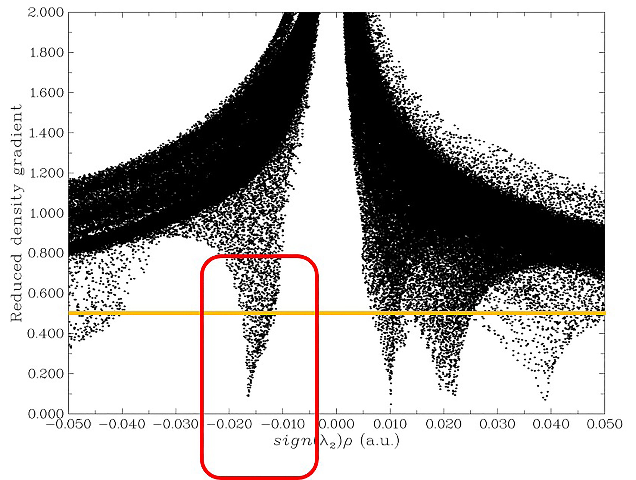
Figure S1. The RDG (Y-axis) versus sign(λ₂)ρ (X-axis) for 6-CN-HPIP system in the ground state. Herein, the weak interactions could be revealed according to RDG principle (i.e., negative values of sign(λ₂)ρ refer to hydrogen bonding interactions; positive values of sign(λ₂)ρ stand for steric effects; values of sign(λ₂)ρ near zero exhibit van der Waal (VDW) interactions).
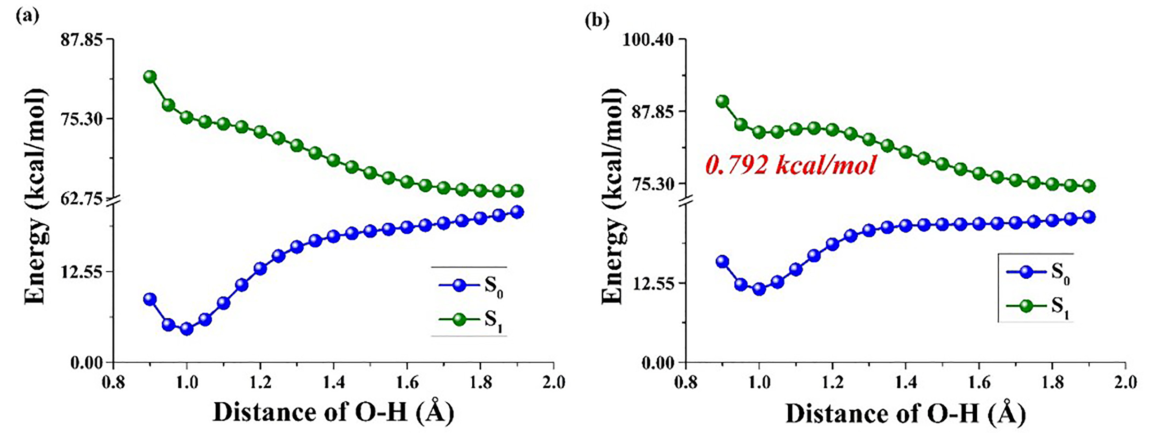
Figure S2. The constructed potential energy curves along with the ESIPT path in CCl4 (a) and DMSO (b) solvents using the Cam-B3LYP functional for 6-CN-HPIP system in both S₀ and S₁ states.

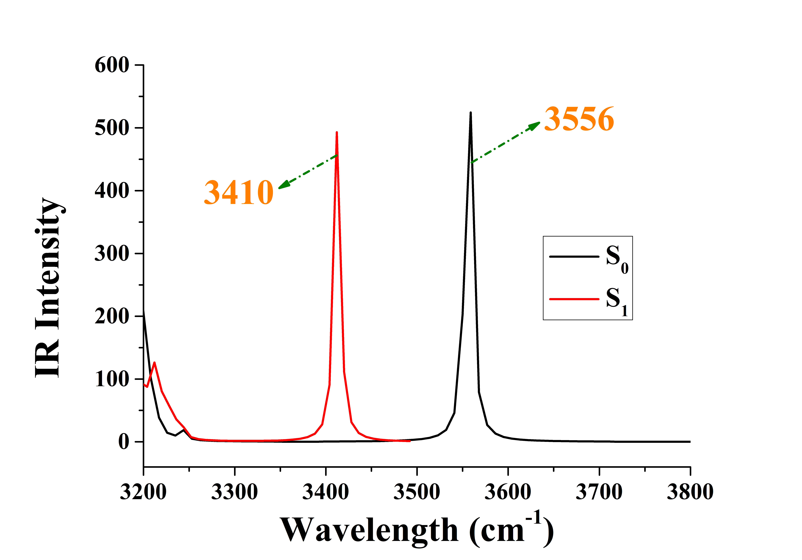
Figure S3. The theoretical IR vibrational spectra at the spectral region of O-H stretching vibration mode for 6-CN-HPIP forms in DMSO solvent.

