**Supporting Information**

***Supramolecular Chemistry***

**Synthesis and Spectroscopic Studies of**

**Diaza-8-Crown-4-Dinitrophenyl Ethers**

Claudia Galea,a Damjan Makuc,b Konrad Szaciłowski,c and Janez Plavecb,d and David C. Magria*

a Department of Chemistry, Faculty of Science, University of Malta, Msida, MSD 2080, Malta.

b Slovenian NMR Centre, National Institute of Chemistry, Hajdrihova 19, SI-1000 Ljubljana, Slovenia

c Academic Centre of Materials and Nanotechnology, AGH University of Science and Technology, al. Mickiewicza 30, 30-059 Kraków, Poland

d EN-FIST Centre of Excellence, Trg Osvobodilne fronte 13, SI-1000 Ljubljana, Slovenia

Corresponding author: Prof. Dr David C. Magri

phone: (356) 2340 2276

email: [david.magri@um.edu.mt](mailto:david.magri@um.edu.mt)

**Table of Contents**

|  |  |
| --- | --- |
|  | Page |
| **Table of Contents** ………………………………………………………………….…. | 1 |
| **Experimental**…………………………………………………………………………... | 2 |
| **Figure S1**. 1H NMR spectrum of **1** in DMSO-*d6*..…………………………………….. | 4 |
| **Figure S2**. 13C NMR spectrum of **1** in DMSO-*d*6.……….…………….…………….... | 5 |
| **Figure S3**. 1H NMR spectrum of **2** in DMSO-*d6* ……………………….…………...... | 6 |
| **Figure S4**. 13C NMR spectrum of **2** in DMSO-*d6*.………………..…………………..... | 7 |
| **Figure S5**. 1H NMR spectrum of **3** in DMSO-*d6*. ………………………………….….. | 8 |
| **Figure S6**.13C NMR spectrum of **3** in DMSO-*d6*. …………………………………....... | 9 |
| **Figure S7**. Mass spectrum (ESI) of **1** ……………………………………………........ | 10 |
| **Figure S8**. Mass spectrum (ESI) of **2** …………..…………………………………….. | 11 |
| **Figure S9**. Mass spectrum (ESI) of **3** …………..……………………………………... | 12 |
| **Figure S10**. IR spectrum of **1** as a KBr disc…………………………………………… | 13 |
| **Figure S11**. IR spectrum of **2** as a KBr disc…………………………………………… | 14 |
| **Figure S12**.IR spectrum of **3** as a KBr disc…………………………………………… | 15 |
| **Figure S13**. 1H-13C HSQC NMR spectrum of **3** at pD 7…………….……………….... | 16 |
| **Figure S14**. 1H-13C HMBC NMR spectrum of **3** at pD 7…………….………...……… | 17 |
| **Figure S15**. UV-vis absorption spectra of **3** versuspH in 1:1 (v/v) ACN/water…….. | 18 |
| **Figure S16**. UV-vis absorption spectra of **1** versus Li+ in 1:1 (v/v) ACN/water….… | 19 |
| **Figure S17**. UV-vis absorption spectra of **2** versus Li+ in 1:1 (v/v) ACN/water…….  **.** | 20 |
| **Figure S18**. UV-vis absorption spectra of **3** versus Li+ in 1:1 (v/v) ACN/water……. | 21 |
| **Figure S19**. 1H NMR titration spectra of **1** (*meta*) pD 1-7……………..……………… | 22 |
| **Figure S20**. 1H-15N HMBC NMR spectrum of **1** (*meta*) at pD 7……………………... | 23 |
| **Figure S21**. 1H-15N HMBC NMR spectrum of **1** (*meta*) at pD 3……........................... | 24 |
| **Figure S22**. 1H NMR titration spectra of **2** (*para*) pD 1-7…………………………….. | 25 |
| **Figure S23**. 1H-15N HMBC NMR spectrum of **2** (*para*) at pD 7…………………...…. | 26 |
| **Figure S24**. 1H-15N HMBC NMR spectrum of **2** (*para*) at pD 3…………….…..……. | 27 |
| **Figure S25**. 1H NMR titration spectra of **3** pD 1-7………..…………………….…….. | 28 |
| **Figure S26**. 1H-15N HMBC NMR spectrum of **3** at pD 7……………………….…….. | 29 |
| **Figure S27**. 1H-15N HMBC NMR spectrum of **3** at pD 3…………….…………….…. | 30 |
| **Figure S28**. Calculated UV-visible absorption spectra for compounds **1-4**………….. | 31 |
| **Figure S29**. Theoretical UV-vis absorption spectra of monosubstituted……………… .ivatives…………….………... | 32 |

**Experimental**

**Materials**

Acetonitrile (99.9%, Sigma-Aldrich), formic acid (AnalaR, BDH), formaldehyde (36.5%, Sigma-Aldrich), 1-amino-4-nitrobenzene (97%, Cambrian Chemicals), 1-amino-3-nitrobenzene (BDH), 1-amino-2-nitrobenzene (96%, Cambrian Chemicals), tetrahydrofuran (99.9%, Sigma-Aldrich), lithium perchlorate (99%, Hopkin & Williams Ltd), magnesium perchlorate (86%, BDH) were used as received. Methanol (99.9%, Sigma-Aldrich) and chloroform (99.9%, Fisher Scientific) were used as TLC solvents. Potassium bromide (Aldrich) was dried in an oven at 125°C. Dimethyl sulfoxide (99.9 atom D%, Acros Organics) was used as purchased. Reactions were carried out in round-bottom flasks (50 mL, 100 mL or 250 mL) partially immersed in mineral oil and heated using an IKA C-MAG HS 7 hotplate fitted with an IKA ETS-D5 temperature probe.

**Instrumentation**

1H and 13C NMR spectra were measured using a Bruker AM250 NMR spectrometer fitted with 1H/13C 5mm dual probe at 250.1 and 62.9 MHz. The measured spectra were transferred to a Bruker Aspect 3000 computer using 16K complex points. Tetramethylsilane (TMS) was used as the internal reference. The NMR samples were taken at room temperature using 5-10 mg of sample dissolved in 0.8 mL of DMSO-*d*6. Chemical shifts are reported in parts per million downfield of TMS. 1H-13C Heteronuclear Single Quantum Correlation (HSQC) andHeteronuclear Multiple Bond Correlation (HMBC) spectra were acquired on a DD2 Agilent Technologies NMR spectrometer at frequencies of 297.81 and 74.89 MHz for 1H and 13C NMR, respectively. 1H-15N HMBC spectra were recorded on a DD2 Agilent Technologies at frequencies of 599.66 MHz and 60.78 MHz for 1H and 15N NMR, respectively. 13C NMR spectra were recorded at a frequency of 150.8 MHz.Peaks are referenced to the residual solvent signal of DMSO-*d*6 or for 15N chemical shifts relative to ammonia (*δ* 0.00 ppm).

IR spectra were recorded using a Shimadzu IR-Affinity-1 spectrophotometer, and the spectra were measured in wavenumbers (cm-1). Samples were measured as pressed KBr discs with dry potassium bromide. Mass spectra of low resolution samples were acquired by a triple quadrupole mass spectrometer-TQD mass spectrometer (Waters Ltd. UK), equipped with an Acquity UPLC and an electrospray ion source. Mass spectra of ASAP and Hi resolution samples were obtained by a quadrupole time-of-flight instrument- Xevo QToF mass spectrometer (Waters Ltd. UK). Melting points were obtained using a Stuart melting point apparatus. pH measurements were obtained using a Hanna Instruments pH 210 pH meter, which was calibrated against standard buffer solutions of pH 4.0 and pH 7.0.

UV-visible absorption spectra were recorded on a Jasco V-650 spectrophotometer connected to a desktop computer in 10 mm quartz cuvettes. The instrumentation parameters were set to medium response, 2 nm bandwidth and scan speed of 200 nm min-1. Samples were scanned from 300-600 nm. All spectra were background corrected for the solvent by scanning the appropriate blank solvent prior to beginning the experiments.

Fluorimetric studies were conducted using a Jasco FP-8300 spectrofluorimeter with a 10 mm pathlength quartz cuvette. The excitation and emission slits were set at 2.5 nm and 5.0 nm at a scan rate of 200 nm min-1. The emission range was between 400-650 nm. Solid-state fluorescence measurements were placed between two microscope slides. The cuvette holder was removed and the slides set at a 45° angle. The excitation wavelengths were 370 nm, 351 nm and 406 nm for **1-3**, respectively. Spectral emission and excitation bandwidth were set to 5.0 nm. The spectra were measured from 450-600 nm. A blank was taken prior to any measurements using two glass microscope slides.



CH2Cl2

Ha-Hd

He

Figure S1. 1H NMR spectrum of 1 in DMSO-*d*6 at 250 MHz.





**Figure S2**. 13C NMR spectrum of **1** in DMSO-*d*6 at 63 MHz.



Ha

Hb

Figure S3. 1H NMR spectrum of 2 in DMSO-*d*6 at 250 MHz.





**Figure S4**. 13C NMR spectrum of **2** in DMSO-*d*6 at 63 MHz.

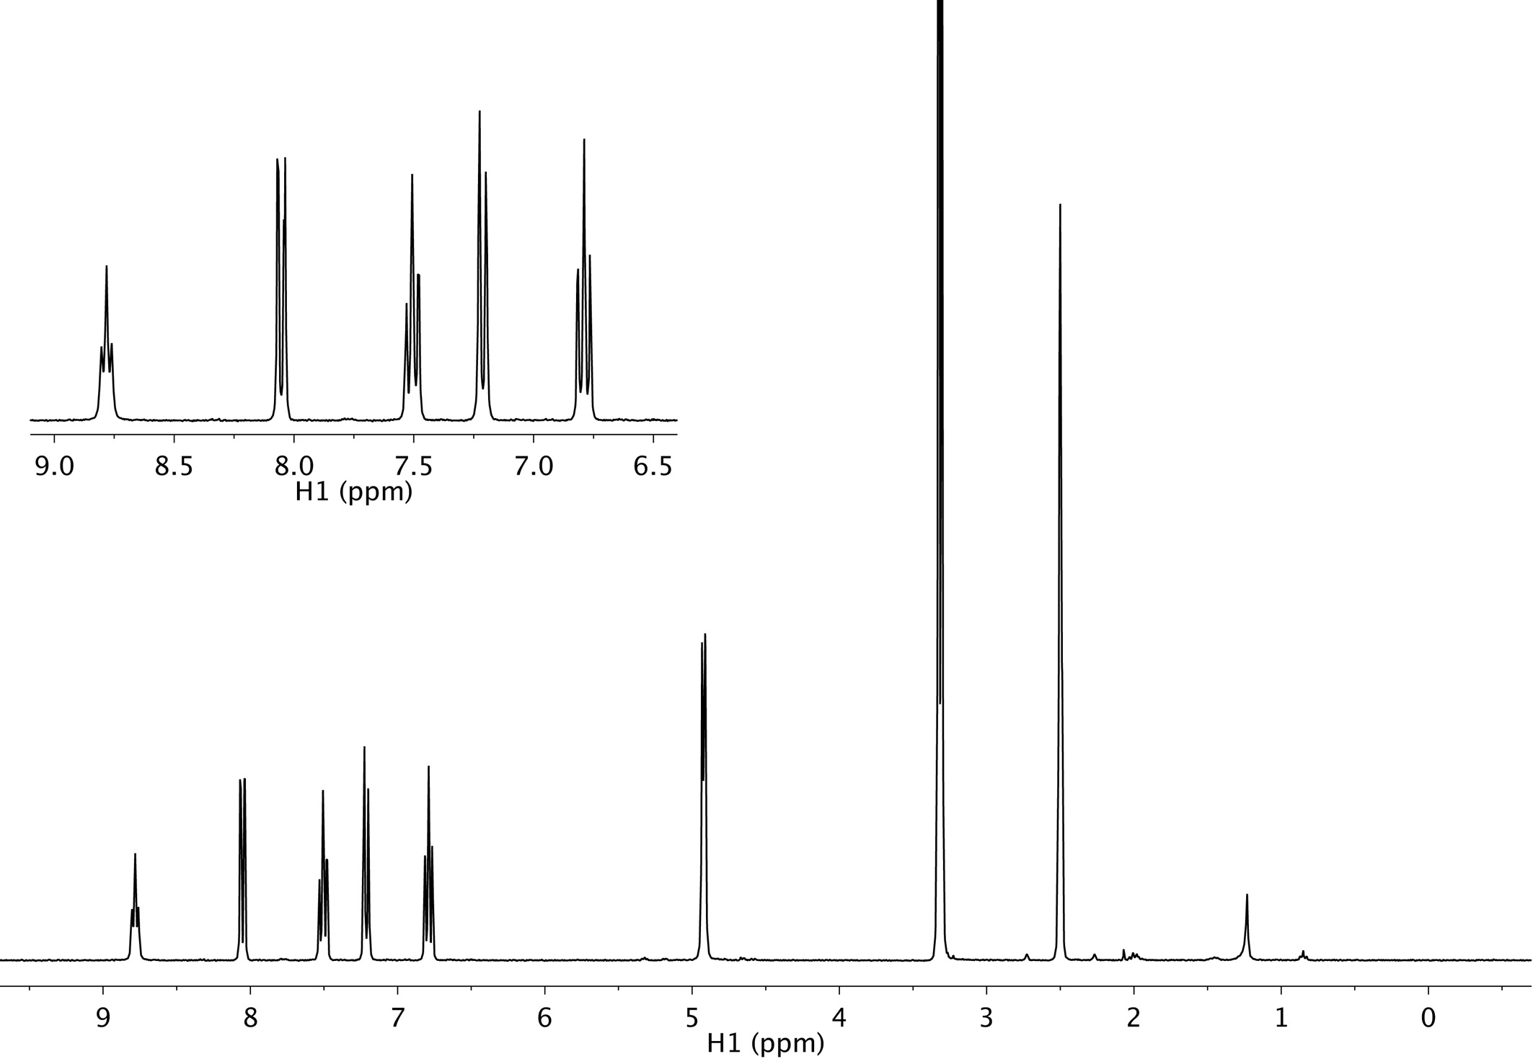

Hc

Ha

Hd

Hb

DMSO

Hf

He

H2O



Figure S5. 1H NMR spectrum of 3 in DMSO-*d*6 at 298 MHz.

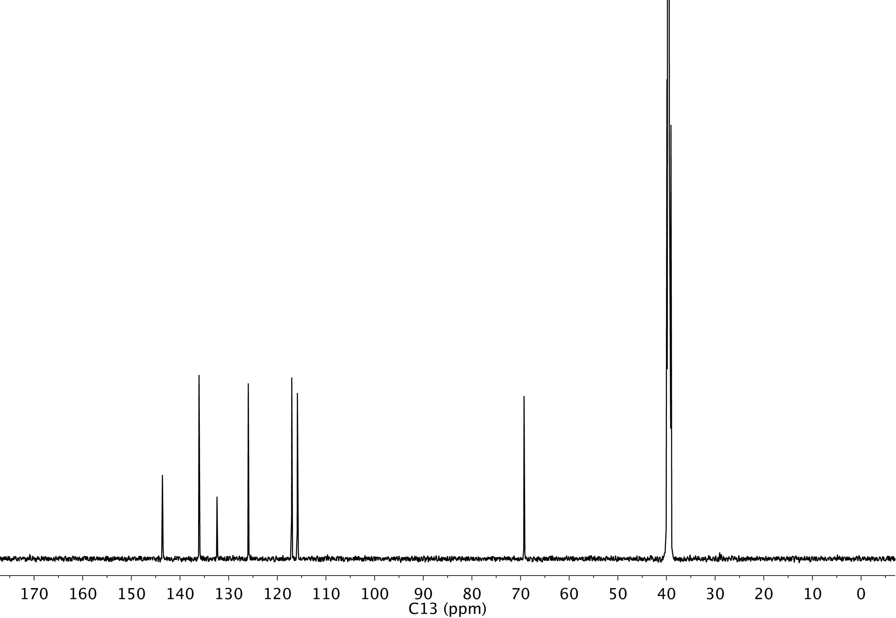



**Figure S6**. 13C NMR spectrum of **3** in DMSO-*d*6 at 150 MHz.



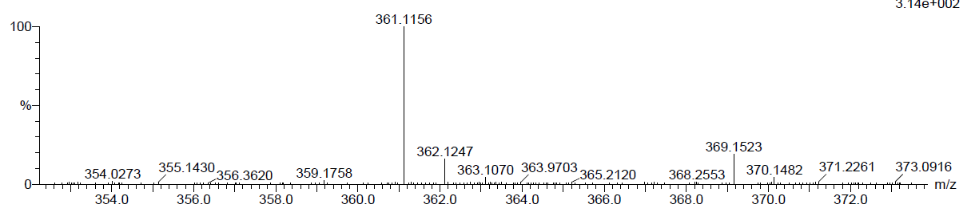

**Figure S7**. Mass spectrum (ESI) of **1.**





**Figure S8**. Mass spectrum (ESI) of **2.**





**Figure S9**. Mass spectrum (ESI) of **3.**



**Figure S10.** IR spectrum of **1** as a KBr disk.



**Figure S11.** IR spectrum of **2** as a KBr disk.



**Figure S12.** IR spectrum of **3** as a KBr disk.



**Figure S13**. 1H-13C HSQC NMR spectrum of **3** at pD 7.



**Figure S14**. 1H-13C HMBC NMR spectrum of **3** at pD 7.

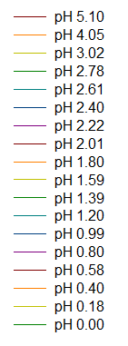



**Figure S15**. UV-Vis absorption spectra of **3** versus pH in 1:1 (v/v) ACN/water.



**Figure S16**. UV-vis absorption spectra of **1** versus Li+ in 1:1 (v/v) ACN/water.



**Figure S17.** UV-visible absorption spectra of **2** versus Li+ in 1:1 (v/v) ACN/water.



**Figure S18**. UV-visible absorption spectra of  **3** versus Li+ in 1:1 (v/v) ACN/water.

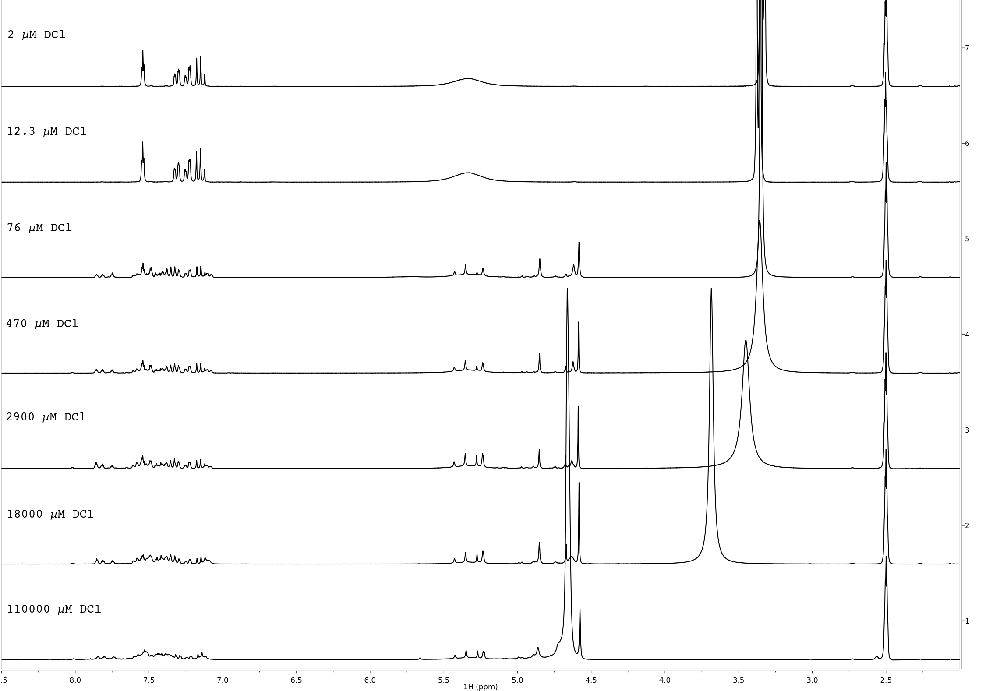

**Figure S19**. 1H NMR titration spectra of **1** (*meta*) pD 1-7.



**Figure S20**. 1H-15N HMBC NMR spectrum of **1** (*meta*) at pD 7. The tertiary amine and nitro groups are observed at *δ* 92 ppm and *δ* 371 ppm.



**Figure S21**. 1H-15N HMBC NMR spectrum of **1** (*meta*) at pD 3.Tertiary amine and nitro groups are observed at *δ* 92 ppm and *δ* 371 ppm.

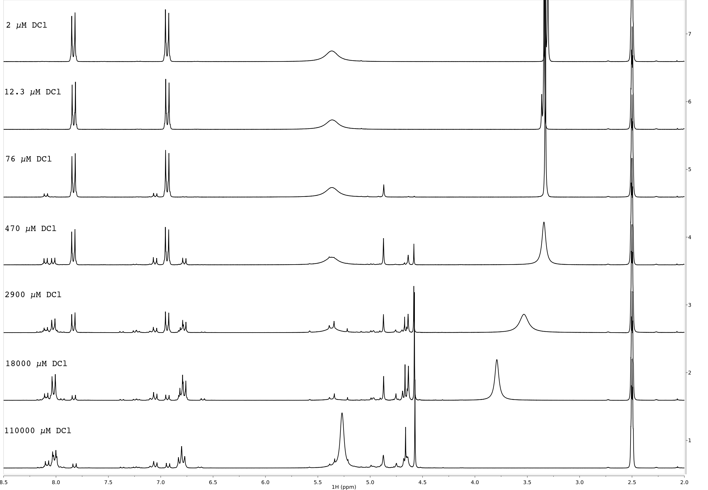

**Figure S22**. 1H NMR titration spectra of **2** (*para*) pD 1-7.



**Figure S23**. 1H-15N HMBC NMR spectrum of **2** (*para*) at pD 7.The tertiary amine and nitro groups are observed at *δ* 102 ppm and *δ* 371 ppm.



**Figure S24**. 1H-15N HMBC NMR spectrum of **2** (*para*) at pD 3.

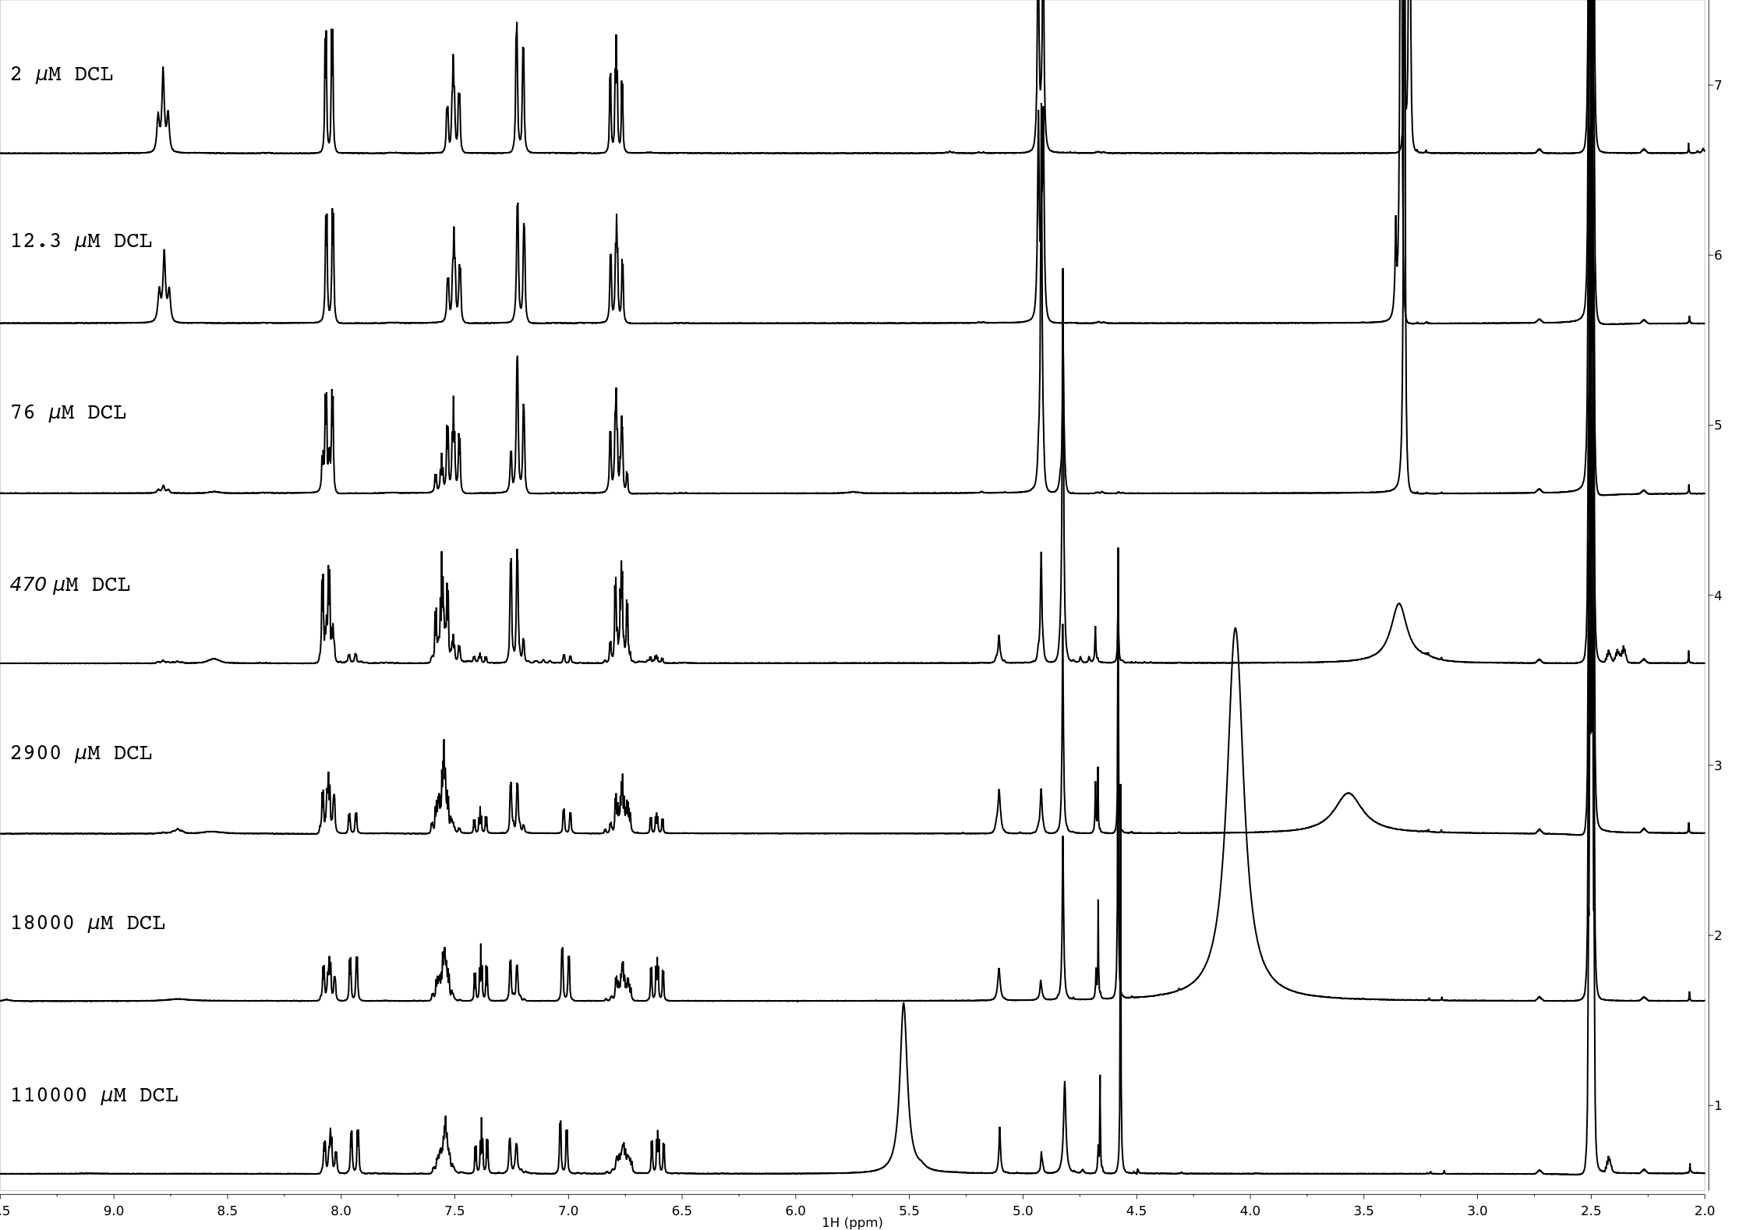

**Figure S25**. 1H NMR titration spectra of **3** at pD 1-7.



**Figure S26**. 1H-15N HMBC NMR spectrum of **3** at pD 7.The amine and nitro groups are observed at *δ* 86 ppm and *δ* 373 ppm.



**Figure S27**. 1H-15N HMBC NMR spectrum of **3** at pD 3.



**Figure S28.** Calculated UV-visible absorption spectra for compounds **1-4**.



**Figure S29**. Theoretical UV-vis absorption spectra of monosubstituted derivatives.