Table S1. Primer sequences used for qRT-PCR.
Gene | Primer | Description
csgA | Forward 5'- GGG CTC AGA TGA CAG CTC AAT C -3' | Curli subunit, major curli subunit
csgA | Reverse 5'- GCC GTT CCA CTG ATC AAG AGT AG -3' | Curli subunit, major curli subunit
csgB | Forward 5'- CAT AAT TGG TCA AGC TGG GAC TAA -3' | Curli nucleator protein curlin CsgB
csgB | Reverse 5'- GCA ACA ACC GCC AAA AGT TT -3' | Curli nucleator protein curlin CsgB
fimA | Forward 5'- ACT CTG GCA ATC GTT GTT CTG TCG -3' | Fimbrin type 1, major structural subunit
fimA | Reverse 5'- ATC AAC AGA GCC TGC ATC AAC TGC -3' | Fimbrin type 1, major structural subunit
fimH | Forward 5'- GAT GCG GGC AAC TCG ATT -3' | Minor type 1 fimbrial subunit
fimH | Reverse 5'- CCC TGC GCG GGT GAA -3' | Minor type 1 fimbrial subunit
motA | Forward 5'- ACA GGT AGC GCG TTC TCA CT -3' | Motility protein A
motA | Reverse 5'- AGC GTG GAT AAA CCG ATA CG -3' | Motility protein A
papA | Forward 5'- GTG CCT GCA GAA AAT GCA GAT -3' | Major pilin protein PapA; P-fimbriae major subunit
papA | Reverse 5'- CCC GTT TTC CAC TCG AAT CA -3' | Major pilin protein PapA; P-fimbriae major subunit
sfaS | Forward 5'- TCT CAC CGG ATG CCA GAA TAT -3' | S-fimbrial adhesin protein SfaS
sfaS | Reverse 5'- GCC CAT CCG CAG TAC CAC TA -3' | S-fimbrial adhesin protein SfaS
rrsG | Forward 5’- CCA GGG CTA CAC ACG TGC TA -3’ | 16S ribosomal RNA  (housekeeping gene)
rrsG | Reverse 5’- TCT CGC GAG GTC GCT TCT -3’ | 16S ribosomal RNA  (housekeeping gene)

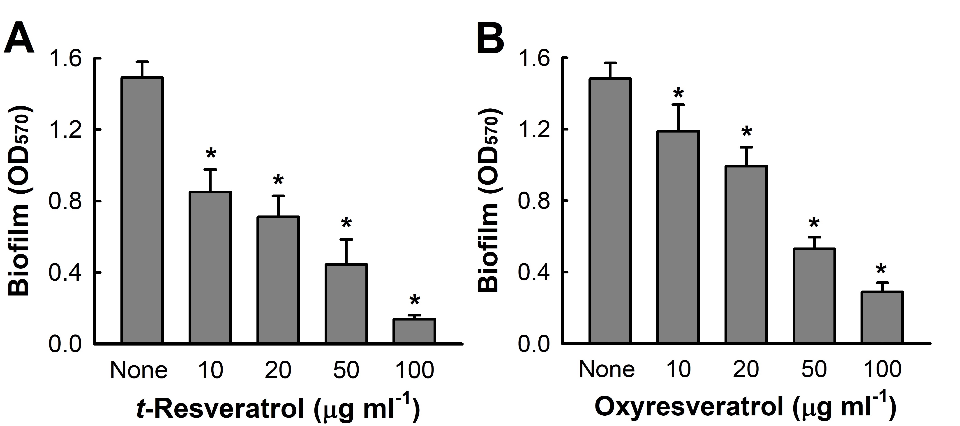

Figure S1. Antibiofilm activities of t-resveratrol and oxyresveratrol against UPEC ATCC 11775 strain. Biofilm formation (OD₅₇₀) by UPEC was quantified after culture in 96-well polystyrene plates in the presence of t-resveratrol (A) or oxyresveratrol (B). P < 0.05 versus non-treated controls.
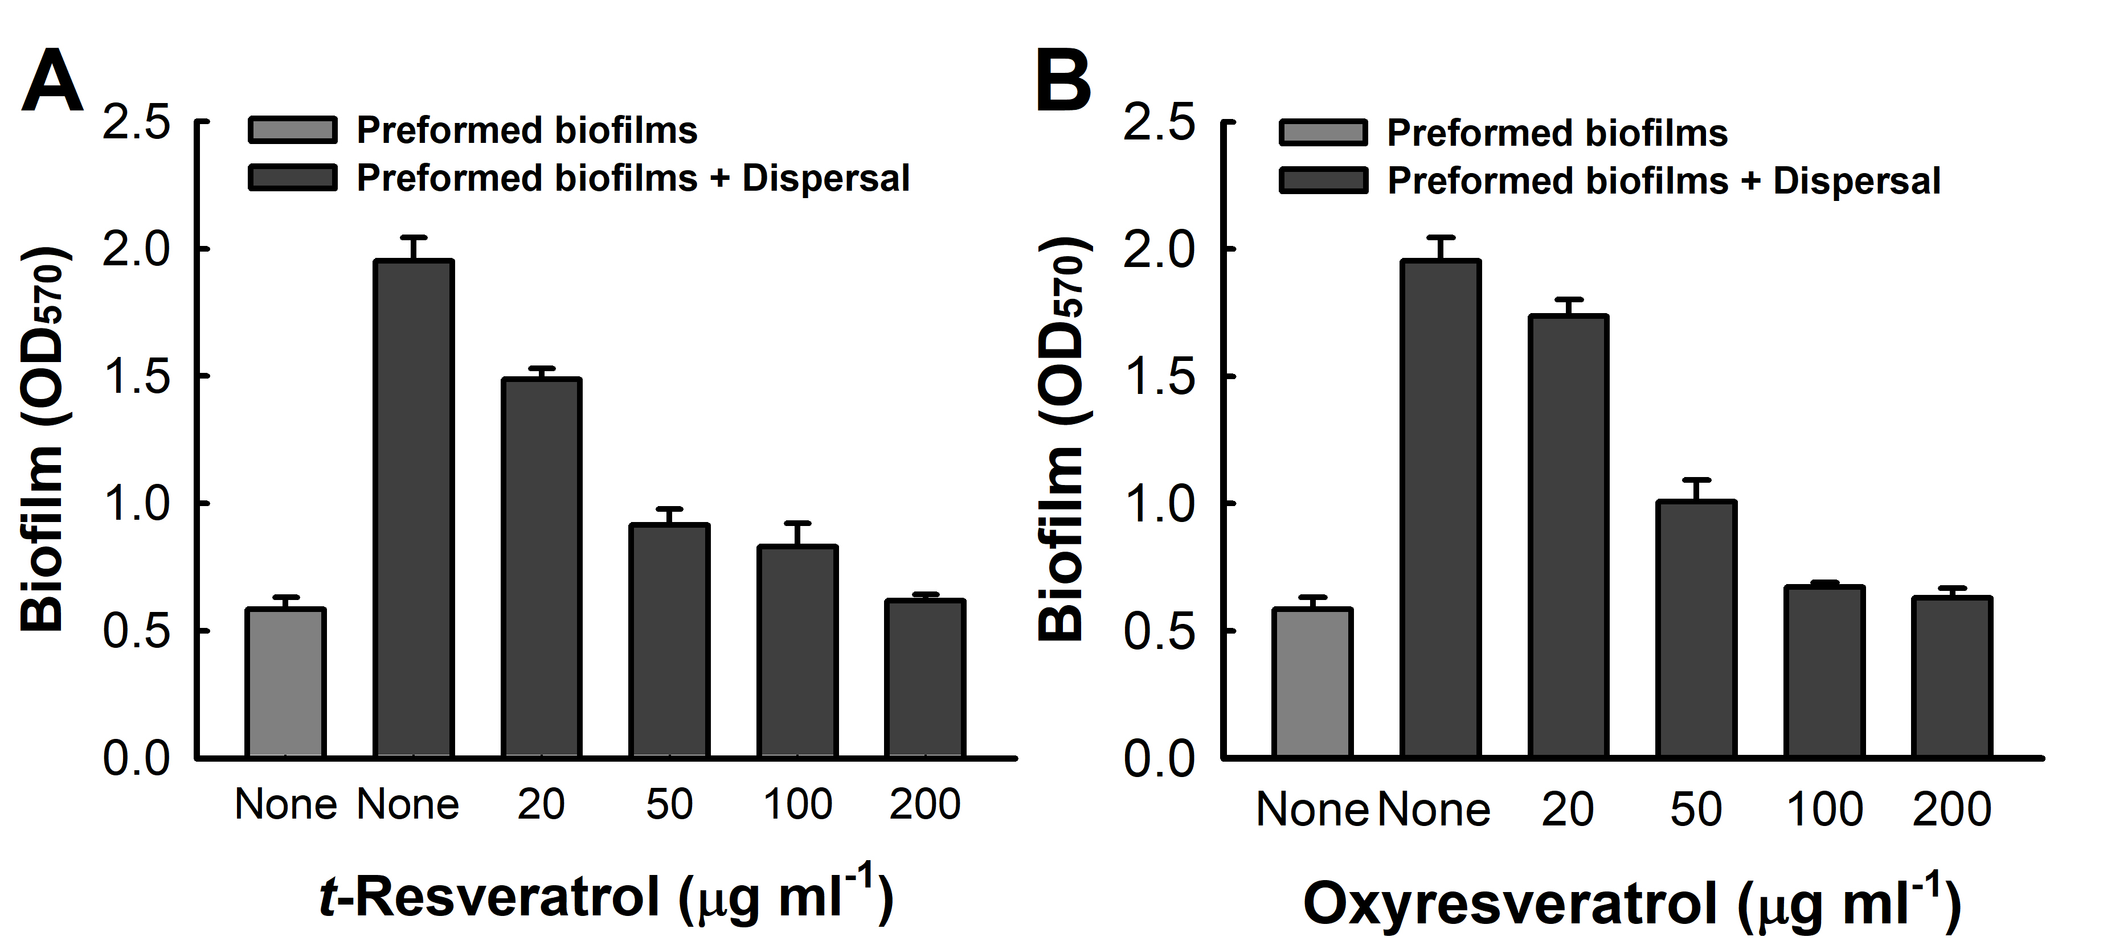
Figure S2. The effects of t-resveratrol and oxyresveratrol on established UPEC biofilms. Biofilm dispersal was investigated in 96-well polystyrene plates at 37 ºC. Cells were cultured to form biofilm for 15 h without shaking, and then t-resveratrol (A) or oxyresveratrol (B) was added and incubated for 24 h more. Total biofilm formation was measured at OD₅₇₀. P < 0.05 versus non-treated controls.

