SPVdF-HFP/SGO Nanohybrid Proton Exchange Membrane for the Applications of Direct Methanol Fuel Cells
Supporting Information

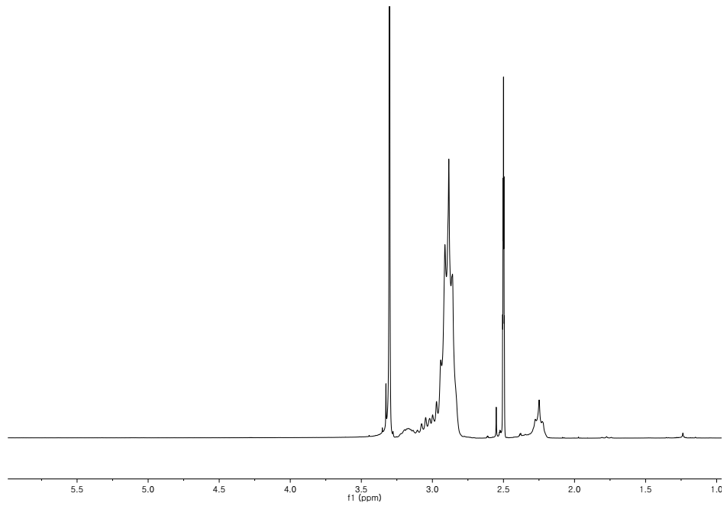

Figure S1. 1H NMR spectrum of SPVdF-HFP.

Figure S2. FT-IR spectra of membranes.
Figure S3. XRD patterns of membranes.

Table.S1. Comparative table of various reported in DMFCs.
Membrane | Proton conductivity (mS/cm)  [RHª (%);Tem^{b} (º C)] | Methanol permeability (cm²/s) | Selectivity  (S s/cm³) | Oxidative stability  (%) | References
Nafion 212 | 24  [100;RT^{c}] | 5.5×10⁻⁶ | - | - | 45
Nafion 117 | 30.2  [100;RT^{c}] | 1.22×10⁻⁶ | 2.47×10⁴ | - | 30
SPVdF-co-HFP^{d} coated Nafion | 30.1  [100;RT^{c}] | 9.71×10⁻⁷ | 3.099×10⁴ | - | 30
SPVdF-HFP^{d} /PES^{e}10 | 3  [100;RT^{c}] | 1.22×10⁻⁷ | 2.33×10⁴ | 99.2 | 46
SPVdF-HFP^{d} /SGO^{f}-7 | 5.52  [100;30] | 1.846×10⁻⁷ | 2.990×10⁴ | 89.5 | 16
SPVHP^{g}70 | 5.12  [100;20] | 1.29×10⁻⁸ | 3.97×10⁵ | - | 47
SPVdF-co-HFP^{d} /SPAni^{h} | 4.54  [100;20] | 1.44×10⁻⁷ | 3.15×10⁴ | - | 48
SPVdF-HFP^{d} /Nafion/Al₂O₃^{i} | 35.7  [100;20] | 6.41×10⁻⁷ | 5.56×10⁴ | - | 49
SPVdF-HFP^{d} /SGO^{f} | 7.8  [100;70] | 2.567×10⁻⁷ | 3.038×10⁴ | 87 | In this work
ªRelative humidity
^{b}Temperature
^{c}Room temperature
^{d}Sulfonated poly (vinylidenefluoride-co-hexafluoropropylene)
^{e}Poly (ether sulfone)
^{f}Sulfonated graphene oxide
^{g}SPVdF-co-HFP/PAni NF membrane (i.e. PAniNF treated with SDS for 70 min).
^{h}Sulfonated polyaniline
^{i}Aluminium oxide

