Supplementary Material

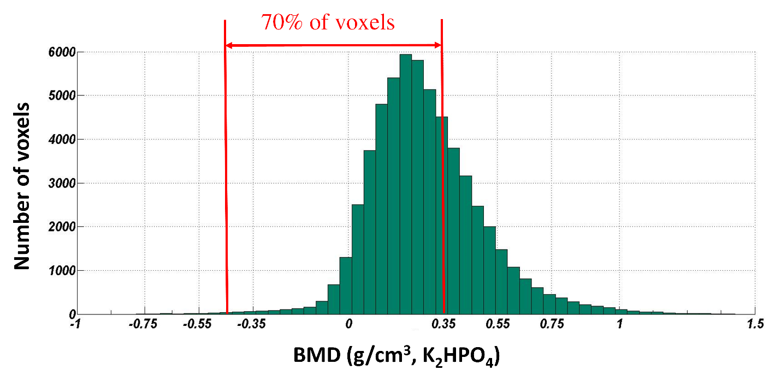
Figure. S1. An example density histogram of segmented cortical regions delimitated via semi-automatic segmentation with manual correction. Approximately 70% of voxels had BMD values below 0.35 g/cm³. Voxels with negative BMD pertained to air and marginal osteophytes. These voxels were not included in E-BMD conversion, and their E was set as 0.1 MPa.

