SUPPLEMENTAL DATA 1
Journal of Vertebrate Paleontology

Occlusion and dental function of Morganucodon and Megazostrodon

KAI R. K. JÄGER,*^{,1} PAM G. GILL,² IAN CORFE,³ and THOMAS MARTIN¹
¹Division of Paleontology, Institut für Geowissenschaften, Universität Bonn, Nussallee 8, D-53115 Bonn, Germany, jaegerk@uni-bonn.de; tmartin@uni-bonn.de;
²School of Earth Sciences, University of Bristol, Wills Memorial Building, Queen’s Road, BS8 1RJ Bristol, United Kingdom, pam.gill@bristol.ac.uk;
³Jernvall EvoDevo Laboratory, Institute of Biotechnology, University of Helsinki, P.O. Box 56, FIN-00014 Helsinki, Finland, ian.corfe@helsinki.fi

*Corresponding author.
APPENDIX S1

Occlusal Fingerprint Analyser Software

To use the provided .ofa-project files, the OFA Software and the user manual can be downloaded at: www.for771.uni-bonn.de/ofa/download/precompiled

Dental Morphology of the antemolar dentition of UMZC_Eo.CR.1

Incisors—Four lower incisors are present on each hemimandible. They are peg-like, inclined in a mesial direction and decrease in size from i1 to i4. Due to damage, the original dimensions for i1 and i2 can be only estimated, but i1 might have been similar in height to the canine. The upper incisors are not preserved.
Canine—The lower canine is inclined mesially as well, with slightly distally facing tip. It is single-rooted and the crown consists of a single large cusp with a convex mesial side.
Premolars—In both dentaries, p2, p3, and p4 are present, with p2 located above the second mental foramen. The latter seems to differ from most other specimens, where the second mental foramen is located between the canine and p1 (if present) (Kermack et al., 1973; pers. obs. PGG). There is more space between the canine and p2 than between any other teeth in the tooth row. This could be either attributed to a full reduction of the first premolar or its loss during ontogeny. The latter has been described for M. watsoni and M. oehleri, as well as for Kuehneotherium (Gill, 1974; Kielan-Jaworowska et al., 2004). The premolars have a similar morphology and increase in size distally, with p4 being the second highest postcanine tooth in the dentary after m2. The mesial cusp is the largest one, and its tip is slightly curved backwards. The mesial flank is convex, the distal one concave. Distal to the main cusp a small cusp is present on the buccal side. Additionally, p4 has a cingulid with small cuspules on its lingo-distal side.
The upper premolars P1-P3 are small and peg-like. P4 differs in shape from the other premolars. P4 is the second longest (mesio-distally) upper tooth after M2. It is molariform, and even though cusp A is broken off, it is apparent that its main cusp was originally higher and more massive than that of the molars. Though cusp C and a very small cusp D are present, cusp B seems to be absent. However, it may have been small and now worn away, since there is a large wear facet mesial to cusp A. It lacks a pronounced lingual or labial cingulum and resembles in shape and cusp dimensions the lower molars. Only distally, next to cusps C and D, are a few small cuspules present that form a lingual and a mesial cingulid.
Tooth Root Morphology—The root of i1 is round and long. The other incisors (i2-i4) have slightly oval roots. They differ from the oval roots of the rest of the tooth row in that they extend mostly bucco-lingually and are shorter mesio-distally. The canine has a single large root with oval cross section (long axis mesio-distally oriented). In all lower premolars, the roots have a round cross-section, with the distal one being the larger one (Fig. 2D). The lower molars have two roots, which are completely separated in m1. At m2 and m3 the roots are partially fused close to the crown, but the alveoli remain separate. In m4 the roots are completely fused with a groove between. Though the cross-section of the mesial root of m1 is round, the distal root has an oval cross-section with mesio-distally oriented long axis. At m2 both roots are oval, with the distal root being larger. In m3 both roots are round, with the distal one being larger. In m4 both roots are of equal oval shape and size.
P1-P3 are single rooted, whereas P4 has two large, round, unfused roots, with the mesial one being slightly smaller. M1-M3 have separated roots as well. In cross section, M1 and M2 have oval roots (mesio-disally elongated), with the distal one being the larger, but both roots of M3 are of equal size and have round cross-sections. M4 appears to be either single-rooted or to have two fully fused round roots.

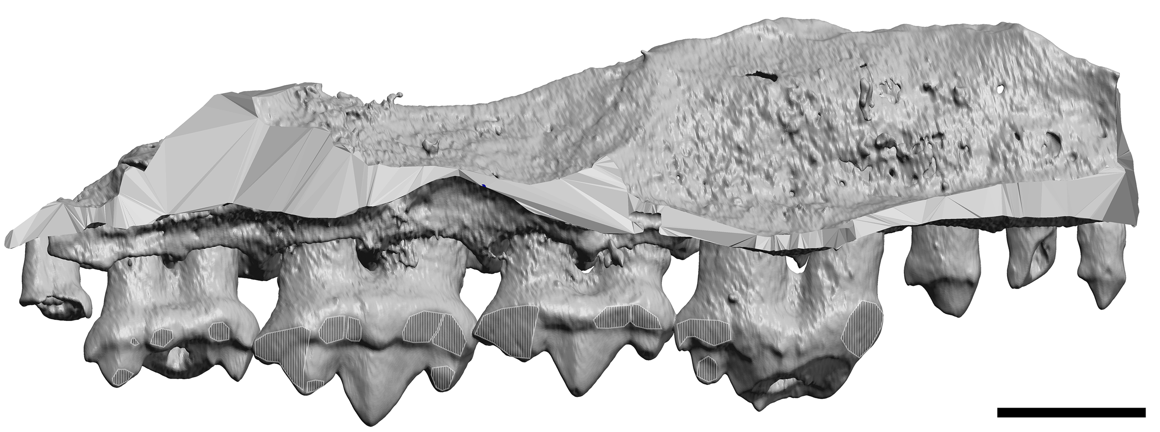
FIGURE S1. Upper left dentition of Morganucodon (UMZC_Eo.CR.1) in lingual view. Wear facets are highlighted. Scale bar equals 1 mm.

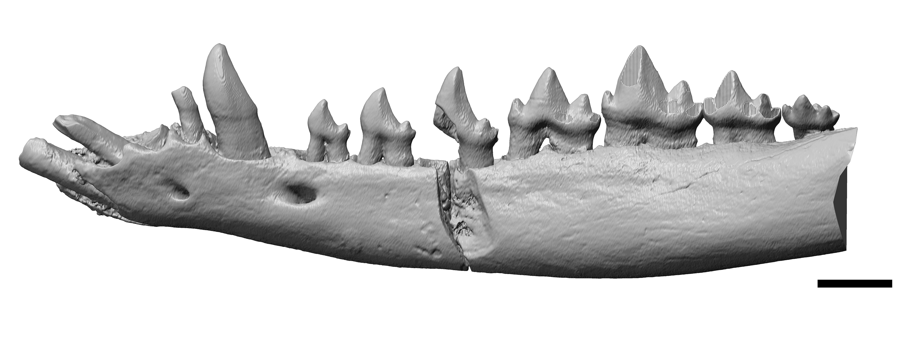
FIGURE S2. Lower left dentition of Morganucodon (UMZC_Eo.CR.1) in buccal view. Wear facets are highlighted. Scale bar equals 1 mm.
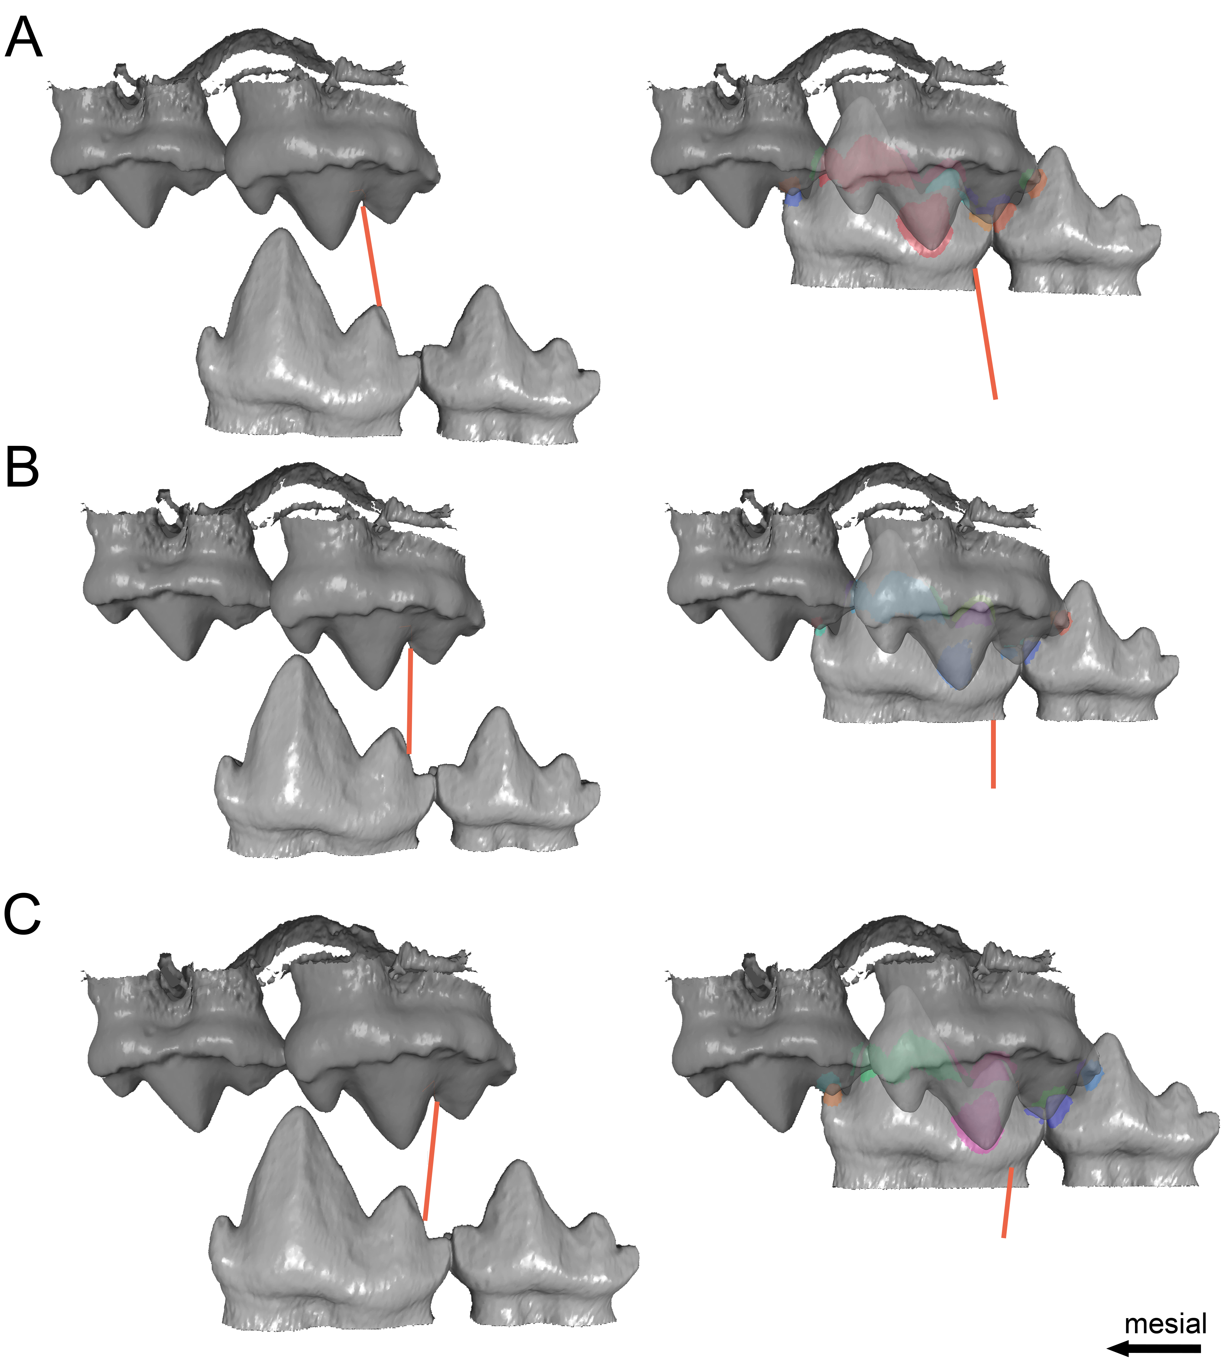
FIGURE S3. Different OFA analysis with of UMZC_Eo.CR.1 (m2, m3, M1, M2) with varying inclinations based on the striations observed on isolated teeth at the beginning (left) and later stages (right) of the power stroke. The orange lines indicate the orientation of the path. The colored areas represent virtual contact areas caused by the collision of the virtual models. A, mesial inclined path; B, straight orthal path; C, distally inclined path. Note the similarities in the later stages of the power stroke. This is caused by slight differences of approximately 0,1 mm in the starting position, with the mesially inclined path starting further posterior and the distally inclined path further anterior. It is unclear if UMZC_Eo.CR.1 had a preferred inclination as present on some of the isolated molars. However, every inclination was likely feasible and likely resulted in the same centric occlusion. For this study we focused on the distally inclined path (C).
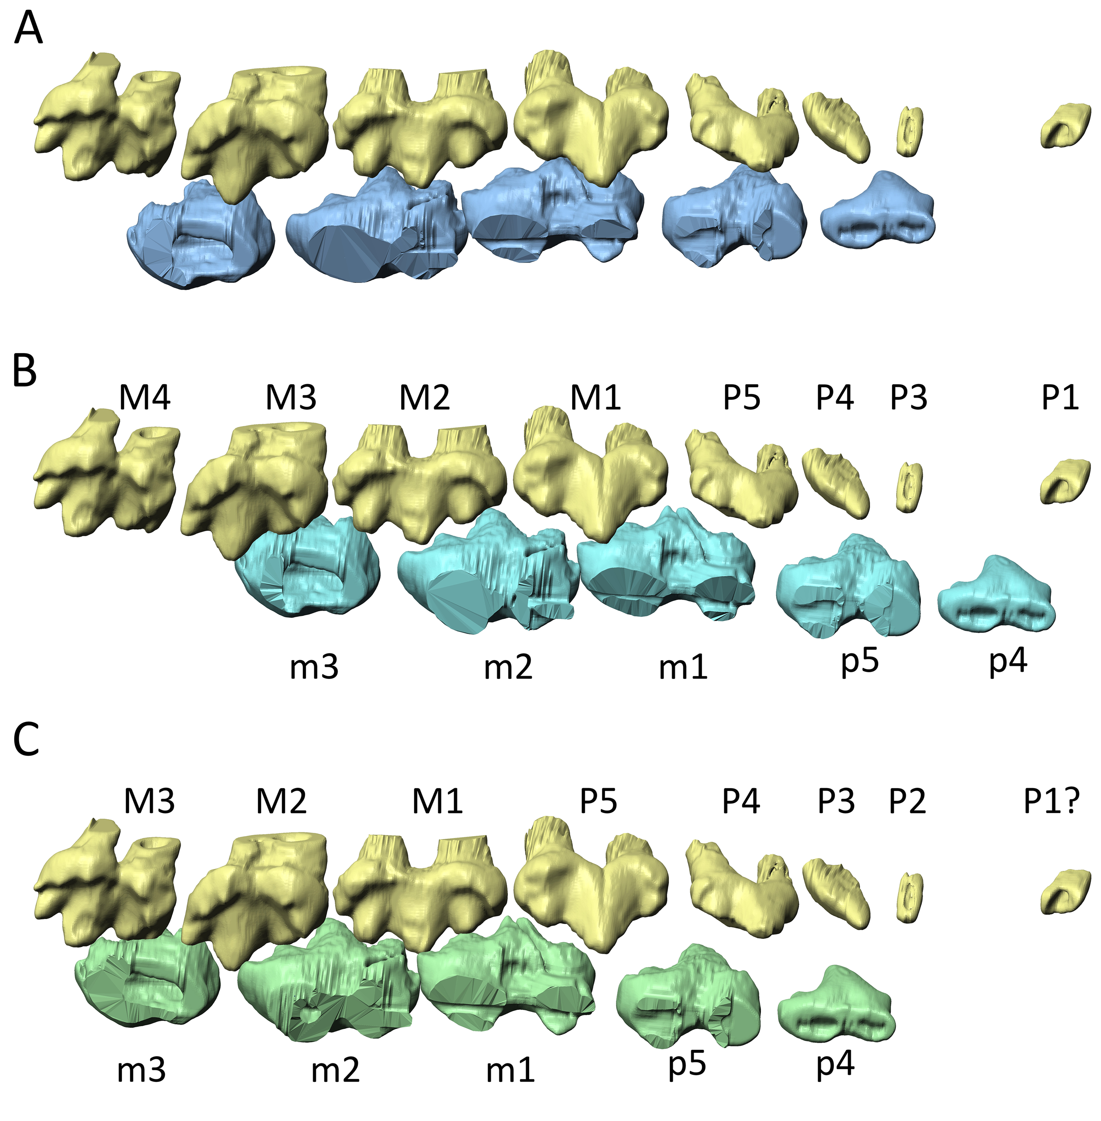
FIGURE S4. Lower and upper right dentition of Megazostrodon rudnerae from a bucco-ventral view. A, Teeth in their current position in the fossil; B, Teeth in occlusion based on the tooth positions assigned by Crompton (1974). Note, that Crompton (1974) interpreted the m4 to be missing; C, Teeth in occlusion based on the interpretation of the tooth position provided here. The amount of repositioning required from the position in the fossil (A) is less and the premolar positions are aligned more convincingly, with the p4 occluding between P3 and P4.

TABLE S1. Specimen list.
Number | Taxon | Fissure | Notes | Collection | Tooth position
NHMUK PV M 26407 | Megazostrodon rudnerae | – | Holotype | NHM | m2
UMZC_Eo.CR.1 | Morganucodon watsoni | Pontalun 3 |  | UMZC
NHMUK PVM 100304 | Morganucodon watsoni | Pontalun 3 | Prepped without acid in Bristol by (PGG) | NHM | m2
NHMUK PVM 100308 | Morganucodon watsoni | Pontalun 3 | Prepped without acid in Bristol by (PGG) | NHM | m2
UMZC_Eo.M(Lr).16 | Morganucodon watsoni | Pontalun 3 |  | UMZC | m2
UMZC_Eo.M(Ur).5 | Morganucodon watsoni | Pontalun 3 |  | UMZC | M2 (?)
UMZC_Eo.M(Lr).32 | Morganucodon watsoni | Pontalun 3 |  | UMZC | m1
AMNH 93800 | Morganucodon watsoni | Pontalun 3 (?) |  | AMNH | m2

