Supplemental Material

Quaternary structures of Vac8 differentially regulate the Cvt and PMN pathways

Running title: Crystal structure of the Vac8-Atg13 complex

Jumi Park^{a,c‡}, Hye-In Kim^{b,c‡}, Hanbin Jeong^{a,c}, Miriam Lee^{b,c}, Se Hwan Jang^{b}, So Young Yoon^{b,c}, Hyejin Kim^{a,c}, Zee-Yong Park^{b}, Youngsoo Jun^{b,c}*, and Changwook Lee^{a,c}*

ªDepartment of Biological Sciences, School of Life Sciences, Ulsan National Institute of Science and Technology, 50 UNIST-gil, Ulsan 44919, Republic of Korea
^{b}School of Life Sciences, Gwangju Institute of Science and Technology, Gwangju 61005, Republic of Korea
^{c}Cell Logistics Research Center, Gwangju Institute of Science and Technology, Gwangju 61005, Republic of Korea
‡These authors contributed equally to this work.

*Correspondence regarding this manuscript to:
Youngsoo Jun, Ph.D.

School of Life Sciences and Cell Logistics Research Center
Gwangju Institute of Science and Technology (GIST)
Gwangju 61005, Republic of Korea.
Telephone – 82-62-715-2510
E-mail – junys@gist.ac.kr

Changwook Lee, Ph.D.
Department of Biological Sciences, School of Life Sciences
Ulsan National Institute of Science and Technology (UNIST)
50 UNIST-gil, Ulsan 44919, Republic of Korea.
Telephone – 82-52-217-2534; Fax – 82-52-217-2639
E-mail – changwook@unist.ac.kr

Supplemental Materials and Methods
Bulk autophagy assay.

Yeast cells expressing EGFP-Atg8 were grown overnight at 30°C in YPD medium. Cells were resuspended in SD-N media and further cultured at 30°C for 2 h. Cells were harvested by centrifugation for 10 s at 11,400 × g at room temperature, and the pellet was resuspended in PBS. Cells were vortexed with glass beads for 3 min, mixed with 2× sodium dodecyl sulfate (SDS) sample buffer, and boiled for 5 min. After centrifugation, the resulting supernatant was separated by SDS-PAGE and analyzed by immunoblotting with anti-GFP antibody (a generous gift from Dr. Bill Wickner, Dartmouth College) or anti-actin antibody (a generous gift from Dr. Bill Wickner, Dartmouth College).

Triton X-114 phase partitioning assay of Vac8.
Lipidation of Vac8 was evaluated by Triton X-114 partitioning assay as previously described [1]. Vacuoles were isolated from wild-type VAC8 or VAC8 mutant strains. Recombinant Vac8 protein expressed in E. coli was used as a non-lipidated protein control. Isolated vacuoles (200 μg) or recombinant Vac8 protein (10 μg) was mixed with lysis buffer (10 mM Tris-HCl, pH 7.4, 150 mM NaCl, 0.5% Triton X-114 [Sigma-Aldrich, X114], 1 mM PMSF [Sigma-Aldrich, P7626], 10 μM leupeptin [Sigma-Aldrich, 108975]). For separation of proteins, 300 μl of cushion buffer (10 mM Tris-HCl, pH 7.4, 150 mM NaCl, 6% sucrose [Amresco, 0335], 0.06% Triton X-114) was prepared in 1.5-mL microcentrifuge tubes. Lysed samples were overlaid on the sucrose cushion and incubated at 30°C for 3 min. Tubes were then centrifuged at room temperature at 300 × g for 3 min, the upper aqueous phase was collected, mixed with 0.5% Triton X-114, and again overlaid on the same cushion buffer. After samples were incubated and centrifuged again, the aqueous phase was washed with 2% Triton X-114, incubated at 30°C for 3 min, and centrifuged at room temperature at 300 × g for 3 min. Finally, the aqueous phase was collected, and the detergent phase was collected from the bottom of the cushion buffer (oily droplet). Each phase was mixed with SDS sample buffer and analyzed by SDS-PAGE and immunoblotting using anti-Vac8 and anti-Pho8 antibodies.

Supplemental Figures

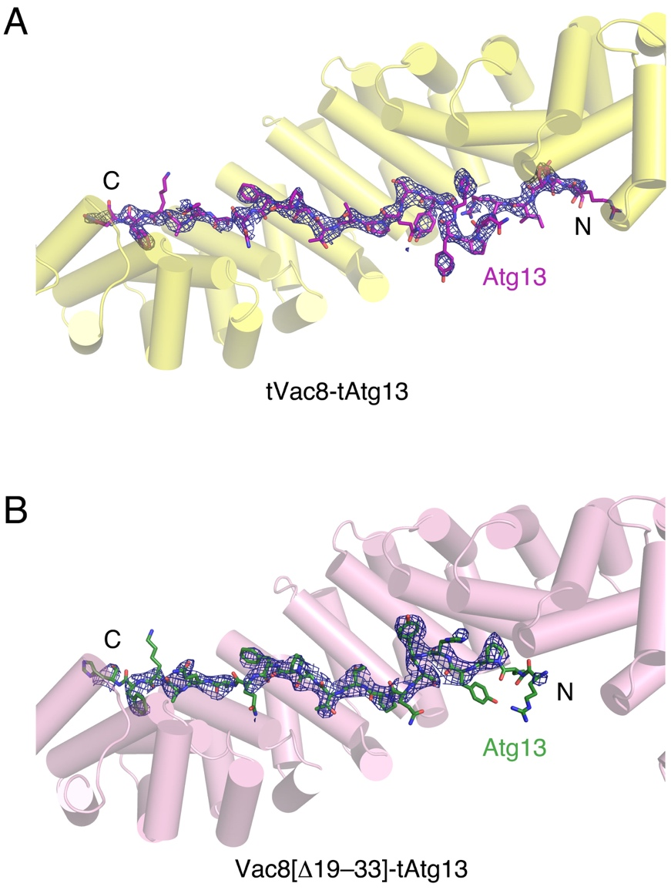

Figure S1. The difference electron density maps (Fo-Fc) for tAtg13 bound to tVac8 (A) and Vac8[Δ19–33] (B) at 2.9 and 3.2 Å resolution, respectively. The maps were calculated in the absence of tAtg13 (contoured at 2.5σ).

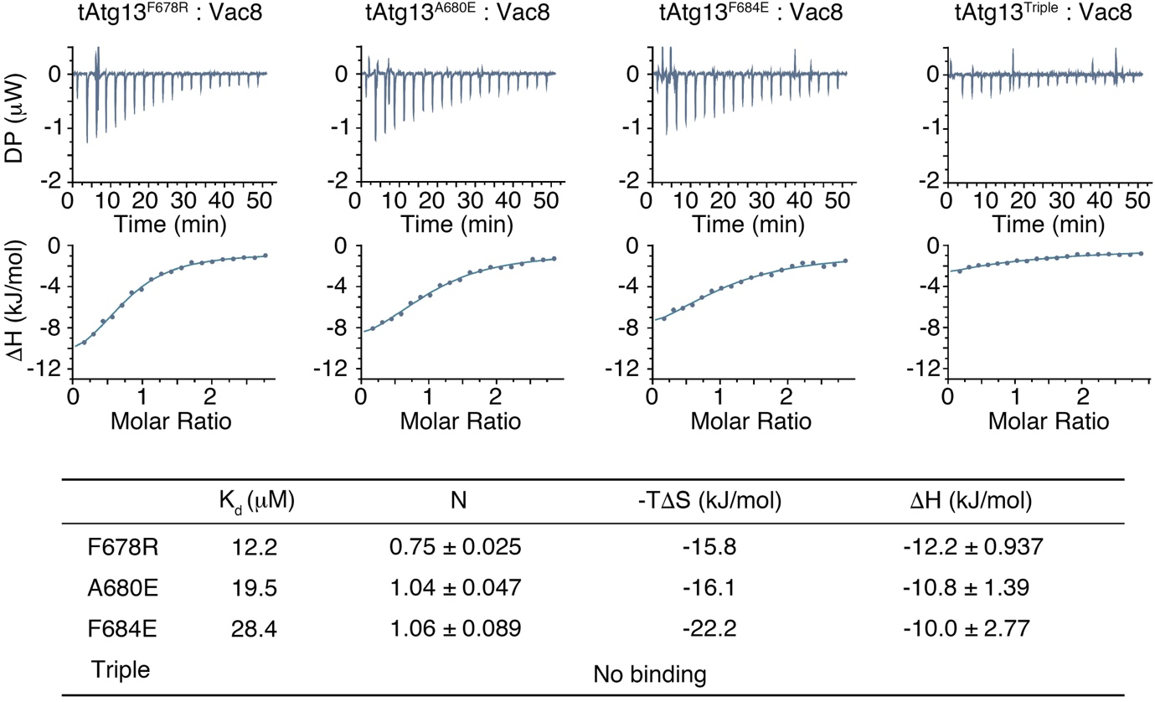

Figure S2. Isothermal titration calorimetry (ITC) analysis of tAtg13 mutants in interface II binding to Vac8. Single (F678R, A680E, or F684E) and triple (F678R A680E F684E) mutants of tAtg13 were titrated with full-length Vac8 at 25°C. Upper and lower panels represent raw data and fitted data of binding isotherms for affinity determination. Thermodynamic parameters are measured and tabulated below.

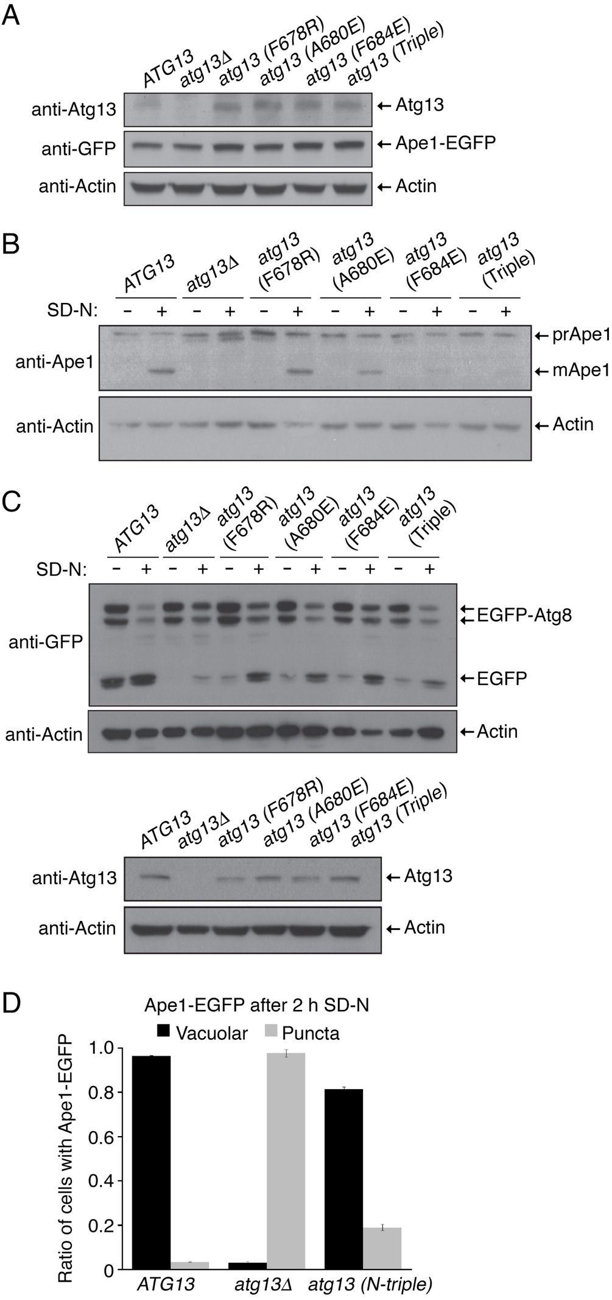
Figure S3. Interface II in Atg13 is important for vacuolar processing of prApe1. (A) Expression of wild-type Atg13 and Atg13 mutants is comparable between cells expressing wild-type Atg13 or mutant Atg13 used in Figure 2E. (B) Interface II in Atg13 is important for vacuolar processing of prApe1. Expression of precursor Ape1 (prApe1) and mature Ape1 (mApe1) was analyzed by immunoblotting with anti-Ape1 antibody. Actin was used as a loading control. (C) Mutations in interface II in Atg13 differentially affect bulk autophagy. Cells expressing EGFP-Atg8 were transferred to SD-N medium for 2 h to induce autophagy. Levels of EGFP-Atg8 and free EGFP were analyzed by immunoblotting with anti-GFP antibody (top). Actin was used as a loading control. Expression of wild-type Atg13 and Atg13 mutants was compared by immunoblotting with anti-Atg13 antibody (bottom). (D) Mutations in interface I in Atg13 marginally affect the Cvt pathway of Ape1. ATG13, atg13Δ, and atg13 (N-triple) cells were separately cultured in SD-N medium for 2 h, and GFP fluorescence from Ape1-EGFP was analyzed. The graph shows quantification of cytoplasmic and vacuolar Ape1-EGFP.

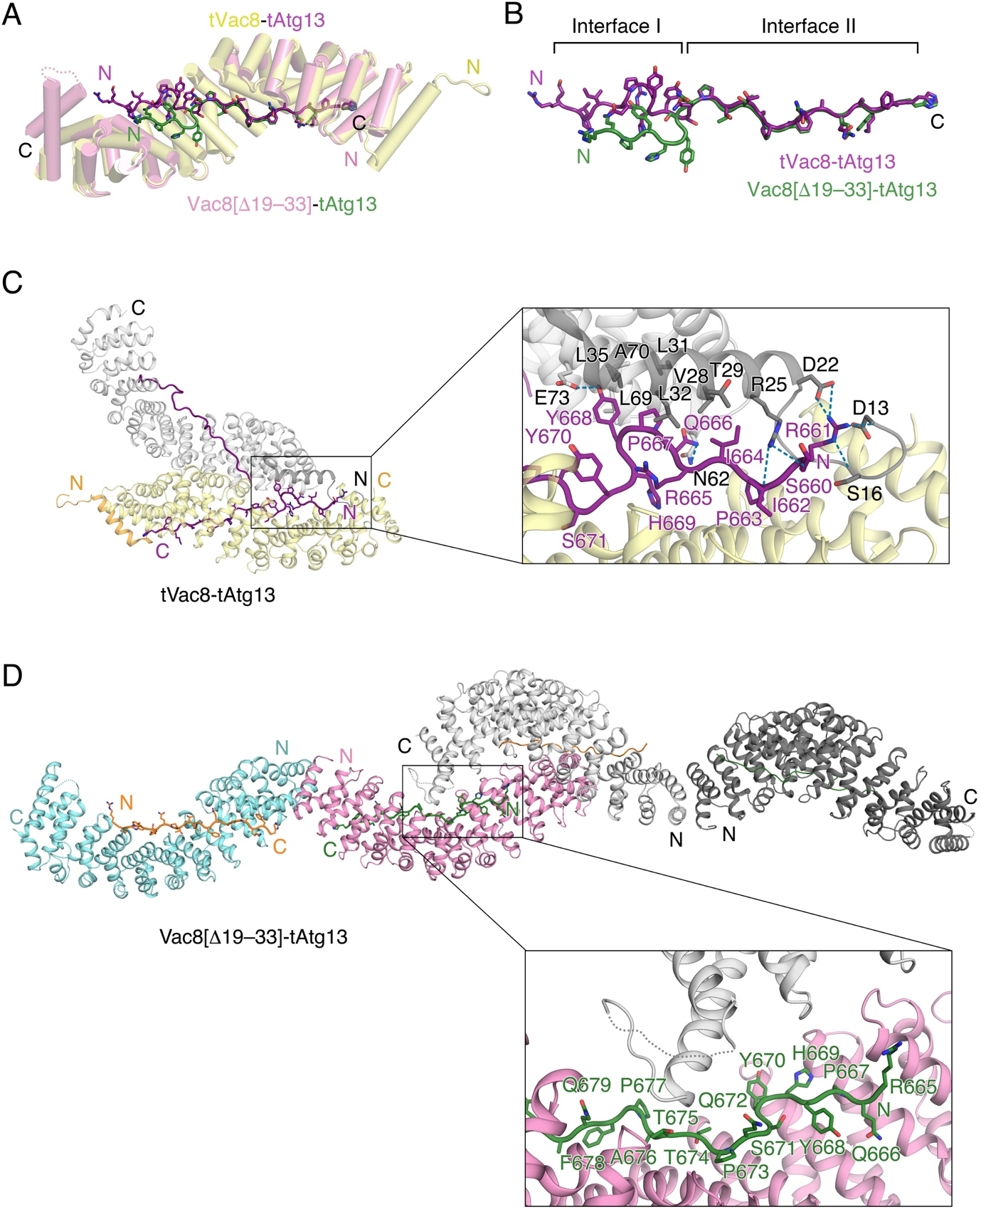

Figure S4. Different conformations of Atg13 at interface I. (A) Ribbon diagram showing the structural alignment of tVac8 (yellow)-tAtg13 (purple) and Vac8[Δ19–33] (pink)-tAtg13 (green). (B) Close-up view of the structures of tAtg13 in (A). Although the structures of tAtg13 bound to Vac8 at interface I have different conformations, the two structures superimpose well at interface II. (C) Cartoon representation (left) showing the overall structure of the tVac8-tAtg13 complex and its symmetry-related molecules (gray). The close-up view on the right clearly shows that the structure of tAtg13 at interface I is affected by neighboring molecules due to crystal packing. Residues involved in the interaction are highlighted in ball and stick representation and H-bonds are indicated with blue dotted lines. (D) Unlike tVac8-tAtg13 shown in (C), tAtg13 in the Vac8[Δ19–33] (cyan and pink)-tAtg13 (orange and green) complex has no direct interactions with symmetry-related molecules (gray). Oxygen atoms are colored red and nitrogen atoms are blue.

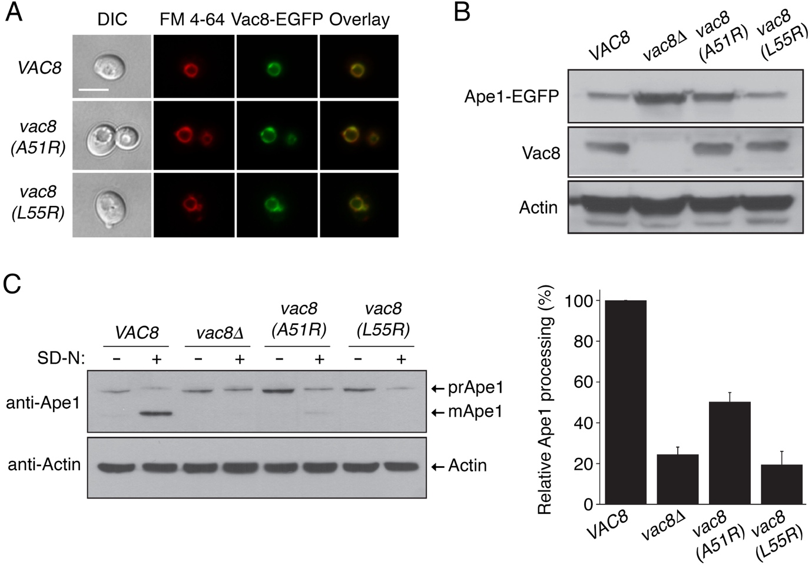

Figure S5. Vac8 self-association is important for vacuolar processing of prApe1. (A) Vac8-EGFP, Vac8^{A51R}-EGFP, and Vac8^{L55R}-EGFP localization determined by fluorescence microscopy. Vacuoles of cells were labeled with FM 4-64 and Vac8 was tagged with EGFP. Overlay images show combined fluorescence from Vac8 and vacuole. Vac8^{A51R}-EGFP and Vac8^{L55R}-EGFP are clearly localized in vacuoles, along with Vac8-EGFP. Scale bar: 5 μm. (B) Expression levels of Vac8 are comparable between wild-type and mutant Vac8 cells used in (A) and Figure 4C. (C) VAC8, vac8Δ, vac8 (A51R), and vac8 (L55R) cells were cultured in SD-N medium for 2 h, and maturation of endogenous Ape1 in vacuoles was analyzed by immunoblotting with anti-Ape1 antibody. Experiments were performed 3 times, and a representative blot is shown (left). The graph shows the relative ratios of mApe1 (100% for cells expressing wild-type Vac8; right).

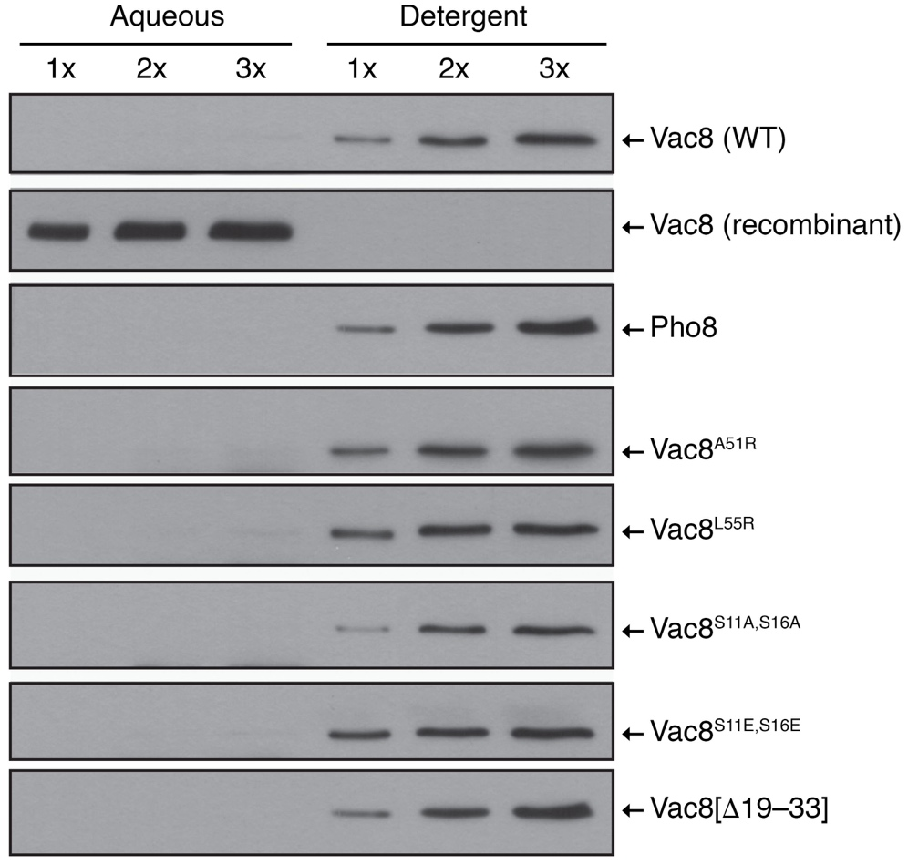

Figure S6. Mutations of Vac8 do not impair its lipidation and vacuolar targeting. Triton X-114 phase partitioning analysis shows that mutations of Vac8 have no effect on its myristoylation or palmitoylation, and therefore vacuolar targeting.

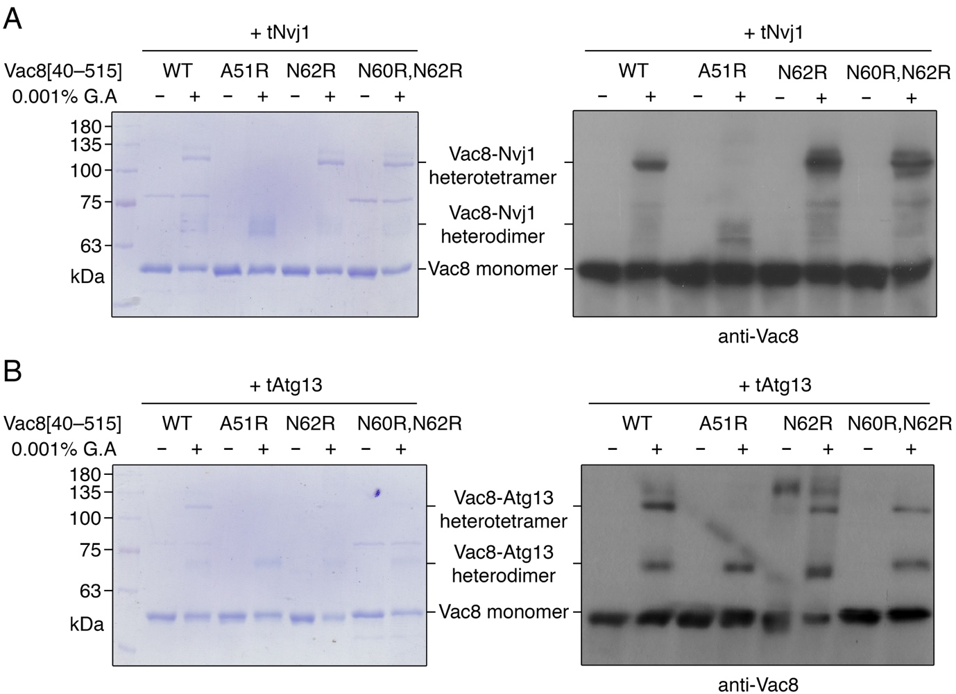

Figure S7. SDS-PAGE and immunoblotting analysis of chemical cross-linking of Vac8[40−515]-tNvj1 (A) and Vac8[40−515]-tAtg13 (B) in Figure 6A,B. The 8% SDS-PAGE gel was stained with Coomassie Brilliant Blue (left) or transferred to a PVDF membrane and immunoblotted with anti-Vac8 antibody (1:2000, diluted in 5% skim milk; right).

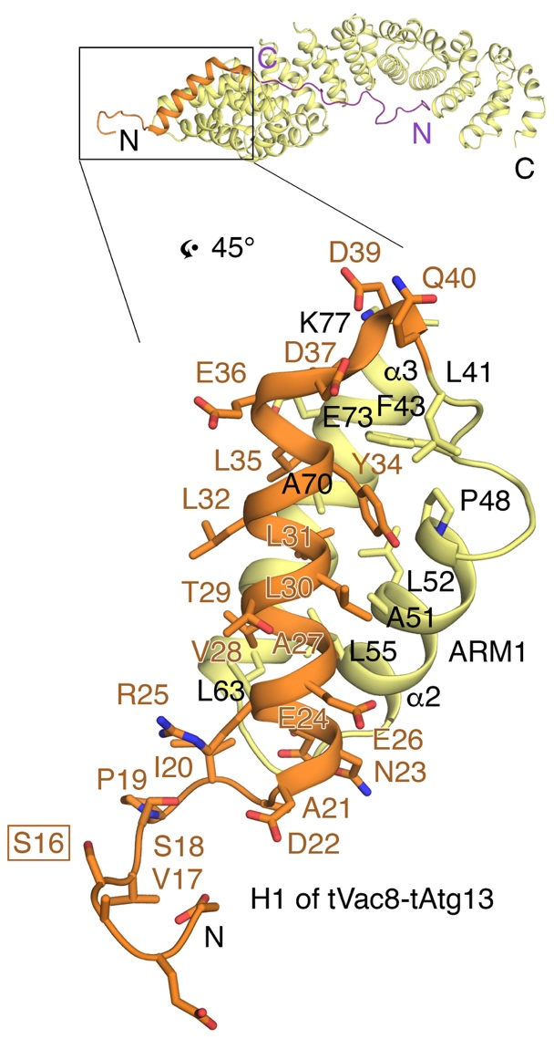

Figure S8. A phosphoserine residue is located close to the H1 helix. The ribbon diagram shows the H1 helix contacting the first ARM (ARM1) and the N-terminal loop of Vac8 in the tVac8 (yellow)-tAtg13 (purple) complex. The H1 helix is colored orange for clarity. Ser16 of Vac8, indicated by a box, is a phosphorylation site phosphorylated by Cdk1. Based on the structure, this residue is solvent-accessible and not involved in any interactions within the molecule.

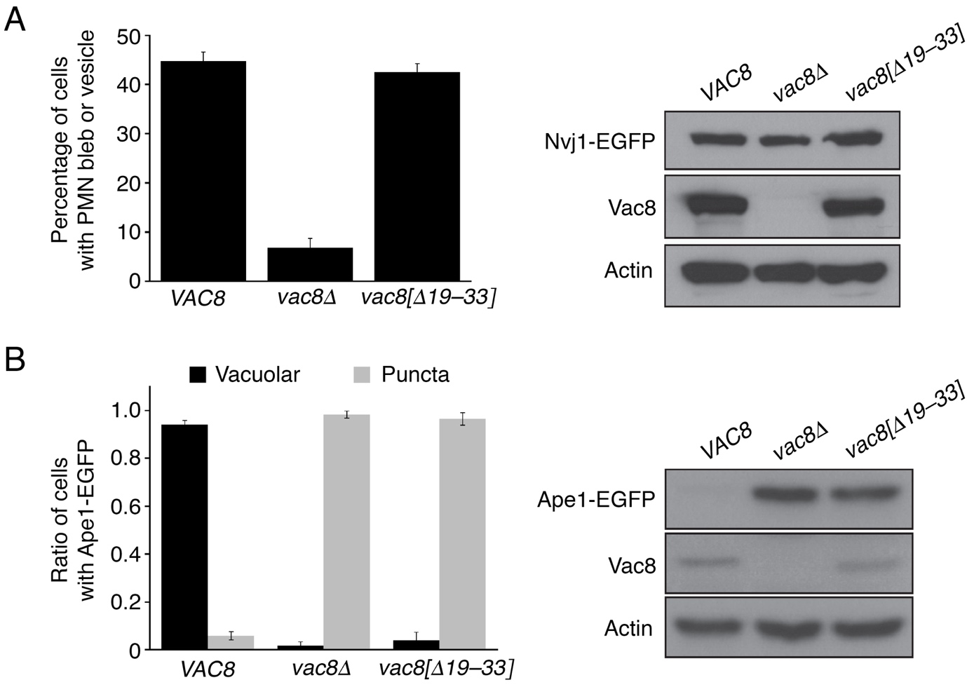

Figure S9. Deletion of the H1 helix abolishes the function of Vac8 in the Cvt pathway of Ape1, but does not affect the Vac8-mediated PMN pathway. (A) The PMN pathway is largely intact in cells expressing mutant Vac8 lacking the H1 helix. Experiment was performed as described in Figure 6E. The graph shows quantification of cells with PMN blebs or PMN vesicles (left). The blot shows that expression of wild-type and mutant Vac8 is comparable, based on immunoblotting with anti-Vac8 antibody (right). Actin was used as a loading control. (B) The Cvt pathway is severely impaired in cells expressing mutant Vac8 lacking the H1 helix. Experiment was performed as described in Figure 2E. The graph shows quantification of cells with vacuolar and cytoplasmic Ape1-EGFP (left). The blot shows that expression of wild-type and mutant Vac8 is comparable, based on immunoblotting with anti-Vac8 antibody (right). Actin was used as a loading control.

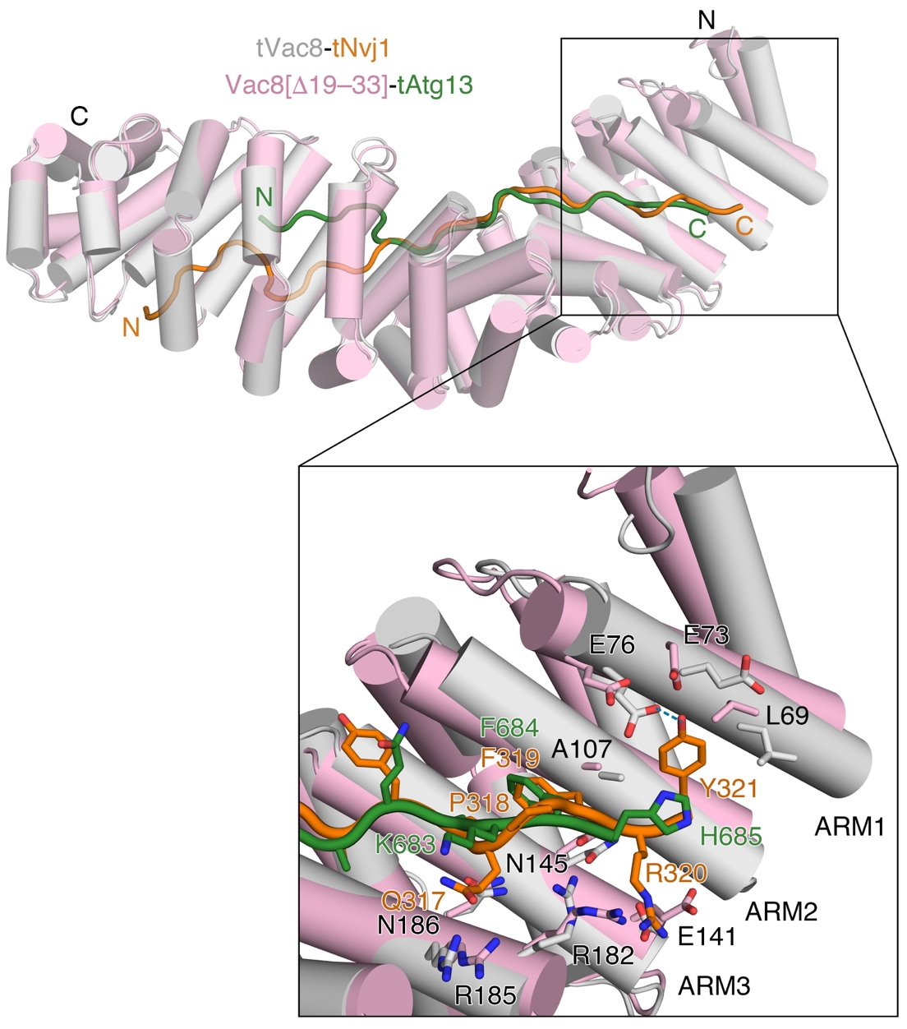

Figure S10. Structural comparison of Vac8[Δ19−33]-tAtg13 and tVac8-tNvj1 complexes. The ribbon diagram shows the structural comparison of Vac8[Δ19−33]-tAtg13 and tVac8-tNvj1 (PDB code: 5XJG). The structure of Vac8[Δ19−33]-tAtg13 is superimposed with that of tVac8-tNvj1 (RMSD = 1.288 Å). Vac8 molecules bound to tAtg13 (green) and tNvj1 (orange) are colored pink and gray, respectively. The box below shows a close-up view of the N terminus of Vac8 (the C terminus of tNvj1 and tAtg13). Compared with the structure of tAtg13, tNvj1 bound to Vac8 includes an additional visible residue (Tyr321) that directly contacts ARM1 of Vac8. Oxygen and nitrogen atoms are colored red and blue, respectively. Blue dotted line indicates the intermolecular H-bond.

Supplemental Tables
Table S1. Yeast strains used in this study.
Strain | Genotype | Reference
BY4742 | MATα his3Δ1 leu2Δ0 lys2Δ0 ura3Δ0 | [2]
BY4742 vac8Δ | BY4742 vac8Δ::KanMX4 | [2]
BY4742 pep4Δ | BY4742 pep4Δ::KanMX4 | [2]
BY-vac8 (A51R)-Ape1-EGFP | BY4742 vac8Δ with pRS316-VAC8 (A51R) & pYJ408-APE1-EGFP | This study
BY-vac8 (L55R)-Ape1-EGFP | BY4742 vac8Δ with pRS316-VAC8 (L55R) & pYJ408-APE1-EGFP | This study
BY-vac8 (N60R,N62R)-Ape1-EGFP | BY4742 vac8Δ with pRS316-VAC8 (N60R,N62R) & pYJ408-APE1-EGFP | This study
BY-pep4Δ-vac8 (N60R,N62R)-Nvj1-EGFP | BY4742 pep4Δ vac8Δ with pRS316-VAC8 (N60R,N62R) & pYJ408-NVJ1-EGFP | This study
BY-pep4Δ-vac8 (S16A)-Nvj1-EGFP | BY4742 pep4Δ vac8Δ with pRS316-VAC8 (S16A) & pYJ408-NVJ1-EGFP | This study
BY-pep4Δ-vac8 (S16E)-Nvj1-EGFP | BY4742 pep4Δ vac8Δ with pRS316-VAC8 (S16E) & pYJ408-NVJ1-EGFP | This study
BY-vac8 (S16A)-Ape1-EGFP | BY4742 vac8Δ with pRS316-VAC8 (S16A) & pYJ408-APE1-EGFP | This study
BY-vac8 (S16E)-Ape1-EGFP | BY4742 vac8Δ with pRS316-VAC8 (S16E) & pYJ408-APE1-EGFP | This study
BY-vac8 (S16A)-EGFP | BY4742 vac8Δ with pRS406-VAC8 (S16A)-EGFP | This study
BY-vac8 (S16E)-EGFP | BY4742 vac8Δ with pRS406-VAC8 (S16E)-EGFP | This study
BY-pep4Δ-Nvj1-EGFP | BY4742 pep4Δ with pYJ406-NVJ1-EGFP | [3]
BY-vac8Δ-pep4Δ-Nvj1-EGFP | BY4742 vac8Δ pep4Δ with pYJ406-NVJ1-EGFP | This study
BY-Ape1-EGFP | BY4742 with pYJ408-APE1-EGFP | [3]
BY-atg13Δ-Ape1-EGFP | BY4742 atg13Δ with pYJ408-APE1-EGFP | This study
BY-atg13 (F678R)-Ape1-EGFP | BY4742 atg13Δ with pRS316-ATG13 (F678R) & pYJ408-APE1-EGFP | This study
BY-atg13 (A680E)-Ape1-EGFP | BY4742 atg13Δ with pRS316-ATG13 (A680E) & pYJ408-APE1-EGFP | This study
BY-atg13 (F684E)-Ape1-EGFP | BY4742 atg13Δ with pRS316-ATG13 (F684E) & pYJ408-APE1-EGFP | This study
BY-atg13 (Triple)-Ape1-EGFP | BY4742 atg13Δ with pRS316-ATG13 (Triple) & pYJ408-APE1-EGFP | This study
BY-vac8Δ-Ape1-EGFP | BY4742 vac8Δ with pYJ408-APE1-EGFP | [3]
BY-vac8Δ-Vac8-EGFP | BY4742 vac8Δ with pYJ406-VAC8-EGFP | [3]
BY-vac8Δ-Vac8^{A51R}-EGFP | BY4742 vac8Δ with pRS406-VAC8 (A51R)-EGFP | This study
BY-vac8Δ-Vac8^{L55R}-EGFP | BY4742 vac8Δ with pRS406-VAC8 (L55R)-EGFP | This study
BY-EGFP-Atg8 | BY4742 atg13Δ with pRS316-ATG13 & pYJ408-EGFP-ATG8 | This study
BY-atg13Δ-EGFP-Atg8 | BY4742 atg13Δ with pYJ408-EGFP-ATG8 | This study
BY-atg13 (F678R)-EGFP-Atg8 | BY4742 atg13Δ with pRS316-ATG13 (F678R) & pYJ408-EGFP-ATG8 | This study
BY-atg13 (A680E)-EGFP-Atg8 | BY4742 atg13Δ with pRS316-ATG13 (A680E) & pYJ408-EGFP-ATG8 | This study
BY-atg13 (F684E)-EGFP-Atg8 | BY4742 atg13Δ with pRS316-ATG13 (F684E) & pYJ408-EGFP-ATG8 | This study
BY-atg13 (Triple)-EGFP-Atg8 | BY4742 atg13Δ with pRS316-ATG13 (Triple) & pYJ408-EGFP-ATG8 | This study
BY-atg13 (N-triple)-Ape1-EGFP | BY4742 atg13Δ with pRS316-ATG13 (N-triple) & pYJ408-APE1-EGFP | This study
BY-vac8Δ-Vac8^{A51R} | BY4742 vac8Δ with pRS406-VAC8 (A51R) | This study
BY-vac8Δ-Vac8^{L55R} | BY4742 vac8Δ with pRS406-VAC8 (L55R) | This study
BY-pep4Δ-Vac8[Δ19–33]-Nvj1-EGFP | BY4742 pep4Δ vac8Δ with pRS316-VAC8[Δ19–33] & pYJ408-NVJ1-EGFP | This study
BY-vac8[Δ19–33]-Ape1-EGFP | BY4742 vac8Δ with pRS316-VAC8[Δ19–33] & pYJ408-APE1-EGFP | This study

Table S2. X-ray diffraction data collection and refinement statistics.
 | tVac8-tAtg13 | Vac8[Δ19−33]-tAtg13
X-ray source | Beamline 5C, PAL | Beamline 5C, PAL
Temperature (K) | 100 | 100
Space group | P2₁2₁2₁ | P2₁2₁2₁
Cell dimension
a, b, c (Å) | 62.727, 92.391, 139.879 | 69.475, 85.268, 272.820
α, β, γ (˚) | 90, 90, 90 | 90, 90, 90
Data processing
Wavelength (Å) | 0.97949 | 0.97949
Resolution (Å) | 50.0−2.90 (2.95−2.90) | 50.0−3.20 (3.26−3.20)
R_{merge} (%) | 12.0 (43.5) | 10.3 (53.7)
I / σ (I) | 11.27 (1.86) | 17.88 (2.18)
High resolution shell CC1/2 | 0.496 | 0.270
Redundancy | 3.3 (2.8) | 3.8 (3.1)
Completeness (%) | 95.2 (86.9) | 98.7 (97.0)
Total number of reflections | 59,423 | 105,995
Number of unique reflections | 17,745 | 27,903
Refinement
Resolution (Å) | 32.84−2.9 | 35.11−3.16
Number of reflections | 17,726 | 27,864
R_{work}/R_{free} (%) | 20.6/24.6 | 21.6/25.5
Number of atoms
Protein | 4055 | 8069
Water | 44 | 0
RMSD
Bond lengths (Å) | 0.004 | 0.008
Bond angles (˚) | 0.824 | 1.667
B-factors (Å²)
Protein | 49.67 | 79.98
Water | 36.09 | 0
*Values in parentheses are for the highest resolution shell.

Table S3. Small-angle X-ray scattering statistics.
 | Vac8[40−578]-tNvj1 | Vac8[40−578]-tAtg13
Data collection parameters
Beamline | Beamline 6D, PAL | Beamline 6D, PAL
Temperature (K) | 293 | 293
Beam geometry (mm) | 1.5 × 1.5 | 1.5 × 1.5
Wavelength (Å) | 1.072 | 1.072
q range (Å⁻¹) | 0.00676−0.19925 | 0.00676−0.19925
Detector | MX225-HS | MX225-HS
Detector distance (mm) | 2707.95 | 2707.95
Exposure time (s) | 30 | 30
Structural parameters
R_{g} (Å) [from Guinier] | 57.82 | 60.40
R_{g} (Å) [from P(r)] | 63.63 | 65.17
D_{max} (Å) | 217.6 | 229.3
Molecular weight determination
Molecular weight (M.W.) (kDa) [from Q_{p}] | 132.16 | 139.15
Calculated M.W. from sequence | 69.32 | 73.27
Software employed
Primary data reduction | SAXSLee
Data processing | PRIMUS
Ab initio analysis | DAMMIF
Validation and averaging | DAMAVER

References
[1] Bordier C. Phase separation of integral membrane proteins in Triton X-114 solution. Journal of Biological Chemistry. 1981;256(4):1604-1607.
[2] Winzeler E, Lee B, McCusker J, et al. Whole genome genetic-typing in yeast using high-density oligonucleotide arrays. Parasitology. 1999;118(7):73-80.
[3] Jeong H, Park J, Kim H-I, et al. Mechanistic insight into the nucleus–vacuole junction based on the Vac8p–Nvj1p crystal structure. Proceedings of the National Academy of Sciences. 2017;114(23):E4539-E4548.

