Supplementary Material
Taguchi DoE methodology for modeling of synthetic dye biosorption from aqueous effluents: Parametric and phenomenological studies
Fatih Deniz*, Hakan Yildiz
Department of Environmental Protection Technologies, Bozova Vocational School, Harran University, 63850 Bozova/Sanlıurfa, Turkey
* Corresponding author. Tel.: +90 414 3183000; fax: +90 414 3183260
E-mail address: f_deniz@outlook.com (F. Deniz)

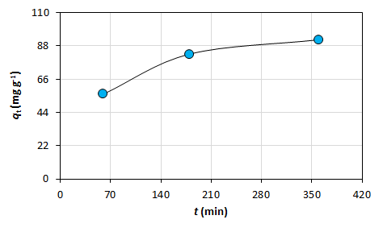
Fig. 1. Effect of contact time.

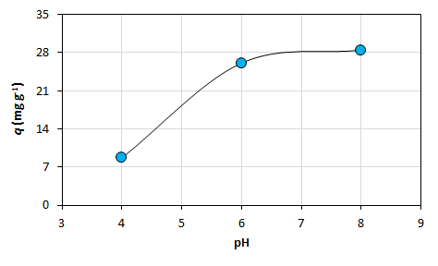
Fig. 2. Effect of pH.

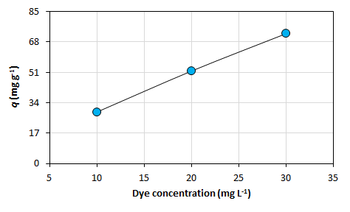
Fig. 3. Effect of synthetic dye concentration.

A
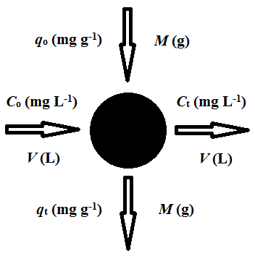
B
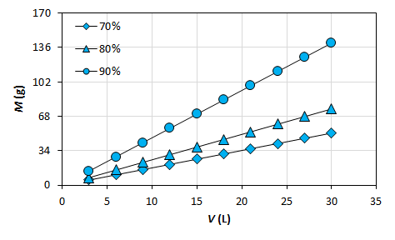
Fig. 5. Schematic plan of single-stage batch bioreactor system (a) and predicted required biosorbent amount for desired % biosorption yield (b).

A
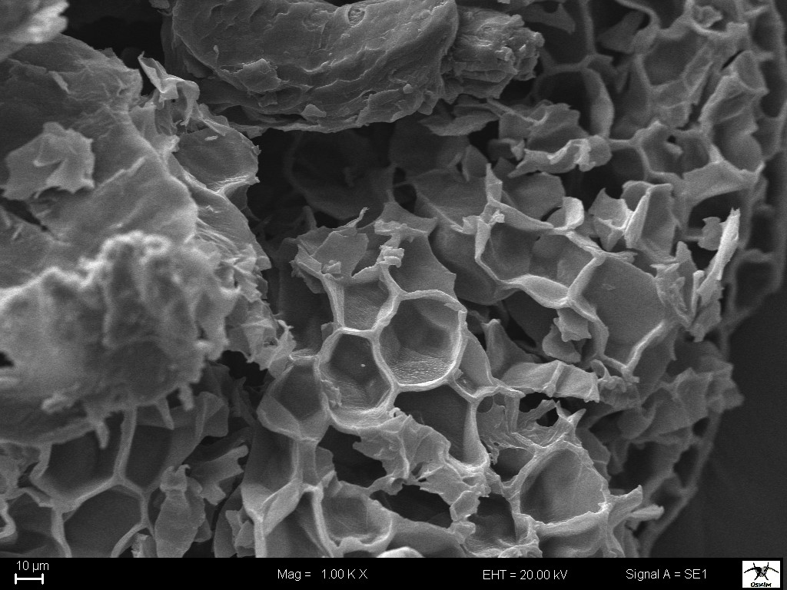
B
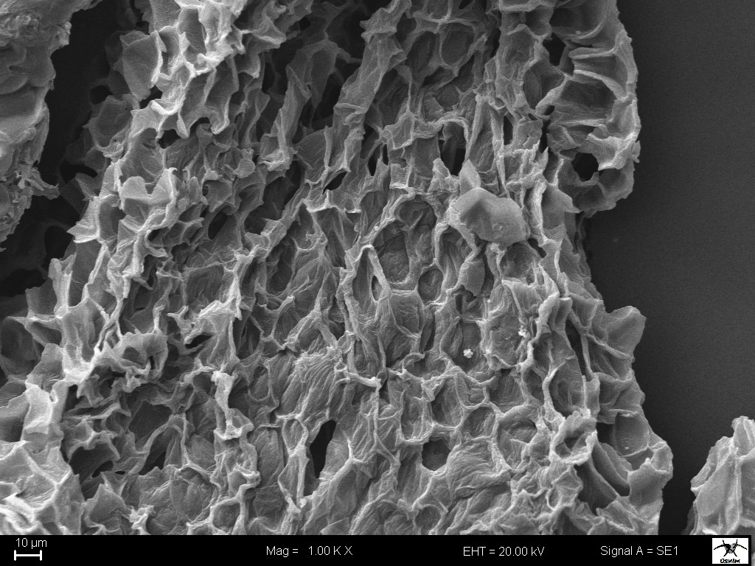
Fig. 8. SEM image of biosorbent before (a) and after dye biosorption (b).

A
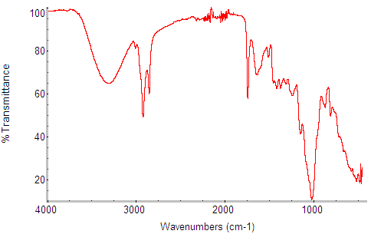
B
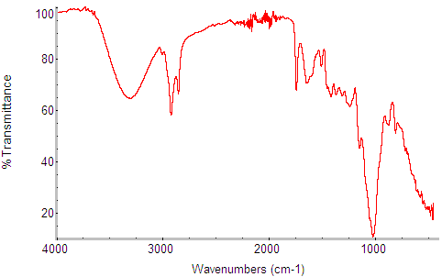
Fig. 9. FTIR spectrum of biosorbent before (a) and after dye biosorption (b).

Table 1. Operational variables and levels studied.
Parameter | Symbol | Level
 |  | 1 | 2 | 3
Contact time (min) | t | 60 | 180 | 360
pH | pH | 4 | 6 | 8
Synthetic dye concentration (mg L⁻¹) | C | 10 | 20 | 30

Table 2. Taguchi L₉ orthogonal array experimental design matrix.
Test run | Operational parameters
 | t (min) | pH | C (mg L⁻¹)
1 | 60 | 4 | 10
2 | 60 | 6 | 20
3 | 60 | 8 | 30
4 | 180 | 4 | 20
5 | 180 | 6 | 30
6 | 180 | 8 | 10
7 | 360 | 4 | 30
8 | 360 | 6 | 10
9 | 360 | 8 | 20

Table 4. Experimental and predicted S/N ratios based on Taguchi L₉ orthogonal array approach.
Test run | S/N ratio
 | Experimental | Predicted
1 | 19.5127 | 19.9483
2 | 32.8201 | 32.8518
3 | 33.9156 | 33.4483
4 | 29.3922 | 28.9248
5 | 37.1980 | 37.6336
6 | 29.4969 | 29.5287
7 | 32.4297 | 32.4615
8 | 32.9364 | 32.4690
9 | 36.8246 | 37.2602

Table 6. System performance parameters.
Parameter |  | Value
R_{i} (min⁻¹) |  | 0.0241
t_{1/2} (min) |  | 41.41
t_{x} (min) | X
t_{0.55} | 0.55 | 50.61
t_{0.65} | 0.65 | 76.90
t_{0.75} | 0.75 | 124.23
t_{0.85} | 0.85 | 234.65
t_{0.95} | 0.95 | 786.78
t_{0.97} | 0.97 | 1338.90

