Supplementary Materials - The Use of Māori Words in National Science Challenge Online Discourse

Table S.1. National Science Challenges and their funding rounds
Challenge | 1st Period  to 30/6/2019  ($ million) | 2nd Period  1/7/2019 to 30/6/2024  ($ million) | Total  ($ million)
A Better Start  To improve the potential of young New Zealanders to have a healthy and successful life | 14.2 | 20.5 | 34.7
Ageing Well  To harness science to sustain health and wellbeing into the later years of life | 14.6 | 20.3 | 34.9
Building Better Homes, Towns, and Cities  To improve the quality and supply of housing and create smart and attractive urban environments | 23.6 | 24.3 | 47.9
Healthier Lives  To reduce the burden of major New Zealand health problems | 13.7 | 17.6 | 31.3
High-Value Nutrition  To develop high-value foods with validated health benefits to drive economic growth | 30.6 | 53.2 | 83.8
New Zealand’s Biological Heritage  To protect and manage New Zealand’s biodiversity, improve our biosecurity and enhance our resilience to harmful organisms | 25.8 | 37.9 | 63.7
Our Land and Water  To enhance primary sector production and productivity while maintaining and improving our land and water quality for future generations | 27.6 | 69.3 | 96.9
Resilience to Nature’s Challenges  To enhance New Zealand’s resilience to natural disasters | 19.6 | 39.8 | 59.4
Science for Technological Innovation  To enhance the capacity of New Zealand to use physical and engineering sciences for economic growth | 33.3 | 72.7 | 106
Sustainable Seas  To enhance utilisation of our marine resources within environmental and biological constraints | 31.3 | 39.8 | 71.1
The Deep South  To understand the role of the Antarctic and the Southern Ocean in determining our climate and our future environment | 24.0 | 27.1 | 51.1
(source: https://www.mbie.govt.nz/assets/e7c91ccacc/science-board-decisions-on-second-period-funding-2018.pdf)

Table S2. Data analysed and included in the National Science Challenge Corpus
Challenge | Websites – number of words | Twitter Feed – number of words
Aging Well | 97,333 | 6,842
A Better Start | 95,564 | 1,036
Building Better Homes, Towns and Cities | 17,551 | (no Twitter feed)
Healthier Lives | 36,992 | 3,213
High-Value Nutrition | 196,453 | 3,081
New Zealand’s Biological Heritage | 139,707 | 12,035
Our Land and Water | 171,182 | 1,145
Resilience to Nature’s Challenges | 239,052 | 1,952
Science for Technological Innovation | 31,154 | 2,342
Sustainable Seas | 273,263 | 5,496
The Deep South | 137,735 | 8,237
TOTAL | 1,501,994 | 4,5379 | 1,547,373

Normalising the frequency of the top 20 loanwords in the NSC corpus over 10,000 words gives the following distribution, see Figure S1.

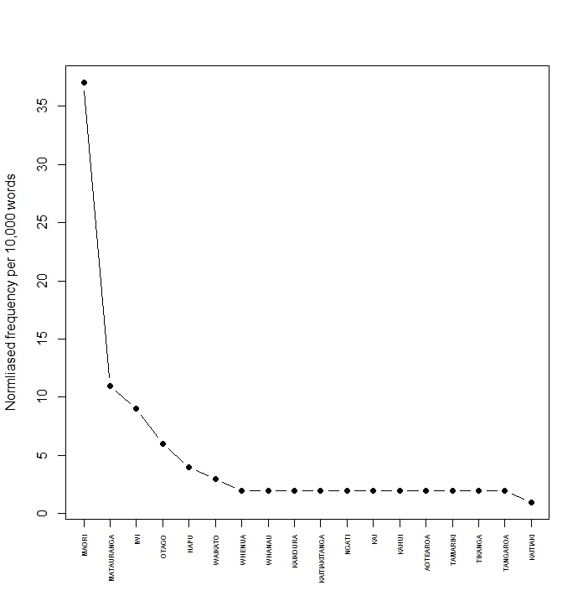
Figure S1. The 20 most frequent Māori loanwords in the entire NSC Corpus.

Table S3. Digital sources for the National Science Challenge Corpus
Challenge | Twitter Handle | Website
A Better Start | @abetterstartnz | https://www.abetterstart.nz/
Ageing Well | @ageingwellnz | https://www.ageingwellchallenge.co.nz/
Building Better Houses, Towns and Cities | none | http://www.buildingbetter.nz/
Healthier Lives | @healthierNZ | https://healthierlives.co.nz/
High-Value Nutrition | @HVNutrition_NZ ‏ | https://www.highvaluenutrition.co.nz/
New Zealand's Biological Heritage | @BioHeritage_NZ | http://www.biologicalheritage.nz/
Our Land and Water | @OurLandandWater | http://www.ourlandandwater.nz/
Resilience to Nature's Challenges | @ResilienceNSC ‏ | https://resiliencechallenge.nz/
Science for Technological Innovation | @sftichallenge ‏ | https://www.sftichallenge.govt.nz/
Sustainable Seas | @Sust_SeasNZ | https://sustainableseaschallenge.co.nz/
The Deep South | @DeepSouth_NZ | https://www.deepsouthchallenge.co.nz/

Table S4. List of loanwords which appear in the ten most frequent loans in each individual Challenge.

BETTER START | Frequency
MĀORI | 415
TAMARIKI | 295
REA | 201
TIPU | 201
WHĀNAU | 111
MĀTAURANGA | 67
TAMAITI | 66
KĀHUI | 59
OTAGO | 45
IWI | 17

AGEING WELL | Frequency
MĀORI | 449
OTAGO | 128
MĀTAURANGA | 70
KĀHUI | 61
WHĀNAU | 49
WAIKATO | 31
KAUMĀTUA | 27
HAUORA | 20
AOTEAROA | 18
HOKOWHITU | 17

BUILDING BETTER HOMES, TOWNS AND CITIES | Frequency
KĀINGA | 74
MĀORI | 37
RUA | 36
TAHI | 30
IWI | 22
MAORI | 19
KAINGA | 18
TUATAHI | 16
NGĀ | 12
NGĀTI | 12

HEALTHIER LIVES | Frequency
MĀORI | 121
WHĀNAU | 34
TAHI | 25
KŌRERO | 24
HAUORA | 21
MORENGA | 18
ORANGA | 18
MANA | 16
PIKINGA | 16
WAIKATO | 16

HIGH-VALUE NUTRITION | Frequency
KAI | 203
WHAI | 203
PAINGA | 201
MĀORI | 186
OTAGO | 122
MĀTAURANGA | 71
MAORI | 64
KIWIFRUIT | 61
MANUKA | 14
KIWI | 13

NEW ZEALAND'S BIO HERITAGE | Frequency
MĀORI | 794
MĀTAURANGA | 222
KAURI | 173
IWI | 152
KĀHUI | 96
TAONGA | 94
HAPŪ | 55
OTAGO | 47
WHENUA | 45
KAIHAUTŪ | 44

OUR LAND AND WATER | Frequency
MĀORI | 378
WHENUA | 147
MĀTAURANGA | 137
IWI | 126
MAURI | 106
ORA | 105
TAITOKERAU | 54
KOROWAI | 34
MAORI | 34
WAIKATO | 33

RESILIENCE TO NATURE'S CHALLENGES | Frequency
MĀORI | 522
IWI | 319
KAIKŌURA | 271
MĀTAURANGA | 191
OTAGO | 74
TAURANGA | 61
WHENUA | 59
HAPŪ | 58
KIWIRAIL | 56
TIKANGA | 49

SCIENCE FOR TECHNOLOGICAL INNOVATION | Frequency
MĀORI | 180
MĀTAURANGA | 80
WAIKATO | 21
OTAGO | 19
TAKA | 19
KĀHUI | 18
MAI | 18
AO | 16
NGĀTI | 14
IWI | 12

SUSTAINABLE SEAS | Frequency
MĀORI | 1805
MĀTAURANGA | 603
IWI | 576
HAPŪ | 325
KAITIAKITANGA | 260
TANGAROA | 232
KAITIAKI | 184
MOANA | 175
NGĀTI | 173
WAIKATO | 150

DEEP SEAS | Frequency
MĀORI | 338
MĀTAURANGA | 155
AOTEAROA | 140
IWI | 81
OTAGO | 61
HAPŪ | 49
NGĀTI | 41
MARAE | 37
WAIKATO | 30
WHĀNAU | 29

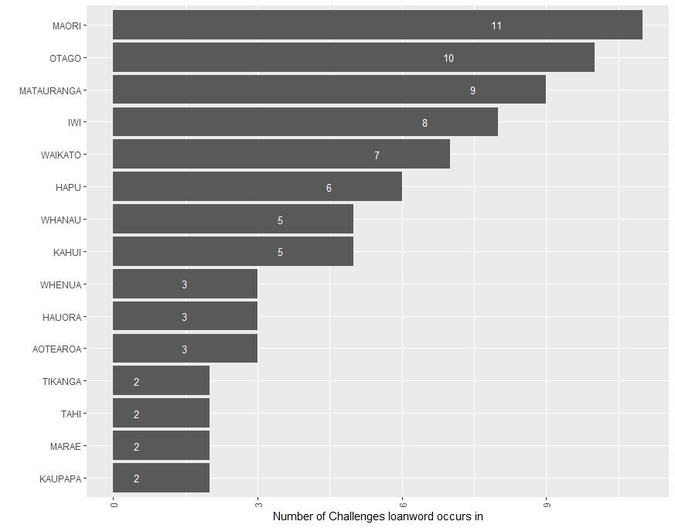Figure S2. The occurrence of the ten most frequent loanwords within each Challenge

Figures S3.A and S3.B how concordance plots obtained from AntConc provide a visual representation of the occurrence of Mātauranga and Matauranga, respectively, within the websites of each Challenge, and also the spread of its use within each website. The text included in the plots comprises the introductory summary and goal content for each site, the main content, and any supplementary content, if available (in that order). The plots indicate that, with few exceptions, the loanword is spread throughout the websites of each Challenge and unlike the funding application template generally asks for, its use is not confined to a particular section (or sub-section) of the overall document.
Note that the overall frequency counts are not directly comparable across Challenges because they are not normalized across the same number of total words used (for example, Building Better Homes, Towns and Cities has a website with the lowest frequency of the loanword Mātauranga, but also the smallest total number of words used overall).
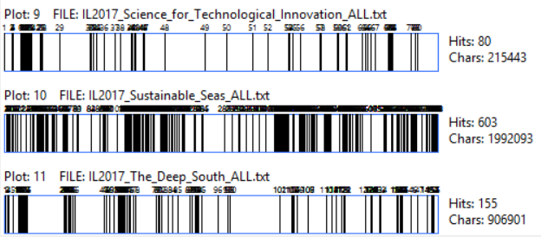
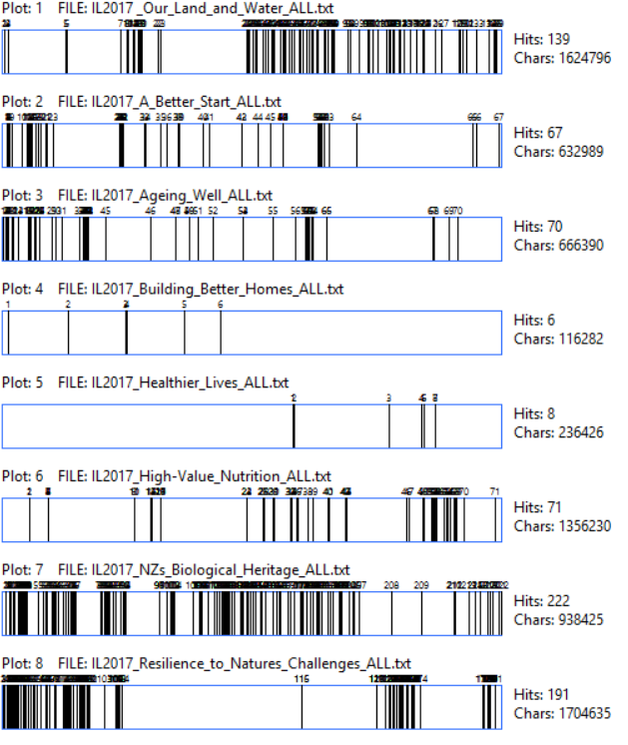

Figure S3.A The spread of Mātauranga within the text of each website of each Challenge

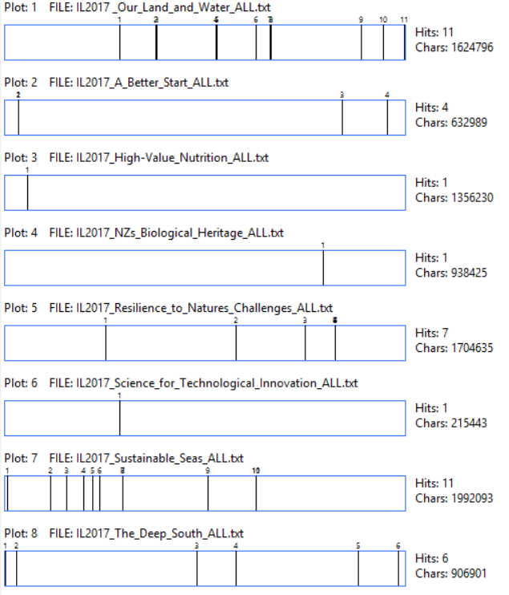

Figure S3.B The spread of Matauranga within the text of each website of each Challenge

