**Supplemental Material**

**Table S1.** Population pairwise Fst values among colonies of *Sula dactylatra* based on data collected herein and Steeves *et al.* (2005; 2010). Codes correspond to Figure 1, with sample sizes in parentheses.

|  |  |  |  |  |  |  |  |  |  |  |  |  |  |
| --- | --- | --- | --- | --- | --- | --- | --- | --- | --- | --- | --- | --- | --- |
|  | BED | NKI | COS | SER | NEH | LHI | NOR | KER | TRN | JON | PAL | MOR | SBI |
| BED (31) |  |  |  |  |  |  |  |  |  |  |  |  |  |
| NKI (30) | 0.244* |  |  |  |  |  |  |  |  |  |  |  |  |
| COS (30) | 0.205* | 0.055* |  |  |  |  |  |  |  |  |  |  |  |
| SER (8) | 0.273* | 0.110* | 0.066* |  |  |  |  |  |  |  |  |  |  |
| NEH (30) | 0.234* | 0.057* | 0.063* | 0.098* |  |  |  |  |  |  |  |  |  |
| LHI (30) | 0.357* | 0.226* | 0.187* | 0.250* | 0.216* |  |  |  |  |  |  |  |  |
| NOR (3) | 0.274 | 0.076 | 0.023 | 0.067 | 0.062 | 0.246 |  |  |  |  |  |  |  |
| KER (3) | 0.274 | 0.076 | 0.023 | 0.067 | 0.062 | 0.246 | 0.000 |  |  |  |  |  |  |
| TRN (30) | 0.243* | 0.111* | 0.072* | 0.109* | 0.101* | 0.225* | 0.075 | 0.075 |  |  |  |  |  |
| JON (30) | 0.243* | 0.111* | 0.072* | 0.109* | 0.098* | 0.225* | 0.075 | 0.075 | 0.110* |  |  |  |  |
| PAL (2) | 0.303 | 0.086 | 0.026 | 0.078 | 0.070 | 0.273 | 0.000 | 0.000 | 0.084 | 0.084 |  |  |  |
| MOR (10) | 0.416* | 0.265* | 0.223* | 0.309* | 0.254* | 0.396* | 0.338 | 0.338 | 0.264* | 0.264* | 0.386 |  |  |
| SBI (30) | 0.231* | 0.100* | 0.061* | 0.096* | 0.088* | 0.214* | 0.059 | 0.059 | 0.099* | 0.058* | 0.066 | 0.251* |  |
| CLP (2) | 0.303 | 0.086 | 0.026 | 0.078 | 0.070 | 0.273 | 0.000 | 0.000 | 0.084 | 0.084 | 0.000 | 0.386 | 0.066 |

\**P*<0.05 following Benjamini–Yekutieli correction (Narum 2006) for simultaneous tests

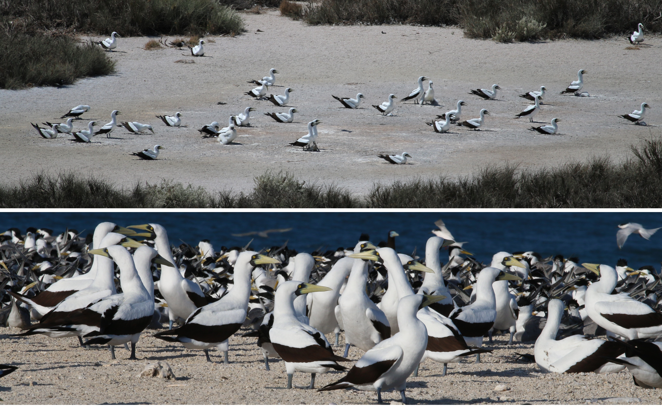**Figure S1.** The main colony of masked boobies on Bedout Island in November 2016 (top panel), and adult masked boobies roosting on the eastern shore of Bedout Island (bottom panel).



**Figure S2.** Wing length and culmen length in *Sula dactylatra bedouti* (Bedout Island) and *S. d. personata* (Raine Island) from this and previous studies (Bailey 1966; Marchant and Higgins 1990; O'Brien and Davies 1990; Pitman and Jehl 1998). Error bars reflect standard deviations (not reported for all studies). Sexes are depicted separately. Marchant and Higgins (1990) separately presented measurements from “museum” and “live” specimens, and reported here as such. Not all studies had measurements of both sexes, or reported standard deviations.