Novel two chain fatty acid based-lipids for development of vancomycin pH-responsive liposomes against Staphylococcus aureus and Methicillin-resistant Staphylococcus aureus (MRSA)
Sifiso S. Makhathini¹, Rahul S. Kalhapure^{1,3}*, Mahantesh Jadhav, Ayman Y. Waddad¹, Ramesh Gannimani¹, Calvin A. Omolo¹, Sanjeev Rambharose^{1,2}, Chunderika Mocktar¹, Thirumala Govender^{1,*}.

¹Discipline of Pharmaceutical Sciences, College of Health Sciences, University of KwaZulu-Natal, Private Bag X54001, Durban, South Africa
²Division of Emergency Medicine, Department of Surgery, University of Cape Town, Cape Town, South Africa
³School of Pharmacy, The University of Texas at El Paso, 500 W University Ave, El Paso, TX 79968, USA.
*Corresponding author.
Email address: govenderth@ukzn.ac.za; rahul.kalhapure@rediffmail.com, rkalhapure@utep.edu

Supporting information
¹H NMR characterization of compound 3
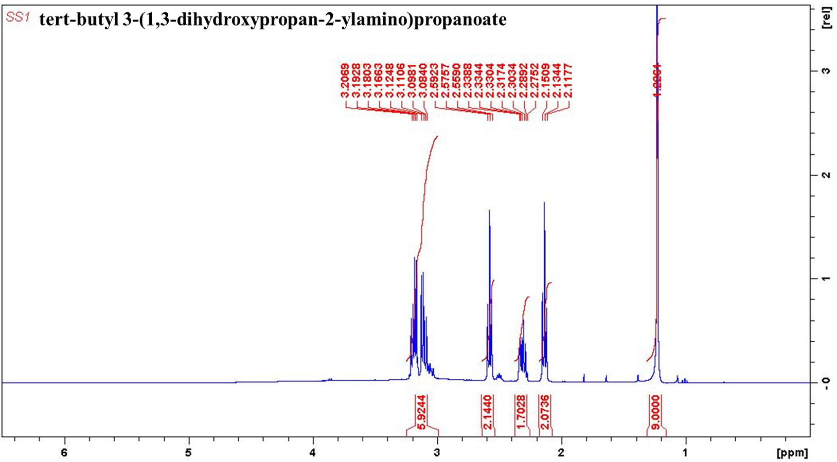

¹³C NMR characterization of compound 3
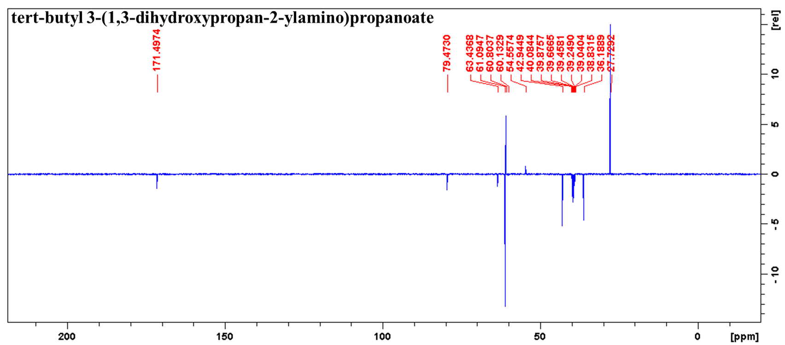
HRMS characterization of compound 3
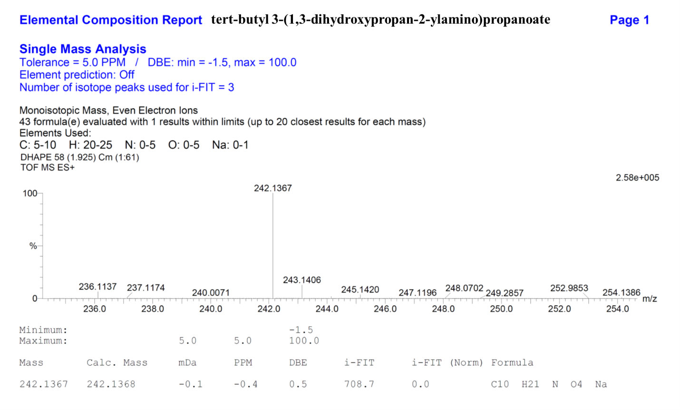

¹H NMR characterization of compound 5a
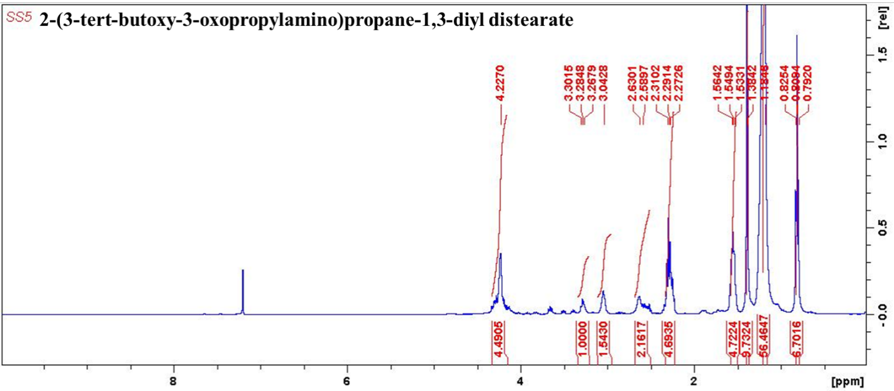
¹³C NMR characterization of compound 5a
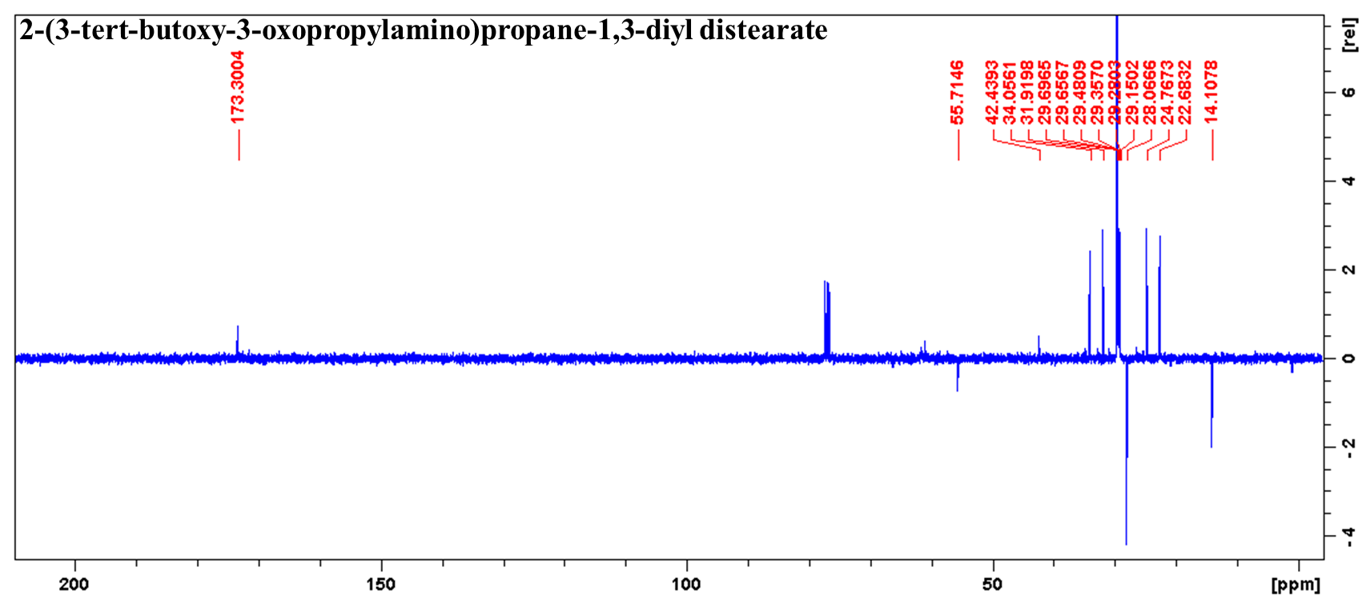

HRMS characterization of compound 5a
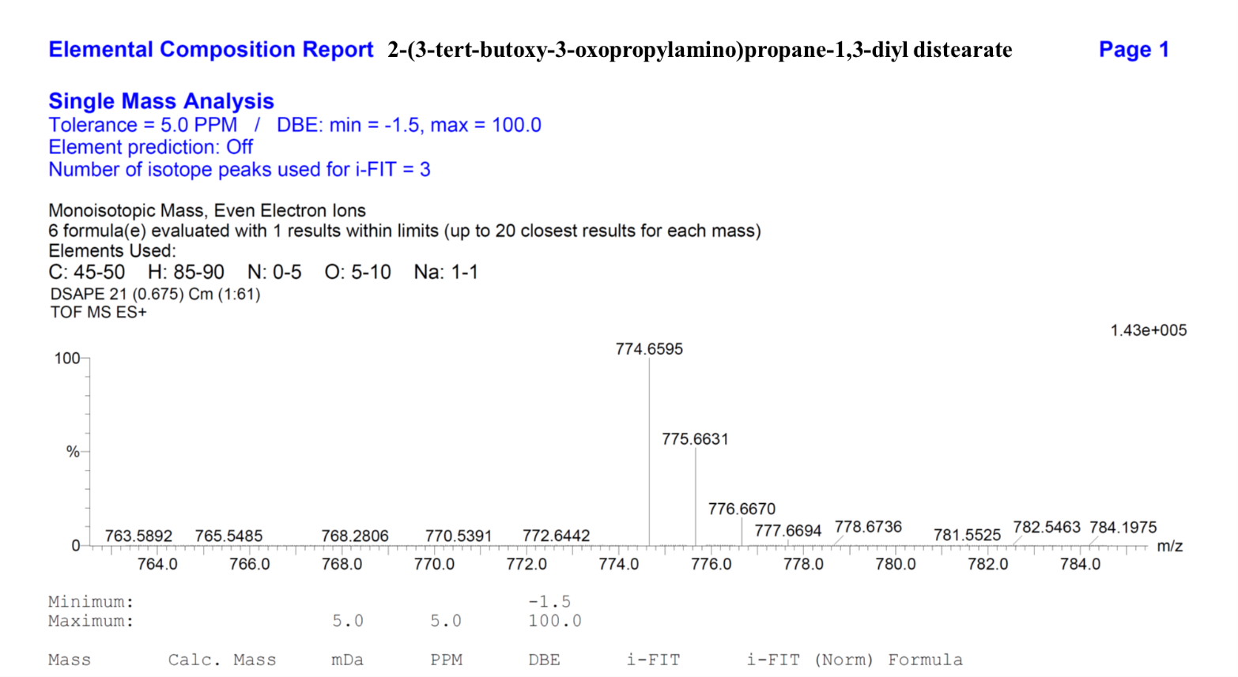

¹H NMR characterization of compound 5b
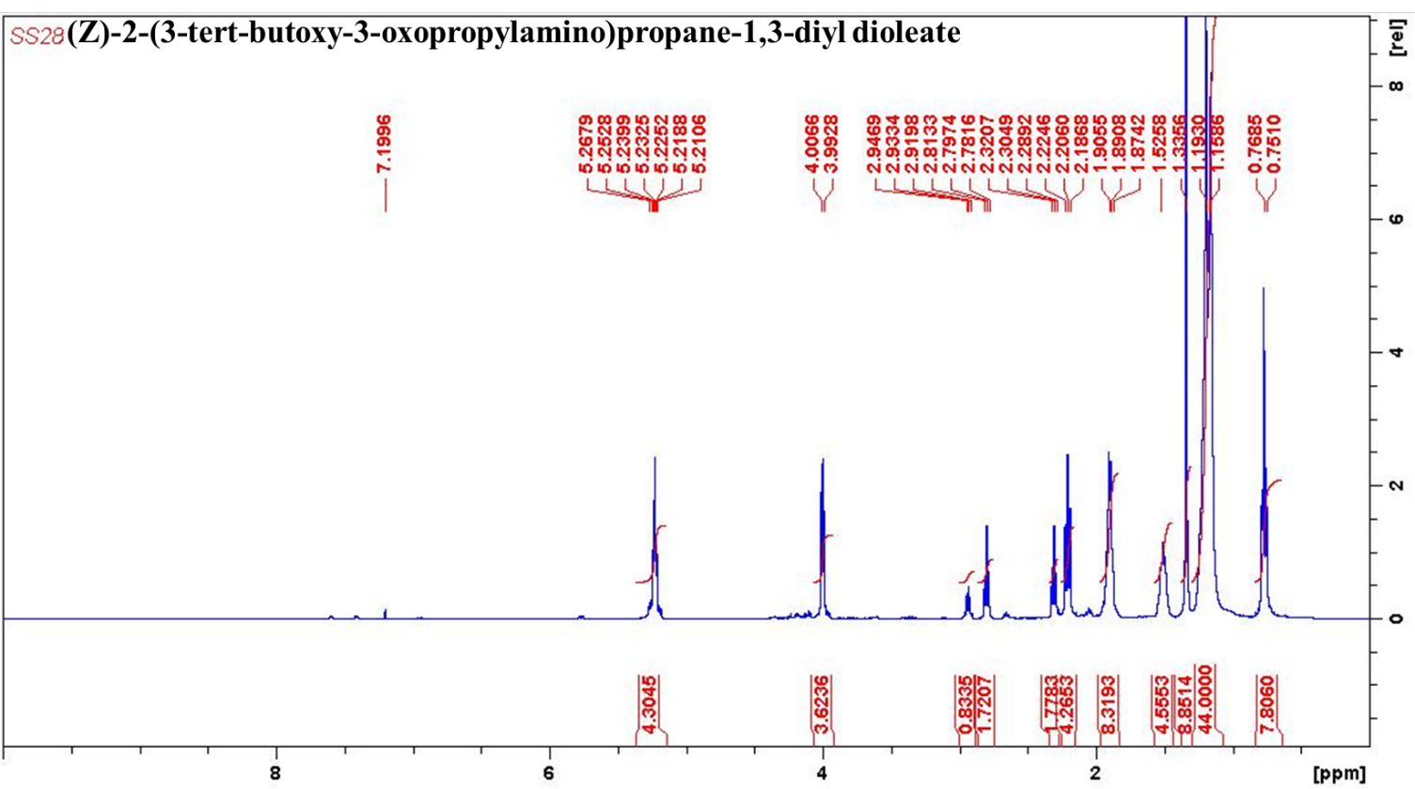

¹³C NMR characterization of compound 5b
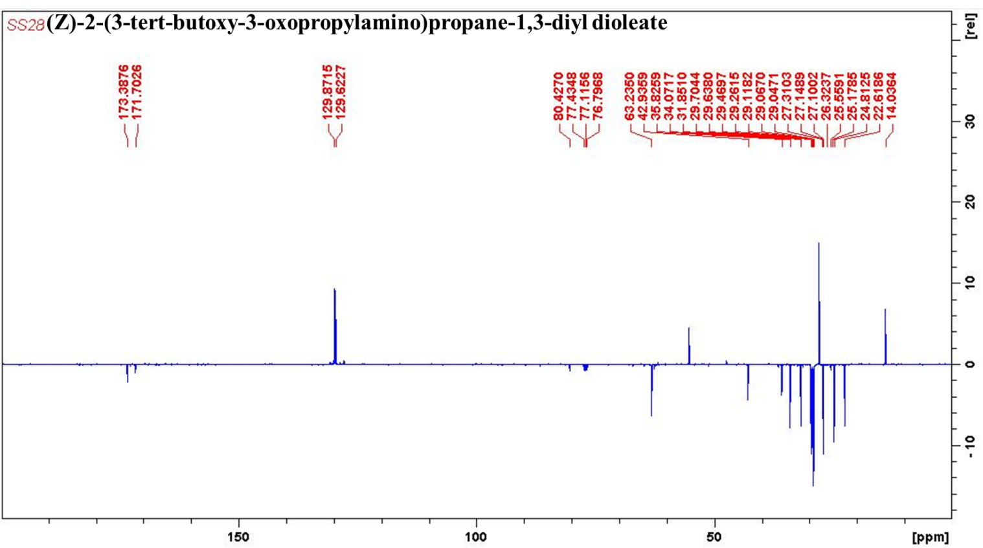

HRMS characterization of compound 5b
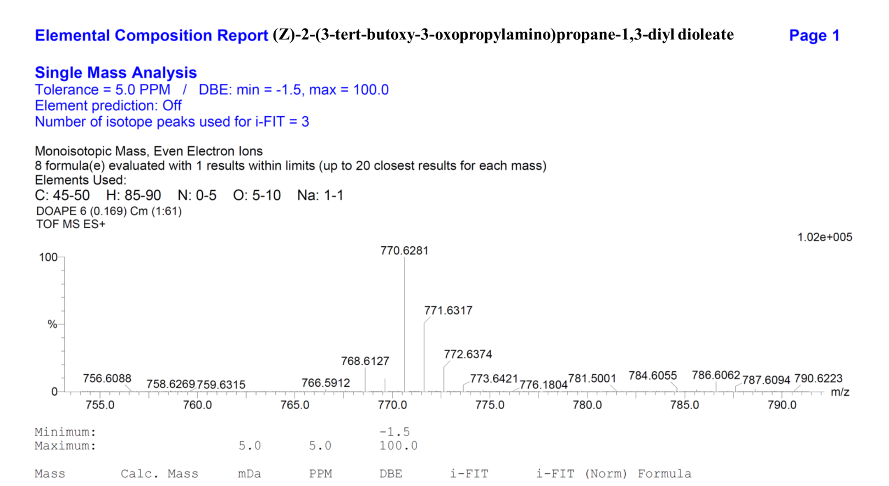
¹H NMR characterization of compound 5c
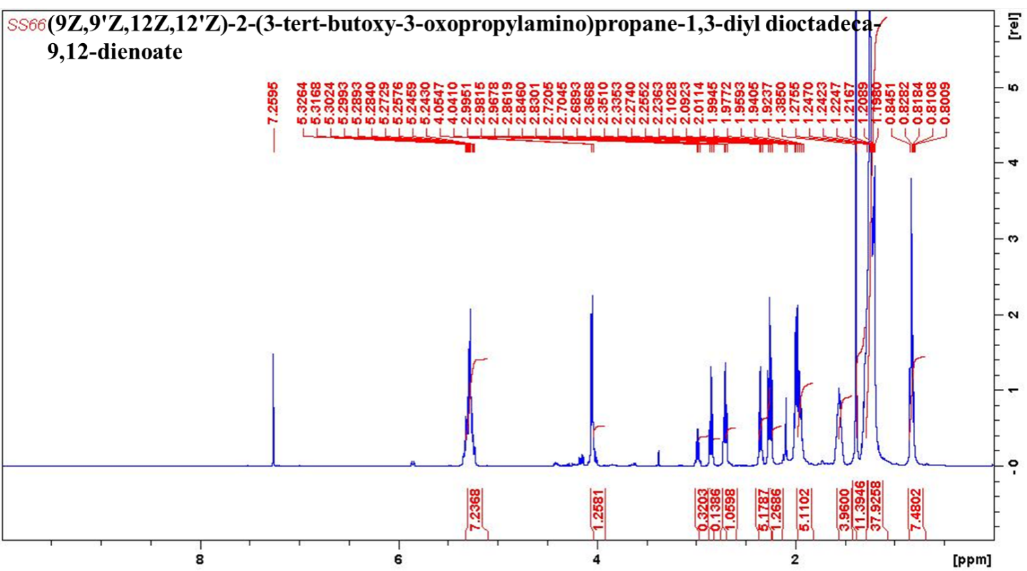

¹³C NMR characterization of compound 5c
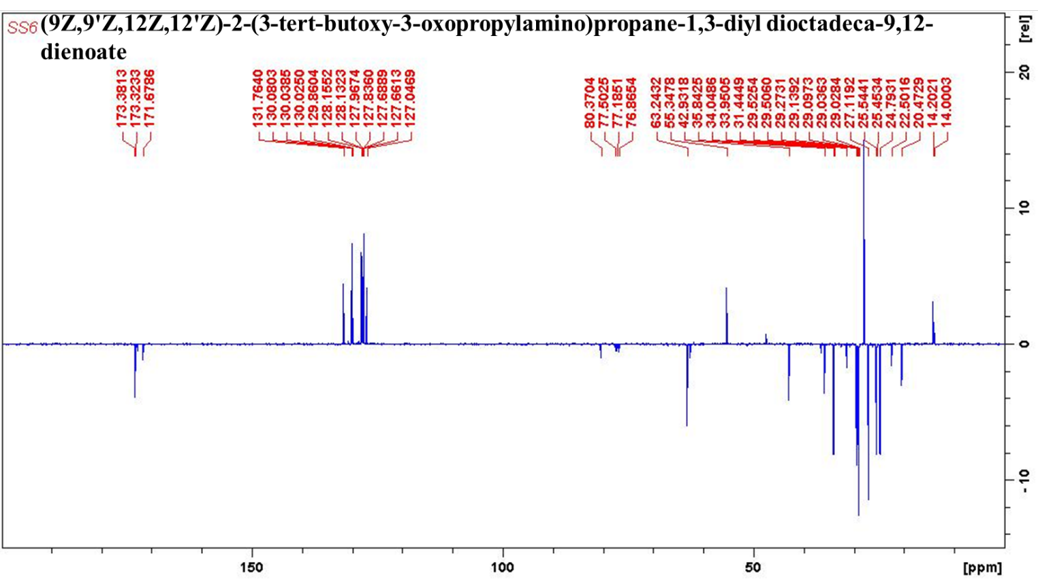

HRMS characterization of compound 5c
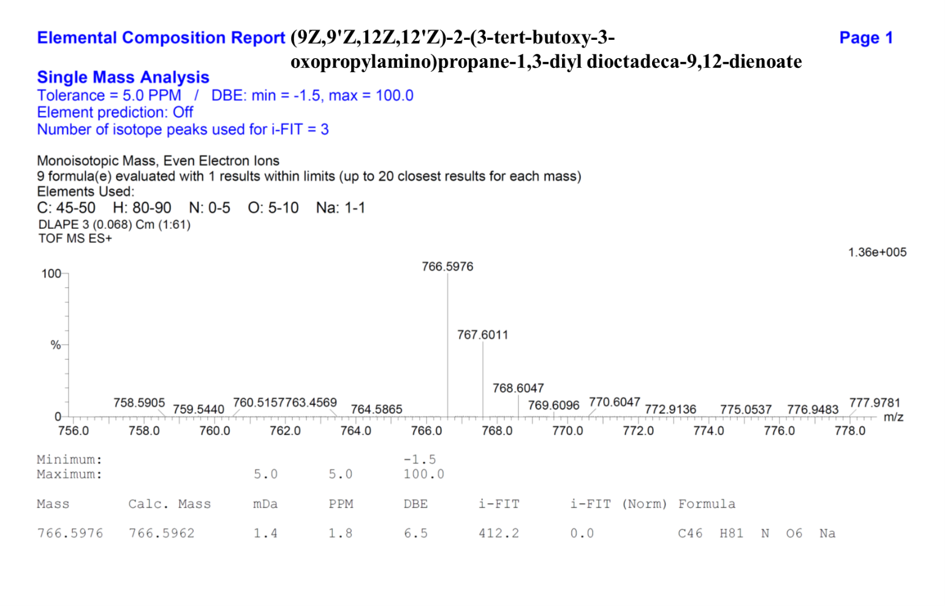
¹H NMR characterization of compound 5d
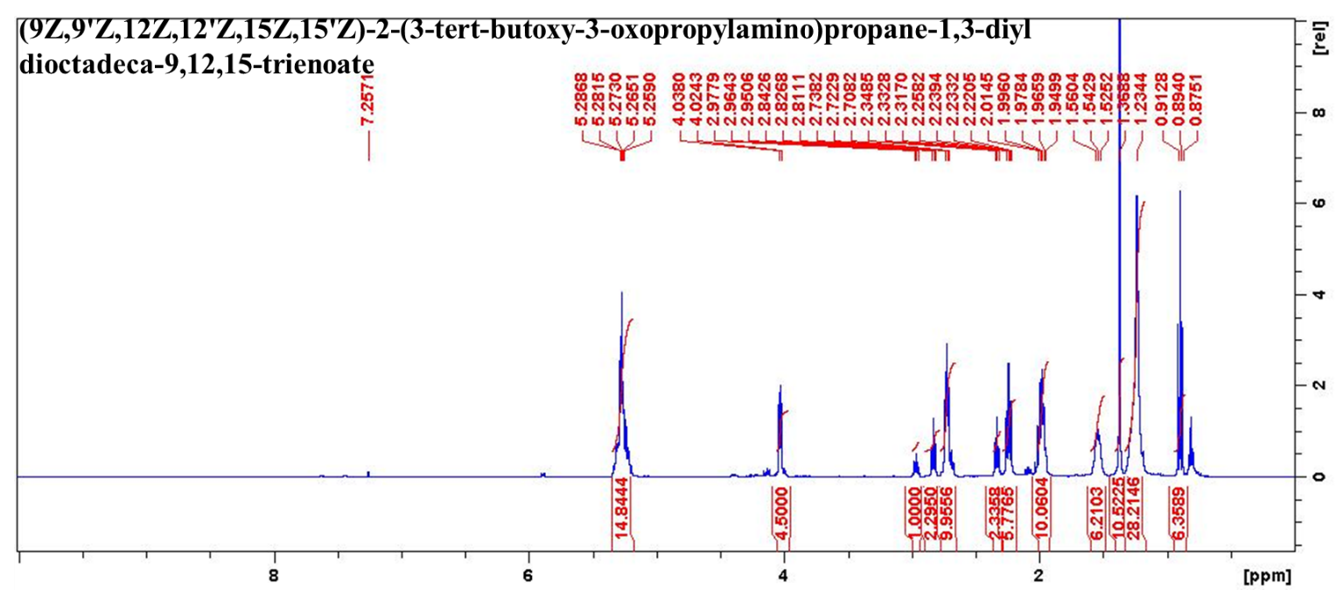

¹³C NMR characterization of compound 5d
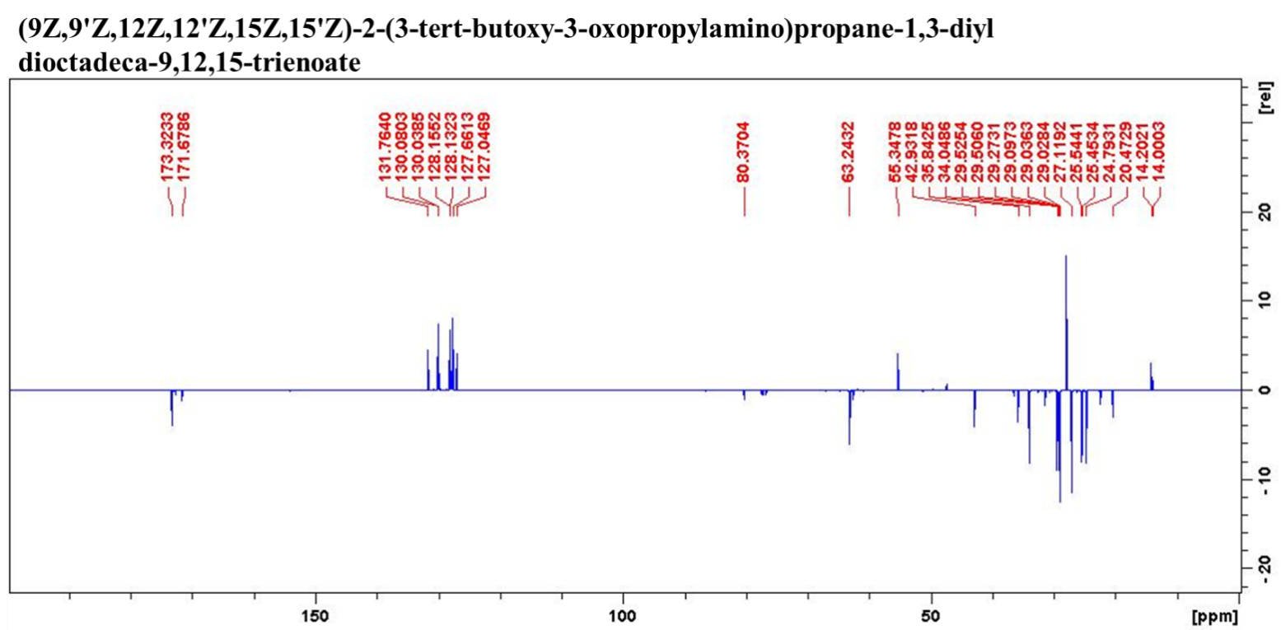
HRMS characterization of compound 5d
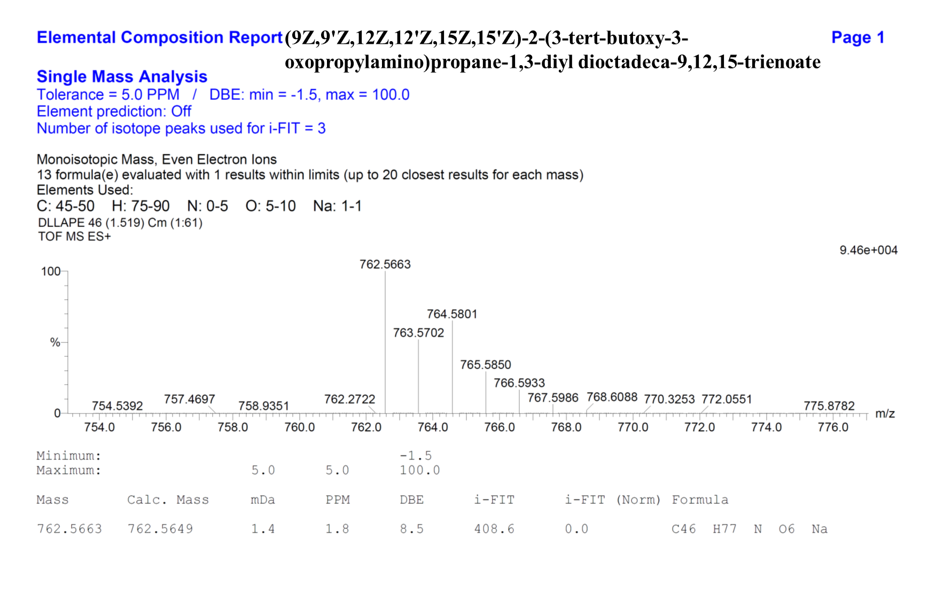
FTIR characterization of compound 6a
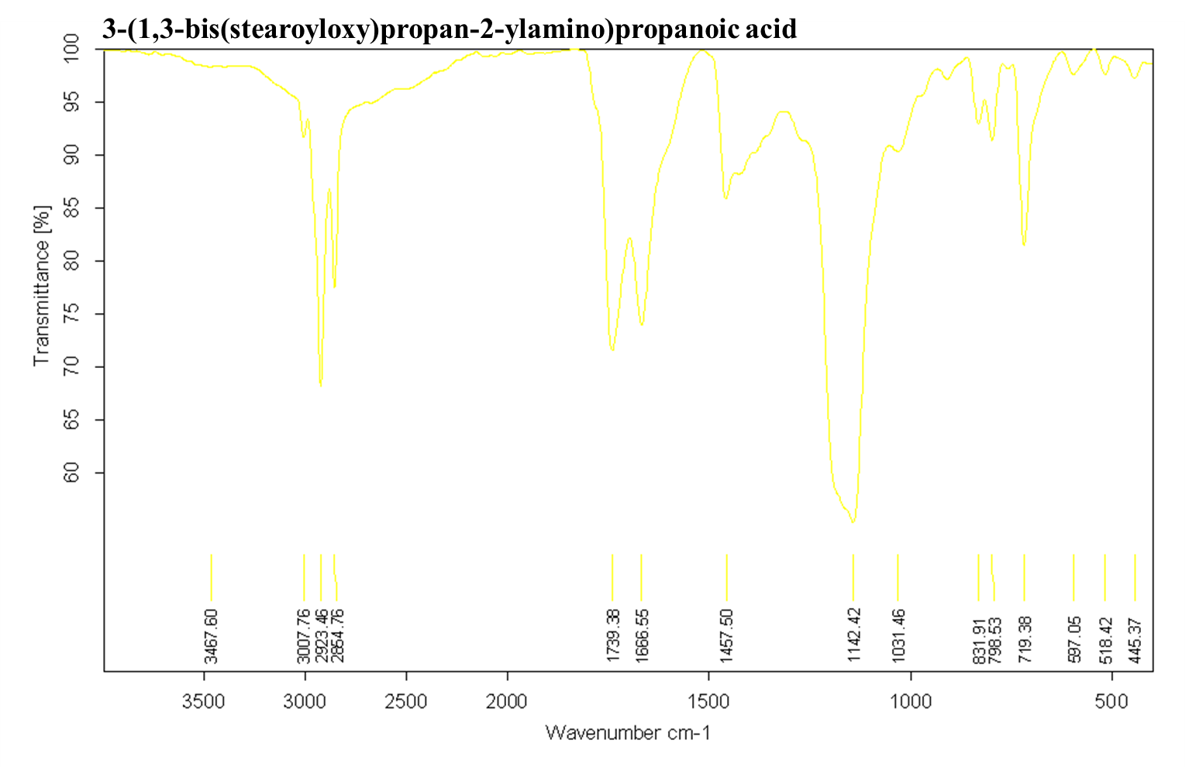
¹H NMR characterization of compound 6a
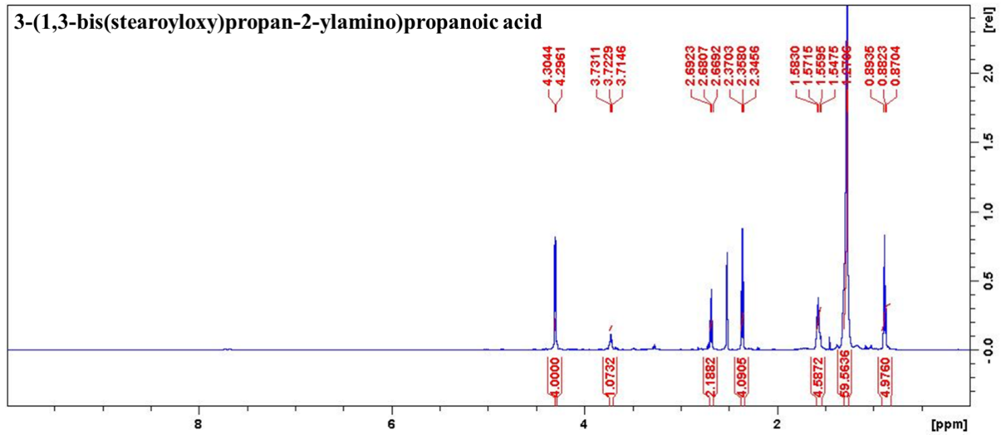

¹³C NMR characterization of compound 6a
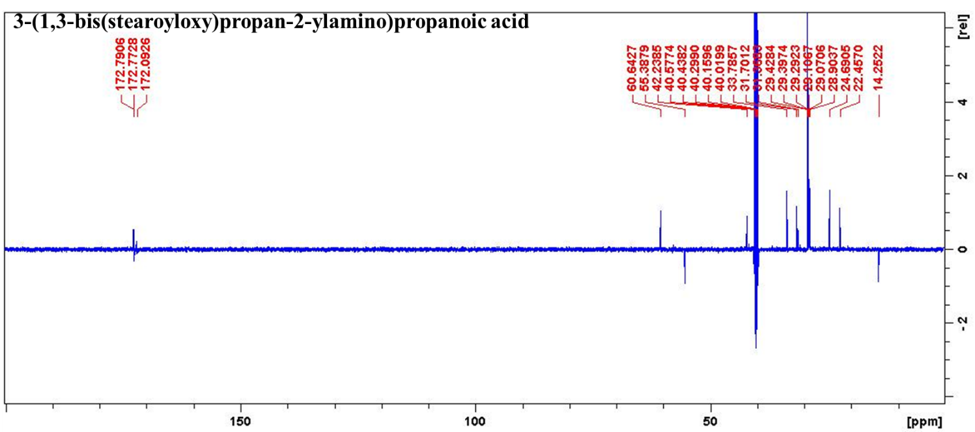
HRMS characterization of Compound 6a
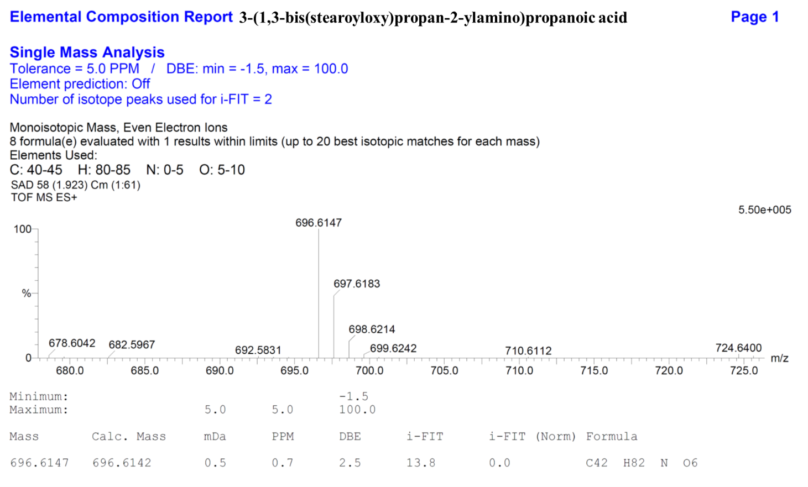
FTIR characterization of compound 6b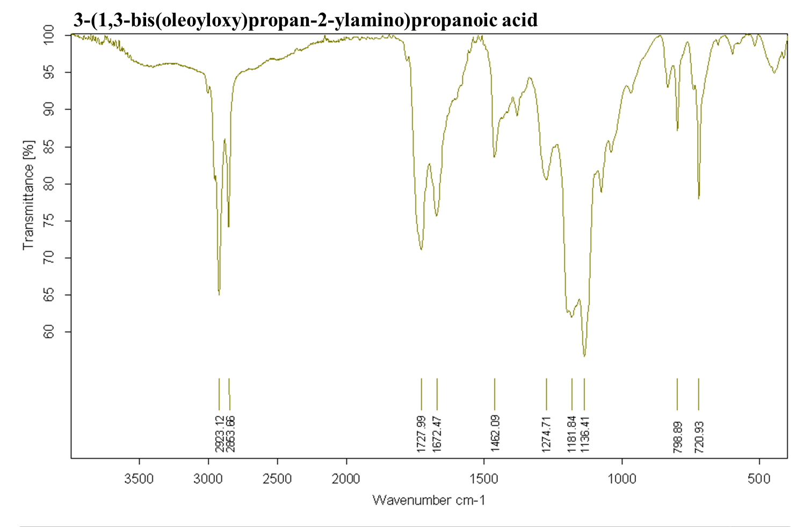¹H NMR characterization of compound 6b
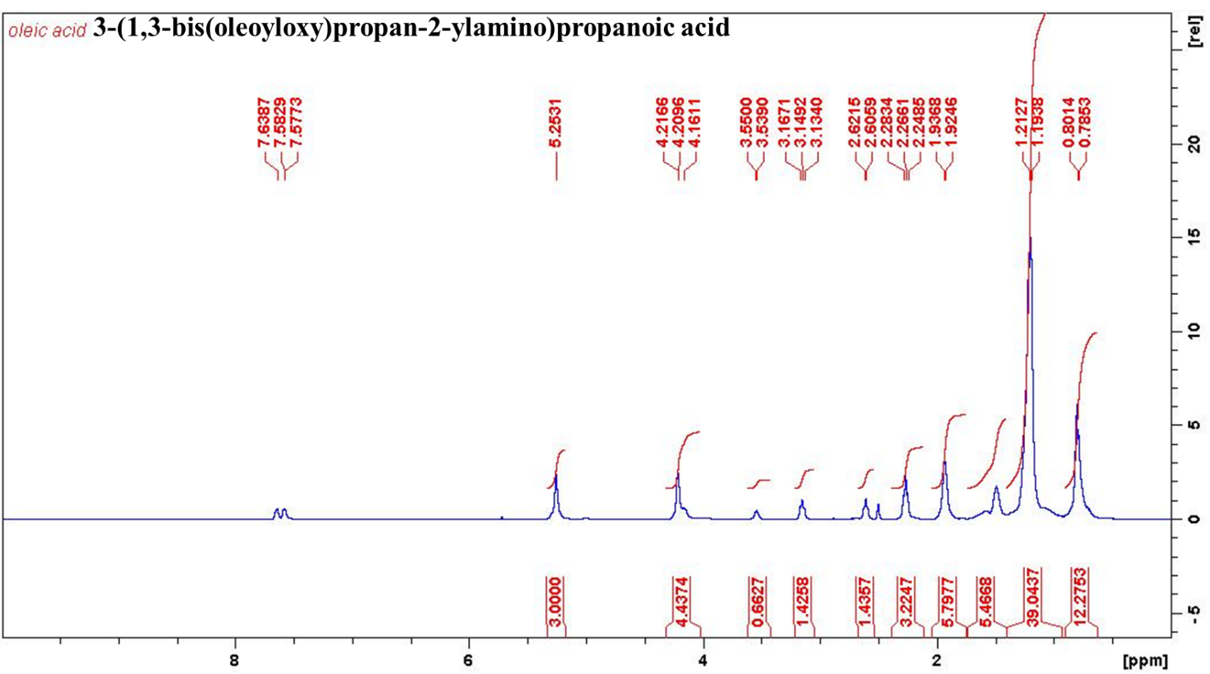
¹³C NMR characterization of compound 6b
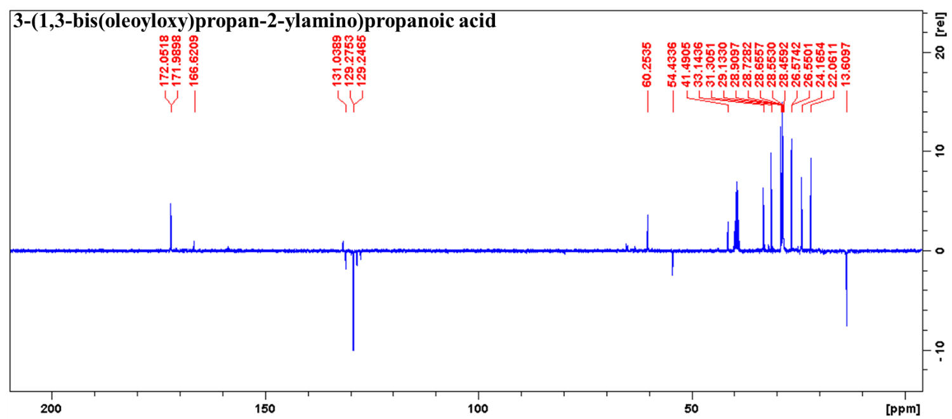

HRMS characterization of Compound 6b
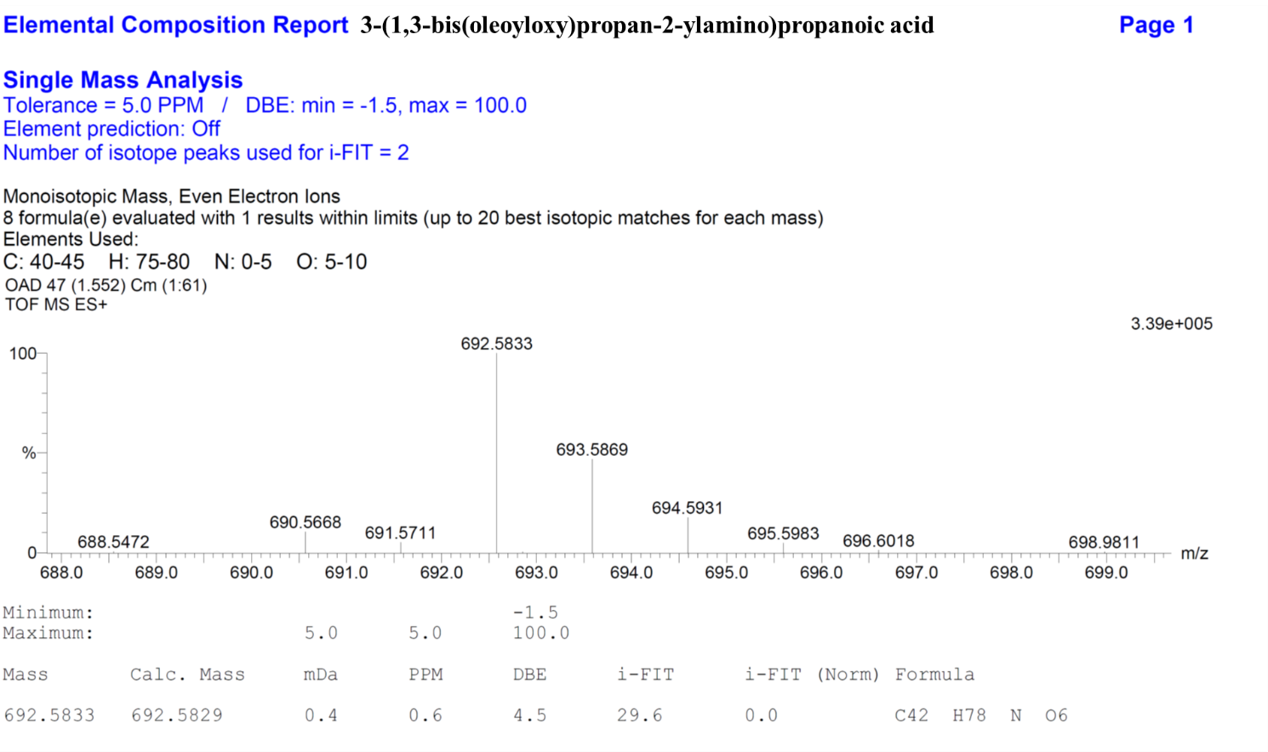
FTIR characterization of compound 6c
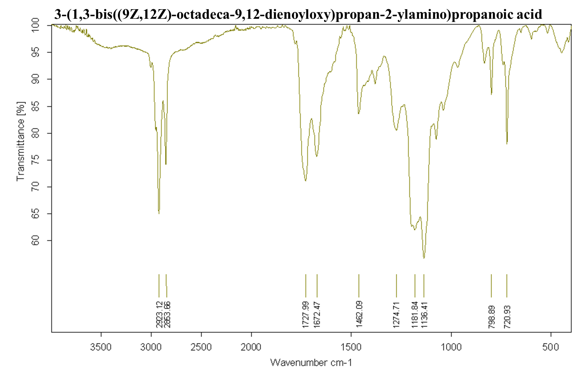¹H NMR characterization of compound 6c
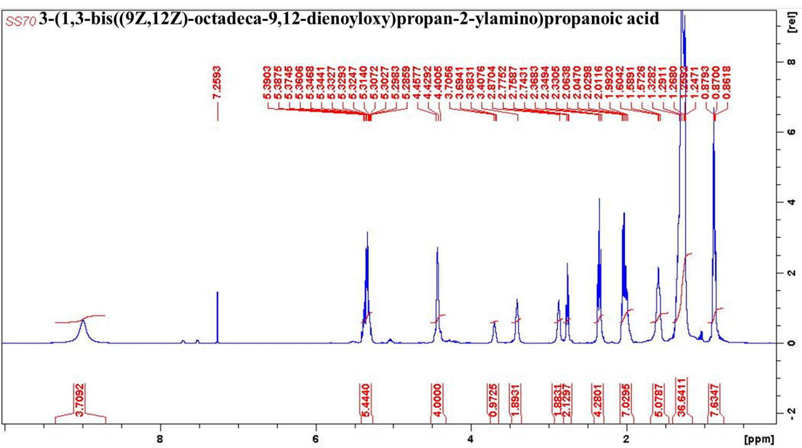
¹³C NMR characterization of compound 6c
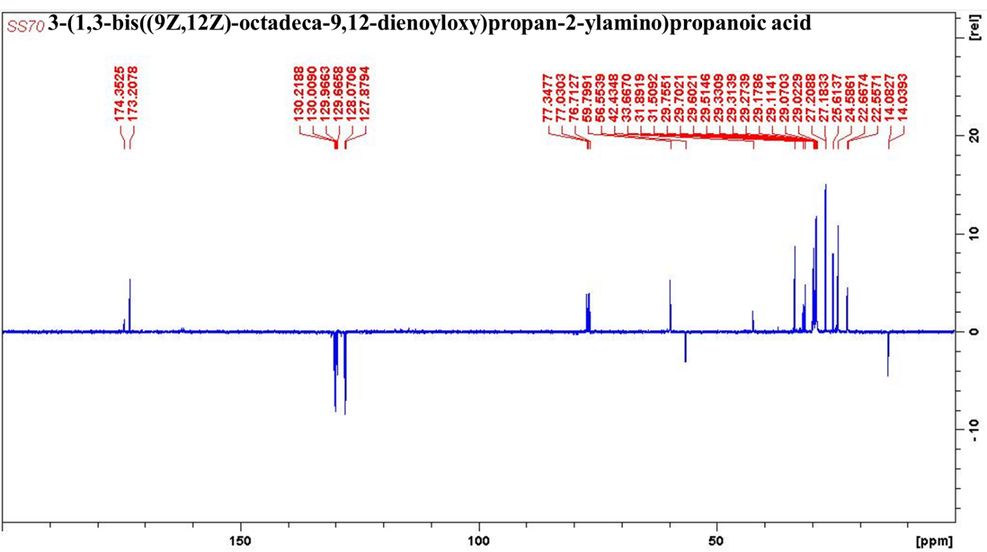

HRMS characterization of Compound 6c
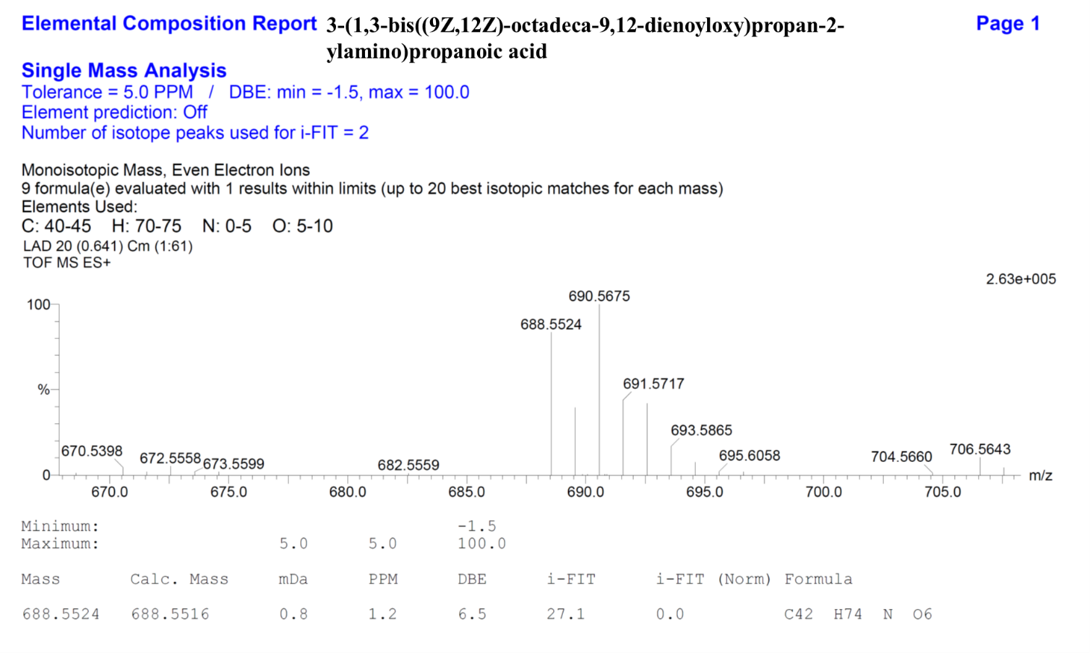
FTIR characterization of compound 6d
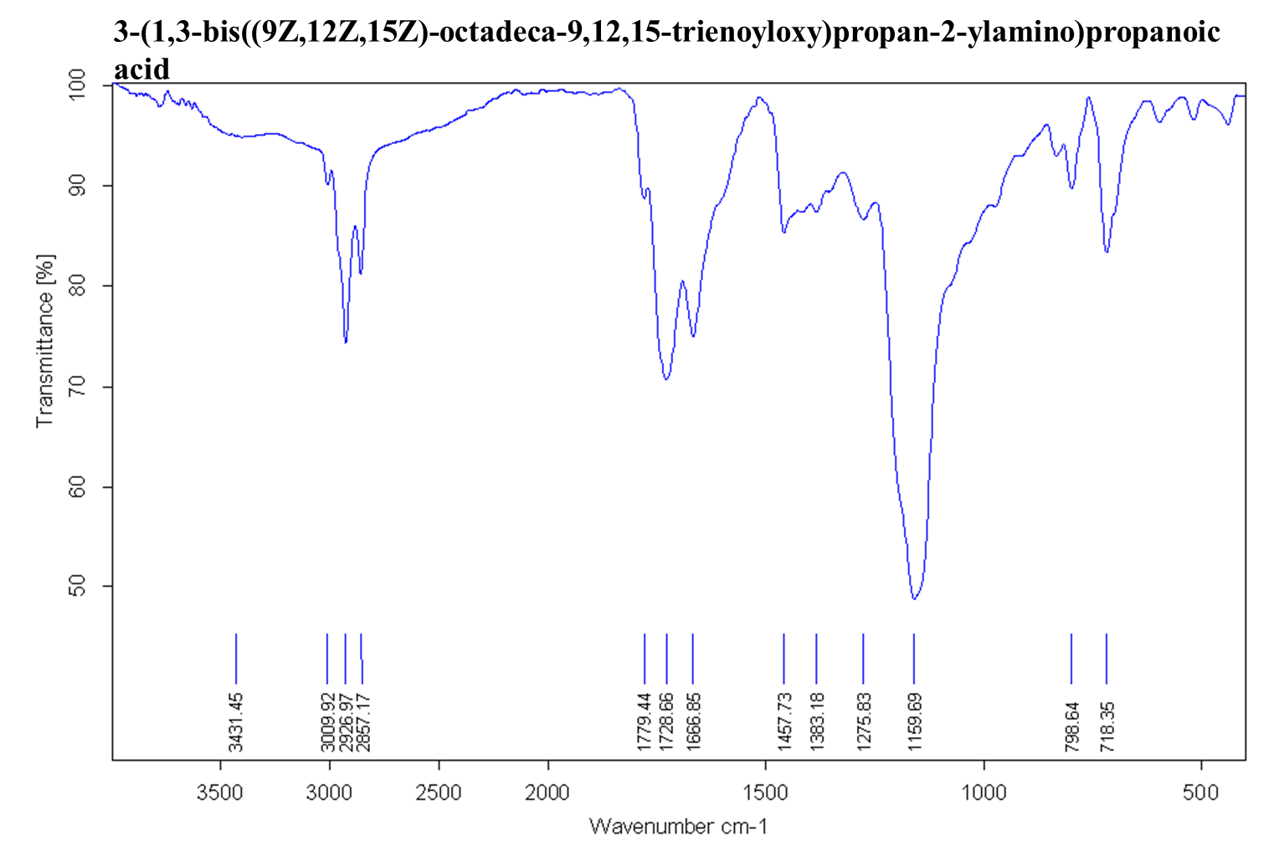

¹H NMR characterization of compound 6d
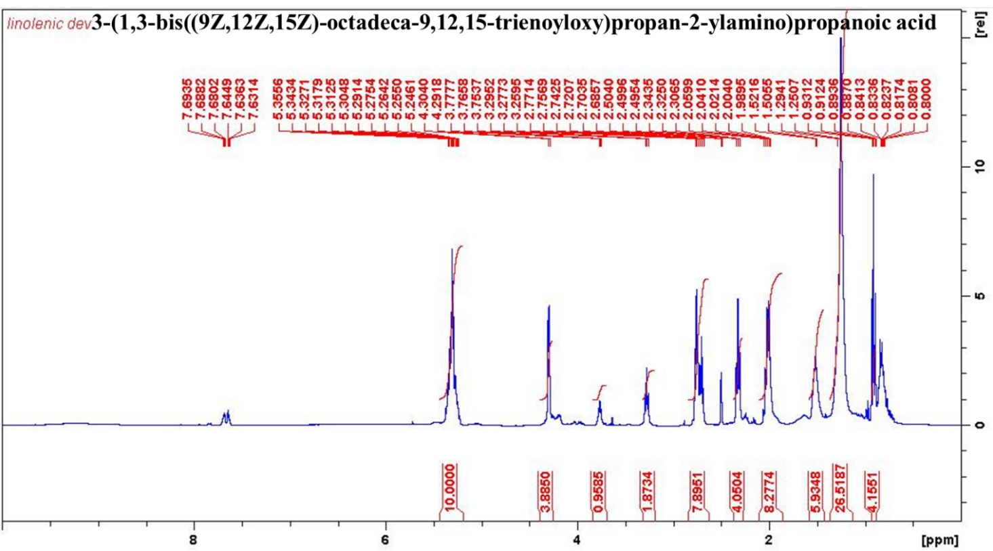

¹³C NMR characterization of compound 6d
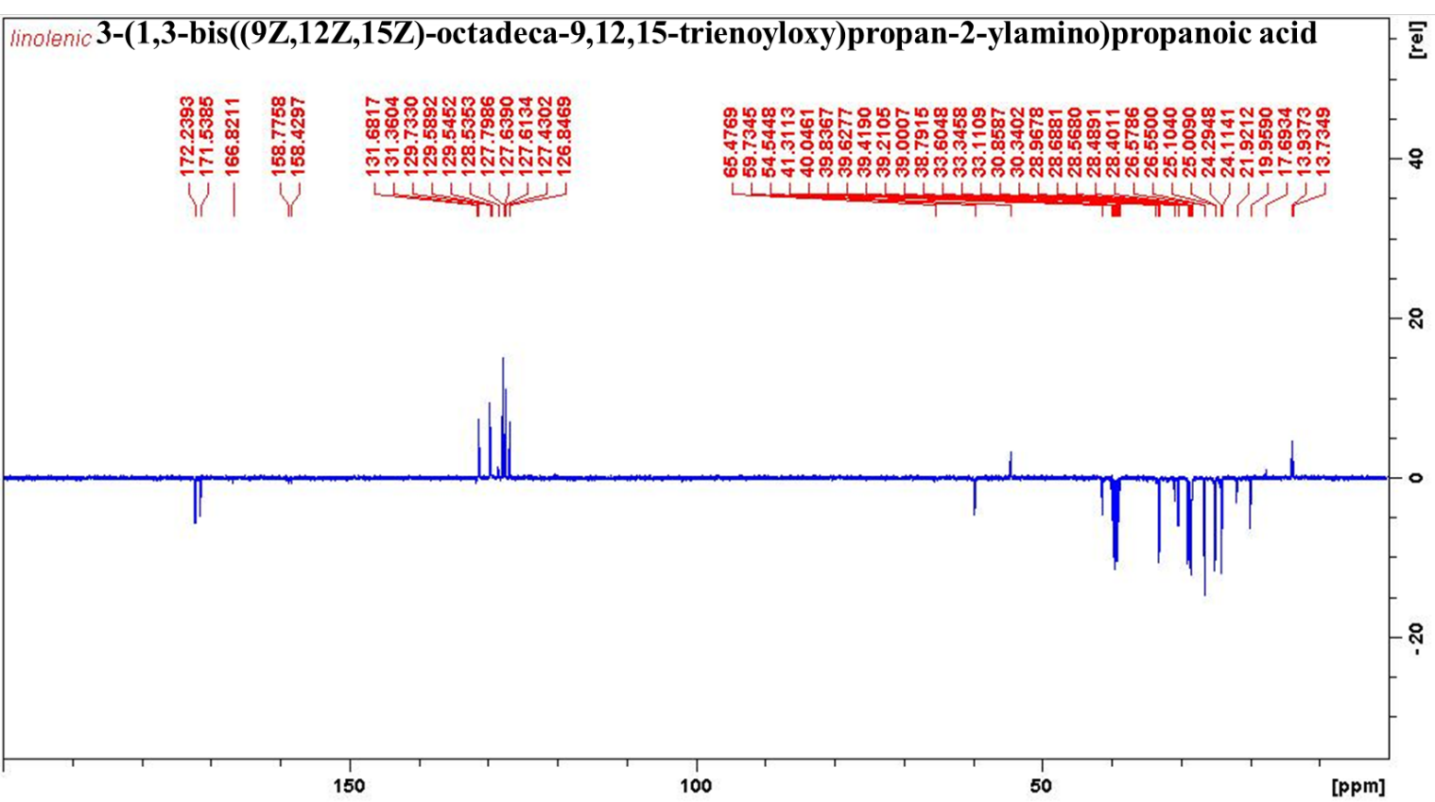
HRMS characterization of Compound 6d
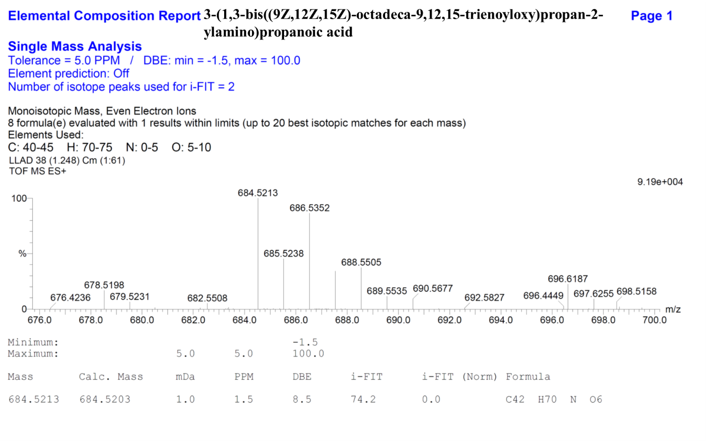

Table S1a: Effect of pH on Particle size, PDI and ZP value for different pH-sensitive VAN loaded liposomes.
liposome | DSAPA-VAN-Lipo |  |  |  | DOAPA-VAN-Lipo
pH | Size(nm) | PDI | ZP (mV) |  | Size (nm) | PDI | ZP (mV)
7.4 | 89.37±0.549 | 0.184±0.007 | -10.4±2.38 |  | 96.92±8.732 | 0.204±0.014 | -8.85±3.19
6.0 | 114.0±2.972 | 0.629±0.107 | -1.20±0.176 |  | 162.8±0.012 | 0.176±0.012 | 1.54±0.101
5.5 | 118.8±1.680 | 0.370±0.016 | 2.05±0.659 |  | 114.5±12.54 | 0.208±0.023 | 0.667±0.654

Table S1b: Effect of pH on Particle size, PDI and ZP value for different pH-sensitive VAN loaded liposomes.
Liposome | DLAPA-VAN-Lipo |  |  |  | DLLAPA-VAN-Lipo
pH | Size (nm) | PDI | ZP(mV) |  | Size (nm) | PDI | ZP (mV)
7.4 | 86.26±11.76 | 0.203±0.010 | -11.3±2.22 |  | 88.52±5.078 | 0.151±0.016 | -11.8±2.99
6.0 | 158±1.908 | 0.129+0.019 | 1.02±0.1012 |  | 301.2±24.41 | 0.644±0.230 | -1.26±0.427
5.5 | 97.37±8.928 | 0.350±0.235 | 3.10±0.583 |  | 282±31.58 | 0.532±0.170 | -0.318±0.746

Table S2a: In vitro VAN release data from the different Liposome formulations at pH 7.4

No | Name of release model | DSAPA-VAN-Lipo |  |  | DOAPA-VAN-Lipo |  |  | DLAPA-VAN-Lipo |  |  | DLLAPA-VAN-Lipo
 |  | R² | RSME | AIC | R² | RSME | AIC | R² | RSME | AIC | R² | RSME | AIC
1 | Zero order | 0.4277 | 17.72 | 90.54 | 0.5626 | 16.05 | 87.61 | 0.4188 | 17.63 | 90.40 | 0.6067 | 17.45 | 90.07
2 | First Order | 0.9457 | 24.29 | 64.18 | 0.9609 | 4.292 | 57.89 | 0.9367 | 5.494 | 64.16 | 0.1185 | 12.88 | 83.49
3 | Higuchi | 0.9358 | 5.919 | 66.44 | 0.9634 | 4.770 | 61.08 | 0.9365 | 5.692 | 65.43 | 0.6945 | 7.610 | 71.70
4 | Korsmeyer-Peppas | 1 | 2 | 38 | 0.9836 | 2.372 | 38.92 | 0.9886 | 1.924 | 36.06 | 0.9878 | 2.231 | 32.55
5 | Weibull | 0.9960 | 1.124 | 25.57 | 0.9752 | 2.926 | 43.86 | 0.9882 | 2.044 | 38.95 | 0.9951 | 0.9455 | 24.30
6 | Hixson-Crowell | 0.8921 | 7.606 | 71.86 | 0.9347 | 5.203 | 61.66 | 0.8818 | 7.593 | 71.48 | 0.1052 | 14.45 | 85.98

Table S2b: In vitro VAN release data from the different Liposome formulations at pH 6.0
No | Name of release model | DSAPA-VAN-Lipo |  |  | DOAPA-VAN-Lipo |  |  | DLAPA-VAN-Lipo |  |  | DLLAPA-VAN-Lipo
 |  | R² | RSME | AIC | R² | RSME | AIC | R² | RSME | AIC | R² | RSME | AIC
1 | Zero order | 0.0033 | 21.14 | 94.39 | 0.0783 | 22.15 | 95.33 | 0.2067 | 21.71 | 95.03 | 0.3804 | 19.37 | 92.49
2 | First Order | 0.8325 | 8.631 | 74.74 | 0.9067 | 7.041 | 70.25 | 0.9322 | 6.096 | 66.43 | 0.9699 | 4.056 | 57.22
3 | Higuchi | 0.8841 | 7.186 | 70.60 | 0.8990 | 7.280 | 70.45 | 0.9160 | 6.932 | 69.70 | 0.9566 | 5.027 | 62.53
4 | Korsmeyer-Peppas | 0.9947 | 1.407 | 31.59 | 0.9969 | 1.162 | 27.65 | 0.9767 | 3.237 | 48.07 | 0.9941 | 1.568 | 33.75
5 | Weibull | 0.9957 | 1.252 | 29.70 | 0.9963 | 1.226 | 28.93 | 0.9818 | 2.877 | 46.47 | 0.9958 | 1.326 | 31.07
6 | Hixson-Crowell | 0.7378 | 10.78 | 79.64 | 0.8510 | 8.864 | 75.33 | 0.8886 | 7.883 | 72.29 | 0.9370 | 6.032 | 66.47

Table S3. In vitro release best fit values for different formulation at pH 7.4 and 6.0
pH |  |  | 7.4 | 6.0
Formulation | Model | Equation | Release Exponent | Release Exponent
DSAPA-VAN-Lipo | KP | Q = k.t^{n} | n = 0.777 | n=0.625
 | WB | Q = 1 exp [-(t)^{a/b} | n = 0.856 | β= 0.792
DOAPA-VAN-Lipo | KP | Q = k.t^{n} | n = 0.629 | β= 0.646
 | WB | Q = 1 exp [-(t)^{a/b} | n = 0.840 | β= 0.842
DLAPA-VAN-Lipo | KP | Q = k.t^{n} | n = 0.777 | β= 0.658
 | WB | Q = 1 exp [-(t)^{a/b} | n = 0.830 | β= 0.825
DLLAPA-VAN-Lipo | KP | Q = k.t^{n} | n =0.536 | n= 0.679
 | WB | Q = 1 exp [-(t)^{a/b} | n = 0.540 | β= 0.667
KP= Korsmeyer-Peppas, WB= Weibull
Table S4a: Effect of storage on physicochemical characteristics of vancomycin loaded liposomes (DSAPA-VAN-Lipo)
Storage condition | Particle size |  | PDI |  | ZP
Time (days) | RT | 4 ºC | RT | 4 ºC | RT | 4 ºC
0 | 94.44±0.8581 | 96.94±0.8865 | 0.225±0.008 | 0.232±0.007 | -11.3±2.65 | -7.93±24
30 | 231.6±71.74 | 107.4±8.824 | 0.686±0.264 | 0.381±0.052 | -17.7±8.89 | -9.10±3.15
60 | 681.6±71.74 | 97.84±6.859 | 0.686±0.264 | 0.250±0.046 | -22.4±10.5 | -15.1±6.94
90 | 1073±8.741 | 104.4±9.384 | 0.534±0.256 | 0.318±0.077 | -25±8.5 | -12.2±2.98

Table S4b: Effect of storage on physicochemical characteristics of vancomycin loaded liposomes (DOAPA-VAN-Lipo)
Storage condition  Time (days) | Particle size |  | PDI |  | ZP
 | RT | 4 ºC | RT | 4 ºC | RT | 4 ºC
0 | 79.83±1.505 | 84.17±5.957 | 0.192±0.009 | 0.169±0.024 | -12.8±3.79 | -13.0±3.45
30 | 84.13±12.59 | 86.46±1.368 | 0.248±0.068 | 0.198±0.025 | -15.8±5.45 | -12.4±3.82
60 | 93.30±12.44 | 80.33±1.566 | 0.293±0.054 | 0.191±0.021 | -20.2±8.82 | -14.4±0.183
90 | 101.2±9.590 | 81.58±1.294 | 0.223±0.040 | 0.182±0.011 | -33.2±7.81 | -11.3±3.30

Table S4c: Effect of storage on physicochemical characteristics of vancomycin loaded liposomes (DLAPA-VAN-Lipo)
Storage condition | Particle size |  | PDI |  | ZP
Time (days) | RT | 4 ºC | RT | 4 ºC | RT | 4 ºC
0 | 82.92±2.615 | 76.98±0.8767 | 0.161±0.010 | 0.170±0.016 | -11.8±3.39 | -11.2±2.90
30 | 128.6±5.178 | 87.13±8.114 | 0.078±0.010 | 0.204±0.043 | -16.3±3.91 | -13.1±5.70
60 | 157.7±1.754 | 74.40±1.467 | 0.207±0.016 | 0.194±0.020 | -18.6±4.4 | -14.6±3.51
90 | 177.6±3.284 | 81.86±1.249 | 0.223±0.020 | 0.182±0.011 | -33.2±7.81 | -13.2±3.24

Table S4d: Effect of storage on physicochemical characteristics of vancomycin loaded liposomes (DLLAPA-VAN-Lipo)
Storage condition |  | Particle size |  | PDI |  | ZP
Time (days) | RT |  | 4 ºC | RT | 4 ºC | RT | 4 ºC
0 | 91.20±16.42 |  | 83.90±6.13 | 0.217±0.080 | 0.149±0.017 | -10.1±3.06 | -11.0±3.27
30 | 177±7.86 |  | 80.51±2.332 | 0.450±0.376 | 0.168±0.00 | -19.4±13.0 | -12.4±3.20
60 | 257.5±55.86 |  | 92.05±4.297 | 0.296±0.151 | 0.232±0.052 | -11.0±14.5 | -13.7±3.94
90 | 393.9±36.9 |  | 104.3±4.949 | 0.296±0.151 | 0.240±0.081 | -15.8±5.47 | -18.8±5.65

