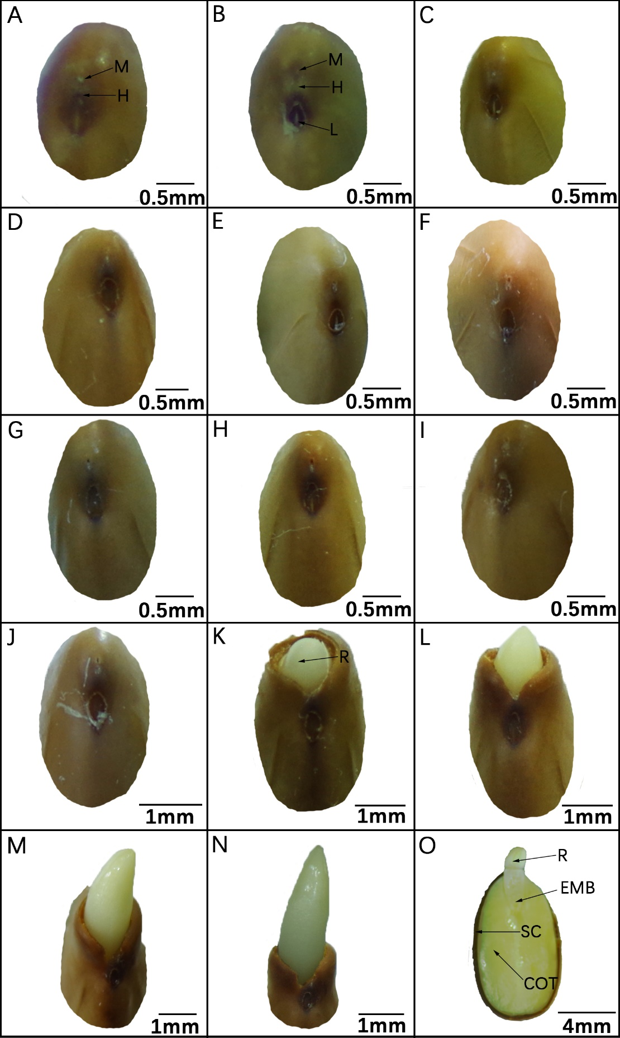
Figure S1: Seed coat morphology of a dormant seed (a); immediately after dipping in hot-water treatment (b); after 6 h (c), 12 h (d), 18 h (e), 24 h (f), 32 h (g), 40 h (i), 48 h (j), 54 h (k), 60 h (l), 66 h (m), 72 h (n), into germination; cross section of 72 h germinated seeds (0). COT, cotyledon ;EMB, embryo; H, hilum; L, lens; M, micropyle; R. radicle; SC, seed coat.

