Biological impact of nanodiamond particles – label free, high-resolution methods for nanotoxicity assessment.

Dipesh Khanal¹, Fan Zhang², Yang Song³, Herman Hau¹, Archana Gautam⁴, Seiji Yamaguchi⁵, Jamie Uertz⁶, Stewart Mills⁶, Alexey Kondyurin⁷, Jonathan C. Knowles^{8,9,10}, George Georgiou⁸, Iqbal Ramzan¹, Weidong Cai³, Kee Woei Ng⁴, Wojciech Chrzanowski^{1*}

*Correspondence: wojciech.chrzanowski@sydney.edu.au

Methods

Nanoparticle tracking analysis (NTA)
NTA measurements were performed to measure the size distribution of ND dispersion with a Nanosight NS300 (NanoSight, Amesbury, United Kingdom), equipped with a sample chamber with a 488 nm laser. ND dispersion (1 mg·mL⁻¹) sonicated for 30 min in DI water was diluted in cell culture medium to a concentration of 5 μg·mL⁻¹ followed by vortexing for 5 minutes prior to NTA measurements. The advanced script controls options were used for the analysis which comprised of an 80 μL syringe pump driven chamber priming interval, a 30 second pause to minimize vibration artifact, three 60 second video capture periods with constant syringe pump driven sample delivery, and automated laser and pump shutdown after video acquisition. An average of three measurement runs were taken for the data analysis.
Cell viability assays

Fao cells were seeded at a density of 2000 cells/well on 96-well plates and were allowed to attach overnight. Media was aspirated and replaced with particle-conditioned media containing 10, 25, 50 and 100 μg·mL⁻¹. At each predetermined time point (days 2, 4 and 7), cells were washed with PBS once and 100 μL of fresh media containing 10% CCK-8 reagent was added to each well. After three hours of incubation in the dark, the media was transferred to a new 96 well plate, and the optical density (OD) of each well was measured using a microplate reader at 450 nm (Victor x4 multilabel plate reader, Perkin Elmer, USA).
For DNA quantification, media was removed at day 2, 4 and 7 and each well was washed with PBS once followed by addition of 75 μL of Cyquant NF dye reaction mix. Plates were incubated in the dark for 45 min before measuring fluorescence at excitation and emission wavelengths of 485 and 535 nm respectively using microplate reader (Victor X4, multilabel plate reader, Perkin Elmer, USA).

Cytotoxicity of ND in 3D mini-liver model
The effect of NDs on cell growth and function in a 3D environment was quantified using 3D ring closure and dot assays following previously published methodology (Timm, et al., 2013) (Tseng, et al., 2015). In brief, cells were cultured in T-75 flasks and incubated with magnetic nanoparticles (NanoShuttle−PL; n3D Bioscience, USA) at a concentration of 8 μL.cm⁻² overnight. After trypsinization magnetized cells were levitated overnight using magnetic drives to form a ‘cluster’ of cells which were then bioprinted in the shape of rings (2 × 10⁵ cells per ring) and spheroids
(1 × 10⁵ cells per spheroid) using a set of magnetic drives. NDs at a concentration of 10, 25, 50 and 100 µg·mL⁻¹ were added onto the rings and spheroids (Fig. S5). Both internal and external diameters were monitored for 48 h. Images of rings and spheroids were recorded using a mobile device (iPod) and the rate of diameter change (shrinkage and closure of ring), which correlates with the loss of cell function/ mobility, was calculated using a custom-built software Cytox®.
The software embeds the algorithms that can automatically differentiate the foreground (cell) and background (medium) objects from the input video data and compute the diameter(s) of the cell. Briefly, the software takes an input video data, where each frame provides the cell shape at a certain time point. For each frame, the Otsu's method (Otsu, 1979) is used to perform image thresholding to detect the foreground cell regions according to the image pixel information. Next, the contour(s) of the cell is/are detected with morphological processing: an inner contour and an outer contour for ring-shape cell; only an outer contour for dot-shape cell (Fig. S6). The diameter of a contour is then computed based on the area of the contour. Therefore, a diameter variation curve is obtained based on the consecutive frames from the input video data. The diameters obtained were used to calculate the areas of both ring and spheroids. These areas were further analyzed to determine the percentage change in area over the 48 h period to estimate IC₅₀ concentrations of NDs.
Dark field hyperspectral imaging
Label-free high-resolution hyperspectral imaging was used to investigate the uptake and interaction of NDs with Fao cells which were plated on glass coverslips functionalized using plasma treatment. Each of the coverslips were transferred to a six well plate. Fao cells at a density of 2.5×10⁴ cells were plated onto the coverslips and allowed to attach overnight. Next, media was replaced with ND conditioned media at a concentration of 10 and 25 µg·mL⁻¹ and cells were cultured for up to 7 days. At day 2 and 7 coverslips were taken out and washed with PBS twice followed by fixing with 4% paraformaldehyde (PFA) for 15 min. Fixed cells were washed with PBS three times before mounting onto a glass slide containing fluormount mounting media. Coverslips were sealed with nail polish before dark field hyperspectral imaging using CytoViva microscope (CytoViva, Auburn, AL, USA). The spectra of cells and NDs were obtained and used to identify ND localization within the cells.
SEM
Fao cells were cultured in complete media on a T75 flask until 70 to 80 % confluency. Media was replaced with media containing 25 µg·mL⁻¹ of NDs and culture continued for 24 h to allow ND internalization. Next, cells were washed with PBS three times to remove remaining nanoparticles and trypsinised (Tryple™) to collect cells. Cells were transferred to Eppendorf tubes and were centrifuged at 1500 RPM for 5 min to yield cell pellets. Pellets were fixed with 2.5% glutaraldehyde 0.1 M phosphate buffer (pH 7.4) for 15 min followed by post-fixation in 1% osmium tetroxide (OsO₄) in the same buffer. All the samples were further dehydrated with graded ethanol, starting with 30 % to 100 % ethanol. Dehydrated samples were embedded in Spurr’s embedding kit (ProScitech, Australia). Ultrathin (70 nm) sections of the cells were the cut on a Leica UltraCut S ultramicrotome (Leica Microsystem GmbH, Vienna, Austria), transferred to formavar coated TEM grids and stained with 2% uranyl acetate and 0.05% aqueous solution of lead citrate. Finally, they were imaged in Gatan back scattered mode with Sigma VP Zeiss field emission SEM maintaining a working distance of 5.1 mm with an electronic high-tension value of 1.60 kV.
Effect of nanodiamond on cytoskeleton
The effect of NDs on cytoskeletal organization was investigated using immunostaining of f-actin. Fao cells were seeded at a density of 2.5 × 10³ cells in 2 mL of complete medium in a 6 well plate (Corning, USA). Cells were exposed to NDs at concentrations of 10, 25, 50 and 100 μg·mL⁻¹ for 4 days. At the end of day 4, the media was aspirated, and cells were washed twice with PBS, followed by fixation with paraformaldehyde (PFA) for 15 minutes. Cells were permeabilised with Triton x for 15 minutes followed by washing with PBS twice followed by staining with Phalloidin CruzFluor 514 for 30 minutes and DAPI 300 nM for 5 minutes (all reagents from Thermo Fisher Scientific). Images were taken using the Nikon eclipse TE2000-U inverted fluorescent microscope.

Fao cell morphology and stiffness measurements
Fao cells were seeded on to plasma treated 50 × 9 mm petri dish (Bacteriological petri dish, Falcon®, Corning, USA) at a density of 5 × 10⁴ cells in 2 mL of complete medium and were allowed to grow overnight. Media was replaced the next day with the ND conditioned media at concentrations of 10, 25 and 50 μg·mL⁻¹. Cells were exposed to NDs for up to 7 days. At day 2, 4 and 7, media was aspirated and cells were washed with PBS twice followed by fixing with 4% PFA for 15 minutes. Fixed cells were washed with PBS three times and fresh PBS was added to each Petri dish. To investigate the influence of NDs on cell stiffness, cells were probed using Molecular Force Probe (MF3D-Bio, Asylum Research, USA) operating in force-volume mode. The cells were first located using a light microscope and imaged in contact mode using a silicon-nitride cantilever with reflex side gold coating (HYDRA-ALL-G-50, AppNano, CA, USA). Spring constant of each probe was determined using thermal method and were typically around ~65 pN Nm⁻¹. Next, the probe was lowered at a speed of 400 nm s⁻¹ onto the cells and cell was indented until the threshold cantilever deflection of 200 nm was reached. The deflection of the cantilever was plotted against the displacement in the z-direction, which gave the force-distance curves. For each sample (control and ND incubated), a minimum of five different cells were scanned and on each sample 50 × 50 μm region was selected for scanning and probing of nanomechanics. For each cell 4900 points were probed (70 × 70 points). Stiffness (apparent elastic modulus, Ea) was calculated using Hertz model assuming uniform Poisson’s ratio of 0.5 (Hertz, 1881). Stiffness values across the surface for all the samples were exported as an array and processed to generate histograms (percent stiffness values within defined bins) as shown in the inserts to stiffness maps shown in Fig. S4. Furthermore, the generated data were processed and presented as lognormal cumulative stiffness plots and as box whisker plots to enable statistical analysis and representation of the changes in cell nanomechanical properties.

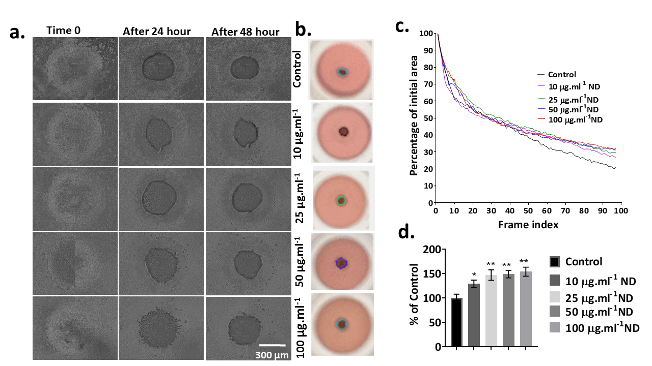
Supplementary Images
Fig.S1: Spheroid shrinkage assay. (a) Phase contrast image of spheroids exposed to nanodiamond (ND); with increased concentrations of ND, rate of shrinkage decreased significantly. (b) Corresponding images of spheroids along with their contours captured using a mobile device and analyzed by Cytox® software. (c) Graph representing rates of spheroid shrinkage compared to the initial area of the spheroids; increased concentrations of ND led to significant drop in spheroid shrinkage confirming concentration-dependent toxicity of ND. (d) Comparison of spheroid area at the end point of experiment (48 h) confirmed that spheroids exposed to ND had significantly larger area than control spheroids (data presented as mean ± SD, student t-test was used for statistical analysis taking *p<0.05 as significant difference).

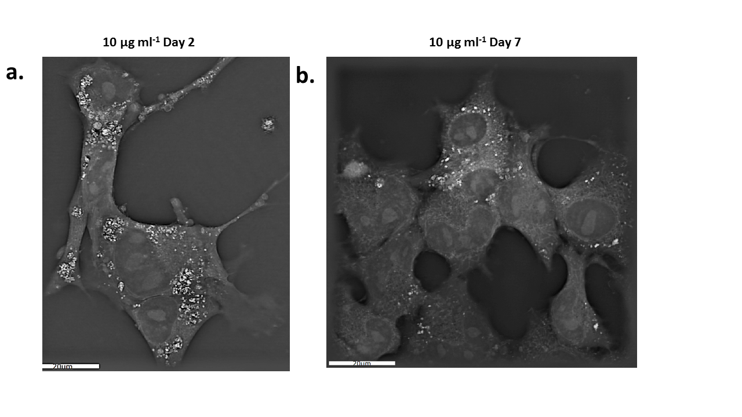

Fig.S2: Unstained holographic tomography images of cells treated with nanodiamond (ND) at day LHS at 2 and RHS at day 7 of exposure. (a) ND (white arrows) are distributed on the surface as well as are internalized. (b) At day 7 lower number of ND (white arrows) can be observed inside the cell possibly due to exocytosis of ND.

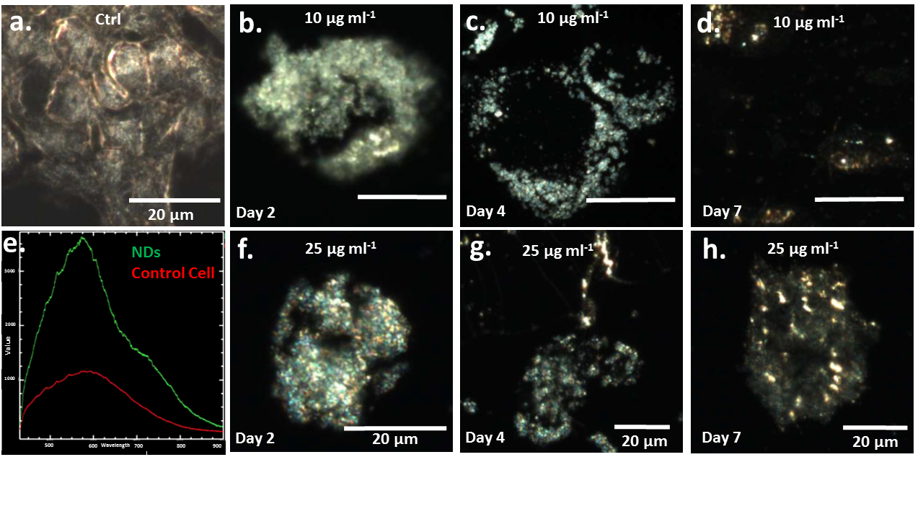

Fig.S3: Dark field hyperspectral imaging of cells before and after exposure to NDs. (a) Control cells show typical morphology of cell with distinct intracellular membrane structures. (b) Cell exposed to ND
(10 μg·mL⁻¹) at day 2 showing the presence of majority of ND on the surface of cell (white arrow) with few internalized ND (red arrows). (c) Cell exposed to ND for 4 days show more ND internalized (white arrows). (d) At day 7 few internalized ND can be visualized inside the cell (white arrow). (e) Spectra collected from NDs and control cell show clear difference in refractive index confirming the presence of ND in the cells (f to h). Cells exposed to 25 μg·mL⁻¹ for days 2, 4 and 7, show similar trends to the cells exposed to 10 μg·mL⁻¹

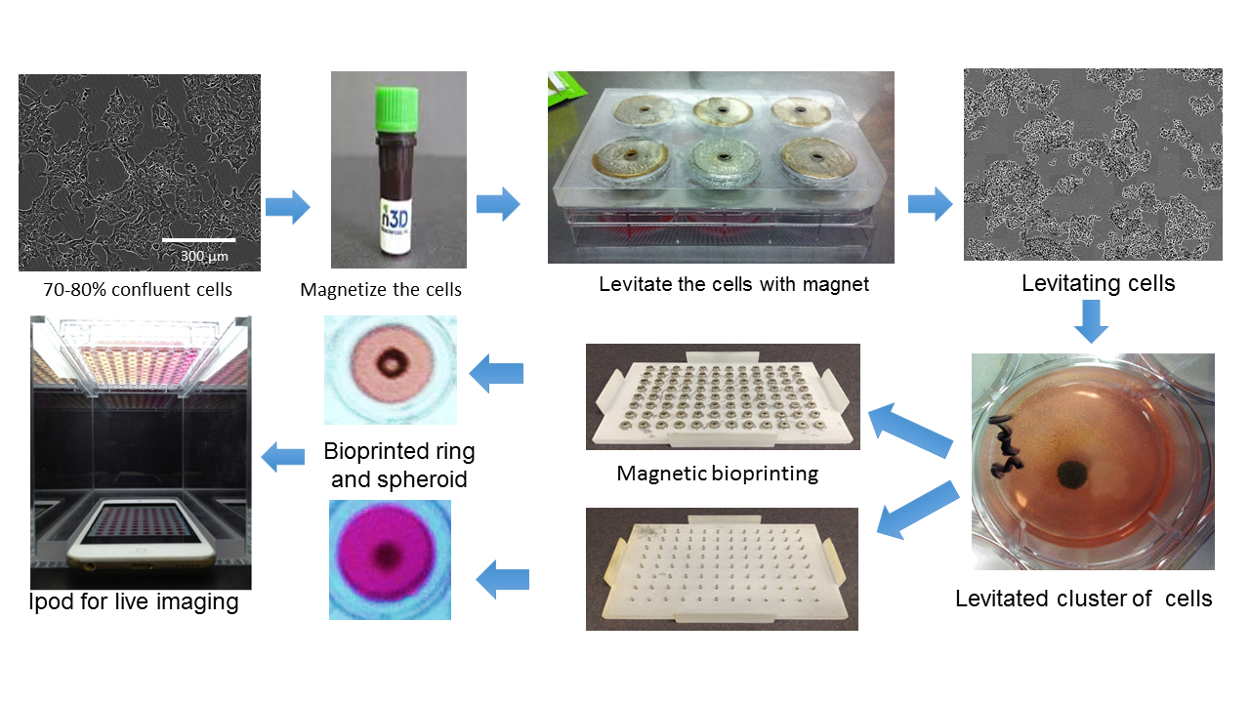
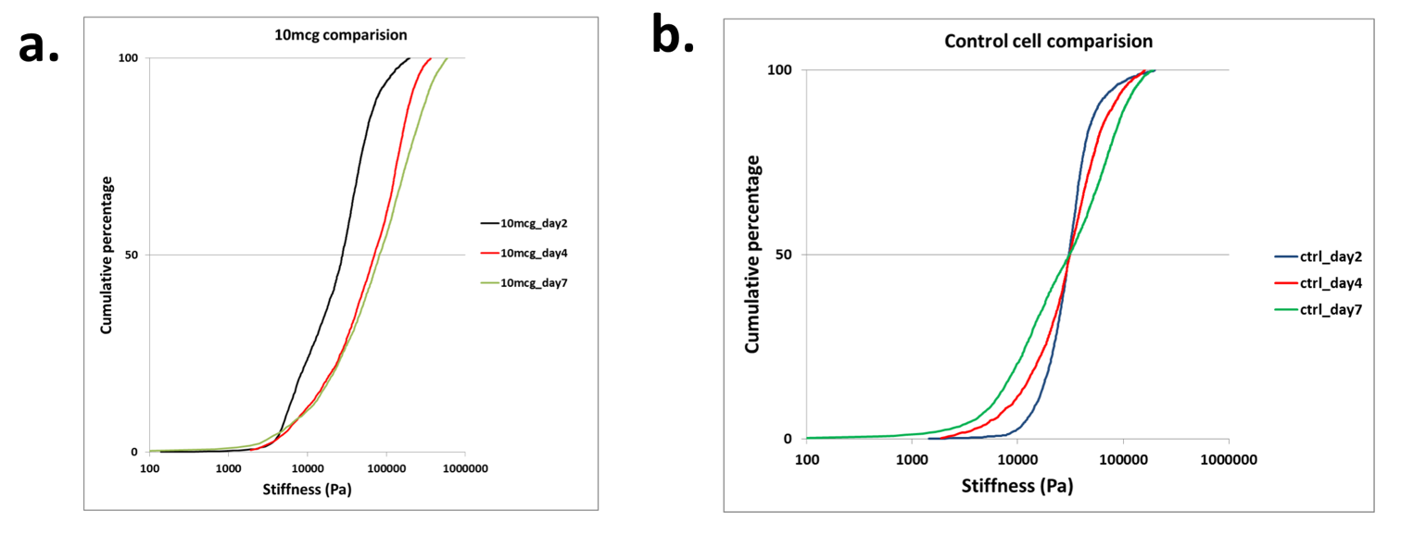
Fig.S5: Schematic for fabricating magnetically bioprinted 3D liver rings and spheroid model and set-up of mobile device for imaging of the rings and spheroids for assessment of toxic effect of nanodiamond.
Fig.S4: Log-normal cumulative stiffness plots. (a) Cells exposed to ND showed duration-dependent shift in stiffness. (b) Control cells had no significant shift in apparent Young’s modulus with longer exposure.

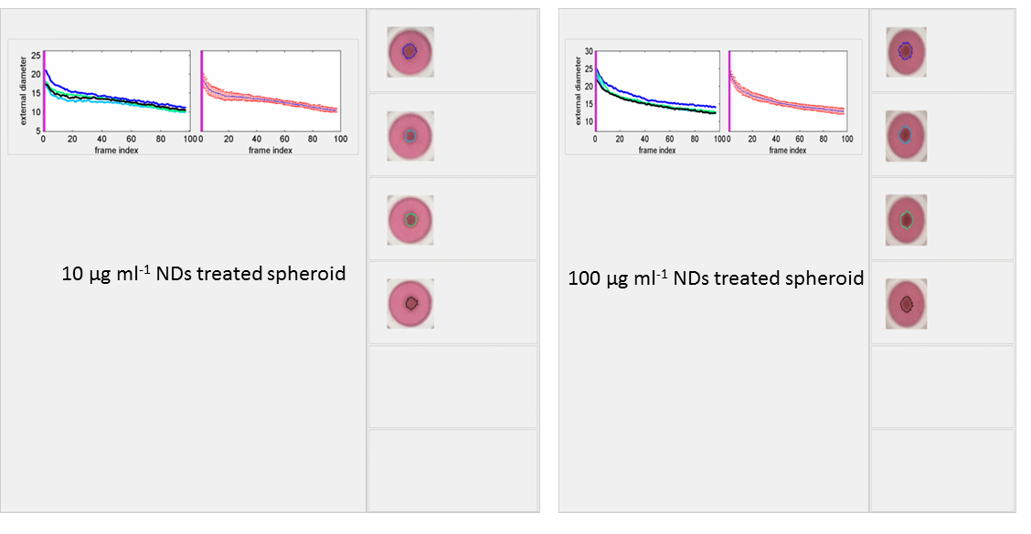
Fig.S7: Distribution of stiffness; apparent Young’s modulus maps of Fao cells after exposure to 25 μg·mL⁻¹ of NDs nanodiamond (ND): maps for cell exposed to 25 μg·mL⁻¹ of NDs confirmed shift in the cell stiffness after exposure to NDs for 48 h (day 2).
Fig.S6: Evaluation of spheroid shrinkage with custom build Cytox® software

