**SUPPLEMENTARY FILE**

**STUDY OF A CROSS-LINKED HYDROGEL OF KARAYA GUM AND STARCH AS A CONTROLLED DRUG DELIVERY SYSTEM**

Sapna Sethia, Balbir Singh Kaithb, Mandeep Kaur, Neeraj Sharmaa and Sadhika Khullar*bID

aDepartment of Chemistry, DAV University Jalandhar, Punjab-144012, India

bDepartment of Chemistry, Dr. B.R. Ambedkar National Institute of Technology, Jalandhar, Punjab-144011, India

[*khullars@nitj.ac.in](mailto:*khullars@nitj.ac.in)

**Table S1:** Optimization of different parameters for the synthesis of KS-g-Poly(AAc)

|  |  |  |  |  |  |  |  |
| --- | --- | --- | --- | --- | --- | --- | --- |
| **Hydrogel Code** | **Starch : Gum** | **AAc**  **(mmol)** | **MBA**  **(mmol)** | **APS**  **(mmol)** | **Water (mL)** | **pH** | **SR**  **(g/g)** |
| **KS-g-poly(AAc)-1** | 1:1 | 118.05 | 4.545 | 0.789 | 20 | 10 | 24.1 |
| **KS-g-poly(AAc)-2** | 1:0 | 118.05 | 4.545 | 0.789 | 20 | 10 | 16.7 |
| **KS-g-poly(AAc)-3** | 1:0.5 | 118.05 | 4.545 | 0.789 | 20 | 10 | 20.2 |
| **KS-g-poly(AAc)-4** | 1:1.5 | 118.05 | 4.545 | 0.789 | 20 | 10 | 19.8 |
| **KS-g-poly(AAc)-5** | 1:2 | 118.05 | 4.545 | 0.789 | 20 | 10 | 18.1 |
| **KS-g-poly(AAc)-6** | 1:1 | 145.83 | 4.545 | 0.789 | 20 | 10 | 30.5 |
| **KS-g-poly(AAc)-7** | 1:1 | 173.60 | 4.545 | 0.789 | 20 | 10 | 22.4 |
| **KS-g-poly(AAc)-8** | 1:1 | 90.27 | 4.545 | 0.789 | 20 | 10 | 21.5 |
| **KS-g-poly(AAc)-9** | 1:1 | 62.50 | 4.545 | 0.789 | 20 | 10 | 20.3 |
| **KS-g-poly(AAc)-10** | 1:1 | 145.83 | 3.243 | 0.789 | 20 | 10 | 27.9 |
| **KS-g-poly(AAc)-11** | 1:1 | 145.83 | 1.948 | 0.789 | 20 | 10 | 26.4 |
| **KS-g-poly(AAc)-12** | 1:1 | 145.83 | 5.844 | 0.789 | 20 | 10 | 25.9 |
| **KS-g-poly(AAc)-13** | 1:1 | 145.83 | 0.648 | 0.789 | 20 | 10 | 23.2 |
| **KS-g-poly(AAc)-14** | 1:1 | 145.83 | 4.545 | 0.657 | 20 | 10 | 24.6 |
| **KS-g-poly(AAc)-15** | 1:1 | 145.83 | 4.545 | 0.526 | 20 | 10 | 27.7 |
| **KS-g-poly(AAc)-16** | 1:1 | 145.83 | 4.545 | 0.877 | 20 | 10 | 29.9 |
| **KS-g-poly(AAc)-17** | 1:1 | 145.83 | 4.545 | 0.789 | 15 | 10 | 30.3 |
| **KS-g-poly(AAc)-18** | 1:1 | 145.83 | 4.545 | 0.789 | 10 | 10 | 29.0 |
| **KS-g-poly(AAc)-19** | 1:1 | 145.83 | 4.545 | 0.789 | 30 | 10 | 24.0 |
| **KS-g-poly(AAc)-20** | 1:1 | 145.83 | 4.545 | 0.789 | 40 | 10 | 22.0 |
| **KS-g-poly(AAc)-21** | 1:1 | 145.83 | 4.545 | 0.789 | 20 | 8 | 25.5 |
| **KS-g-poly(AAc)-22** | 1:1 | 145.83 | 4.545 | 0.789 | 20 | 6 | 23.8 |
| **KS-g-poly(AAc)-23** | 1:1 | 145.83 | 4.545 | 0.789 | 20 | 4 | 20.0 |
| **KS-g-poly(AAc)-24** | 1:1 | 145.83 | 4.545 | 0.789 | 20 | 2 | 19.0 |

**Table S2.** Kinetic interpretation by using different models for release of aspirin from KS-g-Poly(AAc)

|  |  |  |  |  |
| --- | --- | --- | --- | --- |
|  |  | **pH 1.2** | **Distilled Water** | **pH 7.4** |
| **Zero order** | **R2** | 0.988 | 0.991 | 0.992 |
| **k0(mg h-1)** | 0.133 | 0.117 | 0.135 |
| **First order** | **R2** | 0.999 | 0.999 | 0.997 |
| **k1(h-1)** | 1.038 | 0.974 | 1.059 |
| **Higuchi** | **R2** | 0.961 | 0.972 | 0.970 |
| **k2 (h-1/2)** | 0.487 | 0.431 | 0.496 |
| **Korsmeyer-Peppas** | **R2** | 0.944 | 0.957 | 0.958 |
| **k3(h-n)** | 0.790 | 0.729 | 0.741 |
| **Hixson-Crowell** | **R2** | 0.852 | 0.729 | 0.853 |
| **k4(h-1/3)** | 0.137 | 0.112 | 0.140 |

**Table S3.** Kinetic interpretation by using different models for release of paracetamol from KS-g-Poly(AAc)

|  |  |  |  |  |
| --- | --- | --- | --- | --- |
|  |  | **pH 1.2** | **Distilled Water** | **pH 7.4** |
| **Zero order** | **R2** | 0.914 | 0.905 | 0.911 |
| **k0 (mg h-1)** | 0.108 | 0.102 | 0.120 |
| **First order** | **R2** | 0.998 | 0.998 | 0.999 |
| **k1(h-1)** | 0.482 | 0.435 | 0.492 |
| **Higuchi** | **R2** | 0.955 | 0.941 | 0.905 |
| **k2(h-1/2)** | 0.498 | 0.502 | 0.525 |
| **Korsmeyer-Peppas** | **R2** | 0.985 | 0.982 | 0.982 |
| **k3(h-n)** | 0.639 | 0.652 | 0.605 |
| **Hixson-Crowell** | **R2** | 0.844 | 0.737 | 0.639 |
| **k4(h-1/3)** | 0.138 | 0.177 | 0.210 |

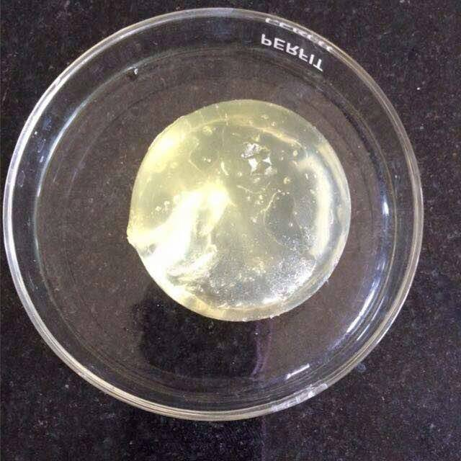

**Figure S1** Photograph of the KS-g-Poly (AAc) hydrogel after synthesis



**Figure S2**. DSC scan of Karaya hydrogel



**a**

**b**

**Figure S3.** (a) Plot of Mt/Mα vs. ln(t) for the release of aspirin from KS-g-Poly(AAc) (b) Plot of ln(Mt/Mα) vs. ln(t) for the release of aspirin from KS-g-Poly(AAc)



**a**

**b**

**Figure S4** (a)Plot of ln (1-Mt/Mα) vs. time for the release of aspirin from KS-g-Poly(AAc) (b) Plot of Mt/Mα vs.t1/2 for the release of aspirin from KS-g-Poly(AAc)



**a**

**b**

**Figure S5** (a) Plot of Mt/Mα vs. ln t for the release of paracetamol from KS-g-Poly(AAc) (b) Plot of ln Mt/Mα vs. ln t for the release of paracetamol from KS-g-Poly(AAc)



**a**

**b**

**Figure S6** (a) Plot of ln (1-Mt/Mα) vs. time for the release of paracetamol from KS-g-Poly (AAc) (b) Plot of Mt/Mα vs. t1/2 for the release of paracetamol from KS-g-Poly(AAc)



a

b

c

d

**Figure S7** (a) Plot of Mt/M∞ vs. time for the release of aspirin from KS-g-Poly(AAc) (b)- (d) Plots of Mt/M∞ vs. tn (n = 0.38, 0.35 and 0.36 in pH 7.4 buffer, distilled water and pH 1.2 buffer, respectively) for the release of aspirin from KS-g-Poly(AAc)



a

b

c

d

**Figure S8** (a) Plot of Mt/M∞ vs. time for the release of paracetamol from KS-g-Poly(AAc) (b)-(d) Plots of Mt/M∞ vs. tn (n = 0.43, 0.37 and 0.39 in pH 7.4 buffer, distilled water and pH 1.2 buffer, respectively) for the release of paracetamol from KS-g-Poly(AAc)



a

b

**Figure S9** (a) Plot of $∛Q_{0 }-∛Q_{t}$ vs. time for the release of aspirin from KS-g-Poly(AAc) (b) Plot of $∛Q_{0 }-∛Q_{t}$ vs. time for the release of paracetamol from KS-g-Poly(AAc)