Supplementary files:

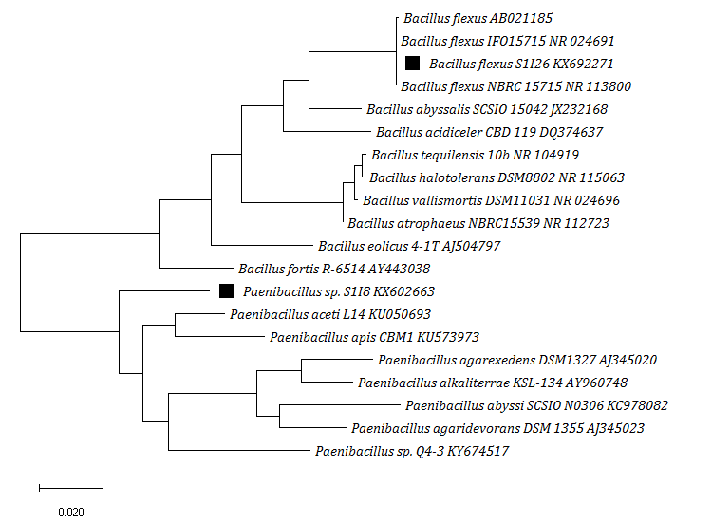
Fig. 1: Molecular Phylogenetic analysis by Maximum Likelihood method. The evolutionary history was inferred by using the Maximum Likelihood method based on the Tamura-Nei model (1993). The tree is drawn to scale, with branch lengths measured in the number of substitutions per site. The analysis involved 20 nucleotide sequences. There were a total of 1566 positions in the final dataset. Evolutionary analyses were conducted in MEGA X (Kumar et al. 2018).

2.
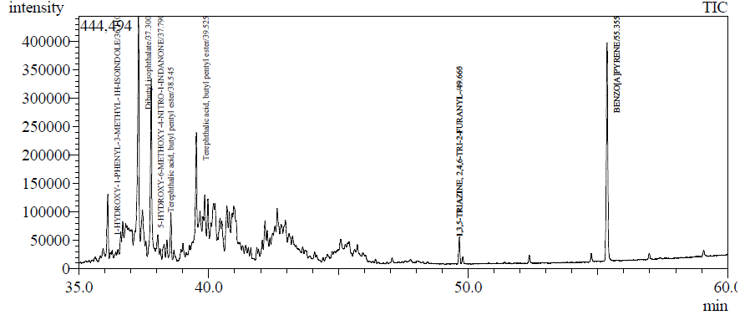
Fig. 2: GC-MS chromatogram of soil BaP residual after 60 days with inoculation of Paenibacillus sp. S1I8

