Supplemental Material

1. Signal Detection Analysis (adjusted ROC curve as per Zhang & Mueller, 2005; p. 205-209)

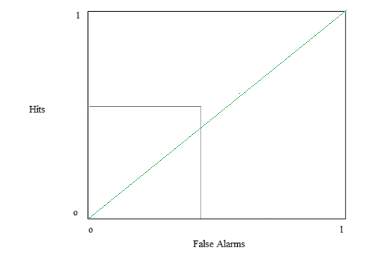

Chance Level Performance

A1

False Alarms

Hits

(F, H) = .6748

A2

*I*

ROC analysis was not a primary aim of the current experimental studies. To offer a pilot exploration of differences in signal detection performance between anger and hostility, and other emotional types under conditions of backward masking, we provide a Bayesian analysis below:

Bayesian Comparison of Signal Detection Performance

|  |  |  |  |  |
| --- | --- | --- | --- | --- |
|  | Anger | Fearful | Sadness | Neutral |
| Hostility | .51 | .1 | NaN (+**∞)** | NaN (+**∞)** |
| Anger |  | .07 | .06 | NaN (+**∞)** |
| Fearful |  |  | .024 | NaN (+**∞)** |

Note that we did not assess the participants for previous experimental participation in emotional assessment experiments including emotional faces. Part of the current results – if the participants had previous experience – could be due to the novelty of the presentation of hostile faces and future research should take that into consideration in dedicated attempts to explore signal detection performance for hostile, angry and other facial emotional types.

1. Pairwise Comparisons

2.1: Stage Two

|  |  |  |
| --- | --- | --- |
|  | Mean | Std. Deviation |
| AngSCR | .484263 | .1975315 |
| HosSCR | .624915 | .1976198 |
| FearSCR | .660627 | .1279978 |
| SadSCR | .254655 | .0535512 |
| NeuSCR | .206088 | .1544950 |

|  |  |  |  |  |  |  |
| --- | --- | --- | --- | --- | --- | --- |
|  | | | | | | |
|  | | | | | | |
| (I) Emotion | (J) Emotion | Mean Difference (I-J) | Std. Error | Sig.b | 95% Confidence Interval for Differenceb | |
| Lower Bound | Upper Bound |
| 1 | 2 | -.141* | .048 | .007 | -.240 | -.041 |
| 3 | -.176* | .046 | .001 | -.270 | -.083 |
| 4 | .230* | .040 | .000 | .147 | .312 |
| 5 | .278* | .051 | .000 | .174 | .383 |
| 2 | 1 | .141* | .048 | .007 | .041 | .240 |
| 3 | -.036 | .037 | .345 | -.112 | .040 |
| 4 | .370* | .038 | .000 | .293 | .447 |
| 5 | .419* | .036 | .000 | .345 | .492 |
| 3 | 1 | .176* | .046 | .001 | .083 | .270 |
| 2 | .036 | .037 | .345 | -.040 | .112 |
| 4 | .406* | .027 | .000 | .351 | .461 |
| 5 | .455* | .033 | .000 | .387 | .522 |
| 4 | 1 | -.230* | .040 | .000 | -.312 | -.147 |
| 2 | -.370* | .038 | .000 | -.447 | -.293 |
| 3 | -.406* | .027 | .000 | -.461 | -.351 |
| 5 | .049 | .031 | .126 | -.014 | .112 |
| 5 | 1 | -.278* | .051 | .000 | -.383 | -.174 |
| 2 | -.419* | .036 | .000 | -.492 | -.345 |
| 3 | -.455* | .033 | .000 | -.522 | -.387 |
| 4 | -.049 | .031 | .126 | -.112 | .014 |
|  |  |  |  |  |  |  |

|  |  |  |
| --- | --- | --- |
|  | Mean | Std. Deviation |
| AngHeartRate | 6.978723 | 2.2837888 |
| HosHeartRate | 9.951934 | 2.1125628 |
| FearHeartRate | 9.792414 | 3.2111630 |
| SadHeartRate | 3.636897 | .8804914 |
| NeuHeartRate | 2.628276 | .8643167 |

|  |  |  |  |  |  |  |
| --- | --- | --- | --- | --- | --- | --- |
|  | | | | | | |
| (I) Emotion | (J) Emotion | Mean Difference (I-J) | Std. Error | Sig.b | 95% Confidence Interval for Differenceb | |
| Lower Bound | Upper Bound |
| 1 | 2 | -2.973* | .624 | .000 | -4.252 | -1.695 |
| 3 | -2.814* | .830 | .002 | -4.514 | -1.114 |
| 4 | 3.342* | .448 | .000 | 2.424 | 4.259 |
| 5 | 4.350* | .466 | .000 | 3.396 | 5.305 |
| 2 | 1 | 2.973* | .624 | .000 | 1.695 | 4.252 |
| 3 | .160 | .519 | .761 | -.905 | 1.224 |
| 4 | 6.315* | .413 | .000 | 5.469 | 7.161 |
| 5 | 7.324* | .396 | .000 | 6.513 | 8.134 |
| 3 | 1 | 2.814* | .830 | .002 | 1.114 | 4.514 |
| 2 | -.160 | .519 | .761 | -1.224 | .905 |
| 4 | 6.156* | .612 | .000 | 4.902 | 7.409 |
| 5 | 7.164* | .609 | .000 | 5.917 | 8.412 |
| 4 | 1 | -3.342* | .448 | .000 | -4.259 | -2.424 |
| 2 | -6.315* | .413 | .000 | -7.161 | -5.469 |
| 3 | -6.156* | .612 | .000 | -7.409 | -4.902 |
| 5 | 1.009* | .256 | .000 | .485 | 1.533 |
| 5 | 1 | -4.350* | .466 | .000 | -5.305 | -3.396 |
| 2 | -7.324* | .396 | .000 | -8.134 | -6.513 |
| 3 | -7.164* | .609 | .000 | -8.412 | -5.917 |
| 4 | -1.009* | .256 | .000 | -1.533 | -.485 |

2.2 Stage Three

|  |  |  |  |
| --- | --- | --- | --- |
|  | | | |
|  | Mean | Std. Deviation |
| AngSCR | .089014 | .0387238 |
| HosSCR | .132087 | .0699359 |
| FearSCR | .146227 | .0516764 |
| SadSCR | .040895 | .0124371 |
| NeuSCR | .024562 | .0146107 |

|  |  |  |  |  |  |  |
| --- | --- | --- | --- | --- | --- | --- |
|  | | | | | | |
| (I) Emotion | (J) Emotion | Mean Difference (I-J) | Std. Error | Sig.b | 95% Confidence Interval for Differenceb | |
| Lower Bound | Upper Bound |
| 1 | 2 | -.043* | .017 | .017 | -.078 | -.008 |
| 3 | -.057* | .012 | .000 | -.082 | -.033 |
| 4 | .048* | .008 | .000 | .033 | .064 |
| 5 | .064* | .008 | .000 | .049 | .080 |
| 2 | 1 | .043* | .017 | .017 | .008 | .078 |
| 3 | -.014 | .017 | .426 | -.050 | .022 |
| 4 | .091* | .013 | .000 | .064 | .119 |
| 5 | .108* | .013 | .000 | .080 | .135 |
| 3 | 1 | .057* | .012 | .000 | .033 | .082 |
| 2 | .014 | .017 | .426 | -.022 | .050 |
| 4 | .105* | .009 | .000 | .087 | .124 |
| 5 | .122* | .010 | .000 | .101 | .142 |
| 4 | 1 | -.048* | .008 | .000 | -.064 | -.033 |
| 2 | -.091* | .013 | .000 | -.119 | -.064 |
| 3 | -.105* | .009 | .000 | -.124 | -.087 |
| 5 | .016* | .004 | .000 | .008 | .024 |
| 5 | 1 | -.064* | .008 | .000 | -.080 | -.049 |
| 2 | -.108* | .013 | .000 | -.135 | -.080 |
| 3 | -.122* | .010 | .000 | -.142 | -.101 |
| 4 | -.016* | .004 | .000 | -.024 | -.008 |

|  |  |  |  |
| --- | --- | --- | --- |
|  | | | |
|  | Mean | Std. Deviation |
| AngHeartRate | 2.831633 | 1.5525523 |
| HosHeartRate | 5.376190 | 1.6317154 |
| FearHeartRate | 5.05136 | 1.535761 |
| SadHeartRate | 2.065646 | .3332749 |
| NeuHeartRate | 1.628571 | .2045315 |

|  |  |  |  |  |  |  |
| --- | --- | --- | --- | --- | --- | --- |
| (I) Emotion | (J) Emotion | Mean Difference (I-J) | Std. Error | Sig.b | 95% Confidence Interval for Differenceb | |
| Lower Bound | Upper Bound |
| 1 | 2 | -2.545* | .456 | .000 | -3.477 | -1.612 |
| 3 | -2.220* | .399 | .000 | -3.036 | -1.403 |
| 4 | .766* | .294 | .014 | .165 | 1.367 |
| 5 | 1.203* | .284 | .000 | .622 | 1.784 |
| 2 | 1 | 2.545* | .456 | .000 | 1.612 | 3.477 |
| 3 | .325 | .329 | .332 | -.348 | .998 |
| 4 | 3.311* | .306 | .000 | 2.685 | 3.936 |
| 5 | 3.748* | .292 | .000 | 3.150 | 4.345 |
| 3 | 1 | 2.220* | .399 | .000 | 1.403 | 3.036 |
| 2 | -.325 | .329 | .332 | -.998 | .348 |
| 4 | 2.986* | .279 | .000 | 2.414 | 3.557 |
| 5 | 3.423* | .266 | .000 | 2.880 | 3.966 |
| 4 | 1 | -.766* | .294 | .014 | -1.367 | -.165 |
| 2 | -3.311* | .306 | .000 | -3.936 | -2.685 |
| 3 | -2.986* | .279 | .000 | -3.557 | -2.414 |
| 5 | .437* | .069 | .000 | .296 | .578 |
| 5 | 1 | -1.203* | .284 | .000 | -1.784 | -.622 |
| 2 | -3.748* | .292 | .000 | -4.345 | -3.150 |
| 3 | -3.423* | .266 | .000 | -3.966 | -2.880 |
| 4 | -.437* | .069 | .000 | -.578 | -.296 |

1. Stimulus Set Selection Summary







Gender Analysis

|  |  |  |  |  |  |  |  |  |  |
| --- | --- | --- | --- | --- | --- | --- | --- | --- | --- |
|  | | Paired Differences | | | | | t | df | Sig. (2-tailed) |
| Mean | Std. Deviation | Std. Error Mean | 95% Confidence Interval of the Difference | |
| Lower | Upper |
| 1 | Stress_Male - Stress_Female | .23077 | 2.00614 | .39344 | -.57953 | 1.04107 | .587 | 25 | .563 |
| 2 | Frustration_Male - Frustration_Female | -.30769 | 2.69472 | .52848 | -1.39611 | .78073 | -.582 | 25 | .566 |
| 3 | Hostility_Male - Hostility_Female | .96154 | 2.64546 | .51882 | -.10699 | 2.03006 | 1.853 | 25 | .076 |
|  |  |  |  |  |  |  |  |  |  |

Male and Female Examples of Hostility and Anger

In the interest of replication of the AU analysis the faces are presented here unprocessed as originally included in the facial dataset (see Noldus, 2017). During the experiment the participants rated the processed and not the current versions of the emotional expressions; see stage one.

Hostility:

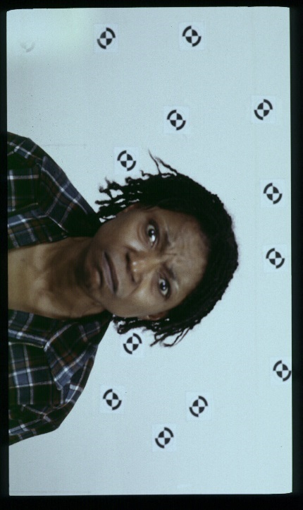 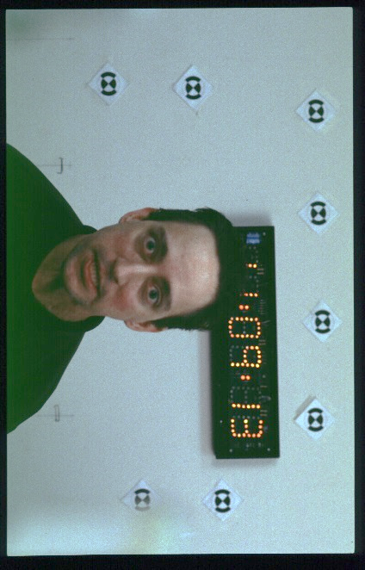

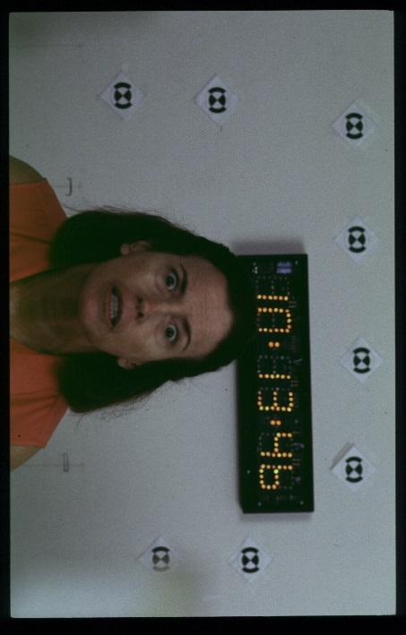 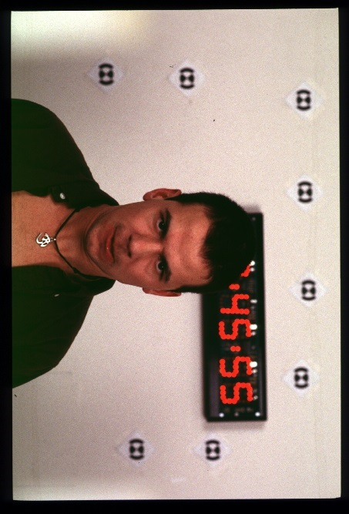

Anger:

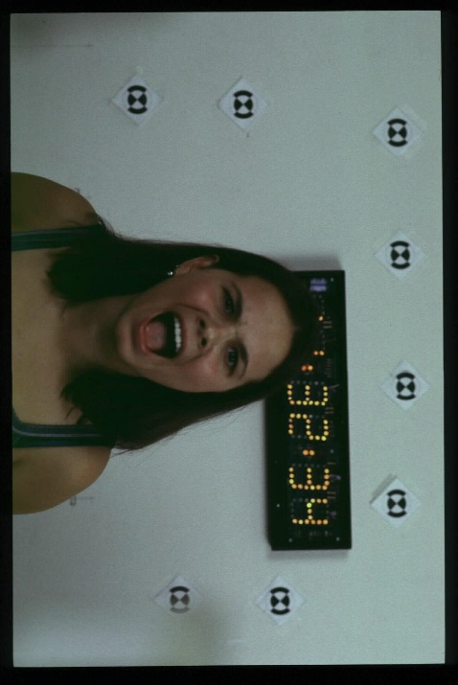 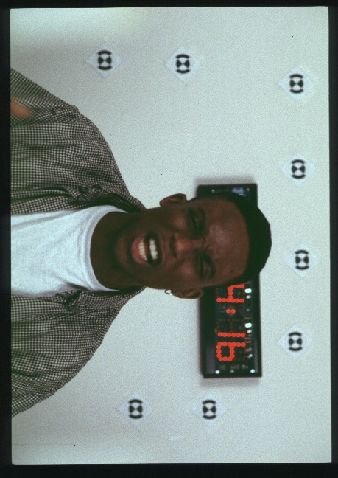

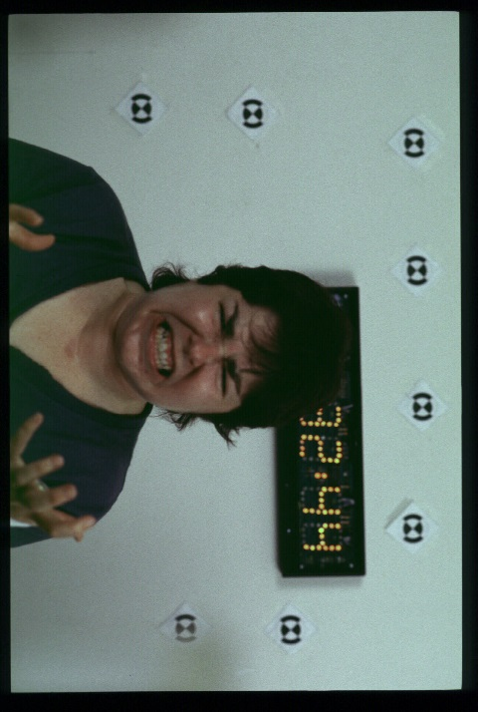 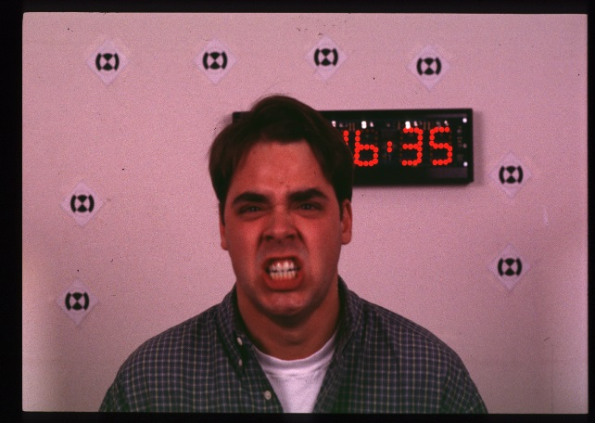

1. Angry and Hostile Facial Expressions

**Hostile Faces Set Codes:** 03_2, 09_1, 28_1, 96_2, 102_1,103_1, 108_1, 137_2, 144_1, 192_1

**Angry Faces Set Codes:** 04_1, 12_1 (2), 22_1, 23_1, 55_1, 59_1, 69_2, 97_1, 101_1, 182_2



Common Action Units:

2. Outer Brow Lowered

4. Brow Lowered

5. Upper Lid Raiser\

6. Cheek Raiser

9. Nose Wrinkled

17. Chin Raiser

24. Lip Presser

57. Head Forward

M69. Direct Gaze

Common Action Units:

2. Outer Brow Raiser

4. Brow Lowered

6. Cheek Raiser

9. Nose Wrinkled\

10. Upper Lip Raiser

17. Chin Raiser

25. Lips Part

26. Jaw Drop

**Hostile Faces Angry Faces**

**Emotional Morphing**

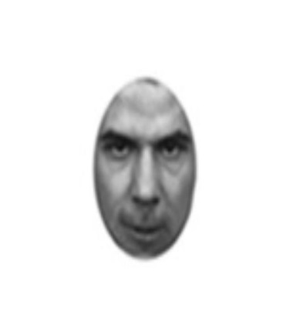 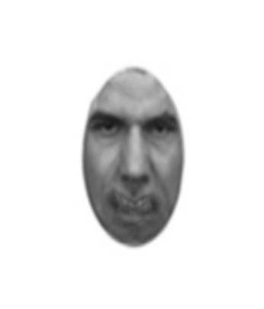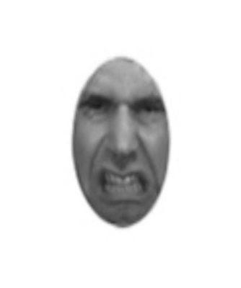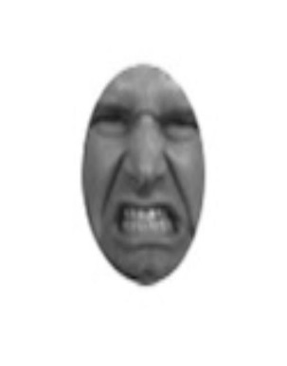

**100% 75/25% 25/75% 100%**

**Hostility 50/50% Anger**



5.1. Physiological Assessment methods

Skin conductance responses (SCR) were used to assess responses to angry and hostile faces. SCR is a measure of subcutaneous sweating and therefore, of sympathetic autonomic nervous system arousal (Carlson, 2014) that can record physiological responses that are automatic and involuntary and also not necessarily under conscious regulation (Öhman, 2005), such as fight or flight responses (Flykt et al., 2007). SCR is also relatively impenetrable to parasympathetic nervous system arousal artefacts, such as indigestion, respiratory and circulatory arrythmias (Cacioppo, Tassinary & Berntson, 2017; p. 159-179). Variations in amplitude for SCR scores are a reliable measure of experienced arousal in response to visual-emotional stimuli and has been previously employed by several studies that assess arousal responses to emotional elicitors (Braithwaite et al., 2013). We also employ heart-rate assessment for responses to angry and hostile faces (Garfinkel & Critchley, 2016). Heart-rate has also being suggested as a reliable assessment of peripheral nervous system arousal (Critchley et al., 2005; see also Cacioppo, Tassinary & Berntson, 2017; p. 182-209) and has been previously employed by several studies that assessed emotional responses to emotional faces to explore experienced arousal to various emotional stimulus types (see van der Ploeg et al., 2017). We implement the first instance of parallel of multiple-physiological and facial-emotional-expressive responses, using, for the latter, Noldus, FaceReader 7.1 for facial-emotional response assessment (Lewinski et al., 2014). We also undertook an Action Units (AUs) analysis to explore differences in expressive characteristics between angry and hostile emotional expressions (see Keltner & Cordaro, 2015).

5.2. Anger and Hostility

The assessment of the differences between anger and hostility acquires further interest when we consider that both empirical research and a dedicated conceptual framework that could account for the differences between these expressions are limited in previous studies. For example, anger and hostility have been used interchangeably in driving research (Galovski, Malta, & Blanchard, 2006; Demir, Demir & Özkan, 2016), clinical research (Harty, Miller, Newcorn, J. & Halperin, 2009; Painuly, Sharan, & Mattoo, 2005), psycho-therapeutic studies (Lee & DiGiuseppe, 2018; Berkout, Tinsley & Flynn, 2018), domestic violence studies (Birkley & Eckhardt, 2015), military (Heesink, Rademaker, Vermetten, Geuze, & Kleber, 2015) orderly and medical personnel research (Tema, Poggenpoel & Myburgh, 2011) facial expression classifying algorithm studies (Larkin, Martin & McClain, 2002; Herridge, Harrison, Mollet & Shenal, 2004) sociological and political studies (Lyman, 2004; Holmes, 2004), and questionnaire assessment review studies (Fernandez, Day & Boy, 2015; Eckhardt, Norlander, & Deffenbacher, 2002).

A distinguishing theoretical account and empirical definition that could contribute as to why these facial expressions could be addressed as separate concepts is missing (Lemerise & Dodge, 2008). The possibility that hostility and anger could elicit different responses is also under-addressed in previous research, and an explicit account associated with the exploration of the context in which these expressions could manifest and the social dynamics, behavioural motivations, and emotional and cognitive processes that could underlie these expressions is not explicitly and thoroughly addressed by previous psychological studies (Eckhardt, Norlander & Deffenbacher, 2004; Fernandez, Day & Boy, 2015).

For example, anger has been defined as a complex emotional state ranging from mild irritation to fury and rage, and hostility has been defined as a complex set of emotions and attitudes that motivate vindictive and aggressive behaviours (Eckhardt, Norlander & Deffenbacher, 2004; p. 19-21). Along the same lines, if we examine the numerous questionnaires that have been developed for the assessment of anger and hostility (for a comprehensive review see Fernandez, Day & Boyle, 2015) we can see that physical aggression is most commonly considered as a part of hostility, while verbal aggression and personal frustration are most commonly associated with anger. As Eckhardt, Norlander and Deffenbacher (2004) correctly note, the association of these variables with anger and hostility is predominantly driven by classical and exploratory theoretical contributions (for a comprehensive literature review see Averill, 2012) and do not provide the necessary framework for a distinction concerning how these two emotional states manifest, what type of eliciting stimuli they are associated with and what type of behavioural output should be expected as a result of encountering each expression.

In the current manuscript, we adapt the limited previous research in this subject and propose a simple and testable hypothesis that stems from the only consistent theme in the evaluation of hostility using questionnaire assessment in previous research (Fernandez, Day & Boyle, 2015). Namely we suggest that hostility could indicate higher intent for physical harm compared to anger. This is an exploratory-adapted hypothesis that is addressed in the introduction and discussion of the main text and constitutes the basis of our experimental testing, our basic hypotheses and the basis for subsequent statistical analysis. In the current addendum, we can add, as further exploratory themes, that hostility is an expression that portrays high arousal and negative valence (Fernandez, Day & Boyle, 2015), an expression that includes more pronounced characteristics for the intent to inflict physical harm but also an expression that possibly has not yet acquired a conclusive behavioural response (see for example Emotional Morphing in Supplemental Material 4). Therefore, hostility could confer anticipatory stress and uncertainty-avoidance arousal relating to the level of contentiousness and further emotional (verbal and predominantly physical) consequences that can occur as a result of the hostile social transaction (Whalen, 2007). It is possible that a certain amount of unpredictability in relation to the subsequent social, behavioural verbal and behavioural physical outcomes that take place as a result of encountering a hostile expression could contribute to the discrimination of hostility and anger. Conversely, anger could indicate, a mild to extreme (depending on circumstance), emotional end-result with fully manifest intentional characteristics and could arguably be suggested to elicit automatic and involuntary fight-or-flight responses (Brooks et al., 2012). The difference with hostility, in this respect, could be that anger does not require intricate decision making processing relating to the intentions of the social transaction and it does not elicit cognitive and emotional uncertainty as to the selection of the appropriate coping mechanism and/or emotional strategy for a response (Greco & Roger, 2001). Along the same lines, it is possible that hostility communicates a highly negative but pending emotional behaviour while anger communicates negative but expressed emotional affect. In this manner, hostility could expressively inform the emotional recipient that their reaction, such as an also hostile or a submissive response (Dodge et al., 2015), will be processed as a trigger that will regulate the level of the forthcoming emotional escalation.

This possibility is also exploratory and is presented here as a possible correlate of the distinction between the two expressions as a result of the action unit differences (e.g. hostility includes more pronounced forward head movement and direct eye-gaze) and emotional morphing techniques used to explore anger and hostility (again see Supplemental Material 4: Emotional Morphing). These possibilities could be addressed using a replication of the current design with the eye-blink startle paradigm (Blumenthal et al., 2005). For example, a negative emotionally modulating stimulus (C+) could be used to explore whether anticipatory stress and uncertainty-avoidance play an important part in physiological and behavioural responses to hostile faces and whether they elicit patterns of behaviour with higher indications for startle and anticipatory stress responses as compared to anger. Conversely exploring the neural correlates associated with anger and hostility could shed additional light to the differences between the two expressions (Heesink et al., 2018).

5.3: Questionnaires related to Anger and Hostility

Anger has been defined as a complex emotional state ranging from mild irritation to fury and rage, and hostility has been defined as a complex set of emotions and attitudes that motivate vindictive and aggressive behaviours (Eckhardt, Norlander & Deffenbacher, 2004; p. 19-21). Along the same lines, if we examine the numerous questionnaires that have been developed for the assessment of anger and hostility (for a comprehensive review see Fernandez, Day & Boyle, 2015) we can see that physical aggression is most commonly associated with hostility, while verbal aggression and frustration are most commonly associated with anger. As Eckhardt, Norlander and Deffenbacher (2004) note, the association of these variables with anger and hostility is predominantly driven by classical and exploratory theoretical contributions (for a comprehensive literature review see Averill, 2012) and does not provide the necessary framework for a distinction concerning how these two emotional states manifest, what type of eliciting stimuli they are associated with and what type of behavioural output should be expected as a result of encountering each expression.

Supplementary Bibliography

Averill, J. R. (2012). *Anger and aggression: An essay on emotion*. Springer Science & Business Media.

Barlow, D. H. (Ed.). (2014). *Clinical handbook of psychological disorders: A step-by-step treatment manual*. Guilford publications.

Berkout, O. V., Tinsley, D., & Flynn, M. K. (2018). A Review of Anger, Hostility, and Aggression from an ACT Perspective. *Journal of Contextual Behavioral Science*.

Berntson, G. G., Cacioppo, J. T., & Tassinary, L. G. (Eds.). (2017). *Handbook of psychophysiology*. Cambridge University Press.

Braithwaite, J. J., Watson, D. G., Jones, R., & Rowe, M. (2013). A guide for analysing electrodermal activity (EDA) & skin conductance responses (SCRs) for psychological experiments. *Psychophysiology*, *49*(1), 1017-1034.

Brooks, S. J., Savov, V., Allzén, E., Benedict, C., Fredriksson, R., & Schiöth, H. B. (2012). Exposure to subliminal arousing stimuli induces robust activation in the amygdala, hippocampus, anterior cingulate, insular cortex and primary visual cortex: a systematic meta-analysis of fMRI studies. *NeuroImage*, 59(3), 2962-2973.

Blumenthal, T. D., Cuthbert, B. N., Filion, D. L., Hackley, S., Lipp, O. V., & Van Boxtel, A. (2005). Committee report: Guidelines for human startle eyeblink electromyographic studies. *Psychophysiology*, 42(1), 1-15.

Birkley, E. L., & Eckhardt, C. I. (2015). Anger, hostility, internalizing negative emotions, and intimate partner violence perpetration: A meta-analytic review. *Clinical psychology review*, *37*, 40-56.

Demir, B., Demir, S., & Özkan, T. (2016). A contextual model of driving anger: a meta-analysis. *Transportation research part F: traffic psychology and behaviour*, *42*, 332-349.

Dodge, K. A., Malone, P. S., Lansford, J. E., Sorbring, E., Skinner, A. T., Tapanya, S., ... & Bacchini, D. (2015). Hostile attributional bias and aggressive behavior in global context. *Proceedings of the National Academy of Sciences*, 112(30), 9310-9315.

Eckhardt, C., Norlander, B., & Deffenbacher, J. (2004). The assessment of anger and hostility: A critical review. Aggression and Violent Behavior, 9(1), 17-43.

Eilenberg, S., & MacLane, S. (1945). General theory of natural equivalences. *Transactions of the American Mathematical Society*, *58*(2), 231-294.

Ekman, P. (2007). *Emotions revealed: Recognizing faces and feelings to improve communication and emotional life*. Macmillan.

Faul, F., Erdfelder, E., Buchner, A., & Lang, A. G. (2009). Statistical power analyses using G* Power 3.1: Tests for correlation and regression analyses. *Behavior research methods*, *41*(4), 1149-1160.

Fernandez, E., Day, A., & Boyle, G. J. (2015). Measures of anger and hostility in adults. In *Measures of personality and social psychological constructs* (pp. 74-100). Academic Press.

Figner, B., & Murphy, R. O. (2011). Using skin conductance in judgment and decision making research. *A handbook of process tracing methods for decision research*, 163-184.

Galovski, T. E., Malta, L. S., & Blanchard, E. B. (2006). *Road rage: Assessment and treatment of the angry, aggressive driver*. American Psychological Association.

Greco, V., & Roger, D. (2001). Coping with uncertainty: The construction and validation of a new measure. *Personality and individual differences*, 31(4), 519-534.

Gur, R. C., Sara, R., Hagendoorn, M., Marom, O., Hughett, P., Macy, L., ... & Gur, R. E. (2002). A method for obtaining 3-dimensional facial expressions and its standardization for use in neurocognitive studies. *Journal of neuroscience methods*, 115(2), 137-143.

Harty, S. C., Miller, C. J., Newcorn, J. H., & Halperin, J. M. (2009). Adolescents with childhood ADHD and comorbid disruptive behavior disorders: aggression, anger, and hostility. *Child Psychiatry and Human Development*, *40*(1), 85-97.

Heesink, L., Rademaker, A., Vermetten, E., Geuze, E., & Kleber, R. (2015). Longitudinal measures of hostility in deployed military personnel. *Psychiatry research*, *229*(1-2), 479-484.

Heesink, L., Gladwin, T. E., Vink, M., van Honk, J., Kleber, R., & Geuze, E. (2018). Neural activity during the viewing of emotional pictures in veterans with pathological anger and aggression. *European psychiatry*, 47, 1-8.

Herridge, M. L., Harrison, D. W., Mollet, G. A., & Shenal, B. V. (2004). Hostility and facial affect recognition: Effects of a cold pressor stressor on accuracy and cardiovascular reactivity. *Brain and Cognition*, *55*(3), 564-571.

Hirt, F. S., Moser, I., Werlen, E., Imhof, C., & Bergamin, P. (2018, October). A comparison of students' emotional self-reports with automated facial emotion recognition in a reading situation. In *Proceedings of the Sixth International Conference on Technological Ecosystems for Enhancing Multiculturality* (pp. 320-327). ACM.

Holmes, M. (2004). Feeling beyond rules: Politicizing the sociology of emotion and anger in feminist politics. *European Journal of Social Theory*, *7*(2), 209-227.

Kerrihard, A. L., Khair, M. B., Blumberg, R., Feldman, C. H., & Wunderlich, S. M. (2017). The effects of acclimation to the United States and other demographic factors on responses to salt levels in foods: An examination utilizing face reader technology. Appetite, 116, 315-322.

Kim, M. J., Loucks, R. A., Neta, M., Davis, F. C., Oler, J. A., Mazzulla, E. C., & Whalen, P. J. (2010). Behind the mask: the influence of mask-type on amygdala response to fearful faces. *Social cognitive and affective neuroscience*, 5(4), 363-368.

Kline, P. (2014). *The new psychometrics: science, psychology and measurement*. Routledge.

Kotani, Y., Ohgami, Y., Yoshida, N., Kiryu, S., & Inoue, Y. (2017). Anticipation process of the human brain measured by stimulus-preceding negativity (SPN). *The Journal of Physical Fitness and Sports Medicine*, 6(1), 7-14.

Larkin, K. T., Martin, R. R., & McClain, S. E. (2002). Cynical hostility and the accuracy of decoding facial expressions of emotions. *Journal of Behavioral Medicine*, *25*(3), 285-292.

Lewinski, P. (2015). Automated facial coding software outperforms people in recognizing neutral faces as neutral from standardized datasets. *Frontiers in psychology*, 6, 1386.

Lewinski, P., Tan, E. S., Fransen, M. L., Czarna, K., & Butler, C. (2016). Hindering facial mimicry in ad viewing: effects on consumers’ emotions, attitudes and purchase intentions. In *Advances in Advertising Research* (Vol. VI) (pp. 281-288). Springer Gabler, Wiesbaden.

Lee, Amy Hyoeun, and Raymond DiGiuseppe. "Anger and aggression treatments: a review of meta-analyses." *Current opinion in psychology* 19 (2018): 65-74.

Lemerise, E. A., & Dodge, K. A. (2008). The development of anger and hostile interactions. *Handbook of emotions*, 3, 730-741.

Luecken, L. J., & Gallo, L. C. (2008). *Handbook of physiological research methods in health psychology*. Sage.

Lyman, P. (2004). The domestication of anger: The use and abuse of anger in politics. *European Journal of Social Theory*, *7*(2), 133-147.

Matthews, G., Warm, J. S., Reinerman, L. E., Langheim, L. K., & Saxby, D. J. (2010). Task engagement, attention, and executive control. *In Handbook of individual differences in cognition* (pp. 205-230). Springer, New York, NY.

Painuly, N., Sharan, P., & Mattoo, S. K. (2005). Relationship of anger and anger attacks with depression. *European archives of psychiatry and clinical neuroscience*, *255*(4), 215-222.

Poli, S., Sarlo, M., Bortoletto, M., Buodo, G., & Palomba, D. (2007). Stimulus-preceding negativity and heart rate changes in anticipation of affective pictures. *International Journal of Psychophysiology*, 65(1), 32-39.

Riem, M. M., & Karreman, A. (2019). Experimental manipulation of emotion regulation changes mothers’ physiological and facial expressive responses to infant crying. *Infant Behavior and Development*, 55, 22-31.

Tema, T. R., Poggenpoel, M., & Myburgh, C. P. H. (2011). Experiences of psychiatric nurses exposed to hostility from patients in a forensic ward. *Journal of Nursing Management*, *19*(7), 915-924.

Tottenham, N., Tanaka, J. W., Leon, A. C., McCarry, T., Nurse, M., Hare, T. A., ... & Nelson, C. (2009). The NimStim set of facial expressions: judgments from untrained research participants. *Psychiatry research*, *168*(3), 242-249.

Tressoldi, P. (2016). Anticipation of random future events. In *Anticipation Across Disciplines* (pp. 11-17). Springer, Cham.

Tsikandilakis, M., & Chapman, P. (2018). Skin conductance responses to masked emotional faces are modulated by hit rate but not signal detection theory adjustments for subjective differences in the detection threshold. *Perception*, *47*(4), 432-450.

Tsikandilakis, M., Chapman, P., & Peirce, J. (2018). Target meta-awareness is a necessary condition for physiological responses to masked emotional faces: Evidence from combined skin conductance and heart rate assessment. *Consciousness and cognition*, *58*, 75-89.

Tsikandilakis, M., Bali, P., & Chapman, P. (2019). Beauty Is in the Eye of the Beholder: The Appraisal of Facial Attractiveness and Its Relation to Conscious Awareness. *Perception*, *48*(1), 72-92.

van der Ploeg, M. M., Brosschot, J. F., Versluis, A., & Verkuil, B. (2017). Peripheral physiological responses to subliminally presented negative affective stimuli: A systematic review. *Biological psychology*, 129, 131-153.

van der Schalk, Job, et al. "Moving faces, looking places: validation of the Amsterdam Dynamic Facial Expression Set (ADFES)." *Emotion* 11.4 (2011): 907.

Whalen, P. J. (2007). The uncertainty of it all. *Trends in cognitive sciences*, 11(12), 499-500.

Zhang, S., Hu, S., Chao, H. H., Luo, X., Farr, O. M., & Chiang-shan, R. L. (2012). Cerebral correlates of skin conductance responses in a cognitive task. *Neuroimage*, 62(3), 1489-1498.