Electronic Supplementary information
UV-light-driven photocatalytic degradation and antimicrobial properties of efficient ternary semiconductor Cd_{x}Ag_{1-x}S nanocomposites
Dasari Ayodhya* and Guttena Veerabhadram
Department of Chemistry, Osmania University, Hyderabad-500007, Telangana state, India
*Corresponding author e-mail: ayodhyadasari@gmail.com
Mobile: 91-9010877323

Author’s information
1. Dr. Dasari Ayodhya
Department of Chemistry, Osmania University, Hyderabad-500007, Telangana state, India
E-mail: ayodhyadasari@gmail.com
Mobile: +91-9010877323

2. Dr. Guttena Veerabhadram
Department of Chemistry, Osmania University, Hyderabad-500007, Telangana state, India
E-mail: gvbhadram@osmania.ac.in
Mobile: +91-9885179305

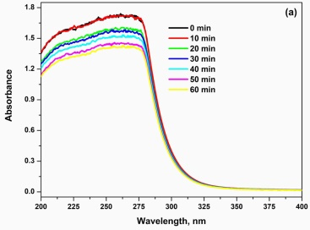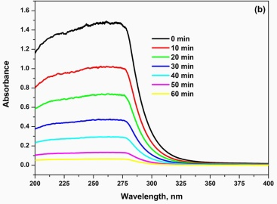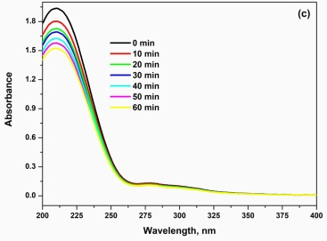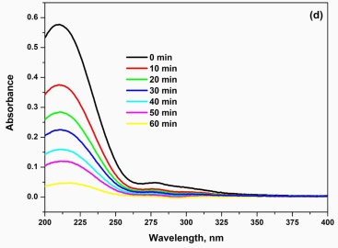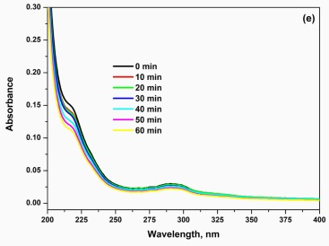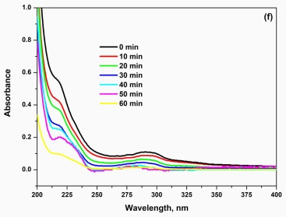
Figure S1. The UV-vis absorption spectra of the photocatalytic degradation of (a-b) MLT, (c-d) MCP and (e-f) CPS in the absence and presence of Cd_{0.5}Ag_{0.5}S composites under 1 h UV light irradiation, respectively
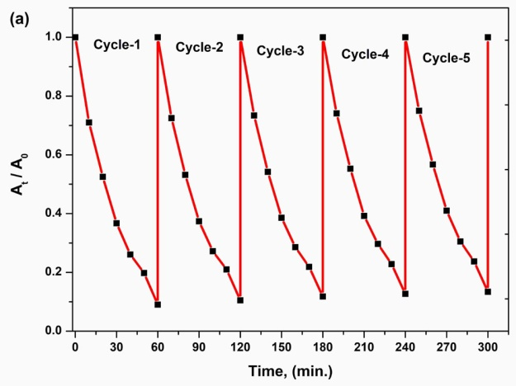
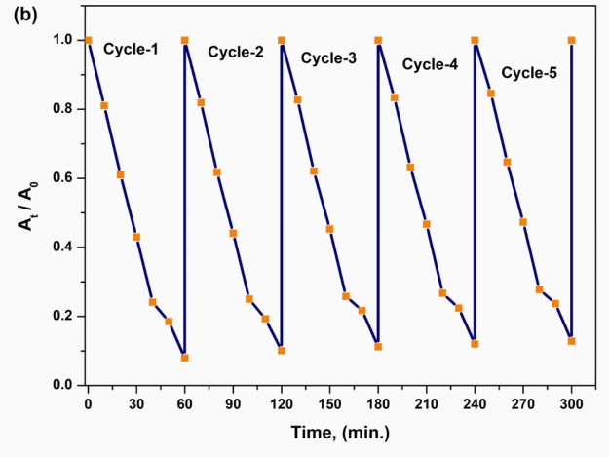
Figure S2. Five cycling runs on the photocatalytic degradation of (a) MCP and (b) CPS using Cd_{0.5}Ag_{0.5}S nanocomposite under 1 h UV light irradiation

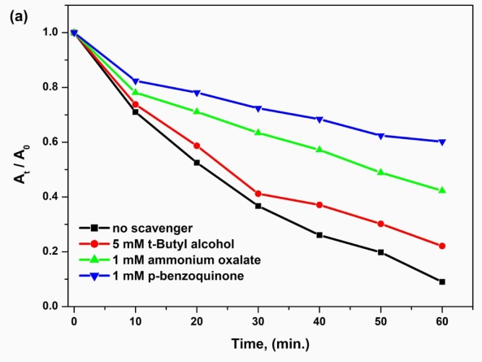
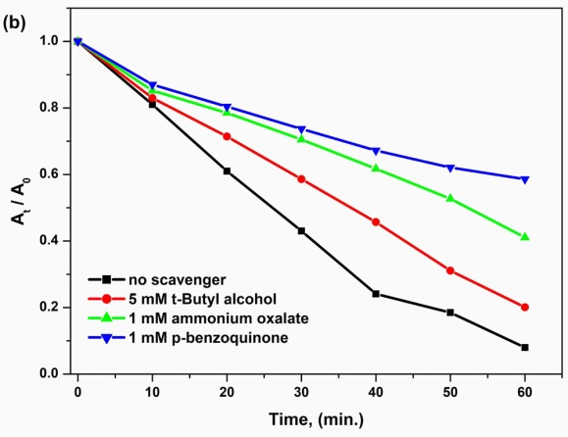
Figure S3. Effects of the addition of different scavengers on the photocatalytic degradation of (a) MCP and (b) CPS using Cd_{0.5}Ag_{0.5}S nanocomposite under 1 h UV light irradiation

