UTM Coordinates |  | Elevation (m a.s.l.) | Place name | Municipality
X | Y | Elevation (m a.s.l.) | Place name | Municipality
395503 | 4647281 | 1151 | above Aschi, near graveyard | Ortona dei Marsi
373889 | 4658427 | 990 | near S. Onofrio | Avezzano
389915 | 4652989 | 820 | above Pescina, near Ex Tiro a Segno | Pescina
392960 | 4648993 | 1142 | Gorga, near Monte Tricella | Ortona dei Marsi
388073 | 4659602 | 981 | near Fontana Vallone | Collarmele
372270 | 4661577 | 984 | Castelnuovo, near Pie' delle Macchie | Avezzano
372236 | 4661624 | 986 | Castelnuovo, near Pie' delle Macchie | Avezzano
387112 | 4659946 | 1087 | Fontana Cituro | Collarmele
395398 | 4648231 | 1056 | below Aschi, near Verrella | Ortona dei Marsi
389760 | 4653624 | 888 | above Pescina, near Monumento Alpini | Pescina
390181 | 4651964 | 940 | near Colle di Mezzo | Pescina
390360 | 4653201 | 938 | near Rocca Vecchia | Pescina
373024 | 4663414 | 1160 | Capo La Maina | Massa d’Albe
392950 | 4649466 | 1165 | Le Stalle | Ortona dei Marsi
393643 | 4648565 | 1186 | Valle Fredda | Ortona dei Marsi
393019 | 4649178 | 1148 | Gorga, near Monte Tricella | Ortona dei Marsi
393553 | 4648419 | 1211 | Valle Fredda | Ortona dei Marsi
Tab. S1 – Location data of the collected specimens identified as F. valesiaca subsp. valesiaca. UTM coordinates are referred to WGS84, fuse 33. Place names are obtained from IGM 1:25,000 maps.

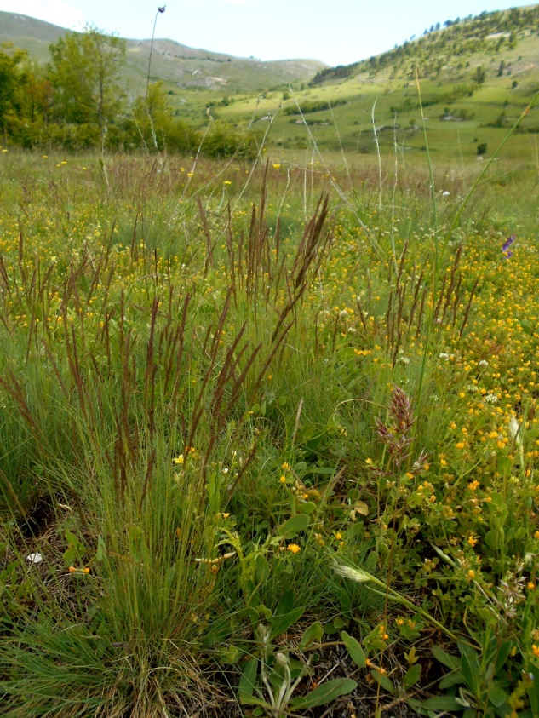
Fig. S1 - Habitus of F. valesiaca in an old-field grassland community near Mt. Tricella, Ortona dei Marsi (20 May 2018).

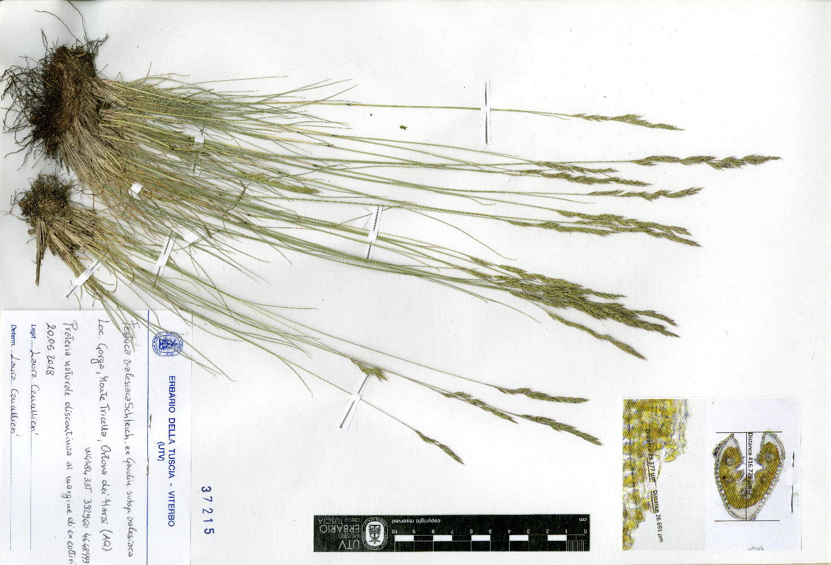
Fig. S2 - Herbarium voucher of F. valesiaca from the Central Apennines, stored in UTV. Specimen collected near Mt. Tricella, Ortona dei Marsi (20 May 2018)

