Interactions in N-[(2-hydroxyl)-propyl-3-trimethyl ammonium] chitosan chloride/sodium carboxymethyl cellulose based films



Fig. S1 Plots of G’ versus oscillation strain for HTCC/CMC blend solutions with different plasticizer types at angular frequency of 10 rad/s.

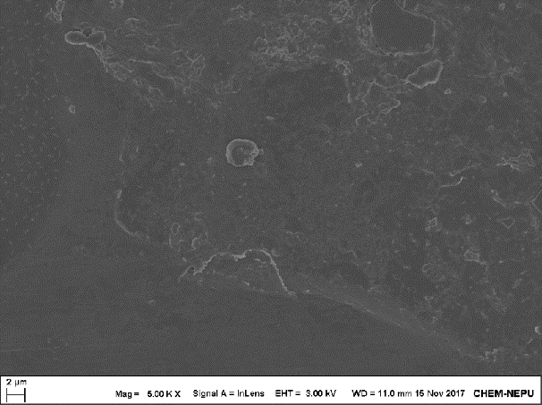

**A**

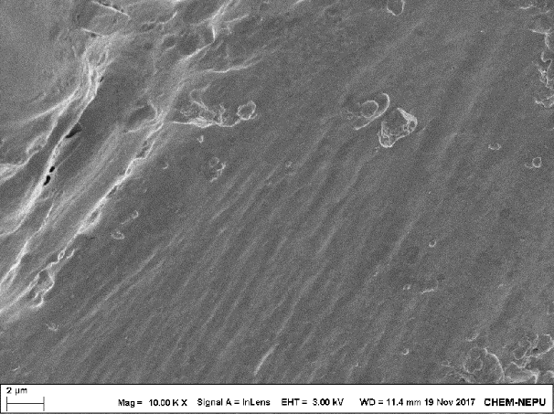

**B**

Fig.S2 Upper surface (A) and cross-section (B) SEM images of pure CMC films.