Supplementary information

Preparation of sterile long-acting injectable medroxyprogesterone acetate microcrystals based on anti-solvent precipitation and crystal habit control

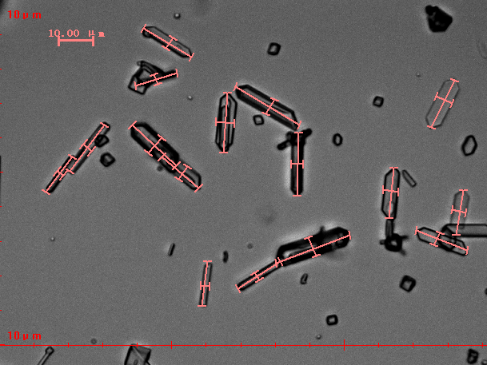
Fig. S1. Dimensional measurement under an electron microscope.

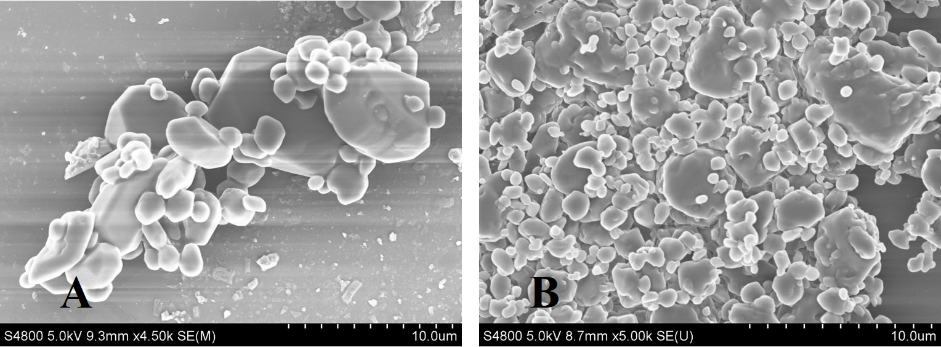
Fig. S2. SEM image of MPA-DP (A) and MPA-API (B)

