Supporting Information for:
Foaming in aqueous solutions of zwitterionic surfactant in presence of monovalent salts: the specific ion effect

Shailesh R Varade and Pallab Ghosh*
Department of Chemical Engineering
Indian Institute of Technology Guwahati
Guwahati – 781039, Assam, India

*Author to whom all correspondence should be addressed.
E-mail: pallabg@iitg.ac.in
Tel: +91 361 2582253
Fax: +91 361 2582291

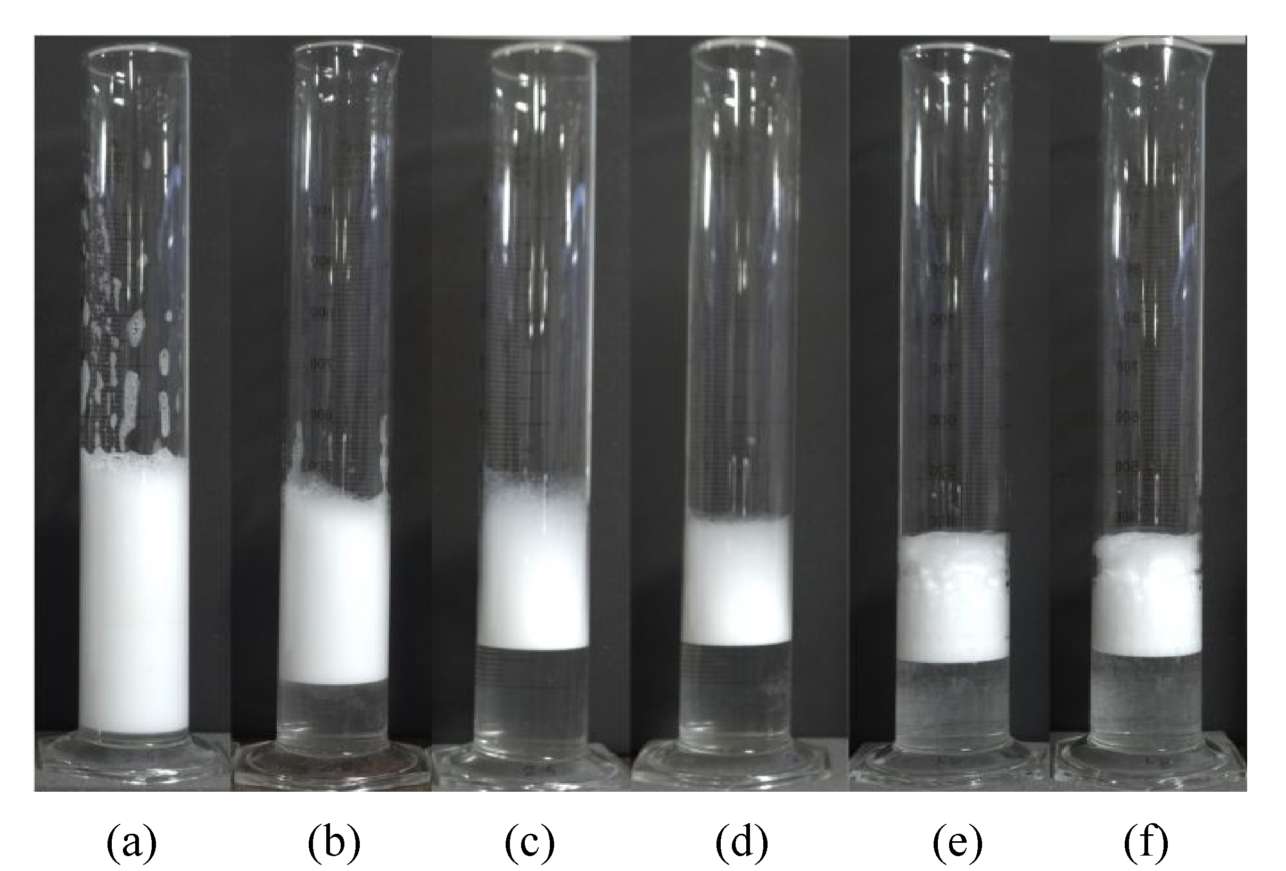
Figure S1. Photographs of foams prepared from 2 mol m^{–3} DDAPS and 50 mol m^{–3} LiCl. Decrease in foam volume can be observed from (a) to (f) over a period of 60 min, at 10 min time interval.

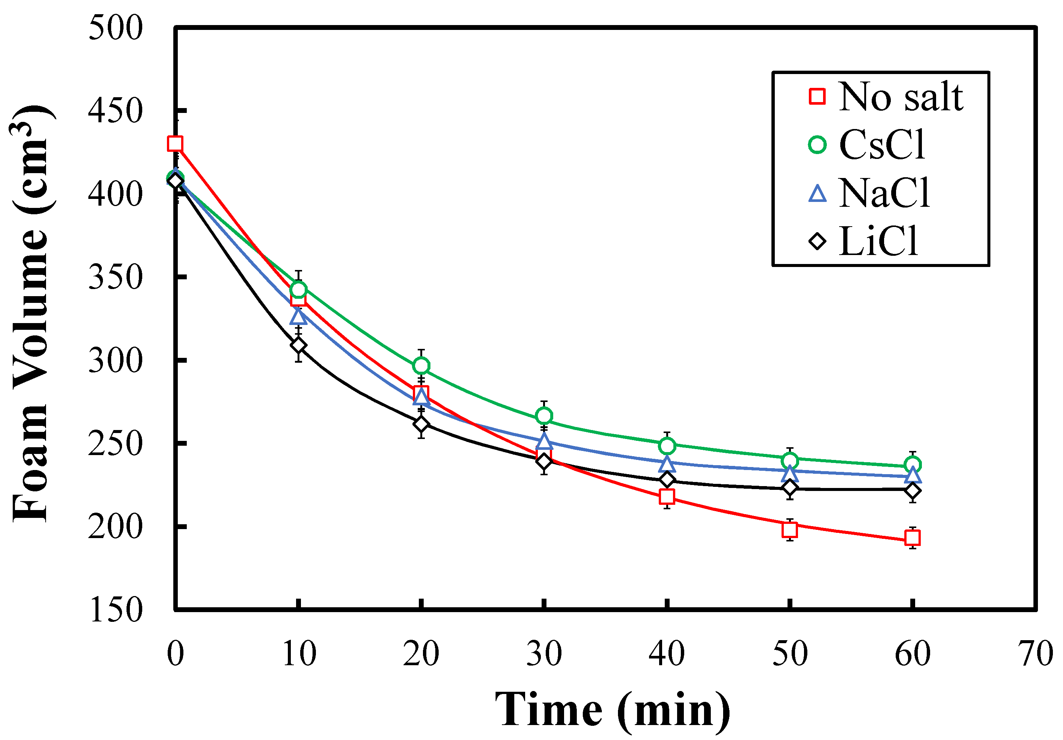 | 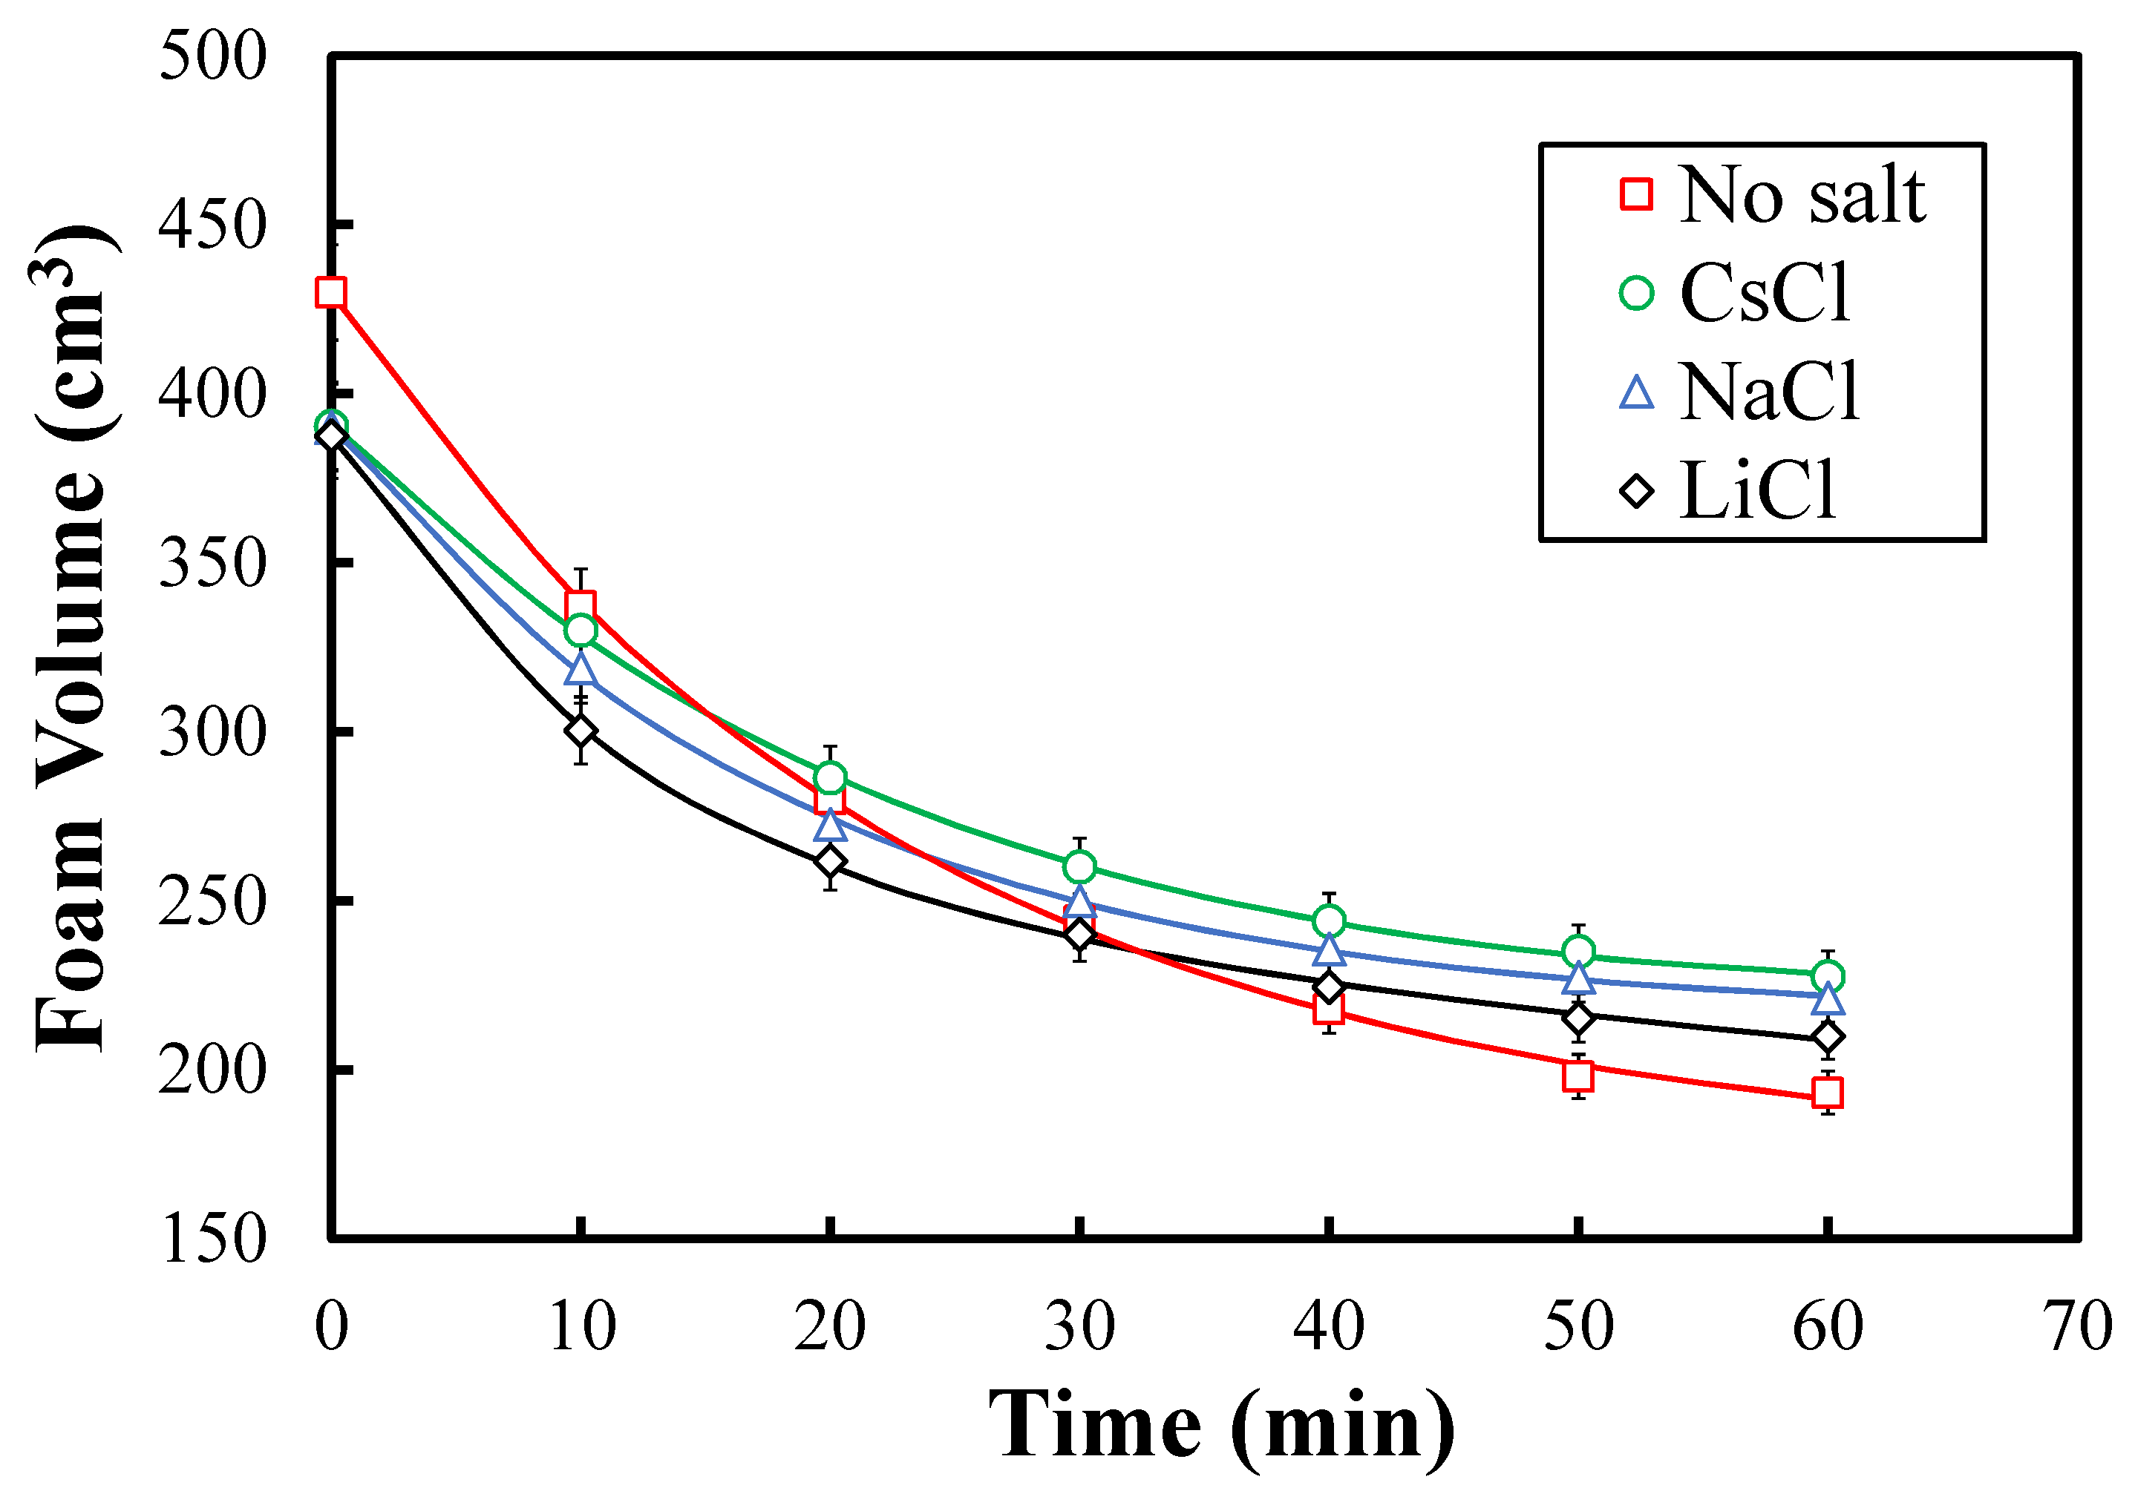
(a) | (b)
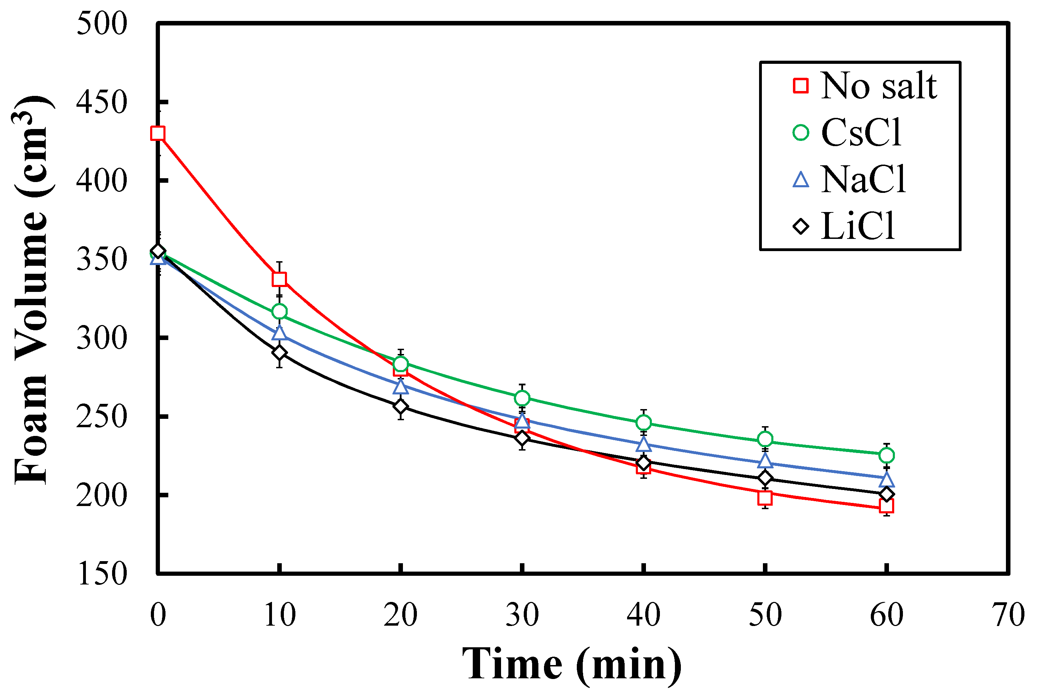
(c)
Figure S2. A comparative study of the lifetime of foams at 0.6 mol m^{–3} DDAPS at (a) 10, (b) 50, and (c) 100 mol m^{–3} CsCl, NaCl, and LiCl. The solid lines indicate the di-exponential fits.

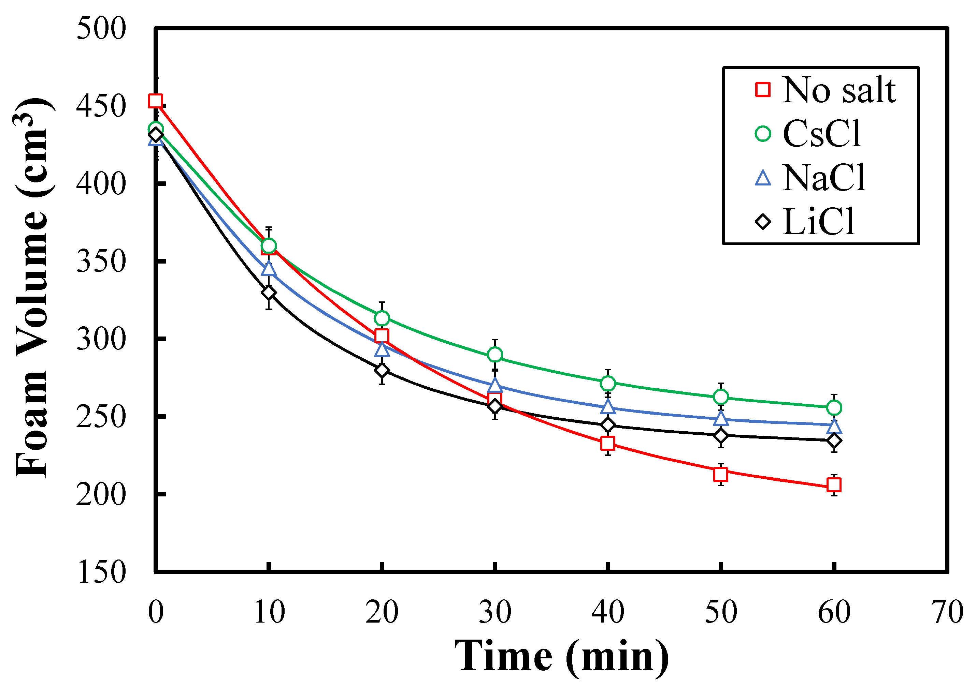 | 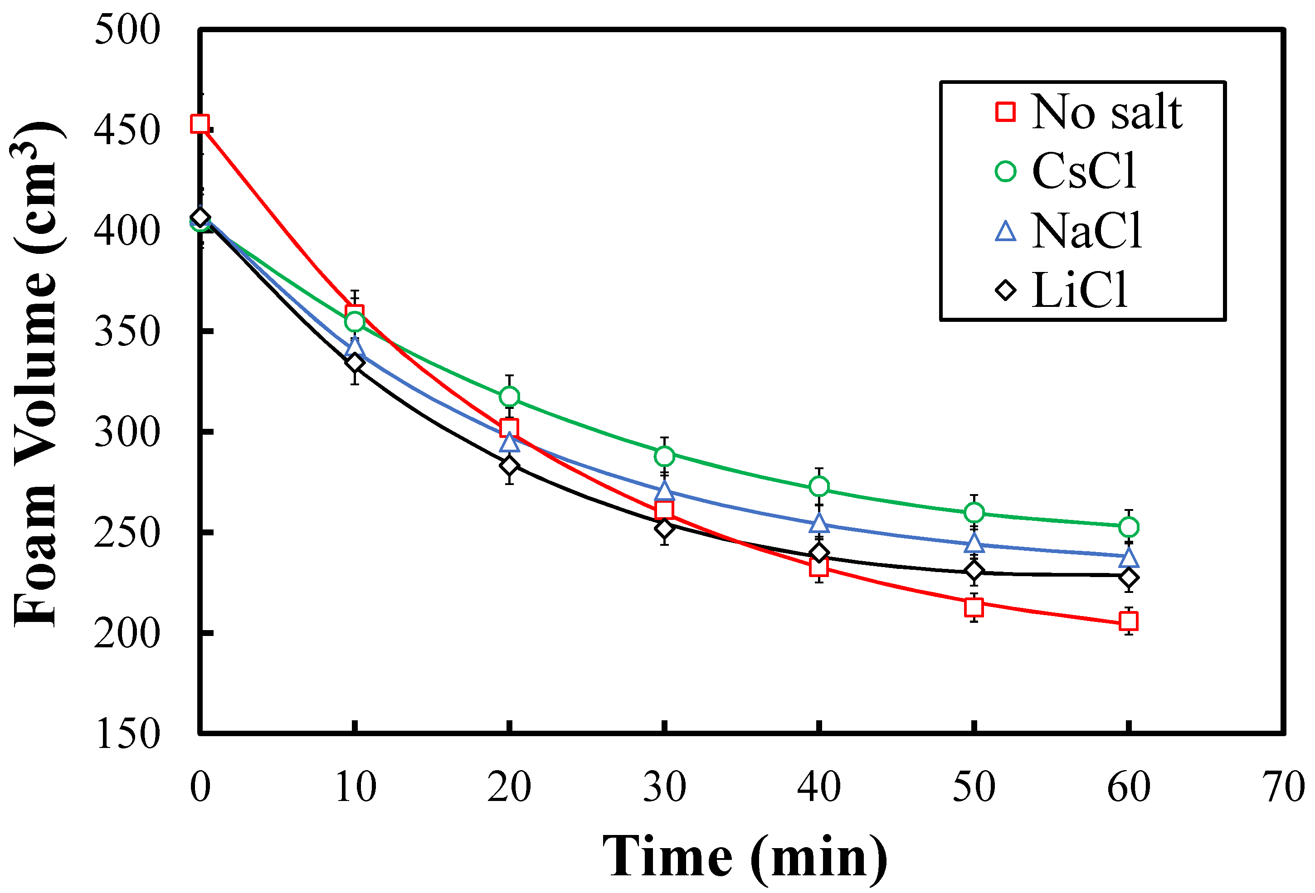
(a) | (b)
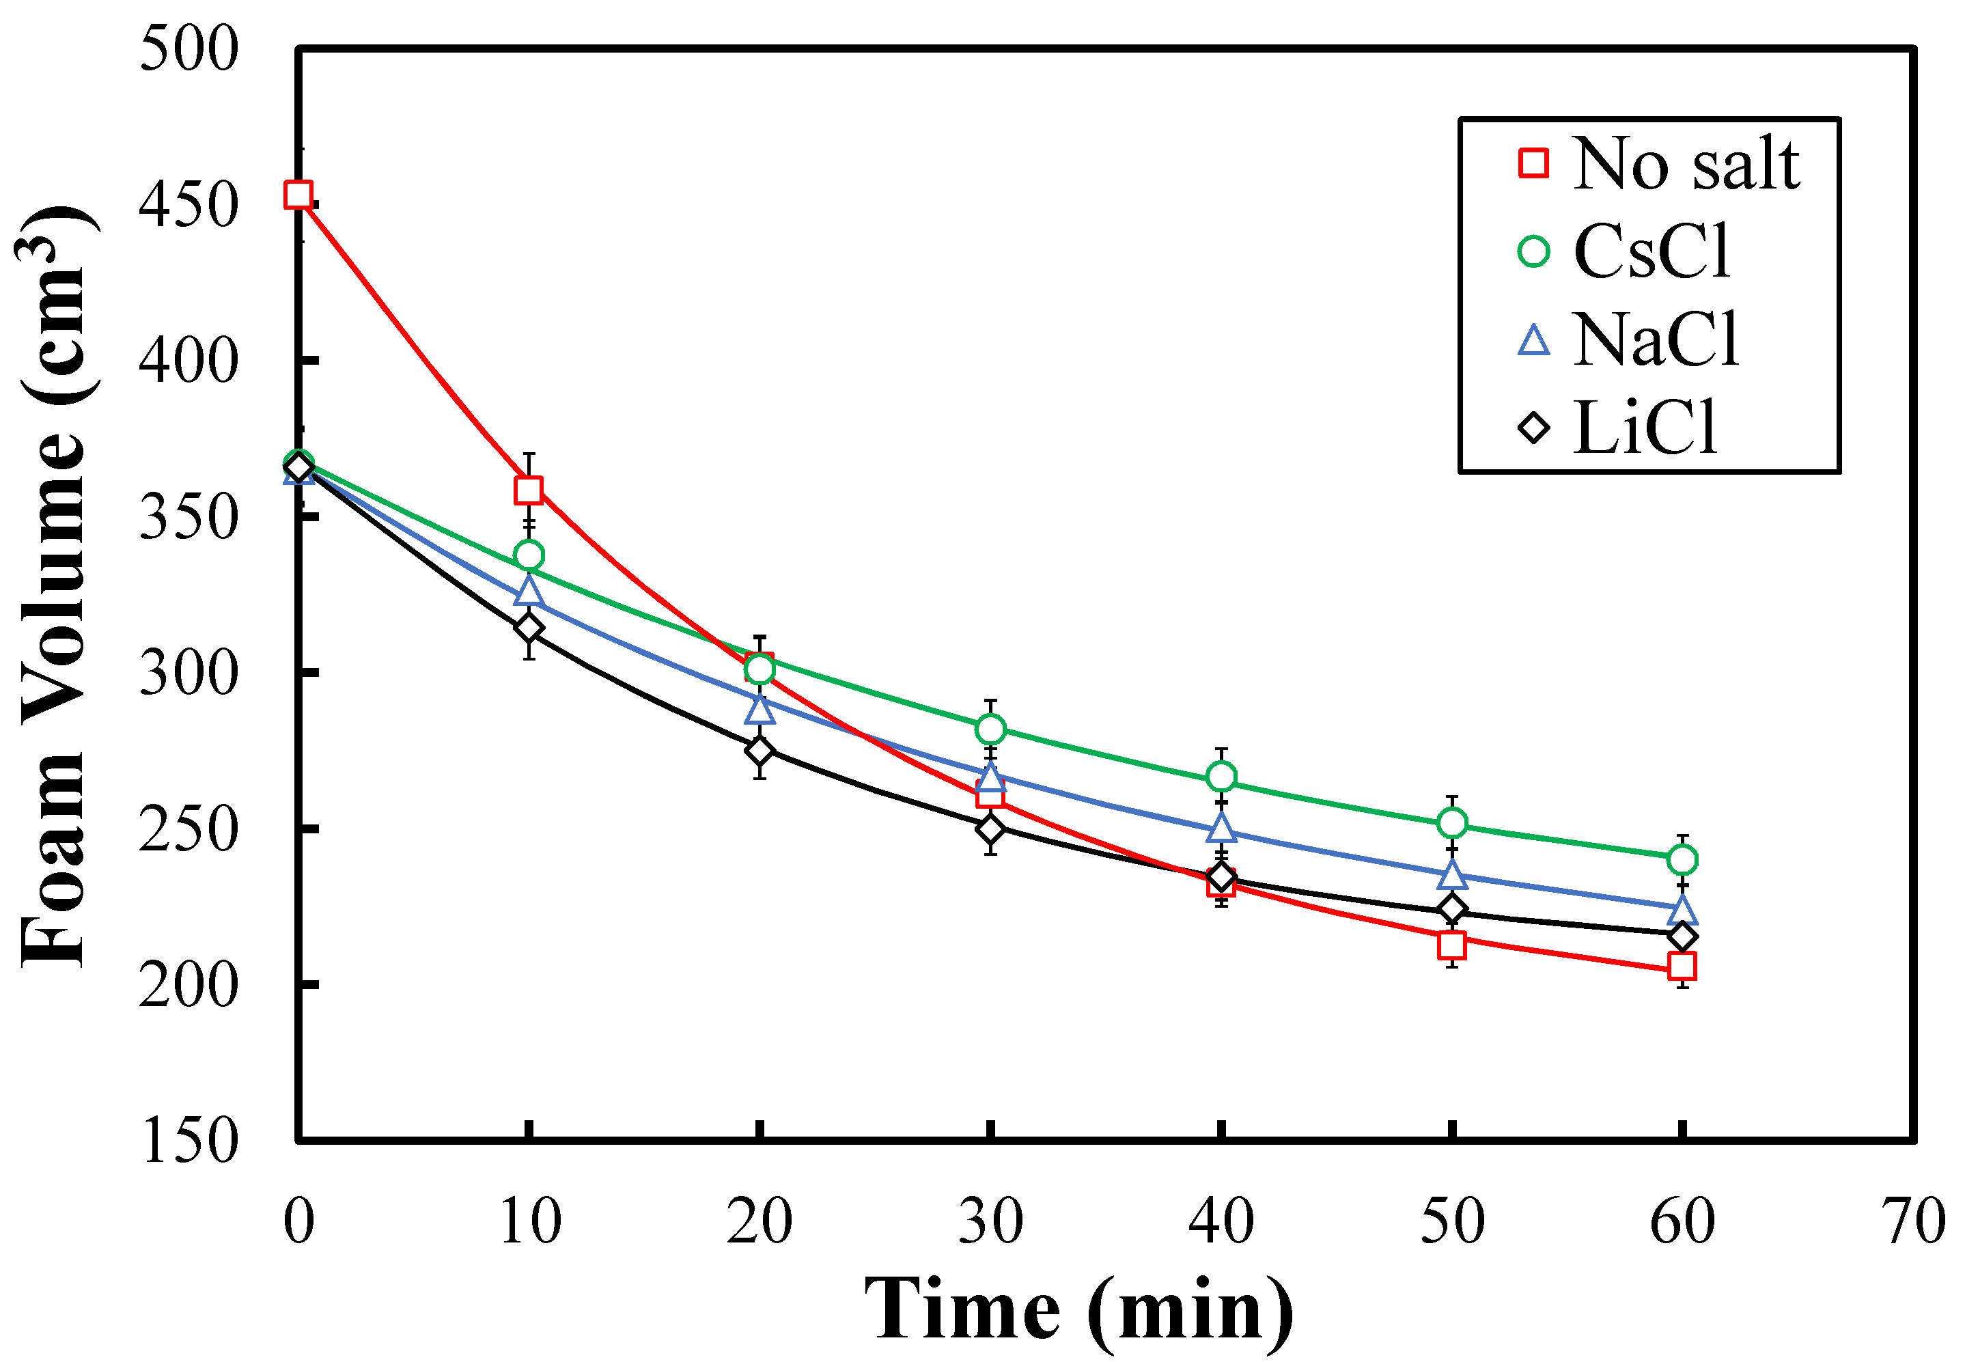
(c)
Figure S3. A comparative study of the lifetime of foams at 1.2 mol m^{–3} DDAPS at (a) 10, (b) 50, and (c) 100 mol m^{–3} CsCl, NaCl, and LiCl. The solid lines indicate the di-exponential fits.

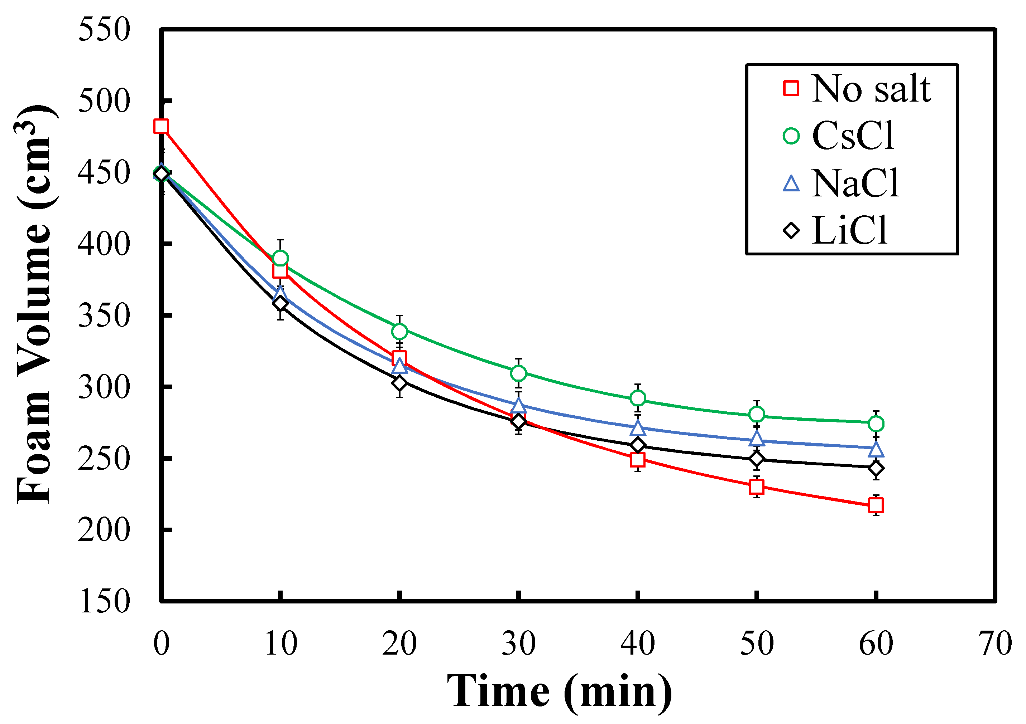 | 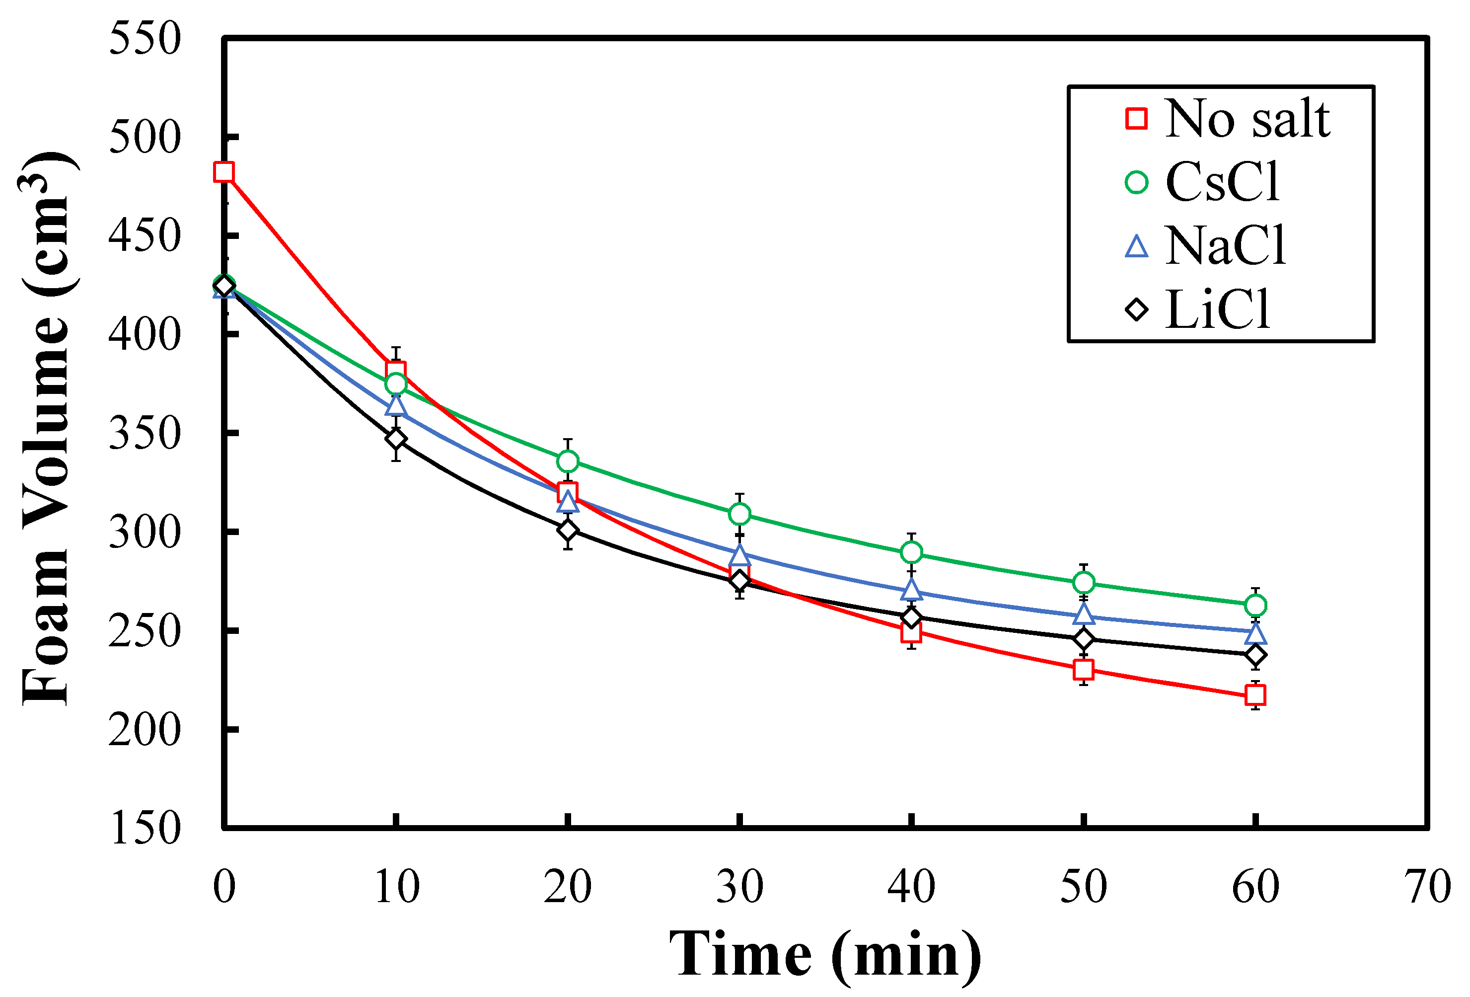
(a) | (b)
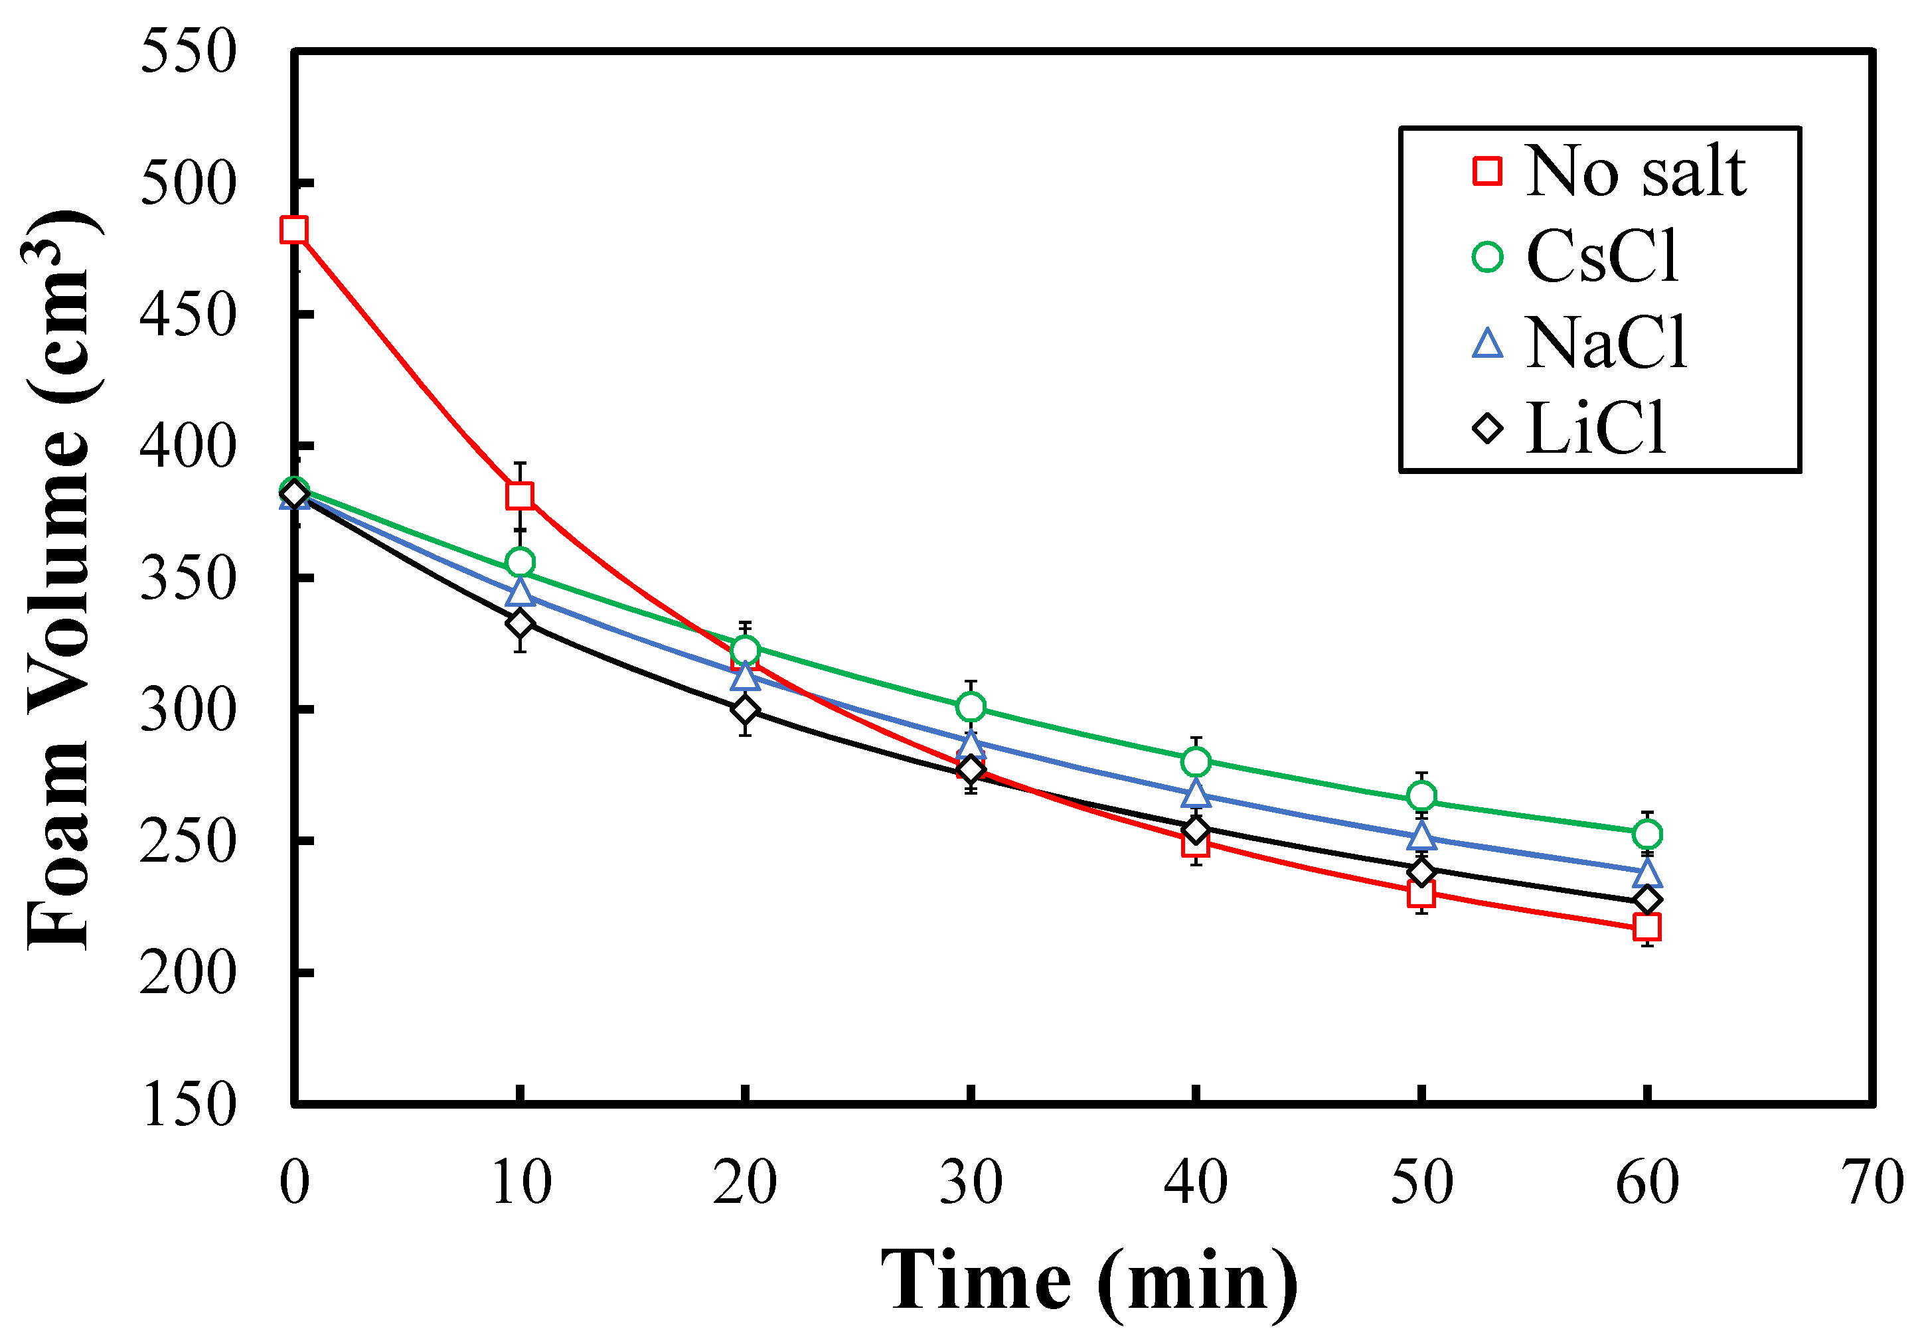
(c)
Figure S4. A comparative study of the lifetime of foams at 1.8 mol m^{–3} DDAPS at (a) 10, (b) 50, and (c) 100 mol m^{–3} CsCl, NaCl, and LiCl. The solid lines indicate the di-exponential fits.

