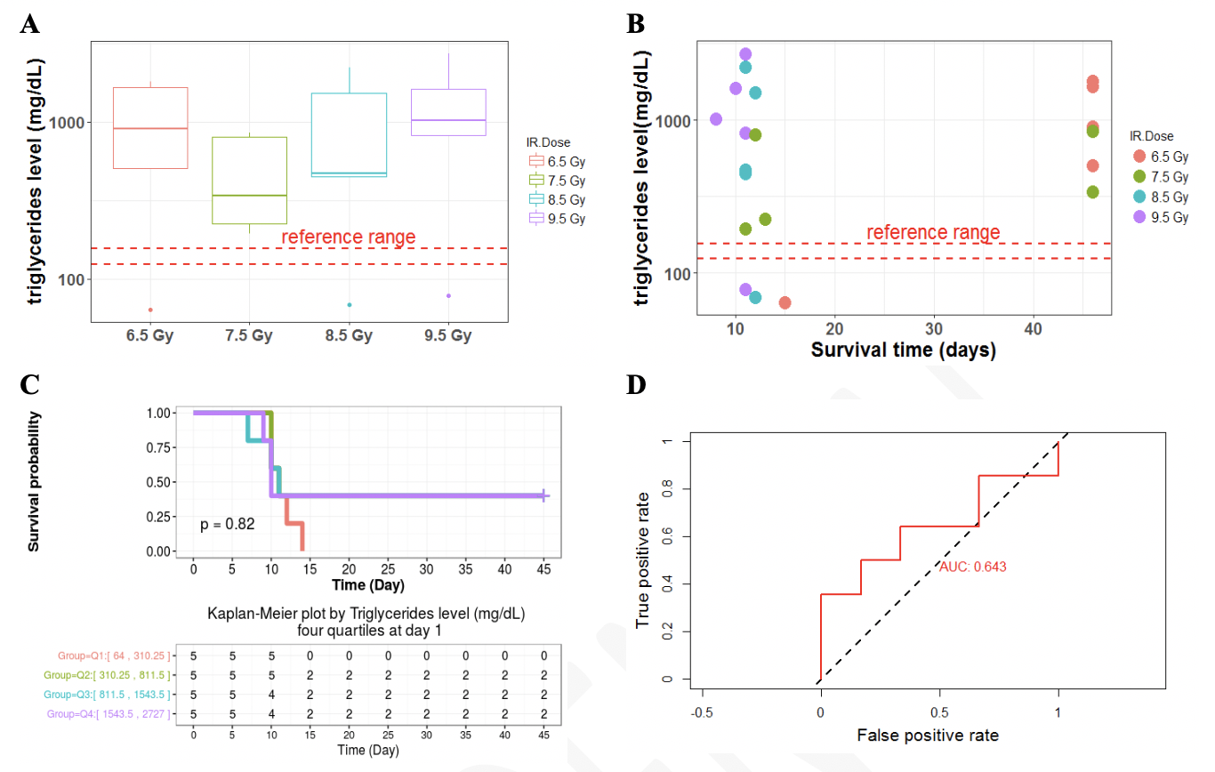

Supplemental, Figure 1. Exploratory and survival analysis of triglycerides on day 1 and correlation with 45-day survival outcomes. A significant, but transient, spike in triglycerides was observed on day 1 postTBI. Therefore, we further evaluated whether the increase in triglycerides correlated with progression of ARS towards organ failure or recovery. A) Box and whiskers plot did not demonstrate a radiation-dose dependent difference in triglyceride levels (mg/dL) on day 1. B) A scatter plot of triglycerides levels (mg/dL) versus survival time for each radiation dose did not indicate prediction of time-to-survival. C) There was no correlation with survival probability based on logistic regression of Kaplan-Meier survival curves (p = 0.82). D) Area under the receiver operating characteristic curve was 0.643 for triglyceride levels on day 1.

