I. Regression Analysis: Average Yield % versus Drug: Polymer ratio, Solvent ratio

Analysis of Variance

Source DF Adj SS Adj MS F-Value P-Value
Regression 2 851.68 425.841 57.85 0.000
Drug: Polymer ratio 1 794.70 794.697 107.96 0.000
Solvent ratio (DCM: Ethanol) 1 56.98 56.984 7.74 0.032
Error 6 44.17 7.361
Total 8 895.85

Regression Equation

Average Yield % = 81.68 - 26.81 Drug: Polymer ratio - 4.04 Solvent ratio

II. Regression Analysis: Average Encapsulation % versus Drug: Polymer ratio, Solvent ratio

Analysis of Variance

Source DF Adj SS Adj MS F-Value P-Value
Regression 2 1056.81 528.41 45.39 0.000
Drug: Polymer ratio 1 1000.73 1000.73 85.97 0.000
Solvent ratio (DCM: Ethanol) 1 56.08 56.08 4.82 0.071
Error 6 69.84 11.64
Total 8 1126.65

Regression Equation

Average Encapsulation % = 94.12 - 30.08 Drug: Polymer ratio - 4.00 Solvent ratio

III. Regression Analysis: Floating time (hr.) versus Drug: Polymer ratio, Solvent ratio

Analysis of Variance

Source DF Adj SS Adj MS F-Value P-Value
Regression 2 17.6699 8.8349 29.96 0.001
Drug: Polymer ratio 1 17.6536 17.6536 59.87 0.000
Solvent ratio (DCM: Ethanol) 1 0.0162 0.0162 0.06 0.822
Error 6 1.7692 0.2949
Total 8 19.4390

Regression Equation

Floating time (hr.) = 8.023 - 3.996 Drug: Polymer ratio + 0.068 Solvent ratio

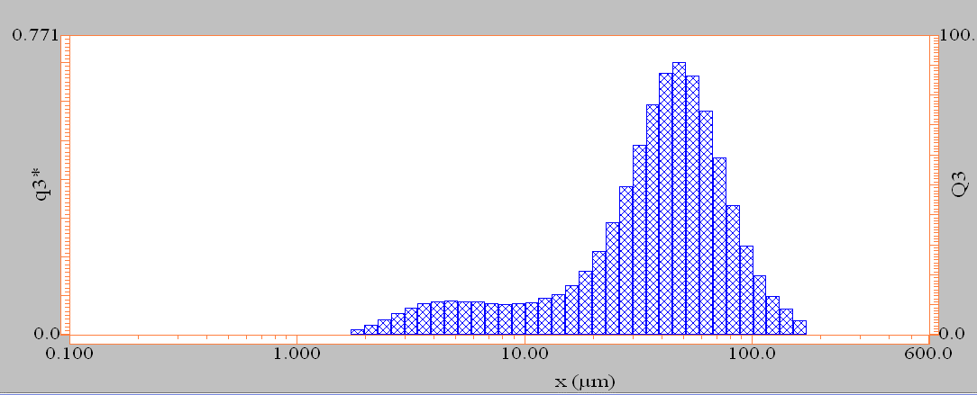

IV. Particle size distribution of the optimized SUL microsponges using laser light scattering. Particles had a d50% of 41.65±1.3 µm

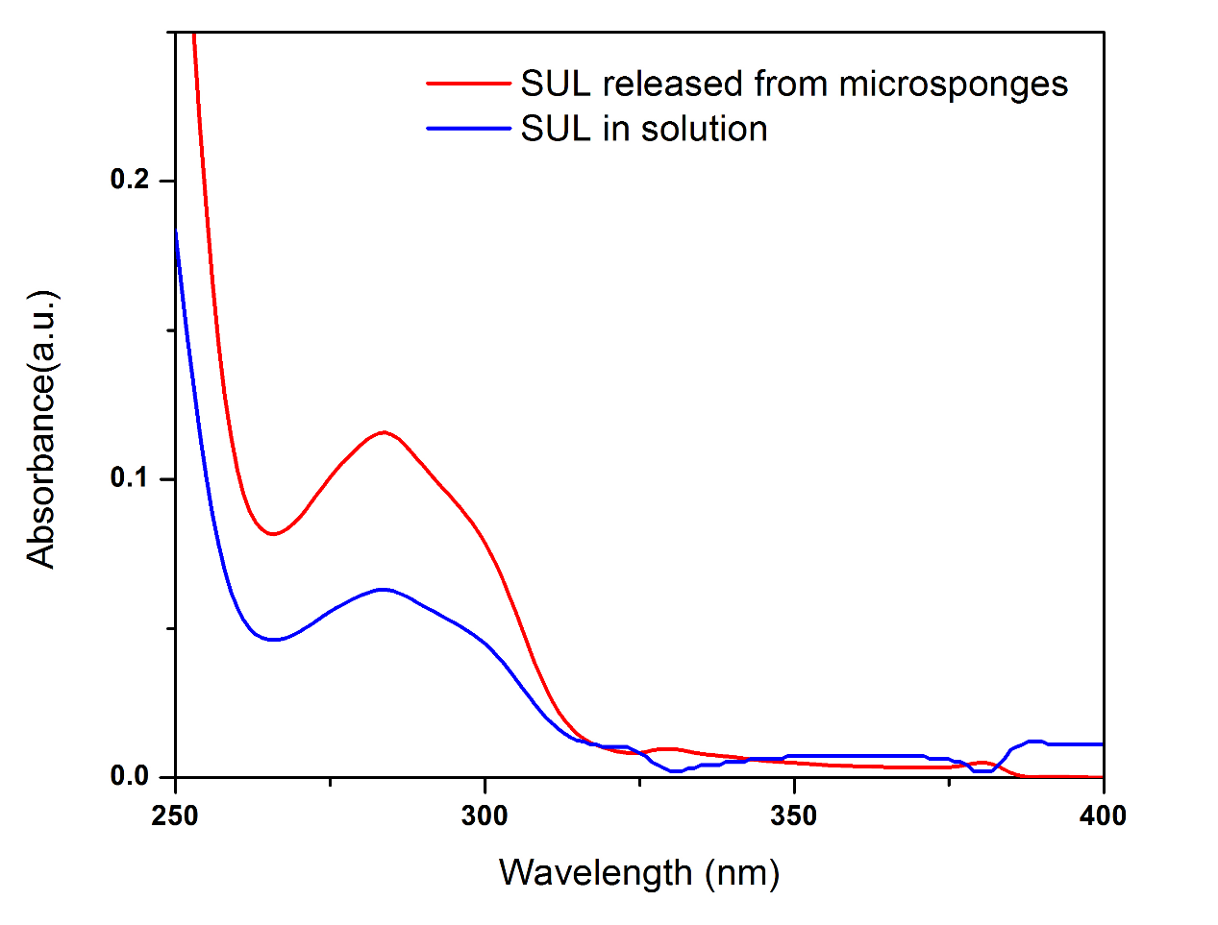
V. UV-Visible absorption spectra of both SUL in buffer solution of pH 1.2 (at zero time) and SUL released from microsponges after 12 hr at pH 1.2. It was clear that both have similar spectrum and λ_{max} indicating the stability of SUL after formulation into floating microsponges.

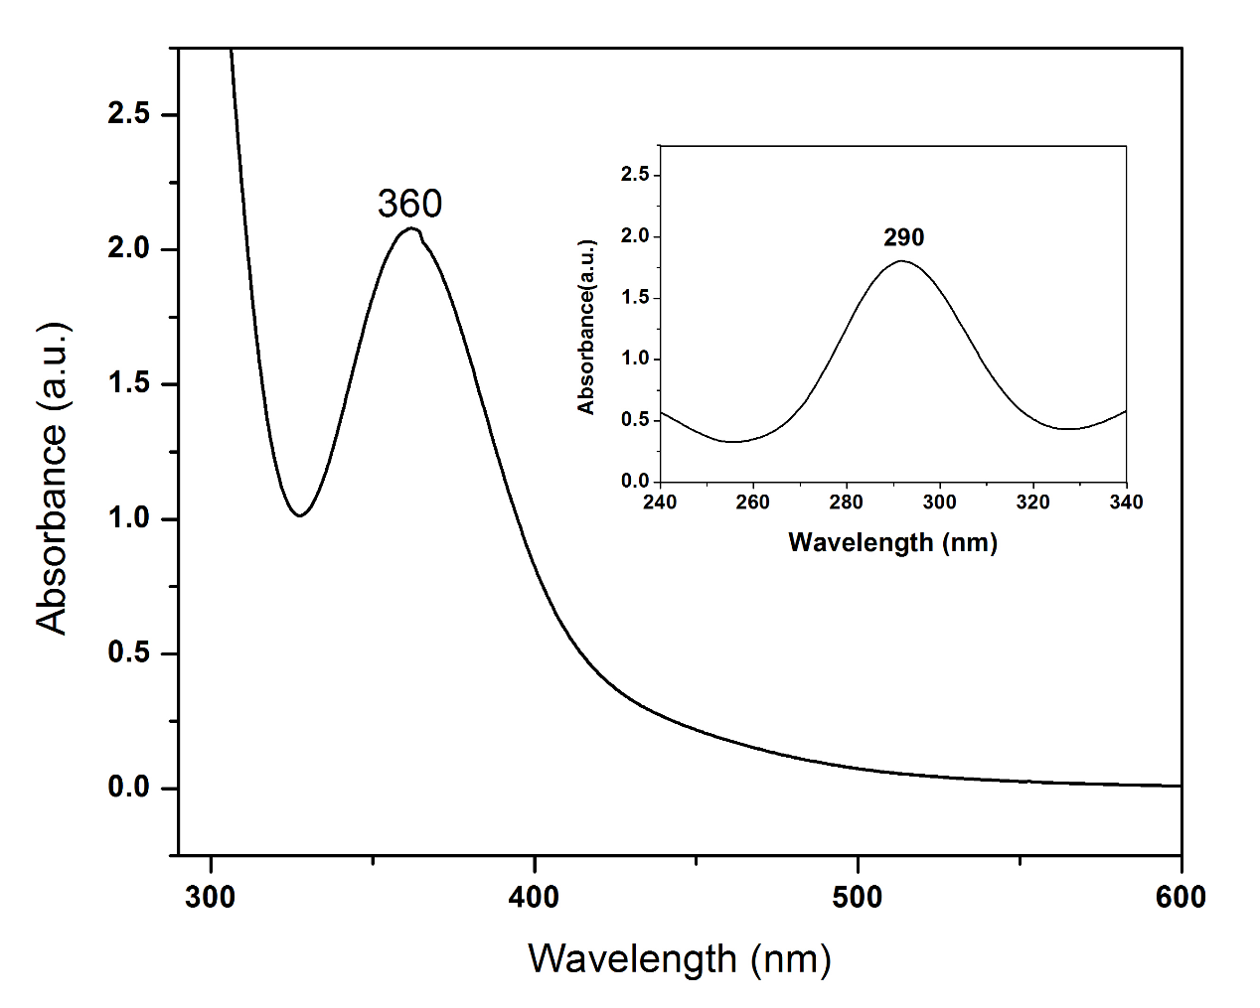
VI. UV-Visible absorption spectra of both free SUL and SUL complex with iodine. Free SUL in buffer has a λ_{max} at 290nm whereas; the complexed SUL has a λ_{max} at 360nm.

