Title: Ruminant urine patch N transformation: effects of urine aucubin rate in a laboratory trial

AUTHORS: C.A. Gardinerª, T.J. Clough*ª, K.C. Cameronª, H.J. Diª, G.R. Edwardsª
ª*Department of Soil and Physical Sciences, Faculty of Agriculture and Life Sciences, Lincoln University, P.O. Box 85084, Lincoln 7647, Christchurch, New Zealand

*Corresponding author email: Timothy.Clough@lincoln.ac.nz

Supplementary Material
Pages: 4
Tables: 0
Figures: 6

Figure Captions
Figure S1. Daily N₂O flux from each of the five experimental treatments (A) and the average N₂O flux over the 37 day experiment for each treatment (B). Data points represent means (A, n=4; B, n=98), with error bars (SEM). Stars indicate days when one or more aucubin treatments were significantly different than the Urine treatment (P<0.05).
Figure S2. The average N₂O flux from Days 5-11 for each treatment (n=20). Error bars represent SEM and stars indicate aucubin treatments that were significantly different than the Urine treatment (P<0.05).
Figure S3. Soil NH₄⁺ concentrations in the five treatments over the 37 day experimental period. Data points represent means (n=4) with error bars (SEM). Stars indicate days when one or more aucubin treatments were significantly (P<0.05) different than the Urine treatment.
Figure S4. Soil NO₃⁻ concentrations over the 37 day experimental period. Data points represent means (n=4) with error bars (SEM). Stars indicate days when one or more aucubin treatments were significantly different (P< 0.05) than the Urine treatment.
Figure S5. Soil CO₂-C fluxes over the 37 day experimental period. Data points are means (n=4) with error bars (SEM). Stars indicate days when one or more aucubin treatments were significantly different (P<0.05) than the Urine treatment.
Figure S6. Soil surface pH over the 37 day laboratory experiment. Data points are means (n=4) with error bars (SEM). Stars indicate days when one or more aucubin treatments were significantly different (P<0.05) than the Urine treatment.

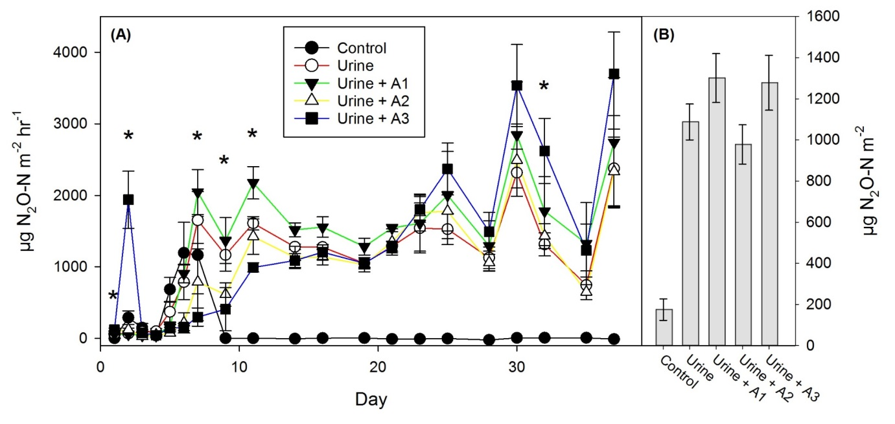
Figure S1. Daily N₂O flux from each of the five experimental treatments (A) and the average N₂O flux over the 37 day experiment for each treatment (B). Data points represent means (A, n=4; B, n=98), with error bars (SEM). Stars indicate days when one or more aucubin treatments were significantly different than the Urine treatment (P<0.05).

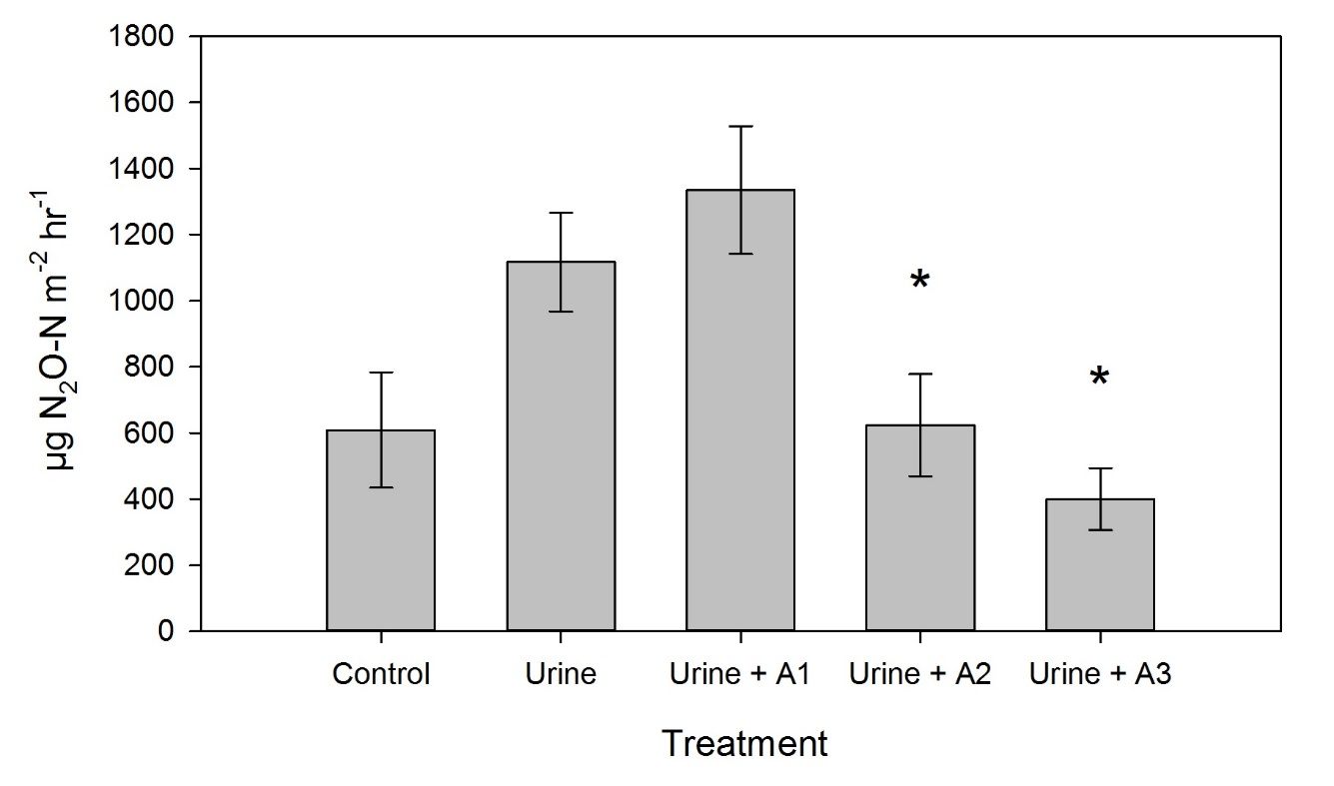
Figure S2. The average N₂O flux from Days 5-11 for each treatment (n=20). Error bars represent SEM and stars indicate aucubin treatments that were significantly different than the Urine treatment (P<0.05).

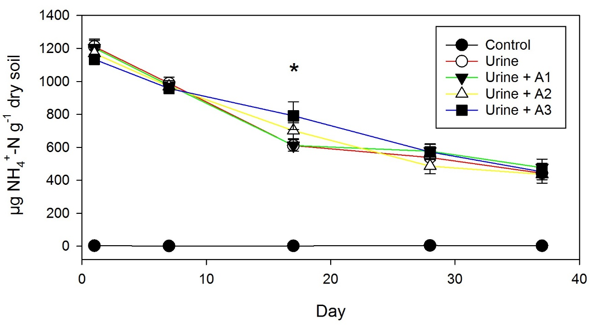
Figure S3. Soil NH₄⁺ concentrations in the five treatments over the 37 day experimental period. Data points represent means (n=4) with error bars (SEM). Stars indicate days when one or more aucubin treatments were significantly (P<0.05) different than the Urine treatment.

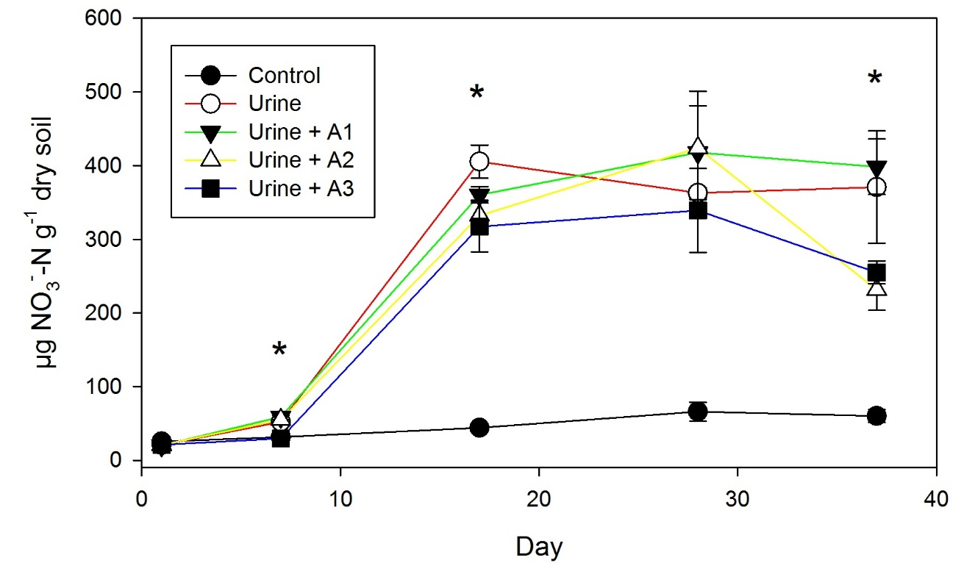
Figure S4. Soil NO₃⁻ concentrations over the 37 day experimental period. Data points represent means (n=4) with error bars (SEM). Stars indicate days when one or more aucubin treatments were significantly different (P< 0.05) than the Urine treatment.

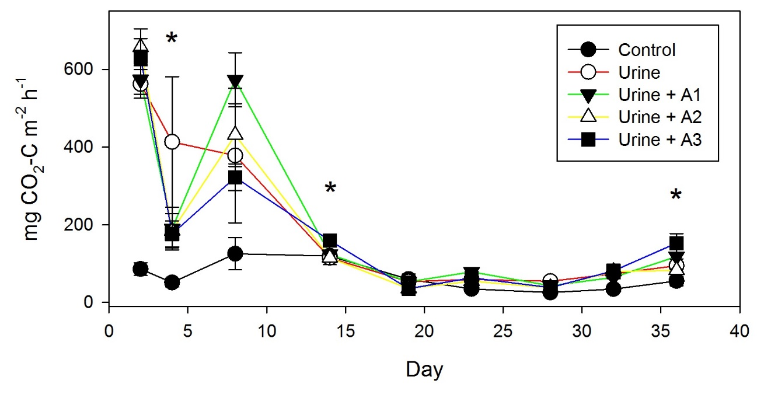
Figure S5. Soil CO₂-C fluxes over the 37 day experimental period. Data points are means (n=4) with error bars (SEM). Stars indicate days when one or more aucubin treatments were significantly different (P<0.05) than the Urine treatment.

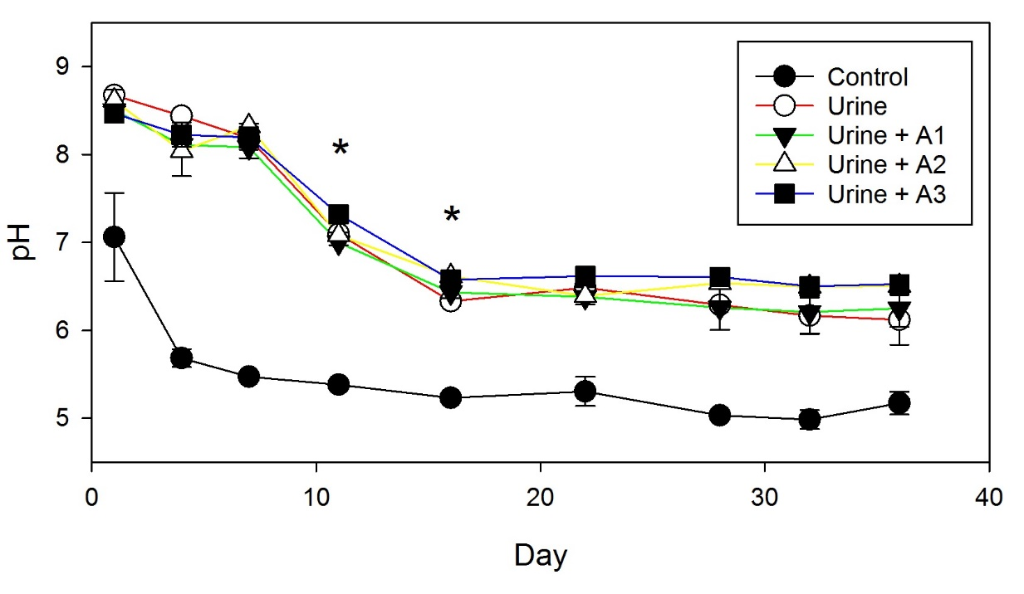
Figure S6. Soil surface pH over the 37 day laboratory experiment. Data points are means (n=4) with error bars (SEM). Stars indicate days when one or more aucubin treatments were significantly different (P<0.05) than the Urine treatment.

