APPENDIX
Table A1 All items measured in this study
Variable | Dimension/ Item sets | Items | Factor loading | Reference
Age |  | What is your age?
Gender |  | What is your gender?
Educational background |  | What is your highest educational level?
Riding experience |  | Since when did you use e-bikes as a mode of transportation?
Riding frequency |  | How often do you ride an e-bike?
Anger | AG1 | I get irritated easily.  I am often in a bad mood.  I keep my cool.* | .826 | IPIP (Goldberg et al. 2006)
 | AG2 | I get upset easily.  I lose my temper.  I am not easily annoyed.* | .800
 | AG3 | I get angry easily.  I rarely get irritated.*  I seldom get mad.*  I rarely complain.* | .774
Altruism | AT1 | I anticipate the needs of others.  I love to help others.  I turn my back on others.* | .783 | IPIP (Goldberg et al. 2006)
 | AT2 | I have a good word for everyone.  I look down on others.*  I am indifferent to the feelings of others.* | .853
 | AT3 | I make people feel welcome.  I am concerned about others.  I make people feel uncomfortable.*  I take no time for others.* | .842
Sensation-seeking | SS1 | I love action.  I enjoy being reckless.  I act wild and crazy. | .863 | IPIP (Goldberg et al. 2006)
 | SS2 | I love excitement.  I seek danger.  I am willing to try anything once. | .843
 | SS3 | I seek adventure.  I enjoy being part of a loud crowd.  I would never go hang gliding or bungee jumping.*  I dislike loud music.* | .807
Normlessness | N1 | It is all right to do anything you want as long as you keep out of trouble. | .644 | Kohn and Schooler’s (1983)
 | N2 | It is OK to get around laws and rules as long as you don’t break them directly. | .656
 | N3 | If something works, it is less important whether it is right or wrong. | .794
 | N4 | Some things can be wrong to do even though it is legal to do it.* | .597
Risk perception | RP1  (Worry insecurity, and concern) | I feel unsafe that I myself could be injured in a traffic accident.  I worry for myself being hurt in traffic.  I think there is a probability of myself being involved in a traffic accident.  I am concerned about traffic risks and I myself could be victimized. | .772 | Ulleberg and Rundmo (2003)
 | RP2 (Perceived crash risks and dangers) | I can ride in a motorized lane when the non-motorized lane is crowded.*  I can ride faster than others in surroundings.*  I can ride after drinking alcohol.*  I can use the opposing lane to overtake slow traffic.*  I can ride against red lights.*  I can use the phone while riding.* | .596 | Wang et al. (2018)
Safety attitude | SA1 (Attitude towards traffic rule) | It is not OK to violate traffic rules to keep you accompanies.  It is not OK to violate rule otherwise I will be late.  It is not OK to violate traffic rule for personal purposes.  Traffic rules are not too complicated to obey. | .868 | Wang et al. (2018)
 | SA2 (Attitude towards risky riding) | It is not OK to drive as fast as you can even when you think you have skills.  It is not OK to drive as fast as you can even when others do.  It is not OK to run the red light or speed under low traffic.  It is not OK to run the red light even when the traffic is good.  It is not OK to run against red light even you have riding skills.  It is not over to drive after drink. | .836
 | SA3  (Attitude towards safety responsibility) | I have the responsibility to avoid traffic crash.  I think safety is more important than speed.  I have the responsibility for others’ safety.  I try what I can do to prevent any crash.  I need to warn those people who violate traffic rules. | .842
Risky riding behavior | RR1  (Error) | Fail to check the traffic before turning around.  Underestimate the speed of oncoming vehicles.  Fail to notice the traffic coming from other directions.  Ride so fast into a corner that you almost lose control.  Fail to notice pedestrians waiting to cross when turning right.  Nearly hit someone because of being distracted. | .720 | Yao and Wu (2012)
 | RR2  (Aggressive behavior) | Deliberately ride closely to those in front to make them get out of your way.  Approach intersections without deceleration.  Weave through traffic.  Keep honking when irritated.  Have words or body conflict with other road users. | .685 | Yao and Wu (2012)
 | RR3  (Rule violation) | Run a red light.  Ride against the traffic.  Ride in the motor vehicle lane.  Overload.  Speeding.  Illegal crossing.  Ride across the stop line when waiting for the green light. | .754 | Yao and Wu (2012)
 | RR4  (Group violation) | Ride faster even under very high speed because others do.  Speeding because other violators are not punished.  Run the red light with other riders together.  Run the red light because other violators are not punished.  Ride in the motorized lane with others.  Wait beyond the stopping line because others do. | .770 | Wang et al. (2018)
Note: * Recoded

Table A2 Dimensions, reliability, distribution, means and standard deviations of latent variables
Variable/ Indicator | Number of items | Eigenvalue | Cronbach’s alpha | Mean (S.D.) | Skewness | Kurtosis
Anger |  |  |  | 2.93 (0.94)
1.AG1 | 3 | 2.278 | .74 | 2.93 (1.09) | .58 | -.07
2.AG2 | 3 |  | .73 | 2.94 (1.08) | .74 | .45
3.AG3 | 4 |  | .73 | 2.95 (1.07) | .69 | -.04
Altruism |  |  |  | 5.10 (1.07)
1.AT1 | 3 | 2.343 | .72 | 5.17 (1.22) | -.52 | .71
2.AT2 | 3 |  | .70 | 5.12 (1.20) | -.91 | .76
3.AT3 | 4 |  | .77 | 5.03 (1.22) | -.68 | .56
Sensation-seeking |  |  |  | 5.09 (1.09)
1.SS1 | 3 | 2.402 | .71 | 3.07 (1.31) | -.85 | .42
2.SS2 | 3 |  | .72 | 3.06 (1.17) | -.84 | .22
3.SS3 | 4 |  | .72 | 3.13 (1.18) | -.74 | .09
Normlessness |  |  | .77 | 2.70 (0.94)
1.N1 | 1 | 2.350 |  | 2.75 (1.21) | .76 | .83
2.N2 | 1 |  |  | 2.67 (1.27) | .87 | 1.03
3.N3 | 1 |  |  | 2.66 (1.28) | .90 | 1.16
4.N4 | 1 |  |  | 2.73 (1.17) | .70 | .65
Risk perception |  |  |  | 4.47 (0.88)
1.RP1 | 3 | 2.553 | .85 | 4.68 (1.41) | -.65 | -.43
2.RP2 | 6 | 4.247 | .93 | 4.25 (1.39) | -.24 | -.87
Safety attitude
1.SA1 | 4 | 3.847 | .86 | 4.24 (1.51) | -.14 | -1.12
2.SA2 | 6 | 2.935 | .90 | 4.15 (1.53) | -.10 | -1.28
3.SA3 | 5 | 2.615 | .91 | 4.60 (1.47) | -.47 | -1.04
Risky riding behaviors
1.RR1 | 6 | 2.847 | .87 | 3.02 (1.18) | .95 | .39
2.RR2 | 5 | 2.628 | .88 | 2.94 (1.20) | .96 | .32
3.RR3 | 7 | 3.365 | .89 | 2.86 (1.08) | .82 | .94
4.RR4 | 6 | 4.271 | .89 | 3.66 (1.29) | .40 | -.72
Note: S.D. denotes standard deviations.

Table A3 Covariance matrices between anger, altruism, sensation-seeking and normlessness
Variable | Anger | Altruism | Sensation-seeking | Normlessness
Anger | 1
Altruism | -.210*** | 1
Sensation seeking | NS | .385*** | 1
Normlessness | .230*** | -.360*** | NS | 1
Note: *** p <.001; NS denotes statistically nonsignificant.

Table A4 Unstandardized estimates of measurement equations for the latent variables
Indicators | Estimate | S.E. | C.R. | p
Anger
-- AG1 | 1.000
-- AG2 | 0.957 | 0.059 | 16.142 | ***
-- AG3 | 0.920 | 0.059 | 15.696 | ***
Altruism
-- AT1 | 1.000
-- AT2 | 1.076 | 0.060 | 17.850 | ***
-- AT3 | 1.079 | 0.061 | 17.622 | ***
Sensation seeking
-- SS1 | 1.000
-- SS2 | 0.986 | 0.051 | 19.275 | ***
-- SS3 | 1.043 | 0.057 | 18.434 | ***
Normlessness
-- N1 | 1.000
-- N2 | 1.066 | 0.103 | 10.391 | ***
-- N3 | 1.314 | 0.113 | 11.592 | ***
-- N4 | 0.899 | 0.092 | 9.723 | ***
Safety attitude
-- SA1 | 1.000
-- SA2 | 0.977 | 0.048 | 20.559 | ***
-- SA3 | 0.947 | 0.045 | 20.813 | ***
Risk Perception
-- RP1 | 1.000
-- RP2 | 0.768 | 0.082 | 9.426 | ***
Risky riding
-- RR1 | 1.000
-- RR2 | 0.965 | 0.070 | 13.745 | ***
-- RR3 | 0.826 | 0.063 | 13.045 | ***
-- RR4 | 1.016 | 0.076 | 13.434 | ***
Note: *** p < .001.

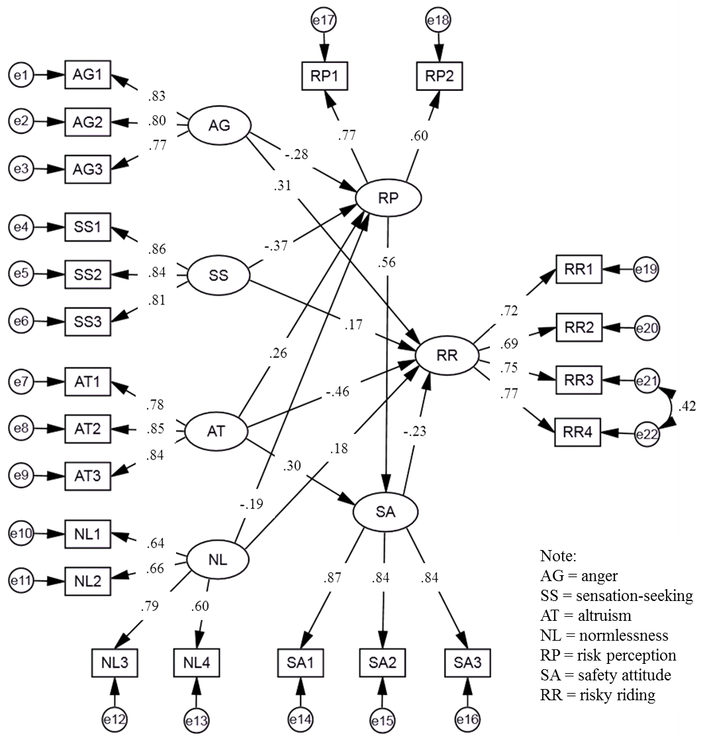
Figure A1 Structural equation model for personality traits, risk perception, safety attitude and risky riding behaviors

