Appendix A: Summary Statistics

Table A1 Summary statistics for variables included in the multivariate models
 | N | M | SD | Min | Max
Dependent variable
Vote | 42,408 | 0.483 | 0.5L | 0 | 1
Independent variables
Patrimony | 40,590 | 0.447 | 0.287 | 0 | 1
Age | 46,864 | 0.395 | 0.202 | 0 | 1
Education | 46,523 | 0.526 | 0.223 | 0 | 1
Female | 46,824 | 0.518 | 0.499 | 0 | 1
Attached to main rightist party | 46,864 | 0.187 | 0.389 | 0 | 1
Ideology | 38,764 | 0.547 | 0.251 | 0 | 1
Economy valence | 45,618 | 0.379 | 0.363 | 0 | 1
Economy positional | 42,110 | 0.292 | 0.289 | 0 | 1
Dalton Polarisation Index | 46,864 | 0.451 | 0.213 | 0 | 1
Liberal Welfare State | 46,864 | 0.256 | 0.436 | 0 | 1
Tax system: incentives to invest/work | 46,864 | 0.497 | 0.279 | 0 | 1
Source of data: CSES Module 4 (2018).
Please note: The base for summary statistics are the cases included in the full dataset.

Table A2 Vote Choice and Attachment to Rightist Party by Country
 | Voted Right | Voted Other | Total | N | Total N
Peru | 31.58 | 68.42 | 100 | 342 | 1194
Latvia | 95.54 | 4.46 | 100 | 224 | 599
Argentina | 100 | 0 | 100 | 4 | 456
Czech Republic | 97.14 | 2.86 | 100 | 210 | 749
Sweden | 95.71 | 4.29 | 100 | 280 | 672
South Korea | 98.82 | 1.18 | 100 | 170 | 468
South Africa | 90 | 10 | 100 | 10 | 399
Slovenia | 100 | 0 | 100 | 48 | 393
Slovakia | 93 | 7 | 100 | 186 | 531
Romania | 93.75 | 6.25 | 100 | 32 | 785
Portugal | 98.31 | 1.69 | 100 | 178 | 673
Norway | 98.04 | 1.96 | 100 | 358 | 1404
Montenegro | 90.91 | 9.09 | 100 | 11 | 270
Israel | 91.01 | 8.99 | 100 | 89 | 656
Finland | 96.88 | 3.13 | 100 | 224 | 454
Turkey | 96.82 | 3.18 | 100 | 409 | 776
Canada | 81.55 | 18.45 | 100 | 233 | 978
Bulgaria | 98.96 | 1.04 | 100 | 192 | 484
Brazil | 79.33 | 20.67 | 100 | 150 | 1545
Switzerland | 94.89 | 5.11 | 100 | 548 | 1206
Serbia | 93.71 | 6.29 | 100 | 318 | 659
Poland | 96.90 | 3.10 | 100 | 548 | 863
New Zealand | 97.81 | 2.19 | 100 | 320 | 570
United States | 94.92 | 5.08 | 100 | 295 | 1130
Mexico | 91.61 | 8.39 | 100 | 155 | 591
Japan | 93.03 | 6.97 | 100 | 617 | 1212
Ireland | 69.59 | 30.41 | 100 | 171 | 1187
Iceland | 97.03 | 2.97 | 100 | 269 | 783
Great Britain | 95.26 | 4.74 | 100 | 359 | 998
Greece | 92.95 | 7.05 | 100 | 156 | 592
Germany | 96.23 | 3.77 | 100 | 424 | 1247
France | 94.99 | 5.01 | 100 | 519 | 1557
Austria | 94.30 | 5.70 | 100 | 193 | 635
Australia | 97.40 | 2.96 | 100 | 1114 | 2567
Source of data: CSES Module 4 (2018).

Appendix B: Variable classifications and survey questions
Please note: all variables included in our multilevel models are standardized to run from 0-1.

Vote for a right-wing party or candidate
This variable measures whether or not a respondent voted for a right-wing party. This is ascertained from variable D3006 in the CSES dataset which probes which party a respondent voted for in the election. Our classification of parties left, and right-wing positioning is detailed in Appendix C.

Patrimony
This variable measures the number of assets a respondent reported owning. This was an additive index created from the answers to variable D3027 in the CSES dataset which asked respondents about their ownership of the following assets:
- Do you or a member of your household own a residence - for example, a home or an apartment?
- Do you or a member of your household own a business, a piece of property, a farm, or livestock?
- Do you or a member of your household own stocks or bonds?
- Do you or a member of your household have any savings?
Respondents who answered yes to any of the above questions were coded 1. Those who answered No were coded 0. Respondents who answered ‘Don’t Know’, ‘Refused’, and missing cases are excluded from the analysis. The original additive index was created by summing the responses to each individual question and runs from 0 to 4.

Age
This variable measures a respondent’s age in years. This is ascertained from variable D2001 in the CSES dataset.

Education
This variable measures a respondent’s education according to the ISCED-2011 (UNESCO 2012). It is a ten-category variable running from 0 capturing respondents who said they had ‘no education’ to 9 capturing respondents who gave an answer which correspondents to ISCED-9.

Female
This variable measures whether a respondent was female or not. This is ascertained from variable D2002 in the CSES dataset. Female respondents were coded as 1 while male/others were coded as 0.

Ideology
This variable measures a respondent’s self-placement on the left-right ideological scale. This is ascertained from variable D3014 in the CSES dataset which asked respondents to place themselves on an 11-point scale with the following question:
“Where would you place yourself on this scale? 0=Left; 10=Right.”
This is a categorical variable, originally running from 0 to 10. Respondents who answered ‘Never Heard of’, ‘Don’t Know’, ‘Refused’, and missing cases are excluded from the analysis.

Economy valence
This variable measures a respondent’s perception of the national economy at the time of their country’s election. This was ascertained from variable D3003-1 in the CSES dataset, based on the following question posed to respondents:
“Would you say that over the past twelve months, the state of the economy in [COUNTRY] has gotten better, stayed about the same, or gotten worse?”
This is a categorical variable, originally running from -1 to 1. Respondents who answered ‘gotten better’ are coded as 1 while respondents who said ‘gotten worse’ are coded -1. Respondents who said ‘stayed the same’ are coded 0. Respondents who answered ‘Don’t Know’, ‘Refused’, and missing cases are excluded from the analysis.

Economy positional
This variable measures a respondent’s attitude as to how much the government should focus on reducing differences in income levels. It was ascertained from variable D3003-1 in the CSES dataset, based on the following question posed to respondents:
“Please say to what extent you agree or disagree with the following statement: The government should take measures to reduce differences in income levels. Do you strongly agree, somewhat agree, neither agree nor disagree, somewhat disagree, or strongly disagree?”
This is a categorical variable originally coded 1 for Respondents who said ‘strongly agree’ and 5 for respondents who said ‘strongly disagree’. Respondents who answered ‘Don’t Know’, ‘Refused’, and missing cases are excluded from the analysis.

Dalton Polarisation Index
This variable measures polarisation in a country on the left-right scale. It is a macro level variable based on Dalton’s Polarization Index which measures the spread of parties along the left-right scale, based on Dalton (2008). The polarisation index uses the public’s mean perception of a party’s left-right position in each nation, weighted by the vote share for each party. The resulting index has a range from 0 when all parties are located at the same position to 10 when all parties are located at the extreme positions (i.e., high levels of polarisation).

Liberal Welfare State
This variable measures the type of welfare state system a country operates. It is a macro level variable based on Epsing-Anderson’s (1990) classification of the welfare state. It is a dichotomous variable with a value of 1 indicating the country is a ‘Liberal Welfare State’ and values of 0 that it is not.

Tax system: incentives to invest and work
This variable measures the extent to which the tax system limits incentives to invest and work. It is a macro level variable based on the World Economic Forum data. In its original form, it is a seven-point variable with a value of 1 indicating the country has a tax system which does limit investment and work and 7 indicating the tax system has no effect.

Attached to rightist party
This variable measures whether a respondent is close to the main rightist party in the said country. This was ascertained from a combination of variables D3018_1, D3018_3, and D3018_4 in the CSES dataset.
The following questions were posed to respondents:
- “Do you usually think of yourself as close to any particular political party? 1) Yes; 2) No; 8) Don’t Know”
- “Which party do you feel closest to?”
- Do you feel very close to this party, somewhat close, or not very close?

Respondents who answered ‘yes’ to identifying with a party and then named a rightist party and said they were very close or somewhat close to this party are coded 1. All others, including those who said they did not identify with a party or those who identified with a non-rightist party, are coded 0. Refused and missing cases are excluded from the analysis.

Appendix C: Classification of political parties into left and rightist parties
Australia (2013)
Party | Our Ideological classification | CSES expert:  party family | CSES expert left-right | Average voters left-right
Liberal Party | Right | Conservative | 6 | 6,68
Labour Party | Left | Social Democratic | 4 | 4,06
Green Party | Left | Ecology | 1 | 2,88
Palmer United Party | Right | Right Liberal
National/Country Party | Right | Nationalist | 7 | 6,39
Australian Democrats | Not classified
Christian Democratic Party | Right
Citizens Electoral Council | Not classified
Family First | Right
One Nation | Right
Australian Shooters Party | Right
Fishing Party | Right
Katers Australia Party | Right
Liberal Democratic Party | Right
Motoring Enthusiasts Party | Not classified
Australian Sex Party | Left
Wikileaks Party | Left
Australia Christians | Right
Austria (2013)
Party | Our Ideological classification | CSES expert:  party family | CSES expert left-right | Average voters left-right
Social Democratic Party | Left | Social Democratic | 4 | 3,87
Austrian People's Party | Right | Christian Democr. | 6 | 5,7
Freedom Party | Right | Nationalist
Greens | Left | Ecology
Team Stronach | Right | Right Liberal
The New Austria | Right | Liberal | 6 | 4,42
Alliance for Future of Aus. | Right | Right Liberal | 7 | 5,42
Communist | Left | Communist
Pirate Party | Left
Citizens Forum Austria | Not classified
Liberal Forum | Not classified
Freedom Party in Carinthia | Right
France (2012)
Party | Our Ideological classification | CSES expert:  party family | CSES expert left-right | Average voters left-right
Workers Struggle | Left
New Anti-Capitalist Party | Left
Left Front | Left | Communist | 1
Greens | Left | Ecology | 2
Socialist Party | Left | Socialist | 3
Democratic Movement | Not classified | Other | 5
Union Popular Movement | Right | Conservative | 7
Arise the Republic | Right
National Front | Right | Nationalist | 10
Movement LaRouche | Not classified
Germany (2013)
Party | Our Ideological classification | CSES expert:  party family | CSES expert left-right | Average voters left-right
Christian Democratic Union | Right | Christian Democr. | 6 | 6,14
Christian Social Union | Right | Christian Democr. | 7 | 6,91
Social Democratic Party | Left | Social Democratic | 4 | 3,7
Left Party | Left | Socialist | 2 | 1,22
Greens | Left | Ecology | 3 | 3,44
Free Democratic Party | Right | Liberal | 6 | 5,92
Alternative for Germany | Right | Other | 8 | 6,07
Pirate Party (Piraten) | Left | Other | 3 | 3,57
National Democratic Party | Right
Free Wahler | Not classified
Animal Protection Party | Left
Ecological Democratic Party | Left
Republicans | Right
Pensioners Party | Not classified
Bavarian Party | Right
Party of Literal Exegesis | Not classified
Civil Movement for Society | Not classified
The Violet Spiritual Politics | Not classified
Die Partei | Not classified
Panthers | Not classified
Greece (2012)
Party | Our Ideological classification | CSES expert:  party family | CSES expert left-right | Average voters left-right
New Democracy | Right | Conservative | 7 | 7,65
SYRIZA | Left | Communist | 2 | 2,86
PASOK | Left | Social Democratic | 4 | 6,13
Independnet Greeks | Right | Conservative | 8 | 7,13
Golden Dawn | Right | Other | 10 | 9,36
Democratic Left | Left | Social Democratic | 3 | 4,06
Communist Party | Left | Communist | 7 | 1,06
Recreate Greece | Right
Popular Orthodox Rally | Right
Ecologist Greens | Left
Anti-capitalist Lef | Left
Pirate Party | Left
Action | Not classified
Democratic Revival | Right
Great Britain (2015)
Party | Our Ideological classification | CSES expert:  party family | CSES expert left-right | Average voters left-right
Conservative | Right | Conservative | 7 | 7,63
Labour | Left | Social Democratic | 4 | 3,37
United Kingdom Ind Party | Right | Nationalist | 9 | 6,91
Liberal Democrat | Left | Liberal | 5 | 4,83
Scottish Nationalists | Left | Nationalist | 3 | 4,36
Green Party | Left | Ecology | 2 | 4,21
Plaid Cymru | Left | Nationalist | 3 | 3,02
Iceland (2013)
Party | Our Ideological classification | CSES expert:  party family | CSES expert left-right | Average voters left-right
Independence Party | Right | Conservative | 8 | 8,34
Progressive Party | Right | Agrarian | 5 | 6,3
Social Democratic Alliance | Left | Social Democratic | 4 | 4,19
Left-Green Movement | Left | Socialist | 2 | 2,24
Bright Future (BF) | Left | Liberal | 5 | 4,51
Priate Party | Left | Other | 6 | 4,11
Dawn | Not classified
Iceland Democratic Party | Not classified
Right Green People's Party | Left
Rural Party | Not classified
Household Party | Right
Ireland (2011)
Party | Our Ideological classification | CSES expert:  party family | CSES expert left-right | Average voters left-right
Fine Gael | Right | Christian Democr. | 6 | 6,81
Labour | Left | Social Democratic | 4 | 4,52
Fianna Fail | Right | Conservative | 6 | 5,95
Sinn Fein | Left | Nationalist | 3 | 2,83
United Left Alliance | Left | Socialist | 2
Green Party | Left | Ecology | 4 | 4,16
Japan (2013)
Party | Our Ideological classification | CSES expert:  party family | CSES expert left-right | Average voters left-right
Liberal Democratic Party | Right | Conservative | 8 | 6,88
Democratic Party | Left | Liberal | 5 | 4,72
Communist Party | Left | Communist | 1 | 2,91
Your Party | Right | Liberal | 7 | 5,02
Japan Restoration Party | Right | Conservative | 9 | 5,71
New Komeito | Right | Other | 6 | 5,26
People's Life Party | Left | Liberal | 4 | 4,32
New Party | Not classified
Social Democratic Party | Left | Social Democratic | 2 | 3,18
Green Wind | Left | Ecology | 3 | 3,71
Greens Japan | Left
New Zealand (2014)
Party | Our Ideological classification | CSES expert:  party family | CSES expert left-right | Average voters left-right
Labour Party | Left | Social Democratic | 3 | 3,25
National Party | Right | Conservative | 7 | 7,35
Green Party | Left | Ecology | 2 | 3,09
New Zealand First | Right | Other | 6 | 5,12
ACT | Right | Right Liberal | 9 | 7,44
United Future | Right | Liberal | 6 | 5,84
Maori Party (MAOR) | Not classified | Ethnic | 6 | 3,75
Conservative Party (CN) | Right | Christian Democr. | 7
MANA (MANA) | Left | Socialist | 1 | 2,07
Aoteroa Legalise Cannabis | Left
Alliance (ALL) | Left
Poland (2011)
Party | Our Ideological classification | CSES expert:  party family | CSES expert left-right | Average voters left-right
Civic Platform | Right | Right Liberal | 6 | 5,99
Law and Justice | Right | National | 8 | 7
Palikots Movement | Left | Other | 1 | 2,86
Polish Peoples' Party | Right | Agrarian | 5 | 5
Democratic Left Alliance | Left | Social Democratic | 3 | 2,08
Poland Comes First | Right | Conservative | 8
Congress of New Right | Right | National | 10
Polish Labour Party | Left
German Minority | Not classified | Ethnic | 5
Our Home Poland | Not classified
Serbia (2012)
Party | Our Ideological classification | CSES expert:  party family | CSES expert left-right | Average voters left-right
Serbian Progressive Party | Right | Nationalist | 6 | 5,55
Democratic Party | Left | Social Democratic | 5 | 4,61
Socialist Party | Left | Socialist | 3 | 3,64
Democratic Party | Right | Conservative | 7 | 4,9
Liberal Democratic Party | Left | Liberal | 6 | 4,18
United Regions of Serbia | Right | Other | 5 | 4,32
Serbian Radical Party | Right | Nationalist | 8 | 5,33
Alliance of Vojv. Hungarians | Right | Ethnic | 7
Dveri for Life of Serbia | Right
Communist Party | Left
Party of Democratic Action | Not classified
Reformist Party | Left
Switzerland (2011)
Party | Our Ideological classification | CSES expert:  party family | CSES expert left-right | Average voters left-right
The Liberals | Right | Liberal | 7 | 6,46
Christian Democratic Party | Right | Christian Democr | 6 | 5,43
Social Democratic Party | Left | Social Democratic | 3 | 2,59
Swiss Peoples' Party | Right | Nationalist | 9 | 8,51
Liberal Party | Right
Evangelical Peoples' Party | Right
Christian Social Party | Left
Swiss Labour Party | Left
Conservative Democratic | Right | Conservative | 7 | 6,17
Green Liberal Party | Left | Ecologist | 5 | 4,82
Green Party | Left | Ecologist | 2 | 3,18
Swiss Democrats | Right
Federal Democratic Union | Right
Freedom Party | Right
Ticiono League | Right
Geneva Citizens Movement | Right
Left Parties | Left
Right Parties | Right
Centre Parties | Not classified
Brazil (2014)
Party | Our Ideological classification | CSES expert:  party family | CSES expert left-right | Average voters left-right
Brazilian Democr. Movemen | Right | Liberal | 5 | 5,66
Brazilian Labour Party | Left
Democratic Labour Party | Left
Workers' Party | Left | Social Democratic | 3 | 4,31
Democrats | Right | Conservative | 8 | 4,49
Communist Party of Brazil | Left
Brazilian Socialist Party | Left | Socialist | 4 | 4,28
Brazilian Social Democratic | Right | Social Democratic | 5 | 5,74
Christian Labour Party | Right
Social Christian Party | Right
National Mobilization | Not classified
Progressive Republican | Right | Conservative | 7
Socialist Popular Party | Left
Green Party | Left
Labour Party of Brazil | Left
Progressive Party | Right | Conservative | 8
Humanist Party | Not classified
Brazilian Republican Party | Right
Socialism and Freedom | Left
Republic Party | Right | Liberal |  | 4,15
Social Democratic Party | Conservative | Conservative |  | 4,16
Repub Party of Social Order | Right
Solidarity | Left
Bulgaria (2014)
Party | Our Ideological classification | CSES expert:  party family | CSES expert left-right | Average voters left-right
Dvizhenie 21 | Left | Social Democratic | 4
Bulgarian Social Democracy | Left
PP New Time | Not classified
United Bulgaria | Not classified
Social Democratic Party | Left
Reformist Bloc | Right | Other | 7 | 8,05
Citizens for European Develop. | Right | Christian Democr. | 6 | 7,53
Ataka Attack | Right | Nationalist | 10 | 5,02
National Movement for Stab | Not classified
Bulgaria without Censorship | Right | Other | 6 | 5,36
Alternative for Bulg Revival | Left | Social Democratic | 4 | 2,27
New Alternative | Not classified
Movement for Rig Freedoms | Left | Ethnic | 5 | 4,3
New Force | Not classified
Left Bulgaria | Left | Socialist | 3 | 1,11
Greens | Left
Patriotric Front | Right | Nationalist | 9 | 6,39
Canada (2011)
Party | Our Ideological classification | CSES expert:  party family | CSES expert left-right | Average voters left-right
Conservative Party | Right | Conservative | 7 | 7,09
New Democratic Party | Left | Social Democratic | 3 | 3,42
Liberal Party | Left | Liberal | 5 | 5,05
Bloc Quebecois | Left | Regional | 3 | 3,7
Green Party | Left | Ecologist | 3 | 3,31
Turkey (2015)
Party | Our Ideological classification | CSES expert:  party family | CSES expert left-right | Average voters left-right
Justice and Development | Right | Conservative | 8 | 8,44
Republican Peoples' Party | Left | Social Democratic | 4 | 2,02
Nationalist Action Party | Right | Nationalist | 9 | 7,22
Peoples' Democratic Party | Left | Ethnic | 2 | 1,48
Felicity Party | Right | Conservative | 8 | 7,13
Patriotic Party | Left | Other | 3 | 2,68
Finland (2015)
Party | Our Ideological classification | CSES expert:  party family | CSES expert left-right | Average voters left-right
Center Party of Finland | Right | Agrarian Parties | 7 | 6,5
National Coalition Party | Right | Conservative | 8 | 8,04
The Finns Party | Right | National Parties | 6 | 6,15
Social Democratic Party | Left | Social Democratic | 3 | 4,35
Green League | Left | Ecology Parties | 4 | 4,82
Left Alliance | Left | Left Liberal | 2 | 2,2
Swedish People's Party | Right | Ethnic | 7 | 6,9
Christian Democrats | Right | Conservative | 6 | 6,25
Pirate Party | Not classified
Independence Party | Not classified
Communist Party | Left
Change 2011 | Right
Communist Workers' Party | Left
Finnish Workers' Party | Left
For the Poor | Left
Israel (2013)
Party | Our Ideological classification | CSES expert:  party family | CSES expert left-right | Average voters left-right
National Liberal Party | Right | National | 7 | 7,53
There is a Future | Not classified | Liberal | 5 | 5,05
Israeli Labor Party | Left | Social Democratic | 4 | 3,71
The Jewish Home | Right | National Parties | 9 | 7,53
Keepers of the Torah | Not classified | Other | 7 | 6,71
United Torah Judaism | Right | Other | 6
The Movement | Left | Liberal | 4 | 4,55
Energy | Left | Left Liberal | 2
United Arab List | Left | Ethnic | 1
Democratic Front for Peace | Left
National Democratic Assembly | Left
Forward | Not classified
Whole Nation | Right
Strength to Israel | Right
The Israelis | Not classified
The Green Party | Not classified
Green Leaf | Not classified
Social Justice | Not classified
Respectful Life | Not classified
New Country | Left
Workers' Party | Left
Hope for Change | Right
The Generation of State Builders | Not classified
We Are All Friends | Right
Power to Influence | Right
Economy Party | Left
We Are Brothers | Not classified
Progressive Liberal Dem | Not classified
Party of Light | Not classified
The Pirates | Left
Hapiratim | Not classified
Ancestors Heritage | Not classified
Mexico (2015)
Party | Our Ideological classification | CSES expert:  party family | CSES expert left-right | Average voters left-right
Institutional Revolutionary Party | Left | Social Democratic Parties | 5 | 7,21
National Action Party | Right | Christian Democratic Parties | 7 | 6,69
Party of the Democratic Revolution | Left | Social Democratic Parties | 3 | 3,27
Ecological Green Party of Mexico | Right | Ecology Parties | 6 | 5,61
Labor Party | Left | Social Democratic Parties | 2 | 3,05
Nueva Alianza | Right | Right Liberal Parties | 6 | 4,24
Citizens' Movement | Left | Social Democratic Parties | 2 | 2,98
Montenegro (2012)
Party | Our Ideological classification | CSES expert:  party family | CSES expert left-right | Average voters left-right
Youth Alliance of Albanians | Not classified
Serbian Unity | Not classified
Croatian Civic Initiative | Left | National Parties | 4 | 4,36
Positive Montenegro | Left | Social Democratic Parties | 2 | 4,41
Socialist People's Party | Left | Ecology Parties | 1 | 4,35
Democratic Union of Albanians | Not classified
Albanian Coalition | Not classified |  |  | 4,84
Democratic Front | Left | Other | 4 | 4,8
Force for Unity | Right | National Parties | 6 | 4,94
Bosniak Party | Right | National Parties | 6 | 5,17
Coalition "For a European Montenegro" | Right | Right Liberal Parties | 9 | 5,79
Zajedno | Left
Serbian People's Party | Not classified
New Serb Democracy | Right
Movement for Changes | Right
People's Coalition | Not classified
Coalition LP and DC | Not classified
Party of Pensionists and Disabled | Left
Forca | Not classified
Albanian List | Not classified
Albanian Coalition - Perspective | Not classified
Montenegrin Communists | Not classified
Serbian List | Not classified
Democratic Party | Not classified
Liberal Party | Centre
Democratic Party of Socialists | Left
Norway (2013)
Party | Our Ideological classification | CSES expert:  party family | CSES expert left-right | Average voters left-right
Labour | Left | Social Democratic | 3 | 4,09
Conservative | Right | Conservative | 8 | 8,11
Progress Party | Right | Right Liberal | 9 | 8,54
Christian Peoples' Party | Right | Christian Democr- | 5 | 5,76
Center Party | Left | Agrarian Parties | 4 | 4,49
Liberals | Right | Liberal Parties | 6 | 4,85
Socialist Left Party | Left | Socialist Parties | 2 | 2,5
The Greens | Left | Ecology Parties | 4 | 3,7
Red Party | Left | Socialist Parties | 1 | 1,33
Portugal (2015)
Party | Our Ideological classification | CSES expert:  party family | CSES expert left-right | Average voters left-right
PORTUGAL AHEAD | Right | Right Liberal | 7 | 7,99
Socialist Party | Left | Social Democratic | 4 | 3,89
Left Bloc | Left | Left Liberal | 2 | 1,44
Unitary Democratic Coalit | Left | Ecology | 2 | 1,34
Party for People, Animals | Left | Ecology | 4
Democratic Republican | Left | Independent | 3 | 3,83
Workers' Communist Party | Left | Communist
Romania (2012)
Party | Our Ideological classification | CSES expert:  party family | CSES expert left-right | Average voters left-right
Social Liberal Union (USL) | Left | Left Liberal | 5 | 3,79
The Alliance for a Just Romania (ARD) | Right | Christian Democratic | 8 | 6,63
People's Party (PP-DD) | Left | Other | 1 | 4,04
Hungarian Democratic Union of Romania (UDMR) | Left | Ethnic | 5 | 4,44
Greater Romania Party (PRM) | Left | Nationalist | 3 | 3,66
Social Democratic Party (PSD)
National Liberal Party (PNL)
Liberal Democratic Party (PDL)
Slovakia (2016)
Party | Our Ideological classification | CSES expert:  party family | CSES expert left-right | Average voters left-right
Social Democracy (Smer) | Left | Social Democratic | 4 | 2,37
Freedom and Solidarity | Right | Liberal | 7 | 7,32
Ordinary people | Right | Independent | 5 | 7,23
Slovak National Party ( | Right | Nationalist | 8 | 4,85
People's Party Our Slovakia | Right | Other | 10 | 5,9
We are Family | Right | Nationalist | 9 | 6,54
Most-Hid | Right | Regional | 5 | 5,94
Siet | Right | Liberal | 6 | 6,15
Christian Democratic Move | Right | Christian Democr. | 8
Hungarian Coalition | Right
Strana TIP | Right
Party of Modern Slovakia | Not classified
Democrats of Slovakia (DS) | Not classified
Chance (SANCA) | Not classified
Green Party (SZS) | Left
Coalition Together | Not classified
People's Party Our Slovakia | Right
Communist Party | Left
Slovak Democratic and Christian Union | Right
Slovak Citizens' Coalition | Not classified
Slovenia (2011)
Party | Our Ideological classification | CSES expert:  party family | CSES expert left-right | Average voters left-right
Positive Slovenia | Left | Left Liberal | 2 | 2,83
Slovenian Democratic Party | Right | Conservative | 5 | 7,6
Social Democrats | Left | Social Democratic | 2 | 2,88
Gregor Virant's Civic List | Right | Independent | 5 | 5,72
Democratic Party of Retired | Not classified | Other | 5 | 4,61
Slovenian People's Party | Right | Agrarian | 8 | 6,44
New Slovenia | Right | Christian Democr. | 8 | 7,38
Slovenian National Party | Right | Nationalist | 10 | 5,03
Liberal Democracy | Left
Zares | Left
South Africa (2014)
Party | Our Ideological classification | CSES expert:  party family | CSES expert left-right | Average voters left-right
African National Congress | Left | Social Democratic | 3 | 5,67
Democratic Alliance | Not classified | Liberal | 6 | 4,96
Economic Freedom Fights | Left | Socialist | 2 | 3,34
Inkatha Freedom Party | Right | Ethnic | 7 | 3,77
National Freedom Party | Not classified | Ethnic | 6 | 3,41
United Democrat Movement | Left | Regional | 4 | 3,25
Freedom Front Plus | Right | Ethnic | 8 | 3,43
Congress of the People | Left | Social Democratic | 1 | 3,46
African Christ Democratic | Right | Christian Democr. | 8 | 3,28
Anang South Africa | Left
Pan Africanist Congress | Left
Africa Muslim Party | Not classified
Afrikaner Unity Movement | Not classified
Minority Front | Not classified
South Korea (2012)
Party | Our Ideological classification | CSES expert:  party family | CSES expert left-right | Average voters left-right
New Frontier Party (NFP) | Right | Conservative | 8 | 7,79
Democratic United Party (DUP) | Left | Liberal | 4 | 3,65
Unified Progressive Party (UPP) | Left | Left Liberal | 1 | 2,93
Liberty Forward Party (LFP) | Right | Conservative | 7 | 5,9
New Progressive Party (NPP) | Left | Social Democratic | 1
Sweden (2014)
Party | Our Ideological classification | CSES expert:  party family | CSES expert left-right | Average voters left-right
Left Party (V) | Left | Socialist | 1 | 1,43
Social Democrats (S) | Left | Social Democratic | 4 | 3,72
Centre Party (CP) | Right | Agrarian | 6 | 6,28
Liberal People's Party (FP) | Right | Liberal | 7 | 6,61
Moderates (M) | Right | Conservative | 8 | 8,18
Christian Democrats (KD) | Right | Christian Democr. | 7 | 6,92
Green Party (MP) | Left | Ecologist | 4 | 3,85
Sweden Democrats (SD) | Right | Nationalist | 7 | 7,19
Feminist Initiative (FI) | Left | Other | 2 | 2,35
Czech Republic (2013)
Party | Our Ideological classification | CSES expert:  party family | CSES expert left-right | Average voters left-right
Czech Social Democratic Party | Left | Socialist Parties | 3 | 2,46
Action of Dissatisfied Citizens | Right | Liberal Parties | 5 | 6,13
Communist Party of Bohemia and Moravia | Left | Communist Parties | 0 | 1,06
Tradition, Responsibility, Prosperity 09 | Right | Conservative Parties | 9 | 8,19
Civic Democratic Party | Right | Conservative Parties | 9 | 8,44
Dawn of Direct Democracy | Right | Other | 6 | 5,73
Christian and Democratic Union-Czech People's Party | Right | Christian Democratic Parties | 6 | 4,88
Party of Greens | Left | Ecology Parties | 3
Czech Pirate Party | Not classified | Other | 6
Party of Free Citizens | Right
Cheer Up - Voting Bloc | Not classified
Roma Democratic Social Party | Left
Club of Committed Non-Party Members | Not classified
Political Change Movement | Not classified
Freeholders Party of the Czech Repbulic | Right
Vote for the Right Bloc | Right
Czech Sovereignty | Not classified
Active Independent Citizens | Right
Party of Civic Rights - Zeman's people | Left
Citizens of the Czech Republic | Not classified
Workers' Party of Social Justice | Left
Communist Party of Bohemia and Moravia | Left
National Socialists - Left of the 21st century | Left
The Crown of Czechs | Right
Argentina (2015)
Party | Our Ideological classification | CSES expert:  party family | CSES expert left-right | Average voters left-right
Front For Victory | Left | Left-Liberal | 4 | 5.23
Cambiemos | Right | Right Liberal | 6 | 7.40
United for a New Alternative | Right | Other | 6 | 4.81
Workers’ Left Front | Left | Socialist | 1 | Unavail.
Progressives | Left | Liberal | 3 | 4.31
Latvia (2014)
Party | Our Ideological classification | CSES expert:  party family | CSES expert left-right | Average voters left-right
Harmony Social Democrats | Left | Ethnic | 3 | 2.89
Unity | Right | Right Liberal | 7 | 6.55
Union of Greens and Farmers | Right | Agrarian | 5 | 6.29
National Alliance | Right | Conservative | 7 | 7
For Latvia from the Heart | Left | Left Liberal | 3 | 4.89
Latvia Association of Regions | Right | Regional | 9 | 5.71
Latvian Russian Club | Right
United for Latvia | Not classified
Latvian Development | Right
New Conservative Party | Right
Peru (2016)
Party | Our Ideological classification | CSES expert:  party family | CSES expert left-right | Average voters left-right
Popular Force | Right | Conservative | 9 | 6,77
Peruvians for Change | Right | Right Liberal | 8 | 6.69
Justice, Life & Liberty | Left | Socialist | 2 | 2.81
Alliance for Progress of Peru | Right | Conservative | 8 | Unavail.
Peoples’ Action | Right | Other | 6 | 5.06
Direct Democracy | Left | Socialist | 1 | 2.50

Appendix D: Additional analyses
Table D1 Multilevel logit model examining the impact of asset ownership on the probability of voting for a center-right-wing party in 34 countries
Dependent variable: Vote for a centre rightist party or candidate
 | I | II | III | IV
Fixed effects
Intercept | -1.280*** | -1.312*** | -4.006*** | -3.126***
 | (0.323) | (0.326) | (0.387) | (0.194)
Micro
Patrimony | 0.982*** | 0.995*** | 0.846*** | 0.710***
 | (0.050) | (0.051) | (0.057) | (0.058)
Age |  | 0.368*** | 0.348*** | 0.426***
 |  | (0.072) | (0.079) | (0.080)
Education |  | -0.243*** | 0.105 | 0.018
 |  | (0.067) | (0.075) | (0.076)
Female |  | -0.020 | 0.062 | 0.086
 |  | (0.026) | (0.029) | (0.029)
Ideology |  |  | 4.402*** | 4.206***
 |  |  | (0.071) | (0.071)
Economy valence |  |  |  | -0.058
 |  |  |  | (0.044)
Economy positional |  |  |  | 1.151***
 |  |  |  | (0.055)
Random effects
Intercept | 3.526 | 3.501 | 4.997 | 5.084
 | (1.007) | (1.001) | (1.375) | (01.396)
Residual (π²/3) | 3.29 | 3.29 | 3.29 | 3.29
Model information
Observations (micro/macro) | 29,381/34 | 29,381/34 | 29,381/34 | 29,381/34
Log Likelihood | -17,290.5 | -17,264.78 | -14,730.82 | -14,507.09
AIC | 34,587.01 | 34,541.29 | 29,475.64 | 29,032.17
BIC | 34,611.87 | 34,591.29 | 29,533.66 | 29,106.76
Source of data: CSES Module 4 (2018).
Please note: Variables are all standardized from 0-1. * p<0.05 ** p<0.01. *** p<0.001.

Table D2 Multilevel logit model examining the impact of asset ownership on the probability of voting for a center-right-wing party in 34 countries: cross-level interactions
Dependent variable: Vote for a center-right party or candidate
 | V | VI | VII
Fixed effects
Intercept | -5.677** | -4.186*** | -4.457***
 | (0.837) | (0.428) | (0.843)
Micro
Patrimony | 0.905*** | 0.571*** | 0.353*
 | (0.151) | (0.072) | (0.131)
Age | 0.426*** | 0.421*** | 0.423***
 | (0.080) | (0.080) | (0.080)
Education | 0.016 | 0.014 | 0.019
 | (0.076) | (0.076) | (0.076)
Female | 0.086** | 0.085** | 0.085**
 | (0.029) | (0.029) | (0.029)
Ideology | 4.211*** | 4.210*** | 4.204***
 | (0.072) | (0.072) | (0.071)
Economy valence | -0.057 | -0.061 | -0.058
 | (0.045) | (0.044) | (0.044)
Economy positional | 1.149*** | 1.139*** | 1.144***
 | (0.055) | (0.055) | (0.055)
Macro
Dalton Polarization Index | 3.271*
 | (1.610)
Liberal Welfare Type |  | 0.368
 |  | (1.014)
Tax Incentives Type |  |  | 1.299
 |  |  | (1.453)
Cross-level interactions
Dalton Polarization Index *Patrimony | -0.406
 | (0.290)
Liberal Welfare Type *Patrimony |  | 0.420***
 |  | (0.120)
Tax Incentives Type *Patrimony |  |  | 0.688***
 |  |  | (0.225)
Random effects
Intercept | 4.556 | 5.083 | 4.977
 | (1.262) | (1.396) | (1.368)
Residual (π²/3) | 3.29 | 3.29 | 3.29
Model information
Observations (micro/macro) | 29,381/34 | 29,381/34 | 29,381/34
Log Likelihood | -14504.372 | -14,500.75 | -14,501.84
AIC | 29,030.74 | 29,023.49 | 29,025.67
BIC | 29,121.91 | 29,114.66 | 29,116.84
Source of data: CSES Module 4 (2018).
Please note: Variables are all standardized from 0-1. * p<0.05 ** p<0.01. *** p<0.001.
Table D3 Multilevel logit model examining the impact of high-risk asset ownership on the probability of voting for a right-wing party in 34 countries
Dependent variable: Vote for a rightist party or candidate
 | I | II | III | IV
Fixed effects
Intercept | -0.221 | -0.134 | -2.897*** | -3.019***
 | (0.136) | (0.144) | (0.191) | (0.195)
Micro
High Risk Patrimony | 0.607*** | 0.627*** | 0.475*** | 0.388***
 | (0.039) | (0.039) | (0.044) | (0.045)
Age |  | 0.256*** | 0.211** | 0.261**
 |  | (0.067) | (0.076) | (0.077)
Education |  | -0.318*** | 0.001 | -0.078
 |  | (0.064) | (0.072) | (0.072)
Female |  | -0.050* | -0.032 | -0.018
 |  | (0.024) | (0.027) | (0.028)
Ideology |  |  | 4.730*** | 4.562***
 |  |  | (0.070) | (0.071)
Economy valence |  |  |  | -0.155***
 |  |  |  | (0.042)
Economy positional |  |  |  | 1.096***
 |  |  |  | (0.053)
Random effects
Intercept | 0.616 | 0.618 | 1.071 | 1.108
 | (0.157) | (0.157) | (0.269) | (0.278)
Residual (π²/3) | 3.29 | 3.29 | 3.29 | 3.29
Model information
Observations (micro/macro) | 29,276/34 | 29,276/34 | 29,276/34 | 29,276/34
Log Likelihood | -18,956.30 | -18,928.96 | -15,784.61 | -15,562.35
AIC | 37,918.61 | 37,869.91 | 31,583.22 | 31,142.7
BIC | 37,943.47 | 37,919.62 | 31,641.22 | 31,217.26
Source of data: CSES Module 4 (2018).
Please note: Variables are all standardized from 0-1. * p<0.05 ** p<0.01. *** p<0.001.

Table D4 Multilevel logit model examining the impact of high-risk asset ownership on the probability of voting for a right-wing party in 34 countries: cross-level interactions
Dependent variable: Vote for a rightist party or candidate
 | V | VI | VII
Fixed effects
Intercept | -3.701** | -2.936*** | -2.729***
 | (0.405) | (0.212) | (0.378)
Micro
High-Risk Patrimony | 0.573*** | 0.262*** | 0.098
 | (0.126) | (0.055) | (0.110)
Age | 0.259** | 0.254** | 0.258**
 | (0.076) | (0.077) | (0.077)
Education | -0.078 | -0.083 | -0.076
 | (0.072) | (0.073) | (0.073)
Female | -0.018 | -0.019 | -0.019
 | (0.027) | (0.028) | (0.028)
Ideology | 4.566*** | 4.566*** | 4.563***
 | (0.071) | (0.071) | (0.071)
Economy valence | -0.155*** | -0.157*** | -0.156***
 | (0.042) | (0.042) | (0.043)
Economy positional | 1.094*** | 1.086*** | 1.091***
 | (0.054) | (0.054) | (0.054)
Macro
Dalton Polarization Index | 1.460
 | (0.766)
Liberal Welfare Type |  | -0.389
 |  | (0.476)
Tax Incentives Type |  |  | -0.613
 |  |  | (0.691)
Cross-level interactions
Dalton Polarization Index *Patrimony | -0.384
 | (0.244)
Liberal Welfare Type *Patrimony |  | 0.368***
 |  | (0.093)
Tax Incentives Type *Patrimony |  |  | 0.530**
 |  |  | (0.185)
Random effects
Intercept | 1.000 | 1.109 | 1.089
 | (0.252) | (0.278) | (0.273)
Residual (π²/3) | 3.29 | 3.29 | 3.29
Model information
Observations (micro/macro) | 29,276/34 | 29,276/34 | 29,276/34
Log Likelihood | -15,559.53 | -15,554.42 | -15,557.96
AIC | 31,141.07 | 31,130.85 | 31,137.93
BIC | 31,232.20 | 31,221.98 | 31,229.06
Source of data: CSES Module 4 (2018).
Please note: Variables are all standardized from 0-1. * p<0.05 ** p<0.01. *** p<0.001.

Table D5 Multilevel logit model examining the impact of low-risk asset ownership on the probability of voting for a right-wing party in 34 countries
Dependent variable: Vote for a rightist party or candidate
 | I | II | III | IV
Fixed effects
Intercept | -0.383 | -0.275 | -3.044*** | -3.019***
 | (0.138) | (0.145) | (0.191) | (0.195)
Micro
Low Risk Patrimony | 0.476*** | 0.487*** | 0.429*** | 0.362***
 | (0.038) | (0.040) | (0.044) | (0.045)
Age |  | 0.189** | 0.146 | 0.205**
 |  | (0.068) | (0.076) | (0.077)
Education |  | -0.305*** | -0.004 | -0.087
 |  | (0.064) | (0.072) | (0.073)
Female |  | -0.060* | -0.037 | -0.022
 |  | (0.025) | (0.028) | (0.028)
Ideology |  |  | 4.755*** | 4.580***
 |  |  | (0.071) | (0.071)
Economy valence |  |  |  | -0.158***
 |  |  |  | (0.042)
Economy positional |  |  |  | 1.107***
 |  |  |  | (0.053)
Random effects
Intercept | 0.618 | 0.621 | 1.059 | 1.099
 | (0.157) | (0.158) | (0.266) | (0.275)
Residual (π²/3) | 3.29 | 3.29 | 3.29 | 3.29
Model information
Observations (micro/macro) | 29,276/34 | 29,276/34 | 29,276/34 | 29,276/34
Log Likelihood | -19002.34 | -18,979.79 | -15,795.79 | -15,567.34
AIC | 38,010.69 | 37,971.57 | 31,605.59 | 31,152.69
BIC | 38,035.54 | 38,021.28 | 31,663.58 | 31,227.25
Source of data: CSES Module 4 (2018).
Please note: Variables are all standardized from 0-1. * p<0.05 ** p<0.01. *** p<0.001.

Table D6 Multilevel logit model examining the impact of low-risk asset ownership on the probability of voting for a right-wing party in 34 countries: cross-level interactions
Dependent variable: Vote for a rightist party or candidate
 | V | VI | VII
Fixed effects
Intercept | -3.868*** | -3.018*** | -2.778***
 | (0.407) | (0.212) | (0.377)
Micro
Low-Risk Patrimony | 0.508*** | 0.246*** | 0.138
 | (0.109) | (0.052) | (0.090)
Age | 0.207** | 0.201* | 0.201*
 | (0.078) | (0.078) | (0.077)
Education | -0.088 | -0.087 | -0.084
 | (0.073) | (0.073) | (0.073)
Female | -0.021 | -0.022 | -0.022
 | (0.028) | (0.028) | (0.028)
Ideology | 4.586*** | 4.585*** | 4.578***
 | (0.071) | (0.071) | (0.071)
Economy valence | -0.157*** | -0.164*** | -0.158***
 | (0.043) | (0.043) | (0.043)
Economy positional | 1.107*** | 1.094*** | 1.103***
 | (0.053) | (0.053) | (0.053)
Macro
Dalton Polarization Index | 1.548
 | (0.771)
Liberal Welfare Type |  | -0.624
 |  | (0.479)
Tax Incentives Type |  |  | -0.806
 |  |  | (0.693)
Cross-level interactions
Dalton Polarization Index *Patrimony | -0.316
 | (0.213)
Liberal Welfare Type *Patrimony |  | 0.452***
 |  | (0.101)
Tax Incentives Type *Patrimony |  |  | 0.491**
 |  |  | (0.172)
Random effects
Intercept | 0.999 | 1.097 | 1.071
 | (0.250) | (0.275) | (0.268)
Residual (π²/3) | 3.29 | 3.29 | 3.29
Model information
Observations (micro/macro) | 29,276/34 | 29,276/34 | 29,276/34
Log Likelihood | -15,564.67 | -15,557.06 | -15,563.07
AIC | 31,151.34 | 31,136.12 | 31,148.01
BIC | 31,242.47 | 31,227.25 | 31,239.14
Source of data: CSES Module 4 (2018).
Please note: Variables are all standardized from 0-1. * p<0.05 ** p<0.01. *** p<0.001.

Table D7 Multilevel logit model examining the impact of asset ownership on the probability of voting for a center-right-wing party in 33 countries with income covariate included
Dependent variable: Vote for a rightist party or candidate
 | I | II | III
Fixed effects
Intercept | -0.362* | -3.312*** | -3.179***
 | (0.149) | (0.326) | (0.201)
Micro
Patrimony | 0.689*** | 0.532*** | 0.443***
 | (0.056) | (0.063) | (0.064)
Age | 0.249*** | 0.225*** | 0.271**
 | (0.076) | (0.085) | (0.086)
Education | -0.650*** | -0.301*** | -0.334***
 | (0.074) | (0.084) | (0.084)
Female | -0.049 | -0.025 | -0.013
 | (0.027) | (0.031) | (0.031)
Income Quintiles | 0.453*** | 0.453*** | 0.375***
 | (0.044) | (0.044) | (0.050)
Ideology |  | 4.740*** | 4.572***
 |  | (0.077) | (0.078)
Economy valence |  |  | -0.204***
 |  |  | (0.047)
Economy positional |  |  | 1.075***
 |  |  | (0.058)
Random effects
Intercept | 0.620 | 1.073 | 1.104
 | (0.162) | (0.278) | (0.284)
Residual (π²/3) | 3.29 | 3.29 | 3.29
Model information
Observations (micro/macro) | 24,486/33 | 24,486/33 | 24,486/33
Log Likelihood | -15,836.18 | -13,233.62 | -13,048.48
AIC | 31,686.36 | 26,483.23 | 26,116.96
BIC | 31,743.10 | 26,548.08 | 26,198.02
Source of data: CSES Module 4 (2018).
Please note: Variables are all standardized from 0-1. * p<0.05 ** p<0.01. *** p<0.001. South Korea not included as no income data available.

Table D8 Multilevel logit model examining the impact of asset ownership on the probability of voting for a right-wing party in 33 countries with income covariate included: cross-level interactions
Dependent variable: Vote for a rightist party or candidate
 | V | VI | VII
Fixed effects
Intercept | -3.915***** | -3.047***** | -2.848*****
 | (0.409) | (0.219) | (0.384)
Micro
Patrimony | 0.699*** | 0.266*** | 0.071
 | (0.160) | (0.076) | (0.138)
Age | 0.271** | 0.265** | 0.268**
 | (0.086) | (0.086) | (0.086)
Education | -0.338*** | -0.337*** | -0.330***
 | (0.084) | (0.084) | (0.084)
Female | -0.013 | -0.014 | -0.014
 | (0.031) | (0.031) | (0.031)
Income Quintiles | 0.376*** | 0.372*** | 0.372***
 | (0.050) | (0.050) | (0.050)
Ideology | 4.579*** | 4.578*** | 4.569***
 | (0.078) | (0.078) | (0.078)
Economy valence | -0.203*** | -0.208*** | -0.204***
 | (0.047) | (0.047) | (0.047)
Economy positional | 1.107*** | 1.106*** | 1.107***
 | (0.058) | (0.058) | (0.058)
Macro
Dalton Polarization Index | 1.586*
 | (0.775)
Liberal Welfare Type |  | -0.574
 |  | (0.482)
Tax Incentives |  |  | -0.694
 |  |  | (0.697)
Cross-level interactions
Dalton Polarization Index *Patrimony | -0.549
 | (0.313)
Liberal Welfare Type *Patrimony |  | 0.544***
 |  | (0.127)
Tax Incentives Type *Patrimony |  |  | 0.723**
 |  |  | (0.237)
Random effects
Intercept | 0.998 | 1.110 | 1.086
 | (0.257) | (0.285) | (0.279)
Residual (π²/3) | 3.29 | 3.29 | 3.29
Model information
Observations (micro/macro) | 24,486/33 | 24,486/33 | 24,486/33
Log Likelihood | -13,045.36 | -13,039.05 | -13,043.67
AIC | 26,114.72 | 26,102.10 | 26,111.34
BIC | 26,211.99 | 26,199.37 | 26,208.61
Source of data: CSES Module 4 (2018).
Please note: Variables are all standardized from 0-1. * p<0.05 ** p<0.01. *** p<0.001. South Korea not included as no income data available.

Table D9 Multilevel logit model examining the impact of asset ownership on the probability of voting for a -right-wing party in 34 countries with partisanship with rightist party as a covariate instead of ideology
Dependent variable: Vote for a rightist party or candidate
 | I | II | III | IV
Fixed effects
Intercept | -0.442*** | -0.296* | -0.851*** | -1.068***
 | (0.136) | (0.143) | (0.146) | (0.152)
Micro
Patrimony | 0.826*** | 0.864*** | 0.416*** | 0.310***
 | (0.048) | (0.05) | (0.061) | (0.062)
Age |  | 0.165* | -0.024** | -0.173*
 |  | (0.068) | (0.083) | (0.084)
Education |  | -0.393*** | -0.351*** | -0.380***
 |  | (0.065) | (0.080) | (0.080)
Female |  | -0.046 | 0.017 | 0.030
 |  | (0.024) | (0.030) | (0.030)
Close to a rightist party |  |  | 3.492*** | 4.566***
 |  |  | (0.045) | (0.071)
Economy valence |  |  |  | -0.136***
 |  |  |  | (0.047)
Economy positional |  |  |  | 1.105***
 |  |  |  | (0.058)
Random effects
Intercept | 0.607 | 0.610 | 0.588 | 0.637
 | (0.154) | (0.156) | (0.150) | (0.162)
Residual (π²/3) | 3.29 | 3.29 | 3.29 | 3.29
Model information
Observations (micro/macro) | 29,276/34 | 29,276/34 | 29,276/34 | 29,276/34
Log Likelihood | -18929.61 | -18901.31 | -13,719.42 | -13,350.72
AIC | 37,865.22 | 37,814.62 | 27,452.85 | 27,079.43
BIC | 37,890.07 | 37,864.33 | 27,510.84 | 27,153.99
Source of data: CSES Module 4.
Please note: Variables are all standardized from 0-1. * p<0.05 ** p<0.01. *** p<0.001.

Table D10 Multilevel logit model examining the impact of asset ownership on the probability of voting for a -right-wing party in 34 countries with partisanship with rightist party as a covariate instead of ideology – cross-level interactions
Dependent variable: Vote for a right party or candidate
 | V | VI | VII
Fixed effects
Intercept | -0.990** | -0.969*** | -0.605*
 | (0.328) | (0.328) | (0.286)
Micro
Patrimony | 0.161 | 0.256*** | -0.054
 | (0.153) | (0.072) | (0.132)
Age | -0.173* | -0.174* | -0.175*
 | (0.084) | (0.084) | (0.084)
Education | -0.379*** | -0.379*** | -0.374***
 | (0.080) | (0.080) | (0.080)
Female | 0.029 | 0.029 | 0.029
 | (0.031) | (0.031) | (0.031)
Close to a rightist party | 3.424*** | 3.423*** | 3.424***
 | (0.045) | (0.045) | (0.045)
Economy valence | -0.136** | -0.137** | -0.136**
 | (0.047) | (0.047) | (0.047)
Economy positional | 1.105*** | 1.103*** | 1.099***
 | (0.055) | (0.058) | (0.058)
Macro
Dalton Polarization Index | -0.173
 | (0.621)
Liberal Welfare Type |  | -0.525
 |  | (0.361)
Tax Incentives Type |  |  | -0.999
 |  |  | (0.525)
Cross-level interactions
Dalton Polarization Index *Patrimony | 0.316
 | (0.298)
Liberal Welfare Type *Patrimony |  | 0.198
 |  | (0.133)
Tax Incentives Type *Patrimony |  |  | 0.736**
 |  |  | (0.235)
Random effects
Intercept | 0.638 | 0.612 | 0.600
 | (0.163) | (0.156) | (0.152)
Residual (π²/3) | 3.29 | 3.29 | 3.29
Model information
Observations (micro/macro) | 29,276/34 | 29,276/34 | 29,276/34
Log Likelihood | -13,530.15 | -13,528.92 | -13,524.93
AIC | 27,082.30 | 27,079.84 | 27,071.85
BIC | 27,173.43 | 27,170.97 | 27,162.98
Source of data: CSES Module 4 (2018).
Please note: Variables are all standardized from 0-1. * p<0.05 ** p<0.01. *** p<0.001.
Table D11 Multilevel logit model examining the impact of asset ownership on the probability of voting for a center-right-wing party in 34 countries with macro controls
Dependent variable: Vote for a centre rightist party or candidate
 | IV
Fixed effects
Intercept | -2.358***
 | (0.416)
Micro
Patrimony | 0.582***
 | (0.056)
Age | 0.193*
 | (0.078)
Education | -0.138
 | (0.073)
Female | -0.014
 | (0.028)
Ideology | 4.569***
 | (0.071)
Economy valence | -0.162***
 | (0.043)
Economy positional | 1.079***
 | (0.053)
Macro
Proportional Electoral System | 0.162
 | (0.266)
Freedom House Score (High values=nonDem) | 0.808
 | (0.557)
Wealth: GINI (High values=High inequality) | -4.239***
 | (0.733)
Random effects
Intercept | 0.491
 | (1.007)
Residual (π²/3) | 3.29
Model information
Observations (micro/macro) | 29,276/34  -15,531.91  31,089.81  31,197.51
Log Likelihood
AIC
BIC
Source of data: CSES Module 4 (2018).
Please note: Variables are all standardized from 0-1. * p<0.05 ** p<0.01. *** p<0.001.

Table D12 Multilevel logit model examining the impact of asset ownership on the probability of voting for a -right-wing party in 34 countries – cross-level interactions with additional macro level covariates
Dependent variable: Vote for a right party or candidate
 | V | VI | VII
Fixed effects
Intercept | -2.667*** | -2.298*** | -2.218***
 | (0.587) | (0.463) | (0.600)
Micro
Patrimony | 0.838*** | 0.402*** | 0.226
 | (0.145) | (0.067) | (0.124)
Age | 0.193*** | 0.187* | 0.190
 | (0.077) | (0.077) | (0.078)
Education | -0.139 | -0.140 | -0.134
 | (0.074) | (0.073) | (0.073)
Female | -0.014 | -0.016 | -0.015
 | (0.027) | (0.027) | (0.032)
Ideology | 4.574*** | 4.575*** | 4.567***
 | (0.070) | (0.071) | (0.071)
Economy valence | -0.161*** | -0.167** | -0.162**
 | (0.042) | (0.042) | (0.042)
Economy positional | 1.077*** | 1.062*** | 1.072***
 | (0.053) | (0.053) | (0.053)
Macro
Dalton Polarization Index | 0.489
 | (0.593)
Liberal Welfare Type |  | -0.223
 |  | (0.407)
Tax Incentives Type |  |  | -0.293
 |  |  | (0.567)
Proportional Electoral System | 0.177 | 0.196 | 0.165
 | (0.263) | (0.303) | (0.270)
Freedom House Score (High values=nonDem) | 0.778 | 0.809 | 0.802
 | (0.552) | (0.605) | (0.589)
Wealth: GINI (High values=High inequality) | -4.128*** | -4.302*** | -4.196***
 | (0.754) | (0.756) | (0.771)
Cross-level interactions
Dalton Polarization Index *Patrimony | -0.543
 | (0.283)
Liberal Welfare Type *Patrimony |  | 0.572***
 |  | (0.118)
Tax Incentives Type *Patrimony |  |  | 0.700***
 |  |  | (0.217)
Random effects
Intercept | 0.481 | 0.492 | 0.492
 | (0.120) | (0.123) | (0.122)
Residual (π²/3) | 3.29 | 3.29 | 3.29
Model information
Observations (micro/macro) | 29,276/34 | 29,276/34 | 29,276/34
Log Likelihood | -15,529.95 | -15,520.08 | -15,526.71
AIC | 31,089.90 | 31,070.16 | 31,083.41
BIC | 31,214.16 | 31,194.42 | 31,207.68
Source of data: CSES Module 4 (2018).
Please note: Variables are all standardized from 0-1. * p<0.05 ** p<0.01. *** p<0.001.

Appendix E: Figures mentioned within text

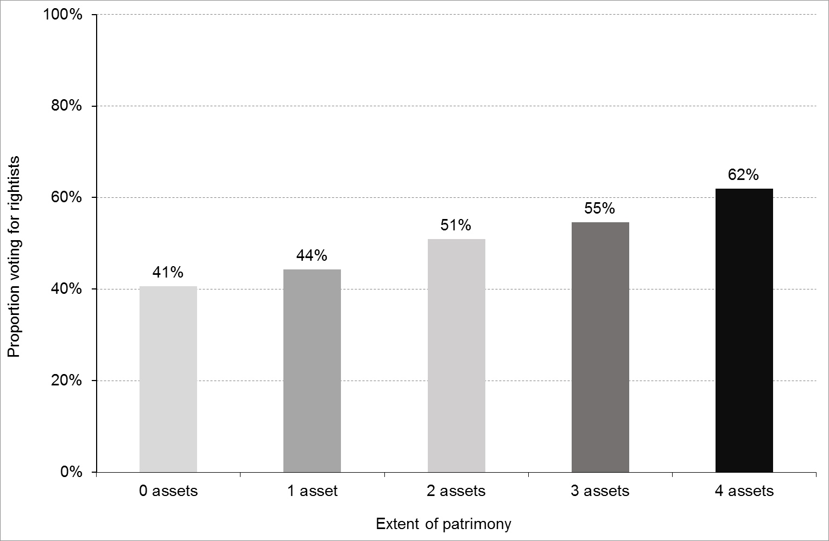
Figure E1 Reported vote for rightist party or candidate by the extent of patrimony (%).
Source of data: CSES 2018. Please note: Voters only. N=29,276.
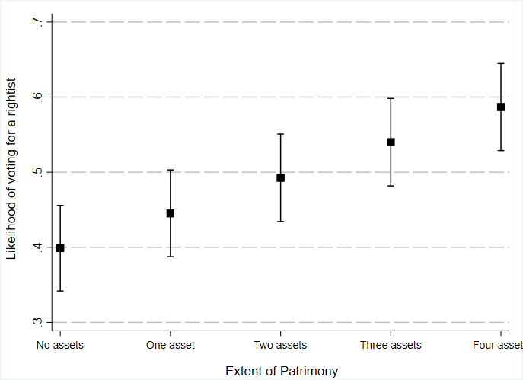
Figure E2 Predicted probability of voting for rightists by the extent of patrimony
. Source of data: CSES 2018.
Note: Voters only. Predicted probabilities based on Table 1, Model II and holding all other variables constant. Estimated using STATA margins command.

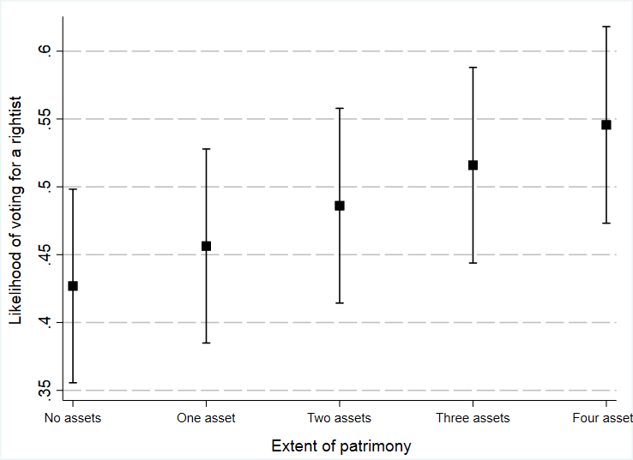
Figure E3 Predicted probability of voting for rightists by the extent of patrimony
. Source of data: CSES 2018.
Note: Voters only. Predicted probabilities based on Table 1, Model IV and holding all other variables constant. Estimated using STATA margins command.

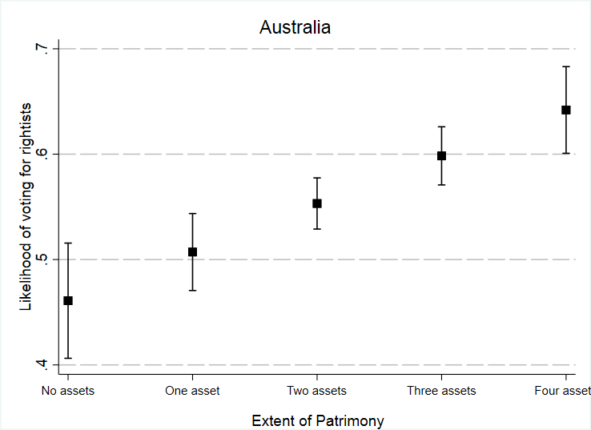 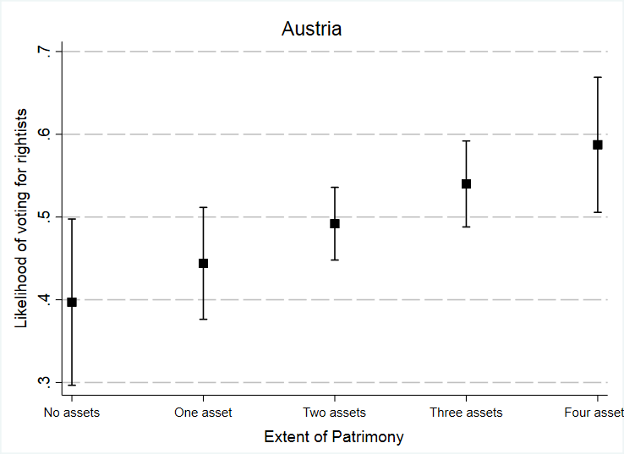b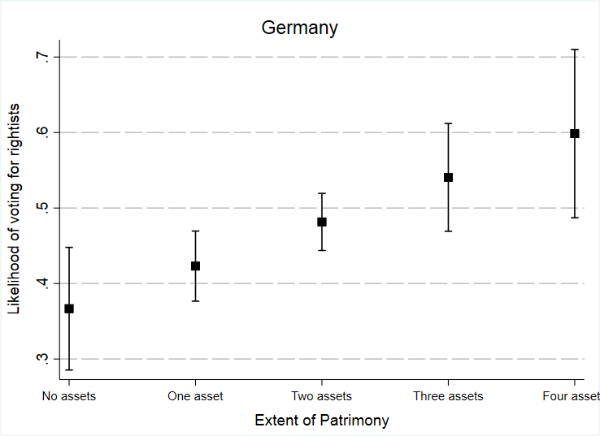
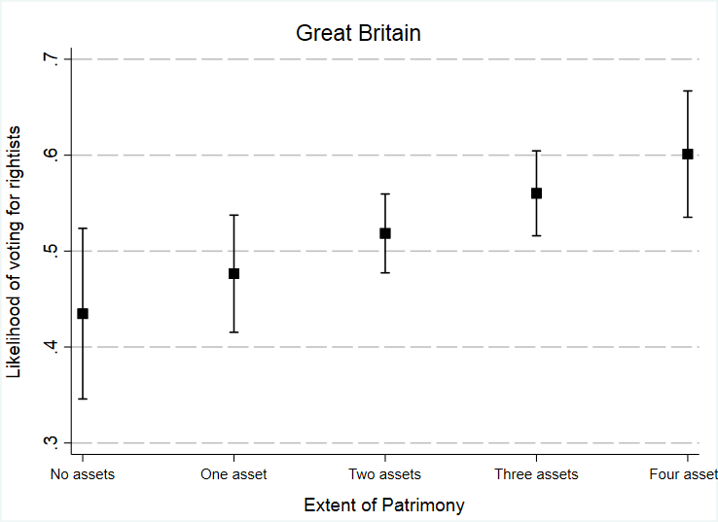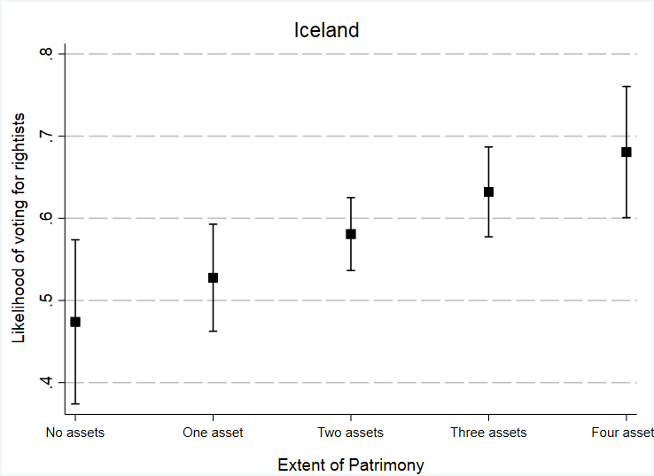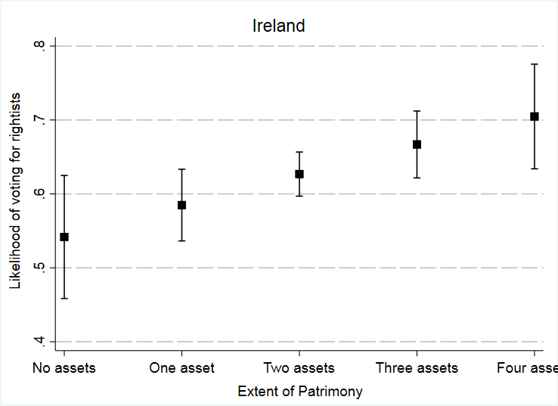
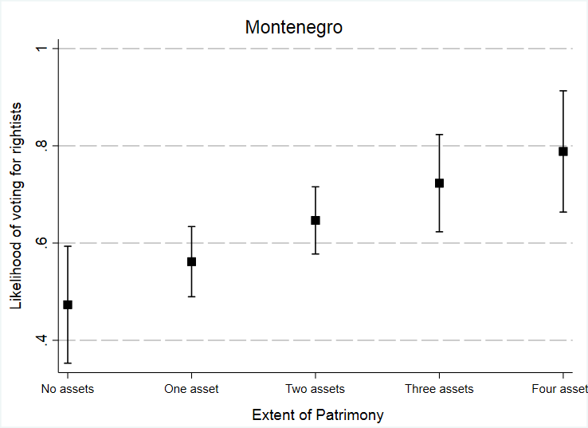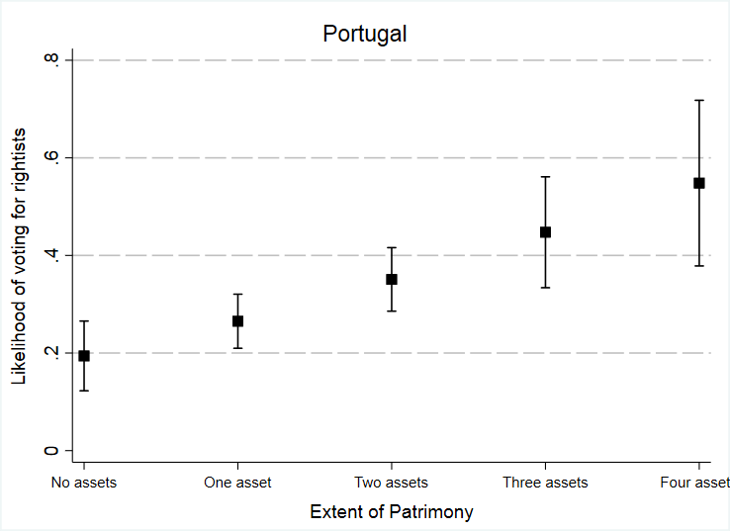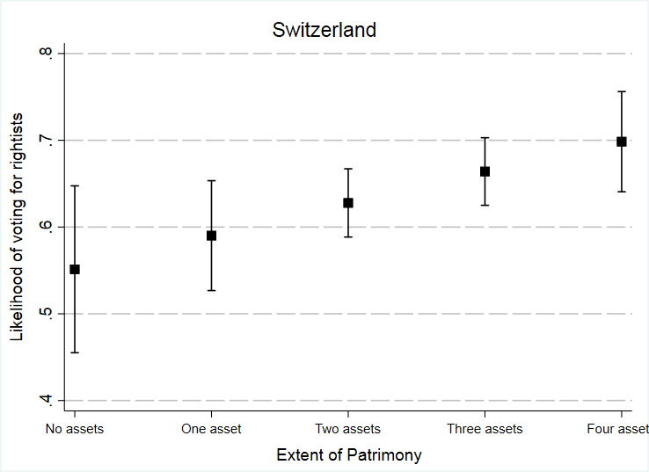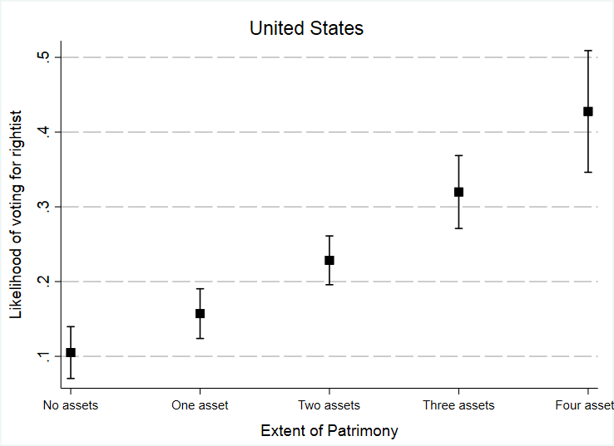

Figure E4 Predicted probability of voting for rightists by the extent of patrimony in countries
where direct effects of patrimony on the vote are detected. Source of data: CSES 2018.
Note: Voters only. Predicted probabilities based on country-level models

Data for the Republican Proposal Party, a constituent part of the Cambiemos alliance.

