Supplementary Figures

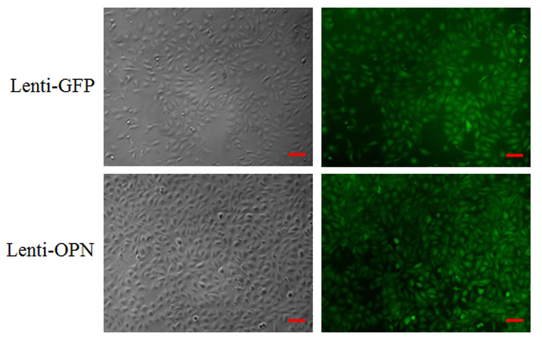Figure S1. The positive monoclonal BRL-3A cell lines in Lenti-GFP and Lenti-OPN groups were captured by using bright field (left panel) and fluorescence (right panel) microscopy. Scale bar = 50μm. The monoclonal BRL-3A cell lines were obtained by selecting some GFP positive cells and expanding them by limiting the dilution cloning in Lenti-OPN and control Lenti-GFP groups.

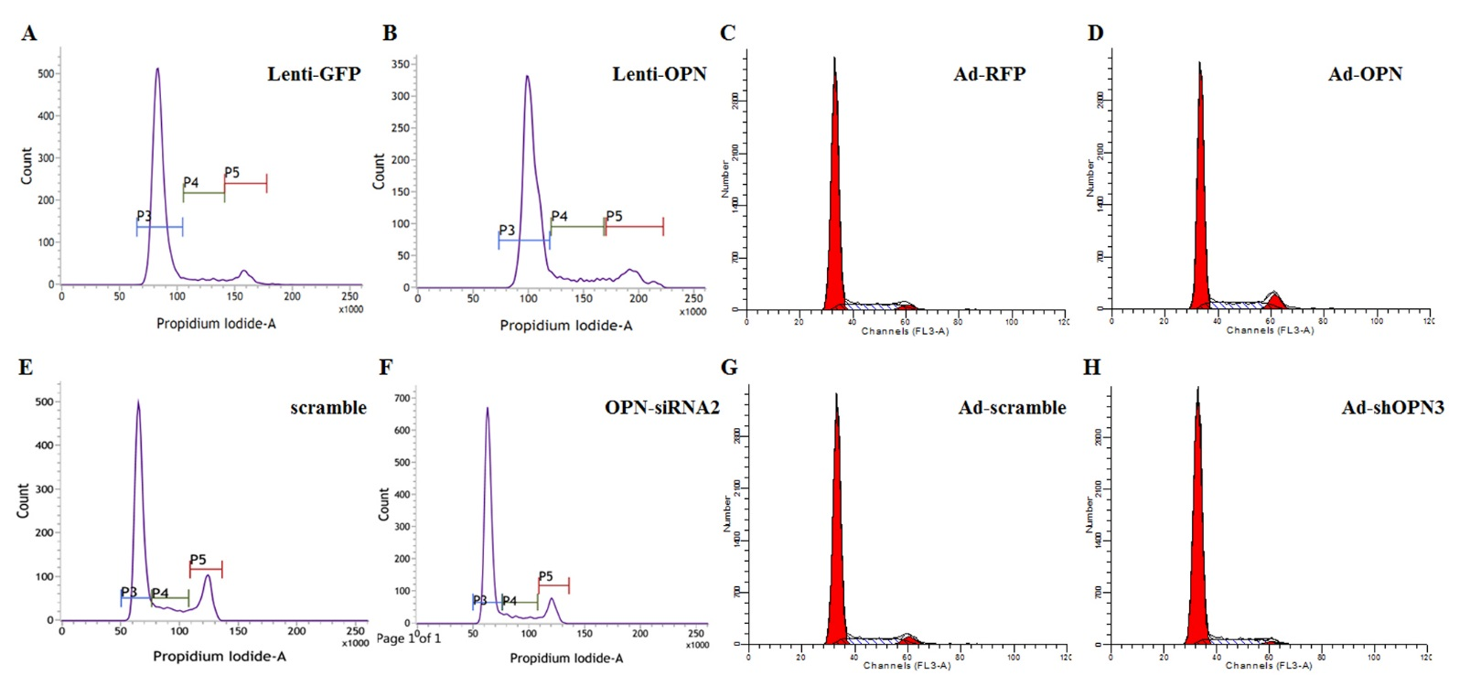
Figure S2. Representative flow cytometry results showing the effects of Lenti-GFP (A) and Lenti-OPN (B) on cell cycle distribution at 48h after seeding positive monoclonal BRL-3A cell lines, Ad-RFP (C) and Ad-OPN (D), scramble (E) and OPN-siRNA2 (F), and Ad-scramble (G) and Ad-shOPN3 (H) on cell cycle distribution at 48h after transfection.

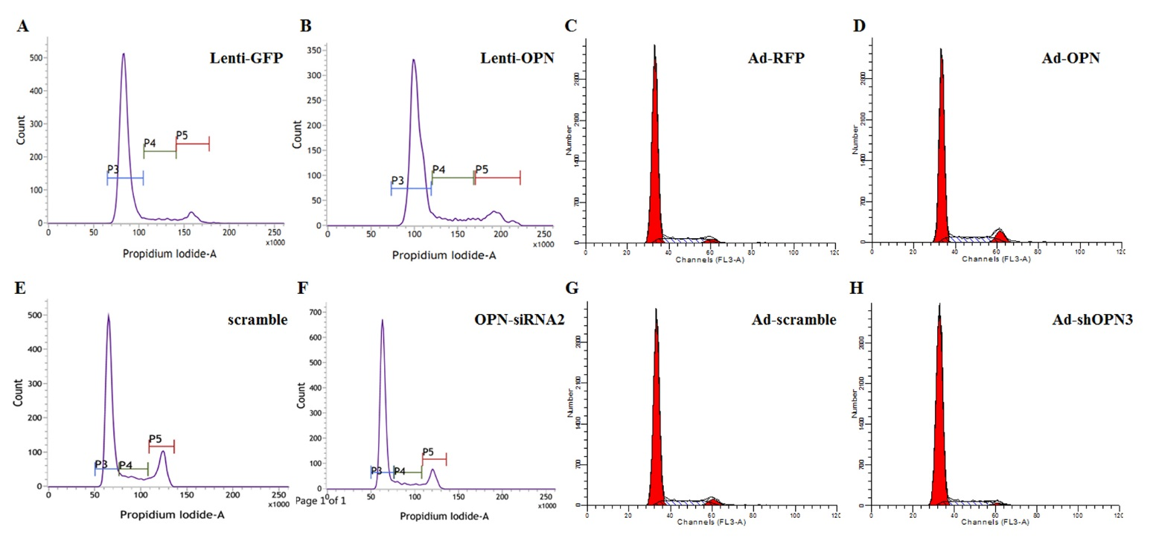
Figure S3. Immunofluorescence assays showing the expressions of Ki-67 in liver tissues at 3 and 24h after partial hepatectomy (PH) (Scale bar = 50μm). All groups were subjected to 2/3 partial hepatectomy, and then the experimental groups were injected with rrOPN, and the control groups with PBS through rat tail vein. Liver tissues were obtained for Ki-67 immunofluorescence assay for detecting the effect of rrOPN on hepatocyte proliferation, and the Ki67-positive cell rate showed no significant changes at 3 and 24h after PH between rrOPN group and control group.

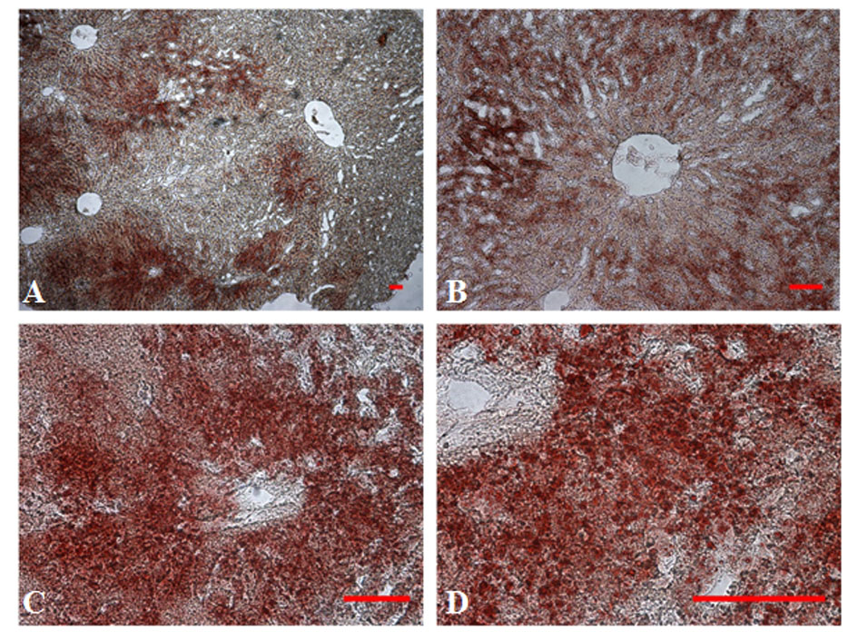

Figure S4. Sudan IV staining results displaying the lipid droplets in the hepatic cells around the liver central vein at 24h after partial hepatectomy. Scale bar = 100μm.

