Supplementary Material
Synthesis, spectral characterization, DFT and molecular docking studies of metal(II) complexes derived from thiophene-2-carboxaldehyde and 2-amino-6-picoline

LIJI JOHN, R. SELWIN JOSEYPHUS* and I. HUBERT JOE
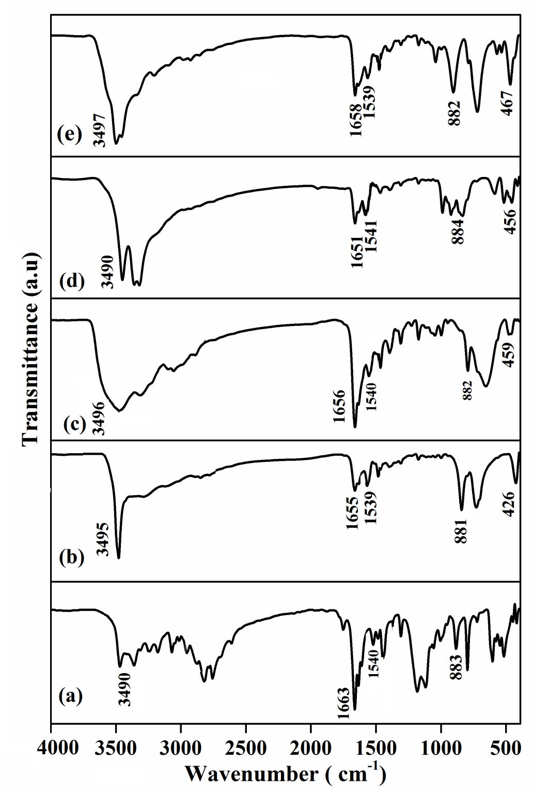
Figure S1. IR spectra of (a) ligand, (b) CoL₂Cl₂, (c) NiL₂Cl₂, (d) CuL₂Cl₂ and (e) ZnL₂Cl₂.
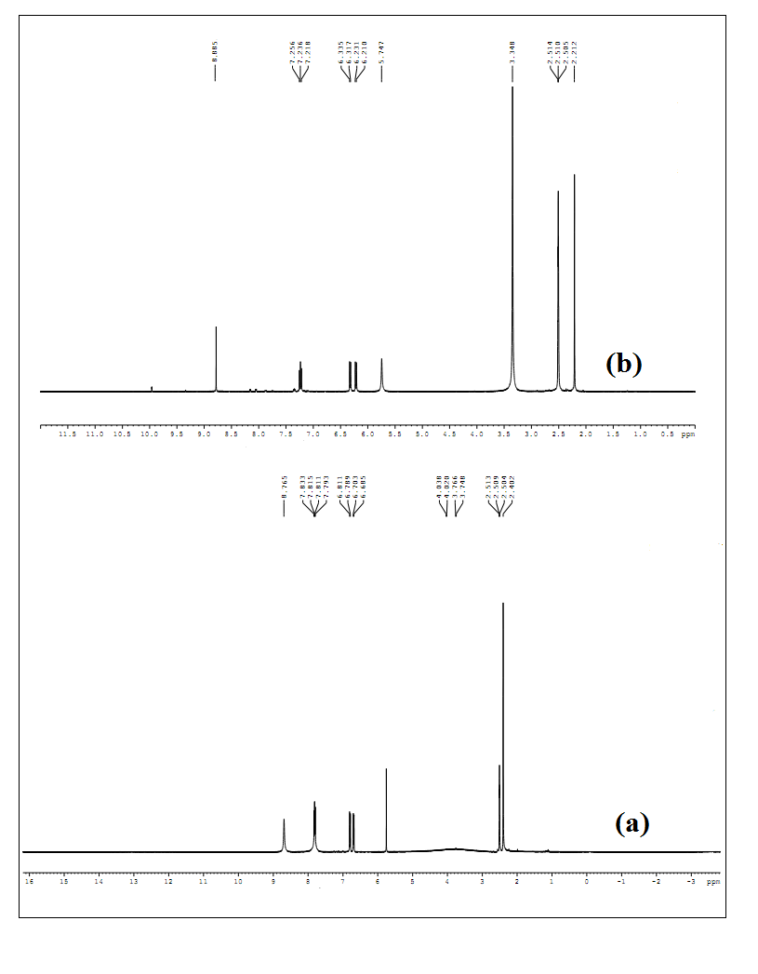
Figure S2. ¹H NMR spectrum of (a) ligand and (b) ZnL₂Cl₂.
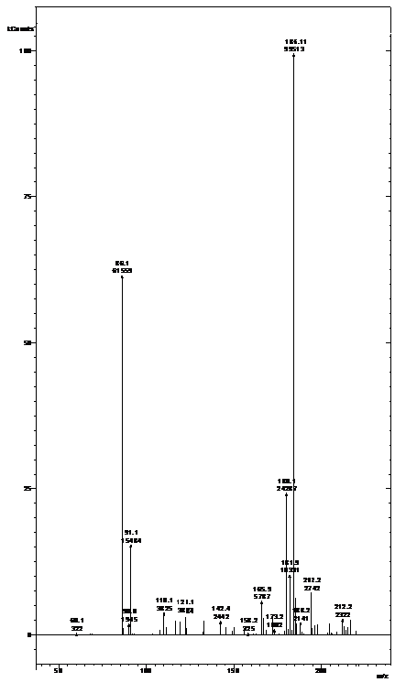
Figure S3. Mass spectrum of ligand.
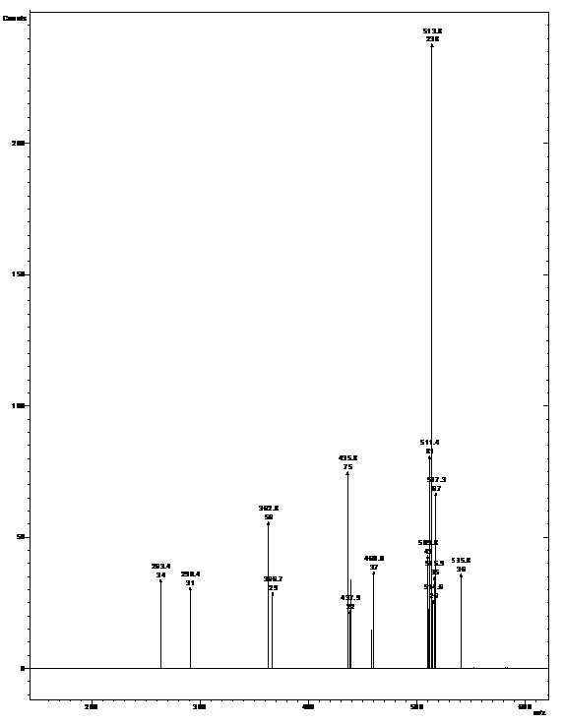
Figure S4. Mass spectrum of CoL₂Cl₂.
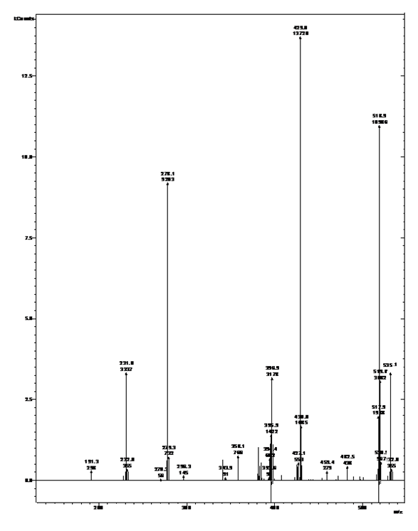
Figure S5. Mass spectrum of NiL₂Cl₂.
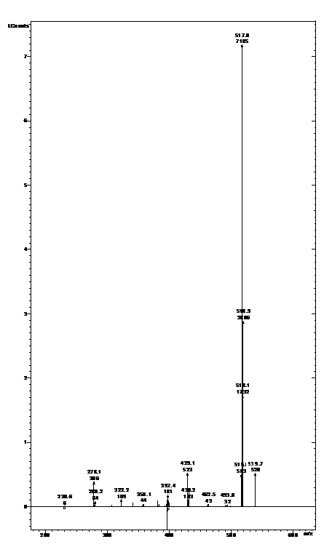
Figure S6. Mass spectrum of CuL₂Cl₂.
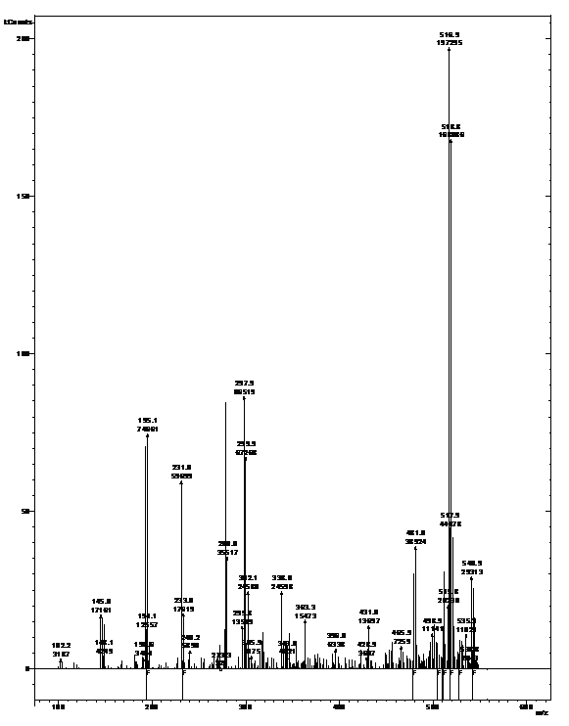
Figure S7. Mass spectrum of ZnL₂Cl₂.
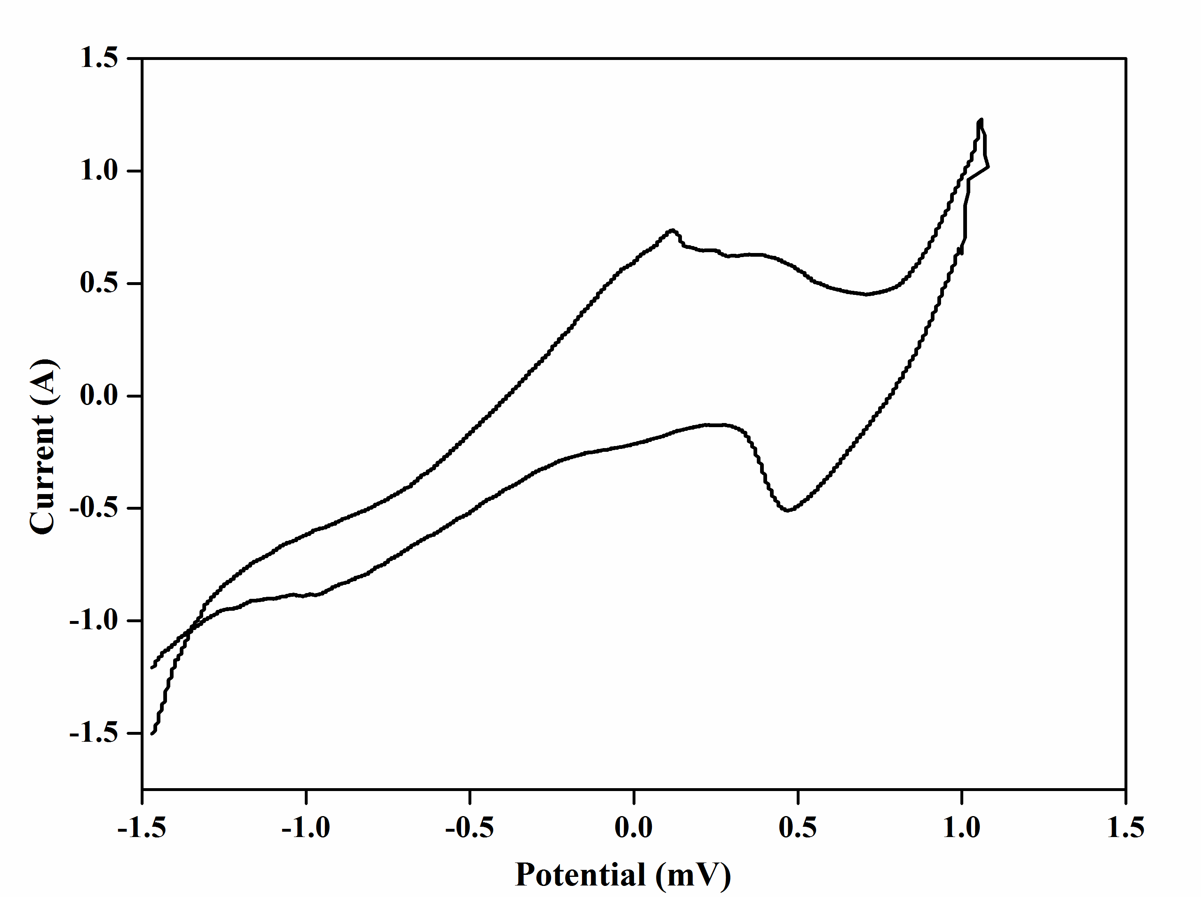
Figure S8. Cyclic voltammogram of CuL₂Cl₂.
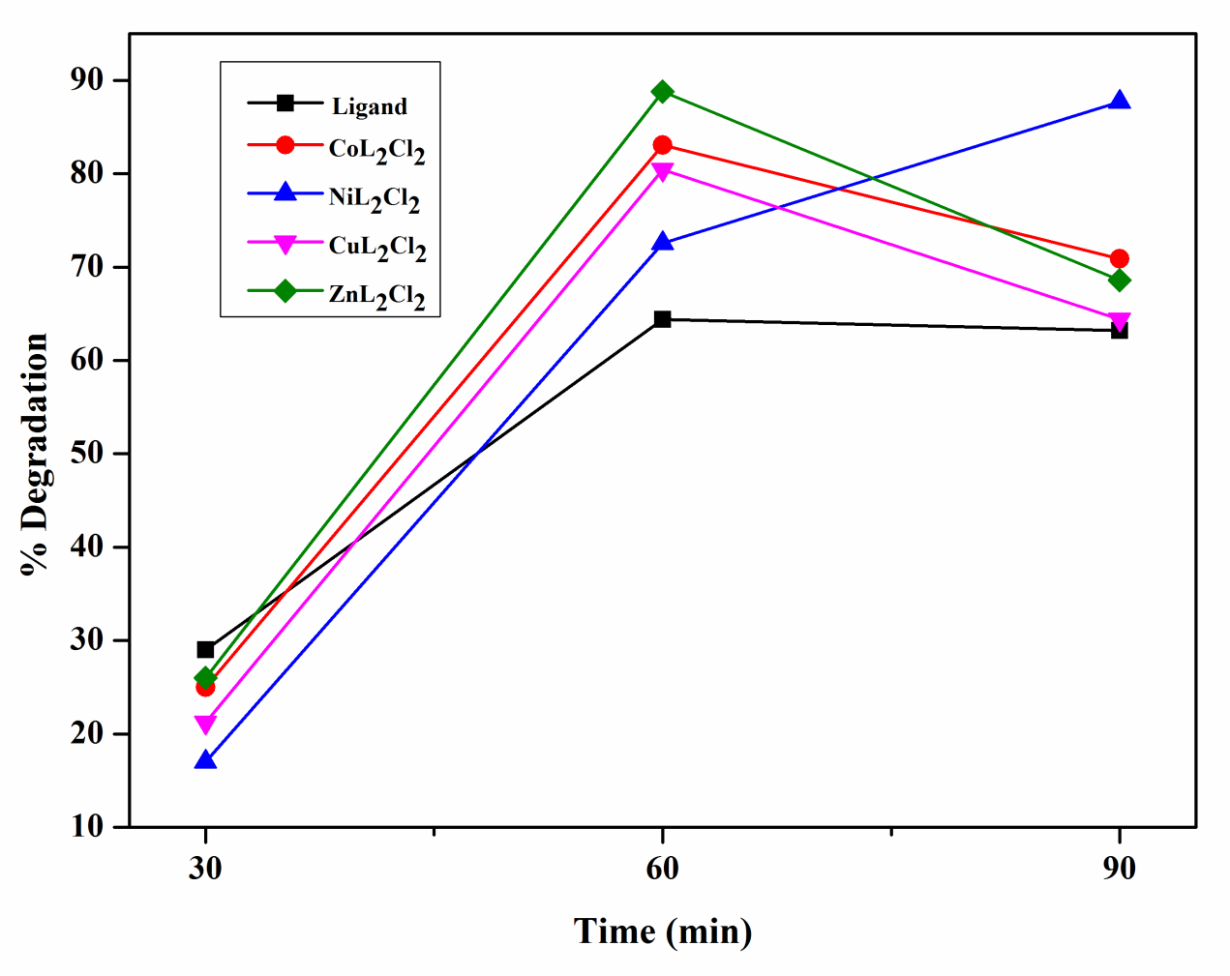
Figure S9. Percentage degradation of MB with time for ligand and metal complexes.
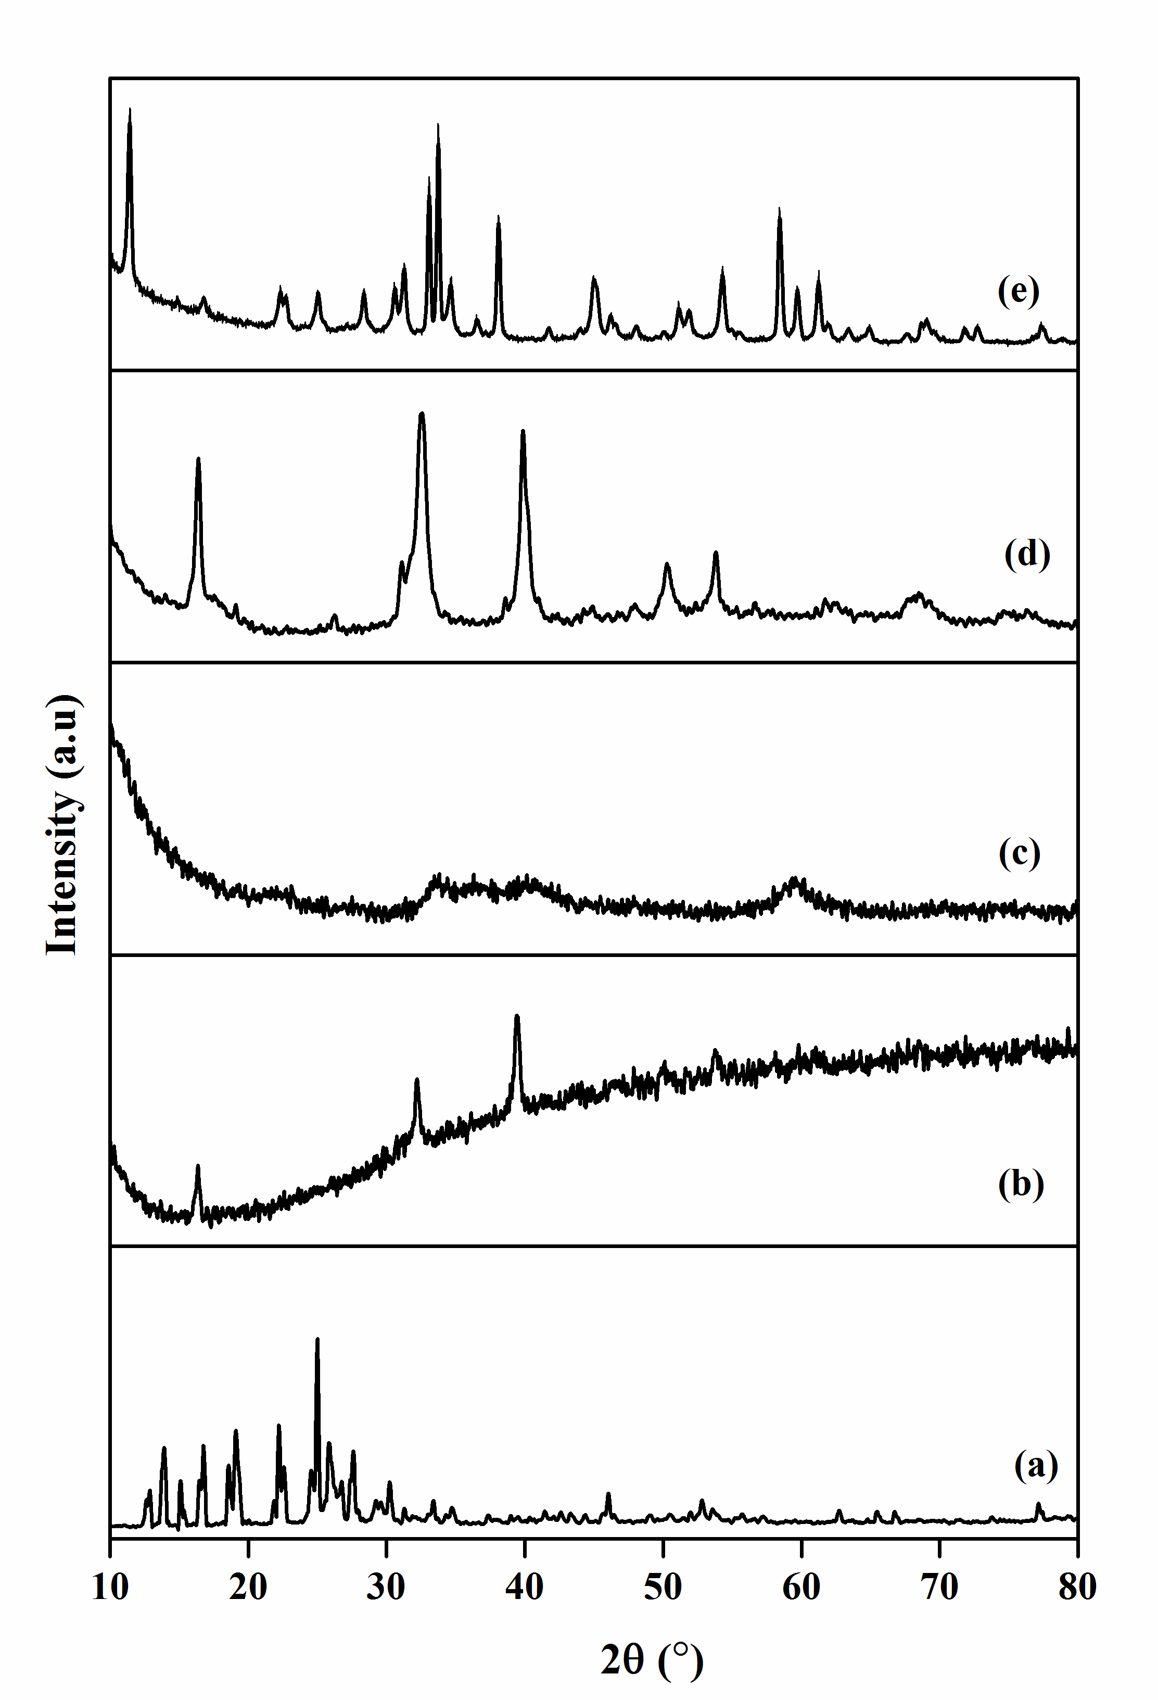
Figure S10. PXRD patterns of (a) ligand, (b) CoL₂Cl₂, (c) NiL₂Cl₂, (d) CuL₂Cl₂ and (e) ZnL₂Cl₂.
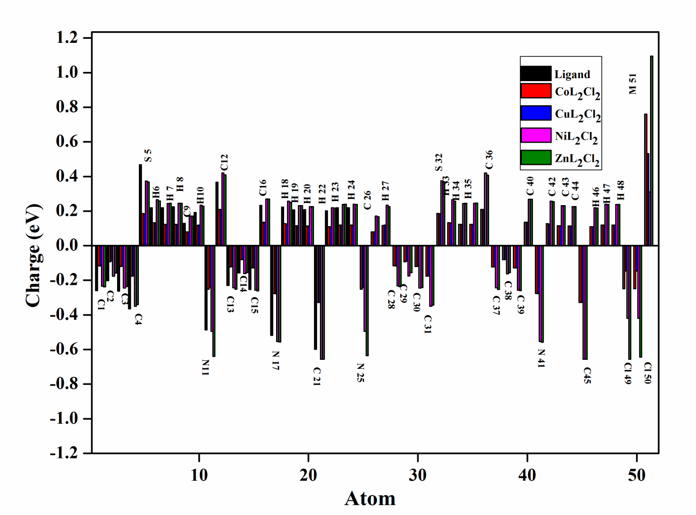
Figure S11. Plot of atomic charges of ligand and complexes.
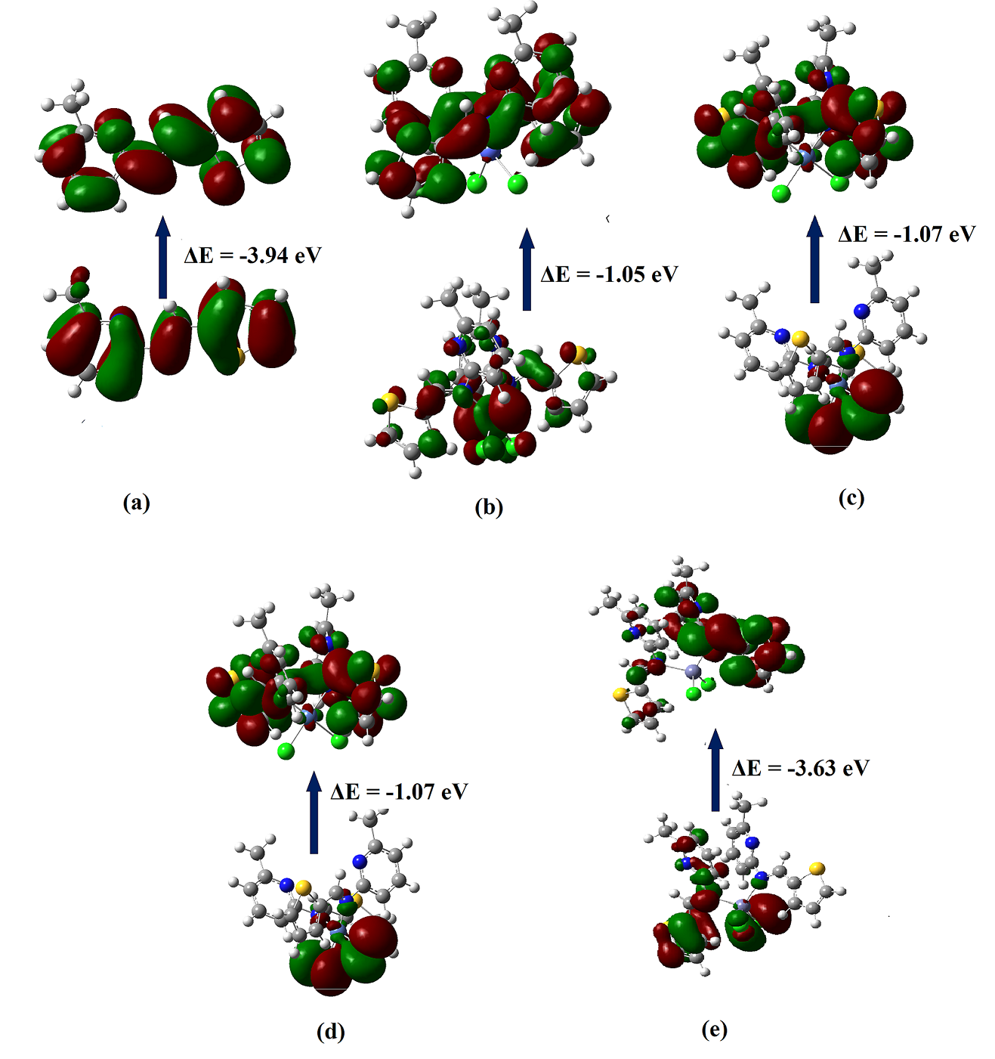
Figure S12. Graphic representation of HOMO and LUMO orbitals of (a) ligand, (b) CoL₂Cl₂, (c) NiL₂Cl₂, (d) CuL₂Cl₂ and (e) ZnL₂Cl₂.
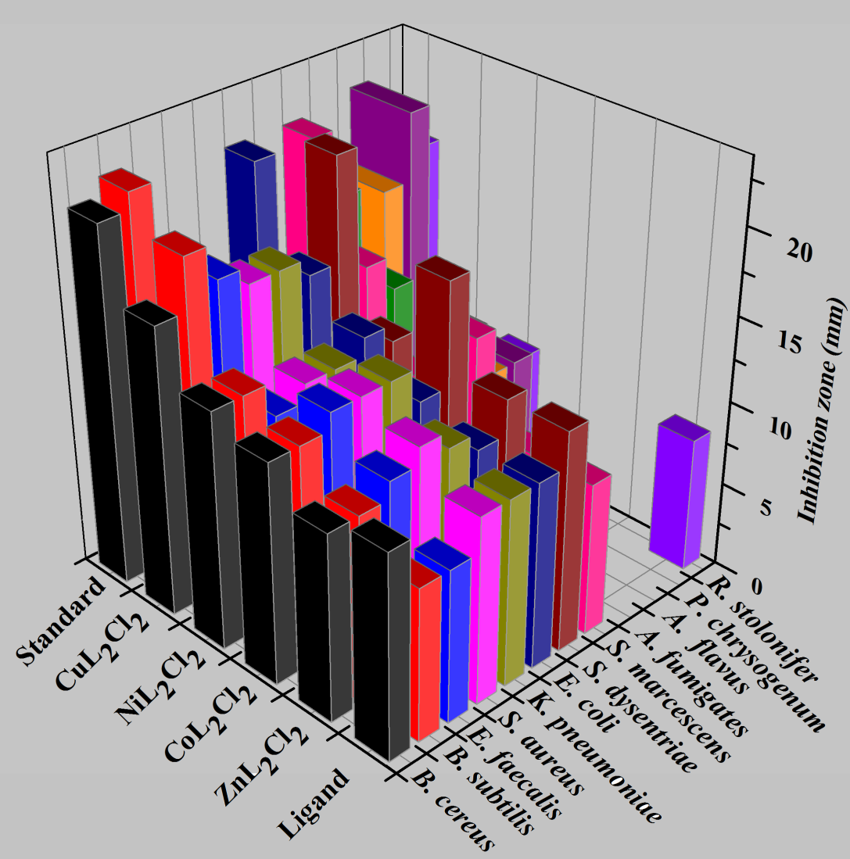
Figure S13. Antimicrobial activity of ligand and complexes.
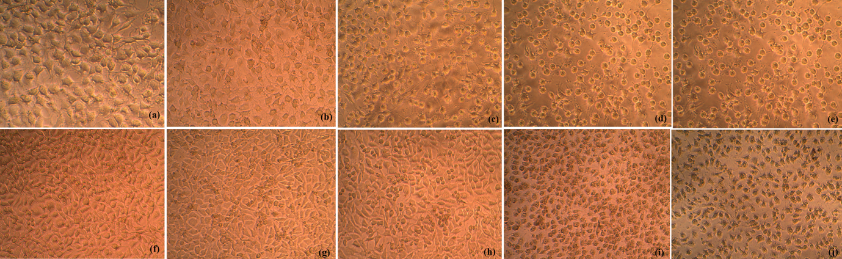
Figure S14. Morphological changes of L927 cells using (a - e) CoL₂Cl₂ and (f - j) CuL₂Cl₂ complexes by MTT assay.
Table S1. Percentage degradation of MB with time for ligand and complexes.
Time (min.) | % Degradation
Time (min.) | Ligand | CoL₂Cl₂ | NiL₂Cl₂ | CuL₂Cl₂ | ZnL₂Cl₂
30 | 29.00 | 25.00 | 17.00 | 21.20 | 26.00
60 | 64.40 | 83.07 | 72.56 | 80.44 | 88.80
90 | 63.20 | 70.87 | 87.70 | 64.40 | 68.60
Table S2. In vitro antimicrobial activities of ligand and complexes.
Microbial species |  | Zone of inhibition (mm) |  |  |  |  | Vanomycin / Clotrimazole
 |  | Ligand | CoL₂Cl₂ | NiL₂Cl₂ | CuL₂Cl₂ | ZnL₂Cl₂ | Vanomycin / Clotrimazole
Antibacterial | B. cereus | 12 | 17 | 14 | 13 | 11 | 21
Antibacterial | B. subtilis | 9 | 20 | 14 | 13 | 11 | 22
Antibacterial | E. faecalis | 9 | 18 | 12 | 14 | 12 | 13
Antibacterial | S. aureus | 13 | 17 | 13 | 14 | 13 | 15
Antibacterial | E. coli | 11 | 17 | 13 | 14 | 12 | 13
Antibacterial | K. pneumonia | 11 | 16 | 14 | 12 | 11 | 21
Antibacterial | S. dysentriae | 13 | 22 | 13 | 18 | 13 | 13
Antibacterial | S. marcescens | 9 | 15 | 10 | 14 | 9 | 21
Antifungal | A. fumigates | - | 13 | 10 | 9 | - | 17
Antifungal | A. flavus | - | - | 9 | - | - | 17
Antifungal | P. chrysogenum | - | - | 9 | - | - | 21
Antifungal | R. stolonifer | 8 | 8 | 8 | - | - | 18
Table S3. Percentage cell viability at different concentrations of CoL₂Cl₂ and CuL₂Cl₂ complexes.
Complexes | Concentration (µg/mL) | Average optical density | Cell viability (%)
 | control | 0.5242 | 100
CoL₂Cl₂ | 6.25 | 0.3925 | 74.88
CoL₂Cl₂ | 12.5 | 0.3567 | 68.05
CoL₂Cl₂ | 25 | 0.3075 | 58.65
CoL₂Cl₂ | 50 | 0.2519 | 48.06
CoL₂Cl₂ | 100 | 0.1899 | 36.23
CuL₂Cl₂ | 6.25 | 0.5106 | 97.40
CuL₂Cl₂ | 12.5 | 0.4955 | 94.52
CuL₂Cl₂ | 25 | 0.4255 | 81.17
CuL₂Cl₂ | 50 | 0.1584 | 30.21
CuL₂Cl₂ | 100 | 0.1284 | 24.49

