Supplementary Material

Bioactive NHC-derived palladium complexes: Synthesis, catalytic activity for the Suzuki-Miyaura coupling of aryl chlorides and bromides and their antibacterial activities

L. BOUBAKRI, L. MANSOUR, İ. ÖZDEMIR, S. YASAR and N. HAMDI*

**Spectroscopic study of Pd-bis(NHC) complex 2d**

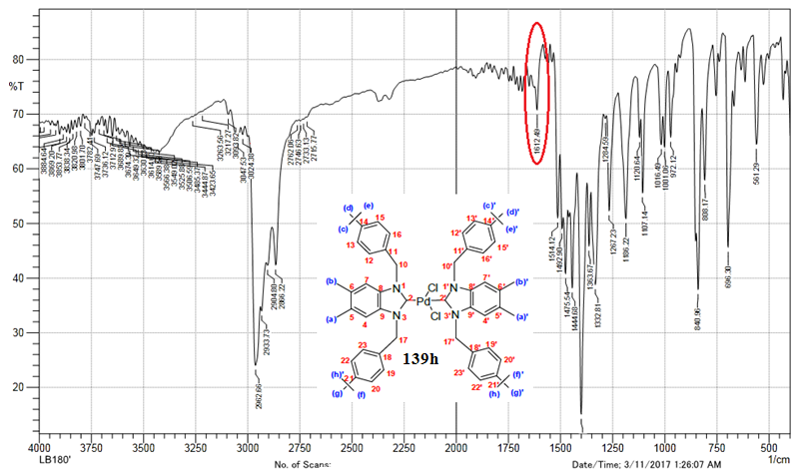

**2d**

ν(C-N)

Figure S1. FT-IR spectrum of **2d** recorded as a solid dispersion in KBr.

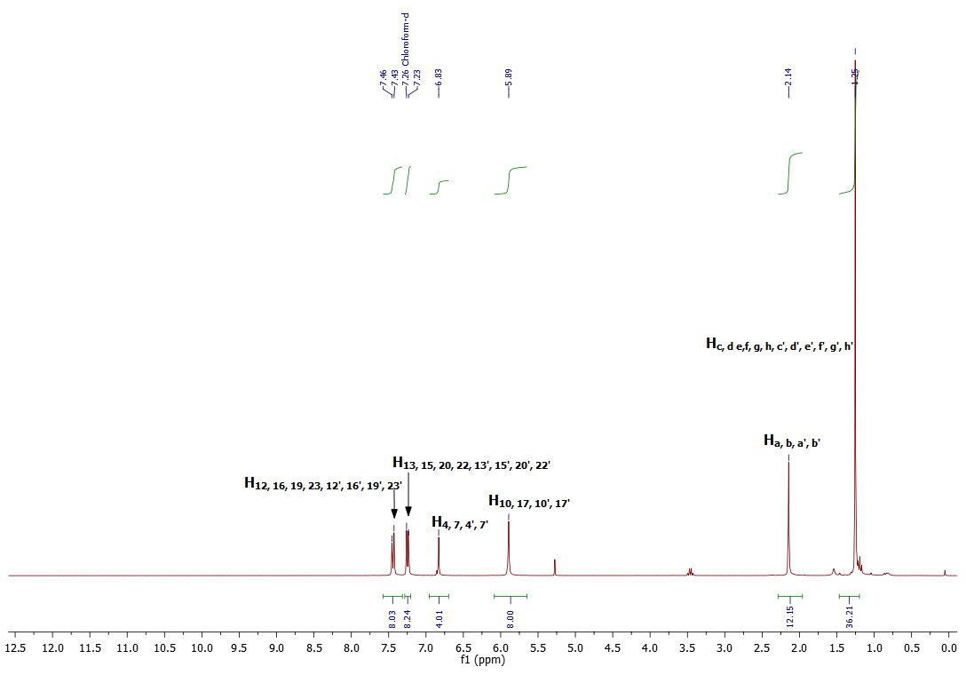

**1d**

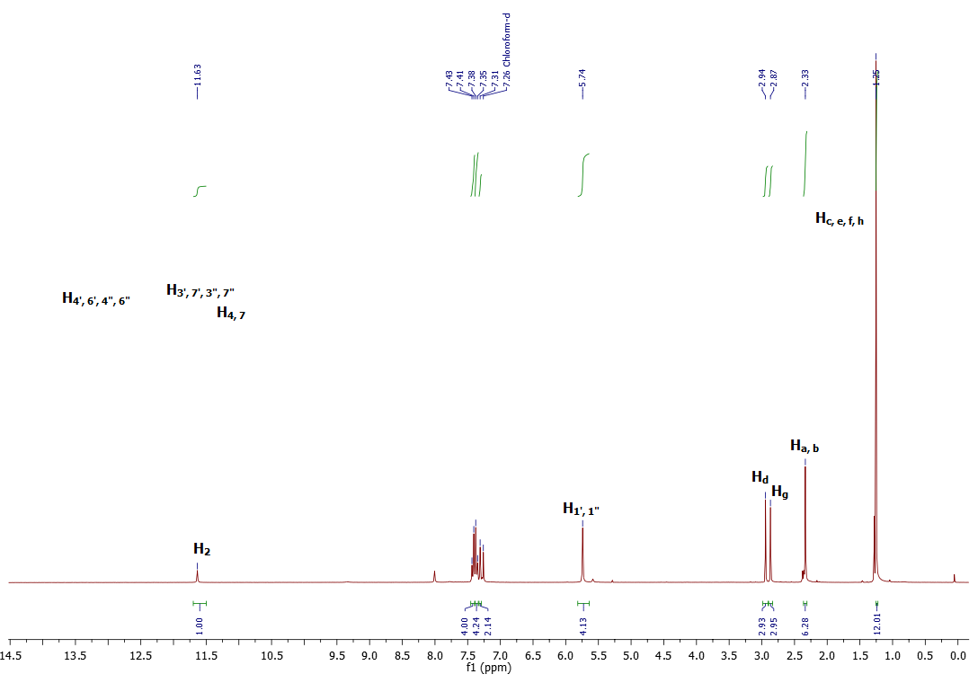



**2d**



δ(ppm)

Figure S2. 1H-NMR spectrum of **2d** in CDCl3.

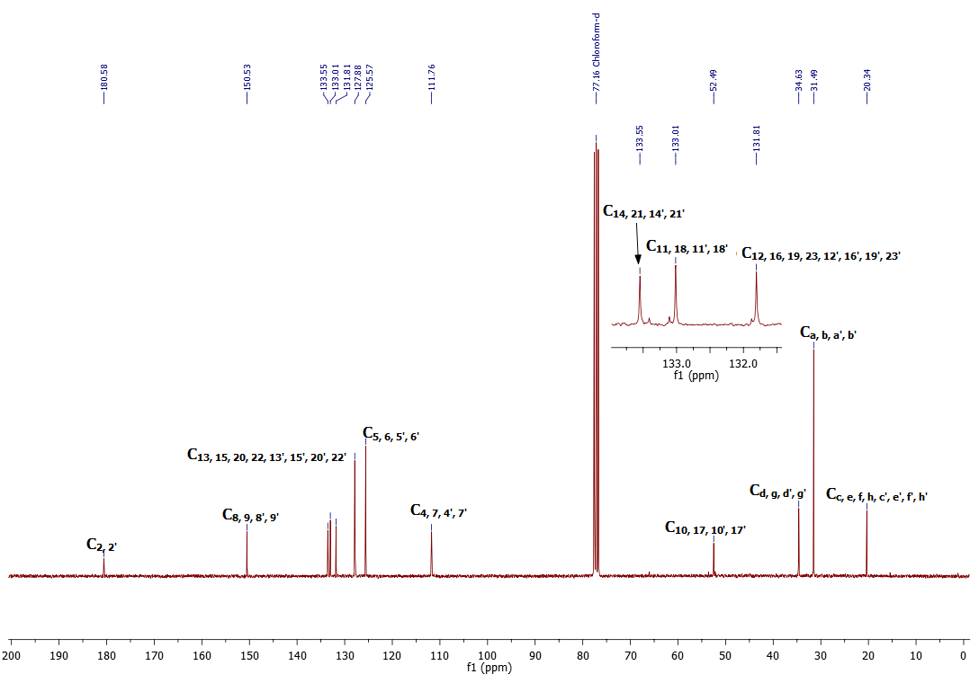

**2d**

**1d**



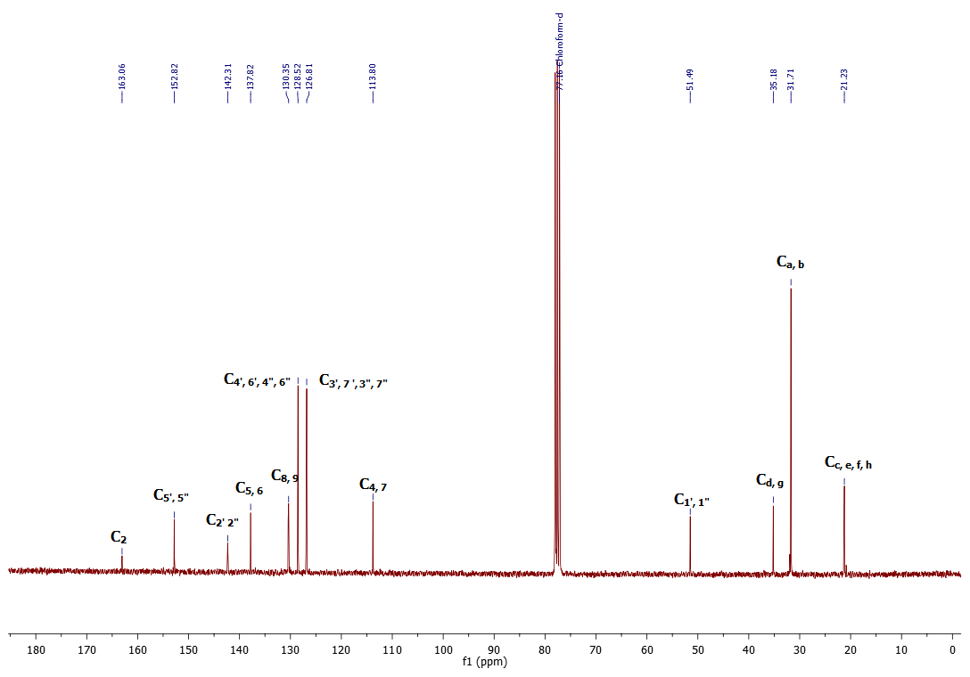



δ(ppm)

**2h**

Figure S3. 13C-NMR spectrum of **2d** in CDCl3.

The results of the mass spectrometry analyses are verification of the synthesized compounds (figure S4).



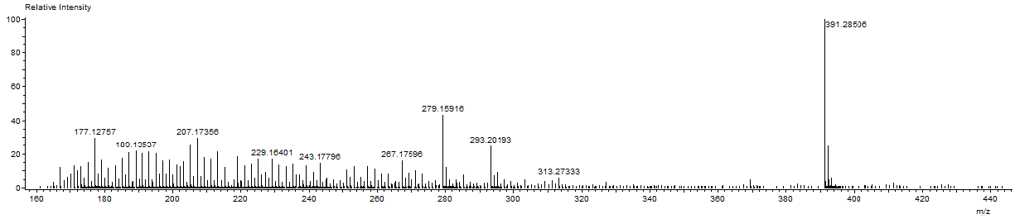

**2d**

Figure S4. DART-TOF-MS of **2d**.

The fragmentation leading to m/z = 293 ion can occur by the mechanisms shown in scheme S1.



Scheme S1. Mechanism of fragmentation leading to m/z = 293.