Appendixes

Appendix A. Search Strategy

Search in Medline, Cochrane Central, and Embase all via OVID
- Emergency Medical Services/
- Emergency Medical Technicians/
- Emergency Treatment/
- Emergency Medicine/
- AMBULANCES/ or AIR AMBULANCES/
- First Aid/
- prehospital.mp.
- pre-hospital.mp.
- paramedic*.mp.
- ambulance*.mp.
- out-of-hospital.mp.
- out of hospital.mp.
- ems.mp.
- emt.mp.
- emergency services.mp.
- emergency medical service*.mp.
- emergency technician*.mp.
- emergency practitioner.mp.
- emergency dispatch*.mp.
- emergency despatch*.mp.
- first responder*.mp.
- emergency rescue*.mp.
- emergency resus*.mp.
- emergency triage.mp.
- military medicine/
- military medicine.mp
- battlefield.mp
- combat.mp
- emergency department.mp
- hospital/
- morphine/
- fentanyl/
- ketamine/
- nitrous oxide/
- ketorolac/
- ketorolac tromethamine/
- ibuprofen/
- acetaminophen/
- morphine.mp
- ketamine.mp
- ketorolac.mp
- fentanyl.mp
- nitrous oxide*.mp
- ibuprofen.mp
- acetaminophen.mp
- 31 or 32 or 33 or 34 or 35 or 36 or 37 or 38 or 39 or 40 or 41 of 42 or 43 or 44 or 45
- 1 or 2 or 3 or 4 or 5 or 6 or 7 or 8 or 9 or 10 or 11 or 12 or 13 or 14 or 15 or 16 or 17 or 18 or 19 or 20 or 21 or 22 or 23 or 24 or 25 or 26 or 27 or 28 or 29 or 30
- 46 and 47
- epidemiologic studies/
- exp cohort studies/
- exp case-contol studies/
- case control.tw.
- (cohort adj (study or studies)).tw.
- cohort analy$.tw.
- (follow up adj (study or studies)).tw.
- (observational adj (study or studies)).tw.
- longitudinal.tw.
- retrospective.tw.
- cross sectional.tw.
- cross-sectional studies/
- or/49-60
- randomized controlled trials as topic/
- randomized controlled trial/
- random allocation/
- double blind method/
- single blind method/
- clinical trial/
- clinical trial, phase i.pt.
- clinical trial, phase ii.pt.
- clinical trial, phase iii.pt.
- clinical trial, phase iv.pt.
- controlled clinical trial.pt.
- randomized controlled trial.pt.
- multicenter study.pt.
- clinical trial.pt.
- exp clinical trials as topic/
- or/62-76
- (clinical adj trial$).tw.
- ((singl$ or doubl$ or treb$ or tripl$) adj (blind$3 or mask$3)).tw.
- placebos/
- placebo$.tw.
- randomly allocated.tw.
- (allocated adj2 random$).tw.
- or/78-83
- 77 or 84
- case report.tw.
- letter/
- historical article/
- or/86-88
- 85 not 89
- 61 or 90
- 91 and 48

Appendix B. Clinical Important Differences

Conclusions were constructed with consideration of the absolute effect estimates and their corresponding confidence intervals compared to clinically important differences (CID) established for this review (Appendix Table 1). These CIDs reflect input from our EPC and consultant experts, NHTSA, and the TEP. When the body of evidence generated a point estimate and confidence interval that exceeded the CID in one direction we concluded a difference exists between the analgesics compared for that outcome. When the point estimate and confidence interval suggested a CID may exist (confidence interval included both a CID and also a smaller difference, but overall was shifted towards a CID) we concluded there “may” be a difference between the two analgesics for that outcome. When the point estimate and confidence interval were entirely within the CID such that a CID in either direction was ruled out, we concluded “there was no evidence of a clinically important difference” for that analgesic comparison and outcome. We reserved use of “inconclusive” for when the confidence interval of the absolute measure was uninformative and included possibility of a CID in either direction or when the evidence base had multiple downgraded domains such that we were uncertain what the true effect was.
Appendix Table 1. Clinically Important Differences for Graded Outcomes
Outcome | Clinically important difference
Pain score | 2 points on a continuous scale from 0 to 10
Presence of pain, hypotension, respiratory depression, mental status changes | ARD of 5%
Time to analgesic effect | 5 minutes on a continuous scale
Any adverse events | ARD of 10%
Abbreviations: ARD=absolute risk difference

Appendix C. Evidence Tables

Appendix Table 2. Study and population characteristics, prehospital setting
Author, year  Country  Design  Risk of Bias | Eligibility | Intervention and Comparator | Population Characteristics | Outcomes
Bronsky, 2018³⁹  United States  Design: OBS  Risk of bias: Low | ≥18y old with severe pain (≥7/10)  Exclusions: Indications other than severe pain, received a combination of analgesics, treated solely by fire department, never visited ED, or received treatment through non-IV route | A: Fentanyl 2 mcg/kg IV q10min prn (max 2 doses, mean morphine equivalent 8.3 (2.4)) (n=79)  B: Ketamine 0.3 mg/kg IV q20min prn (max 3 doses, mean morphine equivalent 8.3 (2.8)) (n=79)  Rescue NR | Age A: 58.1 (19.9) B: 58.4 (21.7)  Males A: 39% B: 39%  Weight: NR  Race/ethnicity A/B: Caucasian 91%/89%, Black 3%/6%, American Indian 0%/1%, Other 6%/4%  Pain etiology/location A/B: Fall 39%/53%, MVC 11%/6%, Assault 3%/3%, Medical complication 10%/3%, Other 20%/28%, Unknown 16%/8%  Pain Classification: Mixed | Mental status changes  Pain severity  Presence of pain  Respiratory depression
Oberholzer, 2017³⁸  Switzerland  Design: OBS  Risk of bias: Low | 15y old transported by EMS with moderate to severe pain (NRS>3/10)  Exclusions: GCS≤12, NACA score ≥VI, patients too unstable or sedated to determine and verbalize 2 NRS scores (at scene and hospital arrival) | A: Morphine IV (mean 7.0 mg (4.6)) (n=107) OR Fentanyl IV (mean 140 mcg (109)) (n=521)  B: Ketamine IV (mean 58 mg (37)) (n=137)  Rescue NR | Age NR  Males NR  Weight NR  Race/ethnicity NR  Pain etiology/location: Trauma 69%  Pain Classification: Mixed | Presence of pain
Tran, 2014²  Vietnam  Design: RCT  Risk of bias: Medium | Trauma patients in need of analgesia, at least 30 months old  Exclusions: objections to pain treatment, coma, in-field anesthesia for invasive life support, deep unconsciousness upon first infield contact, prehospital evacuation time of <10min | A: Morphine 5mg (child) or 10mg (adult) IM (n=139)  B: Ketamine 0.2 to 0.3 mg/kg slow intermittent IV injection (mean dose 15mg) (n=169)  Rescue: NR | Age A:36.9(NR) B:35.5(NR)  Males A:80% B:75%  Weight NR  Race/ethnicity NR  Pain etiology/location: Road traffic accident casualties 61%, falls 24%, mine accidents 9%  Pain Classification: Traumatic | Pain severity  Presence of pain
Jennings, 2012¹⁶  Australia  Design: RCT  Risk of bias: Low/medium | ≥18y reporting traumatic pain with VNRS ≥5 after total dose of morphine 5mg IV, speaking and able to rate their pain  Exclusions: Drug allergy, pregnant or lactating, current ischemic chest pain or acute pulmonary edema, SBP>180 and evidence of a head injury, history of LOC or GCS score <15, inability to obtain venous access, presumed intoxication with alcohol/illicit substances | A: Ketamine 10 or 20mg bolus, repeat 10mg every 3min until pain free or serious adverse event or arrival at the ED, mean 40.6mg (25) (n=70)  B: Morphine 5mg bolus, repeat 1 to 5mg every 5min until pain free or a serious adverse event or arrival at the ED, mean 14.4mg (9.4) (n=65)  Rescue: No therapies other than those randomized were allowed | Age A: 41(26-56) B:45(31-66)  Males A:64% B:58%  Weight NR  Race/ethnicity NR  Pain etiology/location A/B: Extremity fracture 37%/45%, soft tissue injury 24%/23%, fracture- other 20%/20%, dislocation 16%/11%, burn 3%/1%  Pain Classification: Traumatic | Any AE  Hypotension  Mental status changes  Pain severity  Time to analgesic effect
Johansson, 2009¹⁷  Sweden  Design: RCT  Risk of bias: Low/medium | Adults w/bone fractures in acute pain (NRS>4/10) after morphine 0.1 mg/kg IV  Exclusions: Inability to use the rating scale, long-term use of opioids, hx of chronic pain, hx of/or acute MI, unconsciousness | A: Morphine 0.1 mg/kg IV (n=11)  B: Ketamine 0.2 mg/kg IV (n=16)  Rescue: NR | Age A:70(16) B:74(14)  Males A:54.5% B:43.8%  Weight A:72.9kg (13.6) B:70.1kg (10.4)  Race/ethnicity NR  Pain etiology/location: Bone fracture 100%  Pain Classification: Traumatic | Mental status changes  Pain severity
Galinski, 2007¹⁸  France  Design: RCT  Risk of bias: Low | 18-70y old, trauma with severe, acute pain (VAS≥60/100)  Exclusions: Respiratory distress, SBP<90, GCS<15, psychiatric history; chronic respiratory, renal, or hepatic failure; drug allergy, treatment of chronic pain or treatment with opioids; incapacity to understand the VAS; pregnancy; indication for local or regional analgesia, already received an opioid analgesic | A: Morphine 0.1 mg/kg IV + ketamine 0.2mg/kg IV over 10min; then morphine 3mg every 5min until VAS≤30/100 (n=38)  B: Morphine 0.1mg/kg IV + placebo over 10min, then morphine 3mg every 5min until VAS≤30/100 (n=35)  Rescue: NR | Age A:35(13) B:40(14)  Males A:75.8% B:71.9%  Weight NR  Race/ethnicity NR  Pain etiology/location A/B: Suspicion of bone fracture 58%/75%; burns 6%/6%, other 36%/19%  Pain Classification: Traumatic | Mental status changes  Pain severity  Presence of pain  Respiratory depression

Appendix Table 3. Study and population characteristics, emergency department setting
Author, year  Country  Design  Risk of Bias | Eligibility | Intervention and Comparator | Population Characteristics | Outcomes
Frey, 2019¹  United States  Design: RCT  Risk of bias: Low | 8-17y old with acute extremity injury & VAS≥35/100  Exclusions: Significant head, chest, abdomen or spine injury, GCS<15 or inability to report a VAS score, nasal trauma or aberrant nasal anatomy, active epistaxis, drug allergy, history of psychosis, opioid administration prior to arrival, non-English speaking, in police custody, postmenarchal without a negative pregnancy test | A: Fentanyl 2 mcg/kg IN (max 100 mcg, median 1.9 mcg/kg IQR 1.7 to 1.9) (n=42)  B: Ketamine 1.5 mg/kg IN (max 100 mg, median 1.5 mg/kg IQR 1.5 to 1.5) (n=44)  Rescue: NR | Age A:12.2(2.3) B:11.8(2.6)  Males A:74% B:59%  Weight A:50.8kg(22.8) B:45.8kg(14.4)  Race/ethnicity A/B: White 69%/68%, Black 24%/25%, other 7%/7%  Pain etiology/location A/B: Fracture 81%/85%, dislocation 5%/9%, sprain/strain 12%/2%, other 2%/4%  Pain Classification: Traumatic | Any AE  Hypotension  Pain severity  Respiratory depression
Verki, 2019⁶  Iran  Design: RCT  Risk of bias: low | 18-55 years old with limb fracture, VAS score higher than 3  Exclusions: Consumed anti-psychotic, sedative, TCA, MAOI, SSRI drugs, opioid addicts, patients with underlying acute or chronic renal and hepatic disease, cardiac disease, upper and/or lower respiratory infection, asthma, COPD, or allergies, pregnant or breast-feeding women, fentanyl-prohibited patients, those with multiple myeloma, a history of convulsion, ketamine allergy, head injury, or avulsion fractures, and patients with unstable hemodynamic factors | A: Fentanyl 4mcg/kg nebulized (n=62)  B: Ketamine 0.4mg/kg IV over 10 min (n=65)  Rescue: VAS>3 after 60 min-treated with morphine 0.1 mg/kg IV | Age A: 34.5(11.97) B: 36.28(10.73)  Males A:72.6% B:66.2%  Weight NR  Race/ethnicity NR  Pain etiology/location: Limb fracture 100%  Pain classification: Traumatic | Pain severity
Abbasi, 2018²²  Iran  Design: RCT  Risk of bias: Low | 18-65y old previously diagnosed with nephrolithiasis or urinary stone by a urologist w/VAS ≥6/10  Exclusions: Unstable vitals (SBP<90 mmHg, HR<60 or >120, RR <8 or >22, O2 saturation <92%, narcotic analgesic before admission, history of liver disease, kidney disease, chronic respiratory, CVD, known blood coagulation, chronic mental illness, use of psychiatric drugs, addiction to drugs and psychotropic substances, drug allergy, inability to understand the concept of VAS | A: Morphine 0.1 mg/kg + ketamine 0.15 mg/kg IV (n=53)  B: Morphine 0.1 mg/kg + placebo IV (n=53)  Rescue: Morphine IV continued until a VAS ≤3/10, 120 min or 30mg of morphine max | Age A: 51.58 (NR) B: 49.42 (NR)  Males total study 67%  Weight NR  Race/ethnicity NR  Pain etiology/location A/B: Renal colic 100%  Pain Classification: Nontraumatic | Hypotension  Pain severity  Respiratory depression
Al, 2018³¹  Turkey  Design: RCT  Risk of bias: Low | 16-65y old w/suspected renal colic subsequently confirmed with imaging, pain onset within 12h, VAS≥4/10  Exclusions: Hx of direct blunt trauma to the CVAT within the last week, drug allergy, SBP<90, hx prostate, renal and adrenal, and bladder malignancy or surgery on these regions within the last 6m, hx chronic pain syndrome, use of pain-killer, antidepressant, anticonvulsant, muscle relaxant, or steroid within 12h, hx of substance or alcohol dependency, pregnant, nursing mothers, PID | A: Fentanyl 2 mcg/kg IV (n=100)  B: Paracetamol 10mg IV (n=100)  Rescue: Study drugs, diclofenac or tramadol to those who needed them, physician discretion | Age NR  Males A:67% B:67%  Weight NR  Race/ethnicity NR  Pain etiology/location: Renal colic 100%  Pain Classification: Nontraumatic | Hypotension  Mental status changes
Burnett, 2018³  USA  Design: RCT  Risk of bias: Unclear | 3-17y old with medical/traumatic condition requiring IV opioid analgesics  Exclusions: Trauma team activation, drug allergy, inability to provide informed consent, patient unwilling to provide assent, high suspicion of injury related to child abuse, patient/family member is non-English speaking, patient is incarcerated | A: Morphine 0.05 mg/kg IV (n=32)  B: Ketamine 0.3 mg/kg IV (n=31)  Rescue: Morphine given at the discretion of the treatment team | Age A:12.7(3.7) B:13.3(3.6)  Males A:72% B:61%  Weight NR  Race/ethnicity NR  Pain etiology/location NR  Pain Classification: Mixed | Nausea or vomiting
Hosseininejad, 2018¹⁹  Iran  Design: RCT  Risk of bias: Low | 18-65y old w/kidney stones and VAS≥6/10  Exclusions: Unstable vital signs, drug allergy, pregnancy, breastfeeding, contraindications to morphine, history of opium addiction, any analgesic/narcotic within past 6h, peritoneal s/sx on abdominal exam, hx chronic CV, liver, kidney diseases, psychosis | A: Morphine 0.1 mg/kg + ketamine 0.2 mg/kg IV (n=100)  B: Morphine 0.1 mg/kg IV (n=100)  Rescue: Morphine 0.05 mg/kg IV | Age A:35.29(7.12) B:35.91(9.13)  Males A:67% B:70%  Weight A:70.3kg(7.02) B:69.86kg(8.56)  Race/ethnicity NR  Pain etiology/location: Renal colic 100%  Pain Classification: Nontraumatic | Mental status changes  Pain severity
Jahanian, 2018¹⁵  Iran  Design: RCT  Risk of bias: Low | 18-65y old, upper or lower extremity long bone fractures caused by blunt trauma, pain score ≥7/10  Exclusions: Mental or neurological disorders, liver, kidney, stroke, asthma and other respiratory diseases, heart diseases, <45kg or >155kg, pregnant or lactating, SBP>180 or <90mmHg, HR <50 or >150, RR <10 or >30, decreased LOC, blow to the head or eyes, multiple trauma, drug allergy, drug addiction/IV use, other fractures, severe displacement, need of reduction, open fracture, compartment syndrome, analgesic before the study | A: Morphine 0.1 mg/kg IV (n=80)  B: Ketamine 0.5 mg/ kg IV (n=79)  Rescue: In the absence of pain relief at any time of the study, half of the previous doses of the same group was administered. If the pain score remains 9 or 10 out of 10, or more than 2 times to the administered drug, fentanyl 1 µg/kg IV was given. | Age A:36.38(9.3) B:35.87(7.3)  Males A:70.5% B:71.8%  Weight NR  Race/ethnicity NR  Pain etiology/location: Road traffic accidents 71.8%/69.3%, fall 23.1%/24.3%, assault 5.1%/6.4%  Pain Classification: Traumatic | Mental status changes  Pain severity
Mohammadshahi, 2018²³  Iran  Design: RCT  Risk of bias: Low | >18y old w/limb pain resulting from traumatic injuries within the last 24h, NRS≥7/10  Exclusions: open fracture, closed fracture in more than one site, fracture plus dislocation, acute traumatic pain in more than two limbs, BP< 90/60 or > 160/100, HR> 120 or <60, GCS<15, non-limb traumatic injuries, pregnancy, drug allergy, patients leaving the hospital for any reason within 3h of drug administration | A: Morphine 0.05 mg/kg IV + ketamine 1mg/kg IN using a dropper (n=40)  B: Morphine 0.05 mg/kg IV + 0.02 ml/kg distilled water IN using a dropper (n=40)  Rescue: After 10 min if patient requested more analgesics morphine 0.05 mg/kg IV was given | Age A:31.42(10.3) B: 31.75(8.2)  Males total study 54.9%  Weight NR  Race/ethnicity: NR  Pain etiology/location: Traumatic limb 100%  Pain classification: Traumatic | Any AE  Pain severity
Motov, 2018¹⁰  USA  Design: RCT  Risk of bias: Low | ≥65y old w/ acute pain (within 7d onset), NRS≥5/10 requiring opioid analgesia, abdominal, flank, back, or musculoskeletal pain  Exclusions: Altered mental status, drug allergy, weight <40 or >115kg, SBP <90 or >180, HR<50 or >150, RR<10 or >30, hx of acute head or eye injury, seizure, intracranial hypertension, severe COPD, chronic pain, renal or hepatic insufficiency, alcohol or drug abuse, psychiatric illness, or recent (4h before) opioid use | A: Morphine 0.1 mg/kg IV (mean 6.8mg(1.5)) (n=30)  B: Ketamine 0.3 mg/kg IV over 15 min (mean 21.0mg(6.2)) (n=30)  Rescue: Fentanyl 0.5 mcg/kg if NRS ≥5/10 and requested by patient | Age A: 77.1(8.5) B: 77.3(8.4)  Males A:23.3% B:23.3%  Weight NR  Race/ethnicity NR  Pain etiology/location A/B:  Abdominal 33.3%/46.7%, cancer 16.7%/6.7%, back 3.3%/16.7%, musculoskeletal 10%/3.3%, fracture 23.3%/16.7%, flank 13.3%/10%  Pain Classification: Mixed | Any AE  Mental status changes  Pain severity  Presence of pain  Respiratory depression
Quinn, 2018⁷  USA  Design: RCT  Risk of bias: Low | 3-17y old, moderate to severe pain (NRS≥6/10 or equivalent Wong-Baker FACES Pain Scale)  Exclusions: Weight>64kg, insufficient intensity to warrant opioid, facial trauma or any abnormality of the nasal anatomy, circulatory insufficiency, developmental delay, head trauma/increased intracranial pressure/altered consciousness, drug allergy, inability to provide pain scale assessment, opioid pain medication immediately before arrival to the ED | A: Fentanyl 1.5 μg/kg IN (n=11)  B: Ketamine 1 mg/kg IN (n=11)  Recue: Morphine 1mg/kg IV if a patient or parents requested additional pain relief | Age A:9.58(2.92) B:9.77 (2.51)  Males A:73% B:91%  Weight NR  Race/ethnicity NR  Pain etiology/location A/B: Musculoskeletal 73%/73%, abdominal 27%/27%  Pain Classification: Mixed | Any AE  Mental status changes  Pain severity  Presence of pain
Farina, 2017⁹  Iran  Design: RCT  Risk of bias: Low | ≥15y old, renal colic pain and didn't require surgical intervention  Exclusions: opioid addiction, prior use of analgesics, pregnancy, drug allergy, nasal occlusion, SBP >180 or <90, respiratory distress, altered level of consciousness | A: Morphine 0.1 mg/kg IV + placebo IN (n=20)  B: Ketamine 1mg/kg IN + placebo IV (n=20)  Rescue: If no decrease in VAS at 30min fentanyl 1–2 mcg/kg every 5min was titrated to effect | Age A:34.75(11.71) B:39.25(10.75) Males A:85% B:40%  Weight A:76.14(10.32) B:74.10(9.98)  Race/ethnicity NR  Pain etiology/location: Renal colic 100%  Pain Classification: Nontraumatic | Any AE  Mental status changes  Pain severity
Le May, 2017³⁷  Canada  Design: RCT  Risk of bias: Low | 6-17y old w/musculoskeletal injury to upper or lower limb, VAS>29/100  Exclusions: drug or color allergy, suspected child abuse, inability to self-report pain, chronic pain requiring daily analgesics, NSAIDs or opioid use within 3h before triage, injury to >1 limb, known hepatic or renal disease and/or dysfunction, known bleeding disorder, neurocognitive disability precluding assent and participation in the study, hx of sleep apnea or loud snoring in the past 5d | A: Morphine 0.2 mg/kg PO, max 15 mg (n=201)  B: Ibuprofen 10 mg/kg PO, max 600mg (n=99)  Rescue: Eligible to receive rescue analgesia at any time | Age A:11.7(2.7) B:12.2(2.6)  Males A:56.4% B:58.2%  Weight NR  Race/ethnicity NR  Pain etiology/location: Fracture 35.6%/47.3%, soft tissue 62.2%/52.74%, missing 2.1%/0%  Pain Classification: Mixed | Any AE  Mental status changes  Pain severity  Presence of pain
Mahshidfar, 2017¹¹  Iran  Design: RCT  Risk of bias: Low | 18-70y old, musculoskeletal trauma, NRS≥5/10  Exclusions: instability in vital signs, head trauma, GCS score <15, opiate users, psychiatric or cardiac problem, drug allergy, pregnancy, breast-feeding, renal or hepatic insufficiency, contraindications to interventions | A: Morphine 0.1 mg/kg IV (mean 6.8mg(1.2)) (n=155)  B: Ketamine 0.2 mg/kg IV (mean 14.9mg(3.3)) (n=153)  Rescue: <3/10 point decrease in pain score, morphine 3mg IV every 5 minutes | Age A:34.1(7.3) B:34.4(7.6)  Males A:82% B:84%  Weight A:68.4kg(12.9) B:75.1kg(14.6)  Race/ethnicity NR  Pain etiology/location A/B: Fracture 24%/28%, soft tissue injury 76%/72%  Pain Classification: Traumatic | Mental status changes  Pain severity  Respiratory depression
Masoumi, 2017³³  Iran  Design: RCT  Risk of bias: Low | ≥18y old w/long bone fractures  Exclusions: Asthma, COPD, rheumatoid fever, peptic ulcer disease, GI bleeding, drug allergy, without complete consciousness, hemodynamic instability and symptoms of respiratory distress and GIB during the pain relief injection | A: Morphine 5mg IV bolus then 2.5mg q5min X 20min if VAS≥4/10 (n=44)  B: Ketorolac 10mg IV bolus then 5mg q5min X 20min if VAS≥4/10 (n=44)  Rescue: NR | Age A:33.2(11.4) B:29.1(12.5)  Males A:70.5% B:63.6%  Weight NR  Race/ethnicity NR  Pain etiology/location: Long bone fracture 100%  Pain Classification: Traumatic | Any AE  Hypotension  Mental status changes  Pain severity
Reynolds, 2017⁴  USA  Design: RCT  Risk of bias: Low | 4-17y old w/suspected fracture of any single extremity requiring analgesia, Wong-Baker FACES (4-10y) or VAS (11-17y) ≥3/10  Exclusions: GCS<15, drug allergy, pregnancy, intoxication, age-adjusted hypotension at presentation (SBP<70 +2x age if <10y, or <90 for those >10y), weight > 70kg, opioid analgesia administered prior to arrival, multiple injuries, nonverbal from developmental delay, or aberrant nasal anatomy that precluded IN medications | A: Fentanyl 1.5 mcg/kg IN (n=44)  B: Ketamine 1 mg/kg IN (n=43)  Rescue: 2nd dose ≥20 mins after 1st dose of ketamine 0.5 mg/kg IN or fentanyl 0.75 mcg/kg IN | Age A: 4-10y 73%, 11-17y 27% B: 4-10y 72%, 11-17y 28%  Males A:64% B:61%  Weight NR  Race/ethnicity NR  Pain etiology/location: Single extremity fracture 100%  Pain Classification: Traumatic | Any AE  Hypotension  Mental status changes  Pain severity  Presence of pain
Sin, 2017²⁰  USA  Design: RCT  Risk of bias: Low | ≥18y old w/chief complaint of acute pain (w/in 15d), moderate to severe (NRS≥3)  Exclusions: RR not within 12–20, HR not within 60–110, BP<90/50 or >180/100, O2 sat <94%, altered mental status, weight >166kg, pregnancy or breastfeeding, drug allergy, opioid use within 4h, hx of schizophrenia, depression, or substance abuse, traumatic head injury with or without LOC, myocardial ischemia, headache, migraine, or increase in intracranial or intraocular pressure | A: Morphine 0.1 mg/kg IV push, max 10mg (mean 6.6mg(1.4)) + ketamine 0.3 mg/kg infused over 15 min (n=30)  B: Morphine 0.1 mg/kg IV push, max 10mg (mean 5.9 mg (1.7)) + placebo infusion (n=30)  Rescue: Morphine 0.1 mg/kg IV push (max 10mg) was offered at 5, 15, 30, 45, 75, 90, 105, and 120 after initial dose if the patients reported NRS≥4/10 | Age A:41(16) B:48(17)  Males A:40% B:40%  Weight A: 81kg(22) B:85kg(24)  Race/ethnicity A/B: White 10%/16.7%, African American 60%/60%, Hispanic 30%/16.7%, Asian/Pacific Islander 0%/6.7%  Pain etiology/location: Abdominal 63.3%/73.3%, musculoskeletal 20%/16.6%, back 6.6%/0%, elbow fracture 0%/3.3%, abscess 0%/3.3%, hip 0%/3.3%, testicular 3.3%/0%, renal colic 6.6%/0%  Pain Classification: Mixed | Pain severity  Respiratory depression
Jalili, 2016²⁵  Iran  Design: RCT  Risk of bias: Low | ≥18y old w/acute limb trauma and pain score >3/10  Exclusions: drug allergy or contraindication, SBP<90, pregnancy, any analgesic drug use within 6h, known pulmonary, cardiac, renal, or hepatic failure | A: Morphine 0.1 mg/kg IV (n=30)  B: Paracetamol 1g IV (n=30)  Rescue: Morphine IV titrated to effect at 30min if NRS>4/10 | Age NR  Males NR  Weight NR  Race/ethnicity NR  Pain etiology/location: Acute limb trauma 100%  Pain Classification: Traumatic | Mental status changes  Pain severity
Mollaei, 2016³²  Iran  Design: RCT  Risk of bias: Low | 15-60y old with forearm or leg fractures, moderate to severe pain (VAS>4/10)  Exclusions: GCS<15, weight<60 or >100kg, hemodynamic instability, lung problems, previous use of pain killer drugs and narcotics, addiction, previous liver or kidney disease, concussion, pregnancy, previous use of monoamine oxidase, sleeping and sedative drugs, phenobarbital and isoniazid, multiple vomiting incidents and nausea | A: Morphine 0.1 mg/kg IV over 10-15min (n=28)  B: Acetaminophen 1g IV over 10-15min (n=27)  Rescue: VAS>5/10 after 30min morphine will be prescribed for patient | Age A:35(11.3) B:36.0(11.1)  Males A:60.7% B:63%  Weight A:65.0kg(3.0) B:65.5kg(2.9)  Race/ethnicity NR  Pain etiology/location: Traffic accident 82.1%/81.5%, falling from height 14.3%/18.5%, direct injuries 3.6%/0%  Pain Classification: Traumatic | Mental status changes  Pain severity
Pathan, 2016²⁶  Qatar  Design: RCT  Risk of bias: Low | 18-65y old w/renal colic and NRS≥4/10  Exclusions: drug allergy, hx of asthma, known renal or liver failure or impairment, pregnancy, pain caused by a traumatic mechanism (in the setting of injury, for example motor vehicle crash, fall, or assault), or previous use of analgesia within 6h | A: Morphine 0.1 mg/kg IV (n=548)  B: Paracetamol 1g IV (n=549)  Rescue: Morphine 3mg IV q5min until NRS<2/10 or participant refused further analgesia (starting 30min after initial dose) | Age A:34.4(28.6-41.5) B:34.7 (28.8-41.7)  Males A:81% B:83%  Weight A:72kg(65-84.6) B:74.6kg(65-84)  Race/ethnicity NR  Pain etiology/location: Renal colic 100%  Pain Classification: Nontraumatic | Any AE  Pain severity  Presence of pain  Time to analgesic effect
Serinken, 2016²⁷  Turkey  Design: RCT  Risk of bias: Low | 21-65y old presenting w/pain radiating along sciatic nerve, VAS≥40  Exclusions: pain>1w, low back or leg trauma within 1w, sensory or motor deficit, drug allergy, unstable vital signs, fever>37.9°C, hx of malignancy, cauda equina syndrome, chronic pain syndromes, rheumatologic diseases, drug or alcohol addiction, pregnancy or lactation, analgesic, antidepressant, anticonvulsant, muscle relaxant medication, or steroid in past 6h | A: Morphine 0.1 mg/kg IV over 4-5min (n=100)  B: Acetaminophen 1g IV over 4-5min (n=100)  Rescue: Fentanyl 1 mcg/kg at 30min if needed | Age A:44.6(10.2) B:43.7(9.8)  Males A:48% B:43%  Weight NR  Race/ethnicity NR  Pain etiology/location: Sciatic nerve 100%  Pain Classification: Nontraumatic | Hypotension  Pain severity
Shimonovich, 2016⁸  Israel  Design: RCT  Risk of bias: High | 18-70y old w/mild-moderate blunt trauma causing moderate to severe pain (VAS≥80/100)  Exclusions: GCS<15, weight <50 or >110kg, HR>100, SBP <90 or >160, American Society of Anesthesiologists score other than 1 or 2, regular use of opiates, analgesia received within the prior 3h, drug allergy, a large meal ingested within the previous hour, pregnancy, deviated nasal septum or trauma to the nose, hx of psychiatric condition, head trauma, head injury complaining of LOC, dizziness, vomiting, or nausea | A: Morphine 0.1 mg/kg IV (n=24)  B: Morphine 0.15 mg/kg IM (n=27)  C: Ketamine 1 mg/kg IN (n=24)  Rescue: NR | Age A:42.9(38.0-47.8) B:37.7(32.8-42.6) C:37.9(32.3-43.5)  Males A:75% B:59.3% C:70.8%  Weight NR  Race/ethnicity: NR  Pain etiology/location: NR  Pain Classification: Traumatic | Mental status changes  Pain severity  Presence of pain  Time to analgesic effect
Graudins, 2015⁵  New Zealand  Design: RCT  Risk of bias:  Low | 3-13y old w/acute limb injury with moderate to severe pain of 6 or more at triage  Exclusions: serotonergic antidepressants; previous administration of parenteral or IN analgesics or opioid analgesia; opioid antagonist use; allergy to ketamine, fentanyl, or ibuprofen; aberrant nasal anatomy or acute or chronic nasal problems or nasal trauma that may have precluded adequate intranasal delivery; multiple trauma or head injury with loss of consciousness or cognitive impairment. | A: Fentanyl 1.5mcg/kg IN (n=37)  B: Ketamine 1mg/kg IN (n=36)  Rescue: Additional IN fentanyl or IV morphine, based on provider preference | Age A:9(6 to 11) B:7(6 to 9.5)  Males A:65% B:61%  Weight NR  Race/ethnicity  Pain etiology/location: Upper limb fracture (73%/88.9%), upper limb soft tissue injury (13.5%/8.3%), lower limb fracture (13.5%/0%), lower limb soft tissue injury (0%/2.8%)  Pain classification: Traumatic | Any adverse event  Mental status changes  Pain presence  Pain severity
Miller, 2015¹³  USA  Design: RCT  Risk of bias: Low | 18-59y old w/abdominal, flank, low back or extremity pain warranting IV opioid treatment  Exclusions: O2 sat<95%, SBP<90 or >180, HR<50 or >120, RR<10 or >30, altered mental status, intoxication, fibromyalgia or other chronic pain condition requiring the use of opioids or tramadol as an outpatient, ischemic heart disease, heart failure or unstable dysrhythmias, use of an opioid or tramadol within 4h, drug allergy, required pain medication immediately, pregnant or breast-feeding, history of chronic oxygen-dependent pulmonary disease, hepatic cirrhosis, or dialysis dependent, presence of intracranial mass, a history of psychosis, weight<45kg or >115kg, presence of acute ocular or head trauma | A: Morphine 0.1 mg/kg IV over 5min (max 8mg), second dose could be given as early as 20min (n=21)  B: Ketamine 0.3 mg/kg IV infusion over 5min (max 25mg), second dose could be given as early as 20min (n=24)  Rescue: If the patient requested a third dose of pain medication the data collection stopped and patient was eligible for open label pain medication of the providers choosing. | Age A:29(10) B:31(12)  Males A:43% B:58%  Weight NR  Race/ethnicity NR  Pain etiology/location: Abdomen 71%/65%, back 19%/35%, extremity 10%/0%  Pain Classification: Mixed | Any AE  Mental status changes  Pain severity  Respiratory depression
Motov, 2015¹⁰  USA  Design: RCT  Risk of bias: Low | 18-55y old w/acute (within 7d) abdominal, flank, back or musculoskeletal pain NRS≥5/10 and required opioid analgesia  Exclusions: pregnancy, breast-feeding, altered mental status, drug allergy, weight <46kg or >115kg, SBP<90 or >180, HR<50 or >150, RR<10 or >30, hx of acute head or eye injury, seizure, intracranial hypertension, chronic pain, renal or hepatic insufficiency, alcohol or drug abuse, psychiatric illness, or recent (4h) opioid use | A: Morphine 0.1 mg/kg IV push over 3 to 5min (mean 7.7mg (1.6)) (n=45)  B: Ketamine 0.3 mg/kg IV push over 3 to 5min (mean 21.8mg (4.9)) (n=45)  Rescue: NRS ≥5/10 and requested additional pain relief, fentanyl 1 mcg/kg was administered | Age A:36(10.5) B:35(9.5)  Males A:37.8% B:33%  Weight A:78kg(16.6) B:74kg(15.9)  Race/ethnicity: NR  Pain etiology/location A/B:  Abdominal 69%/73%, flank 20%/16%, back and musculoskeletal 11%/11%,  Pain Classification: Mixed | Any AE  Mental status changes  Pain severity  Presence of pain
Beaudoin, 2014²¹  USA  Design: RCT  Risk of bias: Low | 18-65y old w/moderate to severe acute pain (NRS≥5/10) determined to require opioids by emergency physician, still study eligible if they received previous analgesics prior if NRS was still ≥5/10  Exclusions: Neurologic, respiratory, or hemodynamic compromise; drug allergy, acute psychiatric illnesses, history of stroke, renal impairment (creatinine >2mg/dL), liver failure, or history of cardiac disease (prior myocardial infarction, angina, cardiac stents, or bypass surgery); pregnant or breastfeeding | A: Morphine 0.1mg/kg IV (10mg max), after 10min ketamine 0.15mg/kg (n=20)  B: Morphine 0.1mg/kg IV (10mg max), after 10min ketamine 0.3mg/kg (n=20)  C: Morphine 0.1 mg/kg IV (10mg max) followed by placebo (n=20)  Rescue: Morphine 0.5 to 1mg/kg every 1h PRN targeting reduction of NRS by at least 50%, encouraged to wait at least 30min before determining if rescue analgesia was needed | Age A:37.5(25.5-46.0) B: 32.5 (25.5-41.0) C:37.5(31.5-44.0)  Males A:65% B:45% C:75%  Weight A: 80.6kg(67.4-99.8)  B:86.3kg(68.6-102.1) C:80.6kg (68.2-95.7)  Race/ethnicity A/B/C:  White 70%/50%/70%; Black 15%/20%/20%, Hispanic 15%/15%/0%, Asian 0%, Other 0%/15%/10%  Pain etiology/location:  Abdominal 25%/5%/0%; back pain/sciatica 20%/5%/5%; GI 10%/30%/10%; fracture 5%/20%/25%; genitourinary infection 10%/5%/10%; musculoskeletal 5%/10%/15%; orofacial pain/headache 5%/0%/15%; renal colic 10%/15%/5%; sickle cell disease 5%/0%/5%; skin and soft tissue infection 10%/10%/10%  Pain Classification: Mixed | Respiratory depression  Hypotension  Mental status changes  Pain severity  Presence of pain
Majidinejad, 2014¹⁴  Iran  Design: RCT  Risk of bias: Unclear | 18-55y old w/long bone fracture  Exclusions: drug abuse, trauma to the head, symptoms and signs of increased intracranial pressure, decrease LOC, respiratory problems, hx of asthma, contraindications for ketamine (hx of cardiac problems, especially congestive heart failure, ischemic cardiac conditions, HTN, CVA) and morphine (asthma, respiratory problems, hemodynamic instability), drug allergy | A: Morphine 0.1 mg/kg IV (n=63)  B: Ketamine 0.5 mg/kg IV (n=63)  Rescue: Half initial dose if NRS≥3/10 after 10min | Age A: 53.6(14.3) B:35.1(13.5)  Males A:81% B:71.4%  Weight NR  Race/ethnicity NR  Pain etiology/location: Long bone fracture 100%  Pain Classification: Traumatic | Pain severity  Presence of pain
Masoumi, 2014³³  Iran  Design: RCT  Risk of bias: Low | 18-55y old w/renal colic  Exclusions: drug allergy, fever >38C, hemodynamic instability, evidence of peritoneal inflammation, pregnancy, proven or suspected aortic aneurysm or dissection, use of any analgesic drug up to 6h prior, heart failure, renal failure, respiratory failure, liver failure, kidney transplant and opioid addiction | A: Morphine 0.1 mg/kg IV over 5-10 min (n=55)  B: Acetaminophen 1g IV over 5-10 min (n=55)  Rescue: After 30 minutes, if VAS≥5/10 fentanyl 1 mcg/kg IV was administered | Age A: 34.96(8.94) B:36.07(9.7)  Males A:72.2% B:79.6%  Weight NR  Race/ethnicity NR  Pain etiology/location: Renal colic 100%  Pain Classification: Nontraumatic | Any AE  Pain severity
Vahdati, 2014²⁴  Iran  Design: RCT  Risk of bias: Unclear | 18-55y old complaining of headaches due to trauma, VAS≥40  Exclusions: GCS<15, drug allergy or contraindication, fever (>38°C), hemodynamic instability, neurological findings, pregnancy, analgesic within 6h, liver, renal, pulmonary or cardiac disease, transplanted kidney or liver | A: Morphine 0.1 mg/kg IV over 10min (n=30)  B: Paracetamol 1g IV over 10min (n=30)  Rescue: NR | Age A:32.9(11.1) B:37.6(12.5) Males A:80% B:60%  Weight NR  Race/ethnicity NR  Pain etiology/location: Post-traumatic headache 100%  Pain Classification: Traumatic | Any AE  Hypotension  Mental status changes  Pain severity
Eken, 2013²⁸  Turkey  Design: RCT  Risk of bias: Low | 18-55y old w/moderate to severe acute mechanical low back pain according to 4 point VRS  Exclusions: analgesic medications in the last 6h, pregnancy, peritoneal irritation signs, hemodynamic instability, renal transplantation, renal, liver, cardiac or pulmonary failure, malignancy, pain indicating sciatica, positive Straight Leg Raise Test, neurological deficit, known allergy to study drugs, probable renal or biliary colic, illiterate | A: Morphine 0.1 mg/kg IV once (n=45)  B: Paracetamol 1g IV once (n=46)  Rescue: Fentanyl 1mcg/kg if inadequate relief after 30min | Age total study 31.5(9.5)  Males total study 60.6%  Weight NR  Race/ethnicity NR  Pain etiology/location: Acute, mechanical low back pain 100%  Pain Classification: Mixed | Any AE  Hypotension  Mental status changes  Pain severity
Craig, 2012³⁰  UK  Design: RCT  Risk of bias: Low | 16-65y old w/ isolated limb trauma and pain score ≥7/10  Exclusions: Weight <50kg, chest pain, GCS<15, drug allergy, liver disease, or patient clinically jaundiced, major trauma, pregnancy, breast feeding, requiring an immediate limb-saving procedure, extreme distress | A: Morphine 10mg IV infusion over 15min (n=28)  B: Paracetamol 1g IV infusion over 15min (n=27)  Rescue: Morphine IV titrated to effect in after the initial infusion the patient’s pain relief was judged to be inadequate | Age A:35(16-62) B:38(16-64)  Males A:53.6% B:55.6%  Weight NR  Race/ethnicity NR  Pain etiology/location A/B:  Fracture 50%/59.2%, soft tissue 50%/40.7%  Pain Classification: Traumatic | Any AE  Pain severity
Serinken, 2012²⁹  Turkey  Design: RCT  Risk of bias: Low | 18-55y old w/acute renal colic, moderate to severe pan on the 4-point verbal scale  Exclusions: analgesics within 6h, presented with fever or were hemodynamically unstable, signs of peritoneal irritation or cardiac failure, hx of renal failure, hepatic failure or drug allergy, pregnant, vision problems, ultimately diagnosed with other renal pathology | A: Morphine 0.1 mg/kg IV (n=35)  B: Paracetamol 1g IV (n=38)  Rescue: Fentanyl 1mcg/kg IV if inadequate pain relief | Age A:31.3(9.0) B:29.1(8.2)  Males A:65.7% B:73.7%  Weight NR  Race/ethnicity NR  Pain etiology/location: Renal colic 100%  Pain Classification: Nontraumatic | Any AE  Hypotension  Mental status changes  Pain severity  Respiratory depression
Kariman, 2011³⁴  Iran  Design: RCT  Risk of bias: Low/medium | 15-85y old w/isolated extremity trauma, moderate to severe pain per VAS≥4/10  Exclusions: Trauma >6h ago, associated injuries including head and trunk trauma, nonorthopedic limb injuries, GCS<15, abdominal distension, lung disease, hx of a recent dive, pneumothorax, hemothorax, received any form of prehospital analgesia | A: Fentanyl 2 mcg/kg IV, slow injection (n=50)  B: Nitrous oxide:oxygen (50:50) self-administered until VAS<4/10 or 15min (n=50)  Rescue: NR | Age A:35.8(19.9) B:37.0(20.2)  Males A:84% B:72%  Weight NR  Race/ethnicity NR  Pain etiology/location A/B: Fracture 30%/52%, dislocation 70%/48%  Pain Classification: Traumatic | Any AE  Mental status changes  Pain severity
Safdar, 2006³⁶  USA  Design: RCT  Risk of Bias: Low | 18-55y old w/clinical diagnosis of renal colic, VAS≥5/10 or at least "moderate" pain on a 4-category verbal pain scale  Exclusions: pregnancy, breastfeeding, contraindication to NSAIDs or opiates, renal dysfunction, analgesics within 6h, hx of bleeding diathesis, confirmed hx of peptic ulcer disease, current use of warfarin, hx of drug dependence or current use of methadone, peritonitis or presence of any peritoneal sign | A: Morphine 5mg IV, then 5 mg IV at 20min if incomplete relief (n=43)  B: Ketorolac 15mg IV, then 15mg IV at 20min if incomplete relief (n=43)  Rescue: Morphine 5mg IV for persistent pain at 40min, titrated at the discretion of the ED attending | Age A:37.3(10.0) B:39.3(9.9)  Males A:67% B:67%  Weight NR  Race/ethnicity NR  Pain etiology/location: Renal colic 100%  Pain Classification: Nontraumatic | Mental status changes  Pain severity  Presence of pain
Abbreviations: APAP=acetaminophen; ASA=American Society of Anesthesiologists; COPD=chronic obstructive pulmonary disease; CVA=cerebrovascular accident; CVAT=costovertebral angle tenderness; ED=emergency department; EMS=emergency medical services; GCS=Glasgow coma scale; h=hours; HTN=hypertension; hx=history; IBU=ibuprofen; IN=intranasal; IV=intravenous; LOC=loss of consciousness; MAOI=monoamine oxidase inhibitor; mg=milligrams; mmHg=millimeters of mercury; NR=not reported; NSAIDS= nonsteroidal anti-inflammatory drugs; PID= pelvic inflammatory disease; SBP=systolic blood pressure; SSRI= selective serotonin reuptake inhibitors; TCA= tricyclic antidepressants; VAS=visual analog scale; VNRS=verbal numeric rating scale; VRS=verbal rating scale

Appendix Table 4. Study and population characteristics, battlefield
Author, year  Country  Design  Risk of Bias | Eligibility | Intervention and Comparator | Population Characteristics | Outcomes
Schauer, 2017⁴⁰  Afghanistan  Design: OBS  Risk of bias: Medium | 23-28y old with battlefield injury transported directly from point-of-injury to enrolling center  Exclusions: NR | A: Morphine (n=66)  B: Fentanyl (n=85)  C: Ketamine (n=71)  Rescue: NR | Age A: 28(23-33) B: 26(21-30) C: 23(20-25)  Males A: 98% B: 100% C: 100%  Weight NR  Race/ethnicity NR  Pain etiology/location A/B/C: Blast 45%/45%/52%, penetrating 35%/47%/45%, blunt 15%/8%/4%, burn 3%/2%/0%  Pain Classification: Traumatic | Mental status changes
Shackelford, 2015⁴¹  Afghanistan  Design: OBS  Risk of bias: High | Report of 238 traumatic battlefield casualties  Exclusions NR | A: Morphine IV (mean 6.9 mg (2.8)); Morphine IM (mean 7.9 mg (3.2)) (n=40)  B: Fentanyl IV (mean 77 mcg (38)); fentanyl IM (mean 75 mcg (35)); buccal lozenge 800 mcg (n=117)  C: Ketamine IV (mean 43 mg (25)); ketamine IM (mean 58 mg (26)) (n=116)  Rescue NR | Age NR  Males NR  Weight NR  Race/ethnicity NR  Pain etiology/location NR  Pain Classification: Traumatic | Pain severity  Respiratory depression  Respiratory rate
Abbreviations: AE=adverse events; IM=intramuscular; IV=intravenous; mcg=microgram; n=number; NR=not reported

Appendix Table 5. Characteristics of Included Studies for Graded Comparisons, Per Comparison
Characteristic | Opioids vs. Ketamine | Opioids + Ketamine vs. Opioid | Opioids vs. APAP | Opioids vs. Nitrous Oxide | Opioids vs. NSAIDs
N of studies | 17 RCT  3 OBSª | 6 RCT  2 OBSª | 10 RCT | 1 RCT | 3 RCT
Countries  (N studies) | Afghanistan 2^{b}; Australia 1; Israel 1; Iran 5; Sweden 1; 1 New Zealand; USA 8; Vietnam 1 | Afghanistan 1^{b}; France 1; Iran 3; Switzerland 1; USA 2 | Iran 4; Turkey 4; Qatar 1; UK 1 | Iran 1 | Canada 1; Iran 1; USA 1
N of patients | 2,484 | 1,566 | 2,001 | 100 | 474
Gender  (Range of males, %) | 23.3 to 100 | 40 to 100 | 43 to 83 | 72 to 84 | 56.4 to 70.5
Age  (Range of means, years) | 7 to 77.3 | 23 to 51.6 | 29.1 to 44.6 | 35.8 to 37 | 11.7 to 39.3
Pain Classification  (N studies) | Traumatic: 13  Nontraumatic: 1  Mixed: 6 | Traumatic: 3  Nontraumatic: 2  Mixed: 3 | Traumatic: 4  Nontraumatic: 5  Mixed: 1 | Traumatic: 1 | Traumatic: 1  Nontraumatic: 1  Mixed: 1
Setting  (N studies) | Prehospital: 4  ED: 14  Battlefield: 2 | Prehospital: 2  ED: 5  Battlefield: 1 | ED: 10 | ED: 1 | ED: 3
Administered doses  (N studies)^{c} | Single: 11  Multiple: 7  Unknown: 2 | Single: 6  Unknown: 2 | Single: 10 | Single: 1 | Single: 1  Multiple: 2
Dosage forms  (N of studies each) | IV vs. IV: 10  IN vs. IN: 4  IV vs. IN: 2^{d}  IM vs. IN: 1^{d}  IM vs. IV: 1  NEB vs. IV: 1  Mixed/Unknown: 2 | IV+IV vs. IV: 6  IV+IN vs. IV: 1  Unknown: 1 | IV vs. IV: 10 | IV vs. inhaled: 1 | IV vs. IV: 2  PO vs. PO: 1
Specific drugs  (N studies) | Morphine: 12  Fentanyl: 6  Mixed: 2 | Morphine: 6  Mixed: 2 | Morphine: 9  Fentanyl: 1 | Fentanyl: 1 | Morphine: 3  Ketorolac: 2  Ibuprofen: 1
Risk of bias  (N studies)^{e} | Low: 12  Medium: 2  High: 2  Unclear: 2  Low/medium: 2 | Low: 7  Medium: 1 | Low: 9  Unclear: 1 | Low/medium: 1 | Low: 2  Medium: 1
Abbreviations: APAP=acetaminophen; ED=emergency department; IM=intramuscular; IN=intranasal; IV=intravenous; NEB=nebulized; NSAIDs=nonsteroidal anti-inflammatory drugs; OBS=observational; PO=oral; RCT=randomized controlled trial; UK=United Kingdom; USA=United States of American; vs=versus
ª:Two observational studies included two comparisons: opioids vs. ketamine and morphine vs. fentanyl, one of these studies also compares opioids+ketamine vs. opioids.
^{b}:These studies took place in Afghanistan but were US military forces
^{c}: Studies were classified according to the number of doses given of the randomized analgesic. Studies either allowed one dose or multiple doses.
^{d}: One trial included 3 arms and thus has two comparisons: morphine IV vs. ketamine and morphine IM vs. ketamine
^{e}: Some studies had different risk of bias based on the individual outcome, and in this case were listed as “low/medium” risk of bias

Appendix Table 6. Risk of bias assessment for randomzied trials, graded comparisons
Study, Year | Sequence Generation | Allocation concealment | Blinding of participants, personnel | Blinding of Outcome assessors | Incomplete outcome data | Selective outcome reporting | Risk of bias
Frey, 2019¹ | Low | Low | Low | Unclear | Low | Low | Low
Verki, 2019⁶ | Unclear | Unclear | Low | Unclear | Low | Low | Low
Abbasi, 2018²² | Unclear | Unclear | Low | Low | Low | Low | Low
Al, 2018³¹ | Low | Low | Low | Unclear | Low | Low | Low
Burnett, 2018^{a,26} | Unclear | Unclear | Unclear | Unclear | Unclear | Unclear | Unclear
Hosseininejad, 2018¹⁹ | Low | Low | Low | Low | Low | Low | Low
Jahanian, 2018¹⁵ | Low | Low | Low | Low | Low | Low | Low
Mohammadshahi, 2018²³ | Low | Low | Low | Unclear | Low | Low | Low
Motov, 2018¹⁰ | Low | Unclear | Low | Low | Low | Low | Low
Quinn, 2018⁷ | Low | Unclear | Low | Low | Low | Low | Low
Farina, 2017⁹ | Unclear^{b} | Unclear^{b} | Low | Low | Low | Low | Low
Le May, 2017³⁷ | Low | Low | Low | Unclear | Low | Low | Low
Mahshidfar, 2017¹¹ | Unclear | Unclear | Low | Unclear | Low | Low | Low
Masoumi, 2017³⁵ | High^{c} | High^{c} | Low | Low | Low | Low | Medium
Reynolds, 2017⁴ | Low | Low | Low | Low | Low | Low | Low
Sin, 2017²⁰ | Low | Low | Low | Low | Low | Low | Low
Jalili, 2016²⁵ | Low | Low | Low | Low | Unclear | Low | Low
Mollaei, 2016³² | Low | Unclear | Low | Low | Unclear | Low | Low
Pathan, 2016²⁶ | Low | Low | Low | Low | Low | Low | Low
Serinken, 2016²⁷ | Low | Low | Low | Low | Low | Low | Low
Shimonovich, 2016⁸ | High | High | High | High | High | Low | High^{d}
Graudins, 2015⁵ | Low | Unclear | Low | Unclear | Low | Low | Low
Miller, 2015¹³ | Unclear | Low | Low | Low | Low | Low | Low
Motov, 2015¹² | Low | Unclear | Low | Low | Low | Low | Low
Beaudoin, 2014²¹ | Low | Low | Low | Low | Low | Low | Low
Majidinejad, 2014¹⁴ | Unclear | Unclear | Low | Unclear | Unclear | Low | Unclear
Masoumi, 2014³³ | Low | Low | Low | Unclear | Low | Low | Low
Tran, 2014² | High | Low | High | High | Low | Present^{e} | Medium^{f}
Vahdati, 2014²⁴ | Low | Unclear | Low | Unclear | Unclear | Low | Unclear
Eken, 2013²⁸ | Low | Low | Low | Low | Low | Low | Low
Craig, 2012³⁰ | Unclear | Low | Low | Unclear | Low | Low | Low
Jennings, 2012¹⁶ | Low | Low | High | Unclear | Low | Low | Low/Medium^{g}
Serinken, 2012²⁹ | Unclear | Low | Low | Unclear | Low | Low | Low
Kariman, 2011³⁴ | Low | Low | High | High | Low | Low | Low/Medium^{h}
Johansson, 2009¹⁷ | Unclear | Unclear | High | High | Low | Low | Low/Medium^{i}
Galinksi, 2007¹⁸ | Low | Low | Low | Low | Low | Low | Low
Safdar, 2006³⁶ | Unclear | Low | Low | Low | Low | Present^{j} | Low
Abbreviations: AE=adverse events; BP=blood pressure; HR=heart rate; ID=identification; IM=intramuscular; IV=intravenous; RR=respiratory rate
ª Only source of information is the registration in www.clinicaltrials.gov
^{b} Although randomization procedures were not reported thus rated unclear, authors report an imbalance in baseline pain scores thus used and adjusted analysis for this outcome. Other characteristics were stated to be balanced.
^{C} Despite non-random and lack of allocation concealment (used every other patient), baseline characteristics were similar at the start of the trial.
^{d} Used a personal ID number for randomization which was not concealed, the trial was open-label, high differential attrition between ketamine (30%) and both morphine arms (IV 8%, IM 10%) that could be related to the study outcomes
^{e} Methods indicate that blood pressure and heart rate were collected but the results are not reported.
^{f} Non-random assignment (clustered randomization using every other month) but baseline characteristics are balanced at the start of the trial. Not blinded and all subjective outcomes.
^{g} Low for HR, BP, RR, vomiting, hypotension. Medium for pain, time to analgesic effect, mental status changes, nausea, emergence delirium, any adverse event.
^{h} Low for BP, HR, RR, respiratory depression. Medium for pain, any AE, emergence delirium
^{i} Low for vomiting, blood pressure, heart rate, respiratory rate, oxygen saturation. Medium for pain, nausea and mental status changes
^{j} Methods indicate that blood pressure, heart rate, respiratory rate and oxygen saturation were collected but the results are not reported

Appendix Table 7. Risk of bias assessment, observational studies, graded comparisons†
Study, Year | Representative-ness of exposed cohort | Selection of non-exposed cohort | Ascertainment of exposure | Outcome of interest not present at start of study | Comparability of cohorts | Assessment of outcome | Follow-up long enough | Adequacy of follow-up of cohorts | Risk of Bias
Bronsky, 2018³⁹ | *Truly representative | *Drawn from same community | *Secure record | *Yes | **Controls for multiple factors | *Secure records | Unknown | *Complete follow-up | Low
Oberholzer, 2017³⁸ | *Truly representative | *Drawn from same community | *Secure record | *Yes | **Controls for multiple factors | *Secure records | *Yes | *Complete follow-up | Low
Schauer, 2017⁴⁰ | Selected group of users | *Drawn from same community | *Secure record | *Yes | *Controlled for single factor | *Secure records | Unknown | No statement | Medium
Shackelford, 2015⁴¹ | Selected group of users | *Drawn from same community | *Secure record | *Yes | Uncontrolled | *Secure records | Unknown | Inadequate follow-up rate | High
† Allocation of asterix (stars) denoted ‘high’ quality choices. A maximum of one ‘star’ for each item within the ‘Selection’ and ‘Exposure/Outcome’ categories and a maximum of two ‘stars’ for ‘Comparability’ categories.

Appendix Table 8. Conclusions and Strength of Evidence for the Comparison of Opioids versus Ketamine, Initial Analgesia
Outcome | Study Design and Sample Size | Conclusions  (Setting: Supporting Effect Estimates) | Strength of Evidence  (Limitations)
Pain presence – full resolution 15 min | 1 RCT  (n=60)¹⁰ | Inconclusive.  ED: 1 RCT found AR 16.7% vs. 50%; RD -33% (-53 to -9) | Insufficient  (Unknown consistency, indirect)
Pain presence – full resolution 30 min | 3 RCT^{7,10,12} (n=172) | Inconclusive.  ED: Meta-analysis of 3 RCTs found AR 26.7% vs. 27.9%; RD -1% (-39 to 38) | Insufficient  (Indirect, very imprecise)
Pain presence – full resolution 60 min | 2 RCT^{10,12}  (n=146) | Inconclusive.  ED: Meta-analysis of 2 RCTs found AR 23.3% vs. 21.9%; RD 1% (-13 to 14) | Insufficient  (Indirect, very imprecise)
Pain presence- partial resolution - 15 min | 5 RCT^{5,7,10,12,14}  (n=369) | Inconclusive.  ED: Meta-analysis of 5 RCTs found AR 76.1% vs. 77.3%; RD 2% (-25 to 28) | Insufficient  (Inconsistent, indirect, very imprecise)
Pain presence- partial resolution - 30 min | 4 RCT^{4,5,10,12}  (n=301) | Inconclusive.  ED: Meta-analysis of 4 RCTs found AR 74.5% vs. 75.7%;  RD -1% (-6 to 4) | Insufficient  (Indirect, imprecise)
Pain presence- partial resolution - 60 min | 3 RCT^{5,10,12} (n=208)  1 OBS³⁹ (n=158) | Inconclusive.  EMS: One observational study found more patients to have partial resolution of pain with ketamine over the prehospital period.  ED: Meta-analysis of 3 RCTs found AR 76.9% vs. 74.0%; RD 1% (-38 to 39) | Insufficient  (Inconsistent, indirect, very imprecise)
Time to analgesic effect – onset | 1 RCT⁸ (n=48) | Inconclusive.  ED: 1 3-arm trial found time to onset (min) favored IN ketamine vs. IM morphine but was not different compared with IV morphine. | Insufficient  (High study limitations, inconsistent, indirect, imprecise)
Time to analgesic effect – max effect | 1 RCT⁸ (n=48) | Inconclusive.  ED: 1 3-arm trial found time to max effect (min) was not different between IV morphine, IM morphine and IN ketamine. | Insufficient  (High study limitations, inconsistent, indirect, imprecise)
Hypotension | 4 RCTs^{1,4,9,11} (n=508) | Inconclusive.  ED: Meta-analysis of 4 RCTs over the study period found AR 3.6% vs. 0%; RD 8% (-20 to 37) | Insufficient  (Inconsistent, indirect, very imprecise)
Mental status changes - drowsiness | 4 RCTs^{4,5,13,15} (n=356) | Inconclusive.  ED: Meta-analysis of 4 RCTs over the study period found  AR 8.5% vs. 11.2%; RD -2% (-19 to 15) | Insufficient  (Indirect, very imprecise)
Mental status changes - GCS | 1 OBS³⁹ (n=158) | Inconclusive.  EMS: One OBS study found no difference in change in GCS score 0.03 (0.4) vs. -0.1 (0.8), p=0.16 | Insufficient  (Unknown consistency, imprecise)
Mental status changes - sedation | 2 RCT^{5,7}  (n=95) | Inconclusive.  ED: 1 RCT found sedation over the study period in 18.2% vs. 63.6% of patients, RD -45% (-70 to -5). A second trial found sedation scores to be similar between groups. | Insufficient  (Inconsistent, indirect, imprecise)
Mental status changes - confusion | 1 RCT⁸  (n=75) | Inconclusive.  ED: One 3-arm trial found confusion over the study period in 33.3% vs. 50% of patients; morphine IV RD -38% (-58 to -11), morphine IM RD -31% (-53 to -5) | Insufficient  (High ROB, unknown consistency, indirect)
Mental status changes - difficulty concentrating | 1 RCT⁸  (n=75) | Inconclusive.  ED: One 3-arm trial found difficulty concentrating over the study period in 21.6% vs. 58.3% of patients; morphine IV RD -38% (-58 to -10); morphine IM RD -36% (-57 to -9) | Insufficient  (High ROB, unknown consistency, indirect)
Mental status changes - sleepiness/tired | 1 RCT⁴  (n=82) | Inconclusive.  ED: 1 RCT found sleepiness/tired to occur in 36.6% vs. 46.3% of patients, RD -2% (-22 to 18) | Insufficient  (Unknown consistency, indirect, very imprecise)
Mental status changes - RASS | 1 RCT¹³  (n=36) | Inconclusive.  ED: 1 RCT evaluated RASS scores at various times throughout the trial and found no significant differences between groups. Median scores were 0 in both arms at all evaluated times. | Insufficient  (unknown consistency, indirect, imprecise)
Abbreviations: AR=absolute risk; ED=emergency department; EMS=emergency medical services; IM=intramuscular; IN=intranasal; IV=intravenous; MD=mean difference; min=minutes; OBS=observational; RCT=randomized controlled trial; RD=risk difference

Appendix Table 9. Conclusions and Strength of Evidence for the Comparison of Additional Opioids versus Ketamine, In Patients that Inadequately Respond to Initial Analgesia
Outcome | Study Design and Sample Size | Conclusions  (Setting: Supporting Effect Estimates) | Strength of Evidence  (Limitations)
Any adverse event | 1 RCT¹⁶ (n=135) | Inconclusive.  EMS: 1 RCT found adverse events in 13.8% vs. 38.6% of patients, RD -25% (-38 to -1) | Insufficient  (Medium study limitations, unknown consistency, imprecise)
Hypotension | 1 RCT¹⁶  (n=135) | Inconclusive.  EMS: 1 RCT found hypotension in 1.5% vs. 0% of patients, RD 2% (-40 to 9) | Insufficient  (unknown consistency, very imprecise)
Mental status changes – sedation | 1 RCT¹⁷  (n=27) | Inconclusive.  EMS: 1 RCT found no events in either arm. | Insufficient  (medium study limitations, unknown consistency)
Mental status changes - GCS≤13 | 1 RCT¹⁷  (n=135) | Inconclusive.  EMS: 1 RCT found reduced GCS score in 1.5% vs. 4.3% of patients, RD -3% (-10 to 5) | Insufficient  (Medium study limitations, unknown consistency, very imprecise)
Abbreviations: EMS=emergency medical services; GCS=Glasgow Coma Scale; OBS=observational; RCT=randomized controlled trial; RD=risk difference; vs=versus

Appendix Table 10. Conclusions and Strength of Evidence for the Comparison of Combining an Opioid and Ketamine versus an Opioid
Outcome | Study Design  and Sample Size | Conclusions  (Setting: Supporting Effect Estimates) | Strength of Evidence  (Limitations)
Pain presence- partial resolution | 1 RCT¹⁸  (n=65)  1 OBS³⁸ (n=606) | Inconclusive.  EMS: 1 RCT found partial response in 60.6% vs. 40.6% of patients, RD 20% (-4 to 41). 1 OBS study found the proportion of sufficient response was 69% vs. 70.9%, p=NR. | Insufficient  (Inconsistent, imprecise)
Any adverse event | 1 RCT²³ (n=80) | Inconclusive.  ED: 1 RCT found adverse events to occur in 22.5% vs. 17.5% of patients, RD 5% (-13 to 22) | Insufficient  (Unknown consistency, indirect, very imprecise)
Hypotension | 1 RCT²³ (n=106) | Inconclusive.  ED: 1 RCT found hypotension to occur in 0% vs. 3% of patients, RD -6% (-16 to 3) | Insufficient  (Unknown consistency, indirect, imprecise)
Mental status changes - dizziness | 2 RCTs^{18,19}  (n=265) | Inconclusive.  EMS: 1 RCT found dizziness in 18.2% vs. 0% of patients 30 min after the dose, RD 18% (3 to 34).  ED: 1 RCT found dizziness in 22% vs. 11% at 20 mins [RD 11% (1 to 21)] and 42% vs. 45% at 40 min [RD -3% (-16 to 11). | Insufficient  (Inconsistent, indirect, imprecise)
Mental status changes - sedation | 1 RCT¹⁸ (n=65) | Inconclusive.  EMS: 1 RCT found sedation in 21.2% vs. 6.3% of patients 30 min after the dose. RD 15% (-2 to 32) | Insufficient  (Unknown consistency, imprecise)
Respiratory depression | 3 RCTs^{18,20,22} (n=231) | Inconclusive.  EMS: 1 RCT found respiratory depression to occur in 0% vs. 3.1% of patients, RD -3% (-16 to 9)  ED: Meta-analysis of 2 RCTs found AR 1.2% vs. 6.0%, RD -3% (-10 to 4) | Insufficient  (Indirect, very imprecise)
Abbreviations: ED=emergency department; EMS=emergency medical services; MD=mean difference; NR=not reported; OBS=observational; RCT=randomized controlled trial

Appendix Table 11. Conclusions and Strength of Evidence for the Comparison of Opioids versus Acetaminophen
Outcome | Study Design and Sample Size | Conclusions  (Setting: Supporting Effect Estimates) | Strength of Evidence  (Limitations)
Pain presence- partial resolution - 30 min | 1 RCT²⁶ (n=996) | Inconclusive.  ED: 1 RCT found a partial response in 81.8% vs. 78.1% of patients, RD -4% (-8 to 1) | Insufficient  (Unknown consistency, indirect, imprecise)
Mental status changes – “mild” sedation | 1 RCT²⁸  (n=91) | Inconclusive.  ED: 1 RCT found mild sedation in 2.2% vs. 0% of patients, RD 2% (-7 to 12). | Insufficient  (Unknown consistency, indirect, very imprecise)
Respiratory depression | 1 RCT²⁹  (n=73) | Inconclusive.  ED: No events occurred in the 1 RCT. | Insufficient  (Unknown consistency, indirect)
Abbreviations: ED=emergency department; IQR=interquartile range; MD=mean difference; min=minutes; NRS=Numeric Rating Scale; RCT=randomized controlled trial; RD=risk difference

Appendix Table 12. Conclusions and Strength of Evidence for the Comparison of Opioids versus Nitrous Oxide
Outcome | Study Design and Sample Size | Conclusions  (Setting: Supporting Effect Estimates) | Strength of Evidence  (Limitations)
Pain severity – 15 min | 1 RCT³⁴ (n=100) | Inconclusive.  EMS: 1 RCT found MD 0.8 (0.0 to 1.6) | Insufficient  (Medium study limitations, unknown consistency)
Pain severity – 60 min | 1 RCT³⁴  (n=100) | Inconclusive.  EMS: 1 RCT found MD 0.1 (-0.6 to 0.8) | Insufficient  (Medium study limitations, unknown consistency)
Any adverse event | 1 RCT³⁴ (n=100) | Inconclusive.  EMS: 1 RCT found adverse events in 20% vs. 14% of patients, RD 6% (-9 to 21) | Insufficient  (Medium study limitations, unknown consistency, very imprecise)
Mental status changes - dizziness | 1 RCT³⁴ (n=100) | Inconclusive.  EMS: 1 RCT found dizziness in 8% vs. 4% of patients, RD 4% (-7 to 15) | Insufficient  (Medium study limitations, unknown consistency, very imprecise)
Abbreviations: EMS=emergency medical services; MD=mean difference; RCT=randomized controlled trial

Appendix Table 13. Conclusions and Strength of Evidence for the Comparison of Opioids versus Nonsteroidal Anti-inflammatory Drugs
Outcome | Study Design and Sample Size | Conclusions  (Setting: Supporting Effect Estimates) | Strength of Evidence  (Limitations)
Pain severity – 15 min | 1 RCT³⁵  (n=88) | Inconclusive.  ED: 1 RCT found MD 0.2 (-0.4 to 0.8) | Insufficient  (Medium study limitations, unknown consistency, indirect)
Pain presence- partial resolution - 30 min | 1 RCT³⁷ (n=227) | Inconclusive.  ED: 1 RCT found partial response in 20.7% vs. 19.8%, RD 1% (-10 to 10) | Insufficient  (Unknown consistency, indirect, very imprecise)
Pain presence- partial resolution - 60 min | 1 RCT³⁷ (n=243) | Inconclusive.  ED: 1 RCT found partial response in 29.3% vs. 33.0%, RD -4% (-16 to 7) | Insufficient  (Unknown consistency, indirect, very imprecise)
Pain presence- full resolution - 30 min | 1 RCT³⁶  (n=86) | Inconclusive.  ED: 1 RCT found 16.3% vs. 11.6%, RD 5% (-11 to 20) | Insufficient  (Unknown consistency, indirect, very imprecise)
Hypotension | 1 RCT³⁵  (n=88) | Inconclusive.  ED: 1 RCT found hypotension in 6.8% vs. 0% of patients. RD 7% (-3 to 18) | Insufficient  (Unknown consistency, indirect, imprecise)
Mental status changes – dizziness | 1 RCT³⁶  (n=86) | Inconclusive.  ED: 1 RCT found dizziness in 9.3% vs. 0% of patients, RD 9% (-2 to 22) | Insufficient  (Unknown consistency, indirect, imprecise)
Mental status changes – depression | 1 RCT³⁵  (n=88) | Inconclusive.  ED: 1 RCT found depression in 4.5% vs. 0% of patients, RD 4% (-5 to 15) | Insufficient  (Unknown consistency, indirect, very imprecise)
Abbreviations: ED=emergency department; MD=mean difference; NSAIDs=nonsteroidal anti-inflammatory drugs; RCT=randomized controlled trial; RD=risk difference

Appendix D. Figures
Appendix Figure 1. Change in Pain Scores at 15, 30, and 60 Minutes, Opioids versus Ketamine
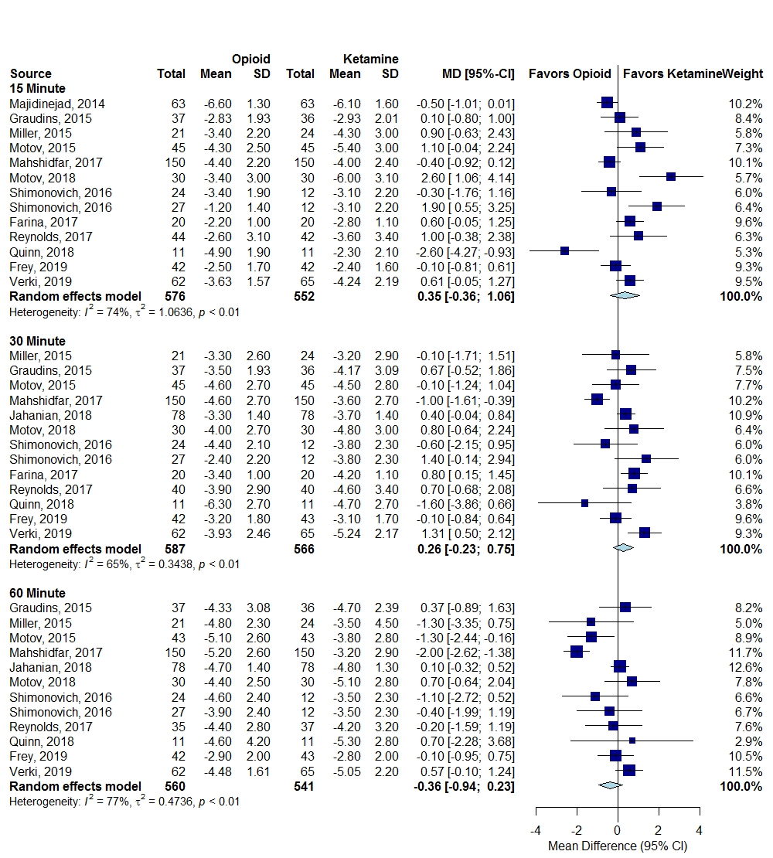

Abbreviations: CI=confidence interval; MD=mean difference; SD=standard deviation

Appendix Figure 2. Risk Difference Dizziness – Subgroup Age <18 years old, ≥18 years old, Opioids versus Ketamine
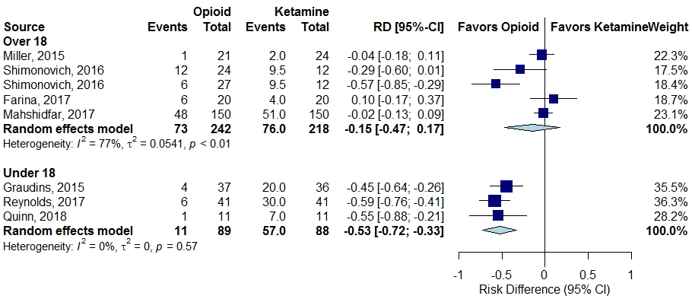

Appendix Figure 3. Risk Difference Dizziness – Subgroup Route of Administration, Opioids versus Ketamine
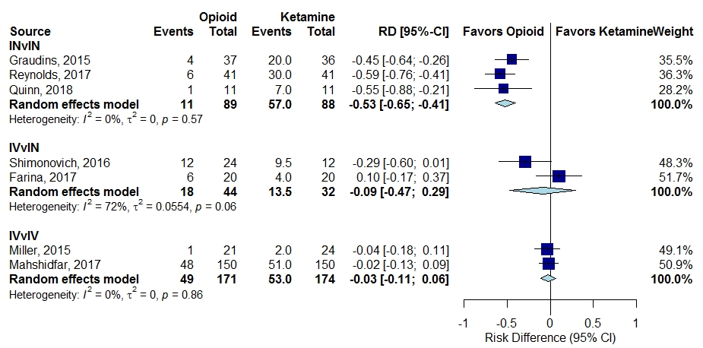

Appendix Figure 4. Mean Difference Change in Pain, Additional Opioids versus Ketamine
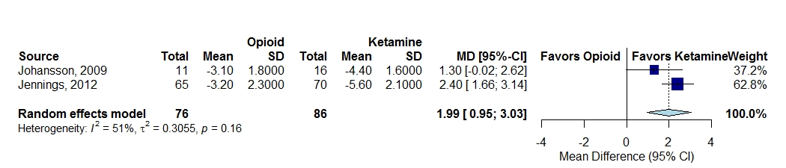

Appendix Figure 5. Change in Pain Scores at 15 (A), 30 (B) and 60 (C) Minutes, Combination of an Opioid and Ketamine versus Opioid Alone

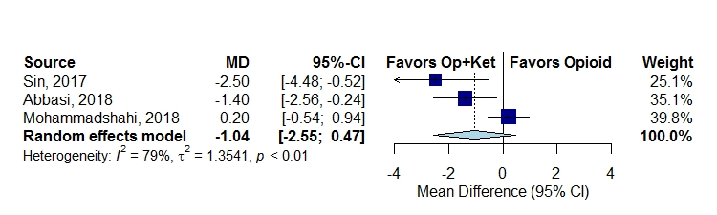
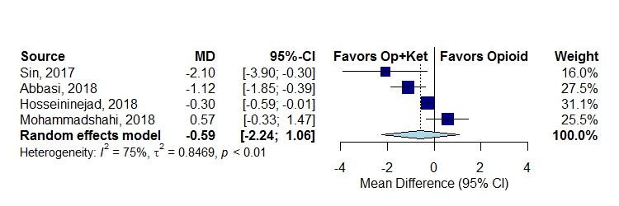
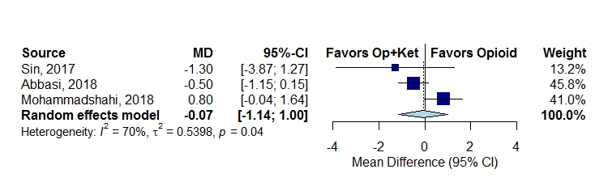
A
C
B

Appendix Figure 6. Change in Pain Scores at 15 (A), 30 (B) and 60 (C) Minutes, Opioid versus Acetaminophen

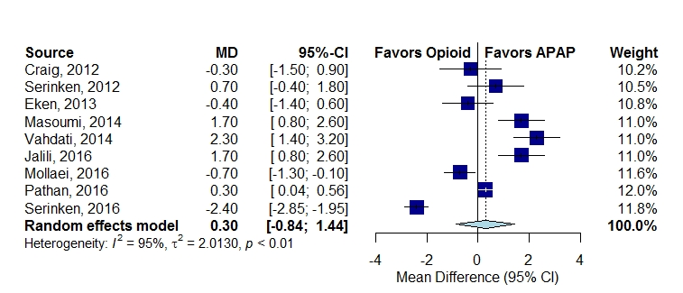
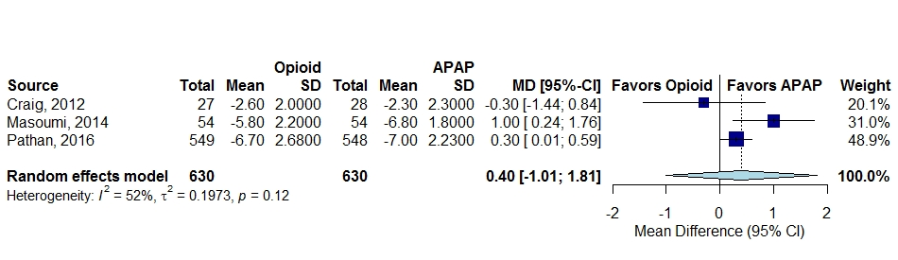
A
B
C

Appendix Figure 7. Change in Pain Score at 30 (A) and 60 (B) Minutes, Opioids versus Nonsteroidal Anti-inflammatory Drugs

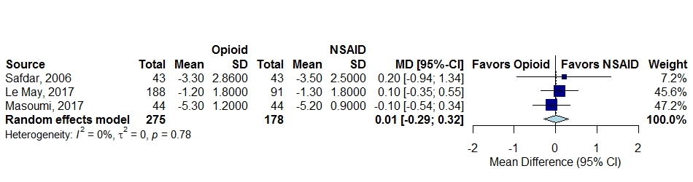
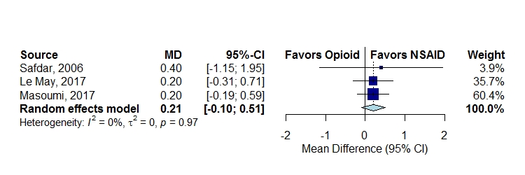
A
B

Appendix E. References
- Frey TM, Florin TA, Caruso M, Zhang N, Zhang Y, Mittiga MR. Effect of intranasal ketamine vs fentanyl on pain reduction for extremity injuries in children: the PRIME randomized clinical trial. JAMA Pediatr. 2019 Feb;173(2):140-146. PMID: 30592476.
- Tran KP, Nguyen Q, Truong XN, Le V, Le VP, Mai N, Husum H, Losvik OK. A comparison of ketamine and morphine analgesia in prehospital trauma care: a cluster randomized clinical trial in rural Quang Tri province, Vietnam. Prehosp Emerg Care. 2014 Apr-Jun;18(2):257-264. PMID: 24400915.
- Sub-dissociative ketamine for the management of acute pediatric pain. NCT01951963. https://clinicaltrials.gov/ct2/show/NCT01951963?term=NCT01951963&rank=1. Accessed 11 March, 2019.
- Reynolds SL, Bryant KK, Studnek JR, Hogg M, Dunn C, Templin MA, Moore CG, Young JR, Walker KR, Runyon MS. Randomized controlled feasibility trial of intranasal ketamine compared to intranasal fentanyl for analgesia in children with suspected extremity fractures. Acad Emerg Med. 2017 Dec;24(12):1430-1440. PMID: 28926159.
- Graudins A, Meek R, Egerton-Warburton D, Oakley E. The PICHFORK (Pain in Children Fentanyl or Ketamine) Trial: a randomized controlled trial comparing intranasal ketamine and fentanyl in children with limb injuries. Ann Emerg Med 2015;65:248-254. PMID: 25447557
- Verki MM, Mozafari J, Tirandaz F, Motamed H, Khazaeli A. Efficacy of nebulized fentanyl and low dose ketamine for pain control of patients with long bone fractures: a randomized, double-blind, clinical trial. African J Emerg Med. 2019;9:119-22. doi.org/10.1016/j.afjem.2019.02.003.
- Quinn K, Kriss S, Drapkin J, Likourezos A, Pushkar I, Brady J, Yasavolian M, Chitnis SS, Motov S, Fromm C. Analgesic efficacy of intranasal ketamine versus intranasal fentanyl for moderate to severe pain in children: a prospective, randomized, double-blind study. Pediatr Emerg Care. 2018 Jul 24; doi: 10.1097/PEC. 0000000000001556. [Epub ahead of print]. PMID: 30045355.
- Shimonovich S, Gigi R, Shapira A, Sarig-Meth T, Nadav D, Rozenek M, West D, Halpern P. Intranasal ketamine for acute traumatic pain in the emergency department: a prospective, randomized clinical trial of efficacy and safety. BMC Emerg Med. 2016 Nov;16(1):43. PMID: 27829367.
- Farnia MR, Jalali A, Vahidi E, Momeni M, Seyedhosseini J, Saeedi M. Comparison of intranasal ketamine versus IV morphine in reducing pain in patients with renal colic. Am J Emerg Med. 2017 Mar;35(3):434-437. PMID: 27931762.
- Motov S, Mann S, Drapkin J, Butt M, Likourezos A, Yetter E, Brady J, Rothberger N, Gohel A, Flom P, Mai M, Fromm C, Marshall J. Intravenous subdissociative-dose ketamine versus morphine for acute geriatric pain in the emergency department: a randomized controlled trial. Am J Emerg Med. 2019 Feb;37(2):220-227. PMID: 29807629.
- Mahshidfar B, Mofidi M, Fattahi M, Farsi D, Hafezi Moghadam P, Abbasi S, Rezai M. Acute pain management in emergency department, low dose ketamine versus morphine, a randomized clinical trial. Anesth Pain Med. 2017 Dec;7(6):e60561. PMID: 29696126.
- Motov S, Rockoff B, Cohen V, Pushkar I, Likourezos A, McKay C, Soleyman-Zomalan E, Homel P, Terentiev V, Fromm C. Intravenous subdissociative-dose ketamine versus morphine for analgesia in the emergency department: a randomized controlled trial. Ann Emerg Med. 2015 Sep;66(3):222-229. PMID: 25817884.
- Miller JP, Schauer SG, Ganem VJ, Bebarta VS. Low-dose ketamine vs morphine for acute pain in the ED: a randomized controlled trial. Am J Emerg Med. 2015 Mar;33(3):402-8. PMID: 25624076.
- Majidinejad S, Esmailian M, Emadi M. Comparison of intravenous ketamine with morphine in pain relief of long bones fractures: a double blind randomized clinical trial. Emerg (Tehran). 2014 Spring;2(2):77-80. PMID: 26495351.
- Jahanian F, Hosseininejad SM, Amini Ahidashti H, Bozorgi F, Goli Khatir I, Montazar SH, Azarfar V. Efficacy and safety of morphine and low dose ketamine for pain control of patients with long bone fractures: a randomized, double-blind, clinical trial. Bull Emerg Trauma. 2018 Jan;6(1):31-36. PMID: 29379807.
- Jennings PA, Cameron P, Bernard S, Walker T, Jolley D, Fitzgerald M, Masci K. Morphine and ketamine is superior to morphine alone for out-of-hospital trauma analgesia: a randomized controlled trial. Ann Emerg Med. 2012 Jun;59(6):497-503. PMID: 22243959.
- Johansson P, Kongstad P, Johansson A. The effect of combined treatment with morphine sulphate and low-dose ketamine in a prehospital setting. Scand J Trauma Resusc Emerg Med. 2009 Nov;17:61. PMID: 19943920.
- Galinski M, Dolveck F, Combes X, Limoges V, Smail N, Pommier V, Templier F, Catineau J, Lapostolle F, Adnet F. Management of severe acute pain in emergency settings: ketamine reduces morphine consumption. Am J Emerg Med. 2007 May;25(4):385-390. PMID: 17499654.
- Hosseininejad SM, Jahanian F, Erfanian Irankar S, Moosazadeh M, Hosseini SA, Shahbakhti N, Bozorgi F. Comparing the analgesic efficacy of morphine plus ketamine versus morphine plus placebo in patients with acute renal colic: a double-blinded randomized controlled trial. Am J Emerg Med. 2019 Jun;37(6):1118-23. PMID: 30201237.
- Sin B, Tatunchak T, Paryavi M, Olivo M, Mian U, Ruiz J, Shah B, de Souza S. The use of ketamine for acute treatment of pain: a randomized, double-blind, placebo-controlled trial. J Emerg Med. 2017 May;52(5):601-608. PMID: 28279542.
- Beaudoin FL, Lin C, Guan W, Merchant RC. Low-dose ketamine improves pain relief in patients receiving intravenous opioids for acute pain in the emergency department: results of a randomized, double-blind, clinical trial. Acad Emerg Med. 2014 Nov;21(11):1193-1202. PMID: 25377395.
- Abbasi S, Bidi N, Mahshidfar B, Hafezimoghadam P, Rezai M, Mofidi M, Farsi D. Can low-dose of ketamine reduce the need for morphine in renal colic? A double-blind randomized clinical trial. Am J Emerg Med. 2018 Mar;36(3):376-379. PMID: 28821365.
- Mohammadshahi A, Abdolrazaghnejad A, Nikzamir H, Safaie A. Intranasal ketamine administration for narcotic dose decrement in patients suffering from acute limb trauma in emergency department: a double-blind randomized placebo-controlled trial. Adv J Emerg Med. 2018;2(3):e30.
- Vahdati S, Morteza Baghi HR, Ghobadi J, Rajaei Ghafouri R, Habibollahi P. Comparison of paracetamol (apotel®) and morphine in reducing post pure head trauma headache. Anesth Pain Med. 2014Jun;4(3):e14903. PMID: 25237630.
- Jalili M, Mozaffarpour Noori A, Sedaghat M, Safaie A. Efficacy of intravenous paracetamol versus intravenous morphine in acute limb trauma. Trauma Mon. 2016 Feb;21(1):e19649.
- Pathan SA, Mitra B, Straney LD, Afzal MS, Anjum S, Shukla D, Morley K, Al Hilli SA, Al Rumaihi K, Thomas SH, Cameron PA. Delivering safe and effective analgesia for management of renal colic in the emergency department: a double-blind, multigroup, randomised controlled trial. Lancet. 2016 May;387(10032):1999-2007. PMID: 26993881.
- Serinken M, Eken C, Gungor F, Emet M, Al B. Comparison of intravenous morphine versus paracetamol in sciatica: a randomized placebo controlled trial. Acad Emerg Med. 2016 Jun;23(6):674-678. PMID: 26938140.
- Eken C, Serinken M, Elicabuk H, Uyanik E, Erdal M. Intravenous paracetamol versus dexketoprofen versus morphine in acute mechanical low back pain in the emergency department: a randomised double-blind controlled trial. Emerg Med J. 2014 Mar;31(3):177-181. PMID: 23407378.
- Serinken M, Eken C, Turkcuer I, Elicabuk H, Uyanik E, Schultz CH. Intravenous paracetamol versus morphine for renal colic in the emergency department: a randomised double-blind controlled trial. Emerg Med J. 2012 Nov;29(11):902-905. PMID: 22186009.
- Craig M, Jeavons R, Probert J, Benger J. Randomised comparison of intravenous paracetamol and intravenous morphine for acute traumatic limb pain in the emergency department. Emerg Med J. 2012 Jan;29(1):37-39. PMID: 21362724.
- Al B, Sunar MM, Zengin S, Sabak M, Bogan M, Can B, Kul S, Murat Oktay M, Eren SH. Comparison of IV dexketoprofen trometamol, fentanyl, and paracetamol in the treatment of renal colic in the ED: a randomized controlled trial. Am J Emerg Med. 2018 Apr;36(4):571-576. PMID: 29029797.
- Mollaei M, Esmailian M, Heydari F. Comparing the effect of intravenous acetaminophen (Apotel®) and intravenous morphine in controlling the pain of forearm and leg fractures in adults. J Isfahan Med Sch. 2016;34(376):293-298.
- Masoumi K, Forouzan A, Asgari Darian A, Feli M, Barzegari H, Khavanin A. Comparison of clinical efficacy of intravenous acetaminophen with intravenous morphine in acute renal colic: a randomized, double-blind, controlled trial. Emerg Med Int. 2014;2014:571326. PMID: 25197573.
- Kariman H, Majidi A, Amini A Dolatabadi AA, Derakhshanfar H, Hatamabadi H, Shahrami A, Yaseri M, Sheibani K. Nitrous oxide/oxygen compared with fentanyl in reducing pain among adults with isolated extremity trauma: a randomized trial. Emerg Med Australas 2011 Dec;23(6):761-768. PMID: 22151676
- Masoumi B, Farzaneh B, Ahmadi O, Heidari F. Effect of intravenous morphine and ketorolac on pain control in long bones fractures. Adv Biomed Res. 2017 Jul;6:91. PMID: 28828342.
- Safdar B, Degutis LC, Landry K, Vedere SR, Moscovitz HC, D’Onofrio G. Intravenous morphine plus ketorolac is superior to either drug alone for treatment of acute renal colic. Ann Emerg Med. 2006 Aug;48(2):173-181. PMID: 16953530.
- Le May S, Ali S, Plint AC, Masse B, Neto G, Auclair MC, Drendel AL, Ballard A, Khadra C, Villeneuve E, Parent S, McGrath PJ, Leclair G, Gouin S; Pediatric Emergency Research Canada (PERC). Oral analgesics utilization for children with musculoskeletal injury (OUCH Trial): an RCT. Pediatrics. 2017 Nov;140(5): pii: e20170186. doi: 10.1542/peds.2017-0186. Epub 2017 Oct 11. PMID: 29021235.
- Oberholzer N, Kaserer A, Albrecht R, Seifert B, Tissi M, Spahn DR, Maurer K, Stein P. Factors influencing quality of pain management in a physician staffed helicopter emergency medical service. Anesth Analg. 2017 Jul;125(1):200-209. PMID: 28489643.
- Bronsky ES, Koola C, Orlando A, Redmond D, D’Huyvetter C, Sieracki H, Tanner A 2nd, fowler R, Mains C, Bar-Or D. Intravenous low-dose ketamine provides greater pain control compared to fentanyl in a civilian prehospital trauma system: a propensity matched analysis. Prehosp Emerg Care. 2018 May;1-8. doi: 10.1080/10903127.2018.1469704. [Epub ahead of print]. PMID: 29775117.
- Schauer SG, Mora AG, Maddry JK, Bebarta VS. Multicenter, prospective study of prehospital administration of analgesia in the U.S. combat theater of Afghanistan. Prehosp Emerg Care. 2017 Nov-Dec;21(6):744-749. PMID: 28829661.
- Schackelford SA, Fowler M, Schultz K, Summers A, Galvagno SM, Gross KR, Mabry RL, Bailey JA, Kotwal RS, Butler FK. Prehospital pain medication use by U.S. forces in Afghanistan. Mil Med. 2015 Mar;180(3):304-309.PMID: 25735021.

