Supporting information
Uptake, Translocation, and Metabolism of Sulfamethazine by Arabidopsis thaliana: Distinguishing Between Phytometabolites and Abiotic Transformation Products in the Media
Khang Huynh¹, and Dawn Reinhold¹*
ªDepartment of Biosystems and Agricultural Engineering, Michigan State University, East Lansing, MI 48824, United States
^{b} Plant and Environmental Sciences Department, Clemson University, Clemson, SC 29634, United States

*To whom correspondence should be addressed.
Tel: +1 (517) 432-7732
Fax: +1(517) 432-2892
E-mail: reinhold@egr.msu.edu (Dawn M. Reinhold)

Supporting Materials and Methods

Chemicals
¹⁴C-SMT (80 mCi/mmol, 98% purity) was obtained from American Radiolabeled Chemicals (St. Louis, MO). Unlabeled SMT (>99% purity), 2-amino-4,6-dimethylpyrimidine (95% purity), formic acid and MS grade acetonitrile were purchased from Sigma-Aldrich (St. Louis, MO). N⁴-acetyl SMT and desamino SMT were purchased from AKos GmbH (Baden-Wurttemberg, Germany). Other chemicals (ACS grade) were purchased from VWR, Inc. (Chicago, IL).

Preparation of Arabidopsis thaliana seeds and culture media
A. thaliana seeds (wild-type quick plantTM) were purchased from VWR, Inc. (Chicago, IL). Seed surface sterilization was carried out as described by (LeFevre et al. 2016). Sterilization solution was freshly prepared each use by adding 2.0 mL of bleach (8.25% sodium hypochlorite, Clorox) and 100 µl of Tween 20 surfactant (BioRad Laboratories Inc.) into 8.0 mL of autoclaved water and mixed well. Aliquot of 1.0 mL of the sterilization solution was added to a 1.5 mL microcentrifuge tube containing approximately 150 seeds. The tube was slowly pipetted for 5 minutes. The supernatant was removed; and 1 mL of autoclaved water was added and then removed to wash the seeds from the sterilization solution. The washing step was repeated for five times. The seeds were then distributed into 10 Magenta boxes (GA-7, Magenta Corp., Lockport, IL) containing 25 mL of sterilized culture media and stratified at 4ºC for 3 days before transferred to a growth chamber. Accordingly, each box contained approximately 15 seeds. The cold stratification period aimed to release dormancy and achieve fast and uniform germination. In this study, germination rate was not closely monitored; however, visual observation suggested that >90% of the seeds germinated following 3-day stratification period.
Half-strength Murashige and Skoog (0.5X MS) solution was used as the culture media. Per 1 L of Milli-Q water, 2.22 g of MS basal medium (Sigma-Aldrich, St. Louis, MO), 0.5 g of MES buffer (Sigma-Aldrich), and 5 g of sucrose (J. T. Baker, Center Valley, PA) were added. The media pH was adjusted to 5.7 using 1M KOH solution. Finally, the culture media was filter sterilized using a 0.22 µm PES membrane (Sigma-Aldrich).
All procedures for seed sterilization and culture media preparation were conducted in a laminar flow biological safety hood, and 70% ethanol spray solution was used to sterilize the working area.

Solid phase extraction (SPE) of the media
For identification of the metabolites in the aqueous phase, media samples were concentrated and cleaned up using solid phase extraction (SPE) as previously described by (Yang et al. 2005) with some minor modifications. Briefly, 1 mL of Na₂EDTA was added to 50 mL of media sample, 70 mL of Milli-Q water and 30 mL of 0.1 M citric acid. SPE cartridges (Oasis HLB 6 cc, 150 mg sorbent, Waters) were sequentially conditioned with 5 mL of methanol, 5 mL of 0.5 N HCl and 5 mL of Milli-Q water. Samples were then passed through the cartridges using a vacuum manifold. After sample loading, cartridges were rinsed with 5 mL of Milli-Q water and dried under vacuum. Analytes were eluted using 5 mL of methanol which was then evaporated to dryness using nitrogen gas and reconstituted in 1 mL of methanol:water (1:1, 0.1% formic acid).

Extraction of plant materials
For the root-exposure experiments, plant tissues (approximately 0.05 g) were extracted with 1 mL of methanol in a microcentrifuge tube by sonication for 15 min in a water bath at room temperature and centrifugation at 10,000 rpm for 15 min to separate plant tissues and supernatant. The supernatant was decanted and the above extraction steps were repeated an additional 2 times. For the whole-plant experiments, approximately 0.5 g of plant tissues was extracted with 10 mL of methanol in a 50 mL centrifuge tube followed the aforementioned extraction steps, with the exception that centrifugation was at 4,000 rpm. After centrifugation, the extracts was pooled, dried under nitrogen, reconstituted in 1 mL of methanol:water (1:1, 0.1% formic acid) and filtered through 0.2 µm PTFE membranes into 2 mL amber vials.
For quantification of the extractable and bound ¹⁴C-residues, aliquots of 0.05 mL of the reconstituted plant extracts of the ¹⁴C-exposed samples were mixed with 10 mL of Hionic Fluor cocktail in 20 mL glass scintillation vials and measured for ¹⁴C-radioactivity by LSC. The obtained values were used to estimate the extractable ¹⁴C-residues in plant tissues. Plant tissues, after sequential methanol extraction, were oven-dried at 50ºC for 48 h and digested using a mixture of perchloric acid:nitric acid (1:1) as described by (Thomson 2012). After digestion, the resulting digestate was diluted to 2.0 mL by Milli-Q water. Aliquots of 0.05 mL were added to 10 mL of Hionic Fluor cocktail and measured for ¹⁴C-radioactivity by LSC, which were subsequently defined as non-extractable or bound residues.

Metabolite candidates screening by UPLC-QTOF-MS^{E} and data processing
Chromatographic separation was achieved using an Acquity BEH C18 column (100 × 2.1 mm, 1.7 µm) at a flow rate of 0.3 mL/min and temperature of 40ºC. The mobile phases consisted of (A) 10 mM ammonium formate and (B) acetonitrile. The elution gradient was: 0 – 1 min, 5% B; 11 – 13 min, 98% B; and 13.1 – 15 min, 5% B. Analyses were carried out with an electrospray ionization (ESI) source operated in positive ion mode within a mass range of 50 – 1500 m/z. Capillary voltage was 3.0 kV and sample cone voltage was 35 V. The MS source and desolvation temperatures were set at 100ºC and 350ºC, respectively. Desolvation gas flow was 600 L/h and cone gas flow was 25 L/h. The lock mass spray for accurate m/z measurement used a solution containing 0.1 µg/mL of leucine enkephalin (m/z 556.2771 in positive ion mode). Data was collected in centroid mode with two scan functions using MS^{E} acquisition: function 1 with no collision energy (0 eV) and function 2 with high collision energy (dynamic ramp of collision energy of 20 – 80 eV).
The centroided MS raw data were then processed using Waters Progenesis QI 2.1 for alignment, normalization, and peak picking, and EZinfo 3.0 software (Umetrics, Malmo, Sweden) for multivariate statistical analysis (Figure S5). The S-plots obtained from the orthogonal projection to latent structures-discriminant analysis (OPLS-DA) models (Figure S5) were subsequently used to determine the m/z variables that significantly contributed to the differences between control and SMT-treated groups. Metabolite candidates were primarily selected from the m/z variables scattered on the top right corner of the S-plots with p(corr) ≥ 0.5, indicating an increase in intensity of these m/z variables in SMT-treated groups compared to control groups. Candidates from the S-plots were imported back to Progenesis QI as the first tag set. In addition, the ANOVA p-values calculated by Progenesis QI that were ≤ 0.05 (reflecting significant differences between variables of control and SMT-treated groups), were used as a second tag set. Data was then filtered using both tag sets. An output table was generated to include paired m/z retention times, raw and normalized peak intensities for group and individual samples. Next, data from SMT-exposed treatments were compared to non-exposed controls. The proposed metabolite candidates were based on their presence in the treatments and absence in the controls. MassLynx 4.1software (Waters) was used to generate possible chemical formulas for the metabolite candidates with the mass accuracy error ≤ 5 ppm. Following primary identification of the metabolite candidates, the proposed structures were further confirmed by characteristic fragment ions in high collision energy mass spectra. Additionally, the MS/MS spectral-data (in MRM mode) of the SMT metabolites observed in this study were also compared with those reported in literature (García-Galán et al. 2011; Majewsky et al. 2015).

Analysis of ¹⁴C-SMT and its transformation products using LC-MS-β-RAM
Separation was carried out on an Ultra Biphenyl (5µm, 250 x 4.6 mm, Restek) at a flow rate of 1.0 mL/min and temperature of 40ºC with water and acetonitrile, both containing 0.1% formic acid, as mobile phases. The gradient program was: 0 – 1 min, 5% B; 3 min, 20% B; 15 min, 60% B; 17 min, 95% B; 20 min, 95% B; and 26 min, 5% B. The flow was diverted to both the β-RAM (0.8 mL/min) and MS operated in positive ESI (0.2 mL/min) using an adjustable splitter (LabLogic).
Supporting Results
Abiotic dissipation and transformation of SMT in the culture media
In the root exposure, dissipation of SMT was observed for both “light” and “dark” no-plant controls. After 21 days, SMT concentrations in these controls decreased from initially 319.7 ± 2.5 µg/L to 232.7 ± 29.3 (p = 0.076) and 246.3 ± 15.6 µg/L (p = 0.034), respectively (Figure S2). All treatments were performed under sterile conditions; therefore, loss of SMT from the hydroponic media was only attributed to abiotic processes (e.g. adsorption, hydrolysis, and phototransformation). In this study, the containers’ inner surface was thoroughly rinsed with methanol and the adsorbed SMT fractions were quantified. Surface adsorption accounted for only 0.2 – 1.1% of the total SMT added to the reactors. Hydrolysis rates of SMT have been found to be negatively correlated to pH and positively correlated to temperature of solutions (Bialk-Bielinska et al. 2012). In this study, pH of the nutrient solution was maintained at approximately 5.7; therefore, SMT existed dominantly in its neutral form (approximately 98%) (Zhang et al. 2016), which is more sensitive to hydrolysis than the anionic form (Bialk-Bielinska et al. 2012). Reduction of SMT concentrations in media was best fitted to a second-order model (Figure S3). In this study, the estimated half-lives of SMT in “light” and “dark” controls were 75 and 91 days, respectively. Bialka-Bielinska et al. reported a shorter half-life of 81 days under sterile, 20ºC, pH 4.0, and no light exposure conditions (Bialk-Bielinska et al. 2012). A higher solution pH used in our study might result in a longer estimated half-life for SMT in the “dark” control media (Bialk-Bielinska et al. 2012). Although the effects of phototransformation were insignificant in this study (p = 0.299 for light vs. dark controls), several SMT transformation products could be detected in the light-exposed abiotic controls using UPLC-QTOF-MS^{E}, including N⁴-glycosyl-SMT, N⁴-formyl-SMT, desulfo-SMT, hydroxyl-SMT, N⁴-Cl-SMT, N⁴-acetyl-SMT, desamino-SMT, and 2-amino-4,6-dimethylpyrimidine. Figure S23 represents the variation of these abiotic transformation products over 4 days of light irradiation.

Identification of M1 and M2 on the LC-β-RAM-MS
When plant tissues were subjected to unlabeled SMT quantification using MS/MS, two peaks exhibiting identical MRM transitions as the parent SMT with earlier retention times were observed (i.e., fragments of m/z 186 and 156 for the precursor m/z 279, SMT, Figure S21-A). Both were absent in the control plants, suggesting that they are the SMT products. In-source fragmentation of plant glycosylated metabolites on the mass spectrometer may result in cleavage of the conjugated bonds, releasing the parent aglycones prior to MS/MS fragmentation (Holder et al. 1999; Justesen 2000; LeFevre et al. 2016). As a result, the presence of the metabolites can be detected, at different chromatographic retention times, with the identical MS/MS signature as the parent compounds. For example, LeFevre et al. observed that the glucoside and amino acid moieties were lost from the Arabidopsis-derived conjugates during MS/MS fragmentation (LeFevre et al. 2016). Accordingly, the two signals observed in the SMT-exposed plants by MS/MS were conjectured to be metabolites of SMT, with the parent SMT structure remained intact through transformation and/or conjugation reactions. The retention times and MS/MS fragmentations subsequently indicated that the first peak corresponded to the N⁴-glycosyl SMT (m/z 441) (Figure S13), while the second peak likely corresponded to N⁴-formyl SMT (m/z 307, Figure S14) or a hydroxylated metabolite of SMT (m/z 295, Figure S17). Due to low abundance of fragments and the precursor ion, we were unable to determine whether M2 was N⁴-formyl SMT or hydroxylated metabolite of SMT definitively. Figure S21-B shows the representative selected ion chromatograms of the A. thaliana extracts on the LC-MS and the equivalent radioactivity peaks on the β-RAM (M1, M2, and ¹⁴C-SMT). Similarly, on the LC-MS/β-RAM, the precursor ion was also confirmed for the metabolite M1 (m/z 441), corresponding to the N⁴-glycosyl SMT. However, the suspected precursor ions of m/z 295 (hydroxylated SMT) or m/z 307 (N⁴-formyl SMT) were not clearly observed (Figure S21-B), likely due to low abundance. As a result, the chemical structure of the metabolite M2 could not be explicitly confirmed using the LC-MS/MS and LC-MS/β-RAM.
Supplemental Data
Figure S1. Photos of Arabidopsis thaliana exposed to SMT in (A): Magenta boxes in the whole-plant exposure, and (B): Root-shoot exposure.
Figure S2. Concentrations of SMT in Arabidopsis-planted and abiotic controls media (“light” and “dark” controls) during root-shoot exposure. Error bars represent standard error of triplicates; some error bars are obscured by data symbols.
Figure S3. First-order and second-order models for dissipation of SMT in the hydroponic media during root-shoot exposure (21 days). Error bars represent standard error of triplicates.
Figure S4. Extractable SMT concentrations in A. thaliana plant tissues (A), and mass balance of SMT in the culture media and plant tissues (B) over 21 days of exposure. Error bars represent standard error of triplicates; some error bars are obscured by data symbols.
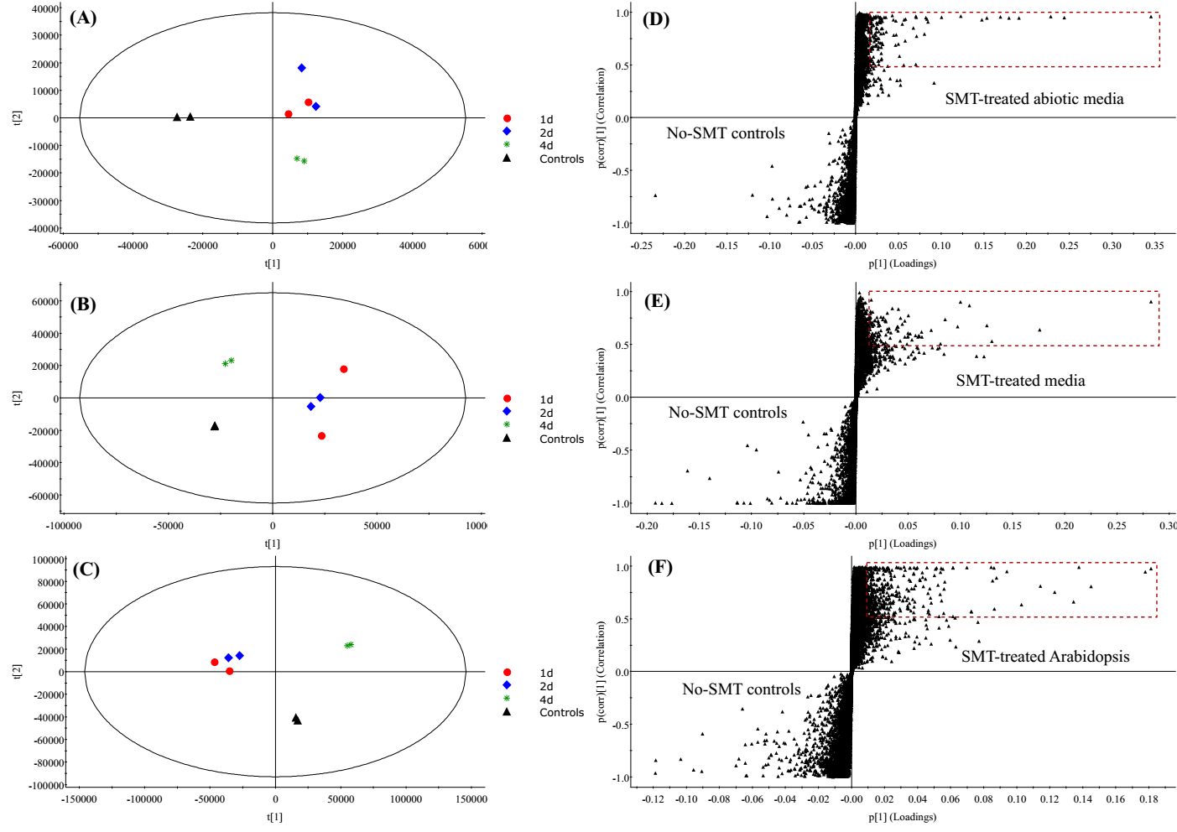
Figure S5. Principal component analysis (PCA) score plots (A – C) and the S-plots from orthogonal projection to latent structures-discriminant analysis (OPLS-DA) (D – F) of the abiotic media, planted media and A. thaliana samples, respectively, obtained by processing QTOF-MS^{E} high resolution mass spectra using Progenesis QI 2.1 and EZInfo 3.0 platforms. Controls: control plants/media without SMT exposure; 1d, 2d, 4d: plants/media exposed to SMT for 1, 2 and 4 days, respectively. The dashed rectangles on the S-plots include m/z variables that significantly contribute to the differences between control and SMT-exposed samples (p(corr) ≥ 0.5). All treatments were performed in duplicates. Some data symbols are overlapped on the PCA score plots.
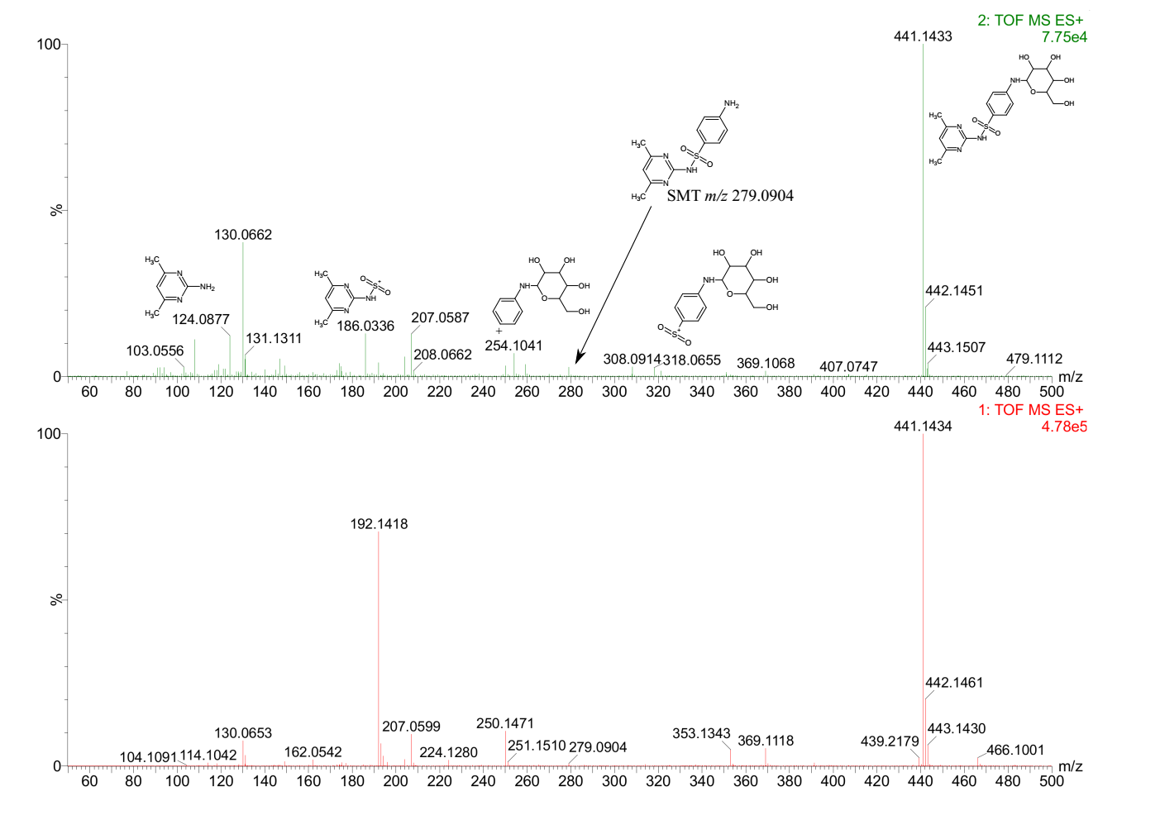
20 – 80 eV ramp
0 eV
Figure S6. Mass spectra of N⁴-glycosyl-SMT on the UPLC-QTOF-MS^{E} system.
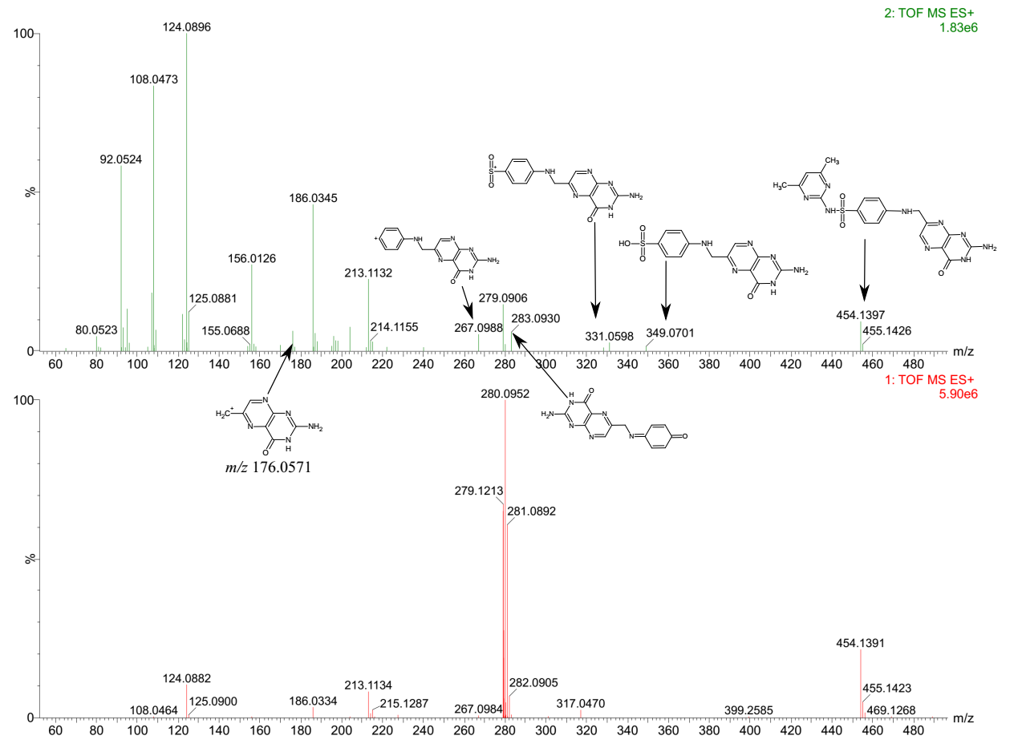
20 – 80 eV ramp
0 eV
Figure S7. Mass spectra of pterin-SMT on the UPLC-QTOF-MS^{E} system.
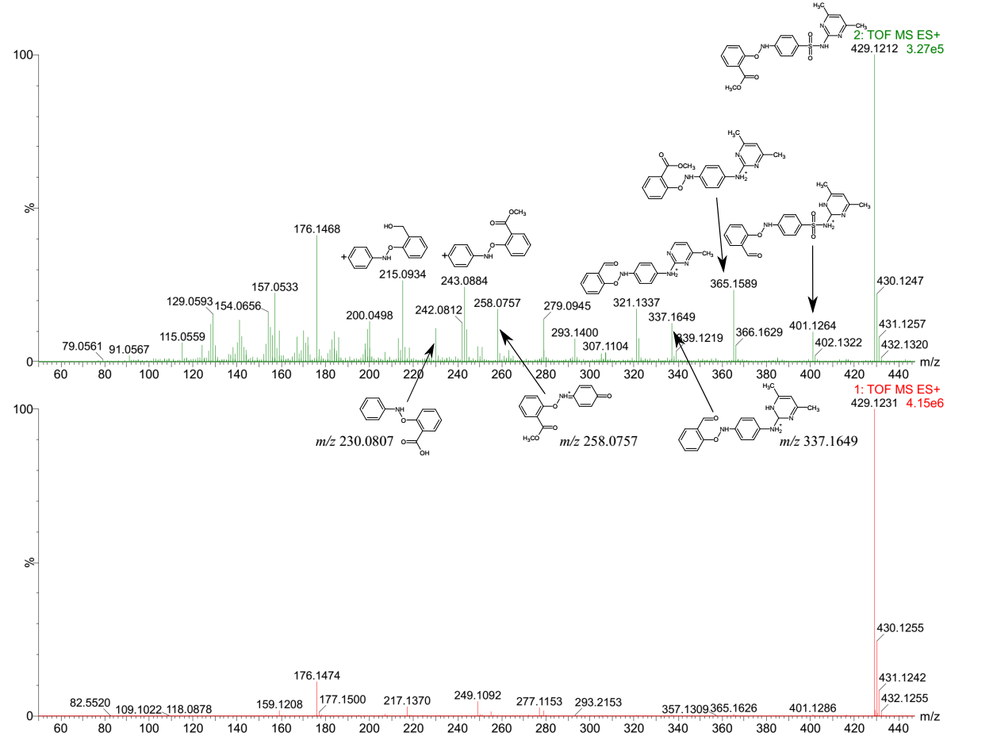
20 – 80 eV ramp
0 eV
Figure S8. Mass spectra of methylsalicylate-SMT on the UPLC-QTOF-MS^{E} system.
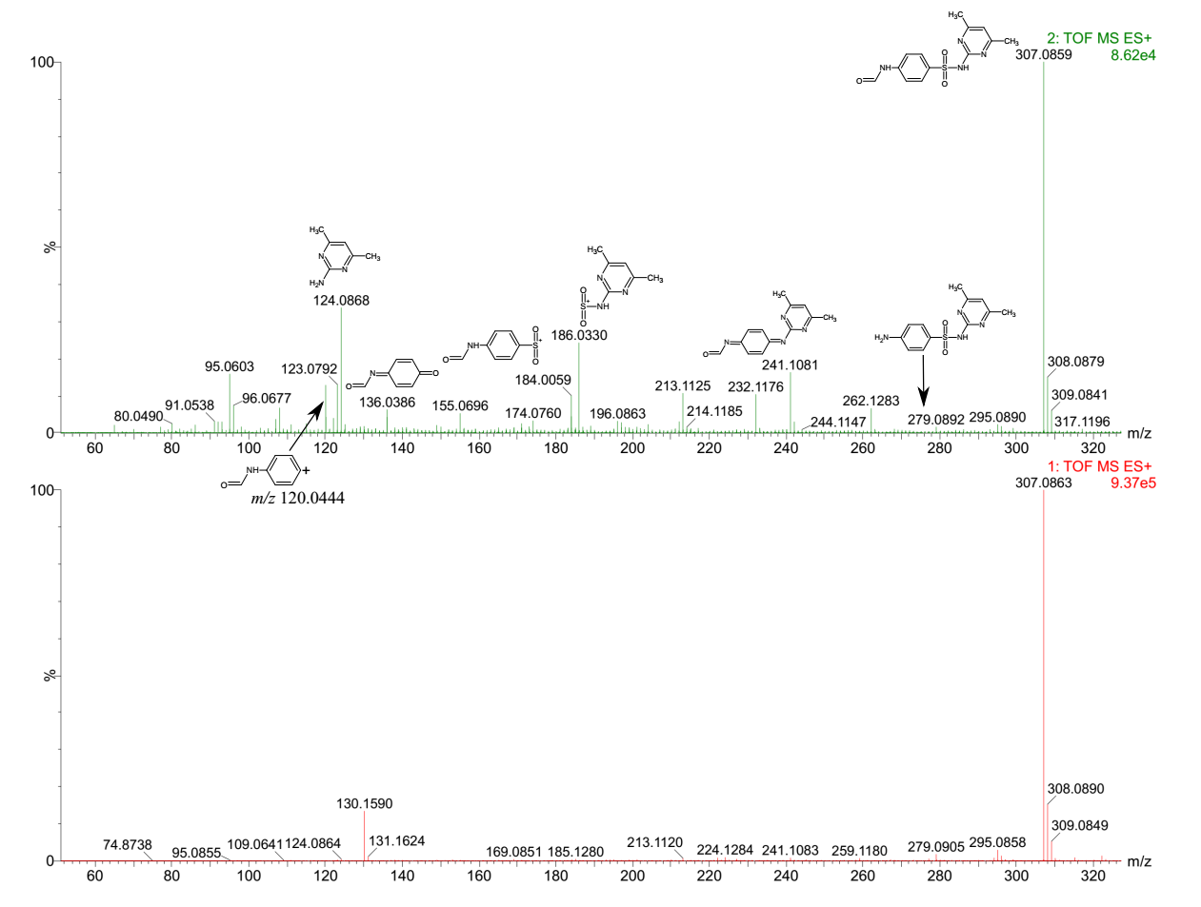
20 – 80 eV ramp
0 eV
Figure S9. Mass spectra of N⁴-formyl-SMT on the UPLC-QTOF-MS^{E} system.
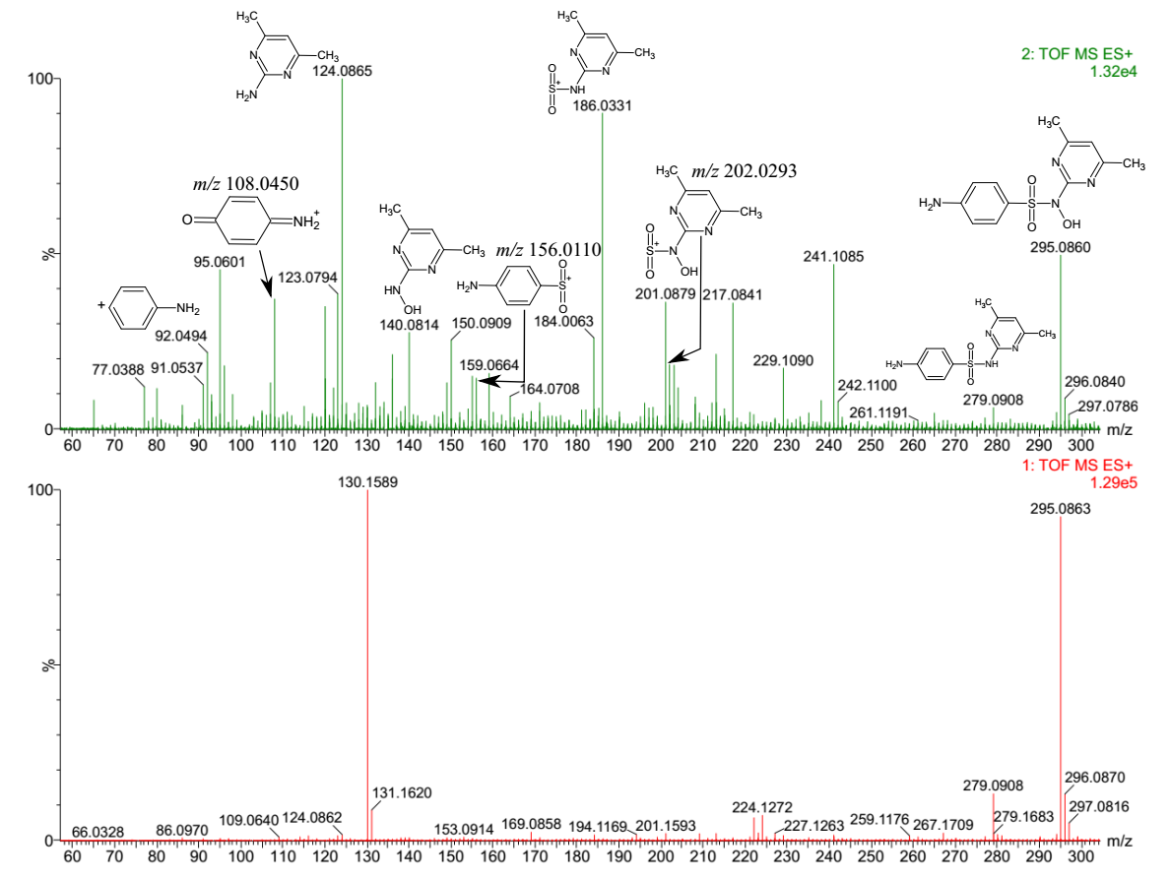
20 – 80 eV ramp
0 eV
Figure S10. Mass spectra of hydroxyl-SMT-1, with N¹-OH-SMT as the representative metabolite
on the UPLC-QTOF-MS^{E} system.
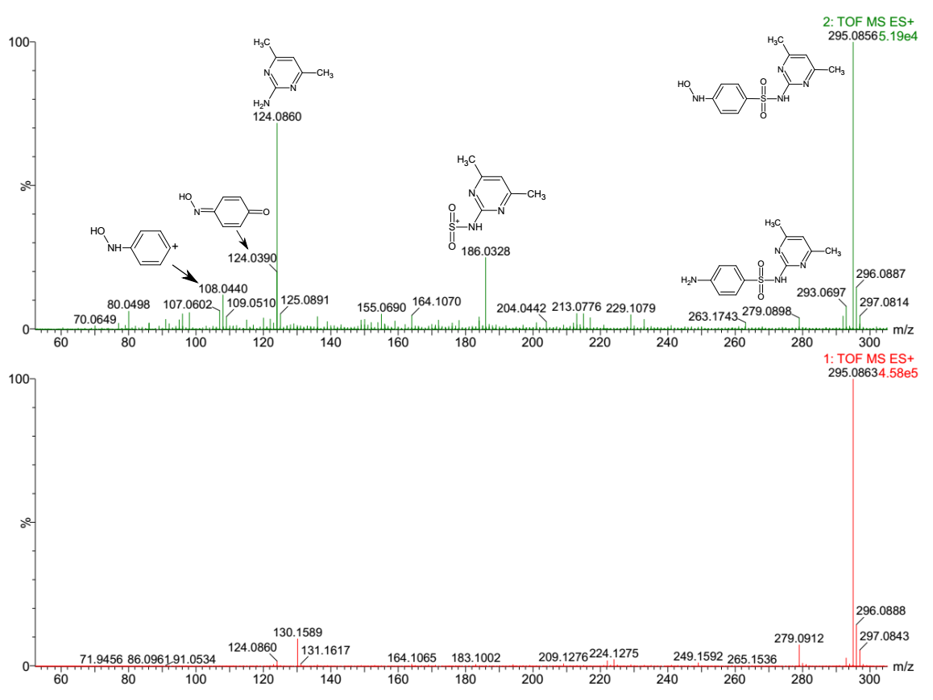
20 – 80 eV ramp
0 eV
Figure S11. Mass spectra of hydroxyl-SMT-2, with N⁴-OH-SMT as the representative metabolite
on the UPLC-QTOF-MS^{E} system.
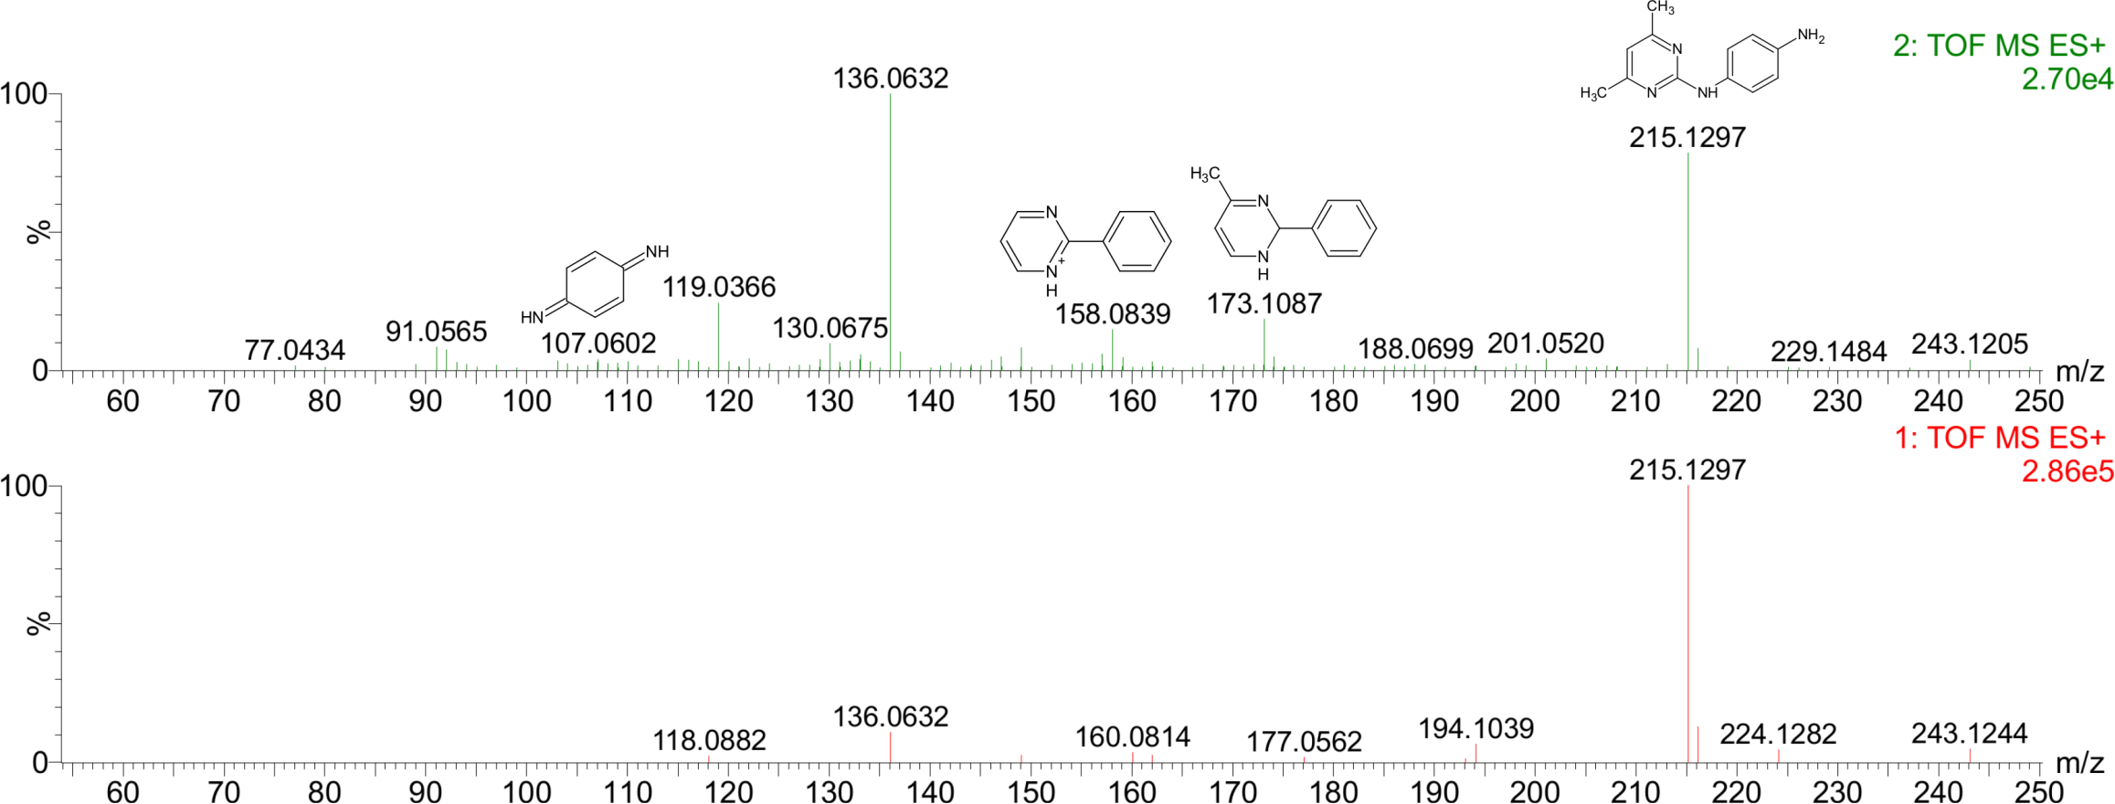
0 eV
20 – 80 eV ramp
Figure S12. Mass spectra of desulfo-SMT on the UPLC-QTOF-MS^{E} system.

Figure S13. Selected ion chromatograms of N⁴-glycosyl-SMT (RT = 3.32 min) on the LC-MS/MS system applying ESI (+) in MRM mode (Majewsky et al. 2015).
Figure S14. Selected ion chromatograms of N⁴-formyl-SMT (RT = 3.83 min) on the LC-MS/MS system applying ESI (+) in MRM mode (Majewsky et al. 2015).

Figure S15. Selected ion chromatograms of desulfo-SMT (RT = 3.11 min and 3.29 min) on the LC-MS/MS system applying ESI (+) in MRM mode (García-Galán et al. 2011). The peak emerged at Rt = 4.09 min potentially represents the artifact from in-source fragmentation of SMT prior to MS analysis (Wang et al. 2003).
Figure S16. Selected ion chromatograms of hydroxyl-SMT-1 (RT = 3.65 min and 3.91 min) on the LC-MS/MS system applying ESI (+) in MRM mode (Majewsky et al. 2015).
Figure S17. Selected ion chromatograms of hydroxyl-SMT-2 (RT = 3.79 min) on the LC-MS/MS system applying ESI (+) in MRM mode (Majewsky et al. 2015).
Figure S18. Selected ion chromatograms of N⁴-acetyl-SMT (RT = 3.92 min) on the LC-MS/MS system applying ESI (+) in MRM mode (Majewsky et al. 2015).
Figure S19. Selected ion chromatograms of desamino-SMT (RT = 4.46 min) on the LC-MS/MS system applying ESI (+) in MRM mode (Majewsky et al. 2015).
Figure S20. Selected ion chromatograms of 2-amino-4,6-dimethylpyrimidine on the LC-MS/MS system (RT = 1.52 min) applying ESI (+) in MRM mode (Bialk-Bielinska et al. 2012). Similar precursor ion (m/z 124) was likely derived from the parent SMT (RT = 4.07 min) and formyl SMT (RT = 3.84 min), leading to similar MRM transitions.
(A) | 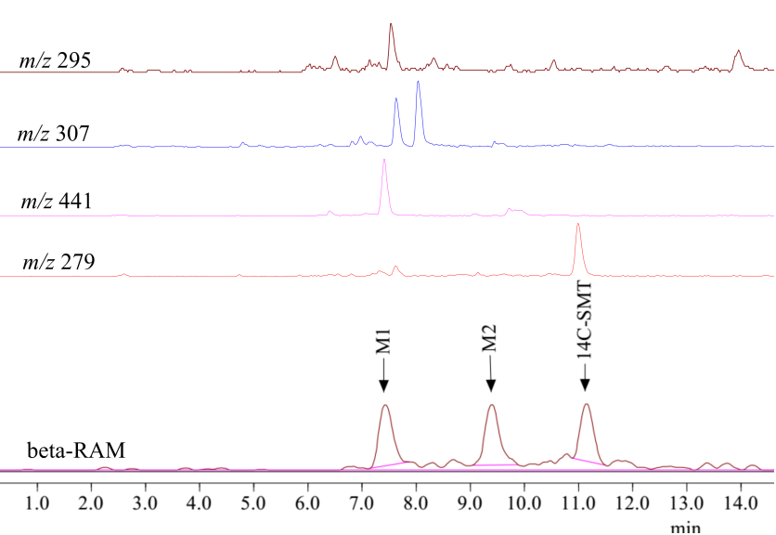
Figure S21. (A): Representative LC-MS/MS chromatograms of A. thaliana extracts. In-source fragmentation on the mass spectrometer revealed two metabolite candidates (M1 and M2), exhibiting identical fragmentation patterns with the parent SMT in MRM mode (blue: m/z 279 186, red: m/z 279 156). Accordingly, the weak conjugated bonds between SMT and the functional groups were likely cleaved, releasing the parent molecule, prior to MS/MS analysis. All three chromatograms were magnified using the same scale to visualize M1 and M2 peaks. (B): Selected ion chromatograms of A. thaliana extracts on the LC-MS 2010 EV coupled with the on-line radioactivity detector β-RAM.
(B)
Figure S22. Temporal variation of SMT products in plant tissues and media during whole-plant exposure of A. thaliana to unlabeled SMT at a concentration of 3 µg/mL. The peak areas of pterin SMT and methyl-salicylate SMT were obtained from the UPLC-QTOF-MS^{E} system, while those of the remaining metabolites were from the LC-MS/MS system in MRM mode.
Figure S23. Temporal variation of SMT products in the abiotic controls. The peak areas of N⁴-Cl-SMT were obtained from the UPLC-QTOF-MS^{E} system, while those of the remaining metabolites were from the LC-MS/MS system in MRM mode.
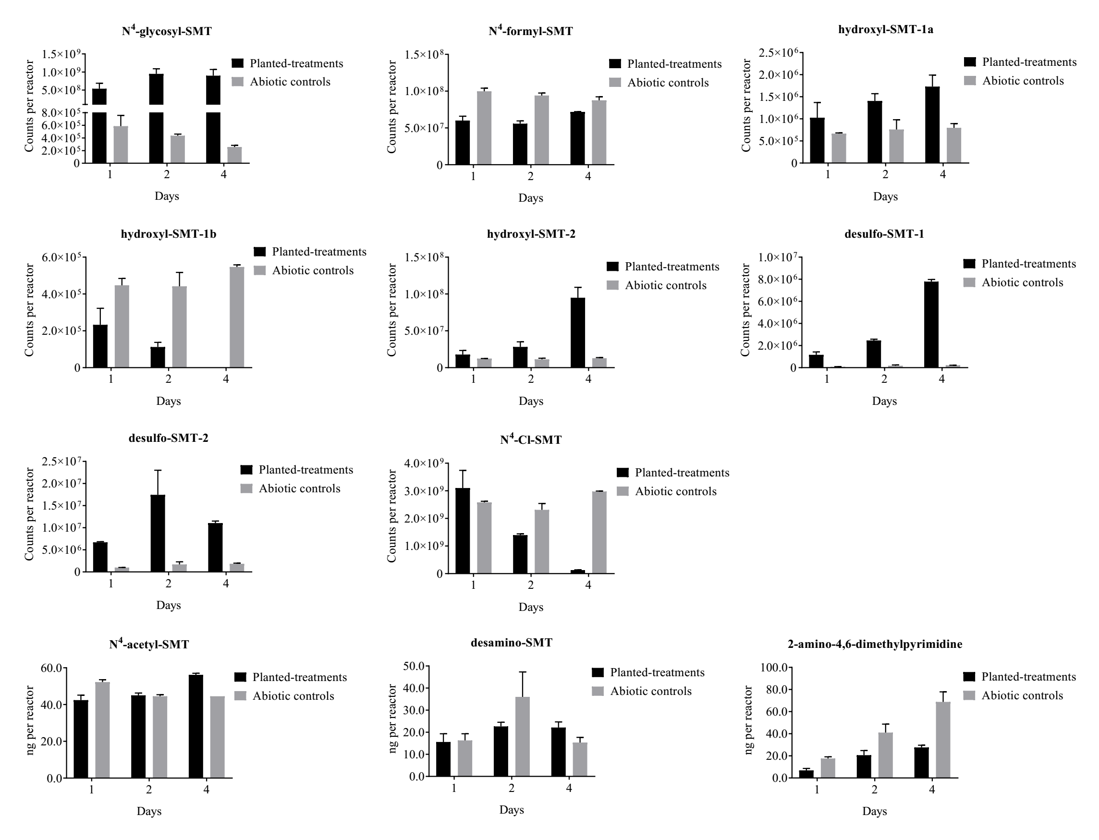
Figure S24. Abundance of the SMT products per each container over 4 days of whole-plant exposure. For the planted-treatments, the amount of each product equals the sum of its abundance in plant tissues and culture media, while that of the corresponding abiotic controls represents the amount in media. Quantification of N⁴-acetyl-SMT, desamino-SMT, and 2-amino-4,6-dimethylpyrimidine (ng per reactor) was performed using authentic standards, while relative quantification using peak areas (counts per reactor) was conducted for other SMT products due to lack of authentic standards.
Table S1. MRM parameters for the analysis of SMT and its metabolites by LC-MS/MS.
compounds | precursor ion  m/z | product ions  m/z | DP  (eV) | EP  (eV) | CEP  (eV) | CXP  (eV) | CE  (eV)
SMTª | 279 | 186  (156) | 37 | 5 | 20 | 18 | 23
N⁴-acetyl-SMTª | 321 | 134  (124) | 37 | 5 | 18 | 10 | 40
desamino-SMTª | 264 | 77  (124) | 37 | 5 | 15 | 10 | 45
2-amino-4,6-dimethylpyrimidineª | 124 | 67  (107) | 37 | 5 | 9 | 10 | 35
N⁴-glycosyl-SMT^{b} | 441 | 186  (124) | 40 | 5 | 24 | 10 | 40
hydroxyl-SMT-1^{b} | 295 | 124  (108) | 40 | 5 | 17 | 10 | 40
hydroxyl-SMT-2^{b} | 295 | 140  (202) | 40 | 5 | 17 | 10 | 30
N⁴-formyl-SMT^{b} | 307 | 124  (184) | 40 | 5 | 17 | 10 | 30
desulfo-SMT^{b} | 215 | 92  (173) | 40 | 5 | 13 | 10 | 40
DP: Declustering Potential; EP: Entrance Potential; CEP: Collision Cell Entrance Potential; CXP: Collision Cell Exit Potential; CE: Collision Energy.
The product ions m/z in bold and in parentheses were used as quantifying and qualifying ions, respectively.
ªReference standards available; ^{b}reference standards not available.

Table S2. Structures proposed for the fragment ions of SMT under ESI (+)-QTOF-MS^{E} conditions (Klagkou et al. 2003).
Sulfamethazine (SMT)  m/z = 279.0910 | Fragment ions | Calculated m/z
 |  | 92.0495
 |  | 156.0114
 |  | 108.0444
 |  | 186.0332
 |  | 124.0869
 | *Loss of H₂SO₂ | 213.1140
*Klagkou et al. proposed the loss of 66 Da from SMT corresponding to the elimination of H₂SO₂ from the protonated molecule; however, the authors did not suggest a structure for the detected product ion (Klagkou et al. 2003).
References

Bialk-Bielinska A, Stolte S, Matzke M, Fabianska A, Maszkowska J, Kolodziejska M, Liberek B, Stepnowski P, Kumirska J. 2012. Hydrolysis of sulphonamides in aqueous solutions. J Hazard Mater. 221-222(2012): 264-274.
García-Galán MJ, Rodríguez-Rodríguez CE, Vicent T, Caminal G, Díaz-Cruz MS, Barceló D. 2011. Biodegradation of sulfamethazine by Trametes versicolor: Removal from sewage sludge and identification of intermediate products by UPLC–QqTOF-MS. Sci Total Environ. 409(24): 5505-5512.
Holder C, Churchwell M, Doerge D. 1999. Quantification of Soy Isoflavones, Genistein and Daidzein, and Conjugates in Rat Blood Using LC/ES-MS. J Agric Food Chem. 47(9): 3764-3770.
Justesen U. 2000. Negative atmospheric pressure chemical ionisation low-energy collision activation mass spectrometry for the characterisation of flavonoids in extracts of fresh herbs. J Chromatogr A. 902(2): 369-379.
Klagkou K, Pullen F, Harrison M, Organ A, Firth A, Langley GJ. 2003. Fragmentation pathways of sulphonamides under electrospray tandem mass spectrometric conditions. Rapid Commun Mass Spectrom. 17(21): 2373-2379.
LeFevre GH, Portmann AC, Muller CE, Sattely ES, Luthy RG. 2016. Plant Assimilation Kinetics and Metabolism of 2-Mercaptobenzothiazole Tire Rubber Vulcanizers by Arabidopsis. Environ Sci Technol. 50(13): 6762-6771.
Majewsky M, Glauner T, Horn H. 2015. Systematic suspect screening and identification of sulfonamide antibiotic transformation products in the aquatic environment. Anal Bioanal Chem. 407(19): 5707-5717.
Thomson J, 2012. Sample Preparation Techniques for Liquid Scintillation Analysis. in: L'Annunziata, M. (Ed.). Handbook of Radioactivity Analysis. Academic Press, San Diego, CA, pp. 589-590.
Wang Z, Hop CECA, Kim M-S, Huskey S-EW, Baillie TA, Guan Z. 2003. The unanticipated loss of SO2 from sulfonamides in collision-induced dissociation. Rapid Commun Mass Spectrom. 17(1): 81-86.
Yang S, Cha J, Carlson K. 2005. Simultaneous extraction and analysis of 11 tetracycline and sulfonamide antibiotics in influent and effluent domestic wastewater by solid-phase extraction and liquid chromatography-electrospray ionization tandem mass spectrometry. J Chromatogr A. 1097(1-2): 40-53.
Zhang C, Lai C, Zeng G, Huang D, Yang C, Wang Y, Zhou Y, Cheng M. 2016. Efficacy of carbonaceous nanocomposites for sorbing ionizable antibiotic sulfamethazine from aqueous solution. Water Res. 95(2016): 103-112.

