APPENDIX
Model Settling Procedure:
Prior to carrying out the frontal low-speed acceleration pulse validation simulations, the leg angles were adjusted through gravity settling. Therefore, the feet would subsequently land on the right foot pedal and left support plate, matching experimental angles as closely as possible. For these settling simulations, all muscles are inactive and the model was set approximately 50 mm above the seat at time zero. The model was then allowed to fall on the seat due to an applied body force equal to gravity. The nodal coordinates along with joint angles were extracted at a time when good contact between the model and the seat was observed.
Implementation in LS-DYNA:
The PID controller was modeled in LS-DYNA using PIDCTL function. A function was defined using *DEFINE_FUNCTION to calculate muscle activation for each muscle using Eq. (1). Joint angle measurement was also carried out using *DEFINE_FUNCTION and *DEFINE_CURVE_FUNCTION. The method of joint angle calculation utilized two coordinate systems is explained in the literature (Kato, et al. 2017). The Hill-type muscle material model was defined in LS-DYNA using *MAT_MUSCLE. *PART_AVERAGED keyword was used to model some muscles to simulate the muscle path as cable.
Effect of PID Controller Gain:
The proportional term is directly related to the controller output, so higher proportional gain leads to larger controller output. The integral term accumulates the error term from the past and thus may cause overshoot and instability in the controller output. While the derivative term uses the slope of the error over time, it predicts system behavior, helps in stabilizing the controller output, and reduce settling time.

Table A1. Percentage Contribution and PCSA of Neck Muscles
Muscle | PCSA  (mm²) | Head-Neck Joint (Left)
 |  | Left Lateral Flexion | Flexion | Left Rotation
Anterior Scalene | 187.301 | 0.55 | 0.42 | 0.03
Middle Scalene | 136.164 | 0.55 | 0.42 | 0.03
Posterior Scalene | 70.35 | 0.55 | 0.42 | 0.03
Iliocostlis | 83.050 | 0.19 | -0.78 | 0.03
Inferior Oblique Capitis | 195.1 | 0.3 | -0.35 | 0.35
Longissimus Capitis | 98.698 | 0.24 | -0.7 | -0.06
Longissimus Cervicis | 149.2 | 0.17 | -0.82 | -0.01
Longus Capitis | 137.1 | 0.69 | -0.22 | -0.09
Major Posterior Rectus Capitis | 164.7 | 0.15 | -0.64 | -0.21
Minor Posterior Rectus Capitis | 94.5 | 0.15 | -0.64 | -0.21
Omohyoid | 78.2 |  | 1
Semispinalis Cervicis | 305.802 | 0.05 | -0.93 | 0.02
Splenius Cervicis | 142.258 | 0.17 | -0.74 | -0.09
Sternocleidomastoid | 483.1 | 0.49 | 0.2 | -0.31
Sternohyoid | 60.3 |  | 1
Sternothyroid | 68 |  | 1
Superior Oblique Capitis | 88.90 | 0.12 | -0.58 | 0.3

Table A2. Percentage Contribution and PCSA of Thorax and Abdomen Muscles
Muscle | PCSA  (mm²) | Thorax-to-Pelvis (Left)
 |  | Left Lateral Flexion | Flexion | Left Rotation
Rectus Abdominis | 1050 |  | 1
External Oblique | 1027.56 | 0.25 | 0.2 | 0.55
Internal Oblique | 597.98 | 0.24 | 0.46 | -0.3
Transversus Abdominis | 2337.5 |  |  | -1
Quadratus Lumborum | 280 | 1
Ilicostalis Lumborum | 600 | 0.33 | -0.6 | -0.07
Erector Spinae | 1638 | 0.17 | -0.77 | -0.06

Table A3. Percentage Contribution and PCSA of Scapulo-Thoracic Muscles
Muscle | PCSA  (mm²) | Thorax-to-Pelvis (Left)
 |  | Depression | Adduction
Trapezius Upper | 317.64 | 0.65 | 0.35
Trapezius Middle | 444.69 |  | 1
Trapezius Lower | 508.22 | 0.65 | 0.35
Levator Scapula | 296.494 | 1
Rhomboid Major | 136.278 | 0.61 | 0.39
Rhomboid Minor | 76.972 | 0.61 | 0.39
Serratus Anterior | 1393 | -0.65 | -0.35
Pectoralis Minor | 374 | 0.61 | -0.39
Subclavious | 42 | 0.61 | -0.39

Table A4. Percentage Contribution and PCSA of Upper Extremity Muscles
Muscle | PCSA  (mm²) | Shoulder-Joint |  |  | Elbow Joint | Wrist Joint
 |  | Adduction | Extension | Internal Rotation | Flexion | flexion
Deltoid Anterior | 546 | -0.27 | -0.03 | -0.7
Deltoid Lateral | 739 | -1
Deltoid Posterior | 469 | -0.17 | 0.7 | -0.13
Coracobrachialis | 240 | 0.23 | -0.55 | 0.22
Supraspinatus | 480 | -0.59 |  | -0.41
Infraspinatus | 994 |  |  | -1
Teres Minor | 370 | 0.23 |  | -0.77
Subscapularis | 1770 |  |  | 1
Teres Major | 250 | 0.24 | 0.43 | 0.33
Latissimus Dorsi | 1390 | 0.22 | 0.5 | 0.28
Pectoralis Clavicular | 307 | 0.11 | -0.53 | 0.36
Pectoralis Major | 1070 | 0.26 |  | 0.74
Brachialis | 1440 |  |  |  | 1
Biceps Brachii Long Head | 450 | 0.12 | -0.24 | 0.22 | 0.42
Biceps Brachii Short Head | 175 | 0.12 | -0.24 | 0.22 | 0.42
Brachioradialis | 390 |  |  |  | 1
Triceps Long Head | 820 | 0.18 | 0.58 |  | 0.24
Triceps Lateral Head | 995 |  |  |  | 1
Triceps Medial Head | 995 |  |  |  | 1
Anconeus | 130 |  |  |  | 1
Pronator Teres | 650 |  |  |  | -1
Flexor Carpi Radialis | 644 |  |  |  | 0.17 | 0.83
Palmaris Longus | 681 |  |  |  | 0.11 | 0.89
Flexor Carpi Ulnaris | 842 |  |  |  | 0.35 | 0.65
Flexor Digit Superfic | 453 |  |  |  | 0.35 | 0.65
Flexor Digi Profundus | 692 |  |  |  | 0.35 | 0.65
Flexor Pollicis Longus | 417 |  |  |  | 0.35 | 0.65
Extensor Carpi Ulnaris | 644 |  |  |  |  | -1
Extensor Carpi Radialis Brevis | 781 |  |  |  | -0.47 | -0.53
Extensor Carpi Radialis Longus | 500 |  |  |  | -0.47 | -0.53
Extensor Digitorium | 198 |  |  |  | -0.47 | -0.53
Extensor Indicis | 178 |  |  |  | -0.47 | -0.53
Extensor Digit Minimi | 181 |  |  |  | -0.47 | -0.53
Extensor Pollicis Longus | 198 |  |  |  | -0.47 | -0.53
Extensor Pollicis Brevis | 143 |  |  |  | -0.47 | -0.53
Abductor Pollicis Longus | 449 |  |  |  | -0.47 | -0.53

Table A5. Percentage Contribution and PCSA of Lower Extremity Muscles
Muscle | PCSA  (mm²) | Hip Joint |  |  | Knee Joint | Ankle Joint
 |  | Adduction | Flexion | Internal Rotation | Flexion | Inversion | Plantarflexion
Psoas Major | 2570 |  | 1
Iliacus | 1130 |  | 1
Sartorius | 258 | -0.1 | 0.23 | -0.15 | 0.52
Rectus Femoris | 6620 |  | 0.3 |  | -0.7
Tensor Fasciae Latae | 246 | -0.19 | 0.04 | 0.77
Piriformis | 1000 | -0.38 | 0.19 | -0.43
Superior Gemellus | 89 |  | -0.28 | -0.72
Inferior Gemellus | 144 |  | -0.28 | -0.72
Obturator Externus | 271 | -0.5 |  | -0.5
Obturator Internus | 907 | -0.24 | -0.02 | -0.74
Quadratus Femoris | 462 | -0.5 |  | -0.5
Gluteus Minimus | 900 | -0.8 |  | 0.2
Gluteus Medius | 2516.1 | -0.8 |  | 0.2
Gluteus Maximus | 2300 | -0.3 | -0.28 | -0.42
Semitendinosus | 490 | 0.24 | -0.3 | 0.25 | 0.21
Semimembranosus | 2100 | 0.24 | -0.3 | 0.25 | 0.21
Biceps Femoris Long Head | 1282 | 0.04 | -0.31 | -0.31 | 0.34
Biceps Femoris Short Head | 814 |  |  |  | 1
Adductor Brevis | 552 | 0.4 | 0.04 | 0.56
Adductor Longus | 726 | 0.4 | 0.04 | 0.56
Adductor Magnus | 2100 | 0.35 | 0.26 | 0.39
Pectineus | 322 | 0.39 | 0.11 | 0.5
Gracilis | 4595 | 0.32 | -0.05 | 0.32 | 0.31
Vastus Lateralis | 6240 |  |  |  | -1
Vastus Intermedius | 8350 |  |  |  | -1
Vastus Medialis | 6800 |  |  |  | -1
Popliteus | 551 |  |  |  | 1
Gastrocnemius Medial Head | 6800 |  |  |  | 0.68 | 0.22 | 0.11
Gastrocnemius Lateral Head | 2800 |  |  |  | 0.68 | 0.22 | 0.11
Soleus | 5800 |  |  |  |  | 0.37 | 0.63
Plantaris | 321 |  |  |  | 0.88 |  | 0.12
Peroneus Longus | 2465 |  |  |  |  | -0.93 | 0.07
Peroneus Brevis | 1961 |  |  |  |  | -0.93 | 0.07
Extensor Digitorum Longus | 746 |  |  |  |  | -0.61 | -0.39
Extensor Hallucis Longus | 649 |  |  |  |  |  | -1
Tibialis Anterior | 1900 |  |  |  |  | 0.39 | -0.61
Tibialis Posterior | 2627 |  |  |  |  | 0.73 | 0.27
Flexor Digitorum Longus | 613 |  |  |  |  | 0.55 | 0.45
Flexor Hallucis Longus | 1374 |  |  |  |  | 0.44 | 0.56
The negative sign indicates the muscle action is the opposite of that mentioned in the column heading.

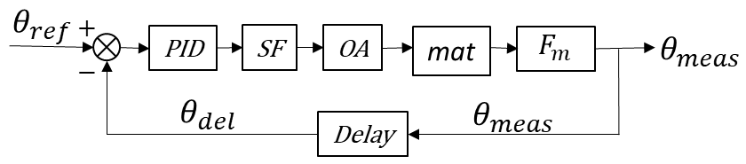
Figure A1. PID controlled muscle activation feedback control system, SF: Sigmoid function, OA: Overall activation, mat: Hill-Type muscle material model, F_{m}: Muscle force, θ_{meas}: Measured angle, θ_{ref}: Reference angle, θ_{del}: Delayed measured angle

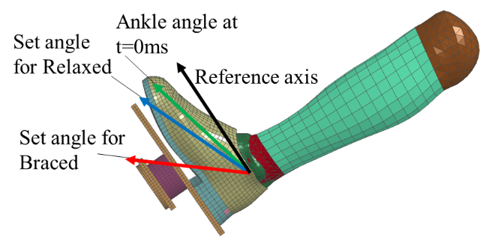
Figure A2. Schematic showing set angle strategy for relaxed and braced condition simulations

Table A6. Regional Joint angles used for the PID controllers
Angle | Direction | Right | Left
Neck | X | 1
Neck | Y | 1
Neck | Z | 1
Scapulo-Thoracic | X | 1 | 1
Scapulo-Thoracic | Z | 1 | 1
Glenohumeral | X | 1 | 1
Glenohumeral | Y | 1 | 1
Glenohumeral | Z | 1 | 1
Elbow | Y | 1 | 1
Wrist | X | 1 | 1
Thorax-Pelvis | X | 1
Thorax-Pelvis | Y | 1
Thorax-Pelvis | Z | 1
Hip | X | 1 | 1
Hip | Y | 1 | 1
Hip | Z | 1 | 1
Knee | Y | 1 | 1
Ankle | X | 1 | 1
Total |  | 32

Table A7. Controller Gains. Note the elbow controller is the only upper extremity controller to have a k_{D} value.
Region | $$k_{P}$$  (rad⁻¹) | $$k_{I}$$  (rad⁻¹ms⁻¹) | $$k_{D}$$  (ms/rad)
Neck | 3 | 0 | 250
Upper Ex. | 4 | 0 | 0, (Elbow-250)
Trunk | 8 | 0 | 0
Lower Ex. | 2 | 0 | 0

Table A8. CORA scores for GHBMC M50-OS+Active in the relaxed condition at 2.5g acceleration
Signal | Corridor | Shape | Size | Phase | CORA score
Steering Column Force | 0.444 | 0.945 | 0.487 | 0.000 | 0.460
Right Pedal Force | 0.594 | 0.901 | 0.867 | 1.000 | 0.758
Left Pedal Force | 0.597 | 0.908 | 0.965 | 1.000 | 0.777
Shoulder Belt Force | 0.572 | 0.867 | 0.614 | 0.888 | 0.680
Lap Belt Force | 0.519 | 0.920 | 0.695 | 0.891 | 0.677
Seatpan Force | 0.566 | 0.975 | 0.999 | 0.967 | 0.773
Seatback Force | 0.432 | 0.889 | 0.633 | 0.859 | 0.612
Retractor Belt Force | 0.082 | 0.832 | 0.493 | 0.879 | 0.408
Head CG Linear Acceleration | 0.334 | 0.878 | 0.446 | 1.000 | 0.554
Head CG Rotational Acceleration | 0.414 | 0.843 | 0.353 | 0.844 | 0.547
C7 Linear Acceleration | 0.392 | 0.576 | 0.444 | 1.000 | 0.532
Sternum Linear Acceleration | 0.490 | 0.718 | 0.632 | 0.459 | 0.546
Sacrum Linear Acceleration | 0.525 | 0.784 | 0.433 | 1.000 | 0.632
 | Total CORA rating |  |  |  | 0.612

Table A9. CORA scores for GHBMC M50-OS+Active in the relaxed condition at 5g acceleration
Signal | Corridor | Shape | Size | Phase | CORA score
Steering Column Force | 0.647 | 0.940 | 0.511 | 0.000 | 0.565
Right Pedal Force | 0.505 | 0.834 | 0.569 | 1.000 | 0.653
Left Pedal Force | 0.521 | 0.857 | 0.767 | 1.000 | 0.697
Shoulder Belt Force | 0.762 | 0.969 | 0.699 | 1.000 | 0.825
Lap Belt Force | 0.458 | 0.989 | 1.000 | 1.000 | 0.727
Seatpan Force | 0.618 | 0.937 | 0.853 | 1.000 | 0.774
Seatback Force | 0.442 | 0.775 | 0.400 | 1.000 | 0.583
Retractor Belt Force | 0.373 | 0.952 | 0.573 | 1.000 | 0.607
Head CG Linear Acceleration | 0.582 | 0.938 | 0.897 | 1.000 | 0.763
Head CG Rotational Acceleration | 0.359 | 0.824 | 0.545 | 1.000 | 0.574
C7 Linear Acceleration | 0.504 | 0.733 | 0.811 | 1.000 | 0.676
Sternum Linear Acceleration | 0.526 | 0.794 | 0.668 | 1.000 | 0.673
Sacrum Linear Acceleration | 0.584 | 0.858 | 0.418 | 1.000 | 0.671
 | Total CORA rating |  |  |  | 0.676

Table A10. CORA scores for GHBMC M50-OS+Active in the braced condition at 2.5g acceleration
Signal | Corridor | Shape | Size | Phase | CORA score
Steering Column Force | 0.389 | 0.875 | 0.143 | 1.000 | 0.530
Right Pedal Force | 0.646 | 0.976 | 0.417 | 1.000 | 0.721
Left Pedal Force | 0.813 | 0.937 | 0.252 | 1.000 | 0.771
Shoulder Belt Force | 0.894 | 0.960 | 0.872 | 0.900 | 0.902
Lap Belt Force | 0.700 | 0.767 | 0.630 | 1.000 | 0.749
Seatpan Force | 0.782 | 0.977 | 0.225 | 1.000 | 0.758
Seatback Force | 0.350 | 0.967 | 0.184 | 1.000 | 0.533
Retractor Belt Force | 0.153 | -0.125 | 0.000 | 1.000 | 0.222
Head CG Linear Acceleration | 0.430 | 0.929 | 0.876 | 1.000 | 0.682
Head CG Rotational Acceleration | 0.390 | 0.750 | 0.161 | 1.000 | 0.513
C7 Linear Acceleration | 0.694 | 0.903 | 0.777 | 0.411 | 0.695
Sternum Linear Acceleration | 0.715 | 0.896 | 0.796 | 1.000 | 0.806
Sacrum Linear Acceleration | 0.871 | 0.957 | 0.648 | 1.000 | 0.869
 | Total CORA rating |  |  |  | 0.673

Table A11. CORA scores for GHBMC M50-OS+Active in the braced condition at 5g acceleration
Signal | Corridor | Shape | Size | Phase | CORA score
Steering Column Force | 0.431 | 0.879 | 0.244 | 1.000 | 0.569
Right Pedal Force | 0.597 | 0.897 | 0.540 | 1.000 | 0.704
Left Pedal Force | 0.766 | 0.870 | 0.560 | 1.000 | 0.788
Shoulder Belt Force | 0.808 | 0.970 | 0.394 | 1.000 | 0.798
Lap Belt Force | 0.721 | 0.975 | 0.312 | 1.000 | 0.741
Seatpan Force | 0.808 | 0.949 | 0.500 | 1.000 | 0.812
Seatback Force | 0.521 | 0.883 | 0.274 | 1.000 | 0.620
Retractor Belt Force | 0.302 | 0.910 | 0.548 | 1.000 | 0.560
Head CG Linear Acceleration | 0.515 | 0.953 | 0.710 | 1.000 | 0.701
Head CG Rotational Acceleration | 0.535 | 0.841 | 0.480 | 1.000 | 0.654
C7 Linear Acceleration | 0.690 | 0.911 | 0.573 | 0.976 | 0.755
Sternum Linear Acceleration | 0.657 | 0.915 | 0.684 | 1.000 | 0.761
Sacrum Linear Acceleration | 0.761 | 0.895 | 0.634 | 1.000 | 0.802
 | Total CORA rating |  |  |  | 0.713

Table A12. CORA scores for GHBMC M50-OS in the relaxed condition at 2.5g acceleration
Signal | Corridor | Shape | Size | Phase | CORA score
Steering Column Force | 0.528 | 0.975 | 0.284 | 0.000 | 0.474
Right Pedal Force | 0.532 | 0.837 | 0.822 | 1.000 | 0.709
Left Pedal Force | 0.622 | 0.865 | 0.620 | 1.000 | 0.725
Shoulder Belt Force | 0.567 | 0.887 | 0.918 | 0.829 | 0.722
Lap Belt Force | 0.484 | 0.943 | 0.919 | 0.820 | 0.689
Seatpan Force | 0.671 | 0.986 | 0.889 | 1.000 | 0.814
Seatback Force | 0.357 | 0.897 | 0.299 | 0.826 | 0.515
Retractor Belt Force | 0.072 | 0.850 | 0.839 | 0.832 | 0.456
Head CG Linear Acceleration | 0.713 | 0.926 | 0.976 | 1.000 | 0.840
Head CG Rotational Acceleration | 0.433 | 0.920 | 0.358 | 0.888 | 0.577
C7 Linear Acceleration | 0.319 | 0.770 | 0.728 | 0.603 | 0.509
Sternum Linear Acceleration | 0.383 | 0.747 | 0.455 | 1.000 | 0.558
Sacrum Linear Acceleration | 0.535 | 0.908 | 0.368 | 1.000 | 0.646
 | Total CORA rating |  |  |  | 0.633

Table A13. CORA scores for GHBMC M50-OS in the relaxed condition at 5g acceleration
Signal | Corridor | Shape | Size | Phase | CORA score
Steering Column Force | 0.620 | 0.933 | 0.289 | 0.000 | 0.513
Right Pedal Force | 0.434 | 0.765 | 0.754 | 1.000 | 0.636
Left Pedal Force | 0.469 | 0.912 | 0.648 | 1.000 | 0.661
Shoulder Belt Force | 0.736 | 0.971 | 0.951 | 1.000 | 0.855
Lap Belt Force | 0.378 | 0.991 | 0.958 | 1.000 | 0.680
Seatpan Force | 0.540 | 0.951 | 0.925 | 1.000 | 0.749
Seatback Force | 0.221 | 0.895 | 0.132 | 1.000 | 0.448
Retractor Belt Force | 0.390 | 0.963 | 0.742 | 1.000 | 0.645
Head CG Linear Acceleration | 0.564 | 0.926 | 0.884 | 1.000 | 0.750
Head CG Rotational Acceleration | 0.466 | 0.847 | 0.541 | 0.926 | 0.618
C7 Linear Acceleration | 0.459 | 0.803 | 0.660 | 1.000 | 0.640
Sternum Linear Acceleration | 0.382 | 0.792 | 0.607 | 1.000 | 0.590
Sacrum Linear Acceleration | 0.642 | 0.926 | 0.423 | 1.000 | 0.712
 | Total CORA rating |  |  |  | 0.654

Table A14. CORA scores for GHBMC M50-OS in the braced condition at 2.5g acceleration
Signal | Corridor | Shape | Size | Phase | CORA score
Steering Column Force | 0.125 | 0.913 | 0.045 | 0.915 | 0.374
Right Pedal Force | 0.086 | 0.673 | 0.083 | 1.000 | 0.335
Left Pedal Force | 0.350 | 0.789 | 0.075 | 1.000 | 0.485
Shoulder Belt Force | 0.682 | 0.805 | 0.028 | 1.000 | 0.646
Lap Belt Force | 0.611 | 0.682 | 0.176 | 1.000 | 0.615
Seatpan Force | 0.267 | 0.947 | 0.073 | 0.000 | 0.303
Seatback Force | 0.110 | 0.658 | 0.023 | 0.594 | 0.267
Retractor Belt Force | 0.107 | 0.699 | 0.038 | 1.000 | 0.343
Head CG Linear Acceleration | 0.478 | 0.958 | 0.877 | 0.676 | 0.657
Head CG Rotational Acceleration | 0.310 | 0.954 | 0.228 | 0.438 | 0.425
C7 Linear Acceleration | 0.452 | 0.804 | 0.900 | 1.000 | 0.676
Sternum Linear Acceleration | 0.410 | 0.795 | 0.723 | 1.000 | 0.624
Sacrum Linear Acceleration | 0.821 | 0.850 | 0.767 | 1.000 | 0.846
 | Total CORA rating |  |  |  | 0.508

Table A15. CORA scores for GHBMC M50-OS in the braced condition at 5g acceleration
Signal | Corridor | Shape | Size | Phase | CORA score
Steering Column Force | 0.160 | 0.904 | 0.091 | 1.000 | 0.412
Right Pedal Force | 0.124 | 0.585 | 0.152 | 1.000 | 0.351
Left Pedal Force | 0.379 | 0.741 | 0.161 | 1.000 | 0.506
Shoulder Belt Force | 0.617 | 0.983 | 0.053 | 1.000 | 0.647
Lap Belt Force | 0.599 | 0.975 | 0.133 | 1.000 | 0.650
Seatpan Force | 0.398 | 0.892 | 0.189 | 0.000 | 0.379
Seatback Force | 0.283 | 0.698 | 0.036 | 1.000 | 0.430
Retractor Belt Force | 0.291 | 0.970 | 0.063 | 1.000 | 0.484
Head CG Linear Acceleration | 0.604 | 0.932 | 0.989 | 1.000 | 0.788
Head CG Rotational Acceleration | 0.432 | 0.842 | 0.218 | 0.120 | 0.412
C7 Linear Acceleration | 0.546 | 0.794 | 0.916 | 1.000 | 0.724
Sternum Linear Acceleration | 0.554 | 0.768 | 0.942 | 1.000 | 0.728
Sacrum Linear Acceleration | 0.815 | 0.884 | 0.507 | 1.000 | 0.806
 | Total CORA rating |  |  |  | 0.563

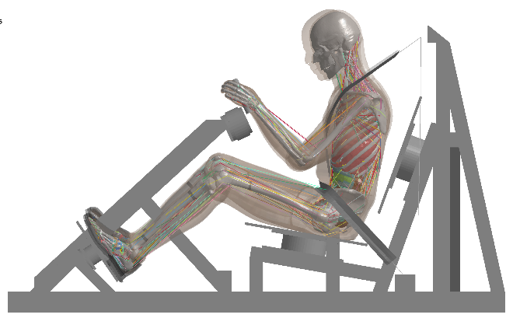
Figure A3. Comparison of simulation response for M50-OS (Control: shown as transparent colored skin) and M50-OS+Active at the time of highest head CG forward excursion in 5g relaxed condition

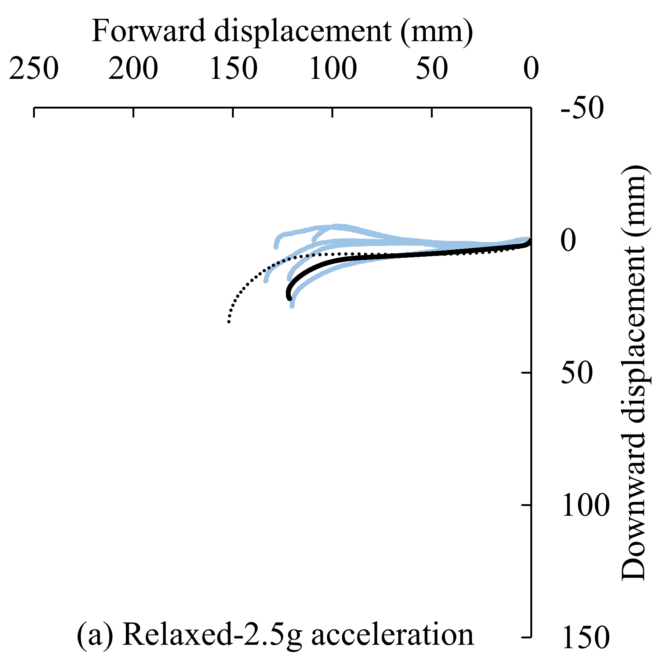 | 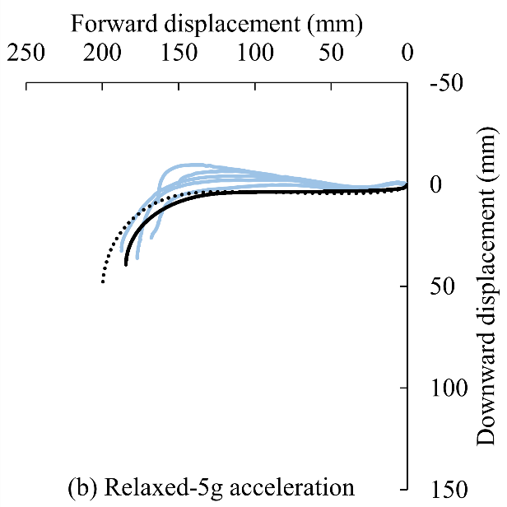
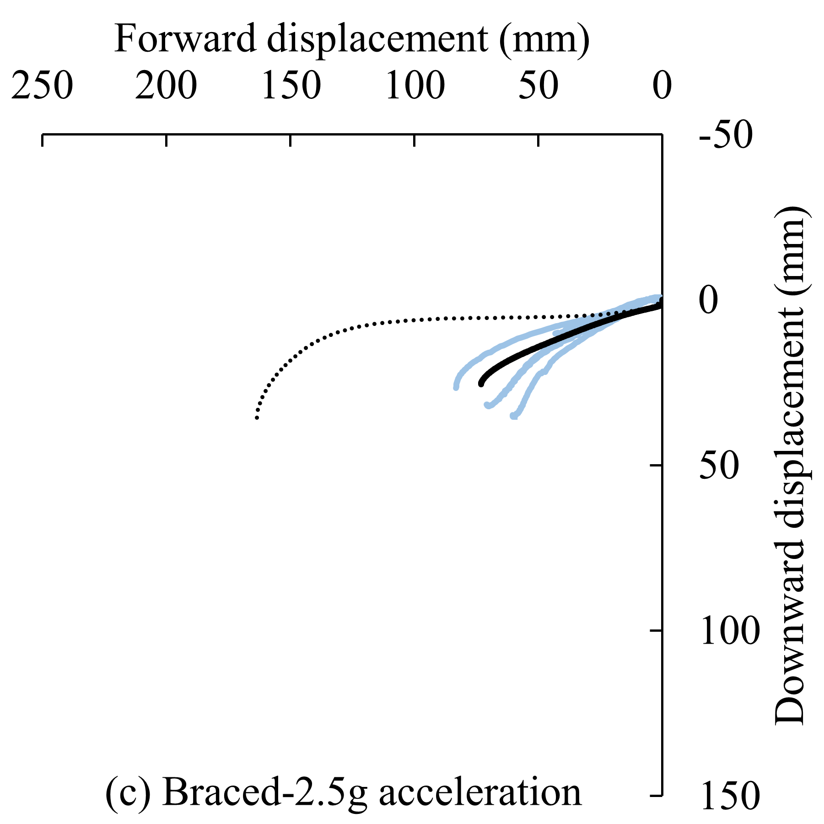 | 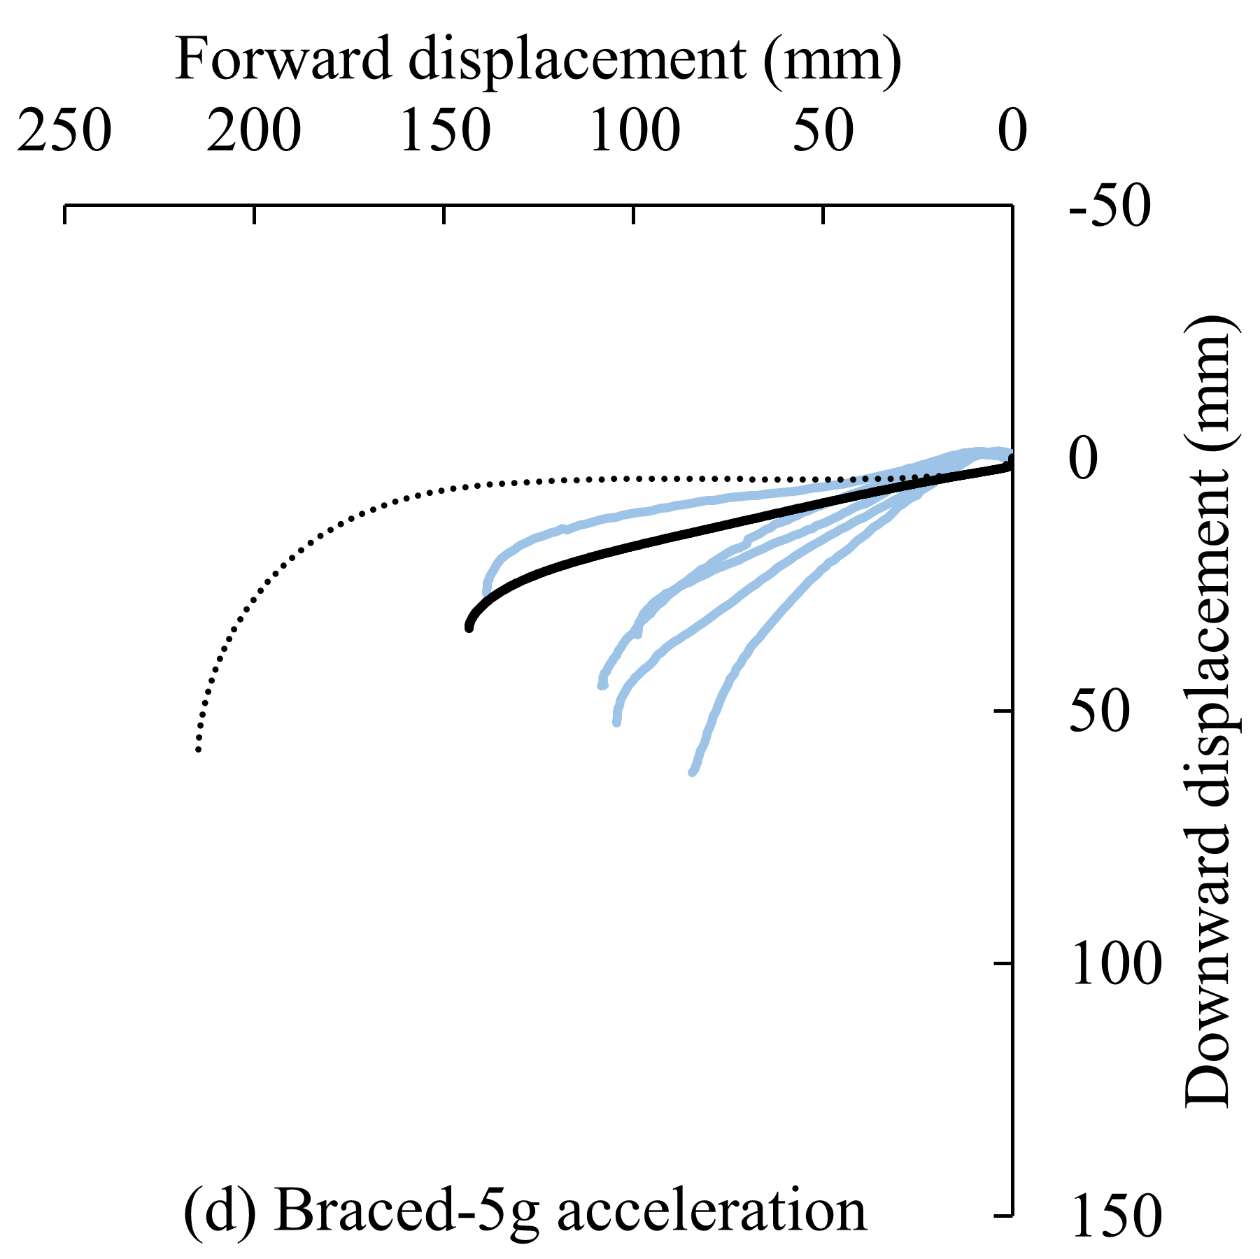
Figure A4. Head CG displacement response of M50-OS and M50-OS+Active along with experimental data (Beeman, et al. 2011)

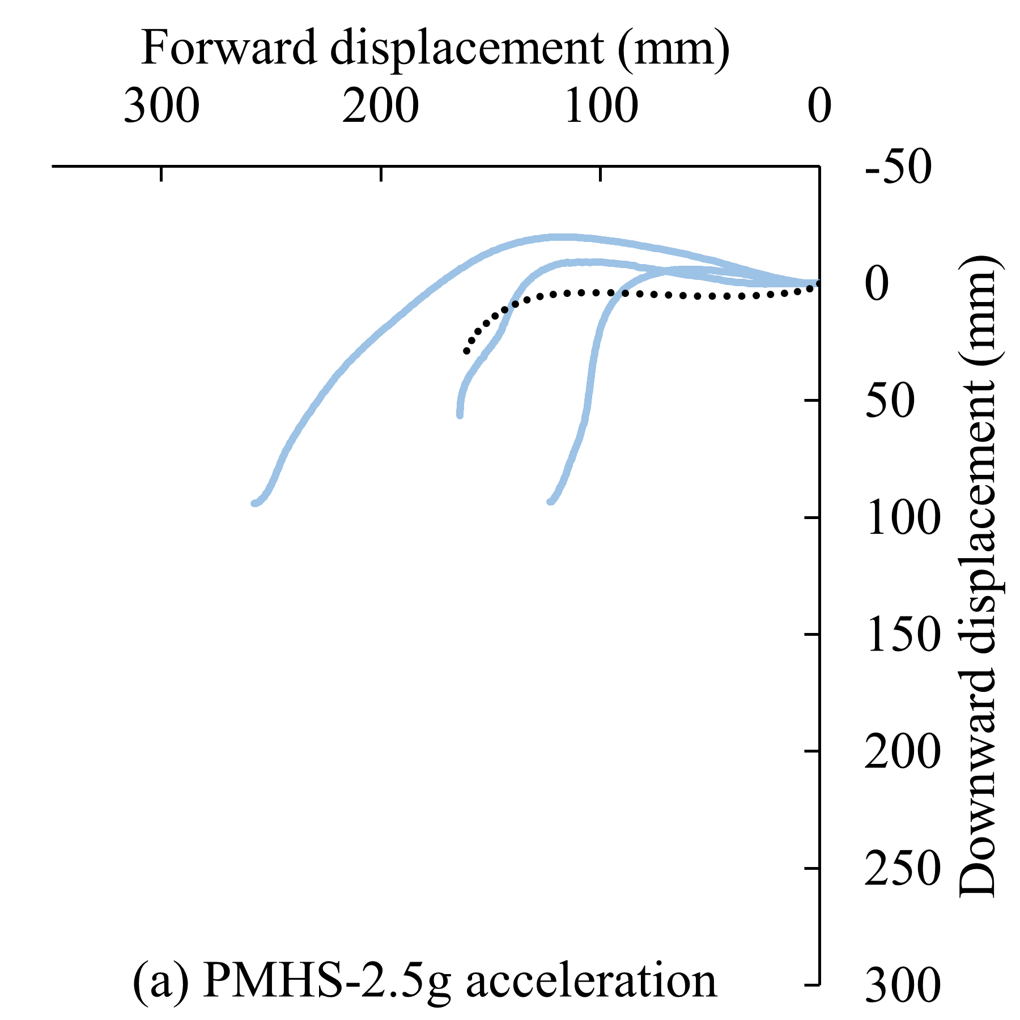 | 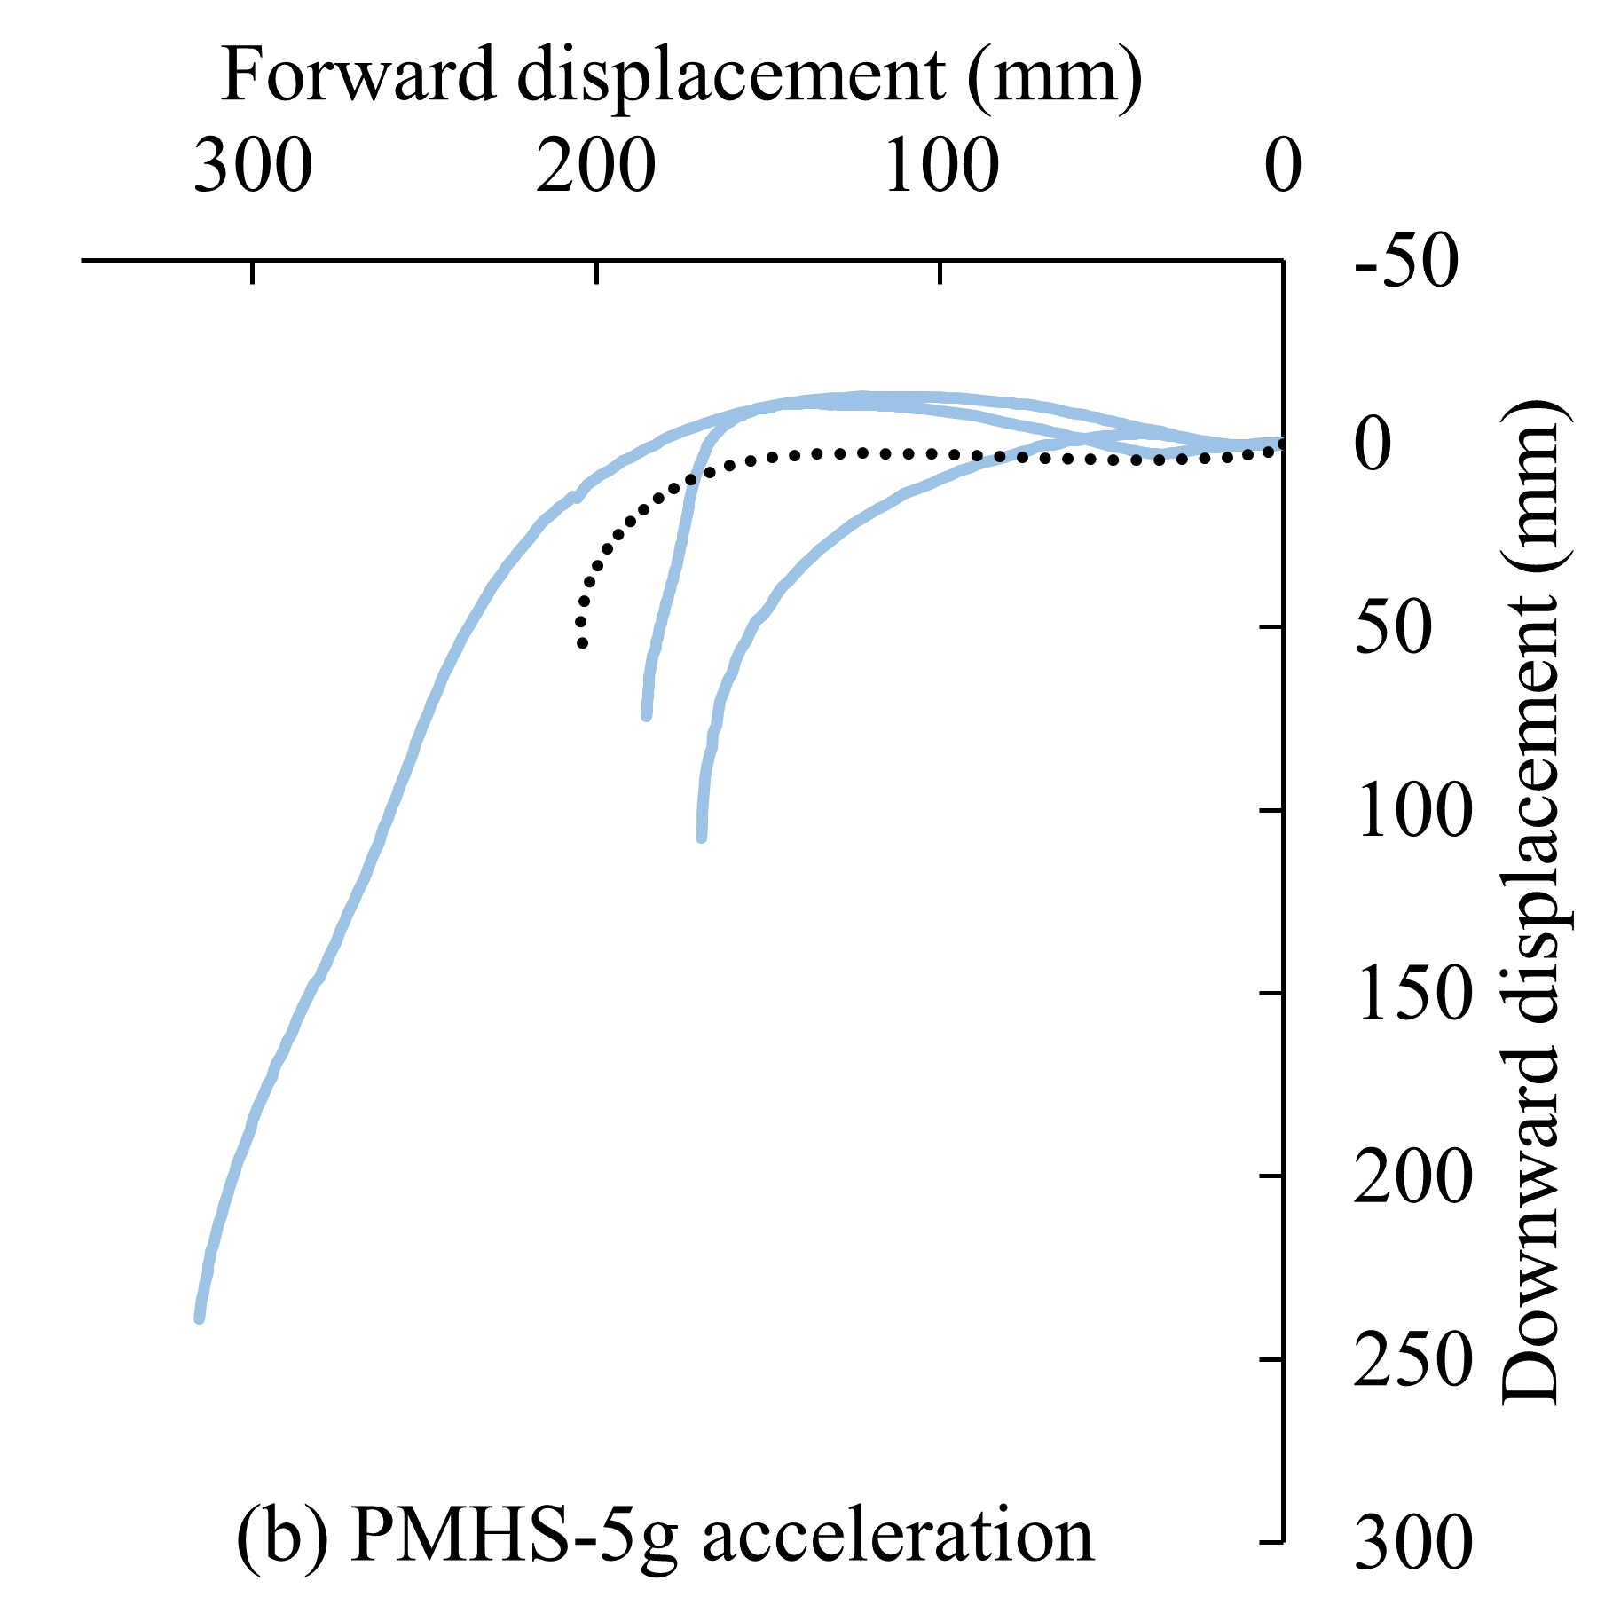
Figure A5. Head CG displacement response of M50-OS along with experimental PMHS data (Beeman, et al. 2012)

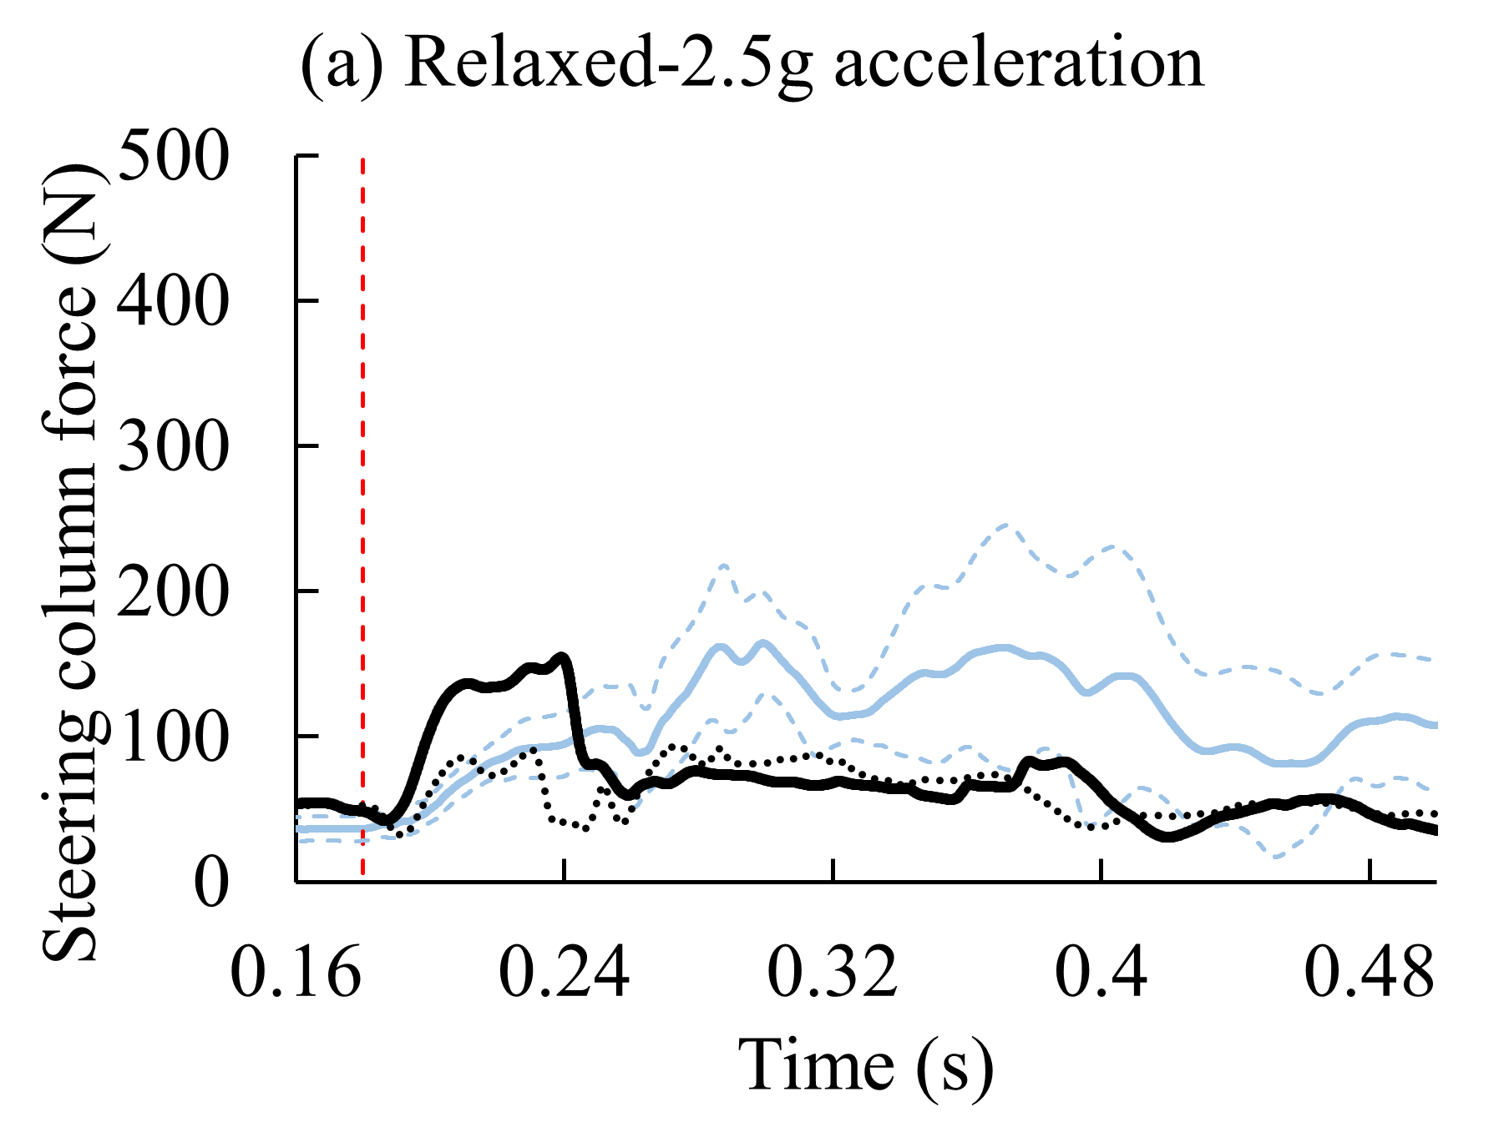 | 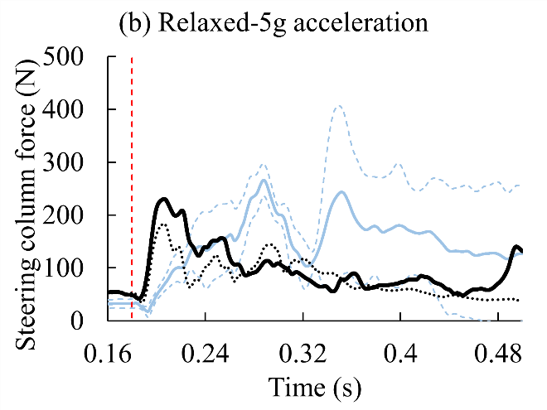
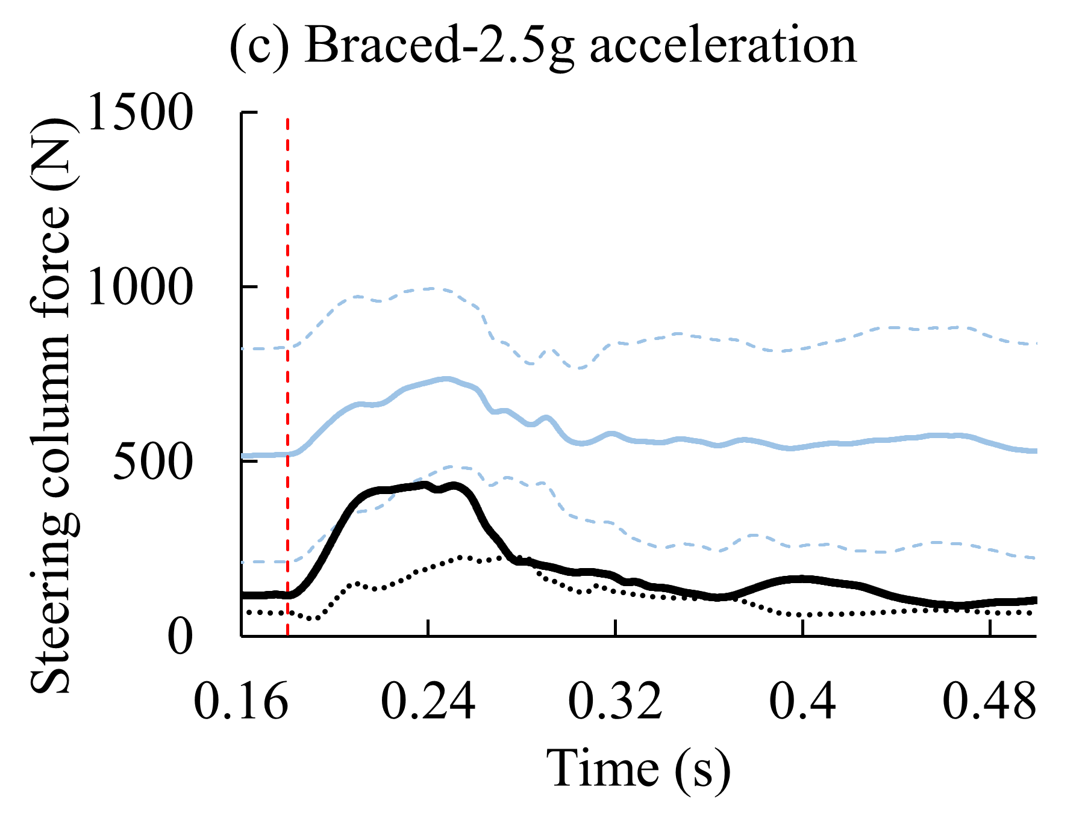 | 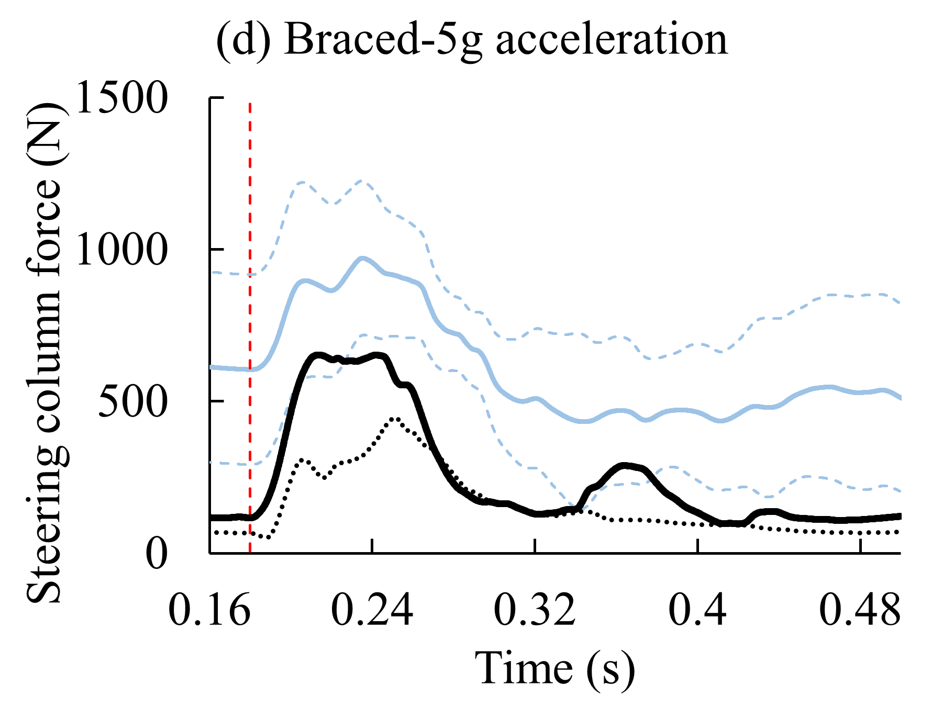
Figure A6. Comparison of steering column force, by muscle state and pulse severity, for M50-OS+Active, M50-OS, and volunteer data (Kemper, et al. 2014)

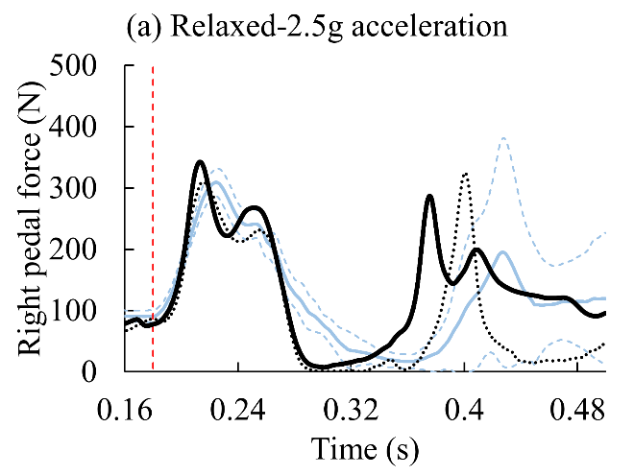 | 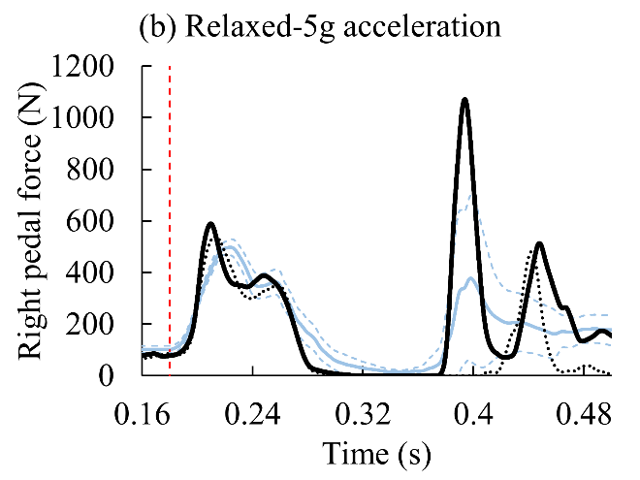
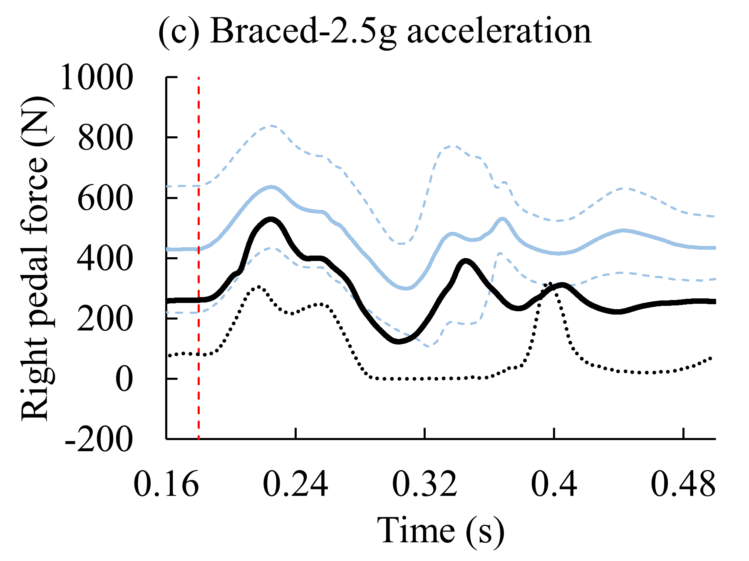 | 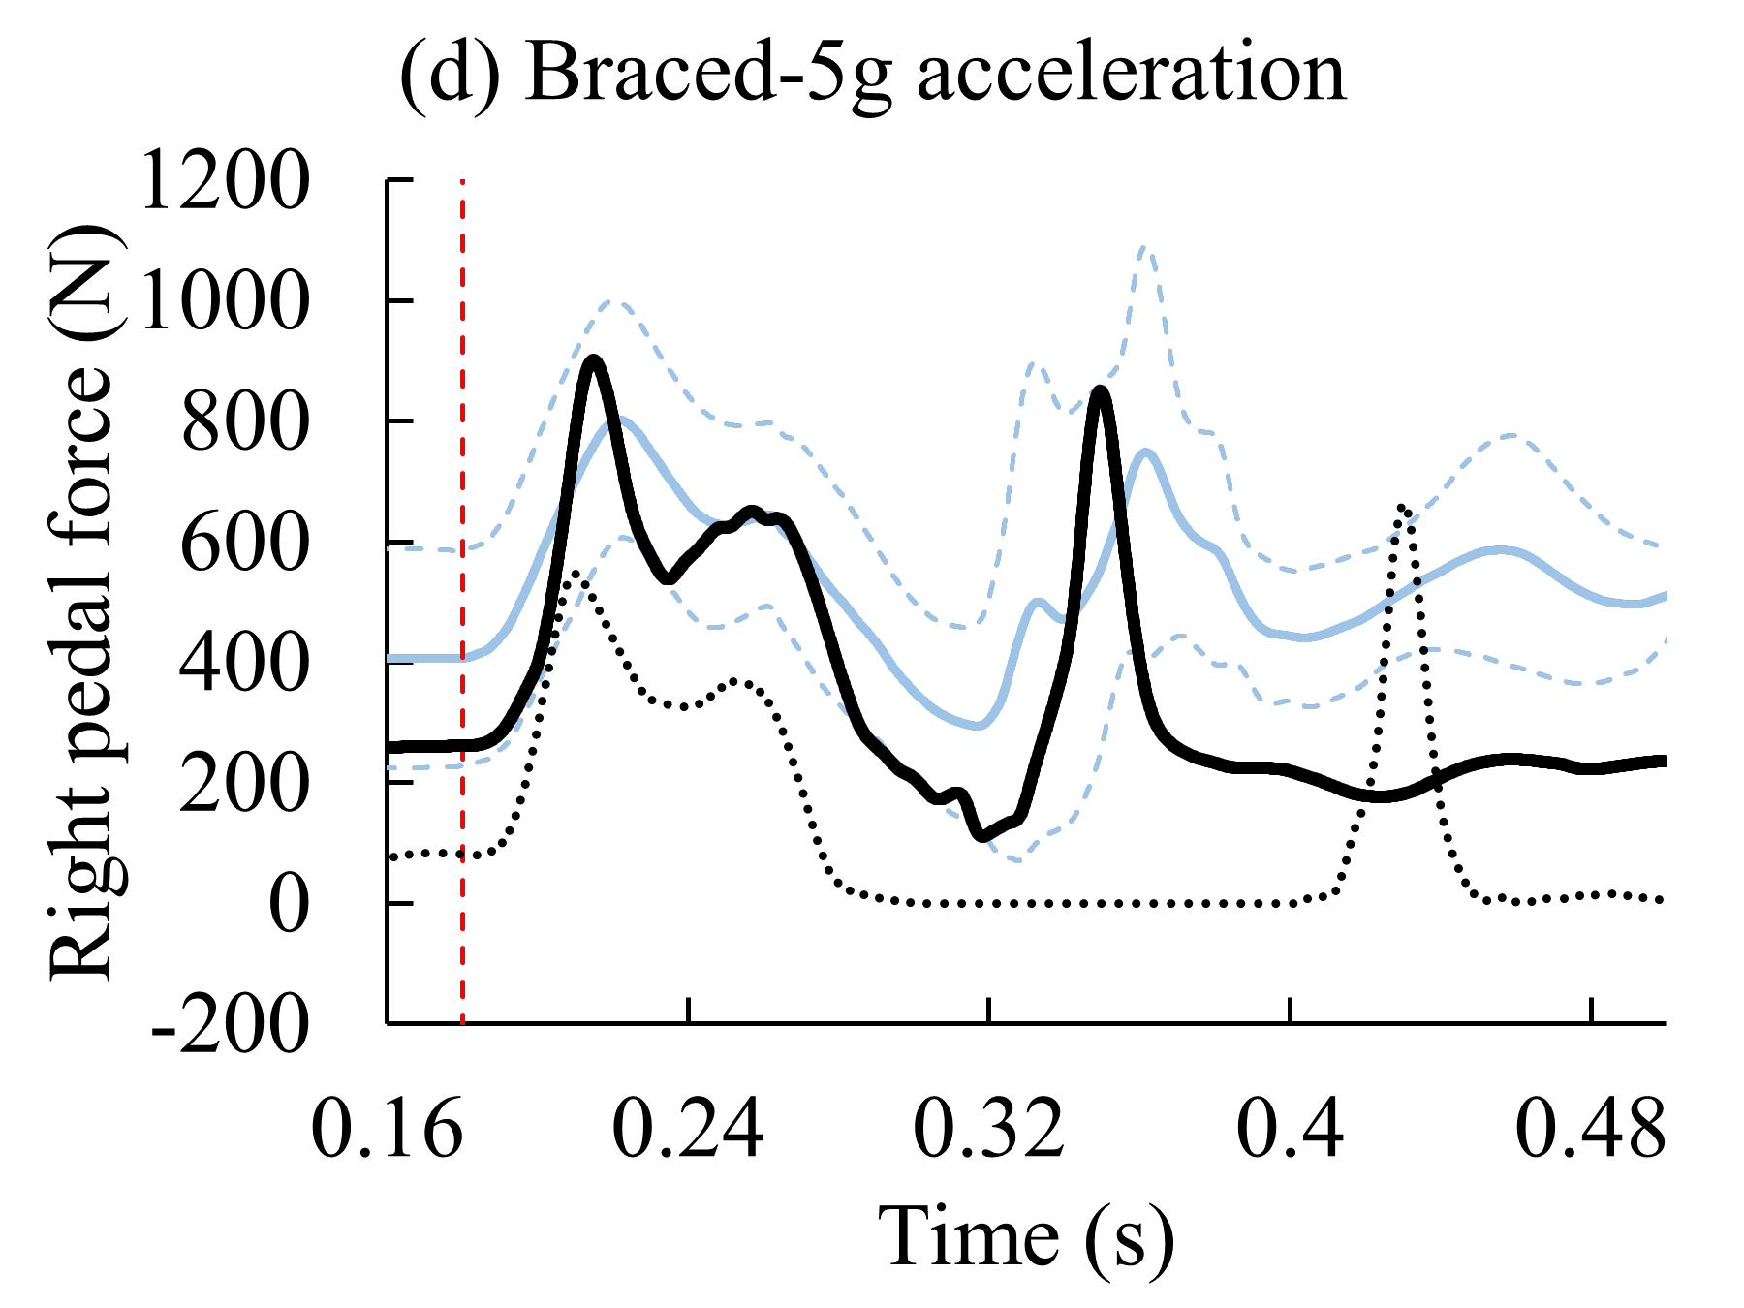
Figure A7. Comparison of right pedal force, by muscle state and pulse severity, for M50-OS+Active, M50-OS, and volunteer data (Kemper, et al. 2014)

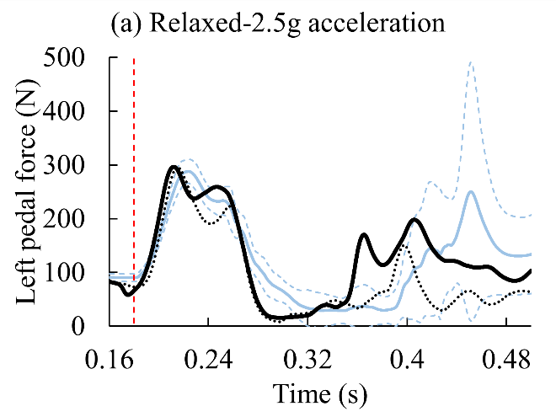 | 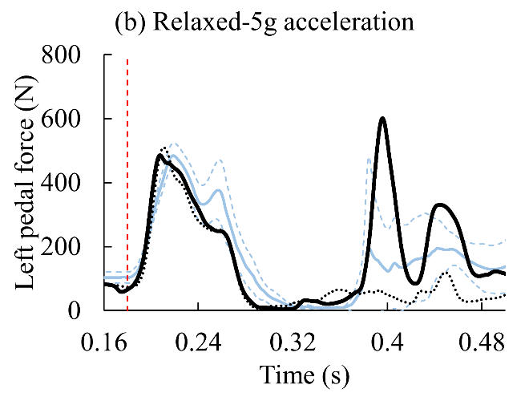
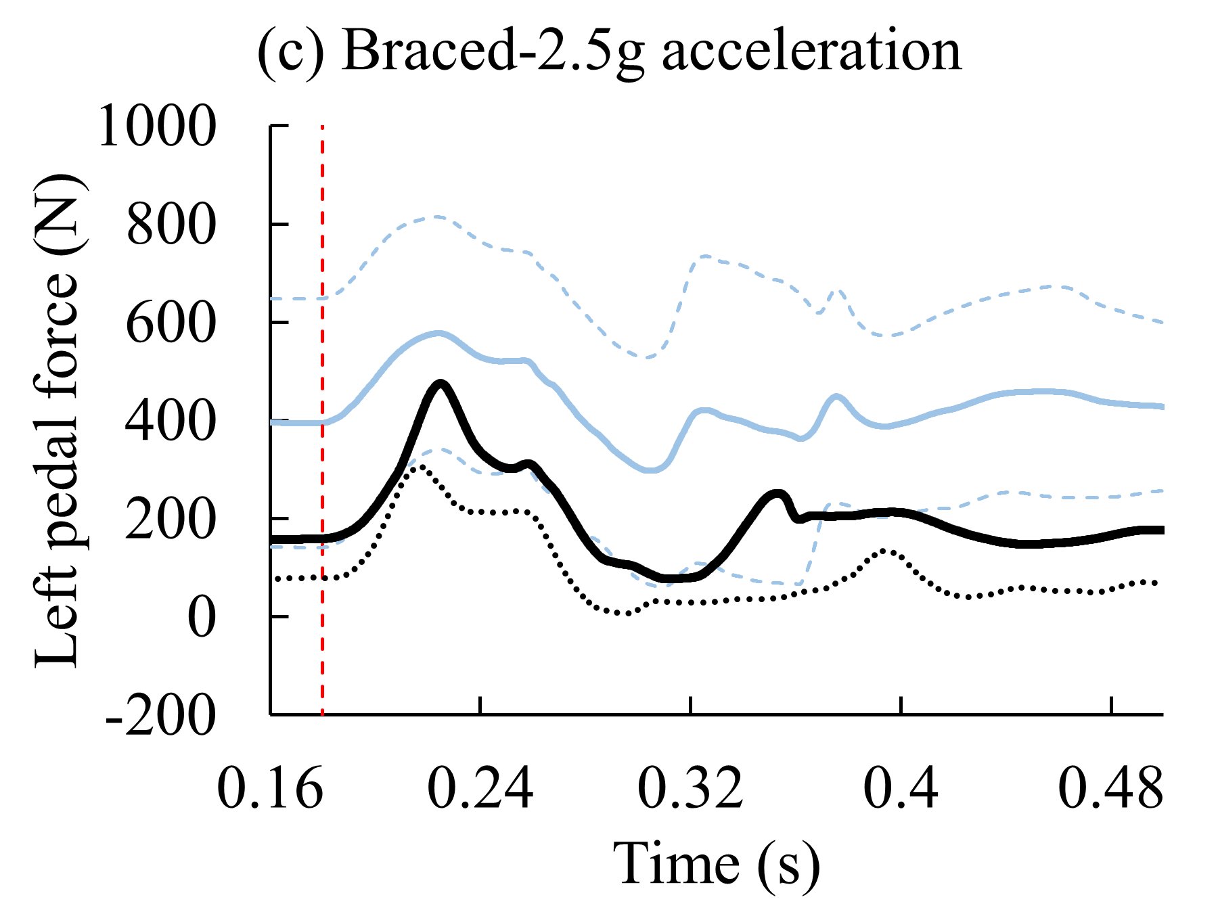 | 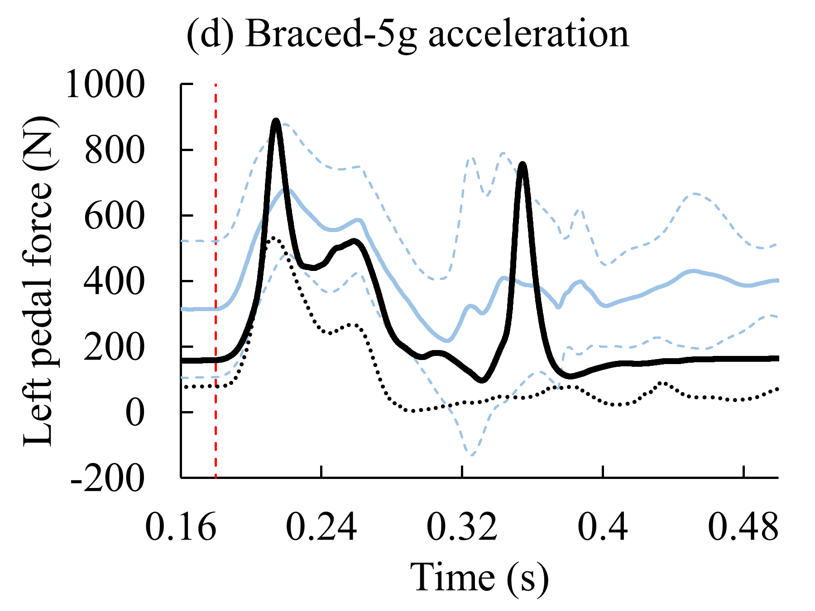
Figure A8. Comparison of left pedal force, by muscle state and pulse severity, for M50-OS+Active, M50-OS, and volunteer data (Kemper, et al. 2014)

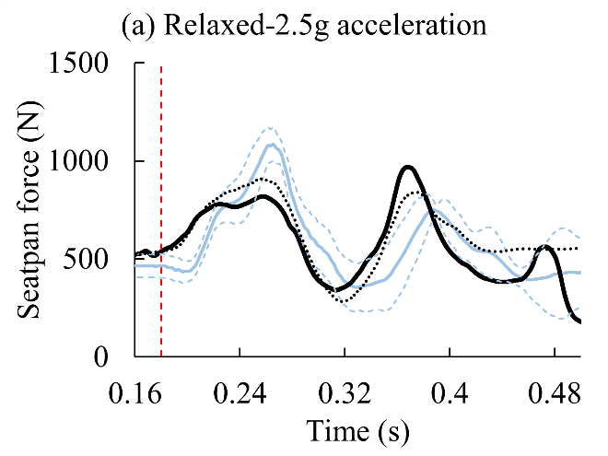 | 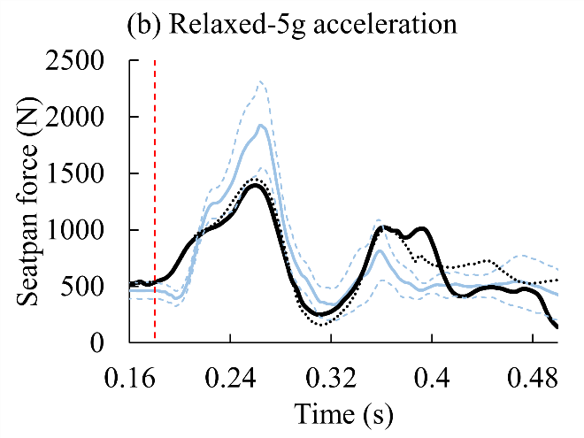
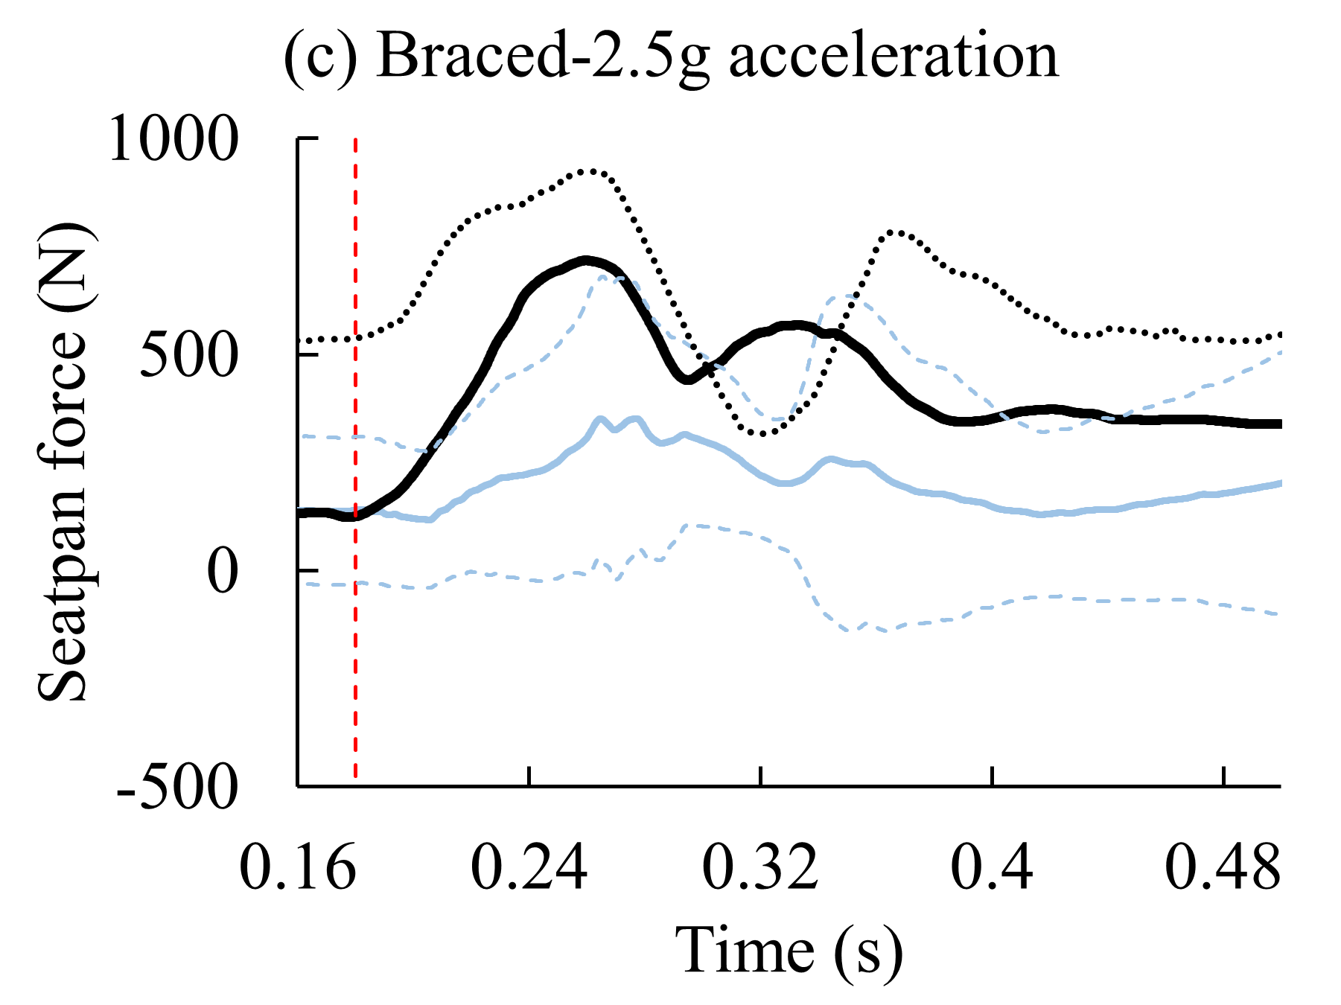 | 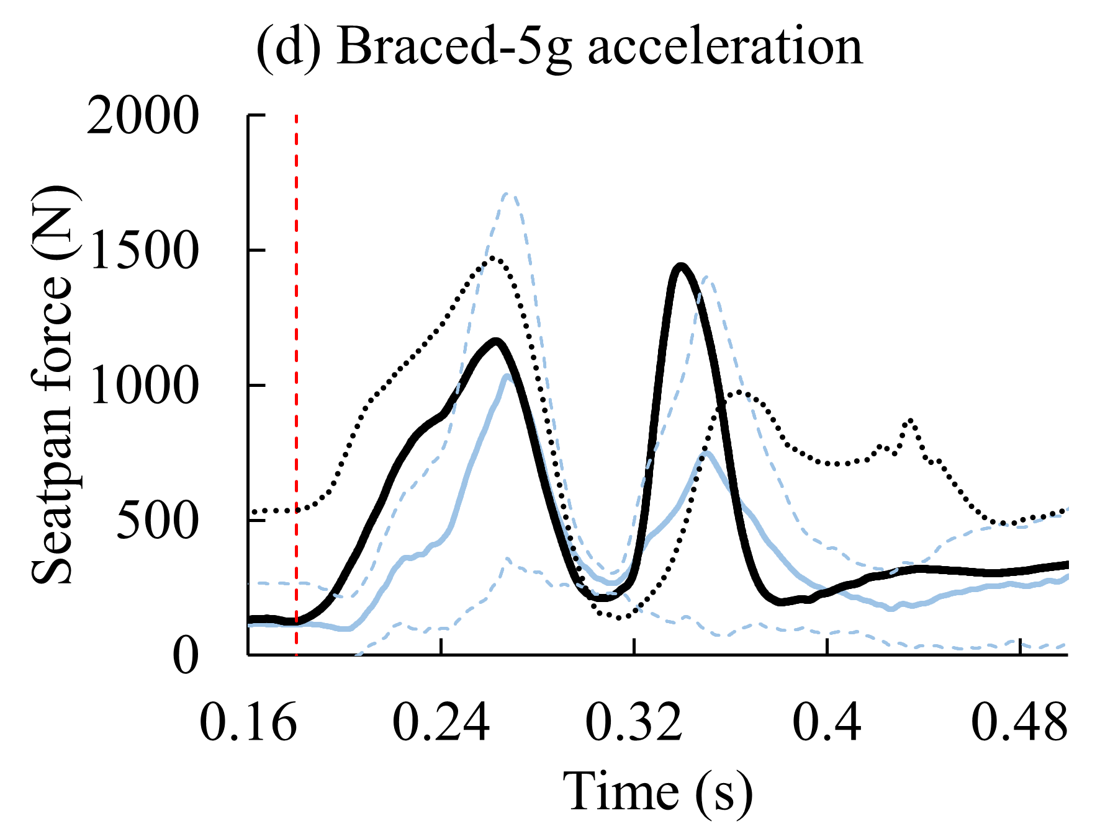
Figure A9. Comparison of seatpan force, by muscle state and pulse severity, for M50-OS+Active, M50-OS, and volunteer data (Kemper, et al. 2014)

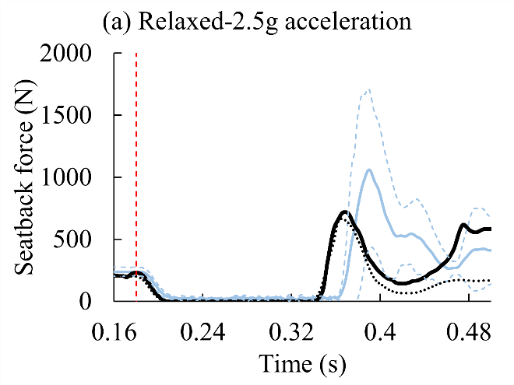 | 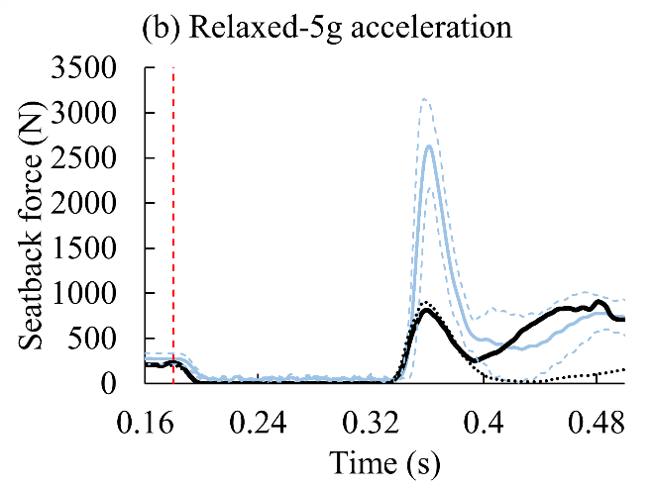
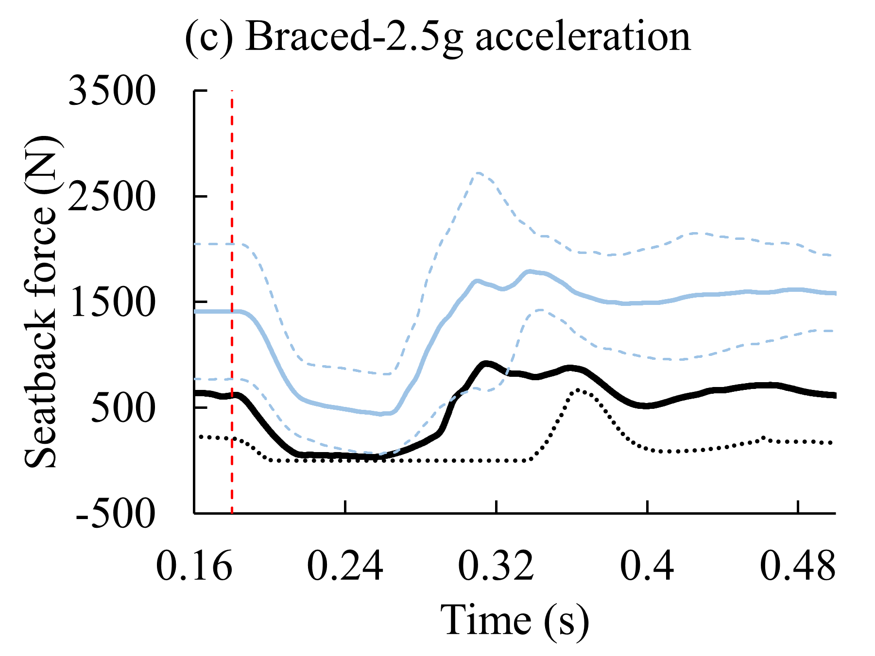 | 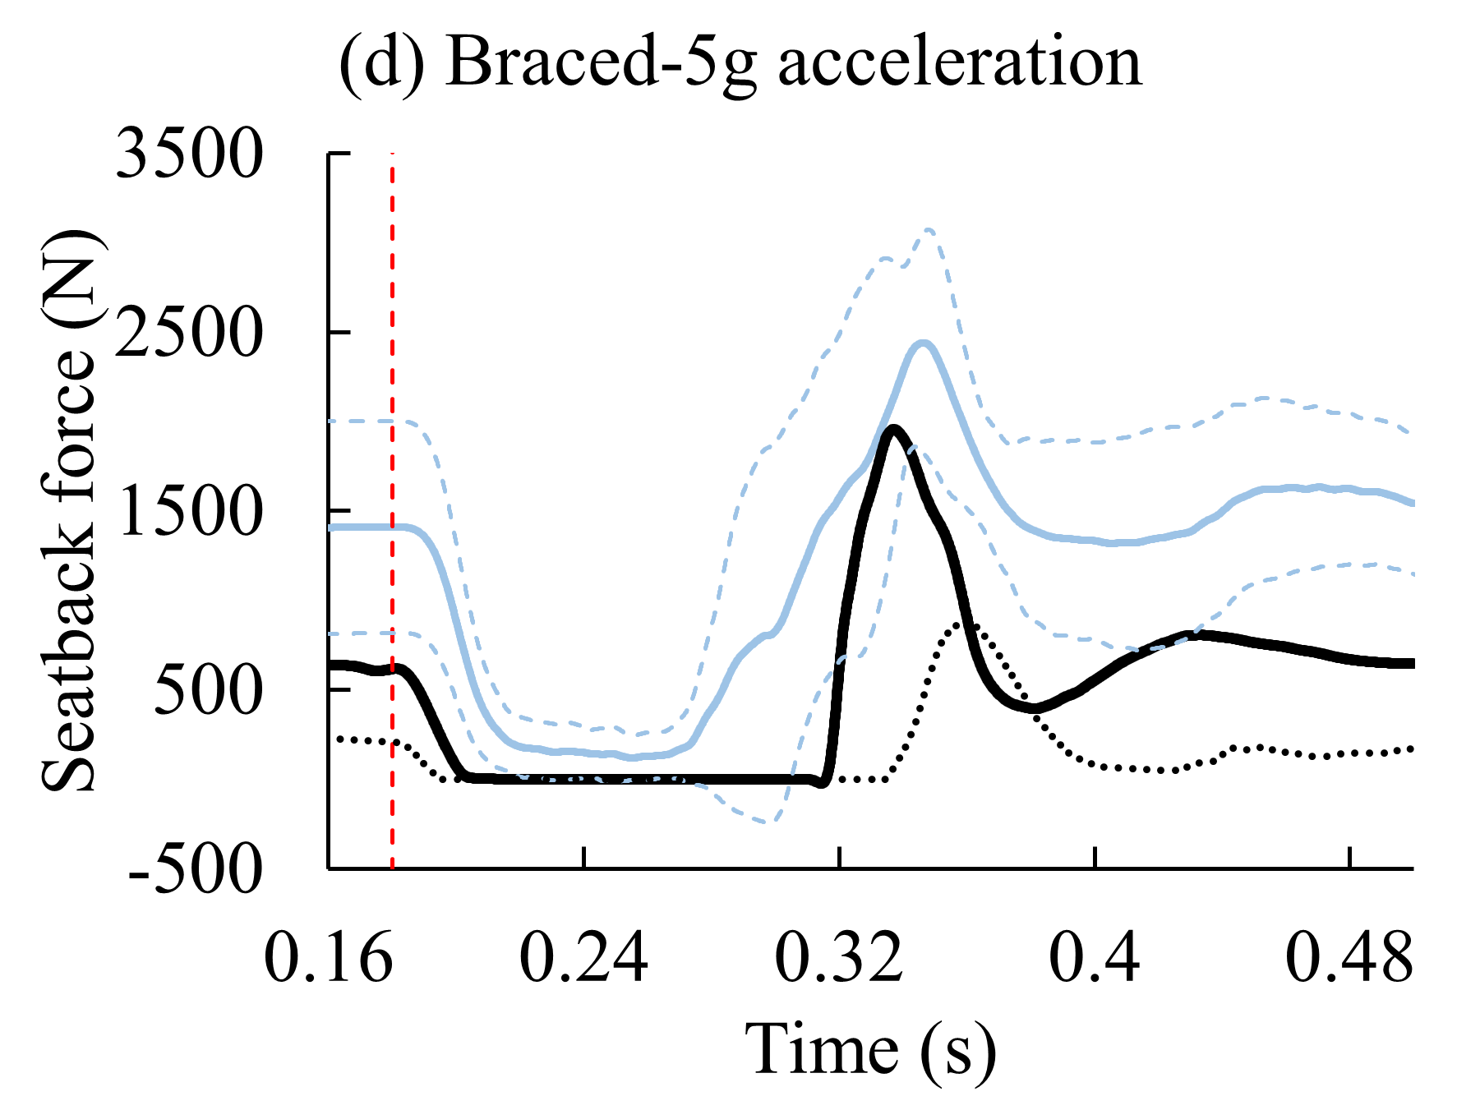
Figure A10. Comparison of seatback force, by muscle state and pulse severity, for M50-OS+Active, M50-OS, and volunteer data (Kemper, et al. 2014)

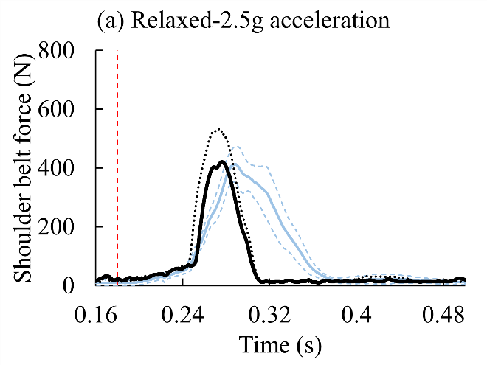 | 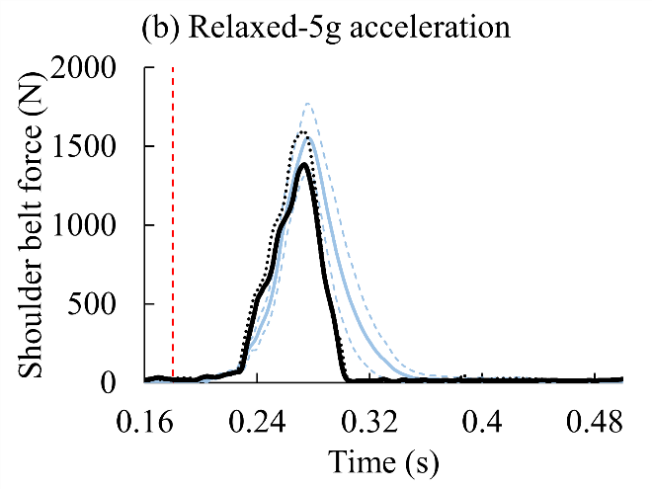
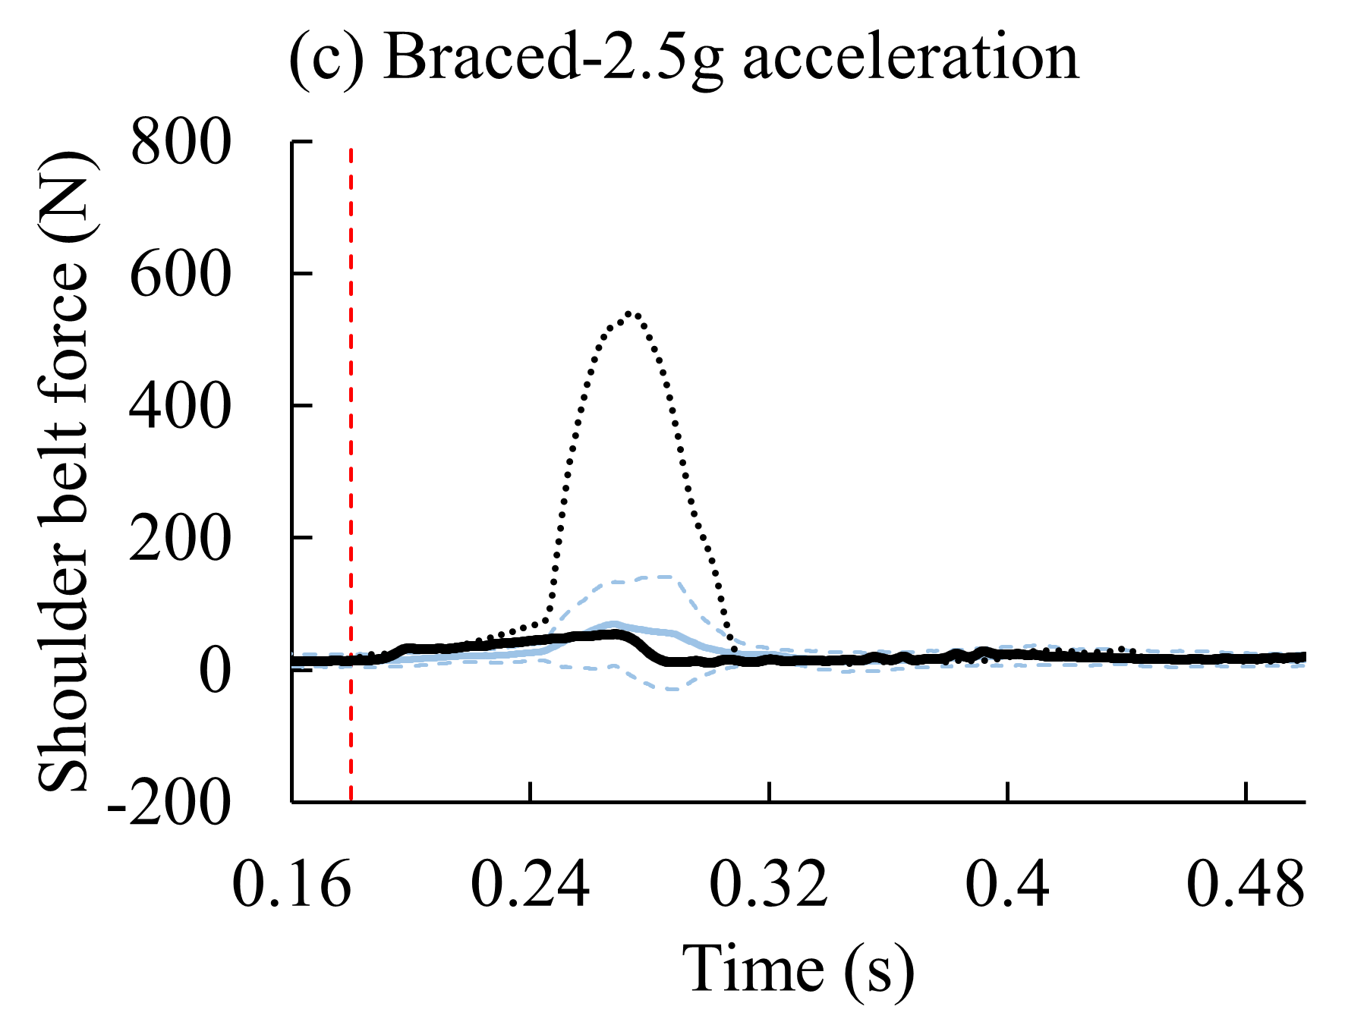 | 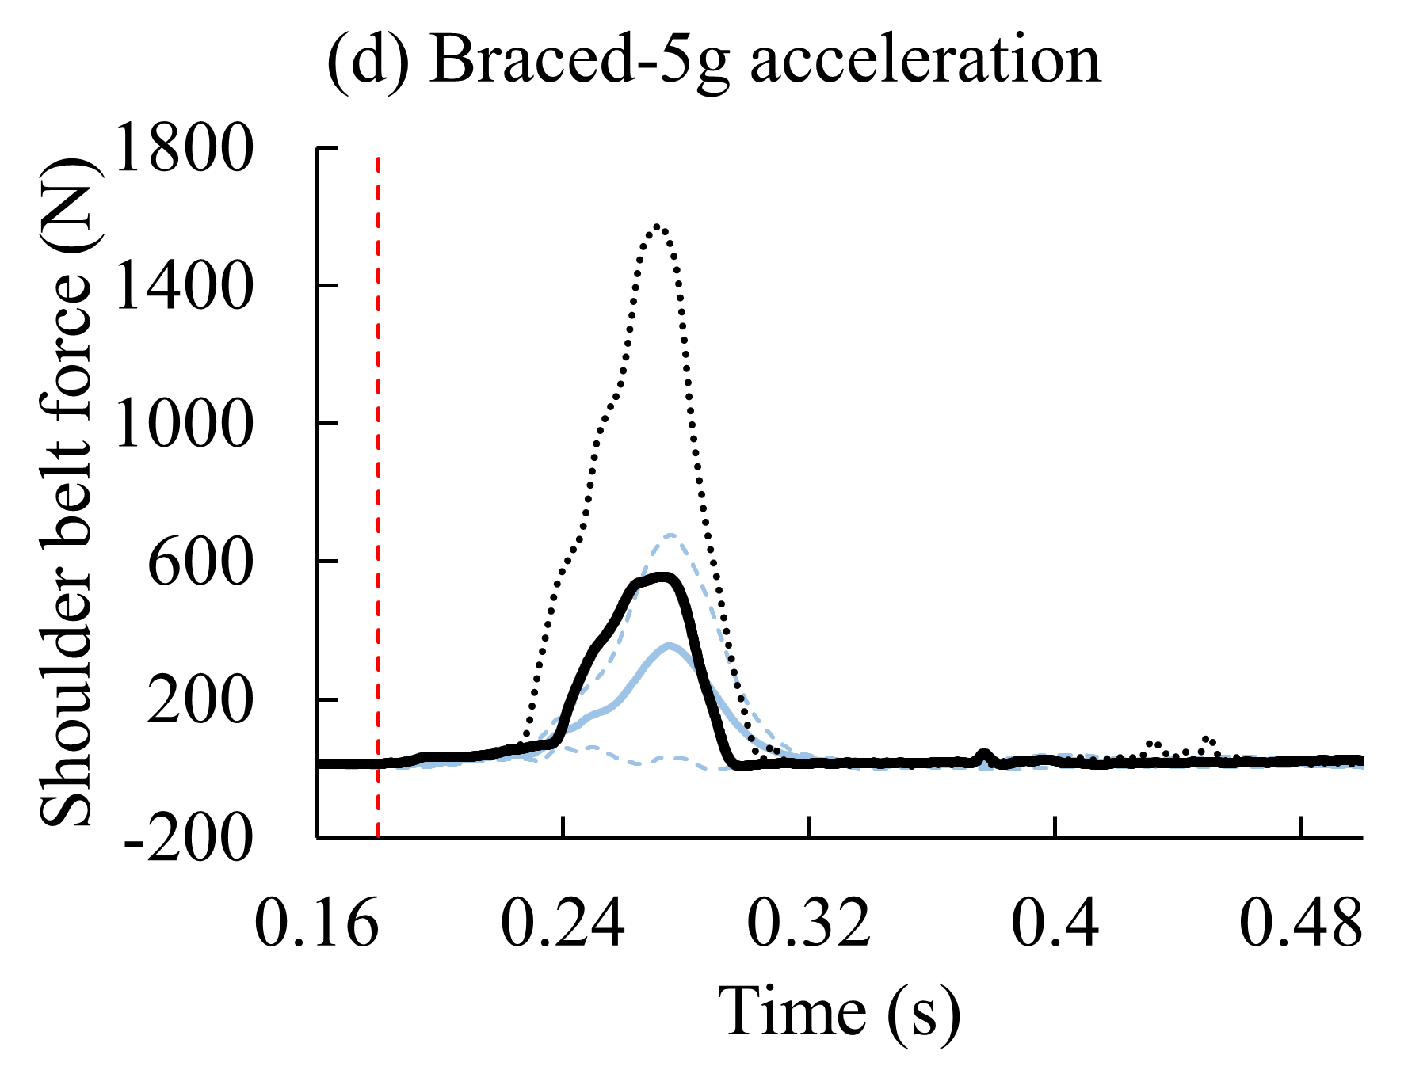
Figure A11. Comparison of shoulder belt force, by muscle state and pulse severity, for M50-OS+Active, M50-OS, and volunteer data (Kemper, et al. 2014)

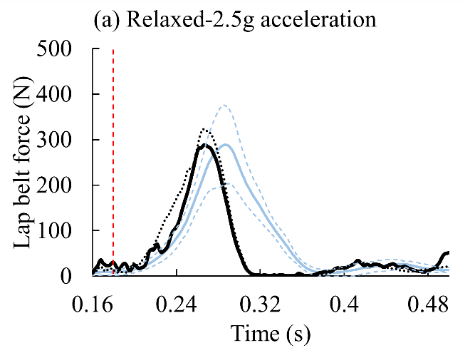 | 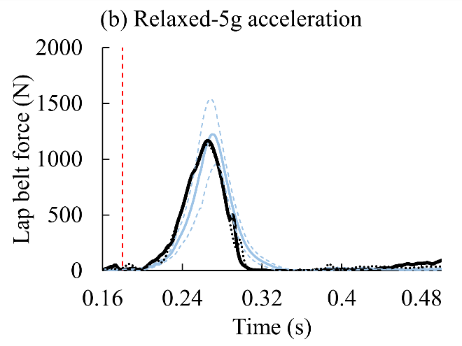
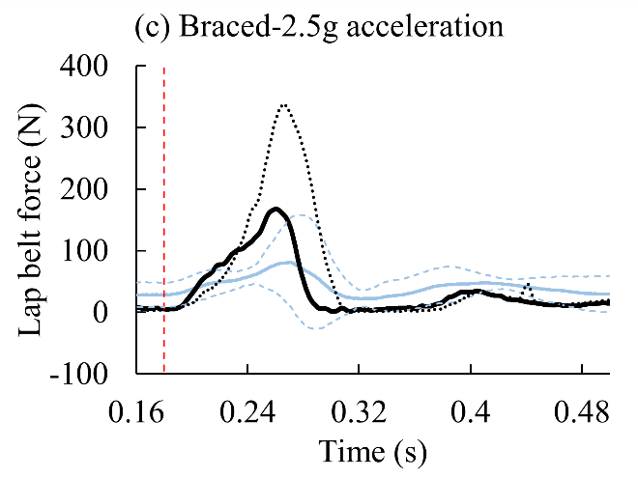 | 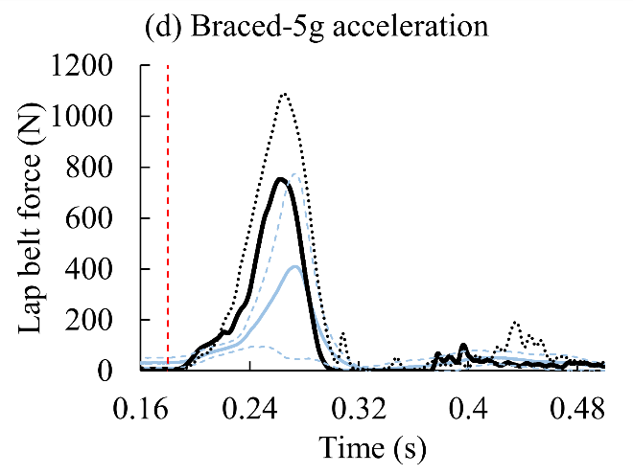
Figure A12. Comparison of lap belt force, by muscle state and pulse severity, for M50-OS+Active, M50-OS, and volunteer data (Kemper, et al. 2014)

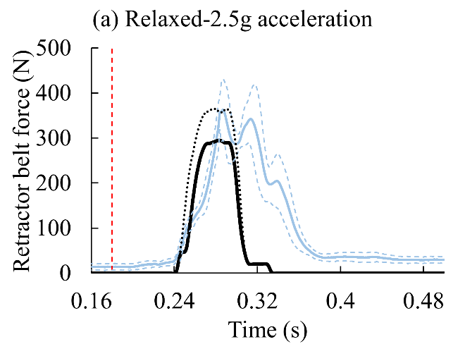 | 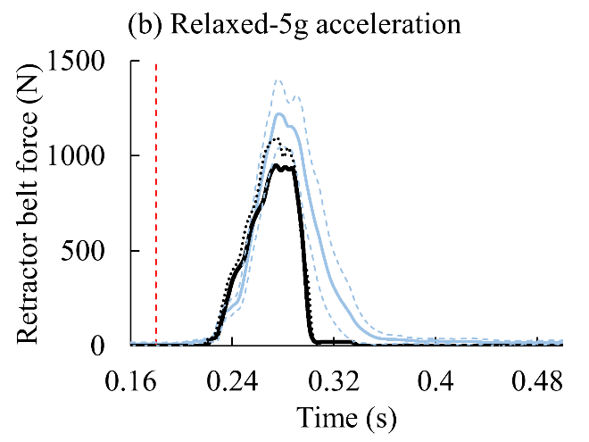
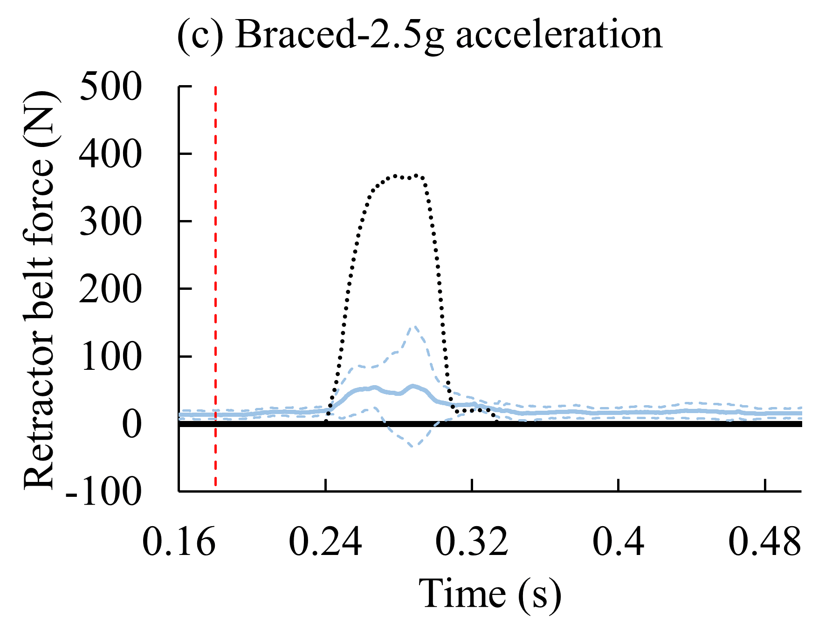 | 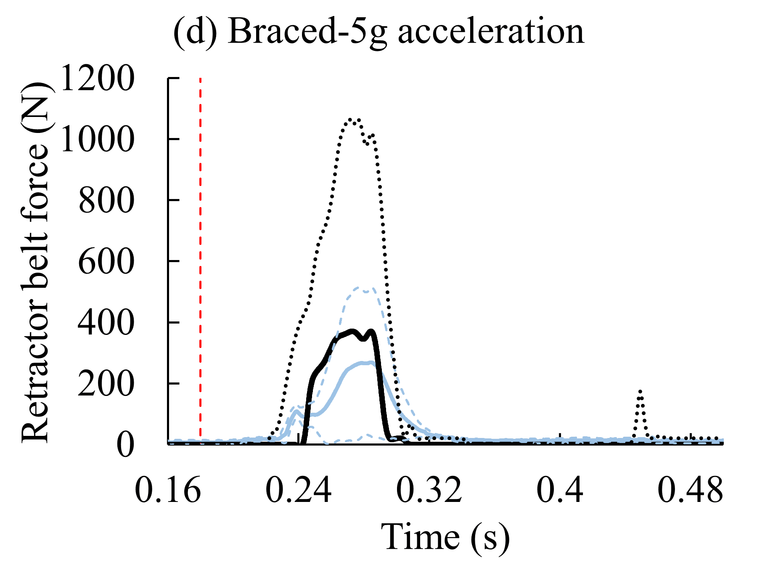
Figure A13. Comparison of retractor belt force, by muscle state and pulse severity, for M50-OS+Active, M50-OS, and volunteer data (Kemper, et al. 2014)

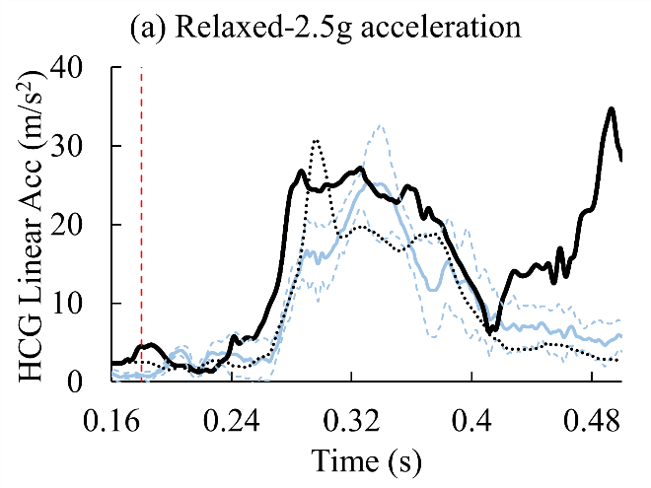 | 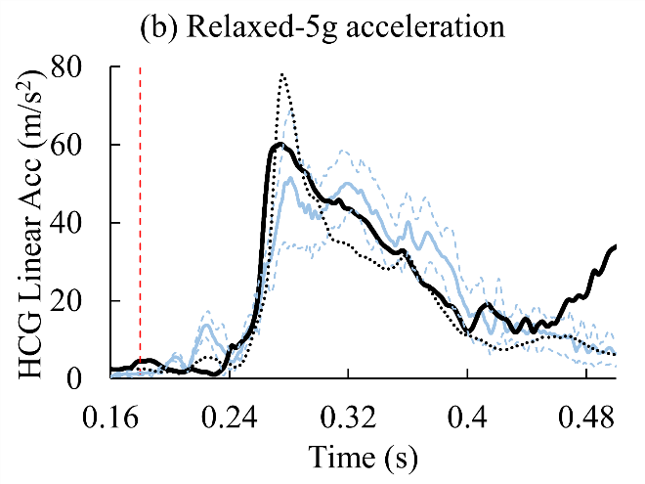
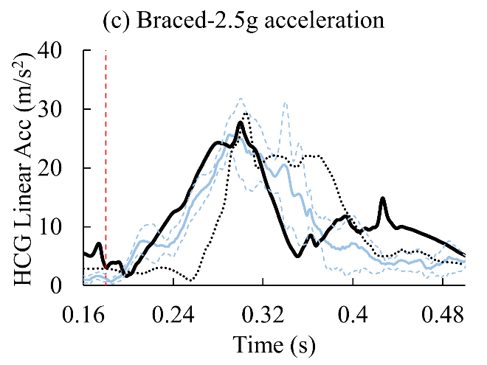 | 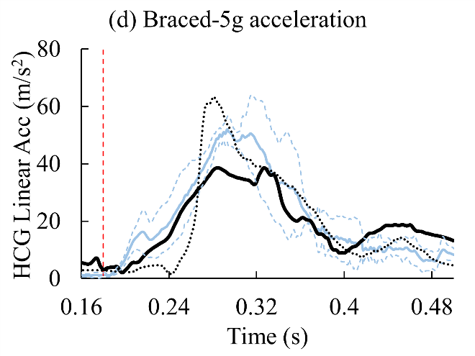
Figure A14. Comparison of head CG linear acceleration, by muscle state and pulse severity, for M50-OS+Active, M50-OS, and volunteer data (Kemper, et al. 2014)

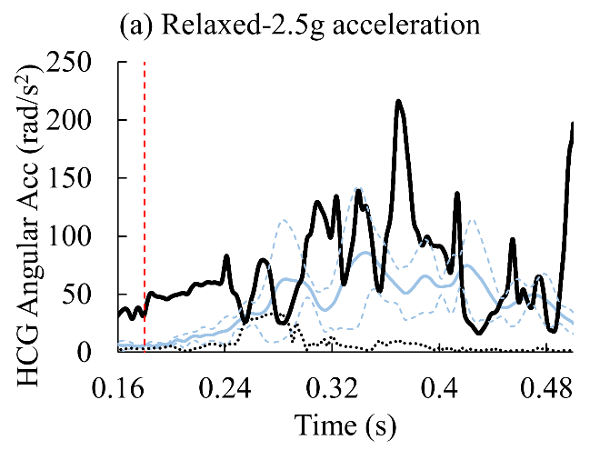 | 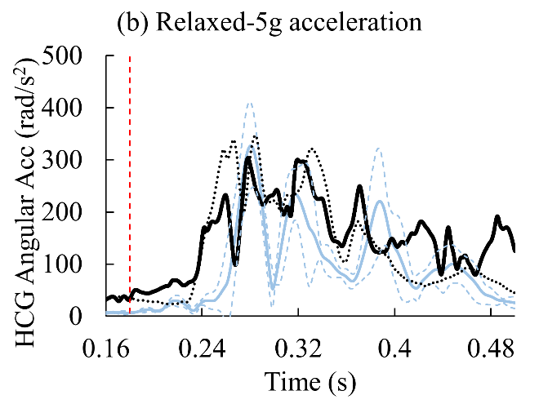
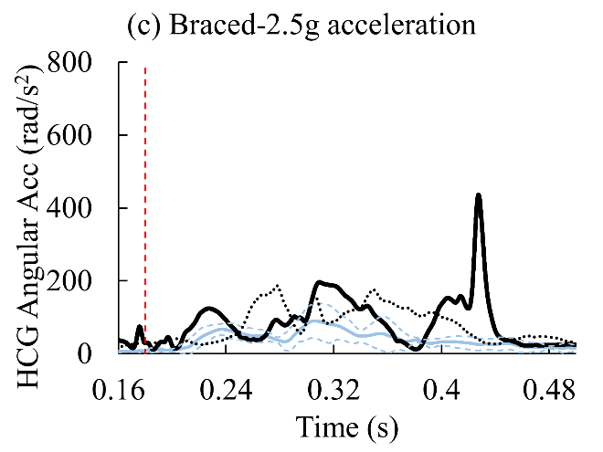 | 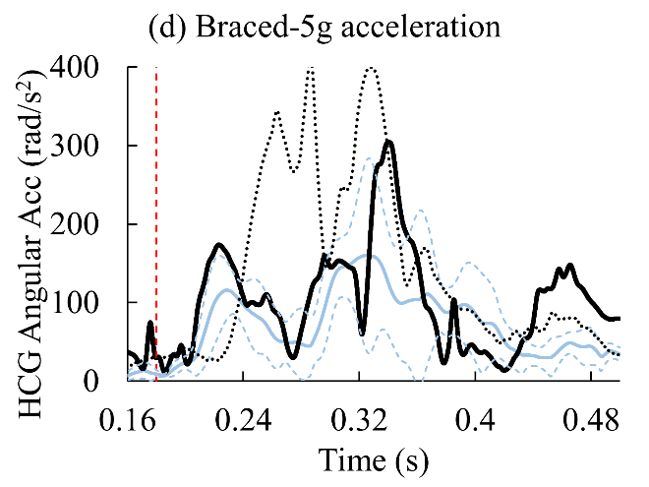
Figure A15. Comparison of head CG angular acceleration, by muscle state and pulse severity, for M50-OS+Active, M50-OS, and volunteer data (Kemper, et al. 2014)

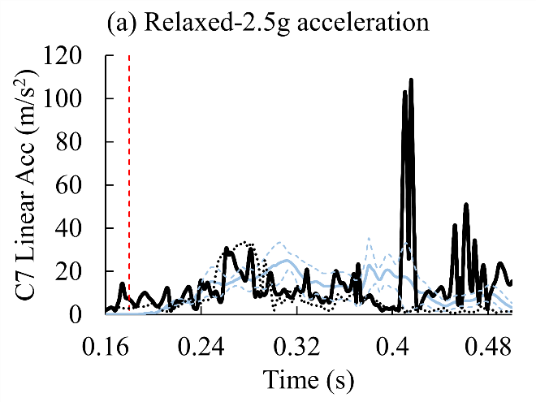 | 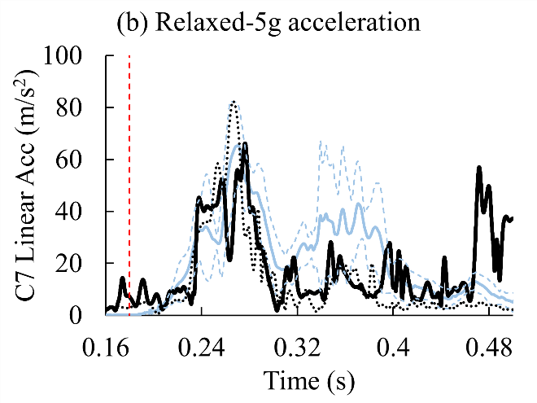
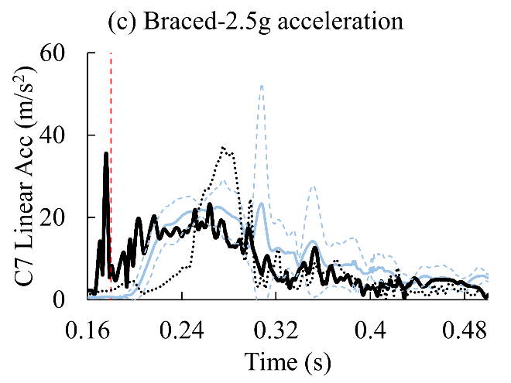 | 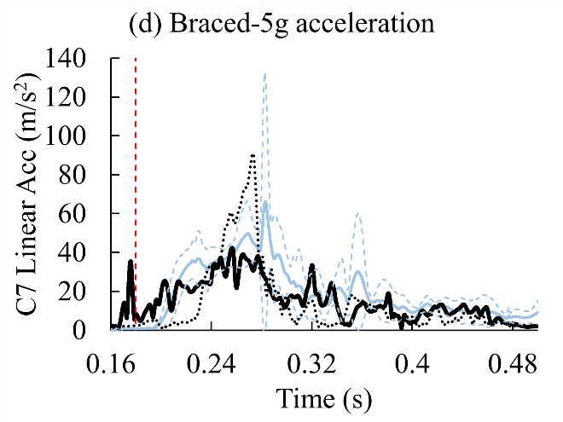
Figure A16. Comparison of C7 linear acceleration, by muscle state and pulse severity, for M50-OS+Active, M50-OS, and volunteer data (Kemper, et al. 2014)

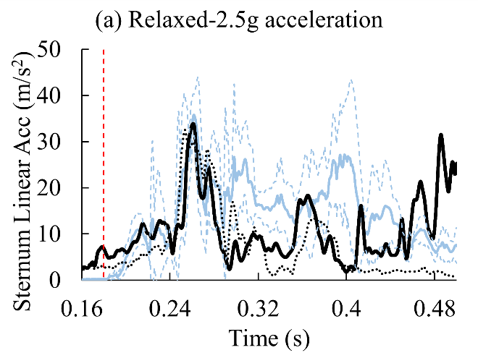 | 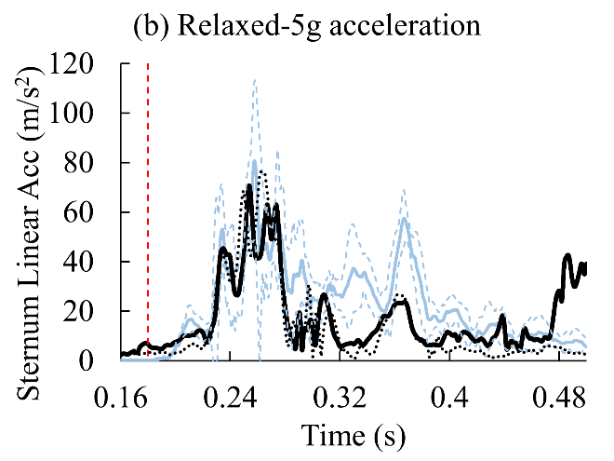
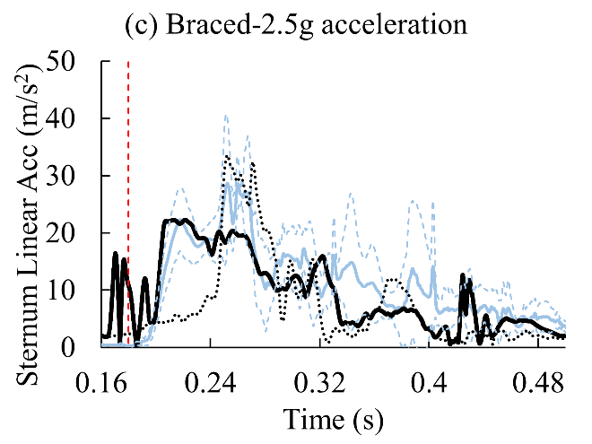 | 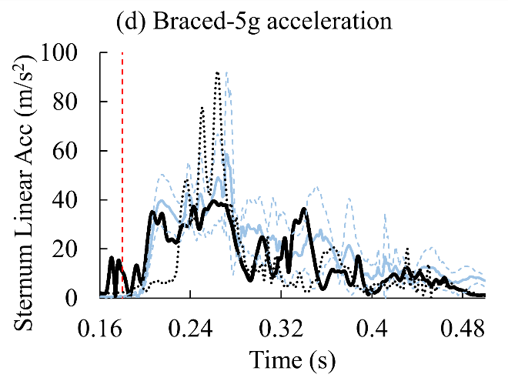
Figure A17. Comparison of sternum linear acceleration, by muscle state and pulse severity, for M50-OS+Active, M50-OS, and volunteer data (Kemper, et al. 2014)

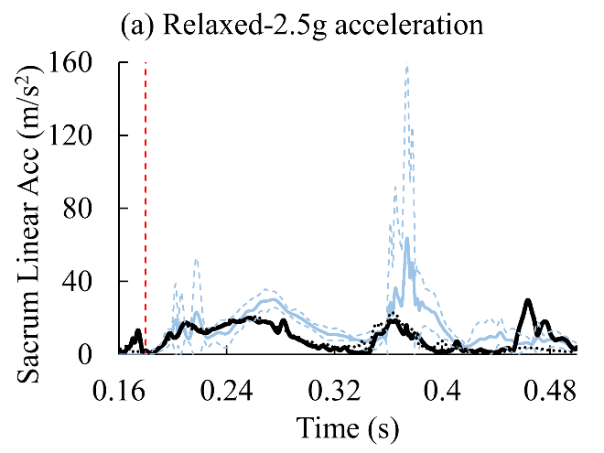 | 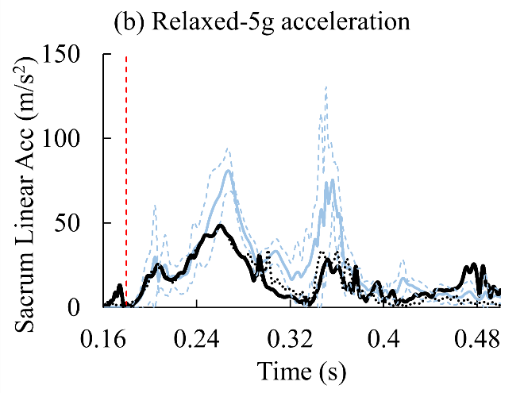
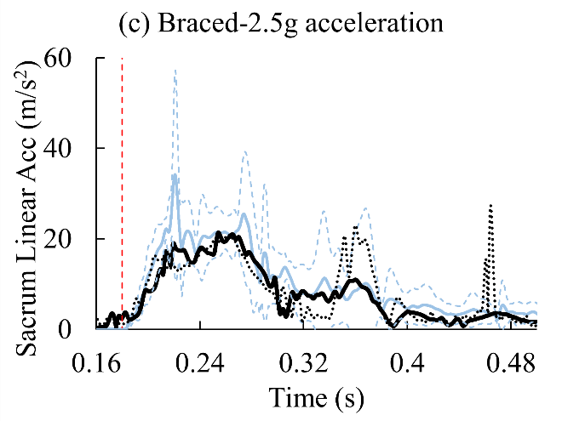 | 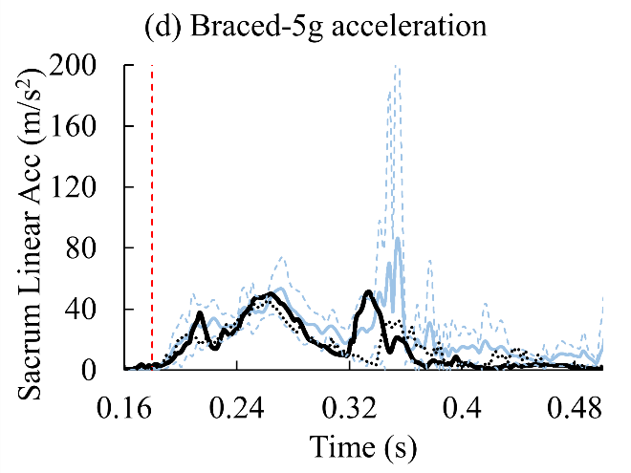
Figure A18. Comparison of sacrum linear acceleration, by muscle state and pulse severity, for M50-OS+Active, M50-OS, and volunteer data (Kemper, et al. 2014)

APPENDIX REFERENCES
Agur AM, Dalley AF. Grant's atlas of anatomy. 11th ed: Lippincott Williams & Wilkins; 2005.
Begeman P, King A, Levine R, Viano DC. Biodynamic response of the musculoskeletal system to impact acceleration. SAE Transactions. 1980:3992-4007.
Bingley L, Morris R, Cross G. Determination of real world occupant postures by photo studies to aid smart restraint development. Paper presented at: Proceedings: International Technical Conference on the Enhanced Safety of Vehicles2005.
Bose D, Crandall JR. Influence of active muscle contribution on the injury response of restrained car occupants. Paper presented at: Annals of Advances in Automotive Medicine/Annual Scientific Conference2008.
Bulcke J, Termote J-L, Palmers Y, Crolla D. Computed tomography of the human skeletal muscular system. Neuroradiology. 1979;17(3):127-136.
Cheng Z, Pellettiere JA. A novel approach for predicting human response from ATD tests. SAE Technical Paper;2004.
Friederich JA, Brand RA. Muscle fiber architecture in the human lower limb. Journal of biomechanics. 1990;23(1):91-95.
Fukunaga T, Roy R, Shellock F, et al. Physiological cross‐sectional area of human leg muscles based on magnetic resonance imaging. Journal of orthopaedic research. 1992;10(6):926-934.
Granata K, Slota G, Bennett B. Paraspinal muscle reflex dynamics. Journal of biomechanics. 2004;37(2):241-247.
Holzbaur KR, Murray WM, Gold GE, Delp SL. Upper limb muscle volumes in adult subjects. Journal of biomechanics. 2007;40(4):742-749.
Langenderfer J, Jerabek SA, Thangamani VB, Kuhn JE, Hughes RE. Musculoskeletal parameters of muscles crossing the shoulder and elbow and the effect of sarcomere length sample size on estimation of optimal muscle length. Clinical Biomechanics. 2004;19(7):664-670.
Muggenthaler H, Adamec J, Praxl N, Schönpflug M. The influence of muscle activity on occupant kinematics. Paper presented at: International IRCOBI Conference on the Biomechanics of Impact, Prague (Czech Republic) September2005.
Murray WM, Buchanan TS, Delp SL. The isometric functional capacity of muscles that cross the elbow. Journal of biomechanics. 2000;33(8):943-952.
Narici M, Landoni L, Minetti A. Assessment of human knee extensor muscles stress from in vivo physiological cross-sectional area and strength measurements. European journal of applied physiology and occupational physiology. 1992;65(5):438-444.
Netter FH. Atlas of Human Anatomy. Sixth ed. Philadelphia: Saunders; 2014.
Ore L, Tanner B, Pritz H. Dummy lower extremity development task. Vehicle research and test center progress report, vrtc-81–0202. 1992.
Phillips A, Pankaj P, Howie C, Usmani A, Simpson A. Finite element modelling of the pelvis: inclusion of muscular and ligamentous boundary conditions. Medical engineering & physics. 2007;29(7):739-748.
Pierrynowski MR. A physiological model for the solution of individual muscle forces during normal human walking, Simon Fraser University. Theses (Dept. of Kinesiology); 1982.
Siegmund GP, Sanderson DJ, Myers BS, Inglis JT. Rapid neck muscle adaptation alters the head kinematics of aware and unaware subjects undergoing multiple whiplash-like perturbations. J Biomech. 2003;36(4):473-482.
Thomas JS, Lavender SA, Corcos DM, Andersson GB. Trunk kinematics and trunk muscle activity during a rapidly applied load. Journal of Electromyography and Kinesiology. 1998;8(4):215-225.
Veeger H, Van Der Helm F, Van Der Woude L, Pronk G, Rozendal R. Inertia and muscle contraction parameters for musculoskeletal modelling of the shoulder mechanism. Journal of biomechanics. 1991;24(7):615-629.

