# Appendix A.



# Appendix B. Summary Statistics for Dependent and Key Independent Variables

Figure B1 shows the distribution of the two dependent variables. Figure B1(a) and B1(b) show the distribution of vote-share for parties that champion deprived groups when they contest in their home state and when they contest outside their home state. Figure B1(c) shows the distribution of vote-def for parties that champion deprived groups.

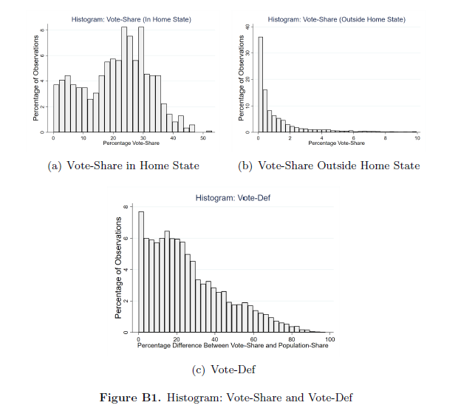

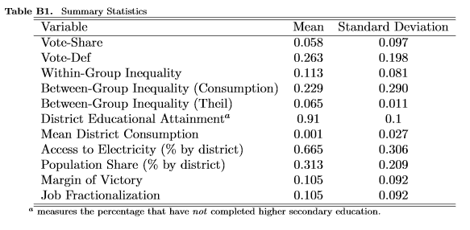

# Appendix C.

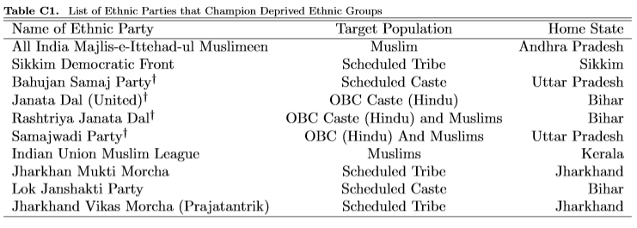

# Online Appendix D: Controlling for Heterogeneity Between Constituencies

In Table D1, instead of one general random effect that captures how each observation deviates from the predicted fixed effects, the mixed model generates multiple random effects that capture how observations deviate within a constituency, and how each constituency deviates from the overall group.[1] We use three levels of nesting, wherein each constituency belongs to a district and each district is a part of a state. We also report the Interclass Correlation (ICC). If ICC approaches 0 then there is no variance to explain at the constituency-level, and if the ICC approaches 1 then there is no variance to explain at the district or state level. Table D1 includes ‘margin of victory’ as a control variable.[2] The purpose is to differentiate between competitive and non-competitive races. The average margin in our sample is 10.5%. We do not find a statistically significant relationship between margin of victory and vote-share.

Table D1: Controlling for Heterogeneity Between Constituencies

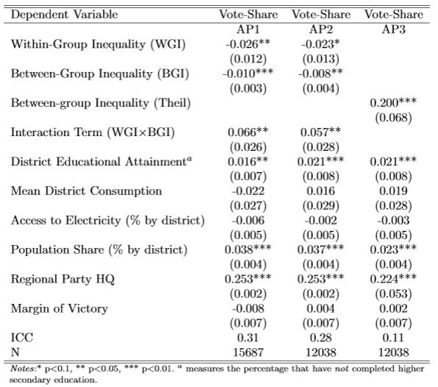

Column AP1 of Table 3 applies to all state legislative constituencies. Column AP 2 excludes those constitutes that are reserved for members of Scheduled Caste or Scheduled Tribe. Such constituencies have higher than average population share of Scheduled Caste or Scheduled Tribe. This may be of advantage to parties that champion the two subaltern groups. We therefore present results for both scenarios, where AP1 includes and AP2 excludes such constituencies. We find that even after controlling for constituency-level effects, within-group inequality is negatively correlated with vote-share.[3] While the coefficient for between-group inequality is negative, the coefficient for the interaction term is positive. The joint-effects can be understood using Figure B1 constructed using the specification in Column AP2. It shows that vote-share increases with an increase in between-group inequality and a decrease in within-group inequality. However, at extreme values of between-group inequality, we find the relationship between within-group inequality and vote-share may turn positive. However, this change occurs when between-group inequality is greater than 0.6. This region covers less 5% of the observations and hence we are unable to verify if the relationship is statistically significant. Second, we believe that the multi-level model does not exactly replicate the Tables 1 and 2 because data on inequality is measured at the district level while vote-share is measured at the constituency level. On an average, each district has 6-7 state legislative constituencies. Since, National Sample Survey reports household consumption only at the district level, we are unable to extend our analysis to the level of constituencies. In Column AP12 we drop within-group inequality and use the Theil Index to measure between-group inequality. We find a positive correlation reaffirming the expectation that high inequality between ethnic groups boosts the vote-share of ethnic parties.

# Online Appendix E: Ethnification of Party Systems

Huber and Suryanarayan (2016) demonstrate that when ethnic inequality is high, the degree to which parties have unique ethnic bases of support increases. Their findings applied to our sample would suggest that parties that champion deprived groups are more likely to succeed in states where inequality between the members and non-members of the group is high. This implies, ethnic inequality not only impacts vote-share but also the variable ‘Regional Party HQ.’ The underlying rationale being that parties that favor deprived groups are more likely to be found in states where such parties are likely to succeed. In order to separate the direct effects of inequality on vote-share from the indirect effects, captured through ‘Regional Party HQ’, we use instrumental variables. In Table E1 we instrument ‘Regional Party HQ’ using three variables, 1) inequality among members of a party’s target ethnic group, 2) inequality between members and non-members of party’s target ethnic group, 3) and population-share of a party’s target ethnic group. All three variables are measured at the state-level and so is ‘Regional-Party HQ.’ Furthermore, the three variables are estimated using the 55th round of National Sample Survey conducted in 1999. Table F1 shows that ethnic inequality not only manifests through ethnic voting but also through *ethnification* of party systems. The first stage regressions, show that an ethnic party that champions deprived groups is more likely to be found when coethnic population-share is high, inequality within target ethnic groups is low, and inequality between members and non-members of target group/s is high. This also implies that the estimated effects of inequality on vote-share are downward biased in Table 2. Or alternately, ethnic inequality manifests through ethnic voting in the short-run and *ethnification* of party systems in the long run.

Table E1: Ethnification of Party Systems

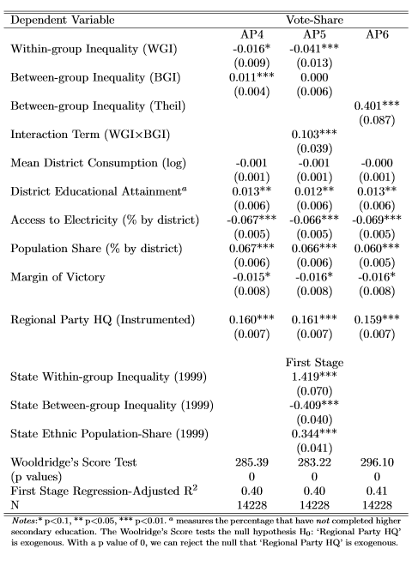

1. Kedar and Shively 2017, 2: “All comparative politics is multilevel.” For examples see: Peng and Lu 2012.
2. Margin of Victory = (Difference between 1st and 2nd highest votes) / total number of votes cast.
3. We cannot estimate effects for the dependent variable vote-def. This is because constituency-level data on

   population-share is not available.