Synthesis and Mesocrystalline Properties of Liquid Crystal Compounds withTetrathiafulvalene and Two Cyanobiphenyl units

Supplementary Data
Fuzhi Wei ^{a,b}, Li Wang ^{a,b}, Yan Xia ^{a,b}, Dongfeng Li ª and Ruibin Hou ^{a,b,*}
ª College of Chemistry and Life Science Changchun University of Technology, Changchun, China; ^{b} Advanced Institute of Materials Science ^{b} Changchun University of Technology, Changchun, China.

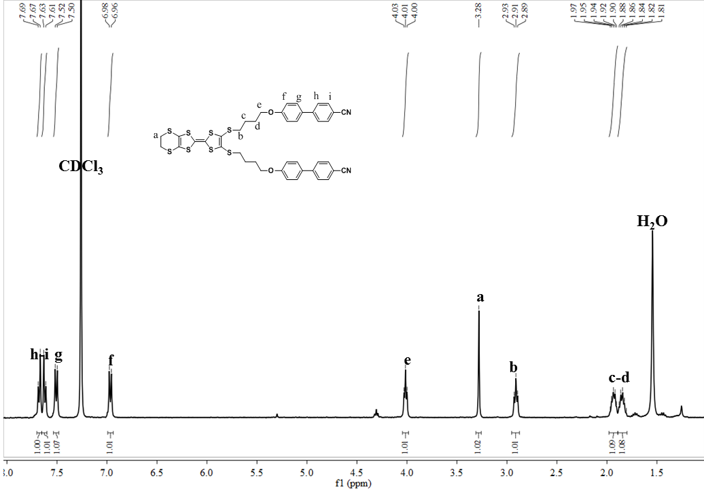
Fig. S1. ¹H NMR of the target compound 3a
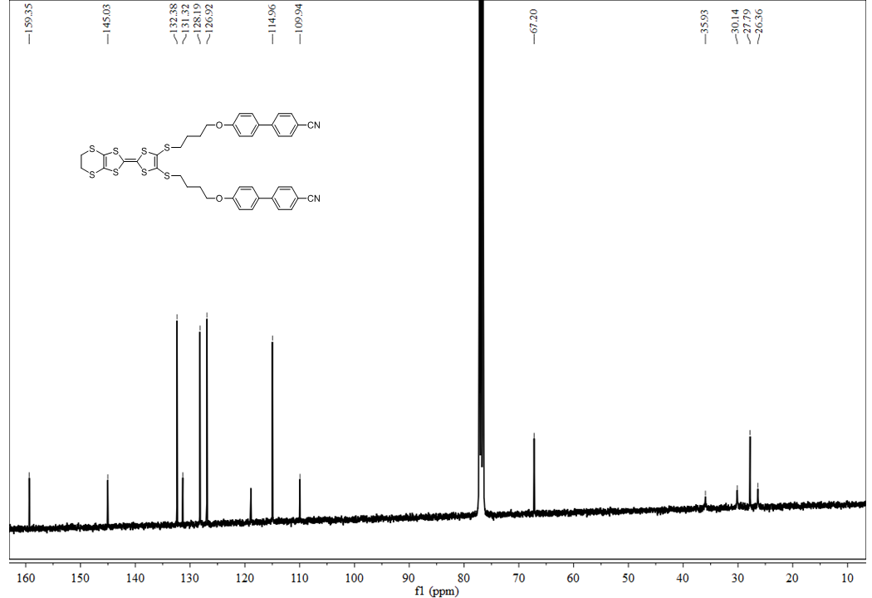
Fig. S2 ¹³C NMR of the target compound 3a
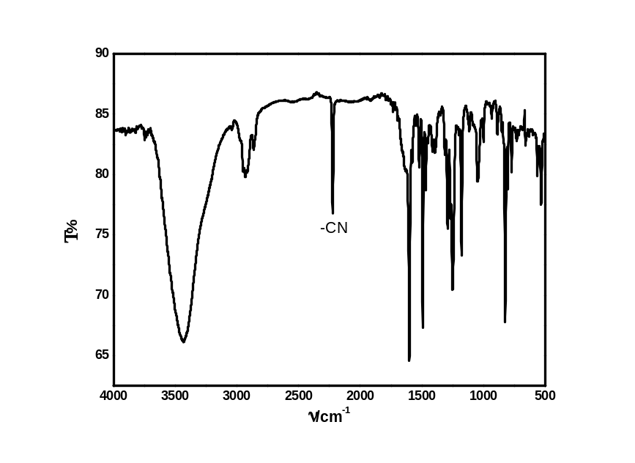
Fig. S3 FT-IR of the target compound 3a
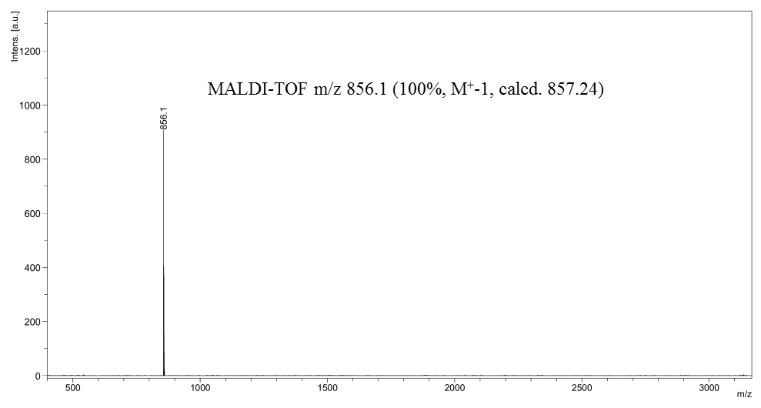
Fig. S4 MALDI-TOF-MS of the target compound 3a

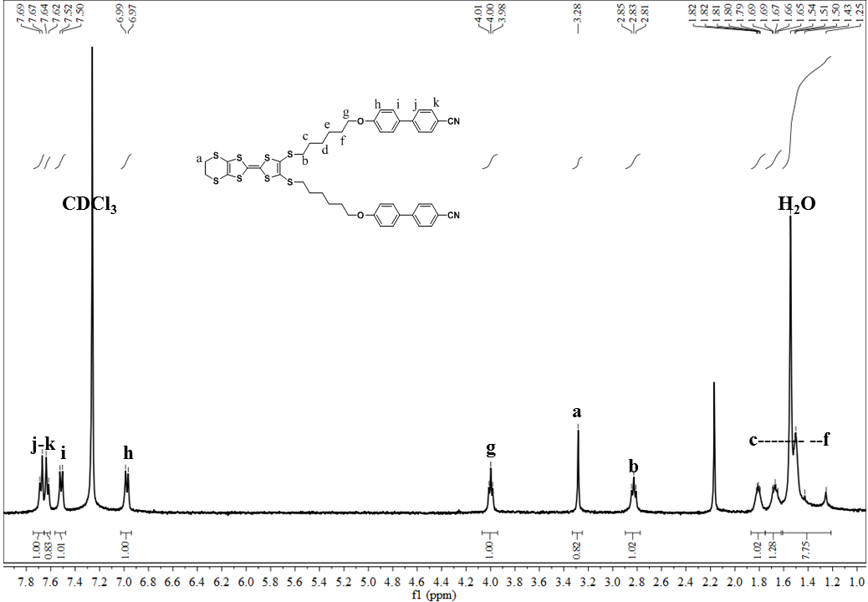
Fig. S5 ¹H NMR of the target compound 3b
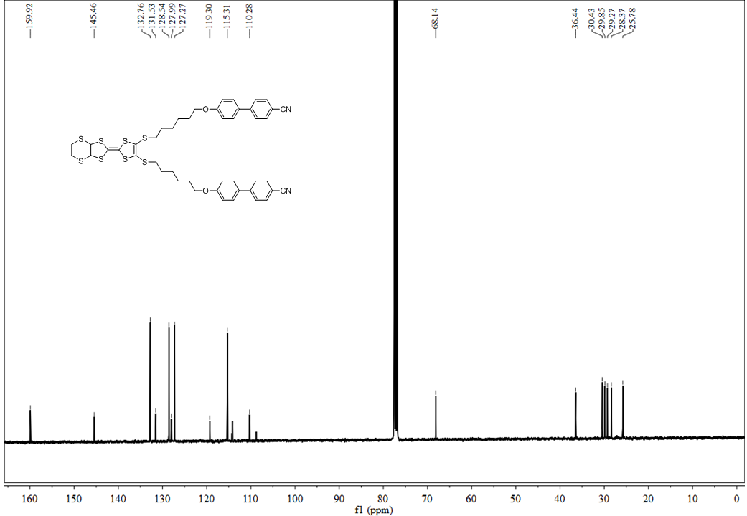
Fig. S6 ¹³C NMR of the target compound 3b
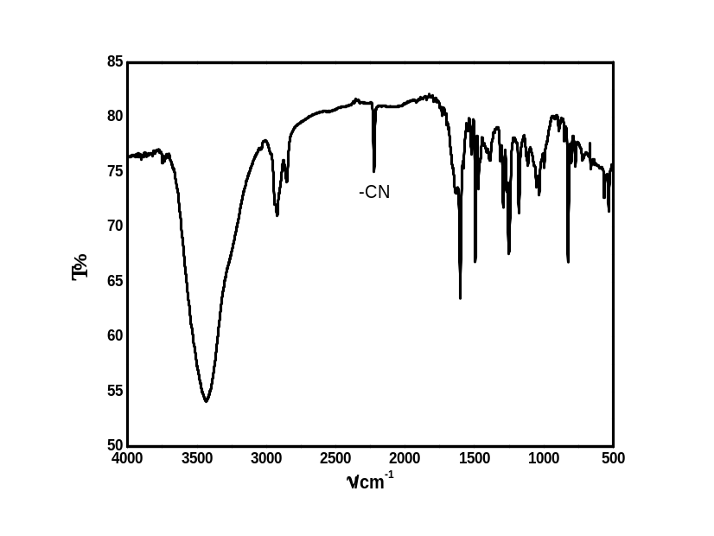
Fig. S7 FT-IR of the target compound 3b
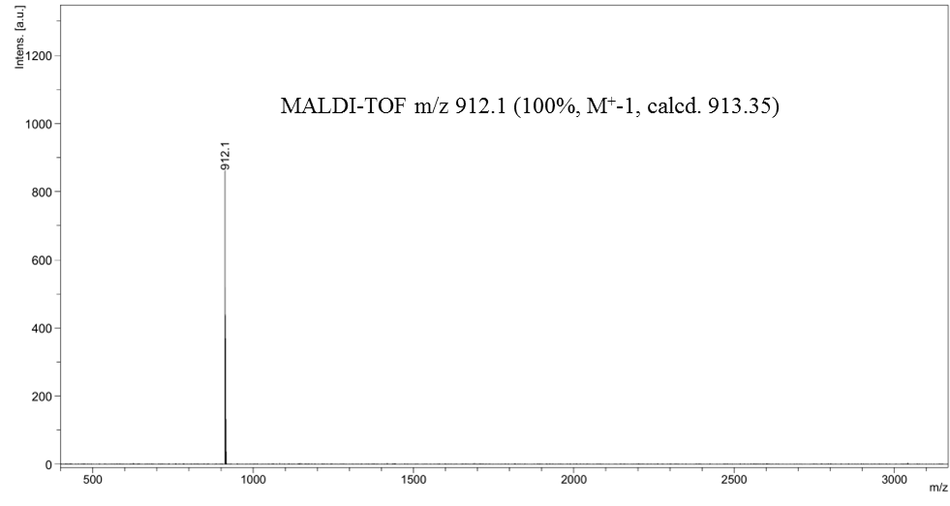
Fig. S8 MALDI-TOF-MS of the target compound 3b

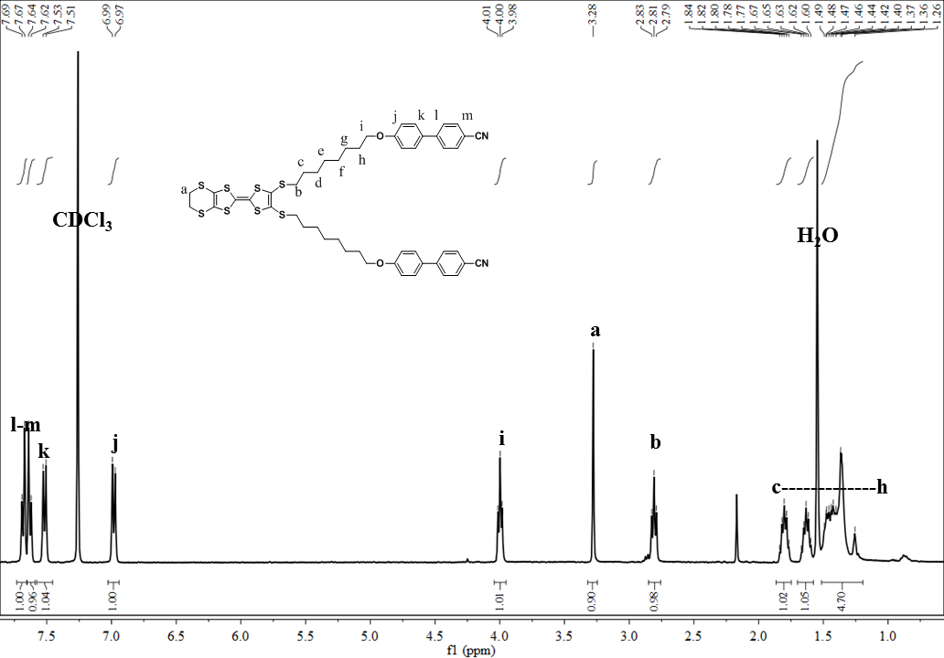
Fig. S9 ¹H NMR of the target compound 3c
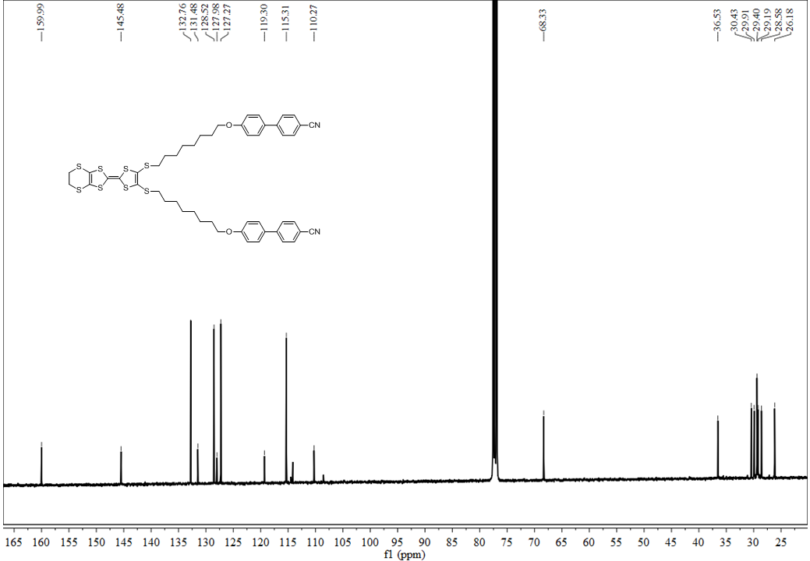
Fig. S10 ¹³C NMR of the target compound 3c
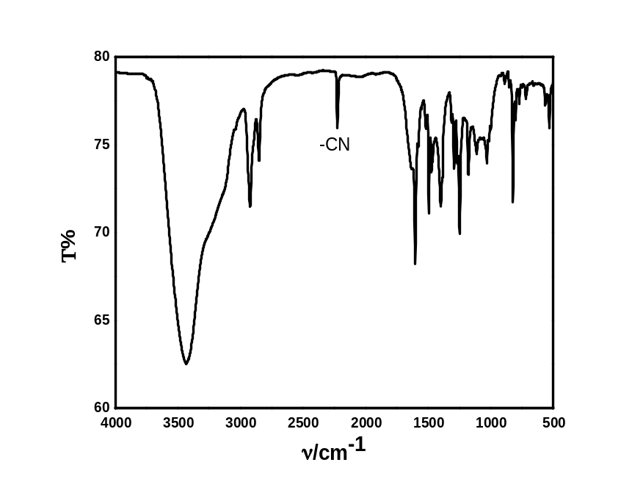
Fig. S11 FT-IR of the target compound 3c
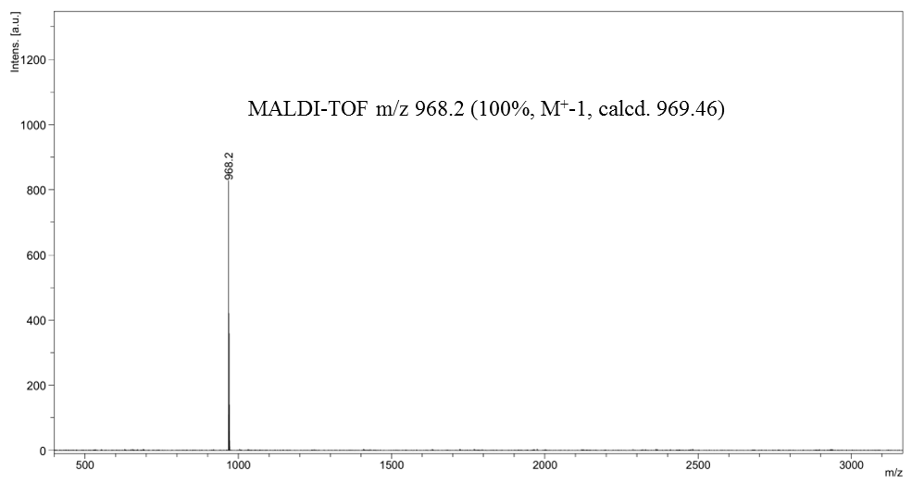
Fig. S12 MALDI-TOF-MS of the target compound 3c

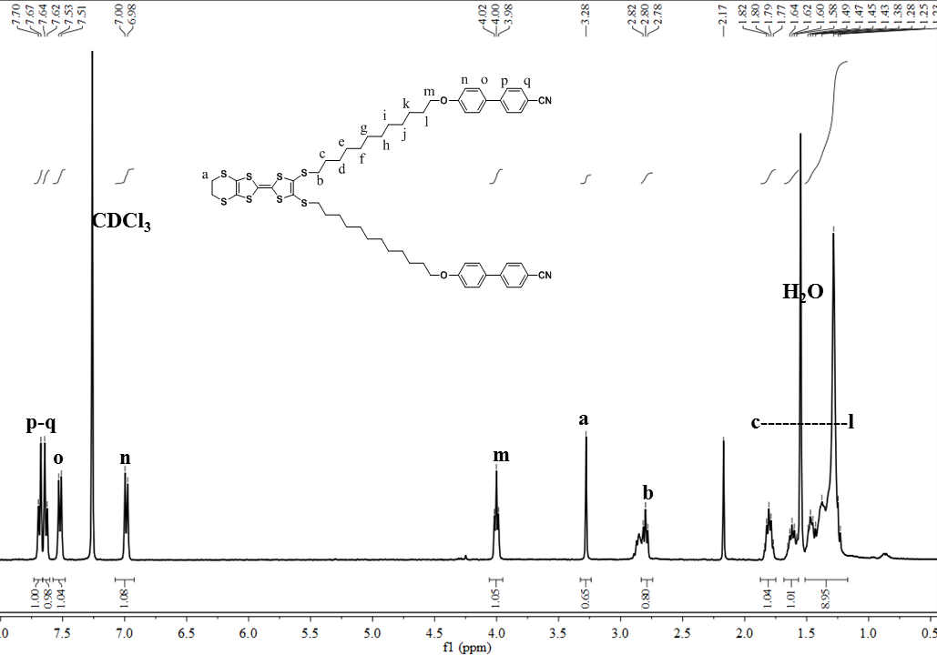
Fig. S13 ¹H NMR of the target compound 3d
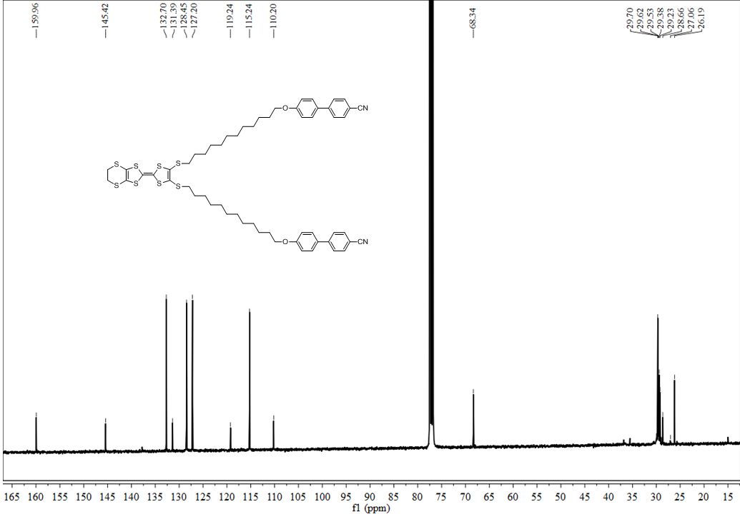
Fig. S14 ¹³C NMR of the target compound 3d
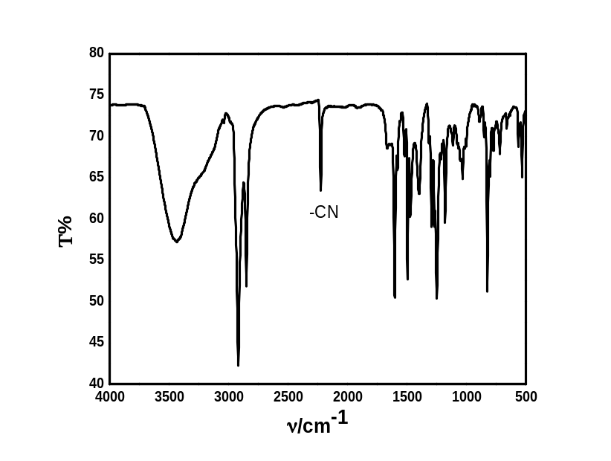
Fig. S15 FT-IR of the target compound 3d
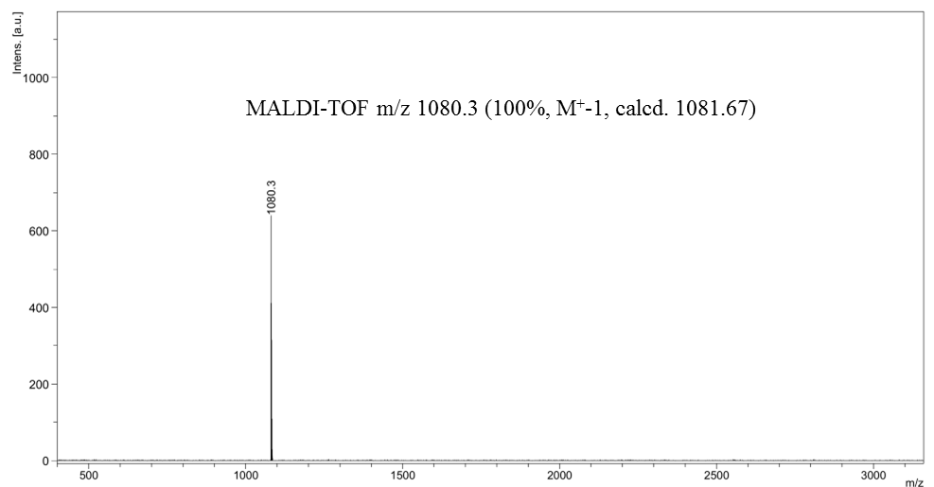
Fig. S16 MALDI-TOF-MS of the target compound 3d

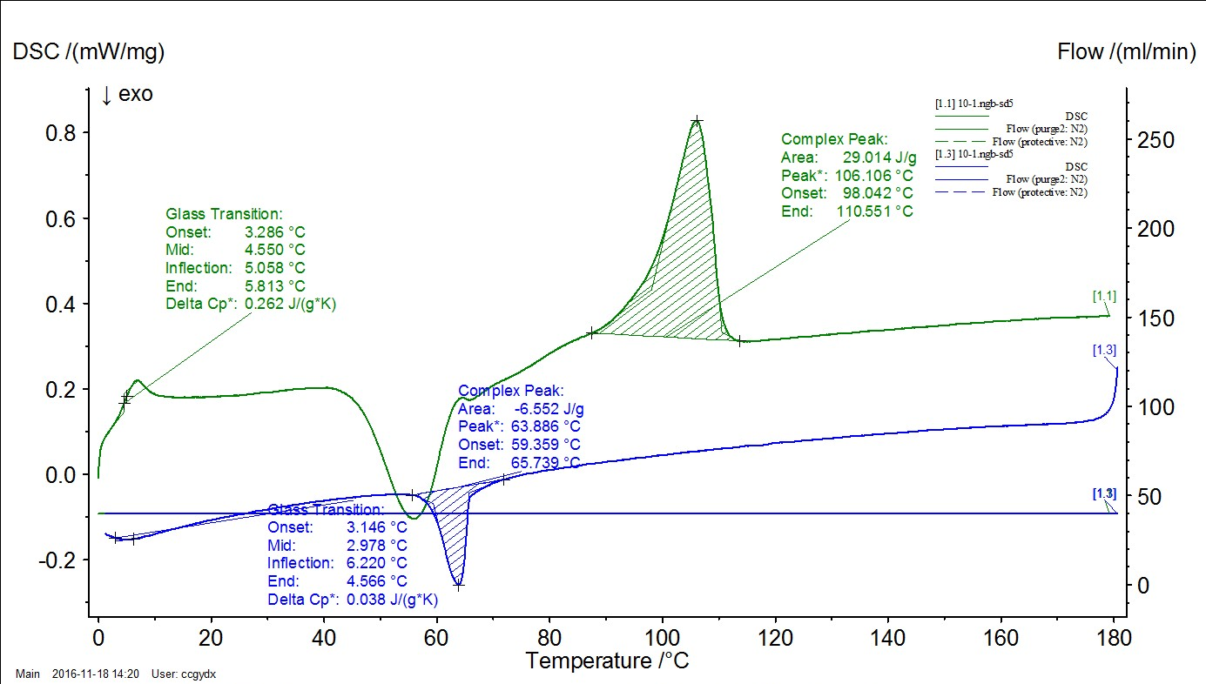
Fig. S17. DSC curve of the target compound 3d.

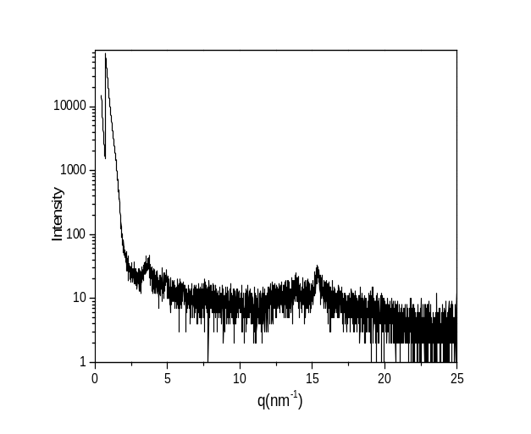

Fig. S18. X-ray diffraction patterns of 3d plotted against q = 4πsinθ/λmeasured at 40 °C.

