Appendix
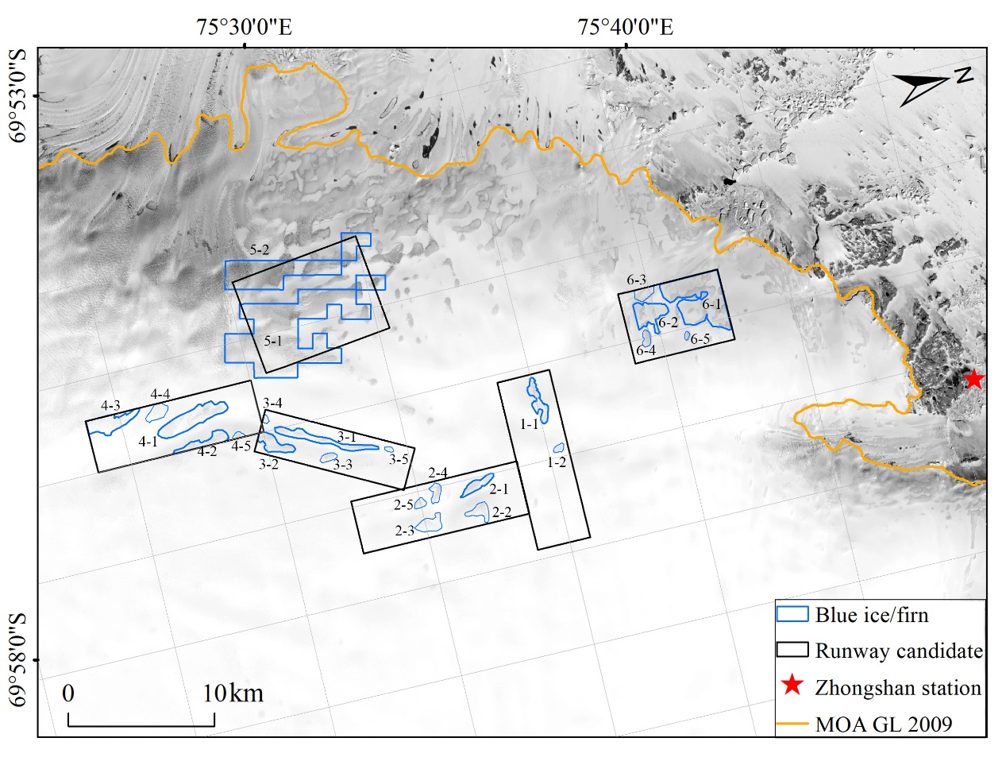
Fig. A1. Distribution and IDs of blue ice in candidate 5 and blue firn in the other five candidate areas.

Table A1. Locations and type of field expedition data (see Fig. 3)
Point ID | Coordinates |  | Measurements used in this study
A1 | S69°44'57.54" | E76°13'47.34" | Ice core, blue firn
A2 | S69°45'00.00" | E76°04'00.00" | Crevasses position by airborne inspection
A3 | S69°44'32.59" | E75°54'17.09" | Ice core, blue ice, landing position
G1 | S69°45'06.00" | E76°29'58.30" | turning point from CHINARE route
G2 | S69°43'39.22" | E76°14'50.72" | Starting point of Line 2
G3 | S69°44'27.26" | E76°14'11.17" | Ice core, blue firn
G4 | S69°45'27.79" | E76°13'07.93" | Ice core, blue firn
G5 | S69°47'24.57" | E76°10'33.92" | End point of Line 3
Line 1 | - |  | Airborne survey, blue ice
Line 2 | From G2 to A1 |  | Ground survey, blue firn
Line 3 | From A1 to G5 |  | Ground survey, blue firn

Table A2. Large blue ice and blue firn areas with their geometric parameters (see Fig. A1)
Area ID | Length (m) | Width (m) | Area (m²)
1-1 | 3250 | 550 | 1702760
2-1 | 2700 | 390 | 1207150
3-1 | 7250 | 370 | 2797200
3-2 | 2680 | 560 | 1840510
4-1 | 5130 | 1000 | 4855340
4-2 | 3970 | 370 | 1821160
4-3 | 3820 | 810 | 3042180
5-1 | 12510 | 3380 | 34253720
5-2 | 10720 | 1380 | 14790480
6-1 | 4240 | 3060 | 11482860
6-2 | 2290 | 1170 | 2953230

Table A3. Statistics of four recent ice flow speeds from 2013 to 2017 in 5 candidate areas from the LISA maps
Time | Candidate | Max (m a⁻¹) | Min (m a⁻¹) | Mean (m a⁻¹) | Std (m a⁻¹)
2013-2014 | 1 | 74 | 21 | 44 | 10
 | 2 | 62 | 9 | 36 | 12
 | 3 | 46 | 6 | 21 | 9
 | 5 | 379 | 1 | 60 | 73
 | 6 | 157 | 1 | 27 | 39
2014-2015 | 1 | 70 | 11 | 39 | 14
 | 2 | 57 | 14 | 33 | 11
 | 3 | 48 | 3 | 22 | 10
 | 5 | 369 | 4 | 61 | 70
 | 6 | 167 | 5 | 36 | 43
2015-2016 | 1 | 66 | 1 | 24 | 15
 | 2 | 51 | 8 | 24 | 9
 | 3 | 49 | 1 | 16 | 11
 | 5 | 374 | 1 | 57 | 75
 | 6 | 166 | 1 | 36 | 42
2016-2017 | 1 | 76 | 10 | 45 | 13
 | 2 | 68 | 7 | 34 | 14
 | 3 | 43 | 3 | 20 | 9
 | 5 | 361 | 3 | 54 | 71
 | 6 | 175 | 3 | 37 | 43

Table A4. Average sizes and depths of crevasses inside boundaries (green) in Fig. 8 and their distances to potential runways
Crevasse ID | Avg. length (m) | Avg. width (m) | Avg. depth (m) | Distance to runway (m)
2-1A | 1094 | 8 | 2.9 | 2524
2-1B | 1090 | 4 | 3.5 | 956
3-1A | 430 | 3 | 2.8 | 436
3-1B | 769 | 4 | 3 | 204
3-1C | 893 | 10 | 1 | 2045
5-1A | 327 | 7 | 3.8 | 0
5-1B | 1368 | 44 | 10 | 867
5-1C | 169 | 4 | 2.3 | 2884
5-1D | 341 | 14 | 4.2 | 2287
5-1E | 219 | 5 | 2.3 | 680

