Solvent Free Synthesis of Three Cyclotriphosphazene Derivatives Containing Piperazine Substitutions Using Microwave Irradiation; Supported by Spectral, Theoretical, Solution and Docking Studies

Mohammad Hakimia*, Homeyra Rezaeia, Keyvan Moeinia, Zahra Mardanib andCameron Carpenter-Warrenc

aChemistryDepartment, Payame Noor University, 19395-4697 Tehran, I. R. Iran

b Inorganic Chemistry Department, Faculty of Chemistry, Urmia University, 57561-51818, Urmia, I. R. Iran

c EaStCHEM School of Chemistry, University of St Andrews, St Andrews Fife UK, KY16 9ST, UK

Email: mohakimi@yahoo.com

**Supplemental Materials**

C:\Users\Zahra\Desktop\Untitled.tif

Figure S 1. FT-IR spectrum of **1**.

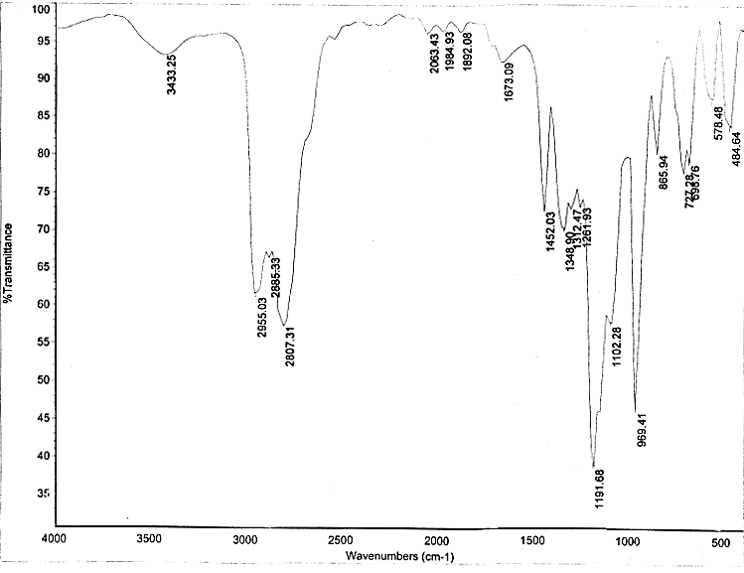

Figure S 2. FT-IR spectrum of **2**.

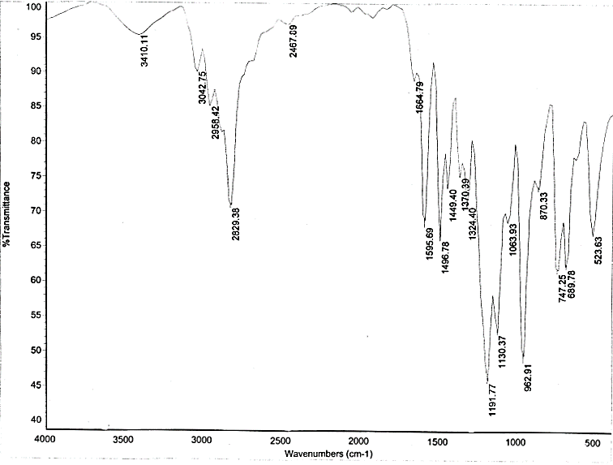

Figure S 3. FT-IR spectrum of **3**.



Figure S 4. Raman spectrum of **1**.



Figure S 5. Raman spectrum of **2**.



Figure S 6. Raman spectrum of **3**.

C:\Users\Zahra\Desktop\Untitled.tif

Figure S 7. 31P NMR spectrum of **1**.

C:\Users\Zahra\Desktop\Untitled.tif

Figure S 8. 31P NMR spectrum of **2**.

C:\Users\Zahra\Desktop\Untitled.tif

Figure S 9. 31P NMR spectrum of **3**.

C:\Users\Zahra\Desktop\Untitled.tif

Figure S 10. 1H NMR spectrum of **1**.

C:\Users\Zahra\Desktop\Untitled.tif

Figure S 11. 1H NMR spectrum of **2**.

C:\Users\Zahra\Desktop\Untitled.tif

Figure S 12. 1H NMR spectrum of **3**.