Supprementary Figures
Figure legends
Figure S1. Changes in temperature and output under microwave irradiation. Temperatures (left axis) of the culture medium (blue lines) and applicator (green lines) are shown. Outputs of the incident and reflected waves are shown using red and pink lines, respectively. (A) All parameters are shown for 0–30 min of microwave irradiation with the applicator temperature set at 10 °C. (B) The full time course of the microwave irradiation is shown in the upper graph, and the lower graph shows an expanded view of the initial transition period before the medium temperature was maintained constant at 37 °C. The data are presented in Fig. 3.

Figure S2. Simulation of electric (A) and magnetic (B) field energy in our microwave irradiation system (MTS03(S)). Electromagnetic simulations transmitted a continuous microwave of 3 W at 2.45 GHz were performed by a finite-difference time domain (FTDT) method with CST STUDIO SUITE 2018 (AET, INC, Kawasaki, Japan).
Figure S3. Gel image of gelatin zymography.

Figure S1.
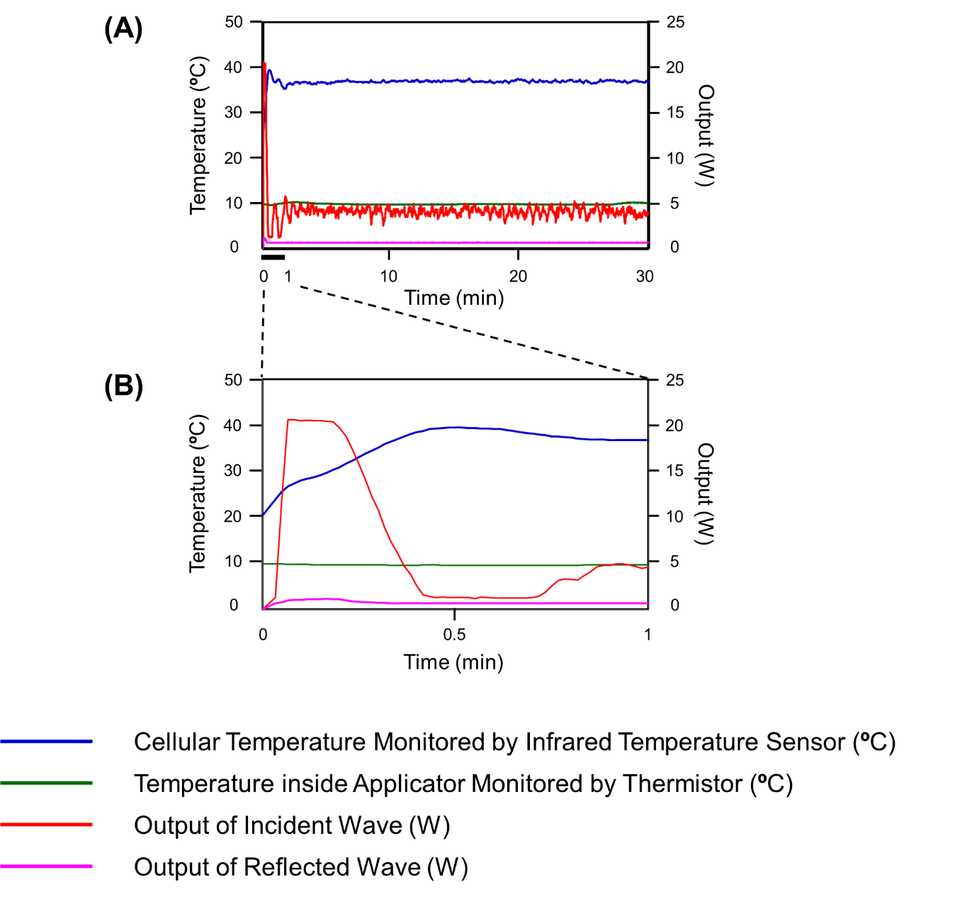

Figure S2.
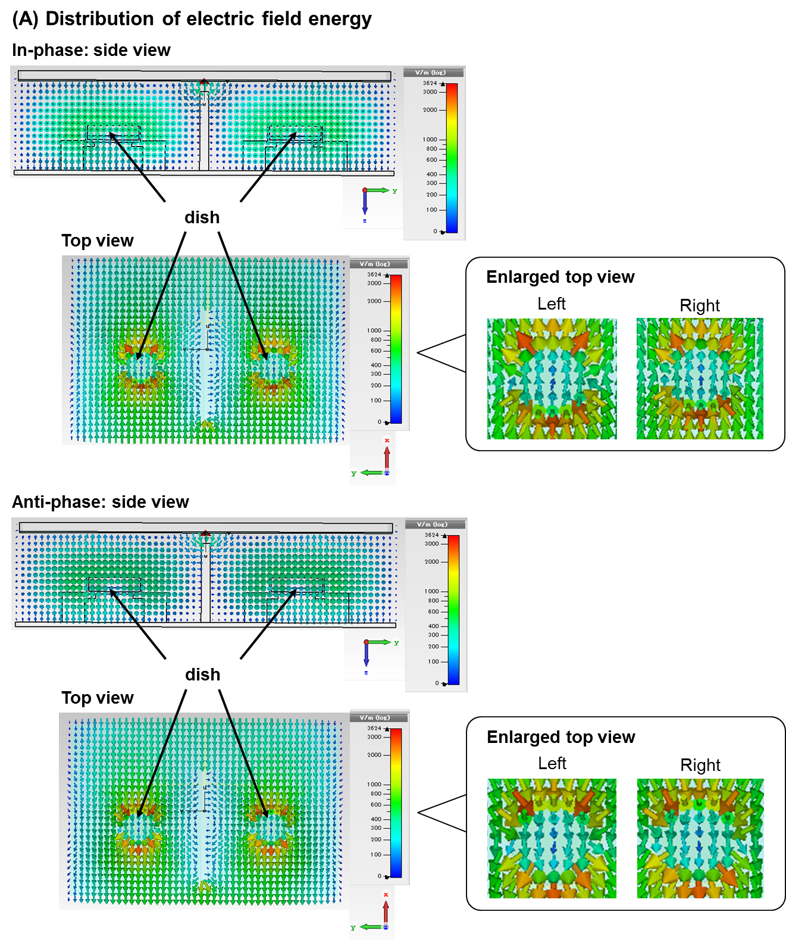

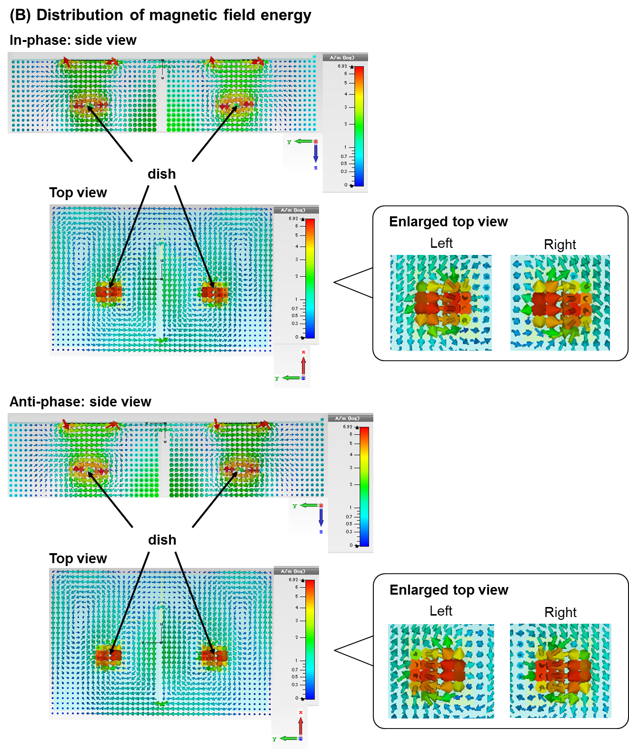

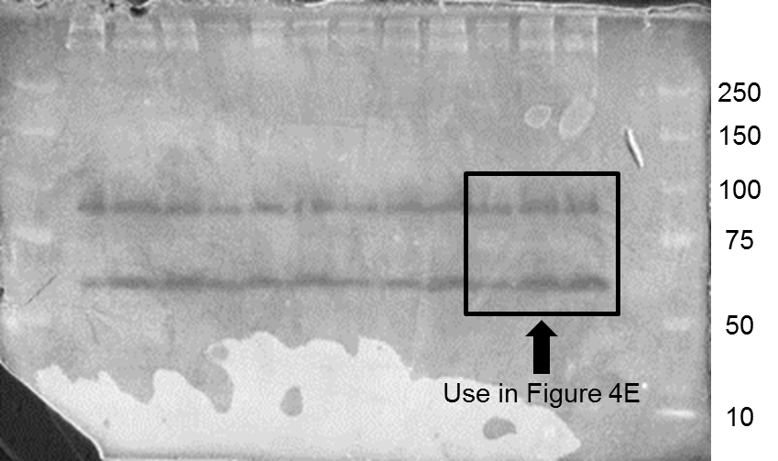
Figure S3

