Supporting information

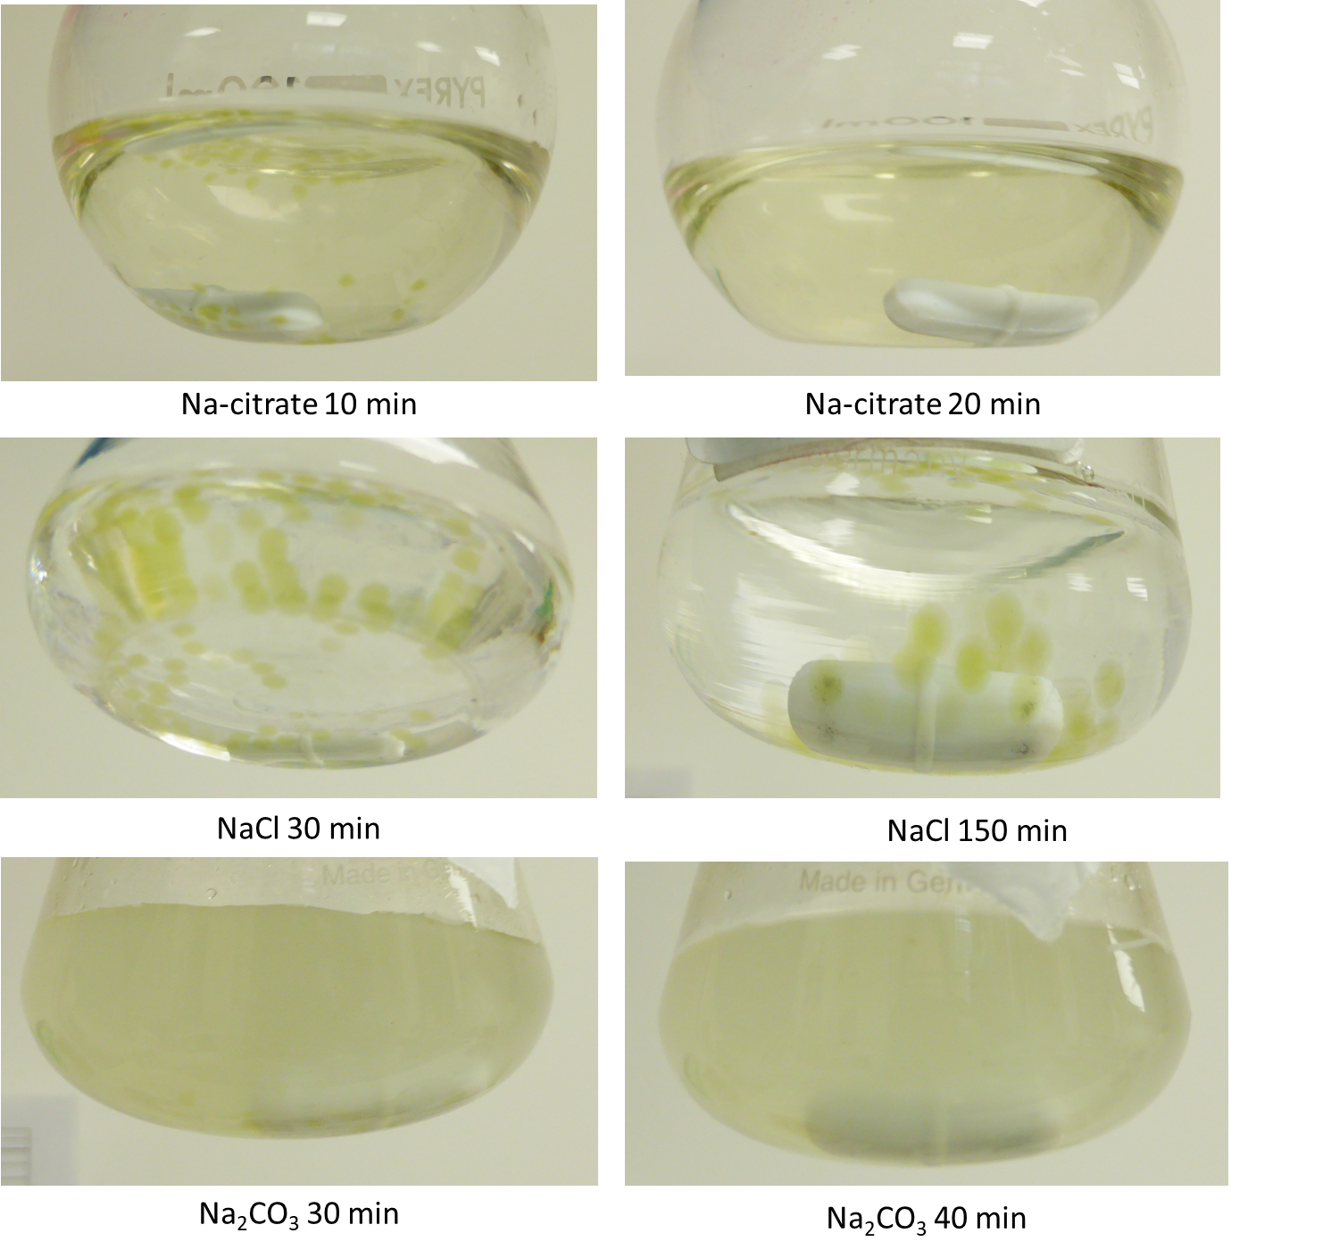
Figure S.1. Algae beads in respective dissolution solutions.

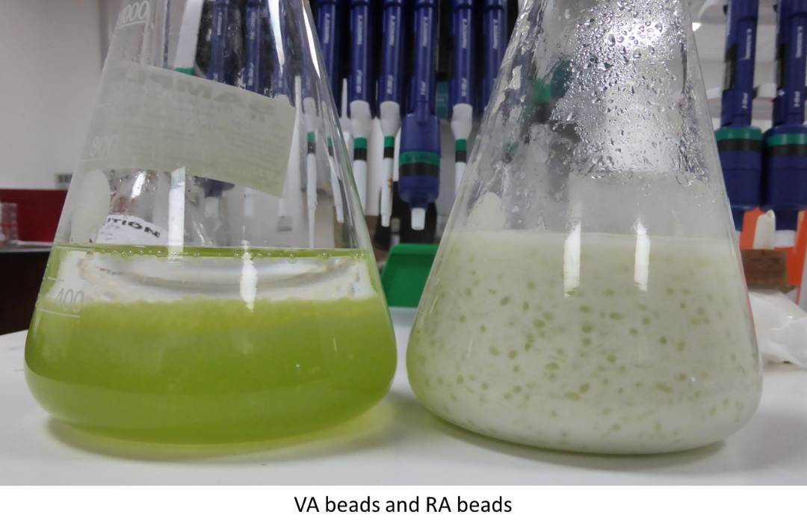
Figure S.2. Algae beads made from VA (left) and RA (right) after stirring.

