Supplementary Materials for
Enhanced solidification/stabilization of lead in MSWI fly ash treatment and disposal by gelatinized sticky rice

Yitian Wang, Hongyong Xu, Cheng Chen, Xiong Wang, Han Zhang, Xiangyu Wu, Lankun Cai*

State Environmental Protection Key Laboratory of Environmental Risk Assessment and Control on Chemical Process, East China University of Science and Technology, Shanghai 200237, China

* Corresponding author:
Tel: (+86) 021 64253321; Fax: (+86) 021 65243321.
E-mail address: cailankun@126.com (L. Cai).

Supplementary Materials Content:
Test S1. Chemicals and reagents
Test S2. Preparation of sticky rice starch and standard samples
Table S1. Heavy metal characteristics of MSWI FA samples
Table S2. Chemical composition of MSWI FA samples
Table S3. Conditions for each step of Tessier sequential chemical extraction method
Figure S1. FT-IR spectrum of sticky rice (SR)
Figure S2. Compressive strength experiments scene picture
Figure S3. XRD patterns of pure OPC and OPC+1.5% SR matrices (without FA) after curing 7 days
Figure S4. SEM images of hydration products of pure OPC and OPC+1.5% SR (without FA) after curing 7d

Test S1 Chemicals and reagents.
Analytical purity grade acetic acid, hydrochloric acid, nitric acid, sulfuric acid, ammonium acetate, sodium hydroxide, hydrogen peroxide, sodium sulfide, magnesium chloride anhydrous, hydroxylamine hydrom chloride, sodium acetate, potassium iodide, iodine, potassium hydroxide and anhydrous ethanol were purchased from Shanghai Titan Technology Co., Ltd. (Shanghai, China) or Shanghai Lingfeng Chemical Reagent Co., Ltd. (Shanghai, China). The amylose and amylopectin standard samples were purchased from Shanghai Yuanye Biotechnology Co., Ltd. (Shanghai, China). The sticky rice was purchased from Heilongjiang Agriculture Co., Ltd. (Heilongjiang, China).

Test S2. Preparation of sticky rice starch and standard samples.
The preparation steps of starch samples were followed by Yang et al. [1] and made some modifications. 0.1 g starch sample was added into 10 mL 0.5 M KOH solution and heated for 10 min at 60℃ by stirring until completely dissolved. The pH value of the suspension solution was adjusted to 3.5 by using 0.1 M HCl and the 0.5 mL I₂-KI solution (2 g KI, 0.2 g I₂ dissolved to 100 mL water) were added into the solution by using a suction pipet and diluted to a total volume of 50 mL using deionized water. These three starch solution samples were subject to spectrophotometry examinations by the UV–Vis simultaneous spectrophotometer (L5, INESA Analytical Instrument Co., Ltd. Shanghai, China).

Table S1. Heavy metal characteristics of MSWI FA sample.
Heavy metal | Leaching concentration measured by HJ/T 300-2007 (mg/L) |  |  | Leaching limit concentration of solid wastes in China Standard (GB16889-2008) (mg/L)
Heavy metal | FA1 | FA2 | FA3
Ba | 1.1 | 1.8 | 6.0 | 25
Cd | 1.4 | N.D. | N.D. | 0.15
Cr* | 0.013 | 0.13 | 0.21 | 4.5
Cu | 16 | 0.081 | 0.053 | 40
Ni | 0.21 | N.D. | N.D. | 0.5
Pb | 15 | 6.7 | 7.9 | 0.25
Zn | 82 | 0.27 | 1.5 | 100
Note: (1) Cr* is total Cr, mg/L; (2) N.D. = Not detected.

Table S2. Chemical composition of MSWI FA samples.
Chemical composition | MSWI fly ash samples (mass %)
Chemical composition | FA1 | FA2 | FA3
CaO | 61.85 | 60.90 | 40.92
Cl | 15.95 | 13.15 | 18.02
Na₂O | 4.85 | 5.88 | 8.18
K₂O | 4.16 | 5.24 | 6.71
SO₃ | 3.07 | 4.05 | 5.63
MgO | 1.56 | 2.40 | 1.86
SiO₂ | 1.76 | 1.89 | 4.89
ZnO | 0.77 | 1.58 | 1.35
Fe₂O₃ | 1.16 | 0.92 | 4.68
Al₂O₃ | 0.57 | 0.57 | 2.03
P₂O₅ | 0.16 | 0.36 | 0.66
TiO₂ | 0.35 | 0.34 | 0.83
PbO | 0.27 | 0.25 | 0.40
Br | 0.12 | 0.12 | 0.17
CuO | 0.10 | 0.099 | 0.12
BaO | - | - | 0.11
SrO | 0.12 | 0.070 | 0.079
MnO | 0.030 | 0.046 | 0.090
Cr₂O₃ | 0.028 | 0.028 | 0.038
LOI* | 3.10 | 2.10 | 3.15
Note: LOI* = Loss of ignition.

Table S3. Conditions for each step of Tessier sequential chemical extraction method .
Fraction | Extraction agent | Extraction conditions
Fraction | Extraction agent | Extraction time (h) | Temperature (℃)
Exchangeable | 8 mL 1 M MgCl₂ pH = 7.0 | 1 | 25℃
Bound to Carbonates | 8 mL 1 M NaOAc pH = 5.0 (HOAc) | 5 | 25℃
Bound to Fe-Mn Oxides | 20 mL 0.04 M NH₂OH·HCl in 25% HOAc | 6 | 96±3℃
Bound to Organic Matter | 3 mL 0.02 M HNO₃ + 8 mL H₂O₂ (30%) pH = 2.0 (HNO₃)  5 mL 3.2 M NH₄OAc in 20% HNO₃ | 5.5 | 85±2℃
Residual | 10 mL HNO₃ + 5 mL HClO₄ + 5 mL HF | 2 | 200℃
Note: The residue was rinsed with 8-10 mL deionized water for the next extraction step.

Figure S1. FT-IR spectrum of sticky rice (SR).
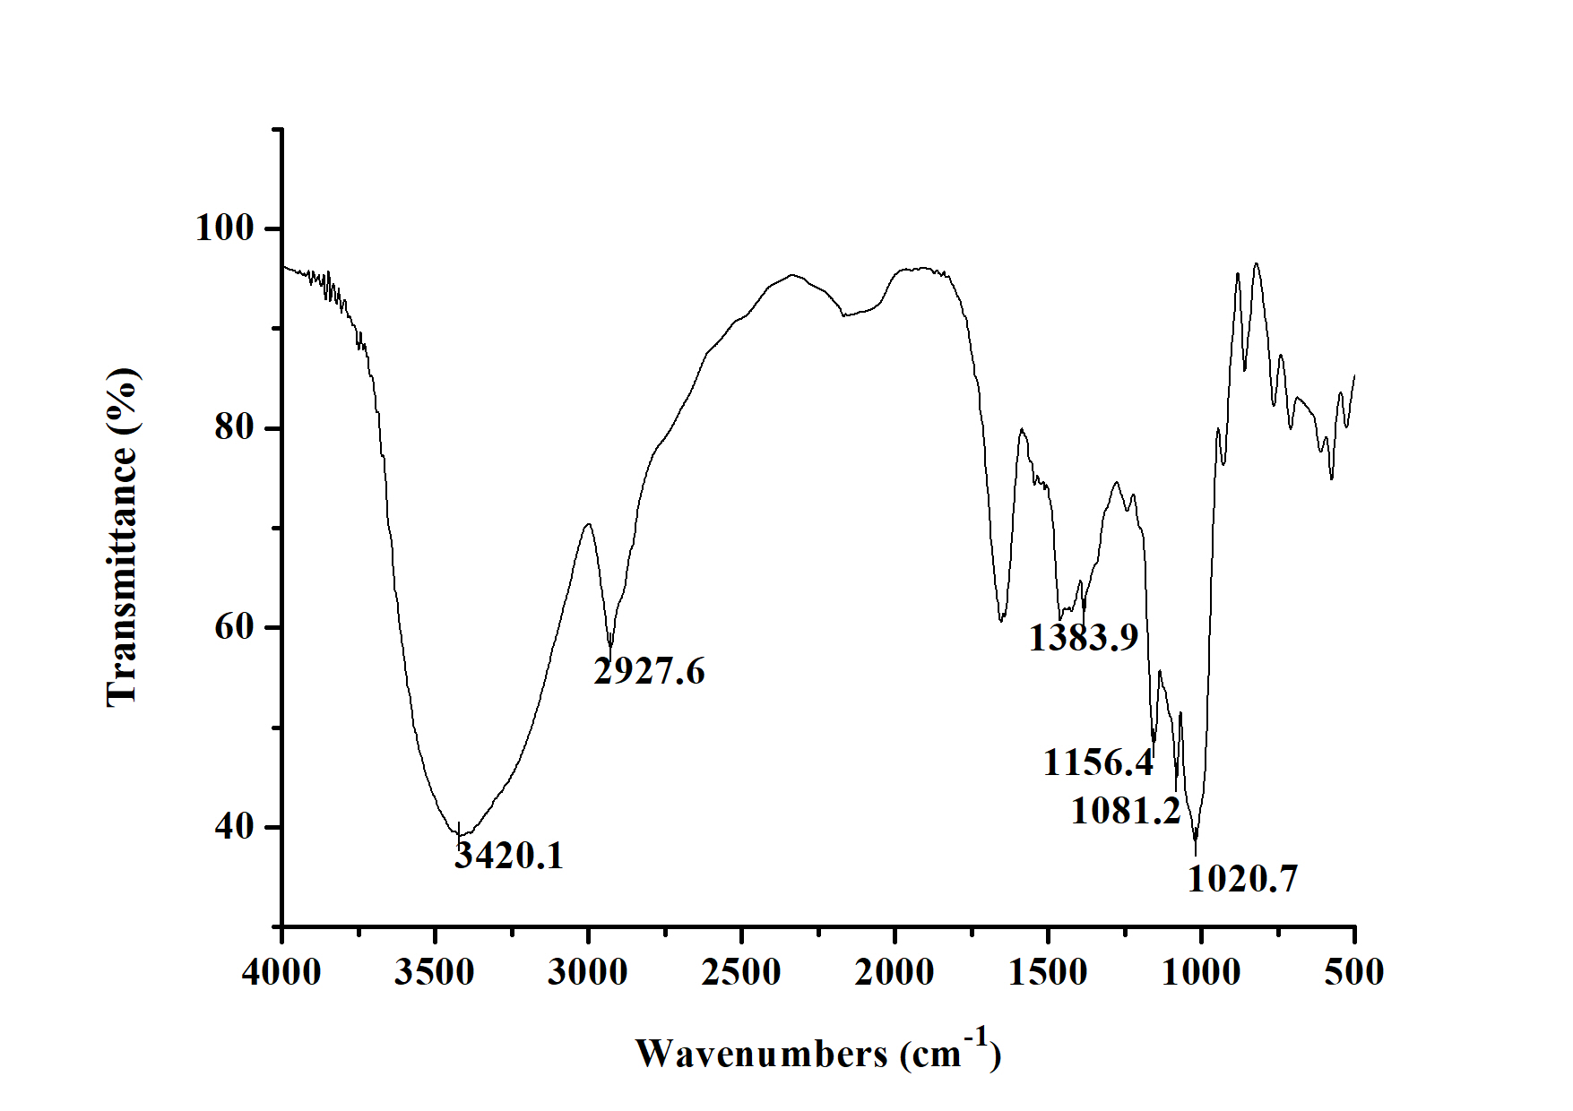

Figure S2. Compressive strength experiments scene picture.

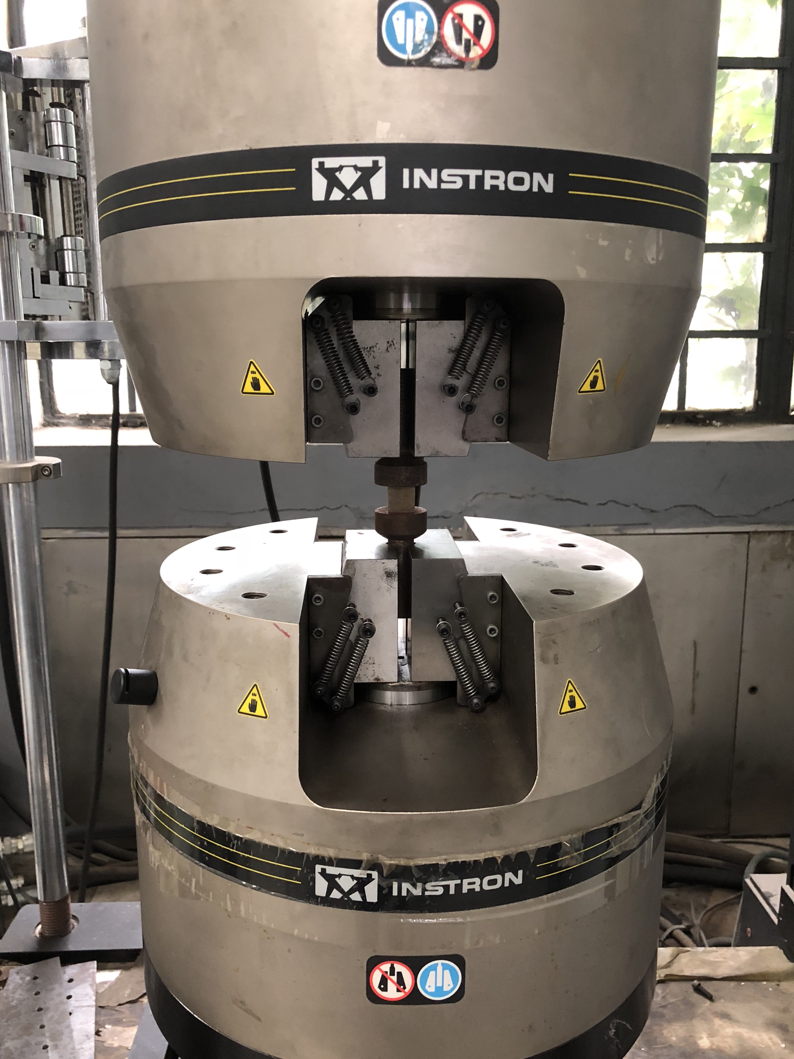

Figure S3. XRD patterns of pure OPC and OPC+1.5% SR matrices (without FA) after curing 7 days.
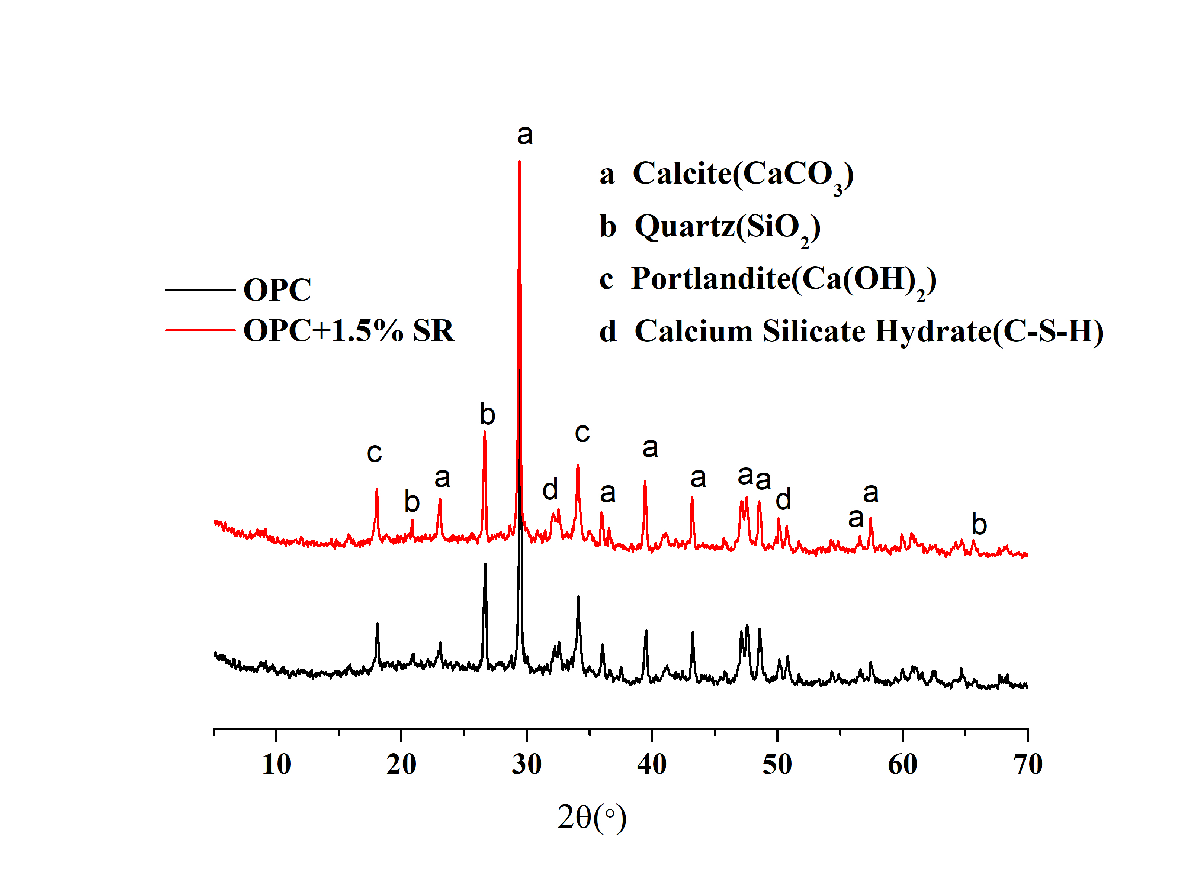

Figure S4. SEM images of hydration products of pure OPC and OPC+1.5% SR (without FA) after curing 7d: (A) pure OPC; (B) OPC+1.5% SR.

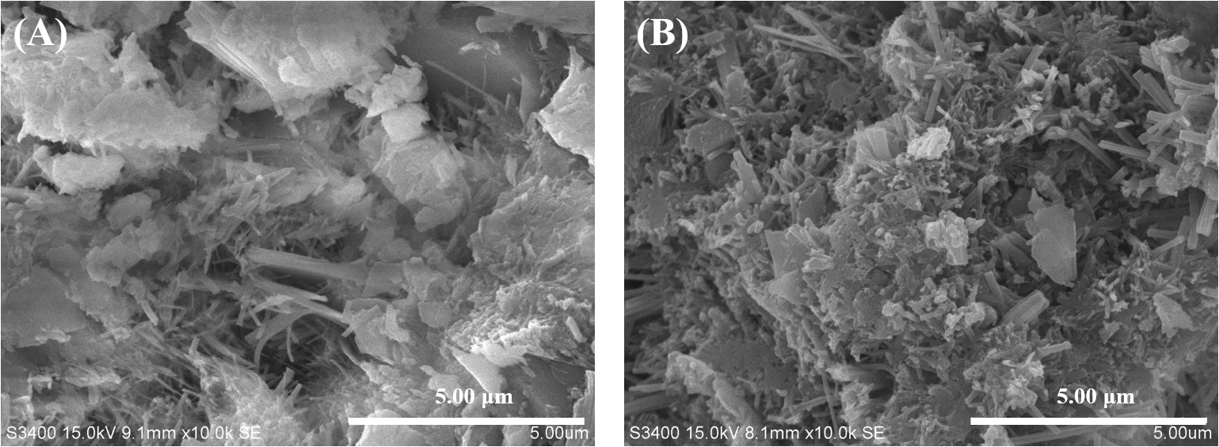
Reference
[1] T. Yang, X. Ma, B. Zhang, and H. Zhang, Investigations into the function of sticky rice on the microstructures of hydrated lime putties, Constr. Build. Mater., 2016, pp. 105-112.
[2] C. M.E.P., Solid waste-Extraction procedure for leaching toxicity-Acetic acid buffer solution method (HJ/T 300-2007), Beijing, 2007.
[3] C. M.E.P., Standard for Pollution Control on the Landfill Site of Municipal Solid Waste (GB16889-2008), Beijing, 2008.
[4] A. Tessier, P.G.C. Campbell, and M. Bisson, Sequential Extraction Procedure for the Speciation of Particulate Trace Metals, Anal. Chem., 1979, pp. 844-851.
[5] B. Zhang, W. Zhou, H. Zhao, Z. Tian, F. Li, and Y. Wu, Stabilization/solidification of lead in MSWI fly ash with mercapto functionalized dendrimer Chelator, Waste Manage., 2016, pp. 105-112.
[6] M.G. Li, C.J. Sun, S.H. Gau, and C.J. Chuang, Effects of wet ball milling on lead stabilization and particle size variation in municipal solid waste incinerator fly ash, J. Hazard. Mater., 2010, pp. 586-591.

