Supplementary materials

Effects of Cadmium-Resistant Plant Growth-Promoting Rhizobacteria and Funneliformis mosseae on the Cadmium Tolerance of Tomato (Lycopersicon esculentum L.)

Yuanyuan Li ^{1,#}, Jiahui Zeng ^{1,#}, Shizhong Wang ^{1,3,4}, Qingqi Lin ^{2,}*, Dishen Ruan ¹, Haochun Chi ¹, Mengyuan Zheng ¹, Yuanqing Chao ^{1,3,4}, Rongliang Qiu ^{1,3,4}, Yanhua Yang ^{1,3}
¹ School of Environmental Science and Engineering, Sun Yat-Sen University, Guangzhou 510006, China
² School of Geography and Planning, Sun Yat-Sen University, 510275 Guangzhou, China
³ Guangdong Provincial Key Lab of Environmental Pollution Control and Remediation Technology, Guangzhou 510275, China
⁴ Guangdong Provincial Engineering Research Center for Heavy Metal Contaminated Soil Remediation, Guangzhou 510275, China

1.1 Siderophores production of EG16 and DJ3
Siderophores produced by DJ3 and EG16 were qualitatively analyzed according to the method of Schwyn and Neilands (1). EG16 and DJ3 were inoculated on chrome azurol S (CAS) agar plate and each treatment was conducted in triplicate. After incubation at 30 °C for 48 h, the appearance of small halos around the colonies indicated the production of siderophores by the tested strains.
1.2 Nitrogen fixation characteristic of EG16 and DJ3
Nitrogen fixation activity were determined by the methods of Belimov et al. (2) with some modifications. EG16 and DJ3 were inoculated on the N-deficient agar plate (10 g sucrose, 0.5 g K₂HPO₄, 0.2 g MgSO₄, 0.2 g NaCl, 1.0 mg CaCO₃, 20 g agar, 1000 mL distilled water, pH 7.2) with three repetitions. After incubation at 30 °C for 3 days, growth situations of the bacteria were determined.
1.3 Phosphate solubilization characteristic of EG16 and DJ3
Phosphate solubilization were determined by the method of King (3). EG16 and DJ3 were inoculated on the agar inorganic phosphorus plate (10 g glucose, 0.5 g (NH₄)₂SO₄, 0.3 g NaCl, 0.3 g KCl, 0.03 g FeSO₄·7H₂O, 0.03 g MnSO₄·4H₂O, 10 g Ca₃(PO₄)₂, 20 g agar, 1000 mL distilled water, pH 7.0) and each treatment was conducted in triplicate. After incubation at 30 °C for 3 days, the appearance of small halos around the colonies indicated the solubilization of inorganic phosphorus by the tested strains.
1.4 IAA production of EG16 and DJ3
IAA production were determined by the methods of Bric et al. (4) with some modifications, DJ3 and EG16 were inoculated to LB liquid media and the concentration of L–tryptophan was 500 mg L⁻¹. Each treatment was conducted in triplicate. After incubation at 30 °C for 24 h at 180 rpm in dark, the OD600 value of bacterial suspension was determined. After centrifugation, 2 mL supernatant was mixed with 2 mL Salkowski’s reagent (5). The mixture was incubated in dark at 25 °C for 30 min and the absorbance at 535 nm was measured. The concentration of IAA was determined by using a standard curve prepared by IAA standard (Sigma, USA).
1.5 Calculation method for Inoculum potential
Inoculum potential (IP) was calculated from the total numbers intraradical vesicles, points of hyphae connected with the roots and viable spores in an inoculum of any type. The formula was IP = ( N × W × K) + S, or IP = ( N × L) + S, where N = numbers of vesicles or/and spores in roots and entry points of hyphae connected with roots, W = root weight, K = root length per unit weight of roots, L = root length, S = numbers of viable spores in an inoculum (6).
1.6 The generation of AMF filtrate
The inoculum consisted of spores, hyphae and mycorrhizal root fragments. The mycorrhizal root fragments were first cut into pieces (3-5 mm) and mixed with spores and hyphae in 2 mL sterile water thoroughly. The inoculum solution was then filtered through three layers of filter paper (Whatman no. 1) which generated a bacterial solution without any AMF spores or hyphae (the average diameter of the spore is larger than 38 μm). An aliquot of this bacterial solution was observed with a microscope to make sure that no spores or hyphae were filtered into the solution (7, 8).

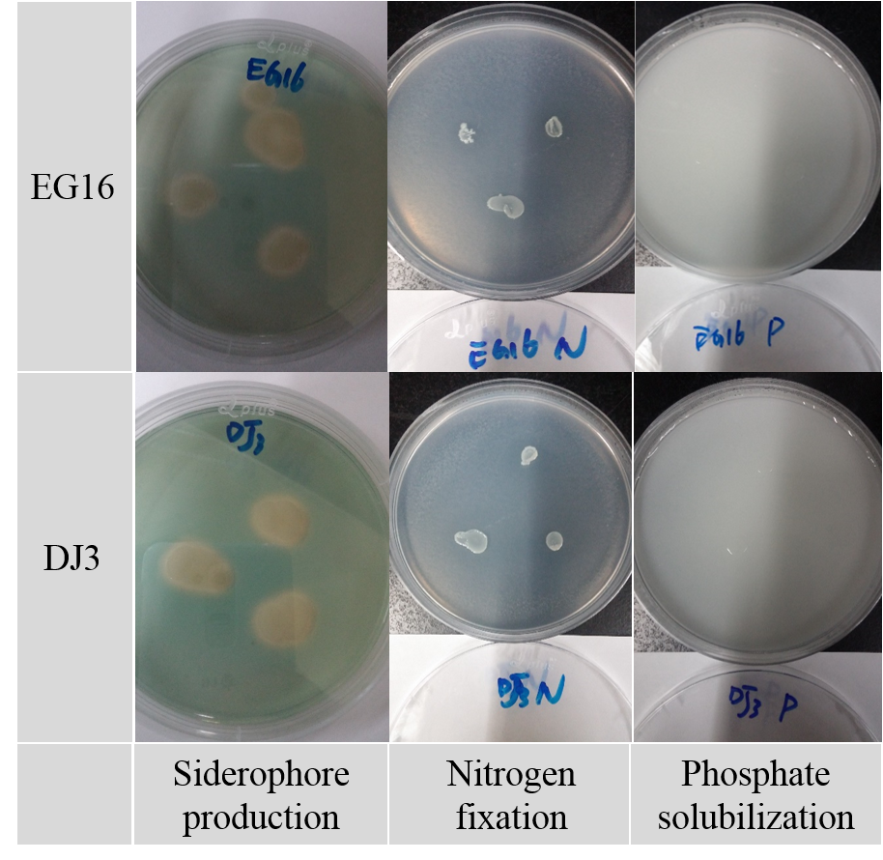
Figure S1. The qualitative results of siderophore production, nitrogen fixation and phosphate solubilization by EG16 and DJ3

Table S1. IAA production by EG16 and DJ3 (n=3).
Strains | IAA (× 10⁻⁶ mol L⁻¹)
EG16 | 16.02 ± 2.65
DJ3 | 14.63 ± 1.51

Table S2. Plant-growth-promoting characteristics of EG16 and DJ3.
Strains | Siderophore production | Nitrogen fixation | Phosphate solubilization | IAA production
EG16 | + | + | - | +
DJ3 | + | + | - | +
+: Positive response to this characteristic by strain.
-: Negative response to this characteristic by strain.

References
1. Schwyn, B. and J. B. Neilands. 1987. Universal chemical assay for the detection and determination of siderophores. Analytical Biochemistry. 160:47-56.
2. Belimov, A. A., N. Hontzeas, V. I. Safronova, S. V. Demchinskaya, G. Piluzza, S. Bullitta and B. R. Glick. 2005. Cadmium-tolerant plant growth-promoting bacteria associated with the roots of Indian mustard ( Brassica juncea L. Czern.). Soil Biol. Biochem. 37:241-250.
3. King, E. J. 1932. The colorimetric determination of phosphorus. Biochem. J. 26:292.
4. Bric, J. M., R. M. Bostock and S. E. Silverstone. 1991. Rapid In Situ Assay for Indoleacetic Acid Production by Bacteria Immobilized on a Nitrocellulose Membrane. Appl. Environ. Microbiol. 57:535-8.
5. Patten, C. L. and B. R. Glick. 2002. Role of Pseudomonas putida Indoleacetic Acid in Development of the Host Plant Root System. Applied and Environmental Microbiology. 68:3795-3801.
6. Liu R. J., Luo X. S. 1994. A new method to quantify the inoculum potential of arbuscular mycorrhizal fungi. New Phytol 128(1):89-92.
7. Liu R. J., Chen Y. L. 2007. Mycorrhizology. Beijing: Science Press of China (in Chinese).
8. Arriagada C., Pereira G., García-Romera I., Ocampo J. A. 2010. Improved zinc tolerance in Eucalyptus globulus inoculated with Glomus deserticola and Trametes versicolor or Coriolopsis rigida. Soil Biol. Biochem. 42, 118-124.

