Silica-coated Fe₃O₄ magnetic nanoparticles-supported sulfonic acid as a highly active and reusable catalyst in chemoselective deprotection of tert-butyldimethylsilyl (TBDMS) ethers
Sayed Hossein Javadiª, Daryoush Zareyee^{b}, Azam Monfaredª, khadijeh Didehbanª and Sayed Ahmmad Mirshokraeeª
ª Chemistry Department, Payam-e-Nour University, Tehran, Iran.
^{b} Department of Chemistry, Qaemshahr Branch, Islamic Azad University, Qaemshahr, Iran.
Email: zareyee@gmail.com
Supplemental Materials
1. Synthesis of magnetic nanoparticles (Fe₃O₄):
In a typical preparation procedure, 5.4 g of FeCl2 and 2 g FeCl₃ was dissolved in 25 mL aqueous hydrochloride acid (2 M) at room temperature and sonicated until the salts dissolved completely [1-2]. Afterwards, 40 mL of aqueous ammonia (25%) was added slowly over 20 min to the mixture. The resultant solution was stirred for 30 min under argon atmosphere at room temperature. Then, the Fe₃O₄ nanoparticles were separated by external magnet and thoroughly washed with distilled water and ethanol and dried under vacuum to obtain the final product. Also, it could be re-suspension Fe₃O₄ nanoparticles in ethanol and stored in refrigerator to use.
2. Synthesis of silica-coated magnetic nanoparticles:
The resulting Fe₃O₄ was then dispersed in deionized water (6 mL) and ethanol (35 mL) and gently sonicated for 15 min to obtain a homogeneous dispersion of magnetic nanoparticles. Subsequently 1.5 mL of tetraethyl orthosilicate (TEOS) was added slowly to the mixture and sonicated for 10 min. and then 1.4 mL of aqueous ammonia (10%,) was added slowly over 10 min under mechanical stirrer. The mixture was heated at 40˚C for 12 h. To this end, the silica coated magnetic nanoparticles (Fe₃O₄@SiO₂) were separated by an external magnet and washed three times with ethanol and dried under vacuum.
3. Synthesis of the mercaptopropyl silica-coated magnetic nanoparticles:
The resulting Fe₃O₄@SiO₂ (10 g) was then dispersed in toluene (200 mL) and gently sonicated for 30 min to produce a homogeneously mixed solution. After that, (3-mercaptopropyl) trimethoxysilane (2.5 mL) was added under mechanical stirring and the mixture was slowly heated to 105˚C and kept at this temperature for 20 h. The final material was separated by an external magnet and washed three times with distilled water and ethanol and dried under vacuum. The concentrated product stored in a refrigerator to use.
4. Synthesis of Sulfonic acid supported on the silica coated magnetic nanoparticles (SMNPs):
The resulting MMNPs were then dispersed in 100 mL hydrogen peroxide (30%) and the mixture was stirred vigorously for 24 h under room temperature. After 12 h, 200 mL sulfuric acid (6 M) was added slowly to the mixture. The final catalyst was separated by an external magnet and washed several times with distilled water and ethanol and dried under vacuum. The concentrated product stored in a refrigerator to use.
5. General procedure for deprotection of TBDMS ethers:
Catalyst (0.03 g, 2 mol %) was added to TBDMS ethers (1 mmol) in methanol (5 mL) at ambient temperature and the mixture was stirred for appropriate time indicated in Table 2 until the reaction was completed as monitored by gas chromatography and thin-layer chromatography. After the completion of reaction, the catalyst was separated by an external magnet and then the product was isolated by rapid filtration through a short pad of silica gel.

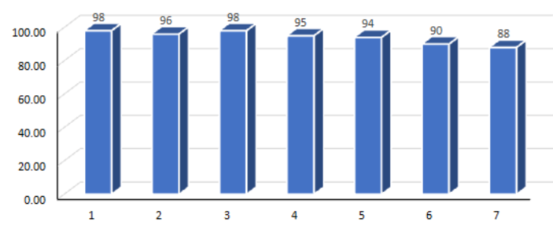

Figure S 1: Reusability study of the Fe₃O₄@SiO₂@PrSO₃H during the deprotection of benzyloxy(tert-butyl)dimethyl silane in methanol after 2h.
References
- Xie, R.-F.; Yang, B.-R.; Cheng, P.-P.; Wu, S.; Li, Z.-C.; Tang, J.-Y.;Li, S.; Tang, N.; Lee, S. M. Y; Wang, Y.-H.; et al. Study on the HPLC Chromatograms and Pro-Angiogenesis Activities of the Flowers of Panax notoginseng. J. Liq. Chromatogr. Relat. Technol. 2015, 38, 1286–1295. DOI: 10.1080/10826076.2015.1037451.
- Duke, J. A. Handbook of Phytochemical Constituents of GRAS Herbs and Other Economic Plants; CRC Press: Boca Raton, 2001.

