This resource includes post-assessment data and fit statistics of the 18 questions on the Mineralogy Concept Inventory (Table 1) and the final MCI.
Table 1: Post-assessment data (n = 155) including difficulty estimates, standard errors, % correct, and Rasch modeling fit statistics for the final MCI items.
Item | Measure | S.E. | % correct | INFIT MNSQ | INFIT ZSTD | OUTFIT MNSQ | OUTFIT ZSTD
Q1 | −1.18 | 0.26 | 92 | 0.65 | −2.20 | 0.49 | −2.0
Q2 | −0.20 | 0.20 | 61 | 1.44 | +3.8 | 1.60 | +3.1
Q3 | −0.90 | 0.24 | 80 | 1.21 | +1.4 | 1.10 | +0.5
Q4 | +0.10 | 0.19 | 69 | 0.95 | −0.6 | 0.87 | −1.0
Q5 | −1.04 | 0.25 | 90 | 0.70 | −2.0 | 0.51 | −2.1
Q6 | −0.81 | 0.23 | 79 | 1.23 | +1.5 | 1.42 | +1.6
Q7 | −0.84 | 0.24 | 79 | 1.39 | +2.4 | 1.42 | +1.6
Q8 | −0.70 | 0.23 | 88 | 0.93 | −0.4 | 1.03 | +0.2
Q9 | +0.60 | 0.18 | 63 | 1.08 | +1.1 | 1.12 | +1.1
Q10 | +1.37 | 0.18 | 39 | 1.02 | +0.4 | 1.10 | +1.1
Q11 | +1.31 | 0.18 | 50 | 1.04 | +0.7 | 1.07 | +0.8
Q12 | +0.39 | 0.18 | 57 | 1.14 | +1.8 | 1.15 | +1.3
Q13 | −0.76 | 0.23 | 78 | 1.24 | +1.6 | 1.29 | +1.2
Q14 | +0.88 | 0.18 | 87 | 1.01 | +0.2 | 1.00 | +0.0
Q15 | +1.77 | 0.18 | 43 | 1.15 | +2.0 | 1.14 | +1.2
Q16 | +1.06 | 0.18 | 55 | 1.02 | +0.4 | 1.07 | +0.8
Q17 | −0.93 | 0.24 | 85 | 0.97 | −0.1 | 0.85 | −0.5
Q18 | −0.11 | 0.20 | 74 | 0.95 | −0.5 | 0.93 | −0.4

Mineralogy Concept Inventory
Please answer the questions below to the best of your abilities. Please bubble in all of your answers on the bubble sheet that is included as the final page of this document.
Completing the assessment counts toward in-class participation, but otherwise it is not graded. There is no penalty for not knowing the correct answer, just do your best.
- Given the ionic radii and charges of the following elements, choose which element is least likely to substitute for Zn (zinc) in sphalerite (chemical formula: ZnS).

Element | Ionic radius (Å) | Charge
Zn (zinc) | 0.74 | 2+

Element  A.  B.  C.  D. | Ionic radius (Å) | Charge
Fe (iron) | 0.645 | 2+
Cd (cadmium) | 0.97 | 2+
Li (lithium) | 0.76 | 1+
K (potassium) | 1.38 | 1+
E. I do not know

- Imagine that a crystal of quartz starts at the earth’s surface and is moved progressively deeper into the earth until it reaches the lower mantle (about 660 kilometers deep). How would the structure of that crystal of quartz change as it moves progressively deeper into the earth?
- The crystal wouldn’t change
- The bonds in the crystal would become more random
- The crystal would melt
- The structure of the crystal would become more dense
- I do not know

- Why can certain minerals be a variety of different colours? For example, quartz can be colourless, purple, pink, yellow, etc.
- Colour is due to small inclusions of other minerals within the main mineral
- Colour is produced by electrons that jump from higher to lower energy levels and release waves
- The colour of a mineral is related to the environment that it formed in
- Colour is caused by elements that occur in trace amounts in the mineral
- I do not know

- In which layer of the Earth would you be most likely to find a mineral with the chemical composition (Mg,Fe)₂SiO₄?
- Crust
- Upper mantle
- Lower mantle
- Outer core
- I do not know

- The diagram below shows the variation in composition between Fe, Al, and Cr. The labels indicate the end-member compositions (i.e. 100% of that element). What is the composition of point ‘X’?

- 10% Fe, 10% Al, 80% Cr
- 40% Fe, 30% Al, 30% Cr
- 60% Fe, 20% Al, 20% Cr
- 80% Fe, 10% Al, 10% Cr
- I do not know

- Examine the (3-dimensional) square-based prism below. Imagine that you are asked to draw a 2-dimensional plane through the object to create a mirror image on both sides of the dividing plane. How many different planes could you draw to do this?
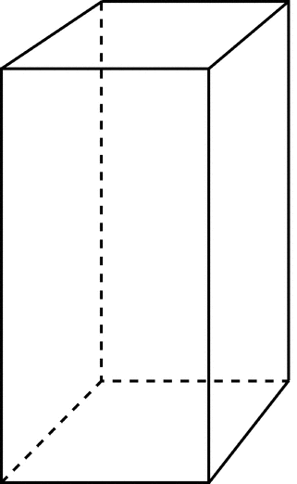
- 1 plane
- 2 planes
- 3 planes
- 4 planes
- 5 planes
- I do not know

- Examine the (3-dimensional) rectangular-based prism below. Imagine that you are asked to draw a 2-dimensional plane through the object to create a mirror image on both sides of the dividing plane. How many different planes could you draw to do this?
- 1 plane
- 2 planes
- 3 planes
- 4 planes
- 5 planes
- I do not know

- In what type of environment would you expect to form the mineral aragonite (chemical formula: CaCO₃)?
- Volcano
- River bed
- Lake
- Ocean
- I do not know
- Examine the (3-dimensional) crystal shown below. Light is shined through the crystal at several different orientations, as indicated by the arrows. The light always enters the crystal perpendicular to one of its faces. Will the light travel at the same speed regardless of the orientation at which it travels through the crystal?
- Yes, all of the beams of light will travel at the same speed
- No, one of the beams of light will travel at a different speed than the other beams
- No, all of the beams of light will travel at different speeds
- I do not know

- Sodium (Na) and potassium (K) are both cations with a +1 charge. Na has an ionic radius of 1.02 Å and K has an ionic radius of 1.38 Å. Which of these two cations would you expect to have the largest number of negatively charged anions surrounding it?
- Na because a smaller ionic radius can fit more negatively charged anions around it
- Na because a smaller ionic radius has a stronger nucleus and can pull more negatively charged anions towards it
- K because a larger ionic radius can fit more negatively charged anions around it
- K because a larger ionic radius has a stronger nucleus and can pull more negatively charged anions towards it
- I do not know

- What is the most common element in the Earth’s crust?
- Oxygen
- Carbon
- Iron
- Silicon
- I do not know

- Below are photos of two minerals. What would be the best way to tell if the two minerals are the same mineral?

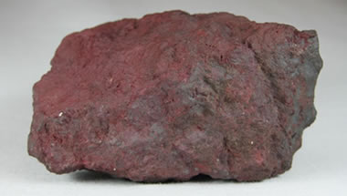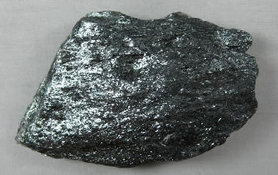

- Pour acid on them to see if they fizz
- Powder each mineral and see what colour the powder is
- Test their hardness
- Hold a magnet near them to see if they’re magnetic
- I do not know

- Why are some minerals harder than others?
- Hardness is related to the environment that the mineral was formed in
- Hardness is related to the type of bonds between the atoms
- Hardness is related to the composition of the mineral
- Hardness is related to the angle of the bonds between atoms
- I do not know

- You are observing a very thin slice of a rock (called a “thin section”) under the microscope using light that is polarized (vibrating in one direction). There are two polarized rays of light that are vibrating perpendicular to one another. They both enter the same side of the crystal. As you slowly spin the thin section in the light under the microscope, which of the following crystal shapes is most likely to stay black, regardless of which side you look through under the microscope? For similar shapes, side lengths have been described.
a ≠ b
a = b
A. 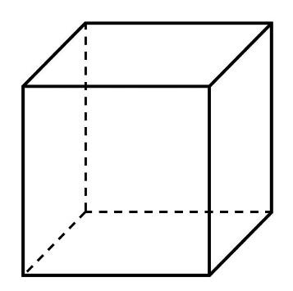 B. 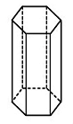 C. 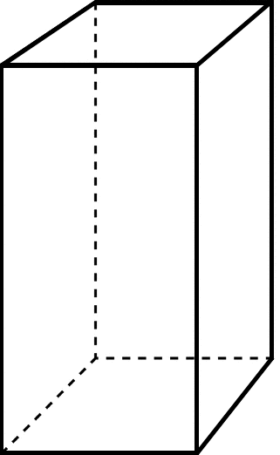 D. 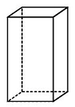
E. I do not know

- Refer again to the crystal shapes above. Which of the shapes will never stay black, regardless of its orientation under the microscope?
- Shape A
- Shape B
- Shape C
- Shape D
- I do not know

- The mineral olivine can vary in composition in between 100% Mg₂SiO₄ and 100% Fe₂SiO₄. Imagine there is some liquid olivine at point ‘X’ on the figure, that has a composition of 70% Fe₂SiO₄ (30% Mg₂SiO₄) and a temperature of 2000°C. What will be the composition of the liquid olivine and, if present, any solid olivine, when it is cooled to 1500°C? Report the composition in terms of %Fe₂SiO₄.
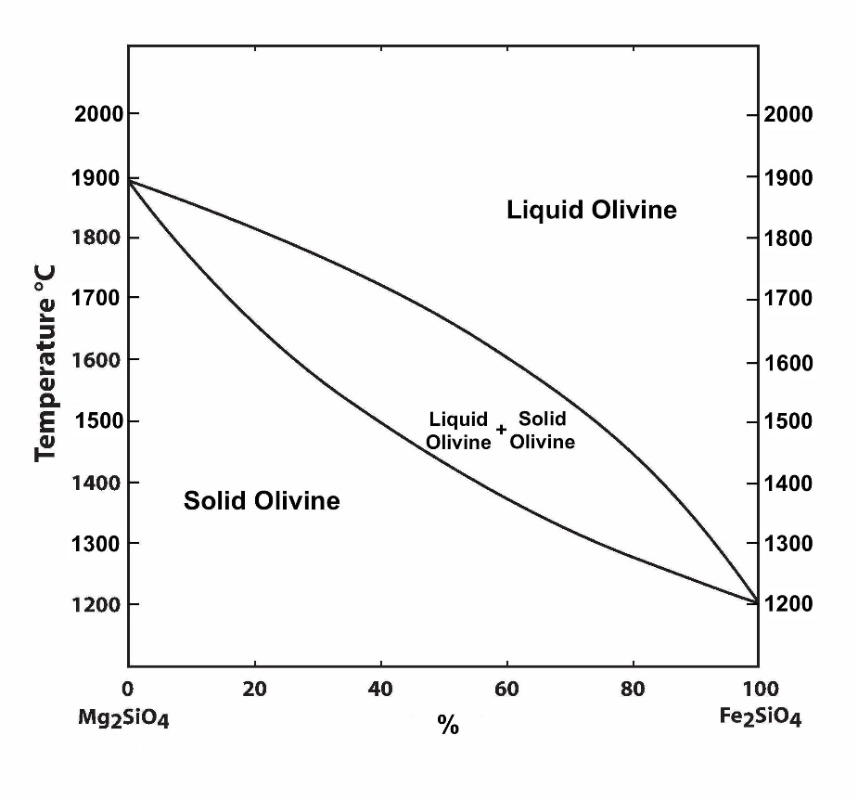
X

Temperature °C

- Liquid olivine: 70% Fe₂SiO₄ Solid olivine: No solid olivine
- Liquid olivine: 70% Fe₂SiO₄ Solid olivine: 70% Fe₂SiO₄
- Liquid olivine: 75% Fe₂SiO₄ Solid olivine: 40% Fe₂SiO₄
- Liquid olivine: 40% Fe₂SiO₄ Solid olivine: 75% Fe₂SiO₄
- I do not know

True or False Questions
For each of the following questions there are the formulae of two minerals listed. Decide whether or not a mineralogist would group those two minerals together if they were classifying them. Bubble in “T” on your bubble sheet to indicate true, and “F” on your bubble sheet to indicate false. Bubble in “X” if you do not know.

- A mineralogist would group the minerals PbSO₄ and Cu₅FeS₄ together.
- True
- False
- I do not know

- A mineralogist would group the minerals CaF₂ and NaCl together.
- True
- False
- I do not know

