Supplemental Table 1. Successive lipase method applications on Roche analyzers
Analyzer | Lipase method application references |  |  |  | Assay characteristics |  |  |  |  |  | Automatic on-board dilution
 | N° | ACN | Test  version | Technical  Sheet | Time  Reaction  (min) | Measure  points | R1  (µL) | Diluent  (µL) | R2  (µL) | Normal  Sample  Volume  (µL) ª | Dilution Ratio ª | Dilution  Sample  Volume  (µL) ^{b} | Reduced  Sample  Volume  (µL) ^{b} | Diluent  Volume  (µL) ^{b}
Modular®P800 | 1 | 731 | 03 | 02-2011 (V16.0) | 10 | 23-27 | 250 | - | 150 | 4.0 | 1/11 | 14 | 3.0 | 140
 | 2 | 731 | 04 | 11-2015 (V18.0) | 10 | 23-27 | 250 | - | 150 | 4.0 | 1/2 ^{c} | 30 | 4.5 | 60
Cobas®c501 | 1 | 731 | 1105 | 07-2013 (V11.0) | 10 | 22-31 | 80 | 20 | 48 | 2.0 | 1/10 | 15 | 2.0 | 135
 | 2 | 731 | 1106 | 11-2015 (V12.0) | 10 | 22-31 | 80 | 20 | 48 | 2.0 | 1/2 ^{d} | 30 | 3.0 | 60
Cobas®C701 | 1 | 8731 | 0804 | 11-2013 (V1.0) | 10 | 26-31 | 80 | 20 | 48 | 2.0 | 1/10 | 15 | 2.0 | 135
 | 2 | 8731 | 1005 | 11-2015 (V2.0) | 10 | 26-31 | 80 | 20 | 48 | 2.0 | 1/2 ^{e} | 35 | 3.0 | 70
 | 3 | 8789 | 0101 | 02-2018 (V2.0) | 10 | 22-25 | 80 | 20 | 48 | 2.0 | 1/10 | 15 | 2.0 | 135
Legend: Samples with initial lipase results >300 U/L were re-assayed after automatic on-board analyzer dilution, from which reduced sample volumes were used for the colorimetric enzymatic reaction.
ª As provided on Roche Diagnostics technical sheets of lipase assay.
^{b} As announced on Roche Diagnostics technical notes for lipase assay (see Supplemental Table 2).
^{c} Dilution 1/2, as compared to LMA1: (30 µL / (30 µL + 60 µL)) * (4.5 µL / 3 µL) = 0.5.
^{d} Dilution 1/2, as compared to LMA1: (30 µL / (30 µL + 60 µL)) * (3 µL / 2 µL) = 0.5.
^{e} Dilution 1/2, as compared to LMA1: (35 µL / (35 µL + 70 µL)) * (3 µL / 2 µL) = 0.5.
Abbreviations: ACN: application code number; R1 and R2: reagent 1 and 2 (from technical sheet); V: version of technical sheet.
Supplemental Table 2. Original tables from technical notes diffused by Roche Diagnostics for changes in dilution volumes of lipase method applications.
A. B.
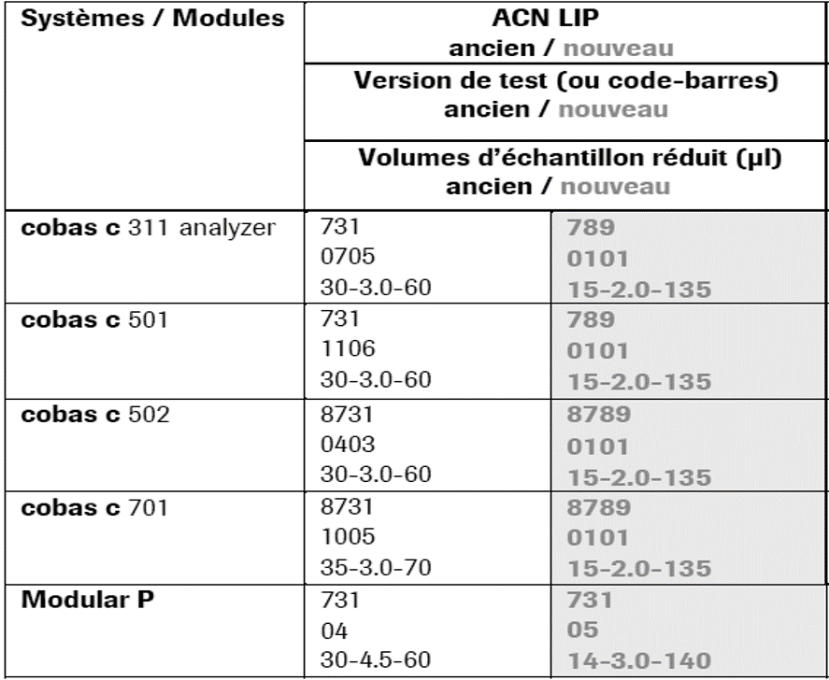
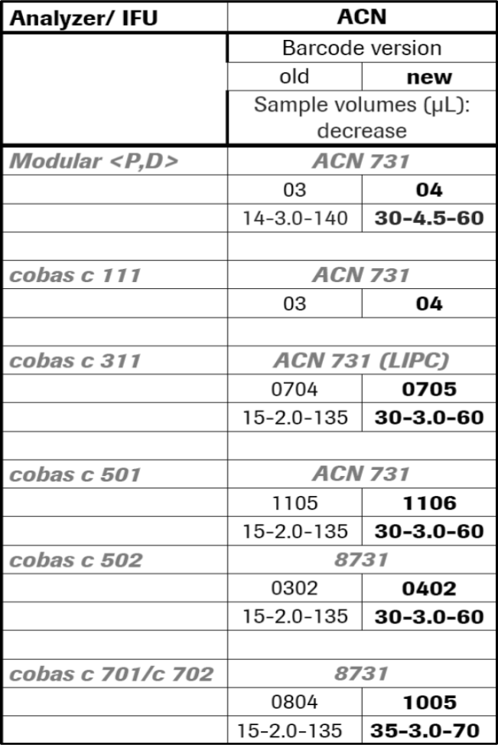
Legend: (A) The first Roche technical note (ref#34-2015; QN-RPD-2015-262, November 18th, 2015) specified the changes in dilution volumes from the previous to the new lipase method application (LMA1 to LMA2), and (B) the second Roche technical note (ref#03-2018; SN-CPS-2017-245v2, March 19th, 2018) specified the changes in dilution volumes from the previous to the new lipase method application (LMA2 to LMA3), for all Roche analyzers, among which Modular®P800, Cobas®c501, and Cobas®C701.

Supplemental Table 3. Relative frequencies (%) of lipase results in subranges of 10 U/L
Analyser | LMA | N ª | Relative frequencies (%) of lipase results by subranges of 10 U/L
 |  |  | 200 | 210 | 220 | 230 | 240 | 250 | 260 | 270 | 280 | 290 | 300 | 310 | 320 | 330 | 340 | 350 | 360 | 370 | 380 | 390 | 400 | 410 | 420 | 430 | 440 | 450 | 460 | 470 | 480 | 490
 |  |  | to | to | to | to | to | to | to | to | to | to | to | to | to | to | to | to | to | to | to | to | to | to | to | to | to | to | to | to | to | to
 |  |  | 210 | 220 | 230 | 240 | 250 | 260 | 270 | 280 | 290 | 300 | 310 | 320 | 330 | 340 | 350 | 360 | 370 | 380 | 390 | 400 | 410 | 420 | 430 | 440 | 450 | 460 | 470 | 480 | 490 | 500
Modular | 1 | 5787 | 10.1 | 8.97 | 8.83 | 7.14 | 6.51 | 6.34 | 6.46 | 4.99 | 5.05 | 3.99 | 0.29 | 0.24 | 0.31 | 0.88 | 1.19 | 2.14 | 2.37 | 1.92 | 2.21 | 1.99 | 2.00 | 2.35 | 2.33 | 1.97 | 1.57 | 1.69 | 1.80 | 1.35 | 1.56 | 1.40
 | 2 | 1001 | 9.19 | 9.59 | 8.99 | 6.59 | 6.59 | 5.00 | 5.59 | 4.10 | 4.60 | 3.60 | 0.50 | 1.10 | 2.20 | 2.70 | 3.70 | 3.20 | 1.80 | 2.10 | 2.50 | 2.50 | 1.80 | 1.90 | 2.60 | 1.20 | 1.30 | 0.90 | 1.10 | 1.20 | 1.00 | 0.90
c501 | 1 | 59 | 8.47 | 11.9 | 17.0 | 1.69 | 10.2 | 6.78 | 6.78 | 1.69 | 1.69 | 6.78 | 0.00 | 0.00 | 0.00 | 0.00 | 0.00 | 0.00 | 0.00 | 0.00 | 1.69 | 3.39 | 1.69 | 0.00 | 0.00 | 3.39 | 1.69 | 5.08 | 3.39 | 3.39 | 0.00 | 3.39
 | 2 | 42 | 4.76 | 14.3 | 7.14 | 9.52 | 9.52 | 2.38 | 0.00 | 2.38 | 7.14 | 0.00 | 0.00 | 0.00 | 0.00 | 0.00 | 0.00 | 2.38 | 2.38 | 4.76 | 2.38 | 2.38 | 4.76 | 4.76 | 2.38 | 4.76 | 2.38 | 2.38 | 2.38 | 2.38 | 0.00 | 2.38
C701 | 1 | 546 | 12.3 | 8.61 | 8.24 | 8.24 | 8.24 | 5.68 | 6.78 | 7.14 | 5.13 | 4.21 | 0.00 | 0.00 | 0.00 | 0.00 | 0.37 | 0.00 | 0.00 | 0.18 | 0.55 | 0.92 | 1.28 | 2.56 | 1.47 | 3.11 | 3.11 | 2.75 | 2.20 | 2.01 | 2.75 | 2.20
 | 2 | 717 | 11.4 | 9.76 | 9.90 | 6.69 | 6.28 | 4.60 | 4.74 | 4.04 | 4.04 | 3.77 | 0.00 | 0.14 | 0.28 | 0.00 | 1.39 | 2.93 | 1.81 | 2.23 | 2.37 | 1.53 | 3.21 | 2.37 | 2.09 | 2.23 | 1.95 | 1.81 | 1.81 | 2.51 | 1.81 | 2.23
 | 3 | 1761 | 11.0 | 8.52 | 7.04 | 7.04 | 6.42 | 6.08 | 5.51 | 5.05 | 5.11 | 3.92 | 0.11 | 0.62 | 1.31 | 3.07 | 3.18 | 2.04 | 2.90 | 2.78 | 2.27 | 1.93 | 2.21 | 1.93 | 1.65 | 1.31 | 1.53 | 1.08 | 0.68 | 1.14 | 1.31 | 1.31
Legend: Relative frequencies of lipase results in subranges of 10 U/L, according to successive lipase method application (LMA). Lipase results were cumulated from two Modular®P800 (LMA1 and 2), from one Cobas®c501 (LMA1 and 2), from two Cobas®C701 (LMA1 and 2), and then from five Cobas®C701 (LMA3). ª Total number of lipase results within the 200 to 500 subranges over the study periods.

Supplemental Figure 1. Relative frequencies of lipase results on Siemens Dimension®Vista (A) and Abbott Architect®C16000 (B) analyzers.
A.
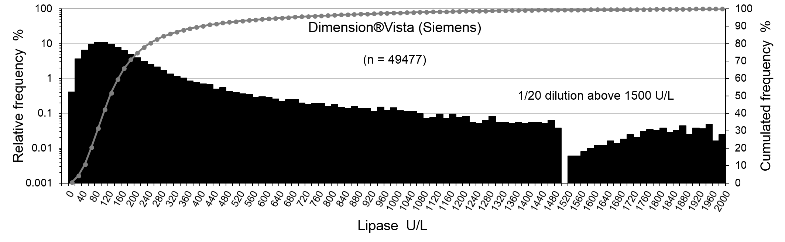
B.
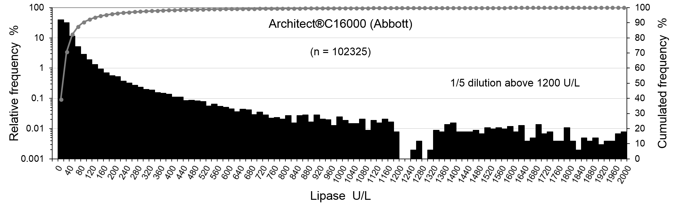
Legend: Relative frequencies of lipase results (subranges of 20 U/L) display a gap between 1500 (LOL) and ~1520 to ~1700 U/L on Siemens Dimension®Vista analyzer (A), and between 1200 (LOL) and ~1320 U/L on Abbott Architect®C16000 (B). The LMA on Dimension®Vista is characterized by a measuring range from 10 to 1500 U/L, with a 1/20 automated repeat-on-dilution for results above 1500 U/L. The LMA on Architect®C16000 is characterized by a measuring range from 3.1 (LOQ) to 1200 U/L, with a 1/5 automated repeat-on-dilution for results above 1200 U/L. Plasma lipase results assayed on two Dimension®Vista were collected over a 5.7-year period (from 11-26-2013 to 7-25-2019), providing 49477 up to 2000 U/L, while those assayed on two Architect®C16000 were collected over a 5.9-year period (from 9-3-2013 to 7-15-2019), providing 102325 results over this measuring range.
Abbreviations: LMA: lipase method application; LOL: limit of linearity; LOQ: limit of quantification.

