Supporting Information

Enzymatic dimerization of phenylacetylene by laccase immobilized on magnetic nanoparticles via click chemistry

Mehdi Mogharabi-Manzari^{1,2}, Marjan Heydari¹, Salar Sadeghian-Abadi¹, Mahsa Yousefi-Mokri¹ and Mohammad Ali Faramarzi^{*,1}

¹ Department of Pharmaceutical Biotechnology, Faculty of Pharmacy and Biotechnology Research Center, Tehran University of Medical Sciences, P.O. Box 14155–6451, Tehran 1417614411, Iran
² The Institute of Pharmaceutical Sciences, Tehran University of Medical Sciences, Tehran 1417614411, Iran
-----------------------------------------
*Corresponding author: Tel: +98-21-66954712; Fax: +98-21-66954712; E-mail: faramarz@tums.ac.ir
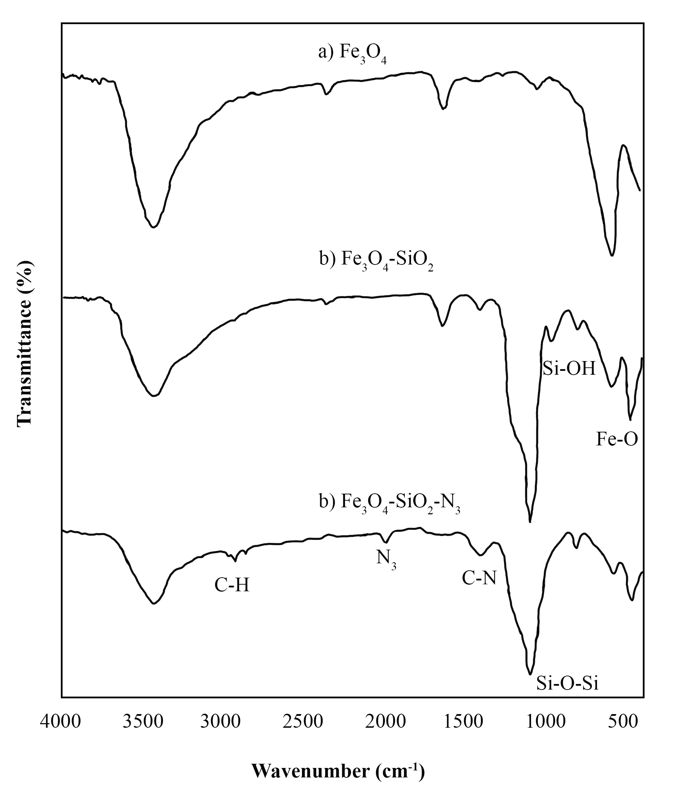
Figure S1. Fourier transform infrared (FTIR) spectra of a) Fe₃O₄, b) Fe₃O₄-SiO₂, and c) Fe₃O₄-SiO₂-N₃.
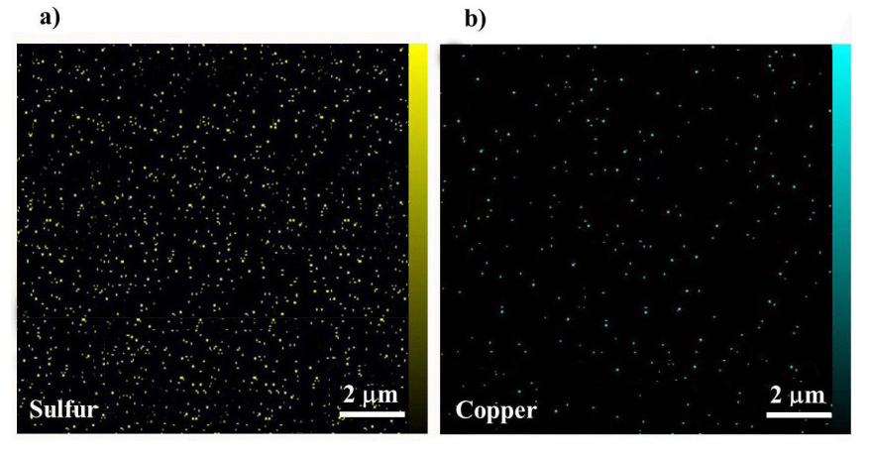
Figure S2. Color coded dot maps of copper atoms of immobilized laccase on Fe₃O₄.
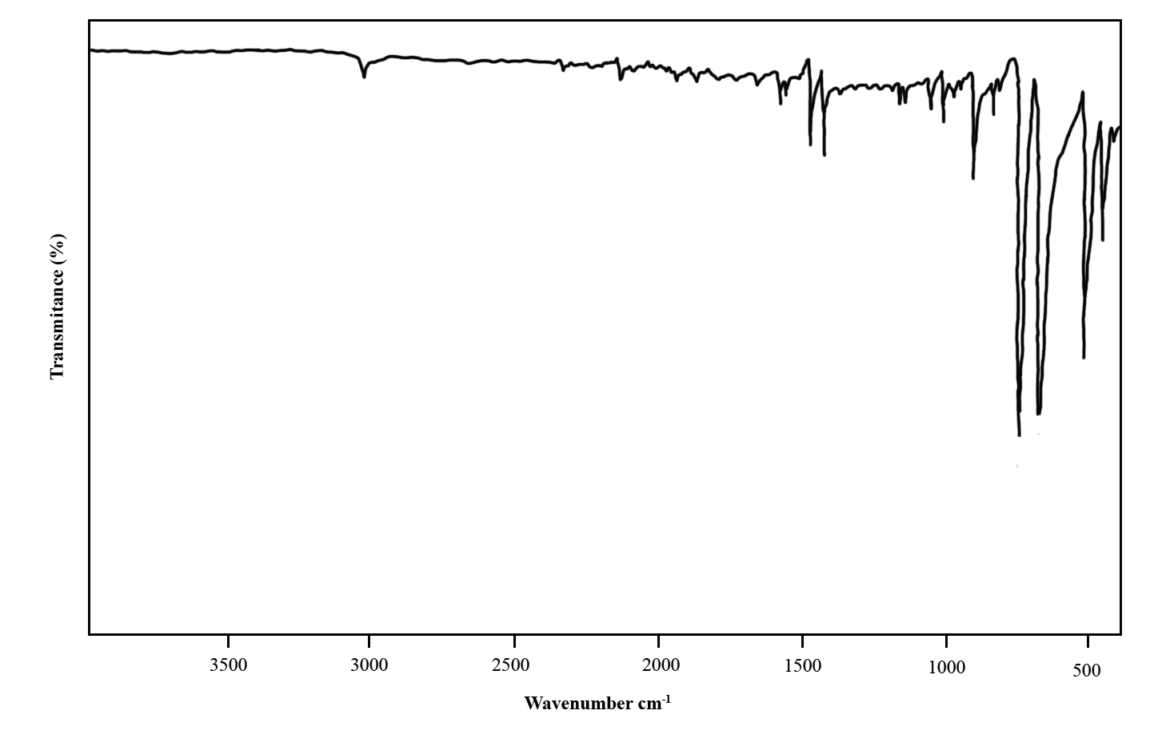
Figure S3. FTIR spectrum of 1,4-diphenylbutadiyne.
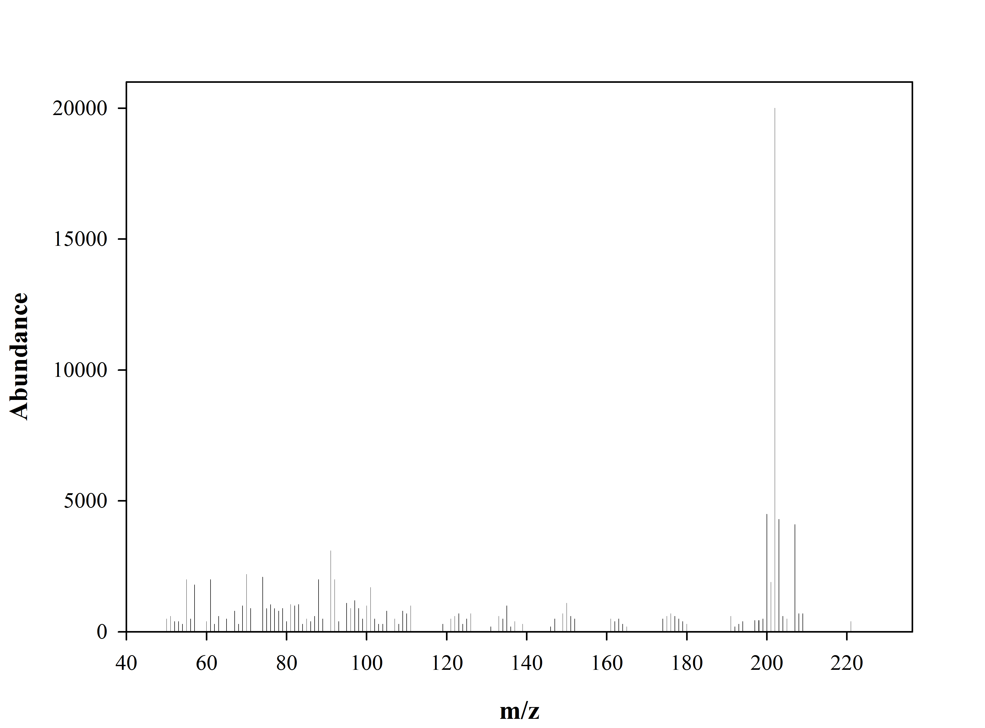
Figure S4. Mass spectrum of 1,4-diphenylbutadiyne.
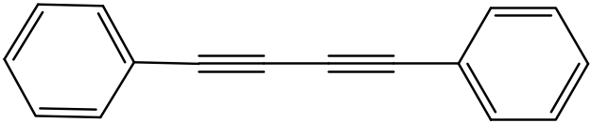
a)
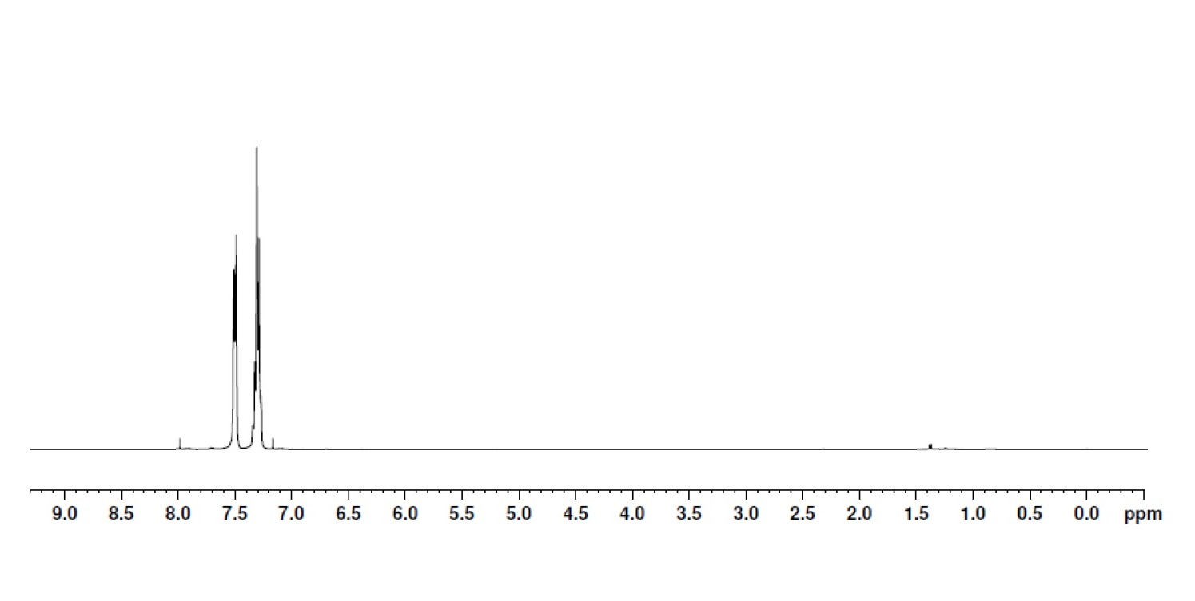
b)
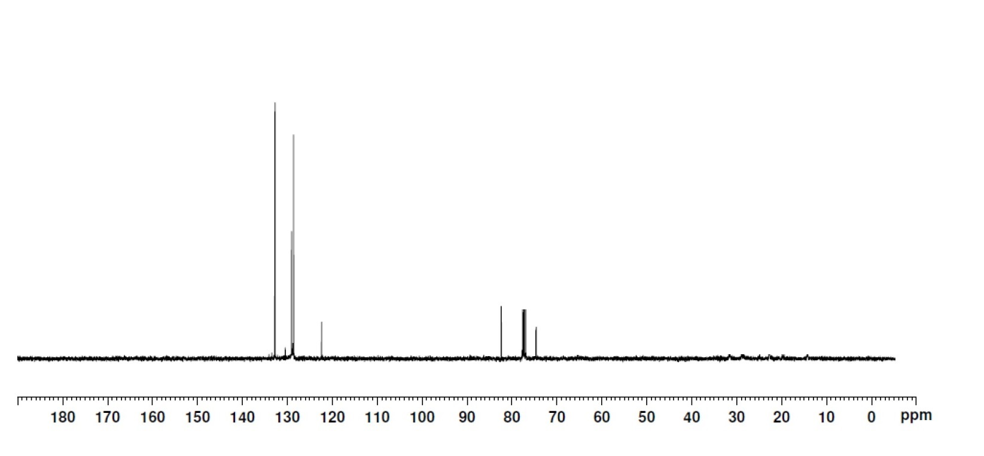
Figure S5. a) ¹HNMR and b) ¹³CNMR of 1,4-diphenylbutadiyne.

