Appendix A. Supplementary Material

Optimization of removal of anionic and cationic dyestuffs from aqueous solution with Cinnamon bark as low-cost and eco-friendly adsorbent
Melisa Güler, Seda Çetintaş & Deniz Bingöl∗
Kocaeli University, Science and Art Faculty, Department of Chemistry, Kocaeli, Turkey

Table A.1. Properties of used dyestuffs
Trade name | Indigo Carmine (IC) | Malachite Green (MG)
IUPAC name | 5,5-indigosulfonic acid sodium salt | 4-[(4-dimethylamino phenyl) phenyl-methyl]-  N,N Dimethylaniline
Molecular Structure | 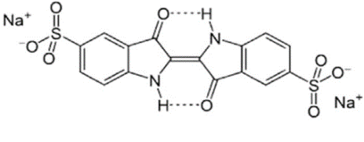 | 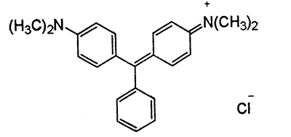
Molecular Formula | C₁₆H₈N₂O₈S₂Na₂ | C₂₃H₂₅ClN₂
Molecular Weight (g/mol) | 466.4 | 364.9
λ_{max} (nm) | 608 | 616

Table A.2. CCD design matrix and the selected factors for (a) IC and (b) MG adsorption onto Cinnamon bark
Factors |  |  |  | (a) |  |  |  |  |  |  |  | (b)
 |  |  |  | Levels of factors |  |  |  |  |  |  |  | Levels of factors
 |  |  |  | -α  (-1.414) | -1 | 0 | +1 | +α  (+1.414) |  |  |  | -α  (-1.414) | -1 | 0 |  | +1 | +α  (+1.414)
X₁: initial dyestuff concentration (mg/L) |  |  |  | 20 | 32 | 60 | 88 | 100 |  |  |  | 20 | 32 | 60 |  | 88 | 100
X₂: adsorbent amount (g) |  |  |  | 0.20 | 0.46 | 1.10 | 1.74 | 2.00 |  |  |  | 0.01 | 0.08 | 0.26 |  | 0.43 | 0.50
Run |  | Coded levels |  |  | Actual levels |  |  |  |  |  | Actual levels
 |  | X₁ | X₂ |  | Co (mg/L) | m (g) |  |  |  |  | Co (mg/L) |  |  |  | m (g)
1 |  | -1 | -1 |  | 32 | 0.46 |  |  |  |  | 32 |  |  |  | 0.08
2 |  | 1 | -1 |  | 88 | 0.46 |  |  |  |  | 88 |  |  |  | 0.08
3 |  | -1 | 1 |  | 32 | 1.74 |  |  |  |  | 32 |  |  |  | 0.43
4 |  | 1 | 1 |  | 88 | 1.74 |  |  |  |  | 88 |  |  |  | 0.43
5 |  | -1.414 | 0 |  | 20 | 1.10 |  |  |  |  | 20 |  |  |  | 0.26
6 |  | 1.414 | 0 |  | 100 | 1.10 |  |  |  |  | 100 |  |  |  | 0.26
7 |  | 0 | -1.414 |  | 60 | 0.20 |  |  |  |  | 60 |  |  |  | 0.01
8 |  | 0 | 1.414 |  | 60 | 2.00 |  |  |  |  | 60 |  |  |  | 0.50
9-13 |  | 0 | 0 |  | 60 | 1.10 |  |  |  |  | 60 |  |  |  | 0.26

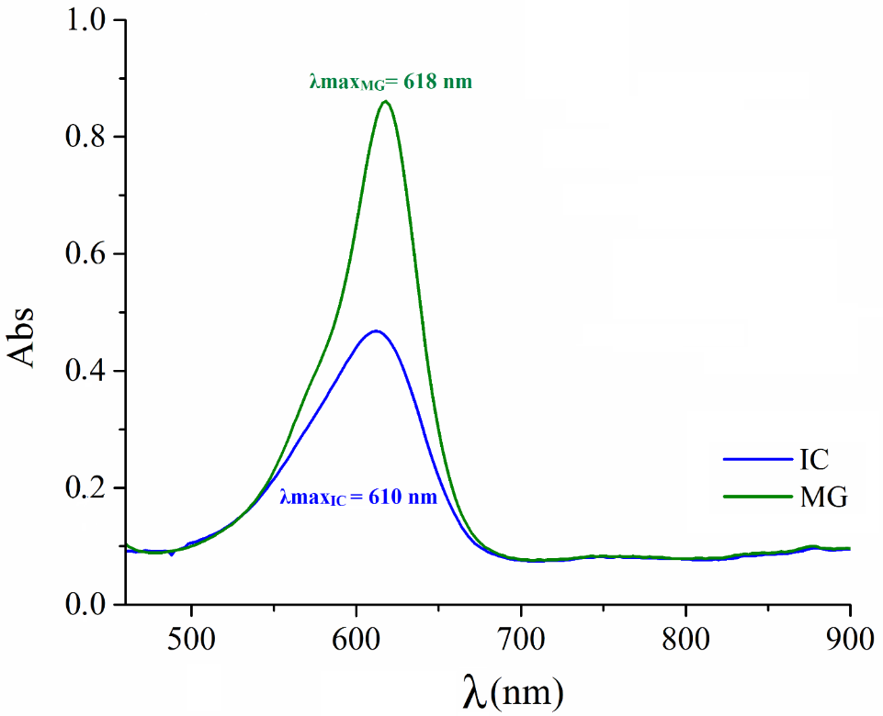
Figure A.1. Absorbance spectra obtained for IC and MG dyestuffs

Figure A.2. pHpzc for Cinnamon bark

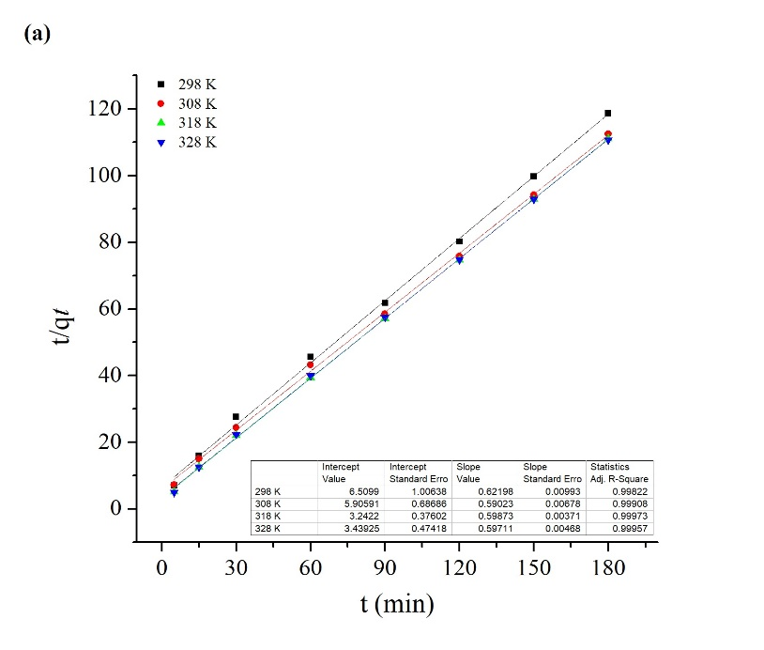 | 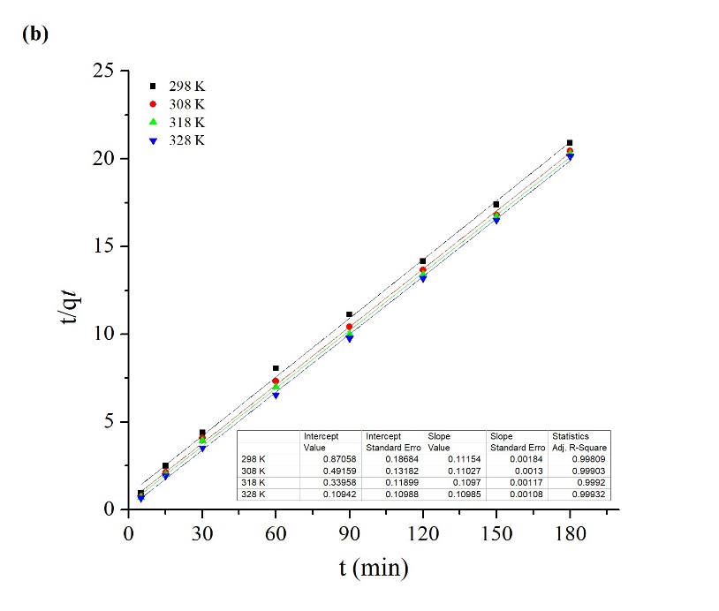
Figure A.3. Fitting curves of (a,b) pseudo-second-order model for IC and MG adsorption

∗ Corresponding author. Tel: +902623032030. Fax: +902623032003. E-mail address: denizbingol1@gmail.com, deniz.bingol@kocaeli.edu.tr (D. Bingöl)

