**Supplementary Materials**

Electrocatalytic activity of cobalt tris(4-nitrophenyl)corrole for hydrogen evolution from water

HAI CHEN, DONG-LAN HUANG, MD SAHADAT HOSSAIN, GUO-TIAN LUO* and HAI-YANG LIU*

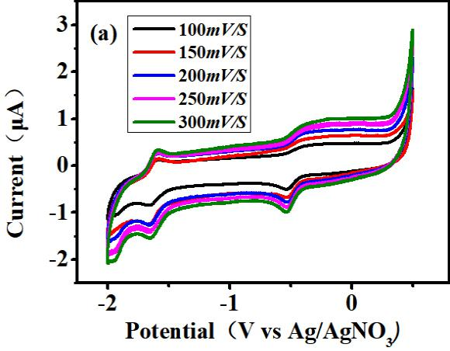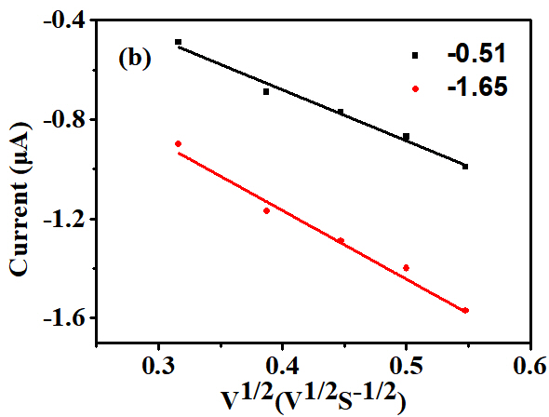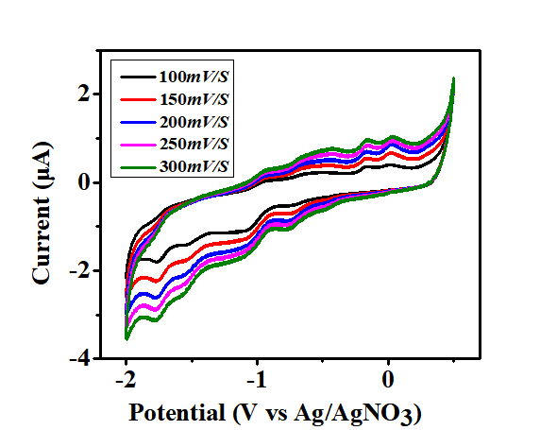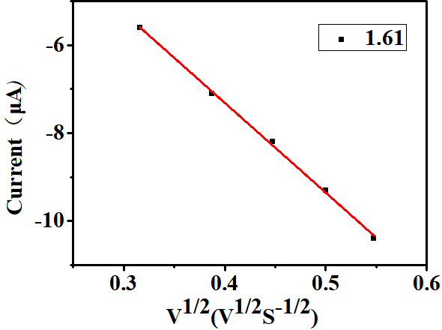

**Figure S1.** Scan rate dependence of precatalytic waves for 2.42 μM solution of complexes **1** and **2** (0.1 M n-Bu4N]ClO4) at scan rates from 100 to 300 mV/s.

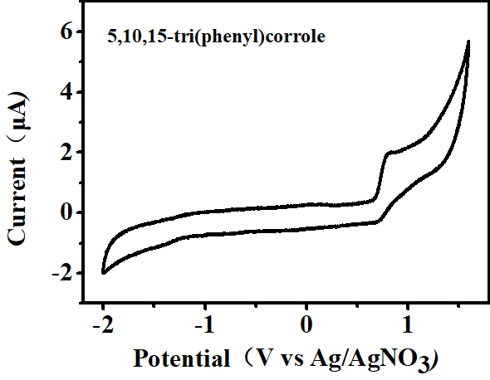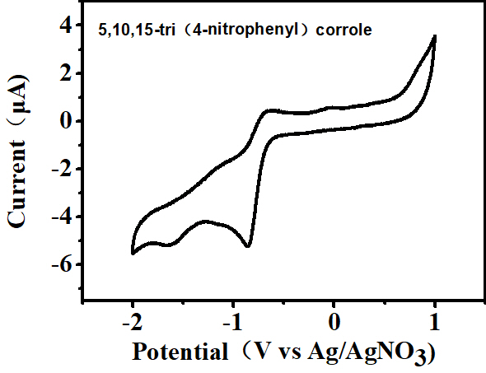

**Figure S2.** CV of ligand (2.56 μM). GC working electrode (1 mm diameter), Pt counter electrode, Ag/AgNO3 reference electrode, scan rate 100 mV/s.

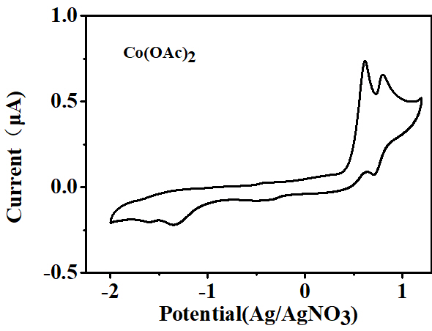

**Figure S3.** CV of Co(OAc)2 (2.56 μM). GC working electrode (1 mm diameter), Pt counter electrode, Ag/AgNO3 reference electrode, scan rate 100 mV/s.

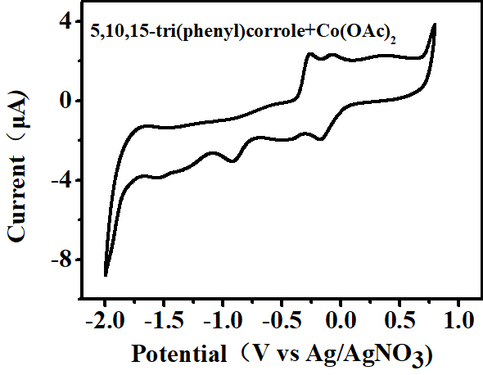

**Figure S4.** CV of the mixture of compound **1** (2.56 μM) and Co(Ac)2 (2.56 μM). GC working electrode (1 mm diameter), Pt counter electrode, Ag/AgNO3 reference electrode, scan rate 100 mV/s.

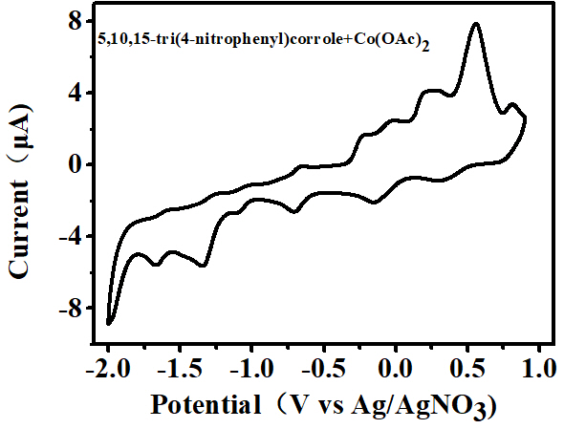

**Figure S5.** CV of the mixture of compound **2** (2.56 μM) and Co(Ac)2 (2.56 μM). GC working electrode (1 mm diameter), Pt counter electrode, Ag/AgNO3 reference electrode, scan rate 100 mV/s.

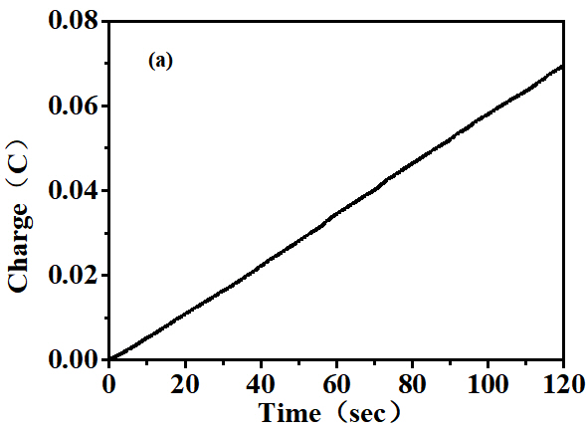 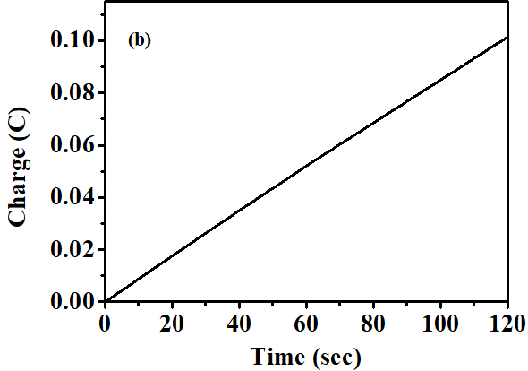

**Figure S6.** Complexes **1** (a) and **2** (b) charge buildup of 0.25 M buffer at pH 7.0 under -1.45 V *vs.* Ag/AgCl.

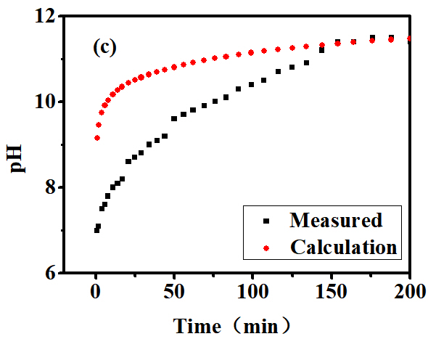 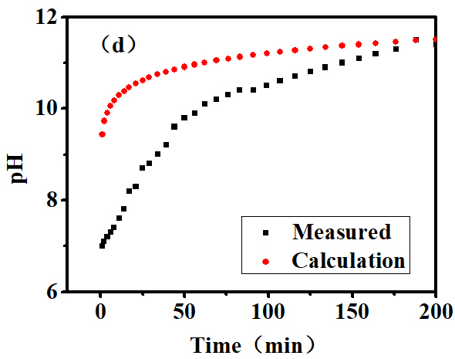

**Figure S7.** Complexes **1** (c) and **2** (d) measured (black) and calculated (red) pH changes assuming 90.7% and 91.8% Faradic efficiency of complexes **1** and **2** during electrolysis. The theoretical pH change over time can be calculated by the equation of  where I = current (A), t = time (s), F = Faraday constant (96485 C/mol), V = solution volume (0.04 L).

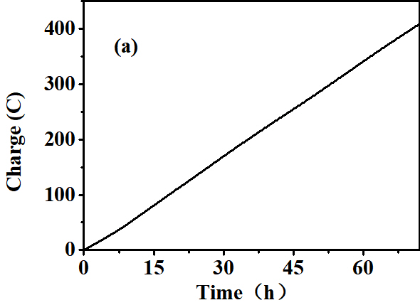 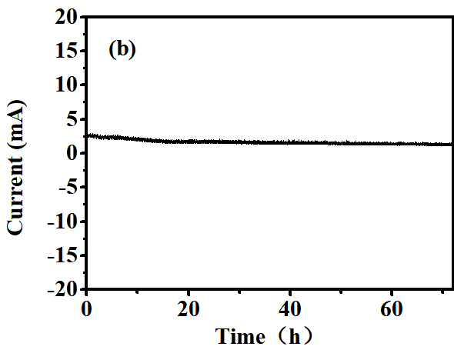

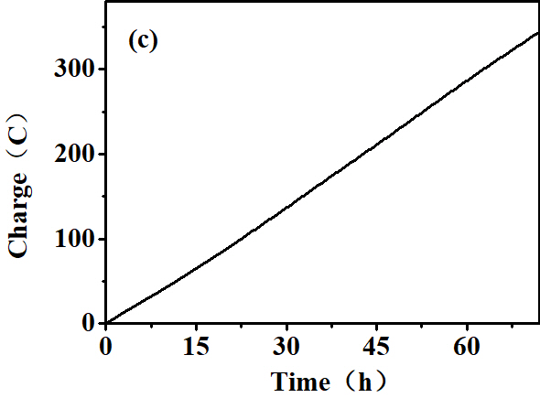 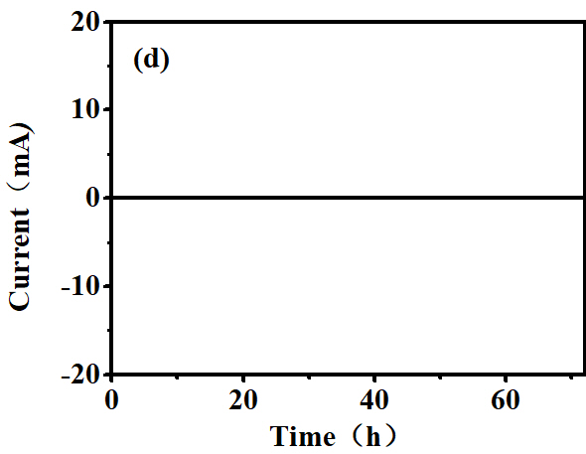

**Figure S8.** Complexes **1** (a) and **2** (c) extended controlled potential electrolysis of each 0.01 μM **1**, **2** and **3** showing charge buildup versus time with an applied potential of -1.45 V *vs.* Ag/AgCl. Complexes **1** (b) and **2** (d) catalytic current obtained upon controlled potential electrolysis with each 0.01 μM **1** and 2. Conditions: 0.25 M buffer solution, pH 7.0, GC working electrode (1.25 cm2), Ag/AgCl in saturated KCl reference electrode, Pt wire counter electrode, 72 h.

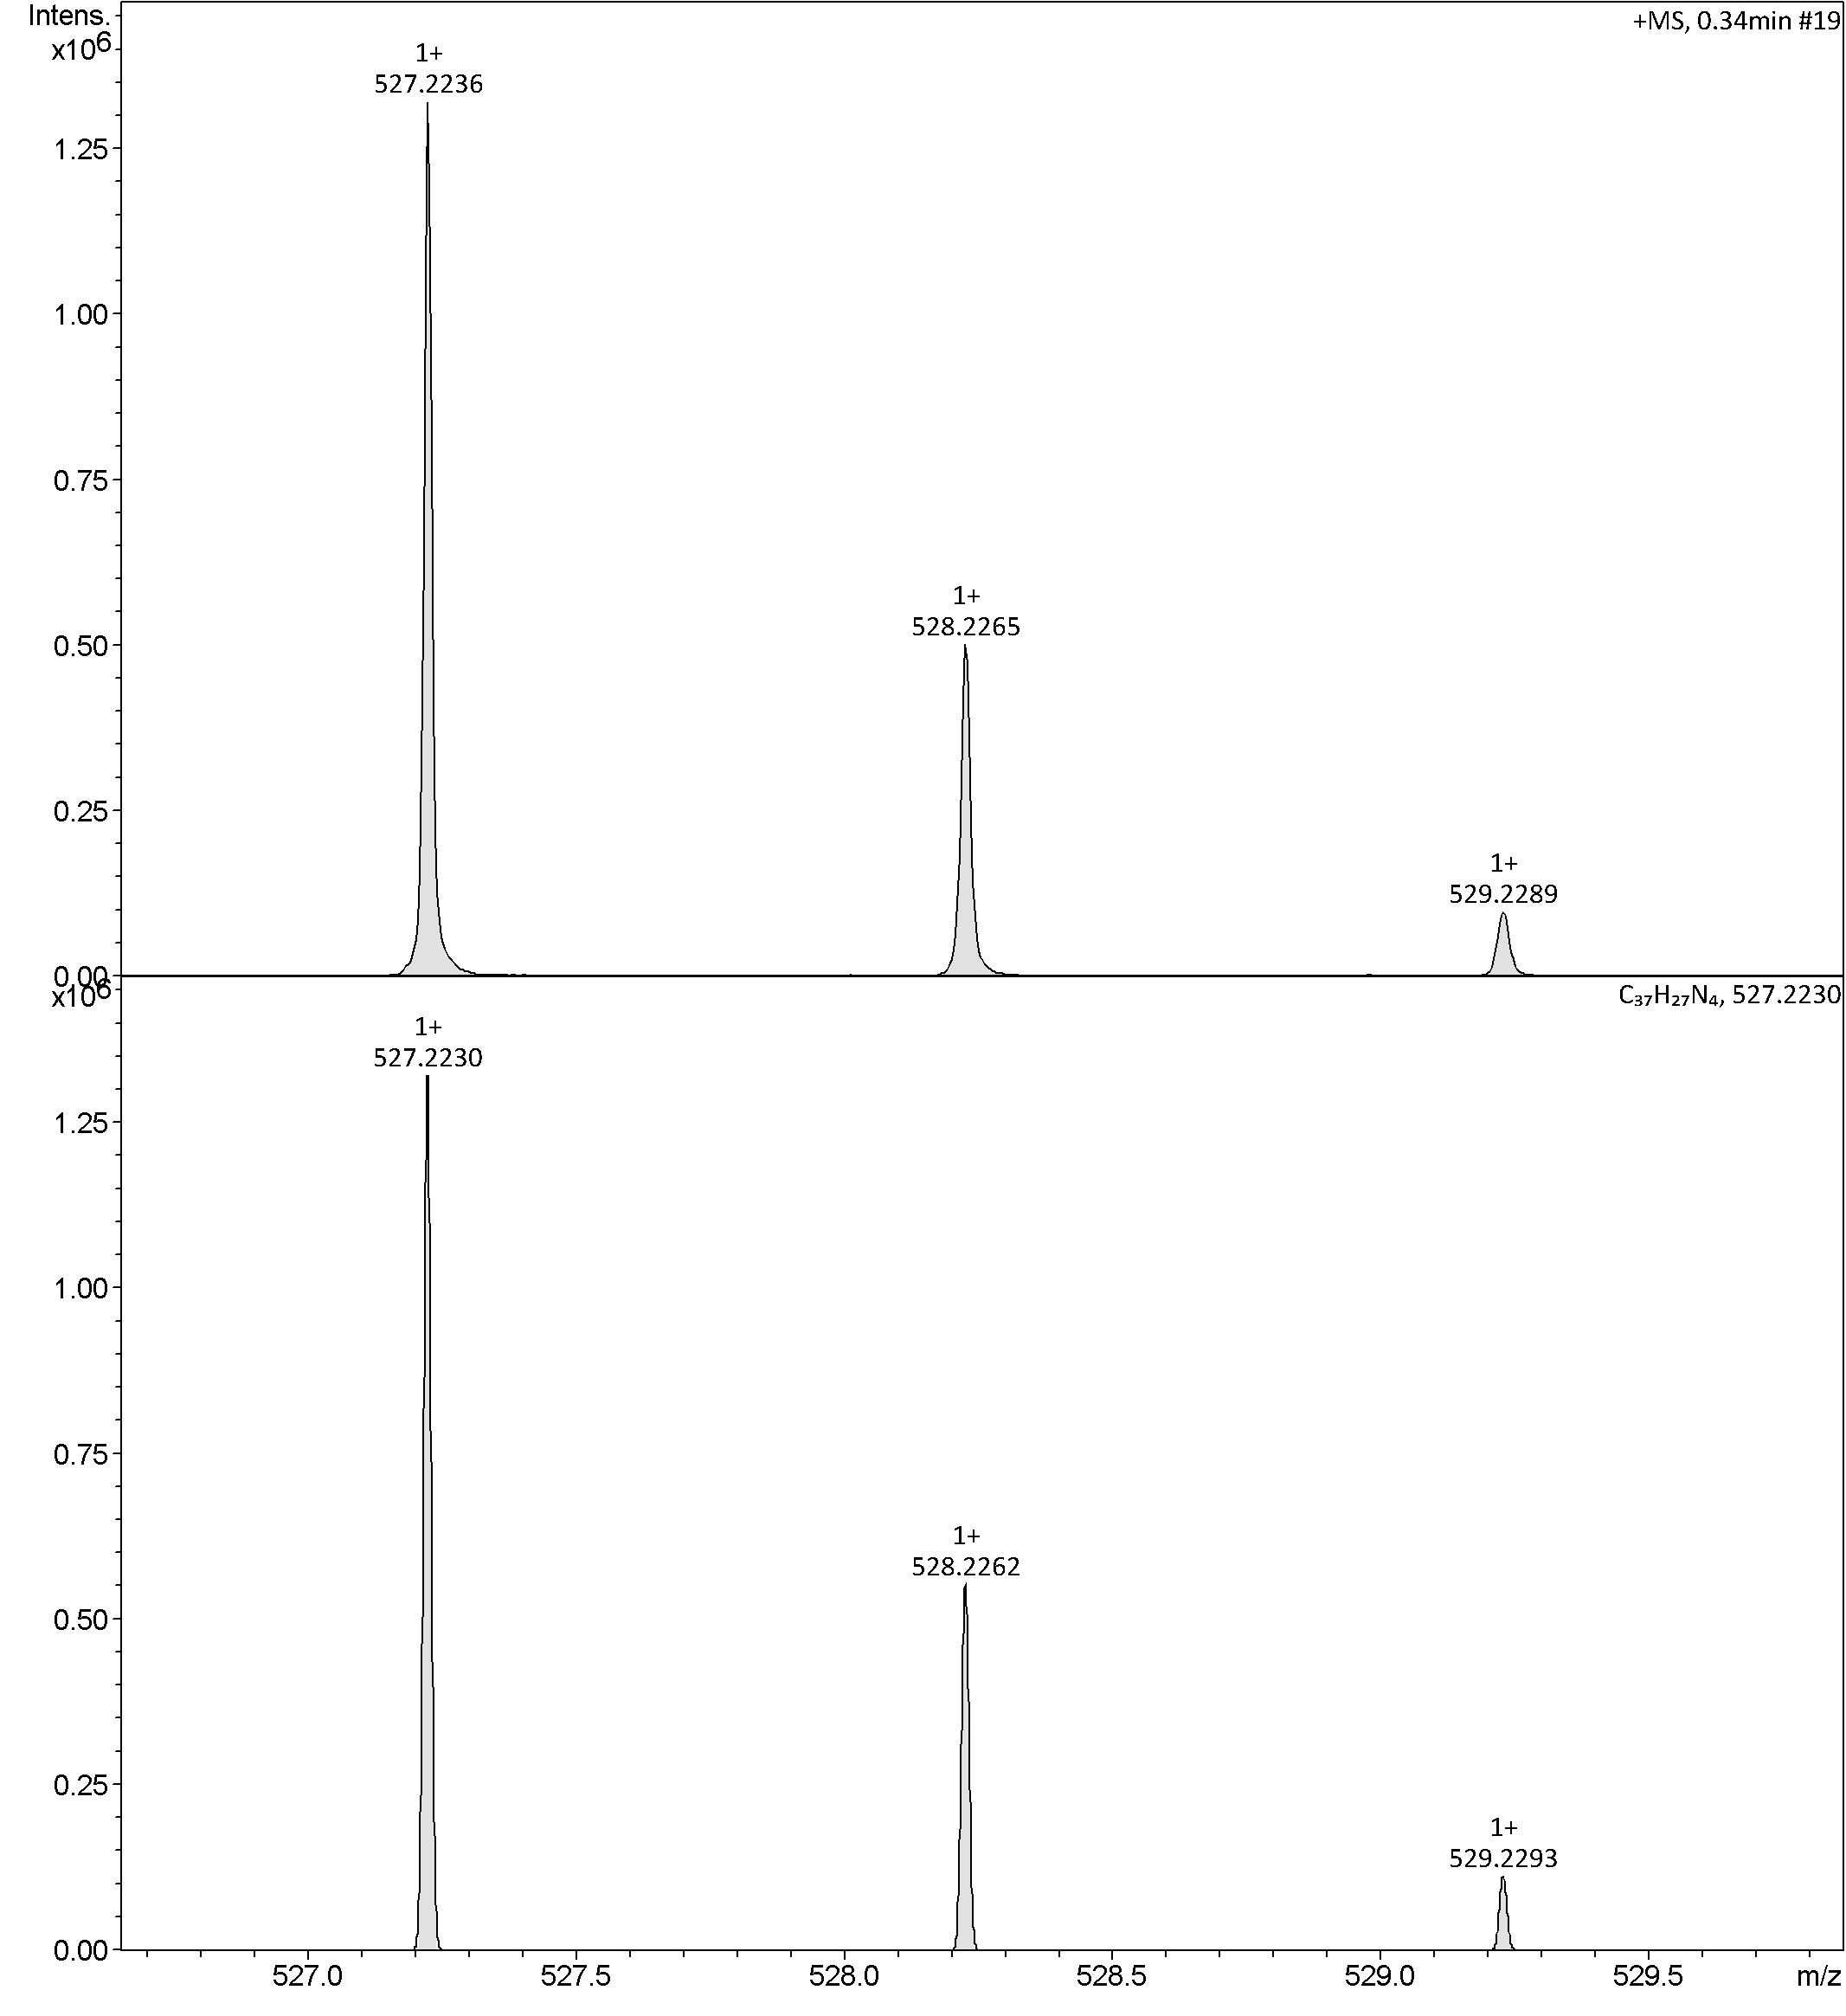

**Figure S9.** HR-MS spectra of 5,10,15-tris(phenyl)corrole.

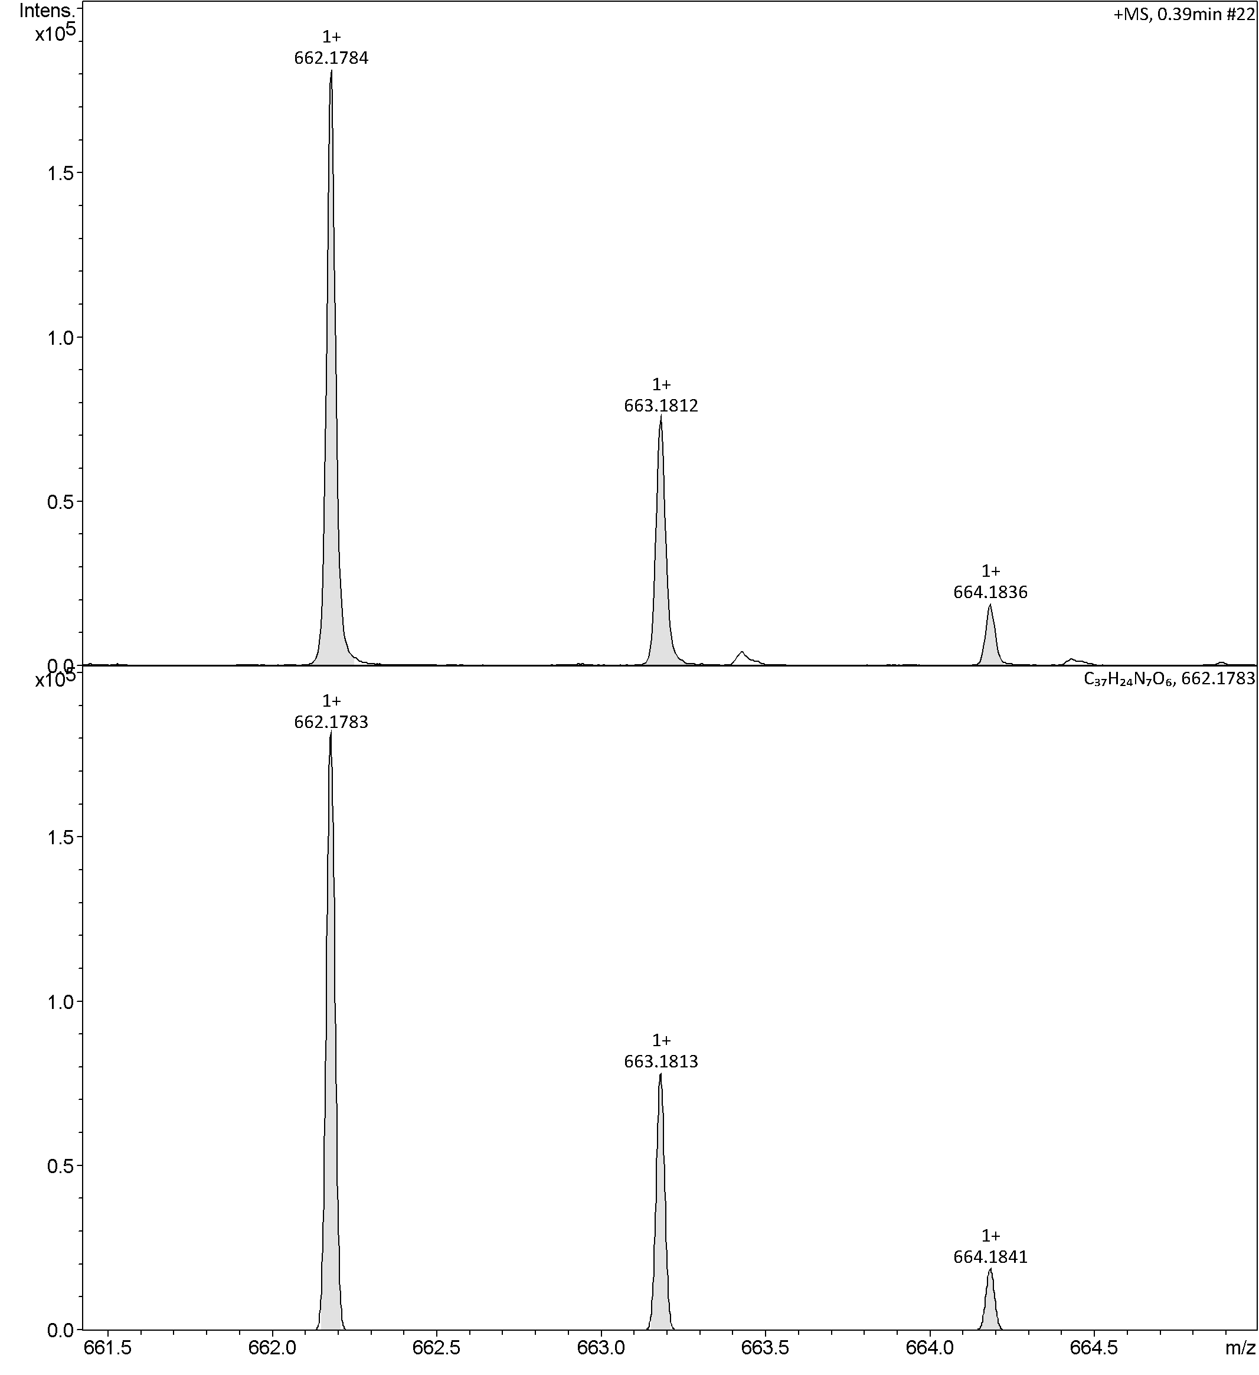

**Figure S10.** HRMS spectra of 5,10,15-tris(4-nitrophenyl)corrole.

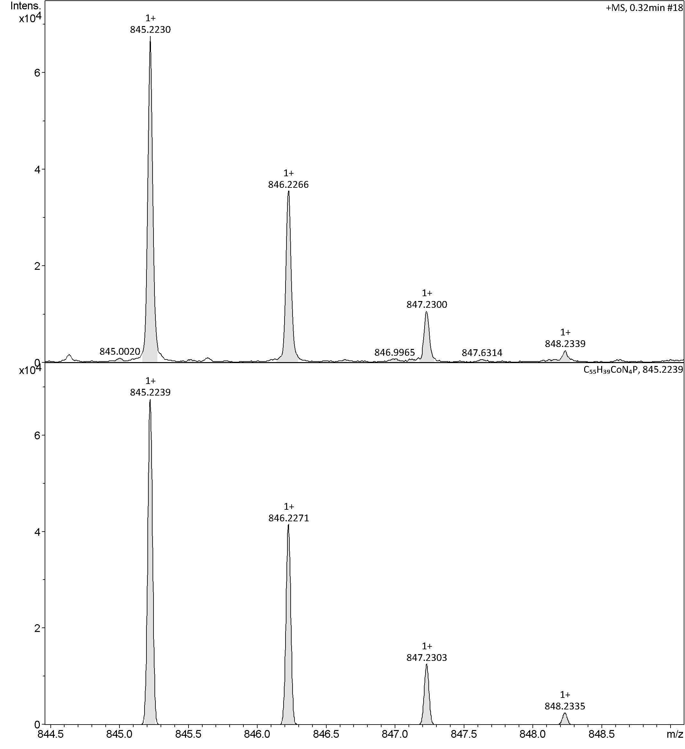

**Figure S11.** HRMS spectra of complex **1**.

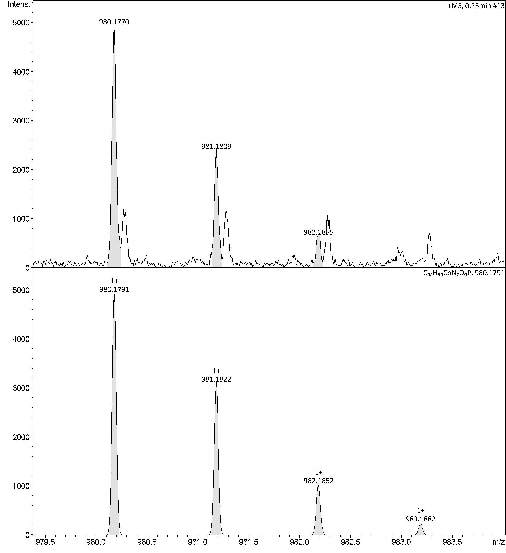

**Figure S12.** HRMS spectra of complex **2**.



**Eq. S1.** The calculation of TOF complex **1** (DMF)



**Eq. S2.** The calculation of TOF complex **2** (DMF)



**Eq. S3.** The calculation of TOF complex **1** (buffer, pH 7.0)



**Eq. S4.** The calculation of TOF complex **2** (buffer, pH 7.0)

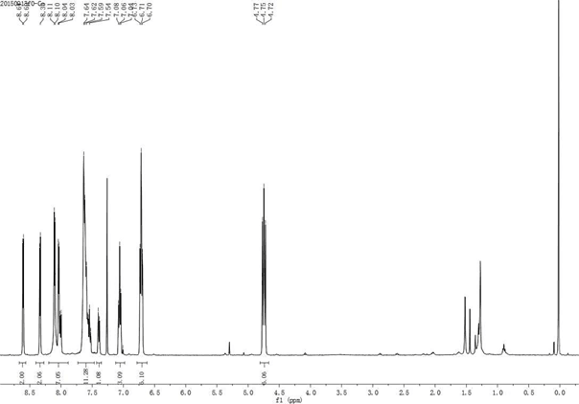

**Figure S13.** 1H NMR spectra of complex **1**.

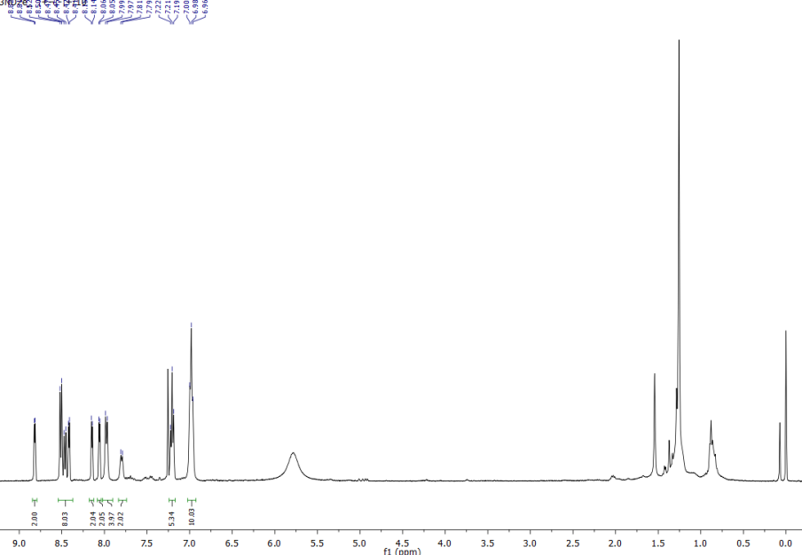

**Figure S14.** 1H NMR spectra of complex **2**.