Synthesis, characterization and biological activities evaluation of novel sulfanyl derivatives.
Kamuran Saraçª and Cahit Orek^{b}
ªDepartment of Chemistry, Faculty of Arts and Science, Bitlis Eren University, 13000 Bitlis, Turkey.
^{b}Department of Genetics and Bioengineering, Faculty of Engineering and Architecture, Kastamonu University, 37000, Kastamonu, Turkey.
Email: ksarac@beu.edu.tr
Supplemental Materials

Table S 1 Antibacterial activities of synthesized compounds (μg mL⁻¹ minimum inhibition concentration values)
 | Listeria monocytogenes | B.subtilis | S.typhimurium | Proteus vulgaris
6a | 256 | 256 | 512 | 1024
6b | 256 | 128 | 512 | 512
6c | 64 | 128 | 128 | 64
6d | 128 | 512 | 256 | 128
Ampisilin | 2 | 2 | 2 | 2

Table S 2 DPPH radical scavenging activities of the synthesized compounds (%)

Compounds and Standards | DPPH % Inhibition  50 µg/mL | DPPH % Inhibition  100 µg/mL | DPPH % Inhibition  250 µg/mL
6a | 47.2 ± 0.02 | 54.23 ± 0.12 | 53.56 ± 1.23
6b | 53.3 ± 0.01 | 52.1 ± 0.1 | 56.2 ± 1.23
6c | 60. 8 ± 1.1 | 62.3 ± 2.12 | 71.3 ± 3.09
6d | 55.43 ± 3.19 | 60.48 ± 2.01 | 63.1 ± 0.12
α-tocopherol | 74.3 ± 0.1 | 72.2 ± 0.11 | 77.2 ± 0.02
BHT | 56.4 ± 0.12 | 64.6 ± 1.03 | 68.6 ± 0.01

Figure S 1: FT-IR spectrum of 4a

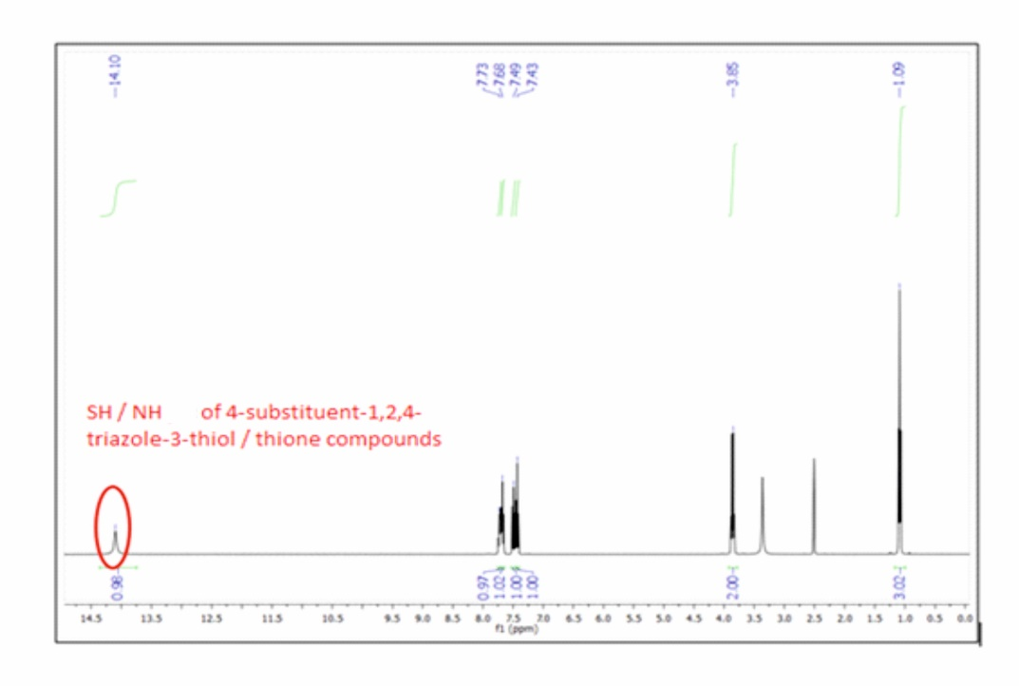

Figure S 2: ¹H NMR spectrum of 4a

Figure S 3: ¹³C NMR spectrum of 4a

Figure S 4: FT-IR spectrum of 4b

Figure S 5: ¹H NMR spectrum of 4b

Figure S 6: ¹³C NMR spectrum of 4b

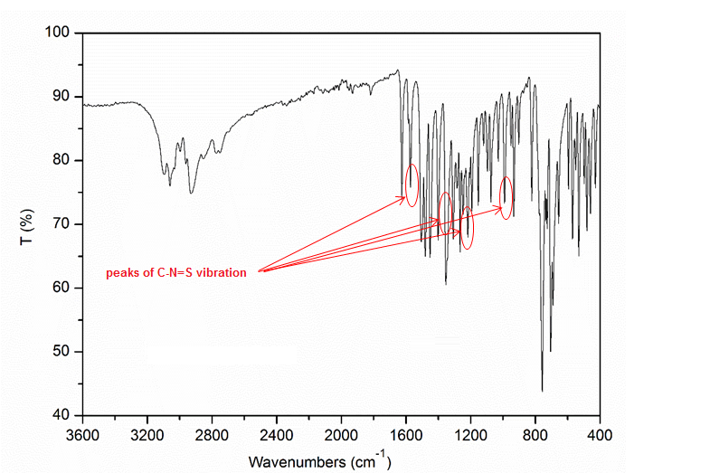

Figure S 7: FT-IR spectrum of 4c

Figure S 8: ¹H NMR spectrum of 4c

Figure S 9: ¹³C NMR spectrum of 4c

Figure S 10: FT-IR spectrum of 4d

Figure S 11: ¹H NMR spectrum of 4d

Figure S 12: ¹³C NMR spectrum of 4d

Figure S 13: FT-IR spectrum of 6a

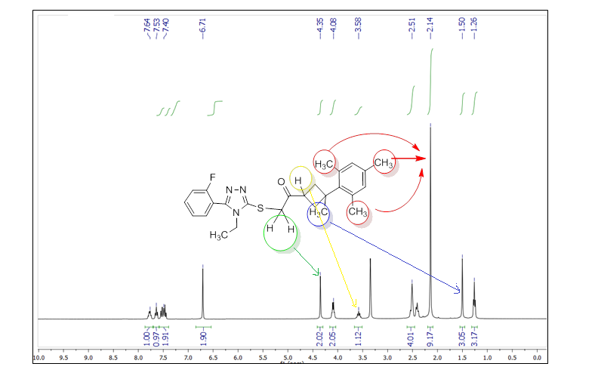
Figure S 14: ¹ H NMR spectrum of 6a

Figure S 15: ¹³C NMR spectrum of 6a

Figure S 16: FT-IR spectrum of 6b

Figure S 17: ¹H NMR spectrum of 6b

Figure S 18: ¹³C NMR spectrum of 6b

Figure S 19: FT-IR spectrum of 6c

Figure S 20: 1H NMR spectrum of 6c

Figure S 21: ¹³C NMR spectrum of 6c

Figure S 22: FT-IR spectrum of 6d

Figure S 23: 1H NMR spectrum of 6d

Figure S 24: ¹³C NMR spectrum of 6d

