Supporting information

Effect of RM based-passivator for the remediation of two kinds of Cd polluted paddy soils and mechanism of Cd(II) adsorption

Hui Li^{a,b}, Yan Liu^{b}, Zirui Luoª, Yaoyu Zhou^{a*}, Dongmei Houª, Qiming Maoª, Dan Zhiª, Jiachao Zhangª, Yuan Yangª , Lin Luo^{a#}

ª College of Resources and Environment, Hunan Agriculture University, Changsha 410128, China

^{b} Hunan Modern Environment Technology Co., LTD, Changsha 410000, China

∗ Corresponding author: zhouyy@hunau.edu.cn

# Corresponding author: luolinwei0@163.com

Table S1 Effects of passivator on rice growth in two Cd-polluted soils
Treatments | Plant height /cm |  |  |  | Leaf area /cm² |  |  | Chlorophyll/SPAD
 | Tillering | Ripening |  | Tillering |  | Ripening | Tillering |  | Ripening
CK | 56.63±1.01a | 88.47±1.20a | 29.27±5.702a |  |  | 45.51±0.16a | 42.87±1.70a |  | 42.28±1.45a
T1 | 54.09±0.60ab | 87.87±2.61a | 27.66±3.17ab |  |  | 40.08±0.14ab | 44.15±0.92a |  | 43.29±0.83a
T2 | 50.96±3.36ab | 86.23±1.29a | 23.65±0.96ab |  |  | 41.61±0.16a | 42.74±0.98a |  | 42.17±0.47a
T3 | 52.00±3.80a | 82.87±0.27a | 19.67±0.37ab |  |  | 38.93±0.11b | 43.20±0.31a |  | 41.38±1.08a
T4 | 48.38±0.62ab | 85.63±0.71a | 28.03±0.78a |  |  | 43.81±0.56ab | 41.43±0.72a |  | 40.23±0.36a
T5 | 44.00±0.89b | 84.73±1.34a | 12.86±0.19b |  |  | 39.23±0.14b | 39.89±0.64a |  | 39.52±0.44a
CK’ | 44.54±1.65a | 86.10±1.61a | 18.89±0.38a |  |  | 40.16±0.11a | 34.65±2.80a |  | 42.66±0.20a
T1’ | 44.21±0.40a | 81.37±3.75ab | 18.36±0.23a |  |  | 33.76±0.57a | 34.09±2.97a |  | 41.66±1.93a
T2’ | 43.17±0.30a | 75.73±0.63ab | 15.76±0.43a |  |  | 46.45±0.36a | 27.18±3.49a |  | 41.70±1.38a
T3’ | 40.59±1.14ab | 80.10±1.54ab | 21.10±0.67a |  |  | 43.41±0.50a | 30.00±2.79a |  | 40.77±2.93a
T4’ | 40.92±1.31ab | 80.80±2.42ab | 19.89±0.48a |  |  | 36.29±0.76a | 25.14±2.78a |  | 39.37±0.43a
T5’ | 37.09±1.31b | 74.87±2.48b | 29.27±5.702a |  |  | 45.51±0.16a | 21.76±0.96a |  | 38.96±0.33a
Note: Different letters above columns indicate significant difference at P < 0.05 between treatments at the stage. CK: CS-0; T1:CS-0.1%; T2:CS-0.3%; T3:CS-0.5%; T4:CS-0.7%; T5:CS-0.5%; CK’:HY-0; T1’:HY-0.2%; T2’:HY-0.4%; T3’:HY-0.6%; T4’:HY-0.8%; T5’:HY-1.0%.

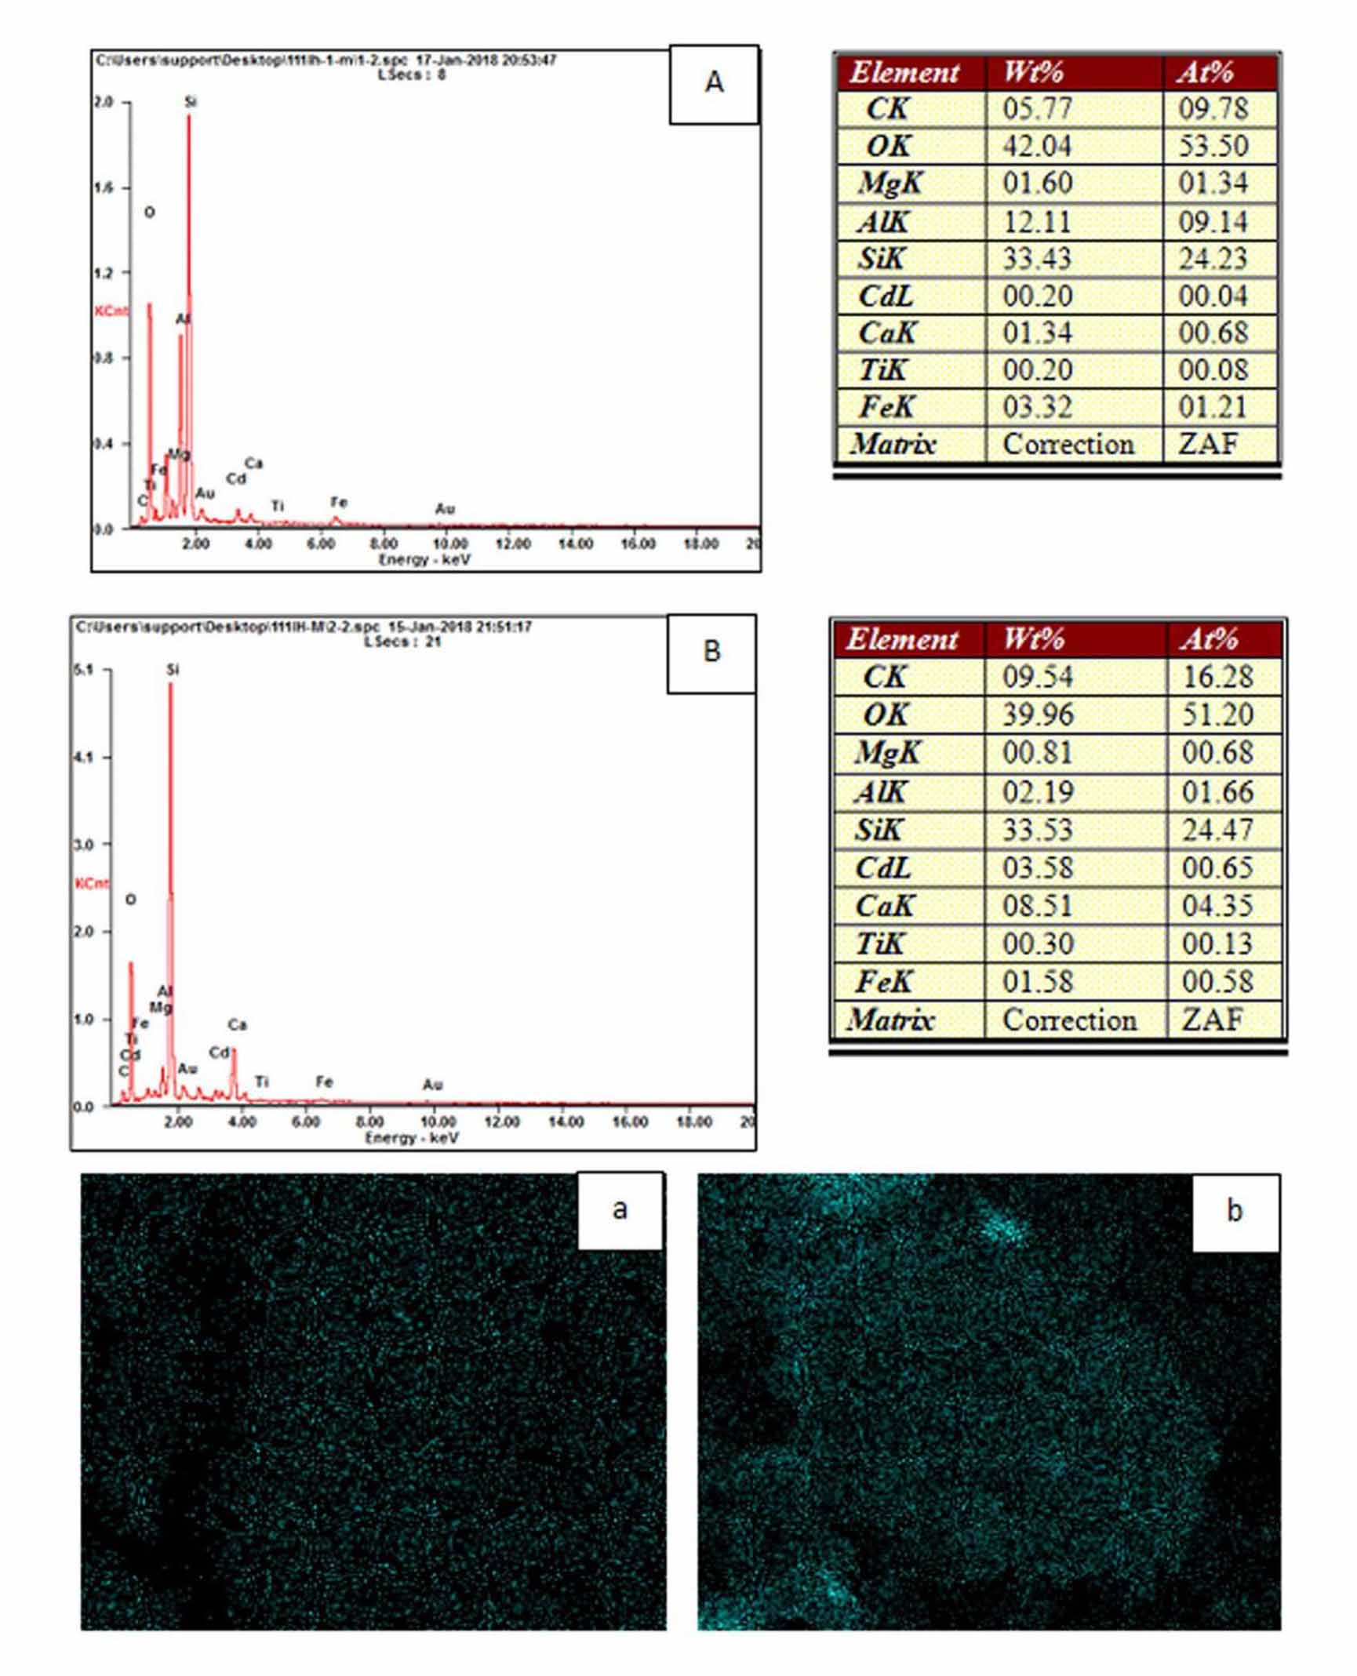
Fig. S1 Analysis of EDX and element mapping (Cd) of passivator before and after adsorption of Cd(Ⅱ)
A, a：Passivator before adsorption; B, b: Passivator after adsorption

