Supplemental file

- Preparation of acid-, alkali-, and salt-modified materials
Aqueous solutions of HCl, NaOH, NaCl, LiCl, MgCl₂, AlCl₃, and LaCl₃ with the same concentration (1 M) were prepared. MMT (10 g per serving) was dispersed in 400 mL of the above solutions in wide-mouth bottles. After ultrasonication for 5 min, each suspension was gently stirred with a magnetic stirrer for 24 h at room temperature. Each mixture was then centrifuged for 10 min at a centrifugal force of 5000 rpm and the clear supernatant fractions were discarded. The solid residues were thoroughly washed with deionized water twice and separated under the same condition (5000 rpm for 10 min). After drying in an oven at 70 °C for 24 h, the obtained solid materials were ground to powders that could pass through a 200-mesh nylon screen and then kept in sealed glass bottles for later use.
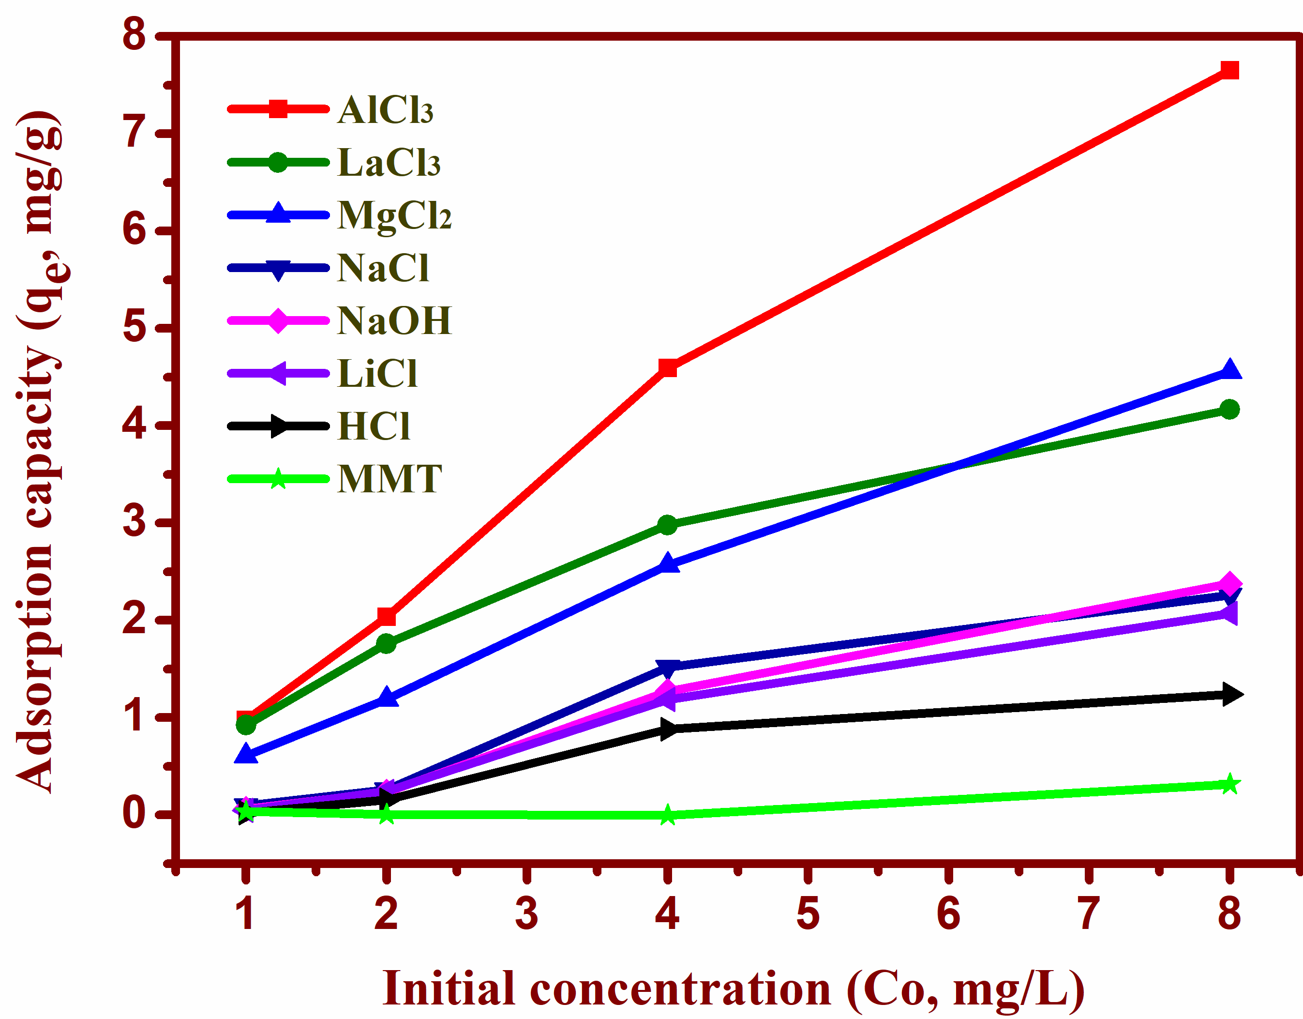
Fig. S1. Phosphate adsorption capacity of MMT modified with acid, alkali, and different cations.
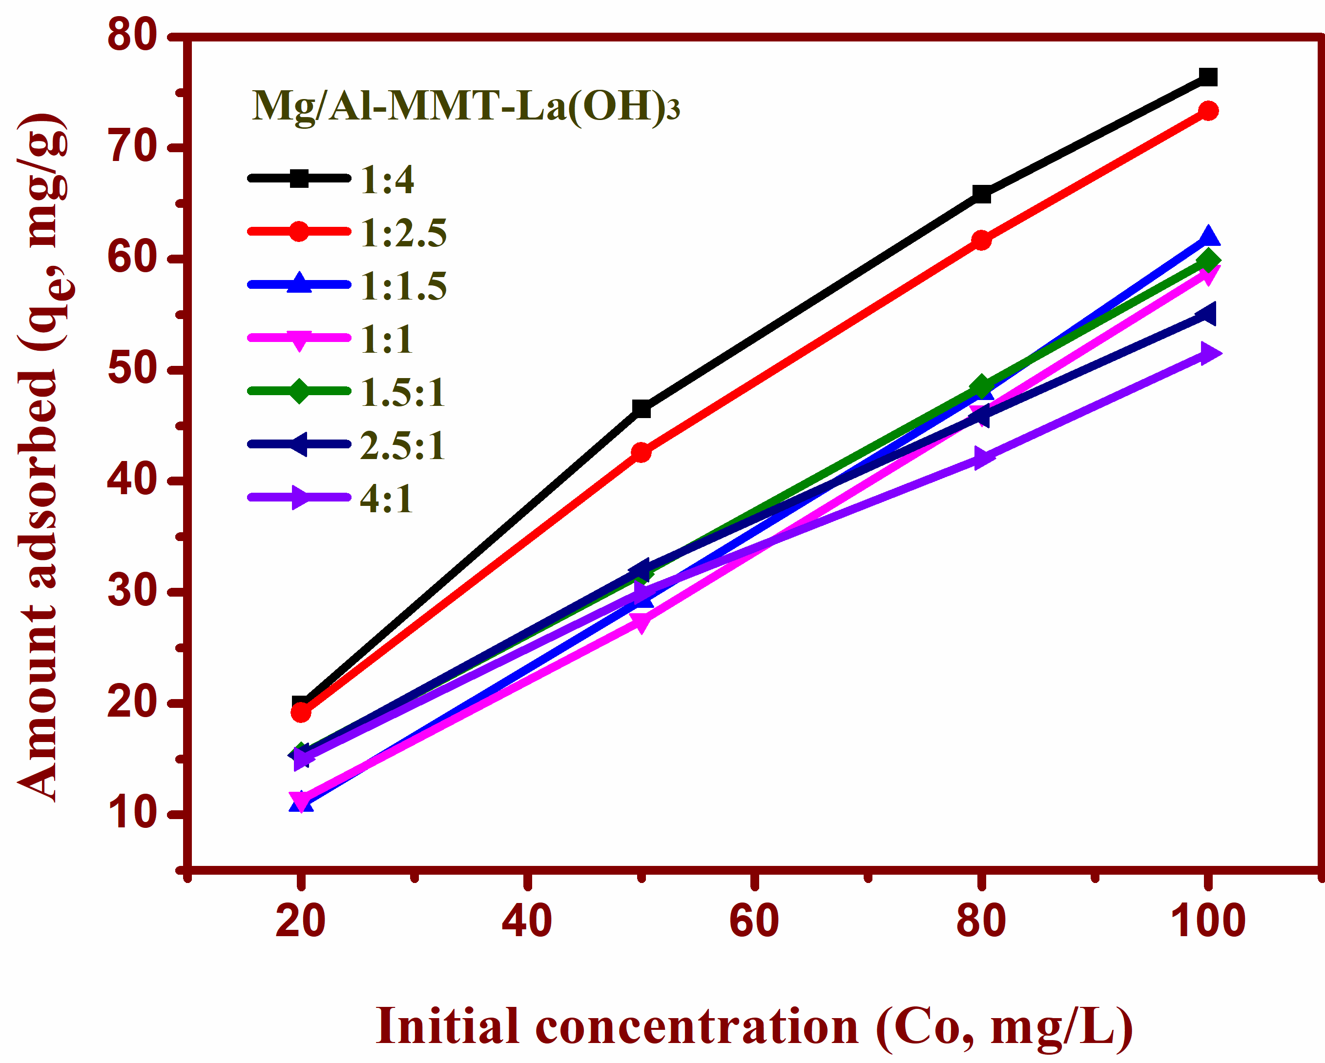
Fig. S2. Phosphate adsorption capacity of Mg/Al-MMT-La(OH)₃ at different molar ratios (Mg/Al) of 4:1, 2.5:1, 1.5:1, 1:1, 1:1.5, 1:2.5, and 1:4.
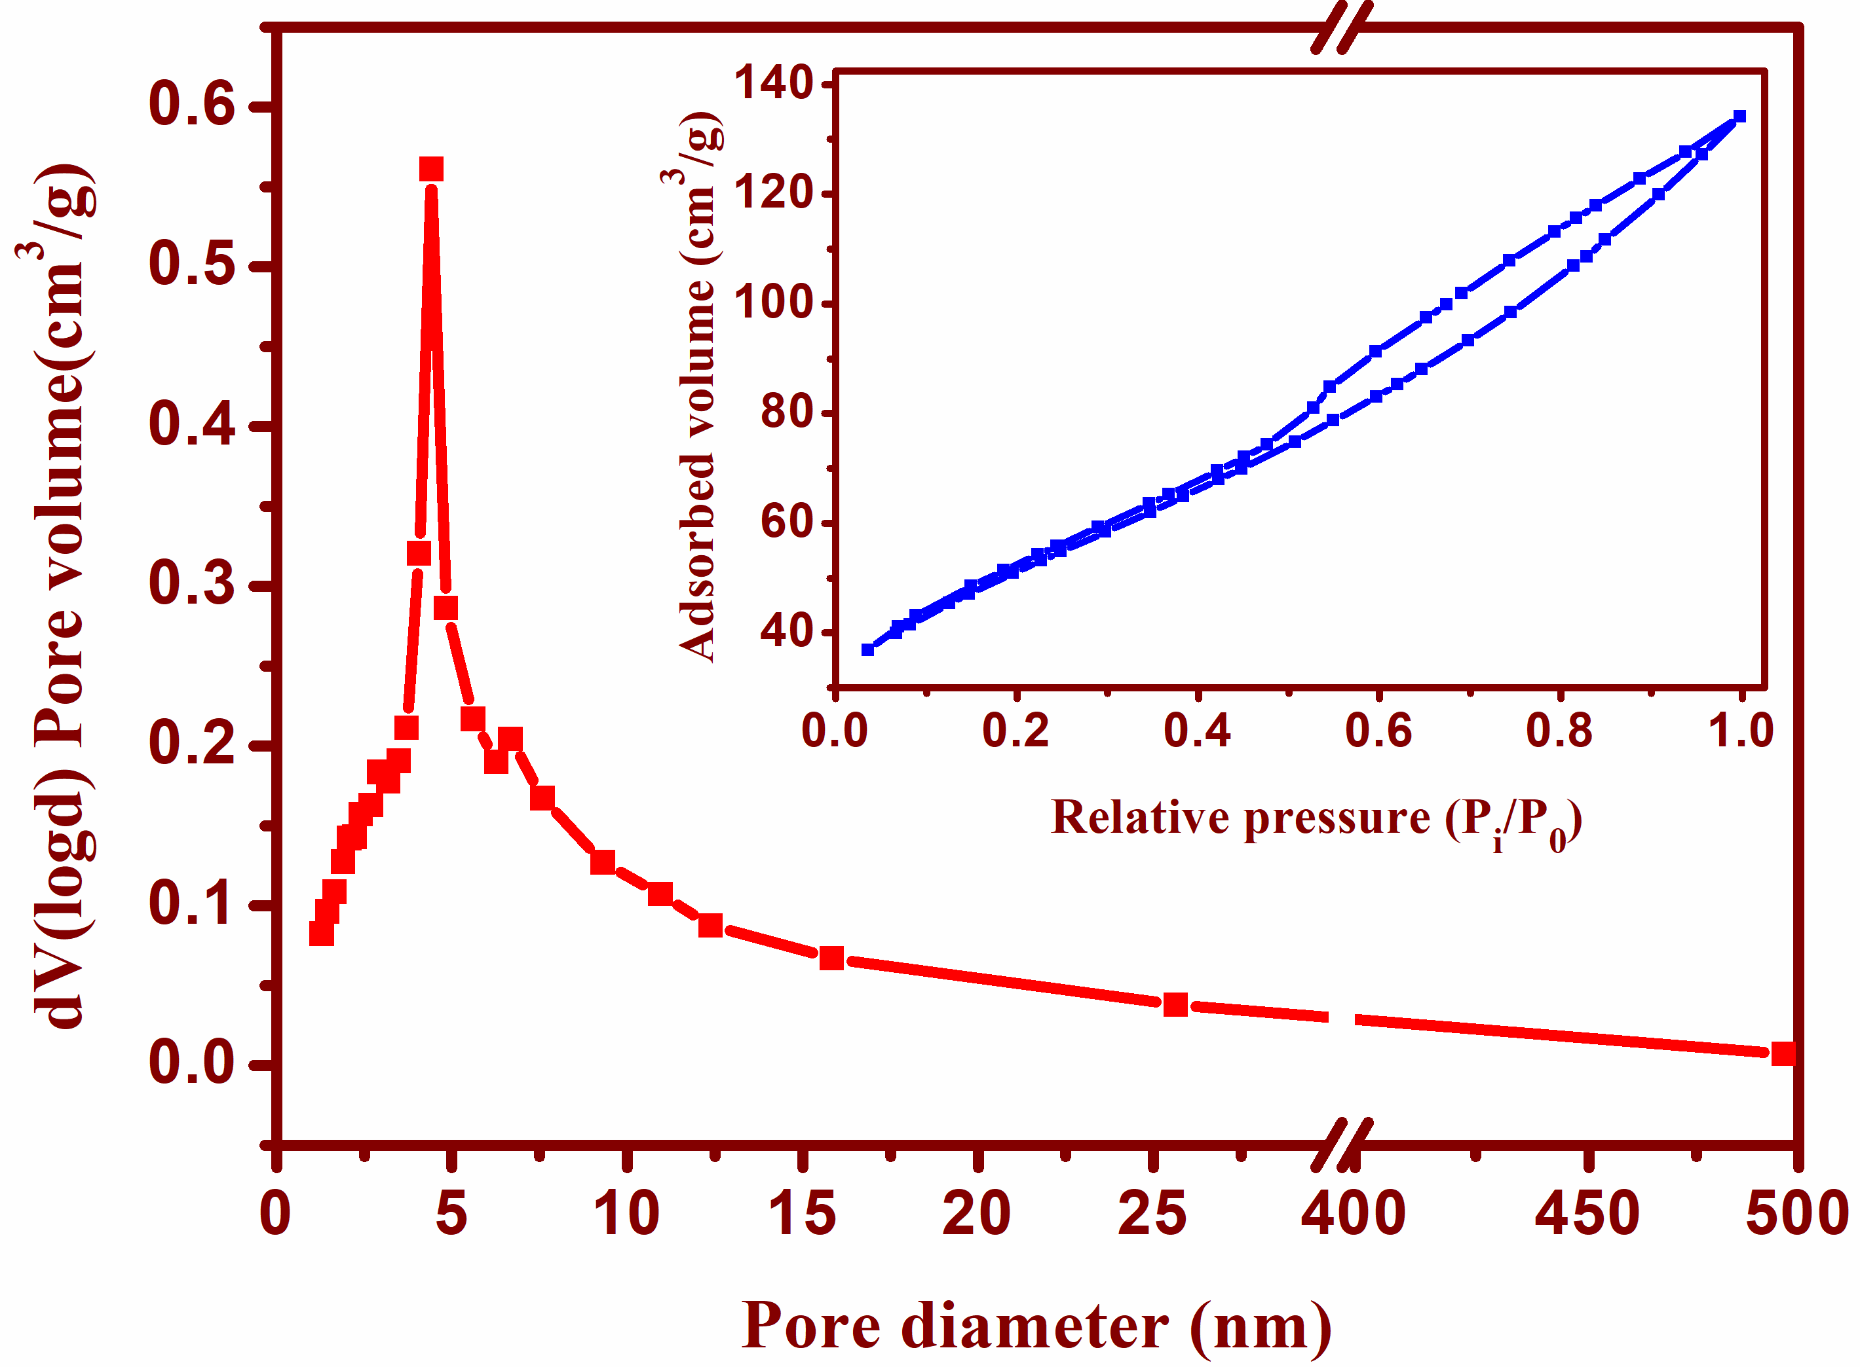
Fig. S3. BJH desorption pore volume distribution and nitrogen adsorption-desorption isotherm of raw MMT.
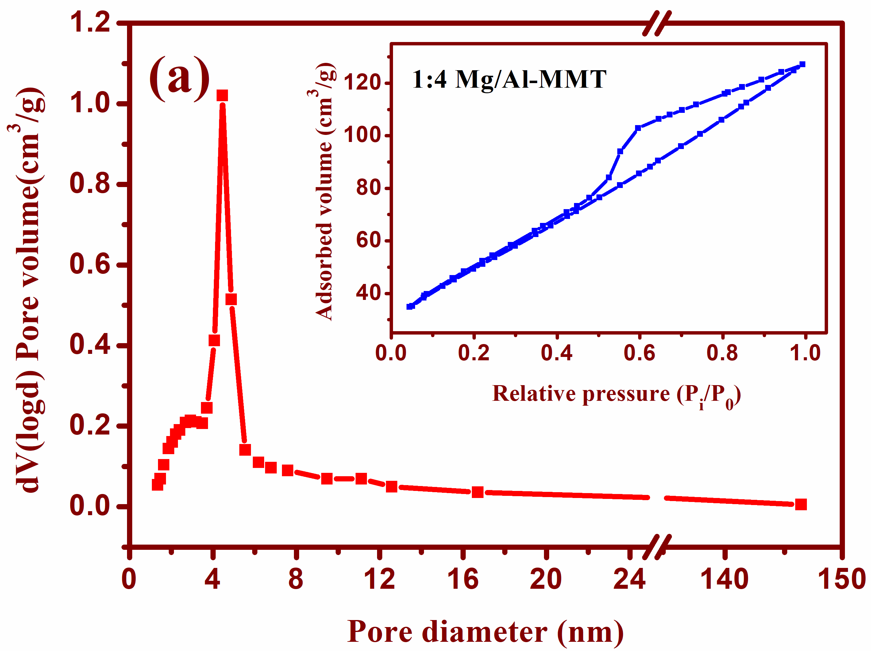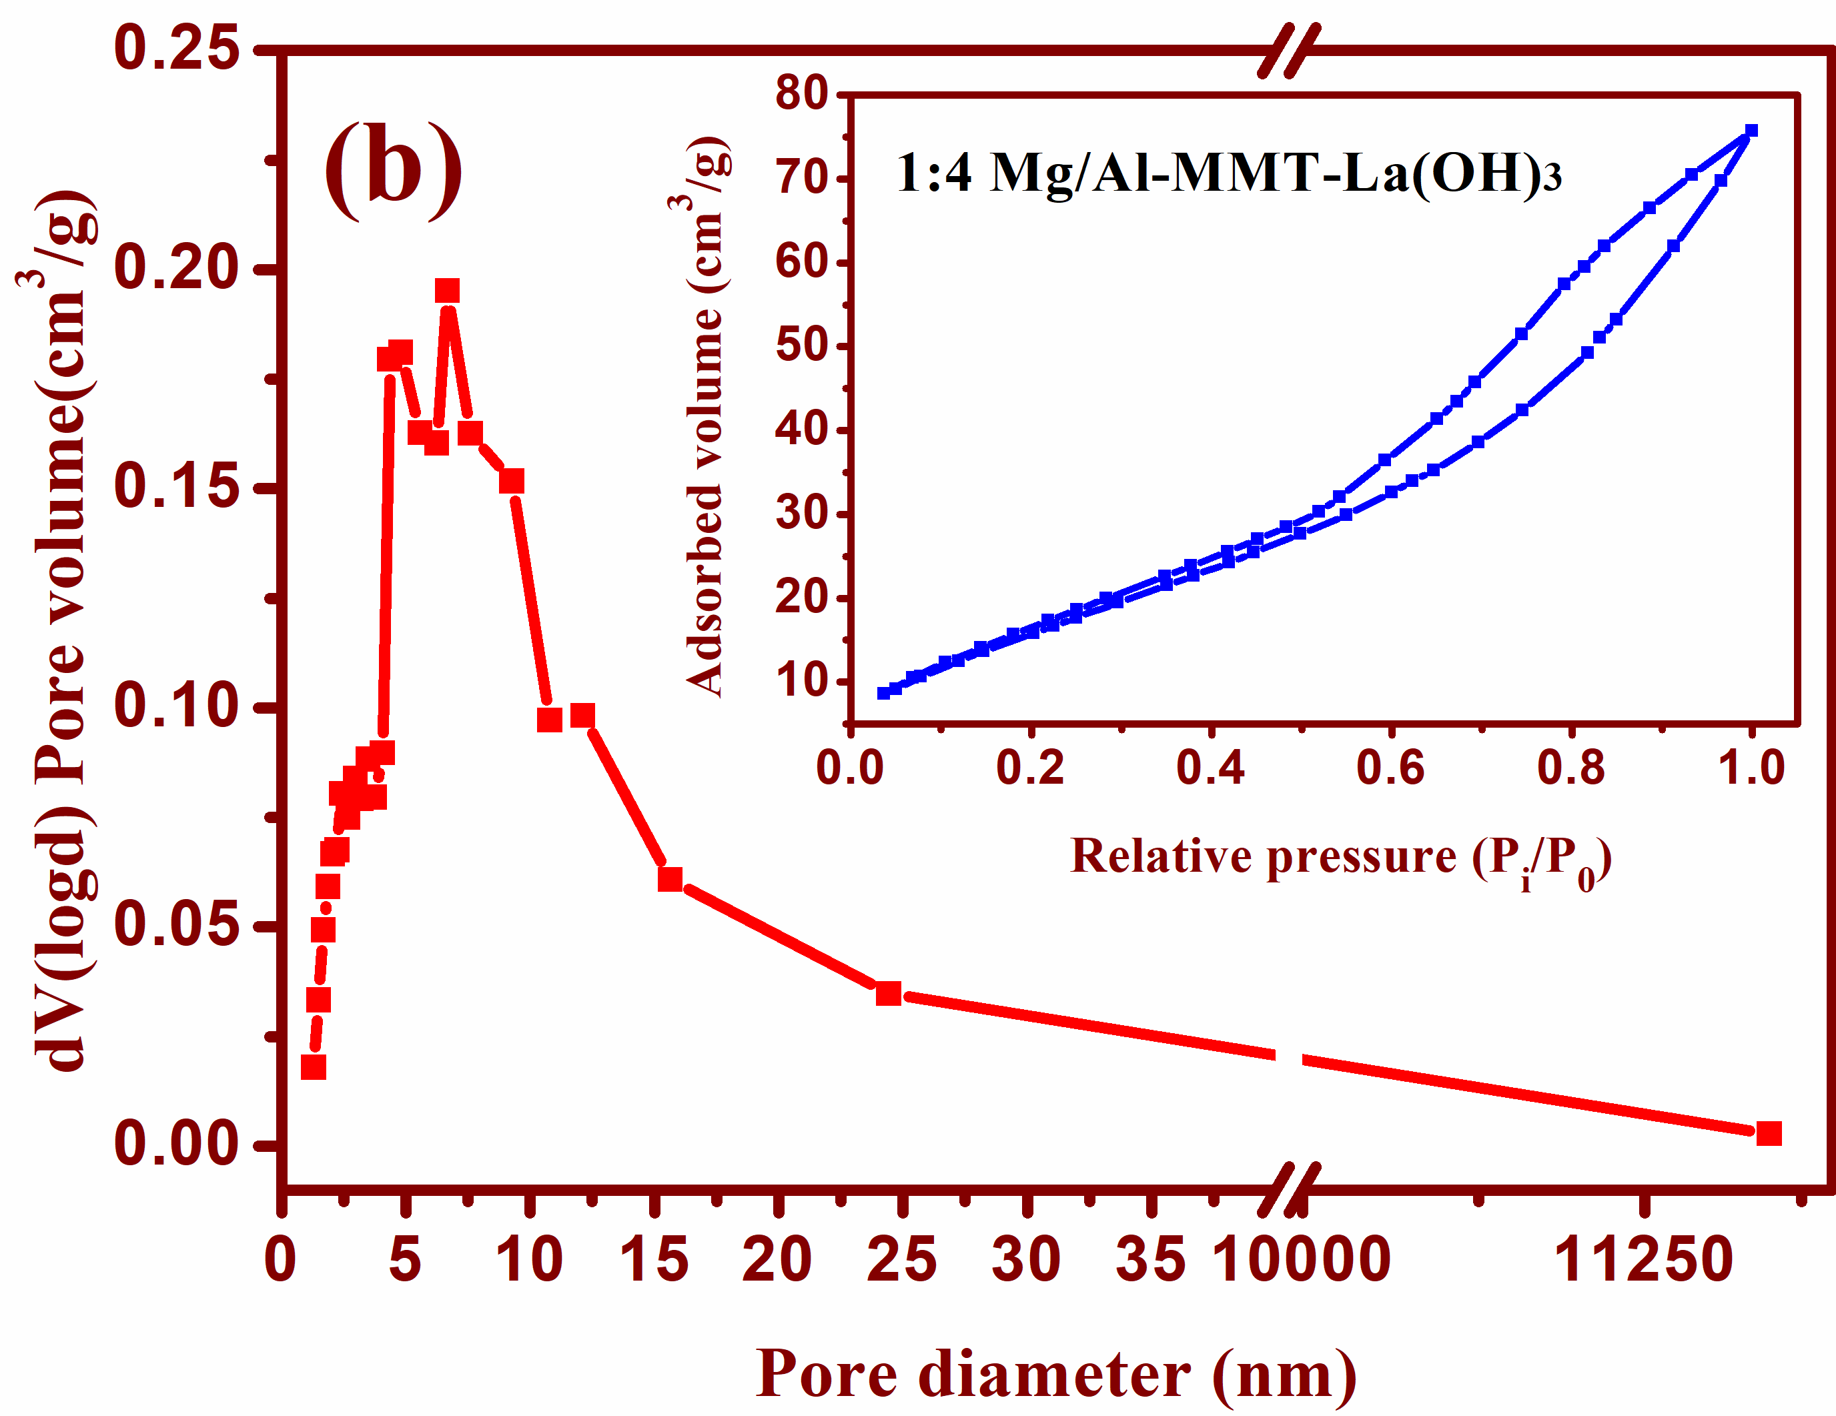
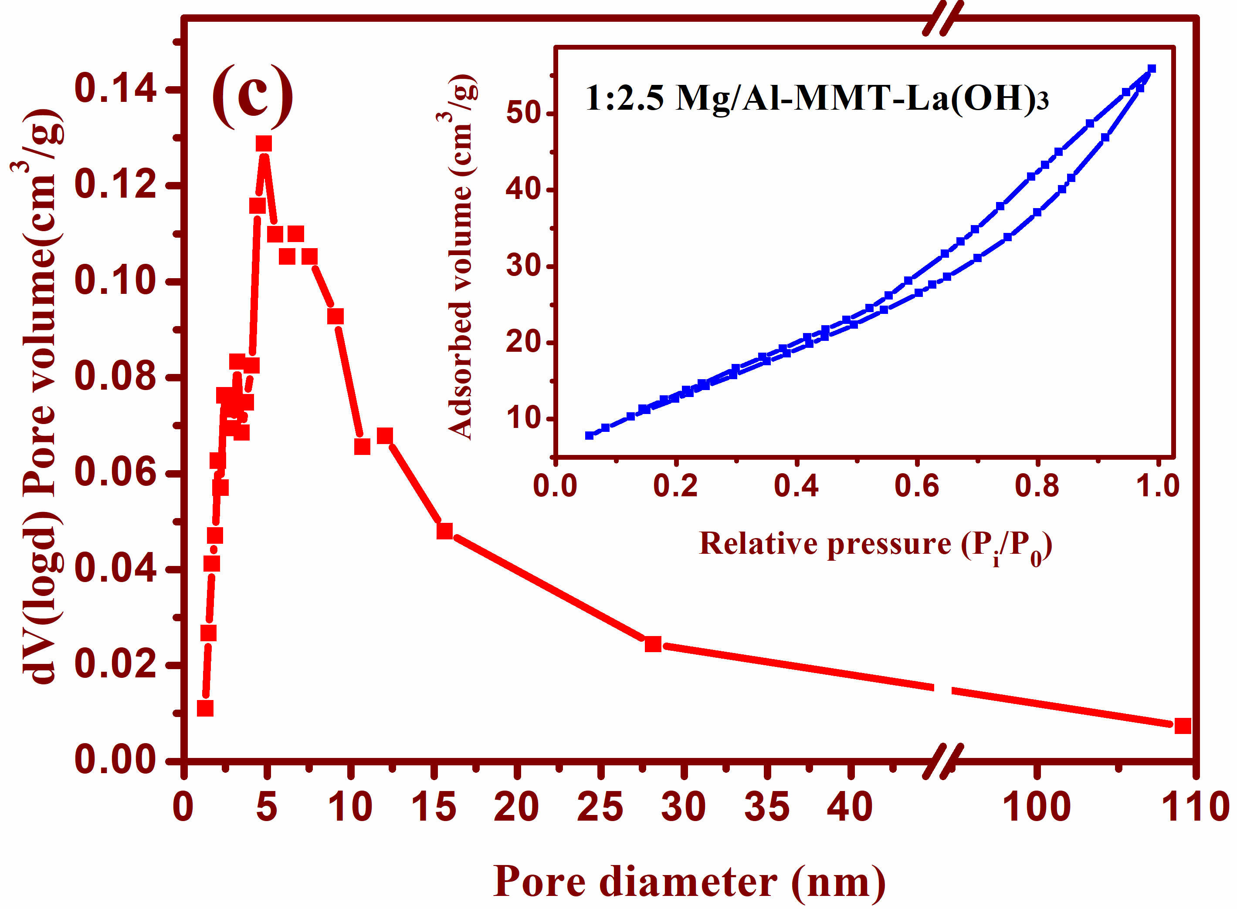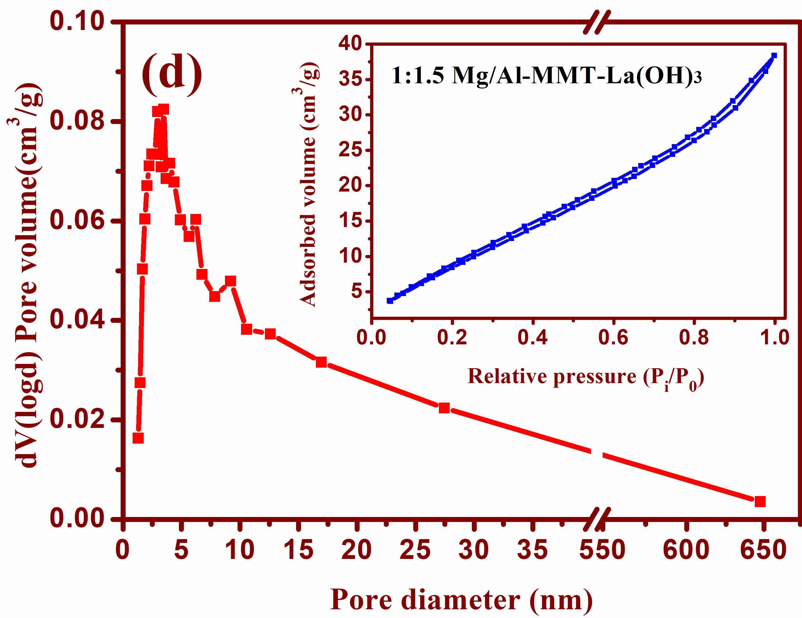
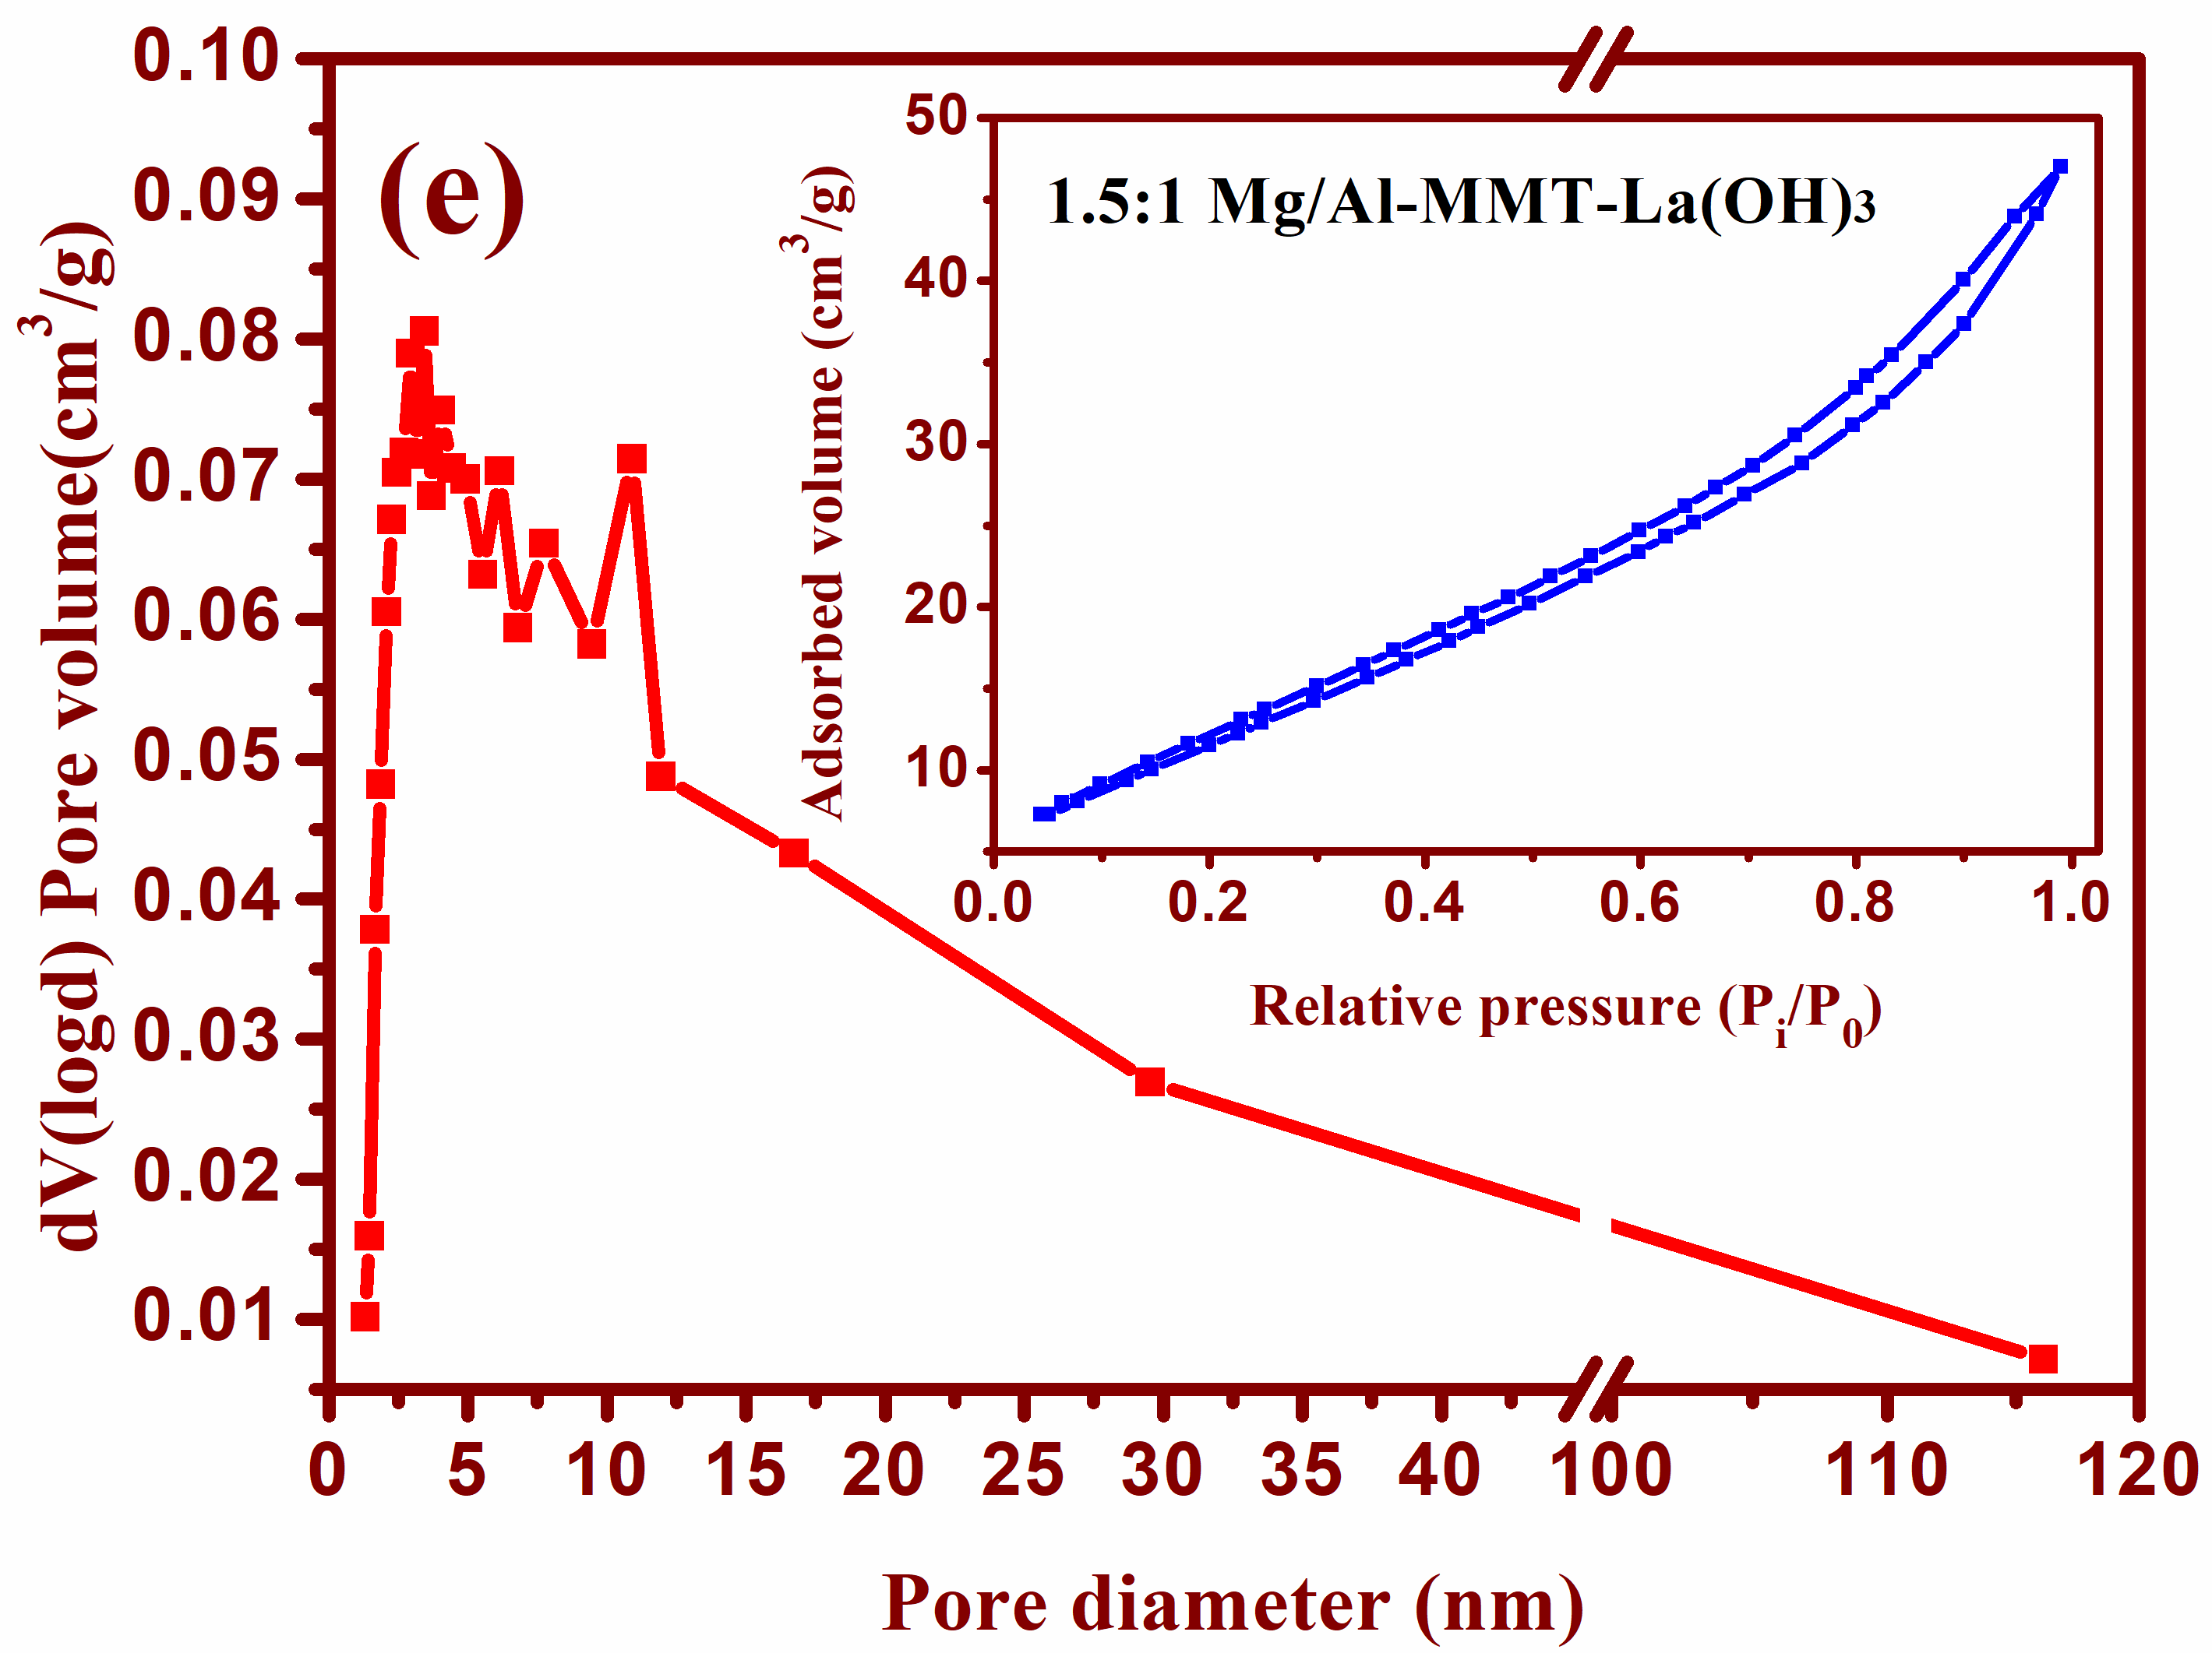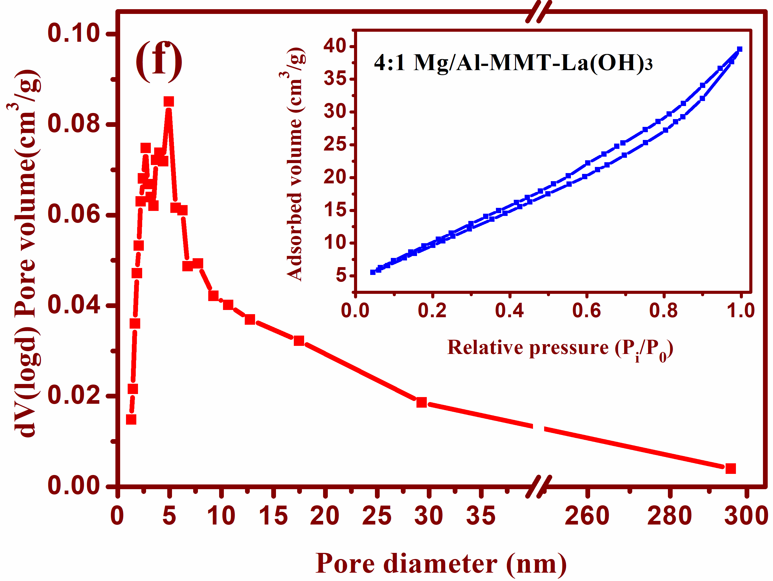
Fig. S4. BJH desorption pore volume distribution and nitrogen adsorption-desorption isotherm of (a) 1:4 Mg/Al-MMT; (b) to (f) Mg/Al-MMT-La(OH)₃ in different Mg²⁺/Al³⁺ molar ratios.
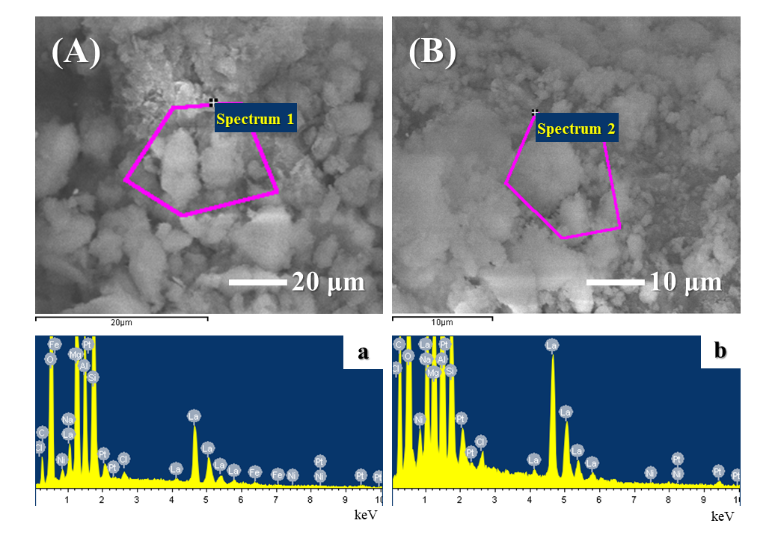
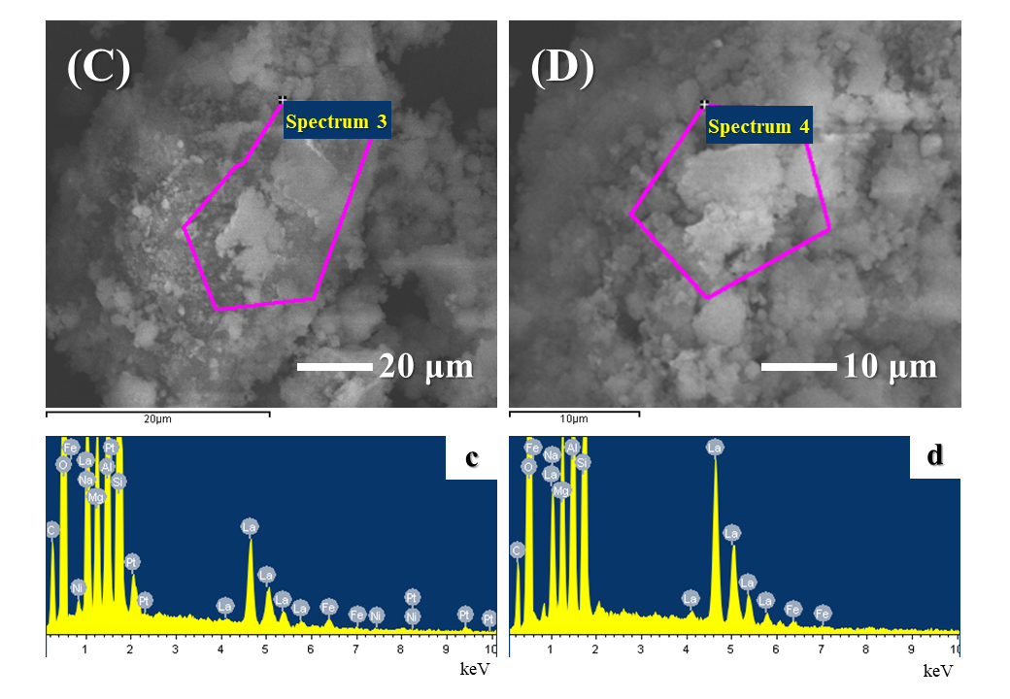
Fig. S5. SEM images of Mg/Al-MMT-La(OH)₃ at different molar ratios (Mg/Al) of (A) 4:1, (B) 1.5:1, (C) (1:4) 1:1.5, and (D) 1:2.5; EDS spectrum of (a) 4:1, (b) 1.5:1, (c) (1:4) 1:1.5, and (d) 1:2.5.
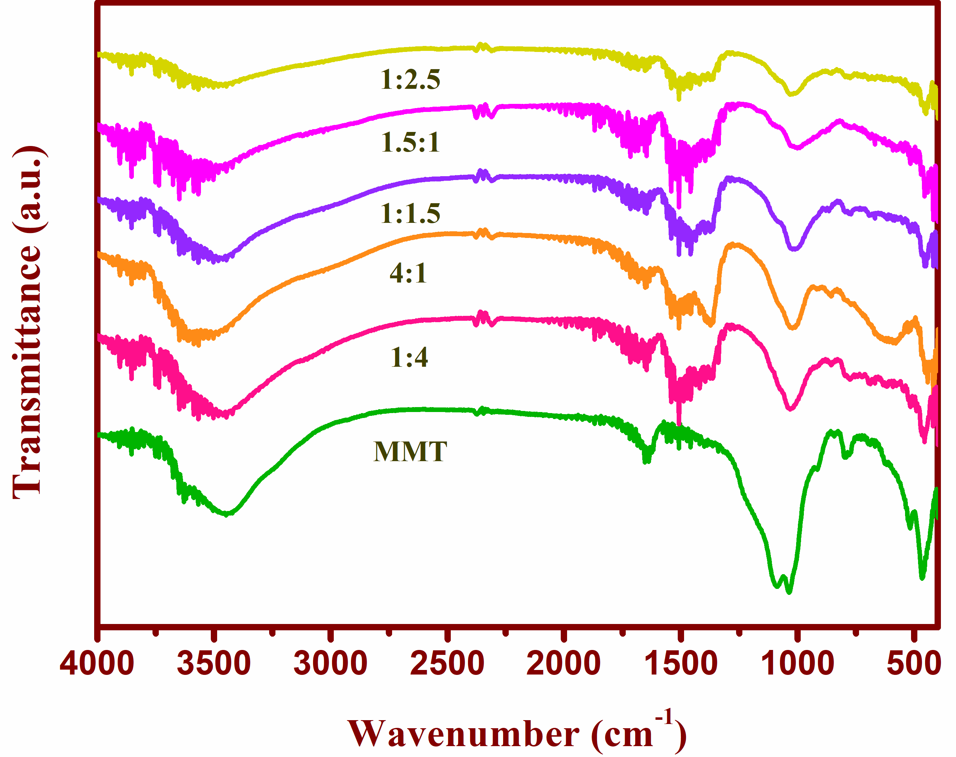
Fig. S6. FTIR profiles of raw MMT and Mg/Al-MMT-La(OH)₃ at different molar ratios (Mg/Al) of 4:1, 1.5:1, 1:1.5, 1:2.5, 1:4.
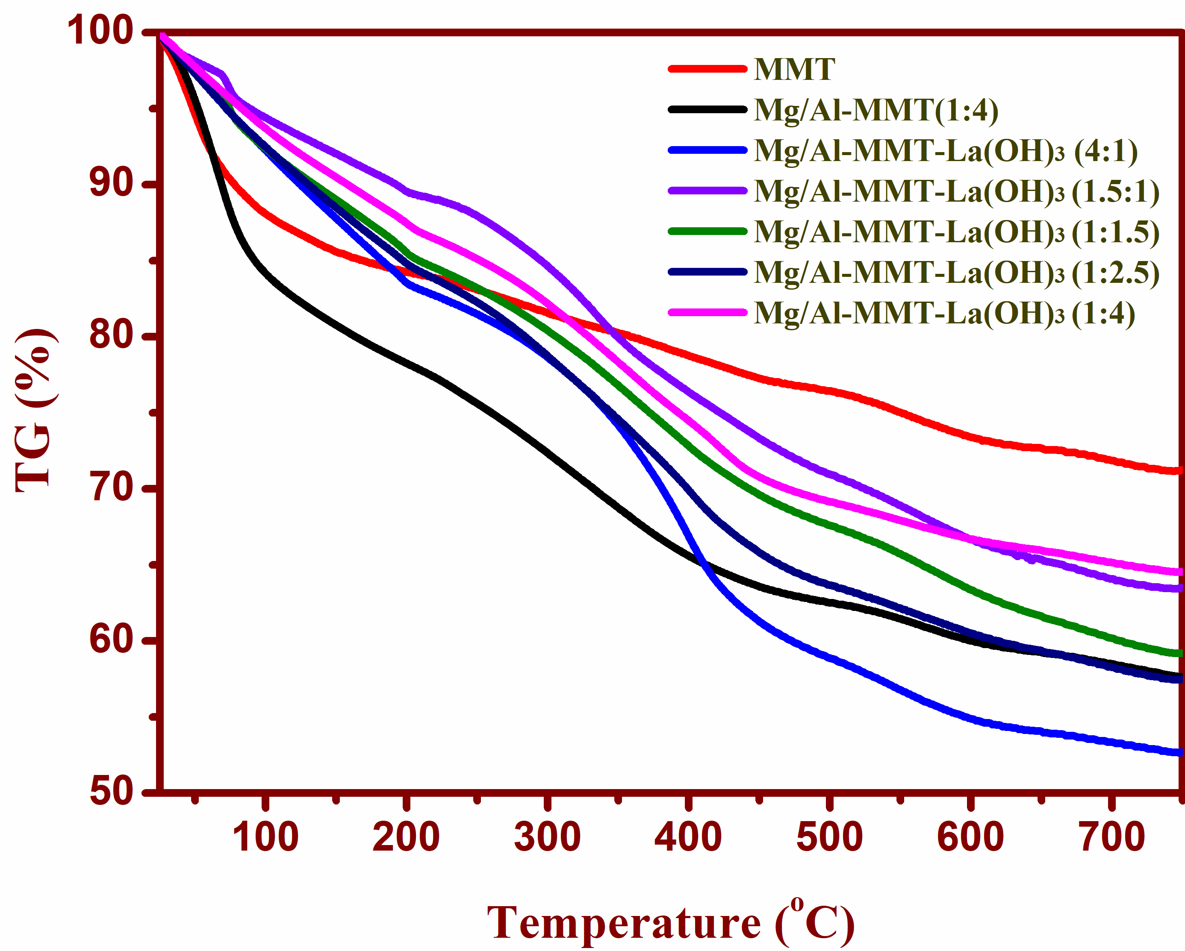
Fig. S7. TGA images of raw MMT, (1:4) Mg/Al-MMT and Mg/Al-MMT-La(OH)₃ at different molar ratios (Mg/Al) of 4:1, 1.5:1, 1:1.5, 1:2.5, 1:4.

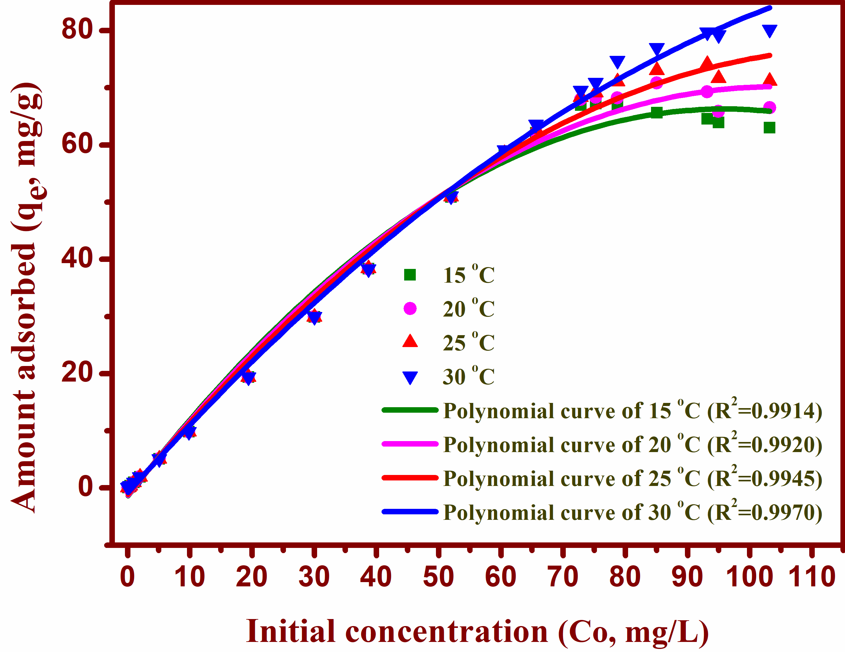
Fig. S8. Effect of initial phosphate concentration on adsorption capacity of 1:4 Mg/Al-MMT-La(OH)₃.
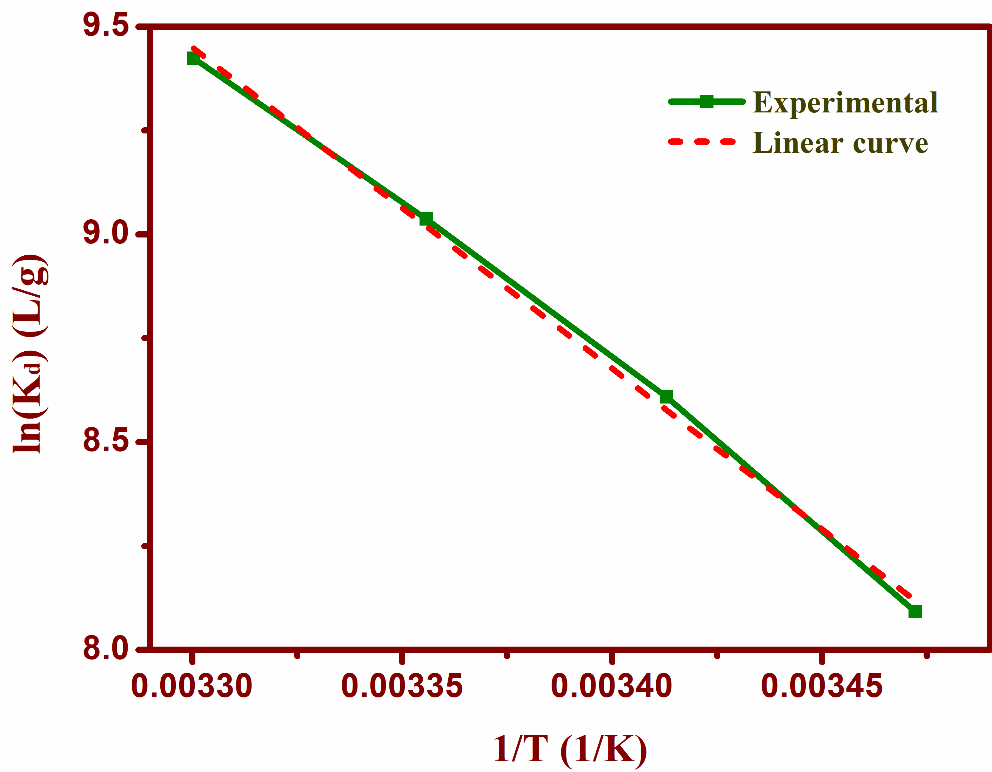
Fig. S9. Thermodynamic analysis for phosphate adsorption to (1:4) Mg/Al-MMT-La(OH)₃ composite.

Table S1- Analysis of the most probable pore diameter and pore volume of synthetic adsorbents.
Adsorbent samples | Molar ratios (Mg²⁺:Al³⁺) | The most probable pore diameter (nm) | The most probable pore volume (cm³/g)
MMT | —— | 4.42 | 0.561
Mg/Al-MMT | 1:4 | 4.46 | 1.021
Mg/Al-La(OH)₃-MMT | 4:1 | 2.70 | 0.075
Mg/Al-La(OH)₃-MMT | 1.5:1 | 3.43 | 0.806
Mg/Al-La(OH)₃-MMT | 1:1.5 | 3.48 | 0.825
Mg/Al-La(OH)₃-MMT | 1:2.5 | 4.80 | 0.129
Mg/Al-La(OH)₃-MMT | 1:4 | 6.68 | 0.195

Table S2- Analysis of the BET surface area and pore structures of synthetic adsorbents.
Adsorbent samples | Molar ratios (Mg²⁺:Al³⁺) | BET surface area (m²/g) | Average pore diameter (nm) | Pore volume (cm³/g)
MMT | —— | 183.49 | 3.704 | 0.180
Mg/Al-MMT | 1:4 | 183.38 | 3.730 | 0.175
Mg/Al-La(OH)₃-MMT | 4:1 | 41.46 | 2.622 | 0.063
Mg/Al-La(OH)₃-MMT | 1.5:1 | 46.78 | 2.626 | 0.072
Mg/Al-La(OH)₃-MMT | 1:1.5 | 41.29 | 2.518 | 0.064
Mg/Al-La(OH)₃-MMT | 1:2.5 | 52.85 | 2.953 | 0.088
Mg/Al-La(OH)₃-MMT | 1:4 | 65.21 | 3.675 | 0.121

